Investigation the DNA binding ability of CIA5 in Chlamydomonas reinhardtii
Bo Chen^{a, b} * and Martin H. Spalding^{b}*
a Panxi Crops Research and Utilization Key Laboratory of Sichuan Province, Xichang University, Sichuan, China 615000
b Department of Genetics, Development, and Cell Biology, Iowa State University, Ames, IA 50011
*: Corresponding Author:
Bo Chen
Telephone: +8619198927306
Martin H. Spalding
Telephone: +1515 294-1749
FAX: 515 294-1303

This paper demonstrates that CIA5 proteins has potential interaction with specific DNA sequences using random binding site selection (RBSS), which was confirmed using a gel mobility shift assay (GMSA) to demonstrate highly specific protein-DNA interaction with purified, full-length CIA5. In addition, promoter fragments containing a 9-bp GC rich (GGGGCGGGG) candidate motif from three CIA5-dependent genes also showed highly specific protein-DNA interaction with CIA5, although the GMSA interactions were somewhat weaker than with the RBSS-identified sequence. Nonetheless, this work clearly provides the first direct evidence that CIA5 can bind specific DNA sequences in vitro and thus opens the way for more extensive in vivo experiments to determine whether the specific DNA-binding of CIA5 has any biological relevance in vivo.

Supplemental information
S1. Materials and Methods
S1.1 Constructs for ad1 complementation
It has been reported that some C2H2 type Zn-finger proteins, such as transcription factor Sp1 (specificity protein 1), strongly bind to G-rich elements such as GC (GGGGCGGGG) and GT/CACC boxes (GGTGTGGGG) [1, 2]. The GGGGCGGGG motif was found in multiple CIA5-regulated genes. To test whether CIA5 can bind the GGGGCGGG DNA motif in vivo, modified pBluescript II KS_LCIB plasmid containing LCIB genomic DNA (Fig. S1) was used to complement the ad1 mutant. LCIB genomic DNA was inserted into this plasmid through SfuI/BamHI site, and LCI1, LCIB and LCI5 promoters (around 800bp ~ 1000bp upstream of +1) with either wild-type or mutated GGGGCGGGG motif (amplifying primers in Table S6) were inserted in place of the original promoter. The 5P and 3P primer pairs were used to amplify wild-type promoters from Chlamydomonas genomic DNA, and the 5P/MR or MF/3P primer pairs were applied to amplify fragments with mutations and used to generate the mutated promoter by fusion PCR. All promoters were inserted into pBluescript II KS_LCIB through NotI/SfuI site to replace the original promoter and to make 8 final constructs named LCI1PB, LCI1PBM, LCIBPB, LCIBPBM, LCI5PB and LCI5PBM1/M2/M3 (M stands for mutation), which were all transformed into Chlamydomonas ad1 cells by glass bead transformation performed as described previously [3].

S1.2 Gene expression analysis

RNA was extracted with an RNeasy Plant Mini Kit (Qiagen, Cat. No. 74904), and the RNA concentration was measured using an ND-2000 Nanodrop spectrophotometer (Nanodrop Technologies). 1-5 μg total RNA was treated with TURBO DNA-FreeTM kit (Life Technologies), and cDNA was generated from 0.5 μg -1 μg of treated total RNA (Verso cDNA Synthesis Kit; Thermo Scientific). cDNA (25-50 ng) was used for reverse transcription polymerase chain reaction (RT-PCR) and for quantitative RT-PCR (qRT-PCR) with a CFX Connect™ Real-Time PCR Detection System (Biorad) using a SYBR green two-step quantitative PCR system (Quanta Biosciences). Primer sequences and efficiencies are provided as supplemental information (Table S6). . For quantitative analyses, the CBLP gene was used as an internal control for normalization of qRT-PCR data [4]. The relative transcript abundance in each sample is defined as ∆Ct = Ct(target gene)-Ct(CBLP) to represent the difference between the transcript abundance of genes examined and the transcript abundance of CBLP.

S1.3 Western immunoblot analysis

For western immunoblotting, total protein was obtained as described previously [5]. Proteins were separated by SDS-PAGE on 4-12% gradient polyacrylamide gels, and immunoblotting using an anti-His-tag antibody (Pierce, Cat. No. MA1-21315) or anti-CIA5 antibody 1 and anti-CIA5 antibody 2 was performed as described in the protocol from Bio-Rad Laboratories (catalog no. 500-0006).
S2 Results
S2.1 The effect of replaced promoter on complementation with ad1 mutant

To test whether there is protein-DNA interaction in vivo between CIA5 and the GC rich motif identified in the BioProspector analysis (GGGGCGGGG), modified constructs containing LCIB genomic DNA (Fig. S1) and LCI1, LCI5 and LCIB promoters with either wild-type or mutated motifs (Table S6) were used to complement the air-dier phenotype of the LCIB ad1 mutant. If the GC rich motif is vital and essential for CIA5 binding in vivo to regulate target gene expression, the mutated promoters should not allow CIA5 binding, as was seen for the LCI5-derived motif in vitro (Fig. 5).
This predicted decrease in CIA5/CCM1 binding might be expected to prevent the constructs from complementing ad1, and might be expected to either decrease or increase LCIB expression in the complemented lines. The 8 constructs containing LCIB genomic DNA combined with either wild-type or mutated LCI1, LCIB and LCI5 promoters (the sequences used to amplify the promoter as shown in Table S6) were transformed into ad1, and all 8 constructs were able to complement ad1, that is, all enabled ad1 transformants to grow under air-level CO₂. LCIB expression was assessed at both the transcriptional and translational levels in all transformants. Western immunoblot analysis using specific anti-LCIB antibody (Fig. S6A), showed LCIB was expressed in all transformants with either the wild-type or mutated promoters but not in the ad1 mutant, which indicated that all constructs with alternative promoters (either wild type or mutated) successfully complemented the mutant. However, when compared with wild type CW10, the expressed LCIB protein levels were lower than wild type in all transformant lines either under high CO₂ or when induced with air-level CO₂. LCIB transcript expression results from both RT-PCR (Fig. S6B) and qRT-PCR (Fig. S6C) yielded very similar results to the western immunoblot results in confirming that all three promoters enabled expression of the LCIB gene. In addition, both western immunoblots and qRT-PCR results indicated that all three promoters provided higher expression in air-level CO₂ than in high-CO₂, as would be expected if they functioned normally. However, there was no clear indication that any of the mutated promoters had a negative impact on LCIB expression.

Table S1. The receipt for making E. coli competent cells.
Buffers | concentrations | components |  | Notes
Buffer 1 | 100mM RbCl | 6.05 g | RbCl | TOTAL: 500mL, adjust pH to 5.8 with acetic acid (Better to use diluted acetic acid). Filter sterilize through a prerinsed 0.22 μm membrane
Buffer 1 | 50mM MnCl₂ | 4.95 g | MnCl₂.4H₂O
Buffer 1 | 30mM KAc | 1.47 g | KAc
Buffer 1 | 10mM CaCl₂ | 0.735 g | CaCl₂.2H₂O
Buffer 1 | 15% Glycerol | 75mL | Glycerol
Buffer 2 | 10mM MOPS | 209mg | MOPS | TOTAL: 100mL, adjust pH to 6.8 with NaOH. Filter sterilize through a prerinsed 0.22μm membrane
Buffer 2 | 10mM RbCl | 121mg | RbCl
Buffer 2 | 75mM CaCl2 | 1.1g | CaCl₂.2H₂O
Buffer 2 | 15% Glycerol | 15mL | Glycerol
SOB |  | 2% | Bactotyptone | Autoclave and then add, filter sterilized,10mM MgSO₄ and 10mM MgCl₂.
SOB |  | 0.50% | Bacto Yeast Extract
SOB |  | 10mM | NaCl
SOB |  | 2.5mM | KCl

Table S2. CIA5 possible biding site from random binding site selection (RBSS).
Candidate binding site sequences from RBSS
----ACTAGGCAGGGTTACA-------- | ----TACTCTCCGGGTCAAT--------
----ACTAGGCAGGGTTACA-------- | ---ACGGGGATGGGGTCGC---------
----ACTAGGCAGGGTTACA-------- | ------GCAGTAGGGTCTTGGG------
----ACTAGGCAGGGTTACA-------- | ----------CCTGGTGGATTACGTT--
----ACTAGGCAGGGTTACA-------- | -ACCAAGTTCTGGGGTA-----------
----ACTAGGCAGGGTTACA-------- | --AGTGTTGTCTCGGTGA----------
-----GTGGCTTAGGTTGCAA------- | ---GGGTCAACAGGGTATA---------
-----GTGGCTTAGGTTGCAA------- | -ACCAAGTTCTGGGGTA-----------
-----GTGGCTTAGGTTGCAA------- | --------ATGGGGGTCGAGAATA----
-----GTGGCTTAGGTTGCAA------- | --------TCAACGGTAATTAACA----
------GGTCTGAGGTTACCCG------ | ---------TACGGGTGGAGGCACG---
--------CGTTAGGTTACCTACT---- | -----ACGAAGGAGGTAAATC-------
-------TACAAAGGTTCAAGGC----- | ------------AGGTCGGATTCGCTAG
---AAGTAGATAAGGTTAC--------- | ----TGGGGTGGGGGTGTGG--------
-----------CTGGTTGGACTGAAAG- | --TAAAAGGGATCGGTCT----------
------------CGGTTCTGCAGCTTCG | ---------AGTGGGTGGGACGAAG---
---ACTCCCCGTTGGTTCG--------- | TAGAACTCGCTGTGGT------------
--CGTGGCCTTGTGGTTG---------- | ------------CGGTGATACAGCTGGG
-----------GTGGTTACCAAGGAAA- | ------TCAGTGGGGTGTAAGT------
---TCAATATTTGGGTAAA--------- | -----------AAGGTGTAGGGGATAC-
------GCGCCTGGGTGCCAAG------ | TTCTCGATCCAAAGGT------------
----AAGTCCGTAGGTCAAA-------- | ------GTGCGAAGGTAGGATA------
----------GCAGGTGAGACGCGGG-- | ---------CATGGGTGCAGTATAT---

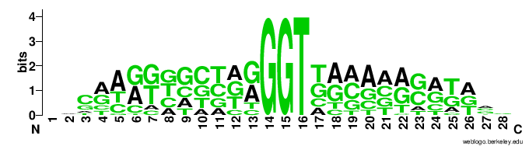
Table S2. CIA5 possible biding site from random binding site selection (RBSS). RBSS was performed as described in Material and Methods. After five to eight rounds of selection, protein-DNA complexes were separated by electrophoresis with a 5% polyacrylamide gel and bound DNA was recovered by ethanol precipitation and ampliﬁed by PCR. The PCR products cloned into pGEM®-T Vector yielded 88 sequences, about 46 of which contained the core sequences either GGT or GGTT and sequence log was also generated based on all 46 sequences.

Table S3: Possible CIA5/CCM1 binding motif
No. | Sequence Name | Bases | Sequence
1 | LCI1 motif F | 29 | TGGCGAGTTGGGGGCGGGGTTGCATGCGA
1 | LCI1 motif R | 29 | TCGCATGCAACCCCGCCCCCAACTCGCCA
2 | LCIB motif F | 29 | CTGGGGTGGCGGGGCGGGGCCGTGGGCGT
2 | LCIB motif R | 29 | ACGCCCACGGCCCCGCCCCGCCACCCCAG
3 | LCIC motif F | 29 | TCAGGGGCGTGGGGGGGGGGCTAGAAGGG
3 | LCIC motif R | 29 | CCCTTCTAGCCCCCCCCCCACGCCCCTGA
4 | CCP1 motif F | 29 | TGGAAATCATGCGGGGGCGAGCGGCATTC
4 | CCP1 motif R | 29 | GAATGCCGCTCGCCCCCGCATGATTTCCA
5 | CCP2 motif F | 29 | TGGACATCATGCGGGGGCGAGCGGCGTTC
5 | CCP2 motif R | 29 | GAACGCCGCTCGCCCCCGCATGATGTCCA
6 | LCI5 motif F | 29 | TTTGAGGAGCGGGGCGGGGCCATTCCTCC
6 | LCI5 motif R | 29 | GGAGGAATGGCCCCGCCCCGCTCCTCAAA
7 | Lhcsr1 motif F | 29 | TGCTGTGCAGGGGGCGGGGAGGGGGGGGG
7 | Lhcsr1 motif R | 29 | CCCCCCCCCTCCCCGCCCCCTGCACAGCA
8 | CAH3 motif F | 29 | ACTGCGGGGGGGGGCGGGGAGAGGGCCCC
8 | CAH3 motif R | 29 | GGGGCCCTCTCCCCGCCCCCCCCCGCAGT

Table S3. The sequences used for GMSA from promoters of 8 candidate genes. Sequences from the promoters were identified by Bioprospector and used for GMSA. Bold red text indicates the 9-nt GC rich motif identified in Bioprospector, which was flanked on each side by 10 nucleotide acids from each promoter. Also shown are mutations within the GGGGCGGGG motif indicated with blue text.

Table S4. Gel Mobility Shift Assay (GMSA) working sheet Date:
 |  | 1 | 2 | 3 | 4 | 5 | 6 | 7 | 8 | 9 | 10 | 11 | 12 | 13 | 14 | 15 | 16 | 17 | 18 | 19 | 20
H₂O | µl
4×Buffer | µl | 5 | 5 | 5 | 5 | 5 | 5 | 5 | 5 | 5 | 5 | 5 | 5 | 5 | 5 | 5 | 5 | 5 | 5 | 5 | 5
dI-dC or dA-dT | µl | 1 | 1 | 1 | 1 | 1 | 1 | 1 | 1 | 1 | 1 | 1 | 1 | 1 | 1 | 1 | 1 | 1 | 1 | 1 | 1
Probe (unlabeled) | µl
Proteins | µl
Antibody | µl
Incubate on ice for 10 min
Probe (labeled) | µl
Others | µl
Incubate on ice for 30 min

Table S4. Gel mobility shift assay (GMSA) working sheet. Each agents were added to the reaction according to the order on the working sheet.

LCI5 motif mutant
 | Forward sequence | Reverse sequence
LCI5 | TTTGAGGAGCGGGGCGGGGCCATTCCTCC | GGAGGAATGGCCCCGCCCCGCTCCTCAAA
M1 | TTTGAGGAGCGGGGTGGGGCCATTCCTCC | GGAGGAATGGCCCCACCCCGCTCCTCAAA
M2 | TTTGAGGAGCGGGTCGGGGCCATTCCTCC | GGAGGAATGGCCCCGACCCGCTCCTCAAA
M3 | TTTGAGGAGCGGAGCGGGGCCATTCCTCC | GGAGGAATGGCCCCGCTCCGCTCCTCAAA
M4 | TTTGAGGAGCGGGGCAGGGCCATTCCTCC | GGAGGAATGGCCCTGCCCCGCTCCTCAAA
M5 | TTTGAGGAGCGGGGCGTGGCCATTCCTCC | GGAGGAATGGCCACGCCCCGCTCCTCAAA

Table S5. The wild-type and mutant LCI5 promoter sequences were used for GMSA. The one where the mutation was highlighted by bold purple color. The oligo annealing and probe labeling are as the same as mentioned on legend Table S3.

Table S6. Primers used to amplify promoters
Primer Name | Primer sequence
LCI1_5P | AAGGAAAAAAGCGGCCGC AACATCCGCTGCATTCAGG
LCI1_3P | AAGGAAAAAATTCGAATGCAACACACTAGTTAATCACCT
LCIB_5P | AAGGAAAAAAGCGGCCGCTCGATGATGGGGCAAGTTTC
LCIB_3P | AAGGAAAAAATTCGAAACTGTGTTTGGGAGCAGGA
LCI5_5P | AAGGAAAAAAGCGGCCGCTTACTCGCACTGCCCAGC
LCI5_3P | AAGGAAAAAATTCGAAAAGGTGAATCTGTGCGCGC
LCI1_MF | GTTGGGGGAGGGGTTG
LCI1_MR | CAACCCCTCCCCCAAC
LCIB_MF | TGGCGGGGAGGGGCC
LCIB_MR | GGCCCCTCCCCGCCA
LCI5_MF1 | AGCGGGGTGGGGCCA
LCI5_MR1 | TGGCCCCACCCCGCT
LCI5_MF2 | AGCGGGTCGGGGCCA
LCI5_MR2 | TGGCCCCGACCCGCT
LCI5_MF3 | AGCGGAGCGGGGCCA
LCI5_MR3 | TGGCCCCGCTCCGCT

Table S6. Primers used to amplify LCIB, LCI1 and LCI5 promoters for in vivo ad1 mutant complementation experiments. Primer pairs 5P and 3P were used to amplify each of the wild type promoter sequences (about 800bp ~ 1000bp upstream of +1), the primer pairs 5P and MR or MF and 3P were used to amplify each partial promoter containing the desired mutation, then 5P/3P primer pairs were used to ligate each partial fragments together by fusion PCR to generate mutated promoters. The promoters were inserted into pBluescript II KS_LCIB through NotI/SfuI to generate final constructs LCI1PB/M, LCIBPB/M and LCI5PB/M1/M2/M3 (M stands for mutation). NotI/SfuI sites are highlighted as italic bold red, the conserved GC motifs are marked as bold red font, and mutated nucleotides are indicated in bold purple.

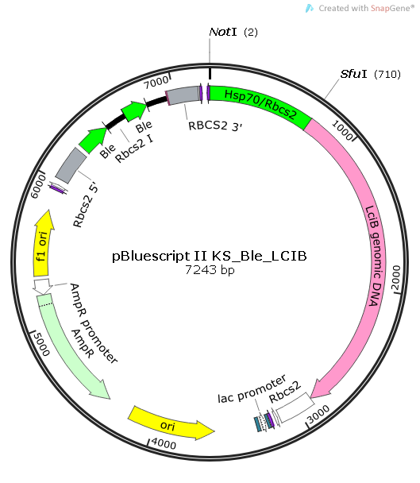
Fig. S1. The map of pBluescript II KS_Ble_LCIB, which was used for cloning the LCIB, LCI1 and LCI5 promoters in place of the HSP70/Rbcs2 promoter in the plasmid.

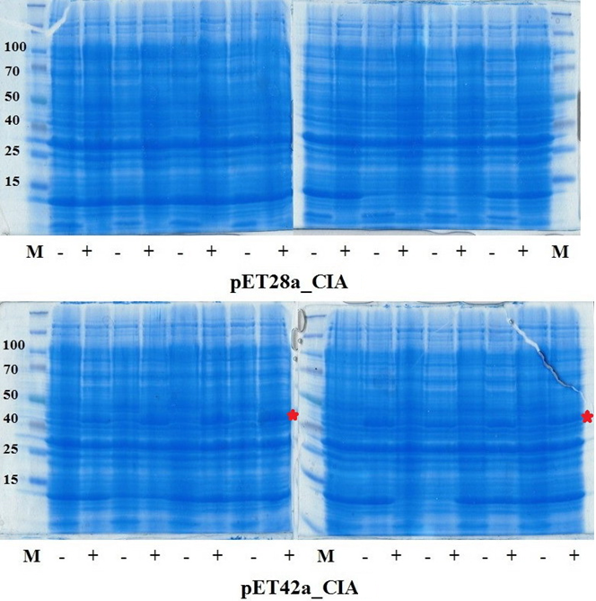
Fig. S2. Overexpression of CIA5 in E. coli. Full length CIA5 coding DNA sequence (CDS) was amplified from a subcloned cosmid containing the full length CIA5 CDS, and sub-cloned into E. coli expression vector pET28a (His-tag) and pET42a (His- and GST-tag) through EcoRI/SalI site to generate the final constructs pET28a_CIA and pET42a_CIA, then transformed into E. coli BL21-CodonPlus (DE3) (see material and methods). The expected fusion protein size should be more than 70kD and 100kD in pET28a_CIA and pET42a_CIA (220aa GST-tag), respectively. None of 8 transformants for each construct with or without IPTG induction, showed expected protein size. Only pET42a_CIA constructs shows an IPTG inducible response, but with the incorrect protein size (marked with red star, around 42 kD).
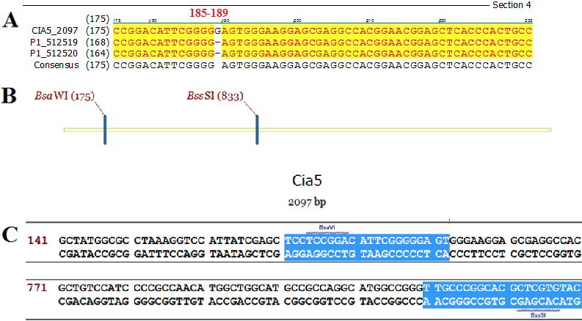

Fig. S3. Schematic showing reconstruction of the CIA5 to repair error. Upper panel indicates one G missing around 185 to 189 nt. Middle panel indicates the position and use of two unique restriction enzyme site to overcome the missing “G” error. Bottom panel shows the primers used to correct the sequence error.

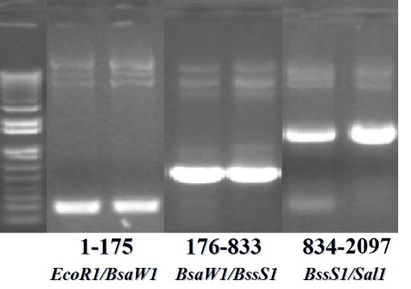
Fig. S4. Three PCR fragments containing CIA5 CDS to be used for constructing full-length CIA5 CDS. These three fragments were purified (Qiagen Gel Extraction Kit, Cat. No. 28704) and digested with EcoRI/BsaWI, BsaWI/BssSI and BssSI/SalI, then ligated with EcoRI/SalI digested vector in a 4-fragments ligation to regenerate the pET28a_CIA5 and pET42a_CIA5 constructs.

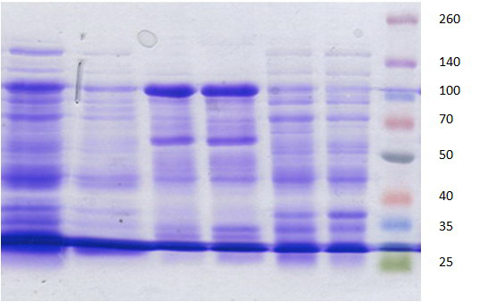

Fig. S5. His-CIA5 purification from pET28a_CIA5. Lane 1: total extraction; Lane 2: flow-through; Lane 3-4: elution; Lane 5-6: wash.
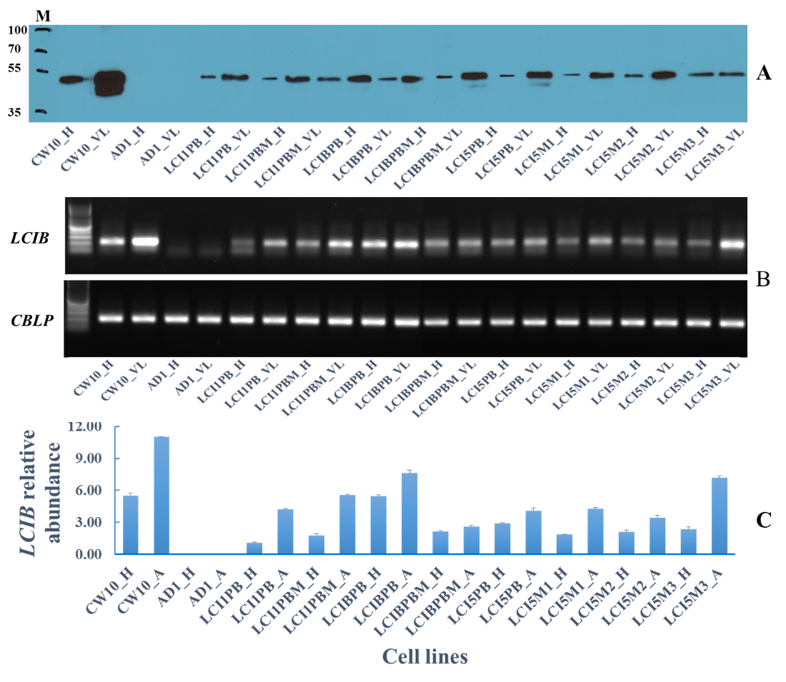
Fig. S6. Analysis of LCIB gene expression under different conditions. A: Western immunoblot analysis of LCIB expression among all ad1 transformants complemented with LCIB under regulation by LCI1, LCIB or LCI5 promoter sequences in either high CO₂ (H) or air-level CO₂ (A). LCI1PB/M, LCIBPB/M and LCI5PB/M1/M2/M3 indicate various ad1 transformants complemented with LCIB containing either LCI1, LCIB or LCI5 promoter; B: RT-PCR analysis of LCIB gene expression as transcript abundance among all ad1 transformants complemented with LCIB under regulation by LCI1, LCIB or LCI5 promoter sequences in either high CO₂ (H) or air-level CO₂ (A). LCI1PB/M, LCIBPB/M and LCI5PB/M1/M2/M3 indicate various ad1 transformants complemented with LCIB containing either LCI1, LCIB or LCI5 promoter: C: qRT-PCR analysis of LCIB gene expression as transcript abundance among all ad1 transformants complemented with LCIB under regulation by LCI1, LCIB or LCI5 promoter sequences in either high CO₂ (H) or air-level CO₂ (A). LCI1PB/M, LCIBPB/M and LCI5PB/M1/M2/M3 indicate various ad1 transformants complemented with LCIB containing either LCI1, LCIB or LCI5 promoter (M stands for mutation).

References

[1] S. Philipsen, G. Suske, A tale of three fingers: the family of mammalian Sp/XKLF transcription factors, Nucleic Acids Res, 27 (1999) 2991-3000.
[2] T. Kamiuchi, E. Abe, M. Imanishi, T. Kaji, M. Nagaoka, Y. Sugiura, Artificial nine zinc-finger peptide with 30 base pair binding sites, Biochemistry, 37 (1998) 13827-13834.
[3] K. Van, M.H. Spalding, Periplasmic carbonic anhydrase structural gene (Cah1) mutant in chlamydomonas reinhardtii, Plant Physiol, 120 (1999) 757-764.
[4] W. Fang, Y. Si, S. Douglass, D. Casero, S.S. Merchant, M. Pellegrini, I. Ladunga, P. Liu, M.H. Spalding, Transcriptome-wide changes in Chlamydomonas reinhardtii gene expression regulated by carbon dioxide and the CO₂-concentrating mechanism regulator CIA5/CCM1, The Plant cell, 24 (2012) 1876-1893.
[5] D. Duanmu, Y. Wang, M.H. Spalding, Thylakoid lumen carbonic anhydrase (CAH3) mutation suppresses air-Dier phenotype of LCIB mutant in Chlamydomonas reinhardtii, Plant physiology, 149 (2009) 929-937.

