Supplementary Information to
Putting the Squeeze on Valence Tautomerism in Cobalt-Dioxolene Complexes
Aston Summers,ª F. Zahra M. Zahir,^{b} Gemma F. Turner,ª Moya A. Hay,^{b} Alan Riboldi-Tunnicliffe,^{c} Rachel Williamson,^{c} Stephanie Boer,^{c} Lars Goerigk,*^{b} Colette Boskovic*^{b} and Stephen A. Moggach*ª
ª School of Molecular Sciences, University of Western Australia, Crowley, Western Australia, 6009, Australia. E-mail: stephen.moggach@uwa.edu.au
^{b} School of Chemistry, University of Melbourne, Parkville, Victoria, 3010, Australia. E-mail: Lars Goerigk lars.goerigk@unimelb.edu.au and c.boskovic@unimelb.edu.au
^{c} Australian Synchrotron, 800 Blackburn Road, Clayton, Victoria, Australia 3168

Contents
S1. Synthesis 1
Materials and methods 1
Ligand synthesis 1
Complex synthesis 2
S2. Single Crystal X-Ray Diffraction 3
Ambient Conditions Single Crystal X-Ray Diffraction 3
Variable Temperature Single Crystal X-Ray Diffraction 4
High-Pressure Single Crystal X-Ray Diffraction 4
S3. Computational Details 6
S4. Crystallographic Tables 7
S5. Structural Data 12

S1. Synthesis

Materials and methods
Synthesis of the complexes was performed using standard Schlenk line techniques under a nitrogen atmosphere. All chemicals used were of reagent grade and used as received. Methanol was dried using 3 Å sieves for three days and degassed through a minimum of ten cycles of vigorous shaking under vacuum and subsequent backfilling with nitrogen. The 3 Å sieves were activated by heating at 300 °C for 48 hours and cooling under vacuum.

Ligand synthesis
bis((6-methyl-2-pyridyl)methyl)(2-pyridylmethyl)amine (ligand Me₂tpa)
This ligand was synthesised according to modified literature procedure.¹ Distilled 2-aminomethylpyridine (0.89 g, 8.3 mmol) and 6-methyl-2-pyridine carboxaldehyde (2.00 g, 16.5 mmol) were added to a stirred dichloromethane (200 mL) solution of sodium triacetoxyborohydride (5.24 g, 24.7 mmol). The reaction mixture was covered with foil and left to stir for 48 hours. A saturated aqueous solution of sodium hydrogencarbonate (2.08 g, 24.7 mmol) was added and the resulting solution was stirred for another 30 minutes. The organic phase was extracted with dichloromethane (20 mL Χ 3) and dried over MgSO₄ to give a dark yellow oil. The oil residue was extracted several times with hexane and removal of solvent afforded colourless needles of bis((6-methyl-2-pyridyl)methyl)(2-pyridylmethyl)amine in 90 – 95 % yield.
Tris(6-methyl-2-pyridylmethyl)amine (ligand Me₃tpa)
The precursor 6-formaldoxime-2-methylpyridine was synthesised from 6-methyl-2-pyridine carboxaldehyde based on reported procedures.² The resulting solid was subsequently dried in the presence of phosphorous pentoxide. The ligand precursor 6-methyl-2-aminomethylpyridine was synthesised using a modified literature procedure.² Product yield was maximized by preparing a dry and degassed methanolic solution of 6-formaldoxime-2-methylpyridine (4 g / 500 mL) with 10 wt. % Pd/C. The reaction mixture was contained in a 3-neck enclosed round bottom flask and stirred under constant flow of hydrogen for up to 6-8 hrs. The yellow oil obtained after hydrogenation was determined via ¹H NMR to be 6-methyl-2-aminomethylpyridine. Using the modified literature procedure described above for ligand Me2tpa,³ the yellow oil (6-methyl-2-aminomethylpyridine) was subjected to a reductive amination with 6-methyl-2-pyridine carboxaldehyde and sodium triacetoxyborohydride. The reaction afforded 95 – 98 % yield of tris(6-methyl-2-pyridylmethyl)amine.

Complex synthesis
[Co(Me₂tpa)(dbdiox)][PF₆].(toluene) - (Me₂tpa)
The synthesised organic ligand Me₂tpa (64 mg, 0.20 mmol) was added to a dried and degassed methanol solution (10 ml) of CoCl₂.6H₂O (48 mg, 0.20 mmol). The resulting green solution was left stirring for 10 minutes under a nitrogen atmosphere. A dried and degassed methanol solution (10 ml) containing 3,5-di-tert-butylcatechol (37 mg, 0.20 mmol) was deprotonated with triethylamine (55 μL, 0.40 mmol) by stirring for 10 minutes. The deprotonated 3,5-di-tert-butylcatechol solution was slowly added to the cobalt-Me₂tpa mixture and stirred for 10 minutes to obtain a reddish-brown solution. The resulting solution was subjected to aerial oxidation followed by the addition of an aqueous KPF₆ solution to afford a black-green precipitate of [Co(Me₂tpa)(dbdiox)][PF₆]. The crude product was washed with diethyl ether (2 Χ 2 mL) and collected by vacuum filtration under ambient conditions. Large dark-green crystals were obtained by heating a moderately concentrated solution of toluene in a sand bath with subsequent slow cooling, affording [Co(Me₂tpa)(dbdiox)][PF₆].(toluene) - (Me₂tpa). Excess concentration resulted in co-crystallization of byproducts.
[Co(Me₃tpa)(dbdiox)][PF₆].(toluene) - (Me₃tpa)
The synthesised organic ligand Me₃tpa (67 mg, 0.20 mmol) was added to a dried and degassed methanol solution (10 ml) of CoCl₂.6H₂O (48 mg, 0.20 mmol). The resulting purple solution was left stirring for 10 minutes under a nitrogen atmosphere. A dried and degassed methanol solution (10 ml) containing 3,5-di-tert-butylcatechol (37 mg, 0.20 mmol) was deprotonated with triethylamine (55 μL, 0.40 mmol) by stirring for 10 minutes. The deprotonated 3,5-di-tert-butylcatechol solution was slowly added to the cobalt-Me₂tpa mixture and stirred for 10 minutes to obtain a reddish-brown solution. The resulting solution was subjected to aerial oxidation followed by the addition of an aqueous KPF₆ solution to obtain a black-green precipitate of [Co(Me₃tpa)(dbdiox)][PF₆]. The crude product was washed with diethyl ether (2 Χ 2 mL) and collected by vacuum filtration under ambient conditions. Large dark-green crystals were obtained by heating a moderately concentrated toluene solution in a sand bath with subsequent slow cooling affording Co(Me₃tpa)(dbdiox)][PF₆].(toluene) - (Me₃tpa).

S2. Single Crystal X-Ray Diffraction

Ambient Conditions Single Crystal X-Ray Diffraction
[Co(Me₃tpa)(dbdiox)][PF₆].(toluene) - (Me₃tpa)
A dull green block-shaped-shaped crystal with dimensions 0.18 × 0.10 × 0.09 mm³ was mounted. Data were collected using a XtaLAB Synergy, Single source HyPix diffractometer operating at T = 293(2) K. Data were measured using ω scans with MoKα radiation. The diffraction pattern was indexed and the total number of runs and images was based on the strategy calculation from the program CrysAlisPro 1.171.40.84a.⁴ The maximum resolution that was achieved was θ = 25.349° (0.83 Å). The unit cell was refined using CrysAlisPro 1.171.40.84a⁴ on 26175 reflections, 27% of the observed reflections. Data reduction, scaling and absorption corrections were performed using CrysAlisPro 1.171.40.84a.⁴ The final completeness is 99.80 % out to 25.349° in θ. A multi-scan absorption correction was performed using CrysAlisPro 1.171.40.84a⁴ using spherical harmonics, implemented in SCALE3 ABSPACK scaling algorithm. The absorption coefficient μ of this material is 0.512 mm⁻¹ at this wavelength (λ = 0.71073Å) and the minimum and maximum transmissions are 0.972 and 1.000. The structure was solved and the space group P2₁/c (# 14) determined by the ShelXT 2018/2⁵ structure solution program using iterative methods and refined by full matrix least squares minimisation on F² using version 2019/1 of ShelXL⁶ (ref). Hydrogen atom positions were calculated geometrically and refined using the riding model.
Under ambient conditions, one of the t-butyl groups was disordered, and refined with 1,2 and 1,3 similarity restraints (SADI) to ensure the group remained tetrahedral. The methyl C-atom anisotropic displacement parameters were constrained to be identical (EADP). Two toluene molecules were in the asymmetric unit. One ordered, the other disordered over two positions. The toluene C-atoms were refined using only isotropic thermal parameters because the data were collected at room temperature (to compare to the high-pressure data) The geometry of each toluene was constrained to be a rigid body (FRAG/FEND), whose geometry was obtained from the fragment database in Olex2.⁷ One of the PF₆ counterions was also disordered. This was refined using both similarity restraints (SADI) to ensure the group remained octahedral, while equivalent F-atoms in both disordered components were constrained to have identical anisotropic displacement parameters (EADP).

Variable Temperature Single Crystal X-Ray Diffraction
[Co(Me₃tpa)(dbdiox)][PF₆].(toluene) - (Me₃tpa)
A dark green block-shaped-shaped crystal with dimensions 0.15 × 0.10 × 0.10 mm³ was mounted. Data were collected using a XtaLAB Synergy, Single source HyPix diffractometer operating at T = 100.01(10) K. Data were measured using ω scans with CuK_{a} radiation. The diffraction pattern was indexed and the total number of runs and images was based on the strategy calculation from the program CrysAlisPro 1.171.41.104a⁸. The maximum resolution that was achieved was θ = 75.592 ° (0.80 Å). The unit cell was refined using CrysAlisPro 1.171.41.104a⁸ (ref) on 28555 reflections, 37% of the observed reflections. Data reduction, scaling and absorption corrections were performed using CrysAlisPro 1.171.41.104a⁸ . The final completeness was 99.90 % out to 75.592° in θ. A multi-scan absorption correction was performed using CrysAlisPro 1.171.41.104a⁸ using spherical harmonics, implemented in SCALE3 ABSPACK scaling algorithm. The absorption coefficient μ of this material is 4.292 mm⁻¹ at this wavelength (λ = 1.54184Å) and the minimum and maximum transmissions are 0.741 and 1.000. The structure was solved, and the space group P2₁/c (# 14) determined by the ShelXT⁵) structure solution program using iterative methods and refined by full matrix least squares minimisation on F² using version 2019/1 of XL⁶. All non-hydrogen atoms were refined anisotropically. Hydrogen atom positions were calculated geometrically and refined using the riding model. At 100K, only one of the PF₆ counterions was disordered. Equivalent F-atoms in both disordered components were constrained to have identical anisotropic displacement parameters (EADP). At 100K, both toluene molecules were ordered.

High-Pressure Single Crystal X-Ray Diffraction
[Co(Me₃tpa)(dbdiox)][PF₆].(toluene) - (Me₃tpa)
A single-crystal of Me₃tpa was loaded into a Merrill Bassett diamond anvil cell (DAC) containing two Boehlar-Almax diamond anvils with 600 µm culet faces fixed to tungsten-carbide backing discs. The DAC had a 40° half-opening angle. A 300 µm hole was drilled through a 200 µm thick tungsten gasket and fixed to one of the diamond culets to create a cylindrical sample chamber. Ruby crystals were also loaded into the sample chamber and used as a pressure calibrant, measured using the ruby fluorescence technique.⁹⁻¹¹ The Me₃tpa crystal was then compressed using Mitegen LVCO-5 oil as a pressure transmitting medium (PTM), from 0.29 to 4.40 GPa. Diffraction data were collected on a Rigaku Oxford Diffraction XtaLAB Synergy, Single source HyPix diffractometer at room temperature using Mo Κα radiation (λ = 0.7107 Å). The diffraction pattern at each pressure was indexed and the total number of runs and images was based on the strategy calculation from the program CrysAlisPro 1.171.40.84a⁴, based on a 40° half-opening angle for the DAC. The unit cell for each was refined using CrysAlisPro 1.171.40.84a⁴. Data reduction, scaling and absorption corrections were also performed using CrysAlisPro 1.171.40.84a⁴. A multi-scan absorption correction was also performed using spherical harmonics, implemented in SCALE3 ABSPACK scaling algorithm.⁴
The structure at each pressure was refined from the starting coordinates of the ambient pressure data. For the data collected from 0.29 to 3.10 GPa, the structures were refined in an almost identical fashion to the ambient pressure data, with one of the t-butyl groups disordered, and refined with 1,2 and 1,3 similarity restraints (SADI) to ensure the group remained tetrahedral. Two toluene molecules were also in the asymmetric unit. One ordered, the other disordered over two positions. The geometry of each toluene fragment was constrained to be a rigid body (FRAG/FEND), whose geometry was obtained from the fragment database in Olex2.⁷ At pressure, no disorder could be seen in the PF₆ counterions (as seen in the ambient and 100K data), probably because of higher thermal motion. The PF₆ counterions were constrained as rigid octahedra, based on a rigid body fragment obtained from the Olex2 fragment database.⁷ All t-butyl, and each of the pyridylmethyl-amine groups were also refined as rigid bodies constructed from the low-temperature coordinates. Only the dioxolene fragment was allowed to refine freely. Only Co, P and F-atoms were refined with anisotropic displacement parameters, all other non-H atoms were refined with isotropic thermal parameters. Thermal similarity restraints were applied for all non-H atoms (RIGU). This parameterisation strategy was used to reduce the number of refined parameters due to the low completeness of the high-pressure data, and the large number of independent atoms (Z’ = 2, with solvent and counterions).
On increasing pressure to 3.1 GPa, a solvent mask was used to model the two toluene solvent molecules. The solvent calculated equated to 340 electrons in a volume of 1048 Å³ located in 1 void per unit cell. This was consistent with the presence of one toluene molecule per asymmetric unit (which account for 400 electrons per unit cell). The one disordered t-butyl group also became ordered at 3.1 GPa. All other refinement parametrisation was kept the same.
On increasing pressure further to 4.40 GPa, the R-factor increased significantly (≈ 20%) and no chemically reasonable refinement could be obtained. This was probably caused by the valence tautomerism induced at pressure, with the reflections becoming broad and polycrystalline in nature. No further compression data were obtained as a result. The Crystallographic data reported and used in this paper have been deposited at the Cambridge Crystallographic Data Centre repository under reference codes (2353216-2353234). Copies of the data can be obtained free of charge by visiting https://www.ccdc.cam.ac.uk/structures/, or Cambridge Crystallographic Data Centre, 12 Union Road, Cambridge CB2 1EZ, U.KCB21EZ, UK (fax +441223336033; deposit@ccdc.cam.ac.uk).

S3. Computational Details
Density functional calculations were performed using the ORCA 4.0-4.1^{12,13} quantum chemistry package. Atomic coordinates for single complexes were obtained from the crystal structures of Me₂tpa and Me₃tpa without further optimisation. Two crystallographically unique molecules A and B of complexes Me₂tpa and Me₃tpa were isolated from each other at each compression or cooling point. Single point calculations were independently performed on each complex using the density functional M06L¹⁴ with DFT-D4¹⁵dispersion correction to account for London dispersion interactions considering atomic charge and spin states. Scalar relativistic effects were considered with the zeroth order regular approximation (ZORA)¹⁶ model using the relativistically contracted ZORA-def2-TZVPP¹⁶ atomic orbital basis set along with the segmented all electron relativistically contracted SARC/J auxiliary basis set.¹⁷ The largest numerical quadrature grid (grid 7) was used in the calculations. The spin-unrestricted formalism was employed for the open shell high spin Co^{II}-semiquinonato tautomer. Calculations were conducted using the singlet state to represent the low spin Co^{III}-catecholato tautomer, and quintet state to represent high spin Co^{II}-semiquinonato tautomer of each molecule. The relative spin state energies were [ΔE = E(low spin Co^{III}-catecholato) - E(high spin Co^{II}-semiquinonato)] obtained at each pressure or temperature point and plotted against the applied pressure or temperature.

S4. Crystallographic Tables
Table S1. Ambient, Low-temperature and High-pressure crystal structure data for Me₂tpa [Co(Me₂tpa)(dbdiox)][PF₆](toluene). All high-pressure structures were collected at 293 K. Table continued overleaf…
 | 95 K | 155 K | Ambient | 0.14 GPa
Formula | C₃₄H₄₂CoN₄O₂·[PF₆]·[C₇H₈] | C₃₄H₄₂CoN₄O₂·[PF₆]·[C₇H₈] | C₃₄H₄₂CoN₄O₂·[PF₆]·[C₇H₈] | C₃₄H₄₂CoN₄O₂·[PF₆]·[C₇H₈]
M_{r} (g mol⁻¹) | 834.75 | 834.75 | 834.75 | 834.75
Crystal System | Monoclinic | Monoclinic | Monoclinic | Monoclinic
Space Group | P2₁/c | P2₁/c | P2₁/c | P2₁/c
a, b, c (Å) | 11.48675 (18), 31.1876 (6), 21.7500 (3) | 11.5492 (2), 31.4342 (6), 21.8595 (4) | 11.6570 (3), 32.1605 (8), 22.0657 (5) | 11.5981 (6), 32.013 (2), 22.004 (10)
β (°) | 94.0985 (14) | 94.453 (2) | 94.189 (2) | 94.039 (10)
V (Å³) | 7771.9 (2) | 7911.9 (3) | 8250.3 (4) | 8150 (4)
Z | 8 | 8 | 8 | 8
ρ (g cm⁻³) | 1.427 | 1.402 | 1.344 | 1.361
Radiation type | Cu Kα | Cu Kα | Mo Kα | Mo Kα
µ (mm⁻¹) | 4.46 | 4.31 | 0.52 | 0.53
Crystal size (mm) | 0.2 × 0.15 × 0.1 | 0.2 × 0.15 × 0.1 | 0.22 × 0.13 × 0.07 | 0.13 × 0.10 × 0.05
Absorption correction | CrysAlis PRO 1.171.41.104a, spherical harmonics, SCALE3 ABSPACK | CrysAlis PRO 1.171.41.104a, spherical harmonics, SCALE3 ABSPACK | CrysAlis PRO 1.171.41.115a, spherical harmonics, SCALE3 ABSPACK | CrysAlis PRO 1.171.41.115a, spherical harmonics, SCALE3 ABSPACK
T_{min}, T_{max} | 0.860, 1.000 | 0.921, 1.000 | 0.840, 1.000 | 0.010, 1.000
No. of measured, independent and  observed [I > 2σ(I)] reflections | 81733, 12973, 9986 | 87140, 13173, 9654 | 66328, 15697, 8274 | 24175, 3089, 2037
R_{int} | 0.090 | 0.106 | 0.082 | 0.075
θ_{max} (°) | 75.6 | 75.5 | 29.1 | 18.9
(sin θ/λ)_{max} (Å⁻¹) | 0.628 | 0.628 | 0.683 | 0.455
R[F² > 2σ(F²)], wR(F²), S | 0.107, 0.308, 1.04 | 0.103, 0.312, 1.05 | 0.116, 0.359, 1.15 | 0.151, 0.457, 1.85
No. of reflections | 12973 | 13173 | 15697 | 3089
No. of parameters | 815 | 813 | 798 | 271
No. of restraints | 156 | 135 | 129 | 266
H-atom treatment | H-atom parameters constrained | H-atom parameters constrained | H-atom parameters constrained | H-atom parameters constrained
Δρ_{max}, Δρ_{min} (e Å⁻³) | 0.76, −0.65 | 0.89, −0.65 | 1.13, −0.91 | 1.15, −0.50
Table S1 (continued). Ambient, Low-temperature and High-pressure crystal structure data for Me₂tpa [Co(Me₂tpa)(dbdiox)][PF₆](toluene). All high-pressure structures were collected at 293 K. Table continued overleaf…
 | 0.29 GPa | 0.43 GPa | 0.72 GPa | 1.01 GPa
Formula | C₃₄H₄₂CoN₄O₂·[PF₆]·[C₇H₈] | C₃₄H₄₂CoN₄O₂·[PF₆]·[C₇H₈] | C₃₄H₄₂CoN₄O₂·[PF₆]·[C₇H₈] | C₃₄H₄₂CoN₄O₂·[PF₆]·[C₇H₈]
M_{r} (g mol⁻¹) | 834.75 | 834.75 | 834.75 | 834.75
Crystal System | Monoclinic | Monoclinic | Monoclinic | Monoclinic
Space Group | P2₁/c | P2₁/c | P2₁/c | P2₁/c
a, b, c (Å) | 11.5300 (7), 31.757 (2), 21.982 (11) | 11.4495 (5), 31.4784 (16), 21.733 (8) | 11.3226 (5), 31.0309 (17), 21.641 (9) | 11.2444 (8), 30.629 (2), 21.224 (12)
β (°) | 94.042 (12) | 93.841 (9) | 93.891 (9) | 94.000 (13)
V (Å³) | 8029 (4) | 7815 (3) | 7586 (3) | 7292 (4)
Z | 8 | 8 | 8 | 8
ρ (g cm⁻³) | 1.381 | 1.419 | 1.462 | 1.521
Radiation type | Mo Kα | Mo Kα | Mo Kα | Mo Kα
µ (mm⁻¹) | 0.54 | 0.55 | 0.57 | 0.59
Crystal size (mm) | 0.13 × 0.10 × 0.05 | 0.13 × 0.10 × 0.05 | 0.13 × 0.10 × 0.05 | 0.13 × 0.10 × 0.05
Absorption correction | Bruker SADABS2016/2.  Min./max. transmission = 0.5663 | Bruker SADABS2016/2.  Min./max. transmission = 0.4278 | Bruker SADABS2016/2.  Min./max. transmission = 0.4655 | Bruker SADABS2016/2.  Min./max. transmission = 0.7879
T_{min}, T_{max} | 0.422, 0.744 | 0.318, 0.744 | 0.347, 0.744 | 0.587, 0.744
No. of measured, independent and  observed [I > 2σ(I)] reflections | 21582, 3078, 2003 | 23893, 3018, 2058 | 22879, 2894, 1833 | 20540, 3013, 1944
R_{int} | 0.114 | 0.144 | 0.143 | 0.099
θ_{max} (°) | 18.9 | 18.9 | 18.8 | 19.4
(sin θ/λ)_{max} (Å⁻¹) | 0.455 | 0.455 | 0.454 | 0.467
R[F² > 2σ(F²)], wR(F²), S | 0.140, 0.446, 1.76 | 0.151, 0.478, 1.98 | 0.146, 0.472, 1.86 | 0.160, 0.449, 2.93
No. of reflections | 3078 | 3018 | 2894 | 3013
No. of parameters | 276 | 277 | 278 | 237
No. of restraints | 269 | 287 | 269 | 269
H-atom treatment | H-atom parameters constrained. | H-atom parameters constrained. | H-atom parameters constrained. | H-atom parameters constrained.
Δρ_{max}, Δρ_{min} (e Å⁻³) | 1.01, −0.52 | 1.35, −0.63 | 1.46, −0.64 | 1.14, −0.87

Table S1 (continued). Ambient, Low-temperature and High-pressure crystal structure data for Me₂tpa [Co(Me₂tpa)(dbdiox)][PF₆](toluene). All high-pressure structures were collected at 293 K.
 | 1.30 GPa | 1.50 GPa | 1.90 GPa
Formula | C₃₄H₄₂CoN₄O₂·[PF₆]·[C₇H₈] | C₃₄H₄₂CoN₄O₂·[PF₆]·[C₇H₈] | C₃₄H₄₂CoN₄O₂·[PF₆]·[C₇H₈]
M_{r} (g mol⁻¹) | 834.75 | 834.75 | 834.75
Crystal System | Monoclinic | Monoclinic | Monoclinic
Space Group | P2₁/c | P2₁/c | P2₁/c
a, b, c (Å) | 11.0961 (5), 30.2754 (17), 21.366 (10) | 11.0390 (6), 30.1447 (19), 21.412 (11) | 10.9775 (7), 29.979 (2), 21.203 (11)
β (°) | 94.166 (10) | 93.966 (11) | 93.936 (12)
V (Å³) | 7159 (3) | 7108 (4) | 6961 (4)
Z | 8 | 8 | 8
ρ (g cm⁻³) | 1.549 | 1.560 | 1.593
Radiation type | Mo Kα | Mo Kα | Mo Kα
µ (mm⁻¹) | 0.60 | 0.61 | 0.62
Crystal size (mm) | 0.13 × 0.10 × 0.05 | 0.13 × 0.10 × 0.05 | 0.13 × 0.10 × 0.05
Absorption correction | Bruker SADABS2016/2.  Min./max. transmission = 0.3374 | Bruker SADABS2016/2.  Min./max. transmission = 0.8787 | Bruker SADABS2016/2.  Min./max. transmission = 0.4973
T_{min}, T_{max} | 0.251, 0.744 | 0.654, 0.744 | 0.370, 0.744
No. of measured, independent and  observed [I > 2σ(I)] reflections | 23264, 2552, 1784 | 19613, 2702, 1896 | 19315, 0.472, 1.96
R_{int} | 0.175 | 0.088 | 0.145
θ_{max} (°) | 18.3 | 18.9 | 18.2
(sin θ/λ)_{max} (Å⁻¹) | 0.442 | 0.455 | 0.439
R[F² > 2σ(F²)], wR(F²), S | 0.176, 0.510, 2.12 | 0.146, 0.456, 1.90 | 0.155, 0.472, 1.96
No. of reflections | 2553 | 2702 | 2428
No. of parameters | 230 | 239 | 232
No. of restraints | 269 | 242 | 245
H-atom treatment | H-atom parameters constrained. | H-atom parameters constrained. | H-atom parameters constrained.
Δρ_{max}, Δρ_{min} (e Å⁻³) | 1.68, −0.83 | 1.25, −0.83 | 1.15, −0.89

Table S2. Ambient, Low-temperature and High-pressure crystal structure data for Me₃tpa [Co(Me₃tpa)(dbdiox)][PF₆](toluene). All high-pressure structures were collected at 293 K. Table continued overleaf…
 | 100 K | Ambient | 0.29 GPa | 0.65 GPa
Formula | C₃₅H₄₄CoN₄O₂·[PF₆]·[C₇H₈] | C₃₅H₄₄CoN₄O₂·[PF₆]·[C₇H₈] | C₃₅H₄₄CoN₄O₂·[PF₆]·[C₇H₈] | C₃₅H₄₄CoN₄O₂·[PF₆]·[C₇H₈]
M_{r} (g mol⁻¹) | 848.77 | 848.77 | 848.77 | 848.77
Crystal System | Monoclinic | Monoclinic | Monoclinic | Monoclinic
Space Group | P2₁/c | P2₁/c | P2₁/c | P2₁/c
a, b, c (Å) | 11.58039 (8), 31.7422 (3), 22.05036 (13) | 11.6435 (2), 32.4363 (7), 22.3533 (3) | 11.5207 (6), 31.798 (11), 22.1159 (13) | 11.3774 (5), 31.272 (10), 21.8464 (10)
β (°) | 94.0771 (6) | 94.416 (1) | 94.249 (5) | 93.952 (4)
V (Å³) | 8084.92 (10) | 8417.2 (3) | 8080 (3) | 7754 (2)
Z | 8 | 8 | 8 | 8
ρ (g cm⁻³) | 1.395 | 1.340 | 1.396 | 1.454
Radiation type | Cu Kα | Mo Kα | Mo Kα | Mo Kα
µ (mm⁻¹) | 4.29 | 0.51 | 0.53 | 0.56
Crystal size (mm) | 0.15 × 0.10 × 0.10 | 0.18 × 0.10 × 0.09 | 0.15 × 0.08 × 0.02 | 0.15 × 0.08 × 0.02
Absorption correction | CrysAlis PRO 1.171.41.104a, spherical harmonics, SCALE3 ABSPACK | CrysAlis PRO 1.171.41.104a, spherical harmonics, SCALE3 ABSPACK | CrysAlis PRO 1.171.41.104a, spherical harmonics, SCALE3 ABSPACK | CrysAlis PRO 1.171.41.104a, spherical harmonics, SCALE3 ABSPACK
T_{min}, T_{max} | 0.741, 1.000 | 0.972, 1.000 | 0.634, 1.000 | 0.322, 1.000
No. of measured, independent and  observed [I > 2σ(I)] reflections | 77273, 16149, 13787 | 98092, 15357, 10747 | 21828, 4344, 2379 | 18962, 3426, 1969
R_{int} | 0.054 | 0.049 | 0.077 | 0.094
θ_{max} (°) | 75.3 | 25.3 | 21.5 | 20.0
(sin θ/λ)_{max} (Å⁻¹) | 0.628 | 0.602 | 0.515 | 0.481
R[F² > 2σ(F²)], wR(F²), S | 0.056, 0.192, 0.83 | 0.090, 0.298, 1.05 | 0.135, 0.430, 1.53 | 0.114, 0.367, 1.32
No. of reflections | 16149 | 15357 | 4344 | 3426
No. of parameters | 996 | 893 | 346 | 346
No. of restraints | 0 | 27 | 228 | 228
H-atom treatment | H-atom parameters constrained. | H-atom parameters constrained. | H-atom parameters constrained. | H-atom parameters constrained.
Δρ_{max}, Δρ_{min} (e Å⁻³) | 0.88, −0.91 | 1.18, −0.76 | 0.87, −0.84 | 0.68, −0.56

Table S2 (continued). Ambient, Low-temperature and High-pressure crystal structure data for Me₃tpa [Co(Me₃tpa)(dbdiox)][PF₆](toluene). All high-pressure structures were collected at 293 K. Table continued overleaf…
 | 1.10 GPa | 2.00 GPa | 2.60 GPa | 3.10 GPa
Formula | C₃₅H₄₄CoN₄O₂·[PF₆]·[C₇H₈] | C₃₅H₄₄CoN₄O₂·[PF₆]·[C₇H₈] | C₃₅H₄₄CoN₄O₂·[PF₆]·[C₇H₈] | C₃₅H₄₄CoN₄O₂·[PF₆]·[C₇H₈]
M_{r} (g mol⁻¹) | 848.77 | 848.77 | 848.77 | 848.77
Crystal System | Monoclinic | Monoclinic | Monoclinic | Monoclinic
Space Group | P2₁/c | P2₁/c | P2₁/c | P2₁/c
a, b, c (Å) | 11.2808 (4), 31.152 (9), 21.6489 (10) | 11.2000 (6), 30.471 (11), 21.4742 (13) | 11.0888 (15), 30.35 (3), 21.216 (3) | 10.9733 (14), 29.70 (3), 21.067 (3)
β (°) | 93.850 (4) | 93.731 (4) | 93.628 (12) | 93.599 (11)
V (Å³) | 7591 (2) | 7313 (3) | 7127 (7) | 6852 (6)
Z | 8 | 8 | 8 | 8
ρ (g cm⁻³) | 1.485 | 1.542 | 1.582 | 1.646
Radiation type | Mo Kα | Mo Kα | Mo Kα | Mo Kα
µ (mm⁻¹) | 0.57 | 0.59 | 0.61 | 0.63
Crystal size (mm) | 0.15 × 0.08 × 0.02 | 0.15 × 0.08 × 0.02 | 0.15 × 0.08 × 0.02 | 0.15 × 0.08 × 0.02
Absorption correction | CrysAlis PRO 1.171.41.104a, spherical harmonics, SCALE3 ABSPACK | CrysAlis PRO 1.171.41.104a, spherical harmonics, SCALE3 ABSPACK | CrysAlis PRO 1.171.41.104a, spherical harmonics, SCALE3 ABSPACK | Bruker SADABS2016/2.  Min./max. transmission = 0.3900
T_{min}, T_{max} | 0.506, 1.000 | 0.621, 1.000 | 0.142, 1.000 | 0.291, 0.745
No. of measured, independent and  observed [I > 2σ(I)] reflections | 20072, 2706, 1808 | 15541, 2343, 1403 | 12967, 2315, 1503 | 10183, 2473, 1525
R_{int} | 0.102 | 0.137 | 0.121 | 0.120
θ_{max} (°) | 18.4 | 17.6 | 17.8 | 18.5
(sin θ/λ)_{max} (Å⁻¹) | 0.444 | 0.424 | 0.430 | 0.446
R[F² > 2σ(F²)], wR(F²), S | 0.124, 0.368, 1.48 | 0.127, 0.363, 1.36 | 0.145, 0.415, 1.60 | 0.143, 0.406, 1.43
No. of reflections | 2706 | 2343 | 2315 | 2473
No. of parameters | 348 | 346 | 347 | 312
No. of restraints | 228 | 228 | 228 | 213
H-atom treatment | H-atom parameters constrained. | H-atom parameters constrained. | H-atom parameters constrained. | H-atom parameters constrained.
Δρ_{max}, Δρ_{min} (e Å⁻³) | 0.85, −0.56 | 0.67, −0.64 | 0.48, −0.59 | 0.46, −0.37

Computer programs: CrysAlis PRO 1.171.40.84a⁴, SHELXT 2018/2⁵ , SHELXT⁵, SHELXL 2019/2⁶, Olex2 1.5⁷ .

S5. Structural Data
S.4.1. Asymmetric Units and Disorder
Figure S1. Asymmetric unit of (a) Me₂tpa and (b) Me₃tpa, viewed along the crystallographic a-axis. The symmetry-independent molecules are labelled A and B. Atoms are coloured as follows: H – white, C – grey, N – light blue, O – red, F – green, P – orange, Co – dark blue.

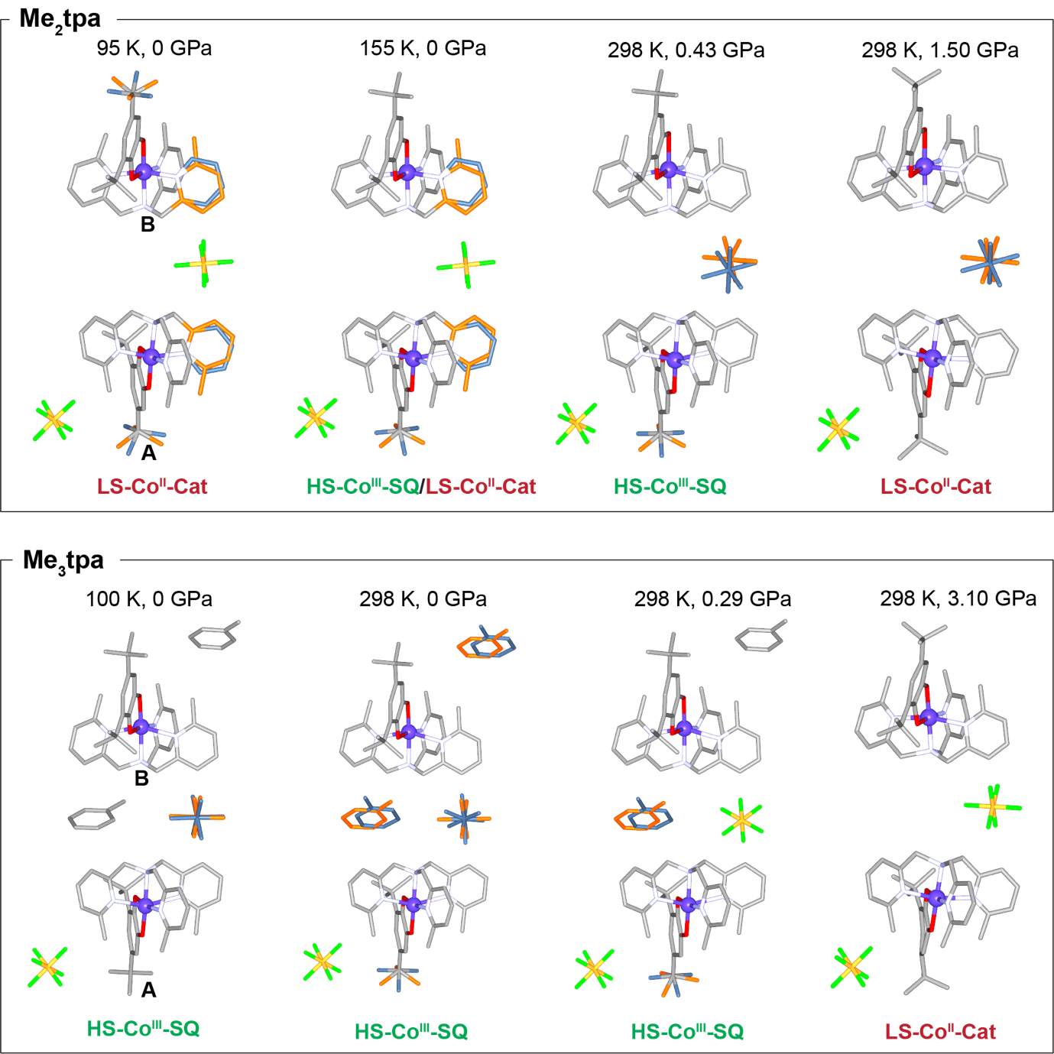
Figure S2. Crystal structures of Me₂tpa and Me₃tpa at variable temperature and pressure showing changes in disorder. Disordered components are coloured in blue and orange. The valence tautometeric state of the complex is given for each structure.

S.4.2. Unit Cell Dimensions
Table S3. Unit cell parameters with variable pressure and temperature for Me₂tpa. All high-pressure structures were collected at 298 K. Dashed lines indicate where valence tautomerism occurs.
P or T | Space group | a (Å) | b (Å) | c (Å) | β (°) | V (Å³)
95 K | P2₁/c | 11.48675(18) | 31.1876(6) | 21.7500(3) | 94.0985(14) | 7771.9(2)
155 K | P2₁/c | 11.5492(2) | 31.4342(6) | 21.8595(4) | 94.453(2) | 7911.9(3)
0.00 GPa | P2₁/c | 11.6570(3) | 32.1605(8) | 22.0657(5) | 94.189(2) | 8250.3(4)
0.14 GPa | P2₁/c | 11.5981(6) | 32.013(2) | 22.004(10) | 94.039(1) | 8150(4)
0.29 GPa | P2₁/c | 11.5300(7) | 31.757(2) | 21.982(11) | 94.042(12) | 8029(4)
0.43 GPa | P2₁/c | 11.4495(5) | 31.4784(16) | 21.733(8) | 93.841(9) | 7815(3)
0.72 GPa | P2₁/c | 11.3226(5) | 31.0309(17) | 21.641(9) | 93.891(9) | 7586(3)
1.01 GPa | P2₁/c | 11.2444(8) | 30.629(2) | 21.224(12) | 94.000(13) | 7292(4)
1.30 GPa | P2₁/c | 11.0961(5) | 30.2754(17) | 21.366(10) | 94.166(10) | 7159(3)
1.50 GPa | P2₁/c | 11.0390(6) | 30.1447(19) | 21.412(11) | 93.966(11) | 7108(4)
1.90 GPa | P2₁/c | 10.9775(7) | 29.979(2) | 21.203(11) | 93.936(12) | 6961(4)
2.20 GPa | P2₁/c | 10.960(1) | 29.907(4) | 21.124(17) | 93.85(2) | 6908(6)
2.50 GPa | P2₁/c | 10.9236(9) | 29.717(2) | 21.071(13) | 93.608(17) | 6827(4)
2.90 GPa | P2₁/c | 10.9411(9) | 29.651(3) | 20.671(15) | 93.038(16) | 6697(5)
3.20 GPa | P2₁/c | 10.957(1) | 29.685(3) | 20.513(16) | 92.960(18) | 6663(5)
3.60 GPa | P2₁/c | 10.9113(13) | 29.492(4) | 20.422(2) | 92.82(2) | 6564(7)
3.90 GPa | P2₁/c | 10.865(2) | 29.334(6) | 20.5(4) | 92.96(4) | 6525(12)
4.20 GPa | P2₁/c | 10.925(2) | 29.483(9) | 20.58(3) | 92.38(4) | 6624(10)
4.50 GPa | P2₁/c | 10.869(2) | 29.306(8) | 20.25(3) | 92.28(4) | 6446(10)

Table S4. Unit cell parameters with variable pressure and temperature for Me₃tpa. All high-pressure structures were collected at 298 K. Dashed lines indicate where valence tautomerism occurs.
P or T | Space group | a (Å) | b (Å) | c (Å) | β (°) | V (Å³)
100 K | P2₁/c | 11.58039(8) | 31.74220(30) | 22.05036(13) | 94.0771(6) | 8084.92(10)
0.00 GPa | P2₁/c | 11.64350(20) | 32.4363(7) | 22.35330(30) | 94.4160(10) | 8417.20(30)
0.29 GPa | P2₁/c | 11.5207(6) | 31.798(11) | 22.1159(13) | 94.249(5) | 8080.0(3)
0.65 GPa | P2₁/c | 11.3774(5) | 31.272(10) | 21.8464(10) | 93.952(4) | 7754.0(2)
1.10 GPa | P2₁/c | 11.2808(4) | 31.152(9) | 21.6489(10) | 93.850(4) | 7591.0(2)
2.00 GPa | P2₁/c | 11.2000(6) | 30.471(11) | 21.4742(13) | 93.731(4) | 7313.0(3)
2.60 GPa | P2₁/c | 11.0888(15) | 30.350(30) | 21.2160(30) | 93.628(12) | 7127(7)
3.10 GPa | P2₁/c | 10.9733(14) | 29.700(30) | 21.0670(30) | 93.599(11) | 6852(6)
4.40 GPa | P2₁/c | 10.8973(15) | 29.010(30) | 20.8410(30) | 93.622(12) | 6576(6)
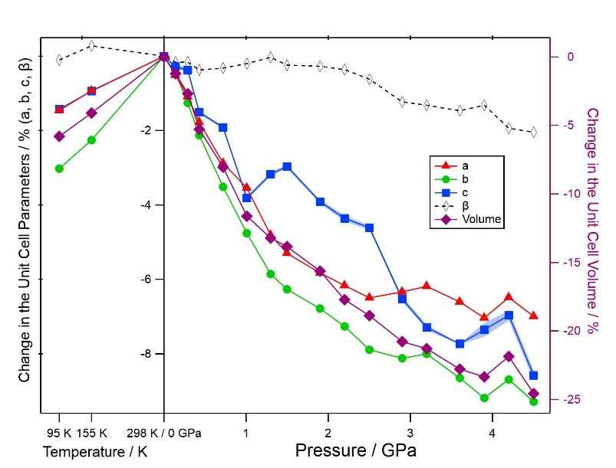
Figure S3. Percentage change in unit cell parameters with variable pressure and temperature for Me₂tpa. All high-pressure structures were collected at 298 K.
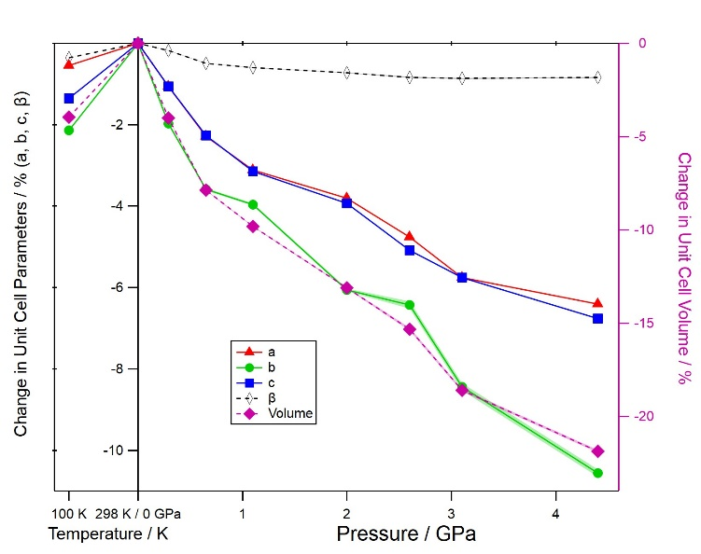
Figure S4. Percentage change in unit cell parameters with variable pressure and temperature for Me₃tpa. All high-pressure structures were collected at 298 K.

S.4.3. CoN₄O₂ Coordination Centres
Octahedral coordination parameters were calculated using the OctaDist Program.¹⁸ Definitions for each parameter are given below:
d_{mean} is the average metal-ligand bond length in the octahedral coordination sphere.
ζ is the average of the sum of the deviation of the six metal–ligand bond lengths around the central metal atom (d_{i}) from the average value (d_{mean}).
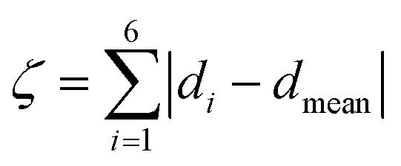
Σ is the sum of the deviation of the twelve cis ligand-metal-ligand angles away from 90°.
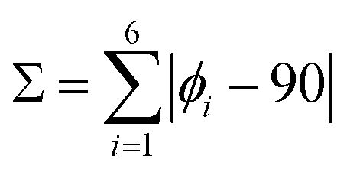
Θ is the sum of the deviation of 24 unique torsional angles between the ligand atoms on opposite triangular faces of the octahedron viewed along the pseudo-threefold axis (θi) from 60°.
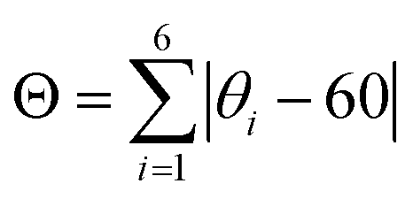
Table S5. CoN₄O₂ octahedral coordination parameters for molecule A in Me₂tpa, calculated using Octadist.¹⁸ All high-pressure structures were collected at 298 K.
P or T | d_{mean} (å) | $ζ$ (å) | $Δ$ (å) | $Σ$ (°) | $θ$ (°)
95 K | 1.9952(21) | 0.356(11) | 0.312(11) | 0.00107(7) | 0.00083(6)
155 K | 2.0950(20) | 0.299(11) | 0.326(11) | 0.00081(5) | 0.00096(6)
0.00 GPa | 2.1311(21) | 0.355(12) | 0.322(12) | 0.00112(6) | 0.00087(5)
0.14 GPa | 2.138(8) | 0.43(5) | 0.24(5) | 0.0015(4) | 0.00049(12)
0.29 GPa | 2.152(8) | 0.19(5) | 0.28(4) | 0.00028(15) | 0.00058(16)
0.43 GPa | 2.113(8) | 0.40(5) | 0.27(4) | 0.0014(4) | 0.00055(17)
0.72 GPa | 2.085(9) | 0.24(6) | 0.38(7) | 0.00062(23) | 0.0016(4)
1.01 GPa | 2.009(10) | 0.26(7) | 0.25(5) | 0.00058(25) | 0.00055(17)
1.30 GPa | 1.991(11) | 0.26(7) | 0.19(7) | 0.00079(22) | 0.00039(27)
1.50 GPa | 1.985(9) | 0.34(6) | 0.12(6) | 0.00119(30) | 0.00020(15)
1.90 GPa | 2.005(11) | 0.27(4) | 0.12(6) | 0.00099(29) | 0.00015(16)

Table S6. CoN₄O₂ octahedral coordination parameters for molecule B in Me₂tpa, calculated using Octadist.¹⁸ All high-pressure structures were collected at 298 K.
P or T | d_{mean} (å) | $ζ$ (å) | $Δ$ (å) | $Σ$ (°) | $θ$ (°)
95 K | 1.9674(20) | 0.356(11) | 0.312(11) | 0.00107(7) | 0.00083(6)
155 K | 1.9773(19) | 0.299(11) | 0.326(11) | 0.00081(5) | 0.00096(6)
0.00 GPa | 2.1263(21) | 0.355(12) | 0.322(12) | 0.00112(6) | 0.00087(5)
0.14 GPa | 2.126(8) | 0.43(5) | 0.24(5) | 0.0015(4) | 0.00049(12)
0.29 GPa | 2.139(8) | 0.19(5) | 0.28(4) | 0.00028(15) | 0.00058(16)
0.43 GPa | 2.123(9) | 0.40(5) | 0.27(4) | 0.0014(4) | 0.00055(17)
0.72 GPa | 2.061(9) | 0.24(6) | 0.38(7) | 0.00062(23) | 0.0016(4)
1.01 GPa | 1.998(10) | 0.26(7) | 0.25(5) | 0.00058(25) | 0.00055(17)
1.30 GPa | 1.960(11) | 0.26(7) | 0.19(7) | 0.00079(22) | 0.00039(27)
1.50 GPa | 2.000(10) | 0.34(6) | 0.12(6) | 0.00119(30) | 0.00020(15)
1.90 GPa | 2.012(10) | 0.27(4) | 0.12(6) | 0.00099(29) | 0.00015(16)

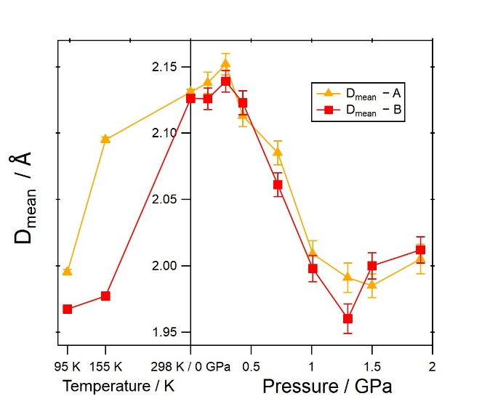
Figure S5. The average Co-O/N bond length (D_{mean}) with variable pressure and temperature for Me₂tpa. All high-pressure structures were collected at 298 K.
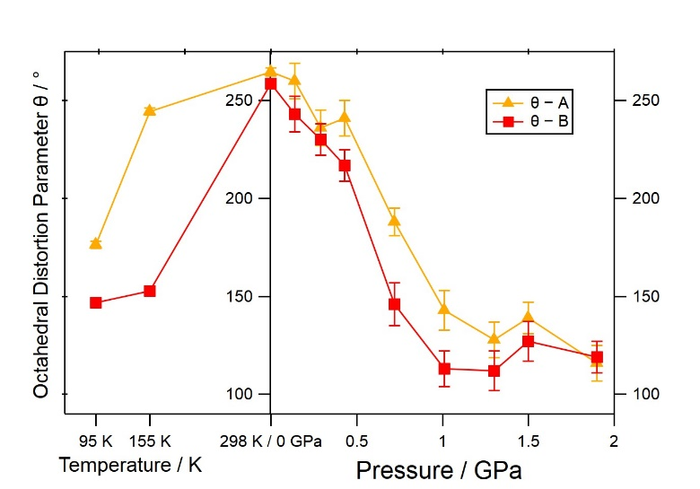
Figure S6. The $θ$ octahedral distortion parameter with variable pressure and temperature for Me₂tpa. All high-pressure structures were collected at 298 K.
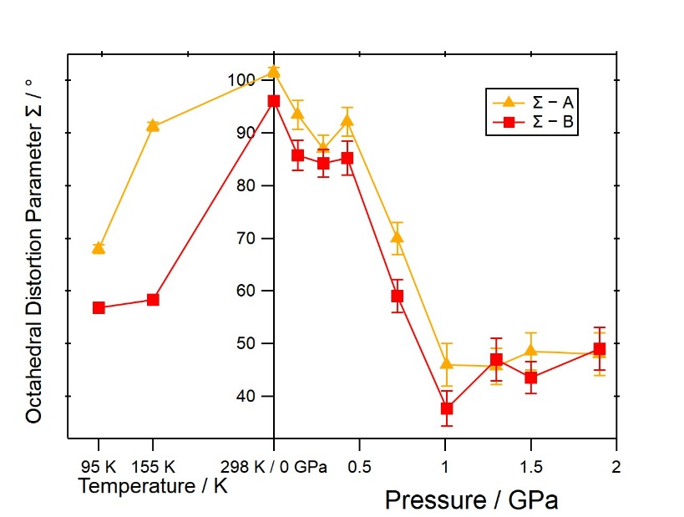
Figure S7. The $Σ$ octahedral distortion parameter with variable pressure and temperature for Me₂tpa. All high-pressure structures were collected at 298 K.

Table S7. CoN₄O₂ octahedral coordination parameters for molecule A in Me₃tpa, calculated using Octadist.¹⁸ All high-pressure structures were collected at 298 K.
P or T | d_{mean} (å) | $ζ$ (å) | $Δ$ (å) | $Σ$ (°) | $θ$ (°)
100 K | 2.1527(8) | 0.437(5) | 0.001611(31) | 103.84(28) | 261.4(7)
0.00 GPa | 2.1576(15) | 0.484(9) | 0.00206(6) | 102.0(6) | 262.6(1.3)
0.29 GPa | 2.144(5) | 0.453(30) | 0.00172(20) | 100.8(1.9) | 261.0(3.1)
0.65 GPa | 2.156(5) | 0.448(33) | 0.00172(23) | 101.2(2.2) | 260(5)
1.10 GPa | 2.140(6) | 0.44(4) | 0.00154(25) | 102.4(2.5) | 263(6)
2.00 GPa | 2.149(8) | 0.42(5) | 0.00142(29) | 105.1(3.1) | 267(7)
2.60 GPa | 2.137(9) | 0.52(6) | 0.0021(5) | 102.2(2.9) | 258(8)
3.10 GPa | 1.972(9) | 0.55(6) | 0.0025(5) | 51.8(2.9) | 133(7)

Table S8. CoN₄O₂ octahedral coordination parameters for molecule B in Me₃tpa, calculated using Octadist.¹⁸ All high-pressure structures were collected at 298 K.
P or T | d_{mean} (å) | $ζ$ (å) | $Δ$ (å) | $Σ$ (°) | $θ$ (°)
100 K | 2.1496(8) | 0.437(5) | 0.445(5) | 0.001611(31) | 0.001652(31)
0.00 GPa | 2.1551(16) | 0.484(9) | 0.470(10) | 0.00206(6) | 0.00185(6)
0.29 GPa | 2.159(5) | 0.453(30) | 0.495(31) | 0.00172(20) | 0.00209(22)
0.65 GPa | 2.159(6) | 0.448(33) | 0.52(4) | 0.00172(23) | 0.00219(27)
1.10 GPa | 2.158(7) | 0.44(4) | 0.61(4) | 0.00154(25) | 0.00285(35)
2.00 GPa | 2.156(8) | 0.42(5) | 0.64(5) | 0.00142(29) | 0.0031(5)
2.60 GPa | 2.138(9) | 0.52(6) | 0.57(5) | 0.0021(5) | 0.0029(5)
3.10 GPa | 2.008(9) | 0.55(6) | 0.79(5) | 0.0025(5) | 0.0052(7)

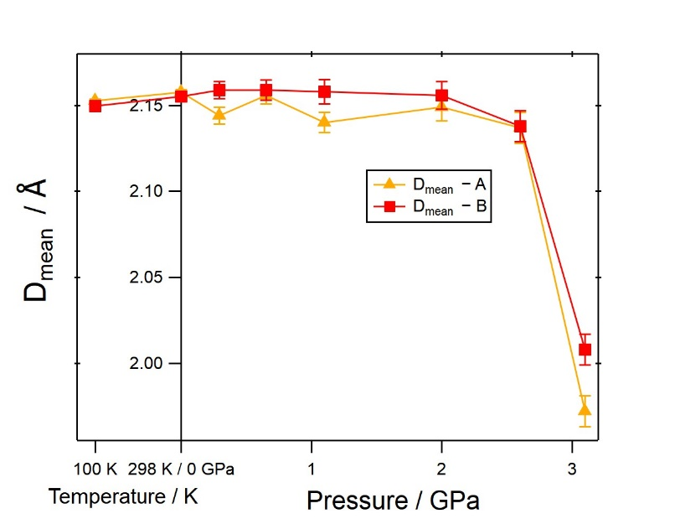
Figure S8. The average Co-O/N bond length (D_{mean}) with variable pressure and temperature for Me₃tpa. All high-pressure structures were collected at 298 K.
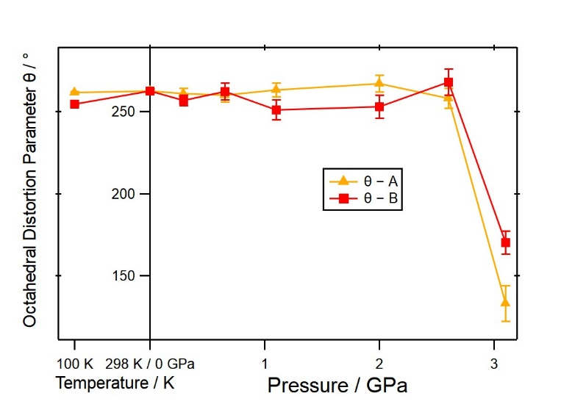
Figure S9. The $θ$ octahedral distortion parameter with variable pressure and temperature for Me₃tpa. All high-pressure structures were collected at 298 K.
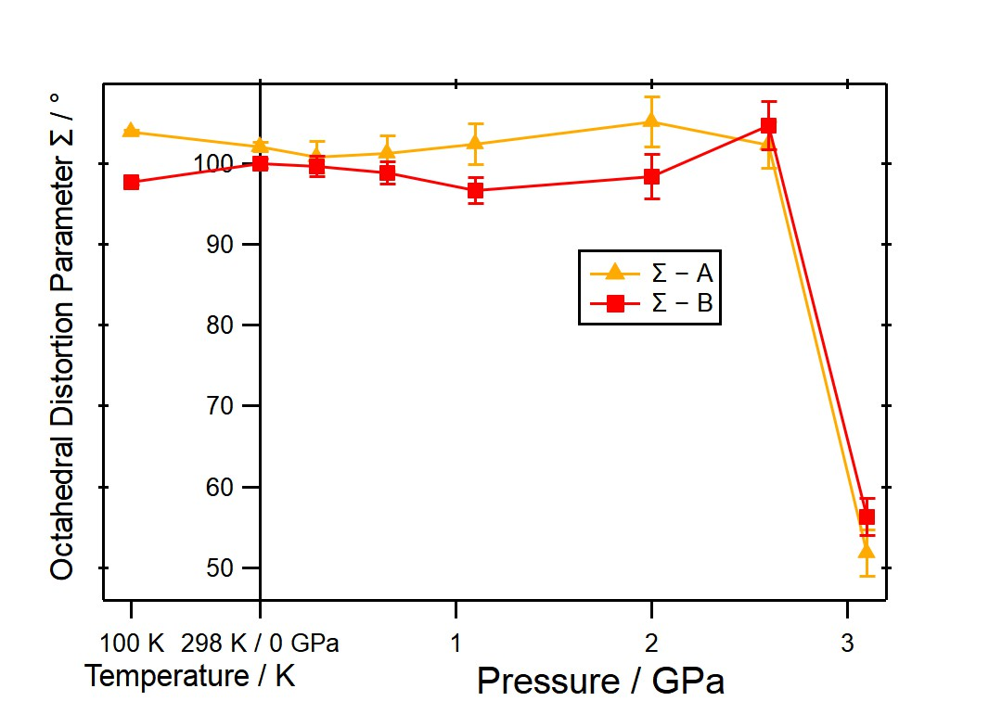
Figure S10. The $Σ$ octahedral distortion parameter with variable pressure and temperature for Me₃tpa. All high-pressure structures were collected at 298 K.
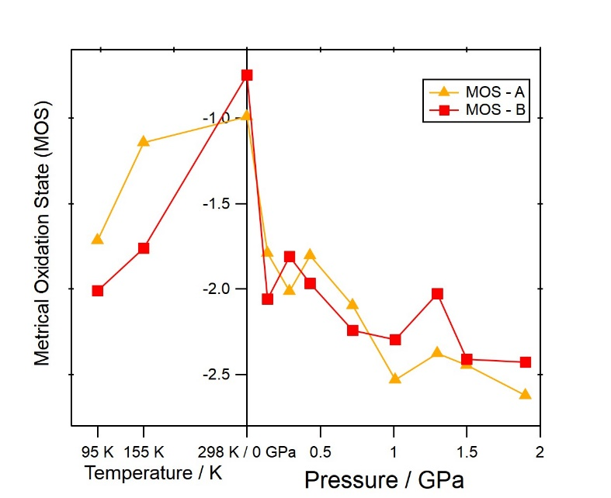
Figure S11. The metrical oxidation state (MOS) calculated using the method proposed by Brown (reference) with variable pressure and temperature for Me₂tpa. All high-pressure structures were collected at 298 K.

Table S9. The metrical oxidation state (MOS) calculated using the method proposed by Brown¹⁹ with variable pressure and temperature for Me₂tpa. All high-pressure structures were collected at 298 K.
P or T | MOS - A | MOS - B
95 K | -1.72 | -2.01
155 K | -1.14 | -1.76
0.00 GPa | -0.99 | -0.75
0.14 GPa | -1.79 | -2.06
0.29 GPa | -2.01 | -1.81
0.43 GPa | -1.80 | -1.97
0.72 GPa | -2.10 | -2.24
1.01 GPa | -2.53 | -2.30
1.30 GPa | -2.38 | -2.03
1.50 GPa | -2.44 | -2.41
1.90 GPa | -2.62 | -2.43

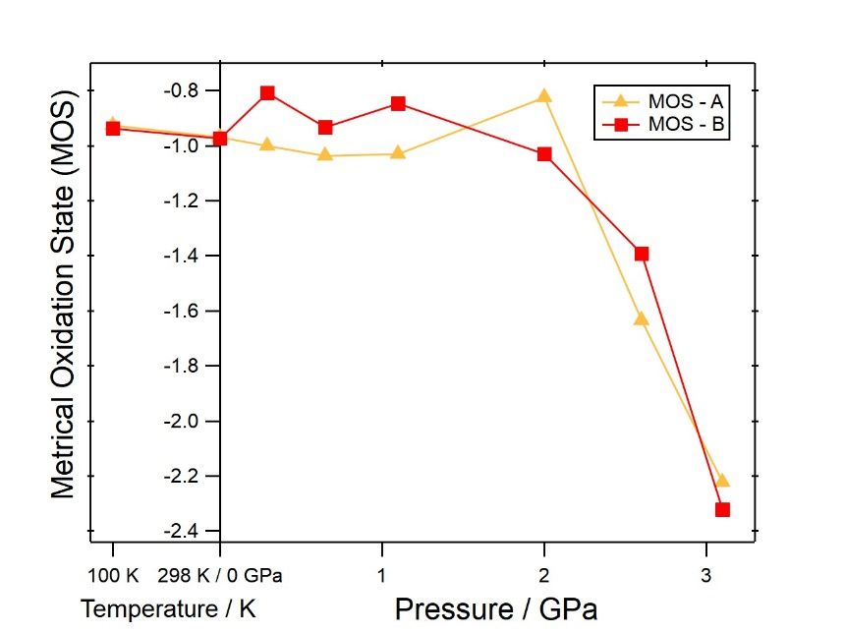
Figure S12. The metrical oxidation state (MOS) calculated using the method proposed by Brown (reference) with variable pressure and temperature for Me₃tpa. All high-pressure structures were collected at 298 K.

Table S10. The metrical oxidation state (MOS) calculated using the method proposed by Brown (reference) with variable pressure and temperature for Me₃tpa. All high-pressure structures were collected at 298 K.
P or T | MOS - A | MOS - B
100 K | -0.93 | -0.94
0.00 GPa | -0.97 | -0.97
0.29 GPa | -1.00 | -0.81
0.65 GPa | -1.04 | -0.93
1.10 GPa | -1.04 | -0.85
2.00 GPa | -0.83 | -1.03
2.60 GPa | -1.64 | -1.39
3.10 GPa | -2.22 | -2.32

Table S11. The area of the tpa-Δ (Å²) with variable pressure and temperature for Me₂tpa. All high-pressure structures were collected at 298 K.
P or T | Molecule A | Molecule B
95 K | 7.42(4) | 7.28(4)
155 K | 7.97(4) | 7.362(35)
0.00 GPa | 8.29(4) | 8.10(5)
0.14 GPa | 8.18(7) | 8.21(7)
0.29 GPa | 7.98(7) | 8.04(7)
0.43 GPa | 7.85(7) | 7.78(7)
0.72 GPa | 7.61(8) | 7.17(7)
1.01 GPa | 7.09(8) | 7.22(7)
1.30 GPa | 7.11(8) | 6.93(8)
1.50 GPa | 6.92(7) | 7.01(7)
1.90 GPa | 7.10(9) | 7.04(8)

Table S12. The area of the tpa-Δ (Å²) with variable pressure and temperature for Me₃tpa. All high-pressure structures were collected at 298 K.
P or T | Molecule A | Molecule B
100 K | 8.378(11) | 8.560(11)
0.00 GPa | 8.546(23) | 8.620(24)
0.29 GPa | 8.38(5) | 8.44(5)
0.65 GPa | 8.31(6) | 8.41(5)
1.10 GPa | 8.22(6) | 8.35(6)
2.00 GPa | 8.13(8) | 8.22(7)
2.60 GPa | 7.87(9) | 8.07(8)
3.10 GPa | 7.26(9) | 7.53(8)

S.4.4. Intermolecular Interactions
Figure S13. Intermolecular CHπ and ππ interactions within each layer of molecules in Me₂tpa and Me₃tpa. Molecules A and B are coloured with light and dark carbon atoms, respectively.

Table S13. Potential ππ intermolecular interaction distances in Me₂tpa at variable temperature and pressure. All values are measured between the ring centroids and are in units of Å. Dashed lines indicate where valence tautomerism occurs. All high-pressure structures were collected at 298 K.
P or T | I | II | III | IV
95 K | 3.512(7) | 3.730(8) | 4.250(6) | 4.517(7)
155 K | 3.485(6) | 3.823(8) | 4.287(5) | 4.598(7)
0.00 GPa | 3.554(7) | 4.099(9) | 4.397(5) | 4.700(8)
0.14 GPa | 3.490(12) | 4.094(9) | 4.408(8) | 4.710(18)
0.29 GPa | 3.445(11) | 3.954(8) | 4.310(8) | 4.748(17)
0.43 GPa | 3.447(11) | 3.956(9) | 4.303(8) | 4.627(17)
0.72 GPa | 3.387(12) | 3.712(9) | 4.266(9) | 4.389(18)
1.01 GPa | 3.334(12) | 3.514(9) | 4.206(9) | 4.287(17)
1.30 GPa | 3.308(12) | 3.464(9) | 4.161(10) | 4.228(18)
1.50 GPa | 3.289(12) | 3.446(8) | 4.155(9) | 4.273(16)
1.90 GPa | 3.237(13) | 3.462(9) | 4.082(10) | 4.274(18)

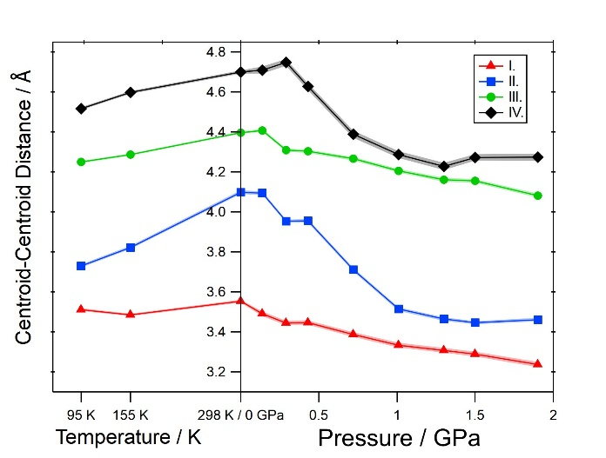
Figure S14. ππ intermolecular interaction distances in Me₂tpa at variable temperature and pressure. All values are measured between the ring centroids and are in units of Å. All high-pressure structures were collected at 298 K.

Table S14. CHπ intermolecular interaction distances in Me₂tpa at variable temperature and pressure. All values for interactions V – IX are measured between the ring centroids and the values for interactions X and XI measured between the ring centroids and carbon atoms (not hydrogen atoms) and are in units of Å. Dashed lines indicate where valence tautomerism occurs. All high-pressure structures were collected at 298 K.
P or T | V | VI | VII | VIII | IX | X | XI | XII | XIII
95 K | 4.937(4) | 4.782(6) | 4.939(5) | 5.083(5) | 5.007(8) | 4.002(8) | 4.194(9) | 4.265(10) | 4.347(10)
155 K | 4.952(4) | 4.845(6) | 5.012(4) | 5.066(5) | 5.148(8) | 3.871(8) | 4.250(9) | 4.388(9) | 4.316(10)
0.00 GPa | 5.058(4) | 5.022(6) | 5.132(5) | 5.185(6) | 5.212(8) | 3.946(9) | 4.252(10) | 4.192(10) | 4.284(12)
0.14 GPa | 5.002(9) | 5.058(9) | 5.031(8) | 5.166(8) | 5.173(9) | 3.889(12) | 4.238(15) | 4.173(13) | 4.224(16)
0.29 GPa | 4.981(9) | 5.006(9) | 5.013(9) | 5.091(8) | 5.112(8) | 3.846(12) | 4.172(16) | 4.119(13) | 4.206(18)
0.43 GPa | 4.903(9) | 4.949(9) | 4.960(9) | 5.061(8) | 5.096(9) | 3.809(13) | 4.115(18) | 4.081(14) | 4.158(18)
0.72 GPa | 4.817(10) | 4.839(10) | 4.936(10) | 5.014(9) | 5.012(9) | 3.867(14) | 4.018(18) | 3.993(15) | 4.173(20)
1.01 GPa | 4.821(10) | 4.773(10) | 4.928(10) | 5.046(10) | 4.867(9) | 3.980(15) | 3.958(18) | 3.928(16) | 4.191(23)
1.30 GPa | 4.752(11) | 4.761(11) | 4.827(11) | 4.963(10) | 4.828(10) | 3.896(18) | 3.823(23) | 3.848(16) | 4.130(23)
1.50 GPa | 4.739(9) | 4.737(10) | 4.779(9) | 4.952(9) | 4.788(9) | 3.892(15) | 3.807(20) | 3.828(14) | 4.093(20)
1.90 GPa | 4.725(11) | 4.651(11) | 4.744(11) | 4.888(11) | 4.731(10) | 3.840(17) | 3.784(23) | 3.768(16) | 4.117(23)

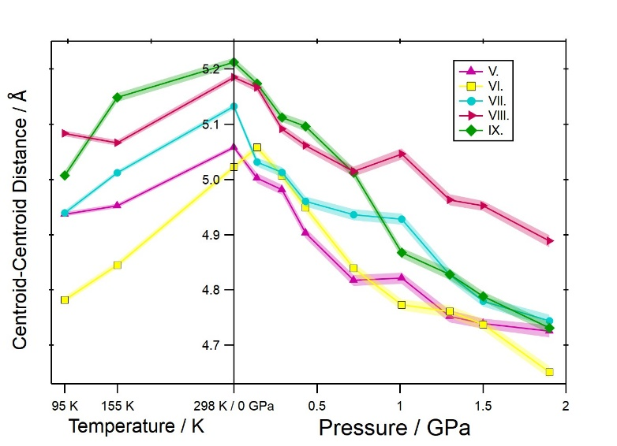
Figure S15. CHπ intermolecular interaction distances (V-IX) in Me₂tpa at variable temperature and pressure for interactions. All interaction distances are measured between the ring centroids and are in units of Å. All high-pressure structures were collected at 298 K.
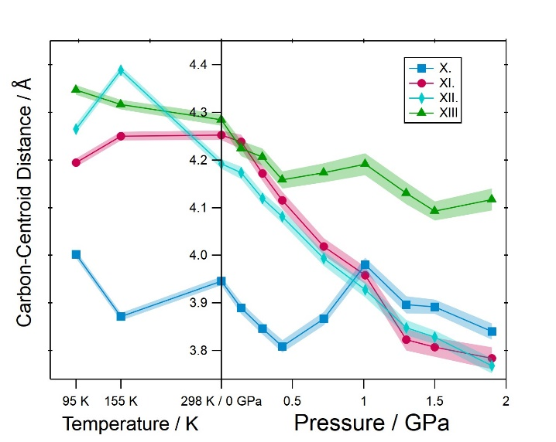
Figure S16. Methyl CHπ intermolecular interaction distances (X and XIII) in Me₂tpa at variable temperature and pressure. Interaction distances are measured between the ring centroids and carbon atoms (not hydrogen atoms) and are in units of Å. All high-pressure structures were collected at 298 K.

Table S15. Potential ππ intermolecular interaction distances in Me₃tpa at variable temperature and pressure. All values are taken between ring centroids and are in units of Å. Dashed lines indicate where valence tautomerism occurs. All high-pressure structures were collected at 298 K.
P or T | I | II | III | IV
100 K | 3.4523(21) | 4.2230(13) | 4.3138(17) | 4.7165(24)
0.00 GPa | 3.532(5) | 4.3248(32) | 4.439(4) | 4.686(6)
0.29 GPa | 3.430(11) | 4.265(5) | 4.308(10) | 4.585(9)
0.65 GPa | 3.317(12) | 4.225(5) | 4.194(12) | 4.512(10)
1.10 GPa | 3.341(14) | 4.206(6) | 4.233(14) | 4.454(11)
2.00 GPa | 3.215(16) | 4.147(8) | 4.142(18) | 4.398(13)
2.60 GPa | 3.206(17) | 4.069(10) | 4.215(19) | 4.386(16)
3.10 GPa | 3.179(20) | 3.531(8) | 4.202(20) | 4.118(13)

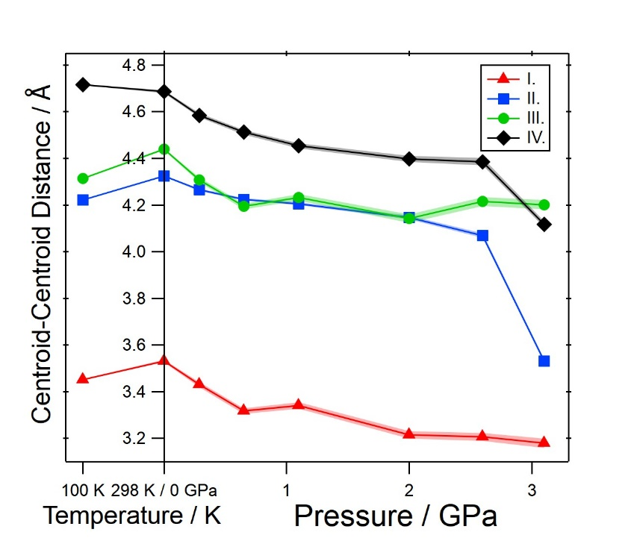
Figure S17. Potential ππ intermolecular interaction distances in Me₃tpa at variable temperature and pressure. All values are taken between ring centroids and are in units of Å. All high-pressure structures were collected at 298 K.

Table S16. Potential CHπ intermolecular interaction distances in Me₃tpa at variable temperature and pressure. All values for interactions V – IX are measured between the ring centroids and the values for interactions X and XI measured between the ring centroids and carbon atoms (not hydrogen atoms) and are in units of Å. Dashed lines indicate where valence tautomerism occurs. All high-pressure structures were collected at 298 K.
P or T | V | VI | VII | VIII | IX | X | XI | XII | XIII
100 K | 4.9425(16) | 5.0204(16) | 4.9620(15) | 5.0960(14) | 5.1867(15) | 3.8429(27) | 4.0795(33) | 4.112(4) | 4.072(4)
0.00 GPa | 5.0499(33) | 5.1116(31) | 5.1253(31) | 5.1967(33) | 5.1996(34) | 3.913(7) | 4.153(9) | 4.186(8) | 4.217(9)
0.29 GPa | 4.887(13) | 5.014(14) | 4.977(14) | 5.091(7) | 5.119(7) | 3.751(13) | 3.994(23) | 4.000(12) | 4.101(21)
0.65 GPa | 4.838(14) | 4.874(16) | 4.857(16) | 4.984(7) | 5.020(7) | 3.669(15) | 3.922(25) | 3.874(13) | 4.009(23)
1.10 GPa | 4.756(16) | 4.897(18) | 4.831(19) | 4.943(9) | 5.020(9) | 3.597(17) | 3.860(28) | 3.794(15) | 3.914(26)
2.00 GPa | 4.594(20) | 4.810(22) | 4.739(24) | 4.848(11) | 4.965(10) | 3.500(21) | 3.82(4) | 3.702(19) | 3.770(34)
2.60 GPa | 4.621(22) | 4.733(25) | 4.757(26) | 4.880(12) | 4.886(12) | 3.396(21) | 3.76(4) | 3.627(18) | 3.687(32)
3.10 GPa | 4.414(22) | 4.626(25) | 4.616(25) | 4.919(12) | 4.659(12) | 3.815(23) | 3.52(4) | 3.588(21) | 3.92(4)

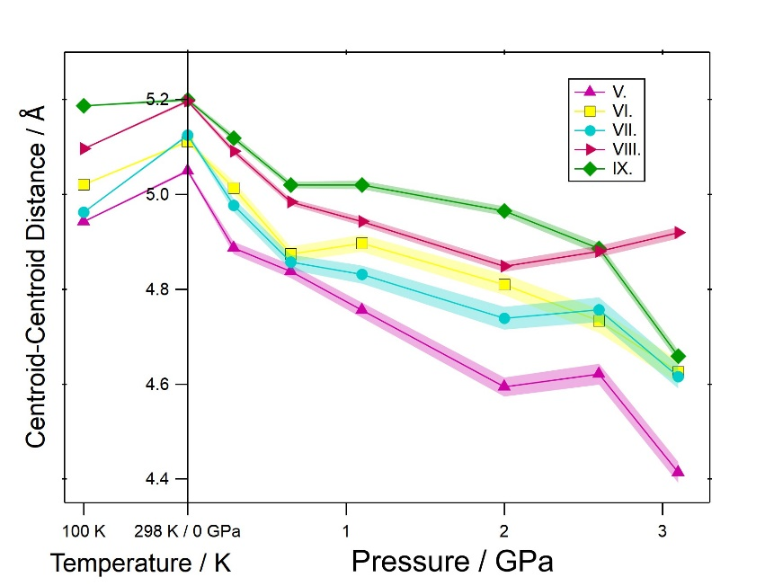
Figure S18. Potential CHπ intermolecular interaction distances (V-IX) in Me₃tpa at variable temperature and pressure for interactions. All interaction distances are measured between the ring centroids and are in units of Å. All high-pressure structures were collected at 298 K.
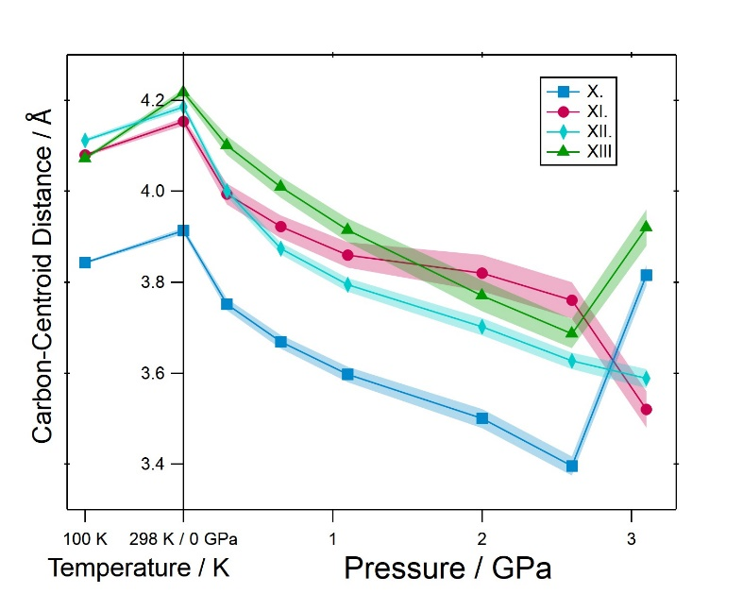
Figure S19. Potential methyl CHπ intermolecular interaction distances (X – XIII) in Me₂tpa at variable temperature and pressure. Interaction distances are measured between the ring centroids and carbon atoms (not hydrogen atoms) and are in units of Å. All high-pressure structures were collected at 298 K.

Table S17. Three shortest Carbon-Centroid distances in CHPi interaction V in Me₂tpa at variable temperature and pressure. All values are measured between the ring centroids ring centroids and carbon atoms (not hydrogen atoms) and are in units of Å. Dashed lines indicate where valence tautomerism occurs. All high-pressure structures were collected at 298 K.
P or T | VI – C31A | VI – C32A | VI – C33A
95 K | 4.408(16) | 3.390(16) | 4.077(20)
155 K | 4.661(16) | 3.517(16) | 3.989(20)
0.00 GPa | 4.980(16) | 3.714(17) | 4.096(18)
0.14 GPa | 4.792(20) | 3.710(12) | 4.273(18)
0.29 GPa | 4.722(20) | 3.663(15) | 4.247(18)
0.43 GPa | 4.649(20) | 3.614(15) | 4.213(18)
0.72 GPa | 4.421(20) | 3.497(16) | 4.232(21)
1.01 GPa | 4.119(20) | 3.454(15) | 4.413(21)
1.30 GPa | 4.129(20) | 3.452(18) | 4.394(22)
1.50 GPa | 4.100(19) | 3.435(15) | 4.385(21)
1.90 GPa | 4.051(22) | 3.351(17) | 4.268(23)

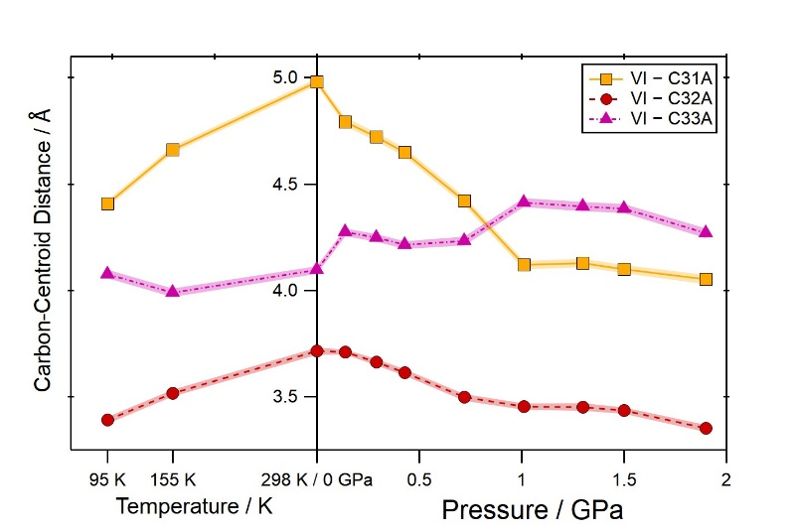
Figure S20. Three shortest Carbon-Centroid distances in CHPi interaction V in Me₂tpa at variable temperature and pressure. All values are measured between the ring centroids ring centroids and carbon atoms (not hydrogen atoms) and are in units of Å. Dashed lines indicate where valence tautomerism occurs. All high-pressure structures were collected at 298 K.

Table S18. Three shortest Carbon-Centroid distances in CHPi interaction V in Me₃tpa at variable temperature and pressure. All values are measured between the ring centroids ring centroids and carbon atoms (not hydrogen atoms) and are in units of Å. Dashed lines indicate where valence tautomerism occurs. All high-pressure structures were collected at 298 K.
P or T | VI – C31A | VI – C32A | VI – C33A
100 K | 4.8878(33) | 3.6988(30) | 4.1302(30)
0.00 GPa | 4.959(7) | 3.810(7) | 4.224(7)
0.29 GPa | 4.890(20) | 3.711(20) | 4.101(19)
0.65 GPa | 4.754(23) | 3.590(23) | 3.979(22)
1.10 GPa | 4.782(27) | 3.619(27) | 3.995(26)
2.00 GPa | 4.720(33) | 3.567(34) | 3.914(32)
2.60 GPa | 4.67(4) | 3.51(4) | 3.82(4)
3.10 GPa | 4.07(4) | 3.32(4) | 4.189(35)

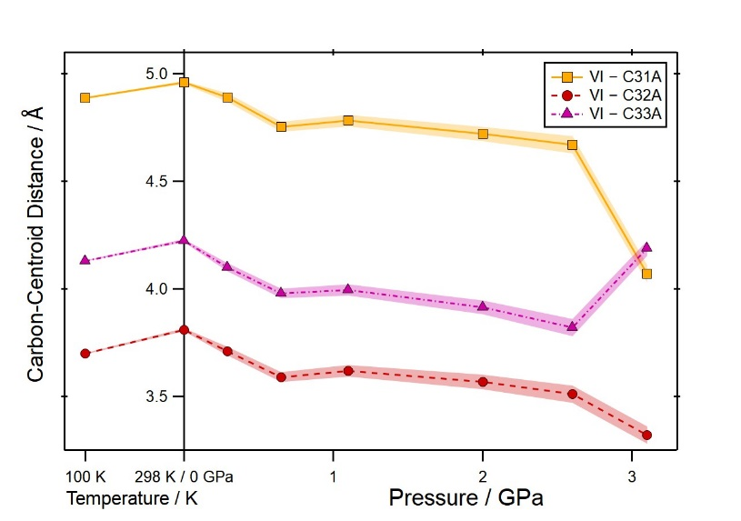
Figure S21. Three shortest Carbon-Centroid distances in CHPi interaction V in Me₃tpa at variable temperature and pressure. All values are measured between the ring centroids ring centroids and carbon atoms (not hydrogen atoms) and are in units of Å. Dashed lines indicate where valence tautomerism occurs. All high-pressure structures were collected at 298 K.

Table S19. The three shortest Cobalt-Cobalt distances between pairs of A species, B species and A to B species in Me₂tpa at variable temperature and pressure. Dashed lines indicate where valence tautomerism occurs. All high-pressure structures were collected at 298 K.
P or T | A – A | B – B | A – B
95 K | 9.0779(19) | 8.3075(19) | 8.7028(13)
155 K | 9.1157(19) | 8.3975(19) | 8.7784(13)
0.00 GPa | 9.2724(13) | 8.4447(13) | 8.9460(10)
0.14 GPa | 9.214(6) | 8.406(6) | 8.920(4)
0.29 GPa | 9.113(6) | 8.309(6) | 8.8763(35)
0.43 GPa | 9.038(6) | 8.227(6) | 8.8162(35)
0.72 GPa | 8.938(6) | 8.128(6) | 8.689(4)
1.01 GPa | 8.789(6) | 8.049(7) | 8.607(4)
1.30 GPa | 8.672(7) | 7.941(8) | 8.516(5)
1.50 GPa | 8.625(6) | 7.893(7) | 8.485(4)
1.90 GPa | 8.550(7) | 7.827(8) | 8.455(5)

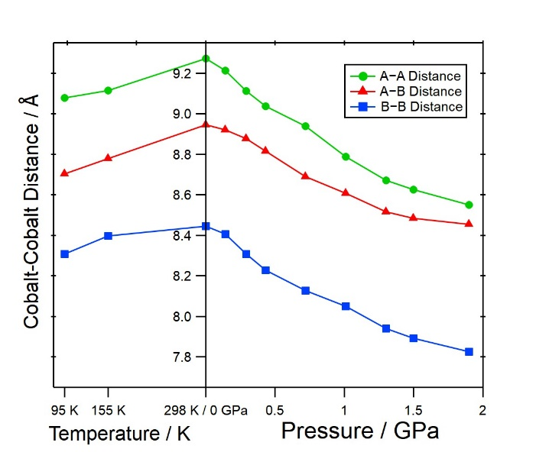
Figure S22. The three shortest Cobalt-Cobalt distances between pairs of A species, B species and A to B species in Me₂tpa at variable temperature and pressure. All high-pressure structures were collected at 298 K.

Table S20. The three shortest Cobalt-Cobalt distances between pairs of A species, B species and A to B species in Me₃tpa at variable temperature and pressure. Dashed lines indicate where valence tautomerism occurs.
P or T | A – A | B – B | A – B
100 K | 8.9029(12) | 8.9695(8) | 8.3488(13)
0.00 GPa | 9.2313(13) | 9.0405(9) | 8.5591(13)
0.29 GPa | 8.976(10) | 8.917(6) | 8.383(10)
0.65 GPa | 8.780(11) | 8.789(7) | 8.240(11)
1.10 GPa | 8.734(12) | 8.741(8) | 8.190(12)
2.00 GPa | 8.472(18) | 8.628(11) | 7.936(18)
2.60 GPa | 8.400(20) | 8.618(13) | 7.819(19)
3.10 GPa | 8.416(19) | 8.482(12) | 7.723(19)

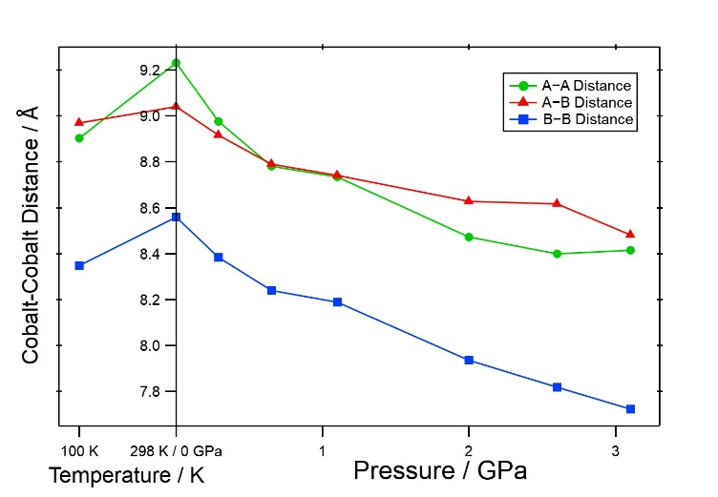
Figure S23: The three shortest Cobalt-Cobalt distances between pairs of A species, B species and A to B species in Me₃tpa at variable temperature and pressure. All high-pressure structures were collected at 298 K.

Table S21. Relative spin-state energy (ΔE) of crystallographically independent molecules A and B of Me₂tpa at variable temperature and pressure calculated with M06L-D4/ZORA-def2-TZVPP.^{14-16,20} Dashed lines indicate where valence tautomerism occurs.
P or T | Relative spin-state energy (ΔE) / kcal mol⁻¹
P or T | Me₂tpa A | Me₂tpa B
95 K | 2.7 | -16.5
155 K | 19.2 | -14.2
0.00 GPa | 24.7 | 27.7
0.14 GPa | 28.6 | 23.0
0.29 GPa | 26.3 | 23.6
0.43 GPa | 25.0 | 18.3
0.72 GPa | 9.7 | 3.3
1.01 GPa | -14.7 | -9.0
1.30 GPa | -25.9 | -21.8
1.50 GPa | -27.6 | -24.9
1.90 GPa | -27.9 | -24.8
ΔE = E(low spin Co^{III}-catecholato) - E(high spin Co^{II}-semiquinonato)

Table S22. Relative spin-state energy (ΔE) of crystallographically independent molecules A and B of Me₃tpa at variable pressure calculated with M06L-D4/ZORA-def2-TZVPP. ^{14-16,20} Dashed lines indicate where valence tautomerism occurs.
P or T | Relative spin-state energy (ΔE) / kcal mol⁻¹
P or T | Me₃tpa A | Me₃tpa B
100 K | 31.8 | 28.1
0.00 GPa | 30.1 | 31.1
0.29 GPa | 30.7 | 29.0
0.65 GPa | 27.0 | 26.5
1.10 GPa | 29.2 | 26.6
2.00 GPa | 24.6 | 20.8
2.60 GPa | 27.6 | 27.4
3.10 GPa | -31.1 | -26.3
ΔE = E(low spin Co^{III}-catecholato) - E(high spin Co^{II}-semiquinonato)

References
1 Beni, A. et al. Tuning the charge distribution and photoswitchable properties of cobalt-dioxolene complexes by using molecular techniques. Chem. Eur. J. 14, 1804-1813 (2008). https://doi.org:10.1002/CHEM.200701163
2 Fuentes, O., Paudler, W. W. & Synthesis of 2-azacycl[3.2.2]azine. J. Org. Chem. 40, 1210-1213 (1975). https://doi.org:10.1021/jo00897a006
3 Beni, A., Dei, A., Rizzitano, M., Sorace, L. & Unprecedented optically induced long-lived intramolecular electron transfer in cobalt–dioxolene complexes. ChemComm., 2160-2162 (2007). https://doi.org:10.1039/B702932B
4 CrysAlisPro Software system v. 1.171.40.84a (Rigaku Corporation, Wroclaw, Poland, 2020).
5 Sheldrick, G. M. & SHELXT– Integrated space‐group and crystal‐structure determination. Acta Crystallogr. A71, 3-8 (2015). https://doi.org:10.1107/S2053273314026370
6 Sheldrick, G. M. & Crystal structure refinement with SHELXL. Acta Crystallogr. C71, 3-8 (2015). https://doi.org:10.1107/S2053229614024218
7 Dolomanov, O. V. et al. OLEX2: a complete structure solution, refinement and analysis program. J. Appl. Crystallogr. 42, 339-341 (2009). https://doi.org:10.1107/S0021889808042726
8 CrysAlisPro Software system (Rigaku Corporation, Wroclaw, Poland, 2021).
9 Mao, H. K., Bell, P. M., Shaner, J. W., Steinberg, D. J. & Specific volume measurements of Cu, Mo, Pd, and Ag and calibration of the ruby R1 fluorescence pressure gauge from 0.06 to 1 Mbar. J. Appl. Phys. 49, 3276-3283 (1978). https://doi.org:10.1063/1.325277
10 Mao, H. K., Xu, J., Bell, P. M. & Calibration of the ruby pressure gauge to 800 kbar under quasi‐hydrostatic conditions. J. Geophys. Res. 91, 4673-4676 (1986). https://doi.org:10.1029/JB091iB05p04673
11 Bell, P. M., Xu, J.-a., Mao, H. K. & in Shock Waves in Condensed Matter. (eds Y M Gupta & ) 125-130 (Springer US, 1986).
12 Neese, F. & The ORCA program system. Wires Comput Mol Sci. 2, 73-78 (2012). https://doi.org:10.1002/wcms.81
13 Neese, F. & Software update: the ORCA program system, version 4.0. Wires Comput Mol Sci. 8 (2018). https://doi.org:10.1002/wcms.1327
14 Zhao, Y., Truhlar, D. G. & A new local density functional for main-group thermochemistry, transition metal bonding, thermochemical kinetics, and noncovalent interactions. J. Chem. Phys. 125 (2006). https://doi.org:10.1063/1.2370993
15 Caldeweyher, E. et al. A generally applicable atomic-charge dependent London dispersion correction. J. Chem. Phys. 150 (2019). https://doi.org:10.1063/1.5090222
16 Weigend, F., Ahlrichs, R. & Balanced basis sets of split valence, triple zeta valence and quadruple zeta valence quality for H to Rn: Design and assessment of accuracy. Phys. Chem. Chem. Phys. 7, 3297 (2005). https://doi.org:10.1039/b508541a
17 Pantazis, D. A., Chen, X.-Y., Landis, C. R. & Neese, F. All-Electron Scalar Relativistic Basis Sets for Third-Row Transition Metal Atoms. J. Chem. Theory Comput. 4, 908-919 (2008). https://doi.org:10.1021/ct800047t
18 Katkaew, R. et al. OctaDist: a tool for calculating distortion parameters in spin crossover and coordination complexes. Dalton Trans. 50, 1086-1096 (2021).
19 Brown, S. N. Metrical Oxidation States of 2-Amidophenoxide and Catecholate Ligands: Structural Signatures of Metal-Ligand π Bonding in Potentially Noninnocent Ligands. Inorg. Chem. 51, 1251-1260 (2012).
20 van Lenthe, E., van Leeuwen, R., Baerends, E. J. & Snijders, J. G. Relativistic regular two-component Hamiltonians. Int. J. Quantum Chem. 57, 281-293 (1996).

