Supplementary Materials
Fig S1: Human bone marrow mesenchymal stem cells (BM-hMSC) characterization.
Fig S2: BM-hMSC decrease expression of steroidogenesis genes in Forskolin-treated human PCOS theca cells.
Fig S3: Timeline for in vivo experimental design.
Fig S4: BM-hMSC reverse brown fat tissue phenotype in the LTZ-induced PCOS mouse.
Fig S5: BM-hMSC reverse adipose tissue adipokines in LTZ-induced PCOS mouse model.
Fig S6: Hormonal analysis in the LTZ-induced PCOS mouse model.
Fig S7: The effect of BM-hMSC on the endometrium in the LTZ-induced PCOS mouse model.
Fig S8: Effect of BM-hMSC secretome injection on the ovary, white fat, brown fat, and fertility in the LTZ-induced PCOS mouse model.
Fig S9: Raw data image of Western blot membranes
Table S1. List of Primers

Supplementary Materials
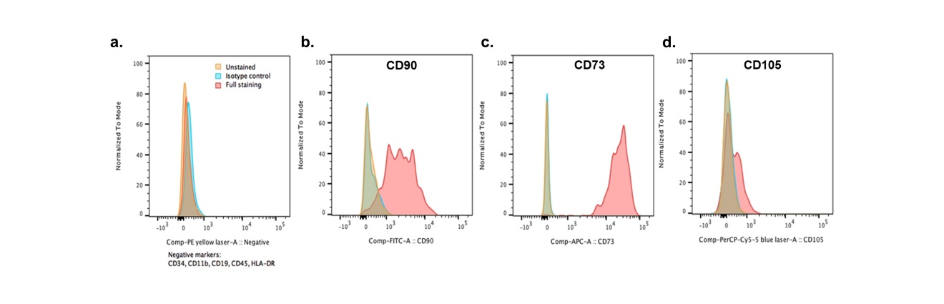
Fig S1: Human bone marrow mesenchymal stem cells (BM-hMSC) characterization. BM-hMSC were isolated from a 32-year-old healthy adult female bone marrow (non-diabetic). Cells were characterized by (a) lineage negative for CD11b, CD34, CD19, CD45, and HLA-DR, and lineage positive for (b) CD90, (c) CD73, and (d) CD105.

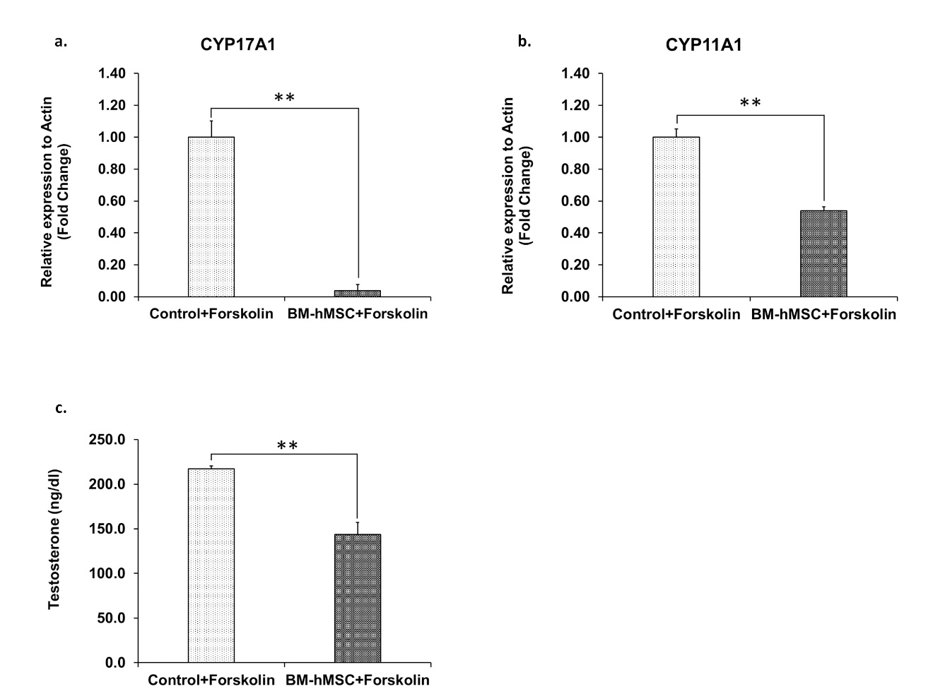
Fig S2: BM-hMSC decrease expression of steroidogenesis genes in Forskolin-treated human PCOS theca cells. (a) Relative mRNA expression of CYP17A1 and (b) CYP11A1 in Forskolin-treated human PCOS theca cells (n=3) after BM-hMSC secretome treatment. (c) Testosterone secretion by Forskolin-treated human PCOS theca cells; BM-hMSC secretome vs. control group. *: p<0.05, **: p<0.005

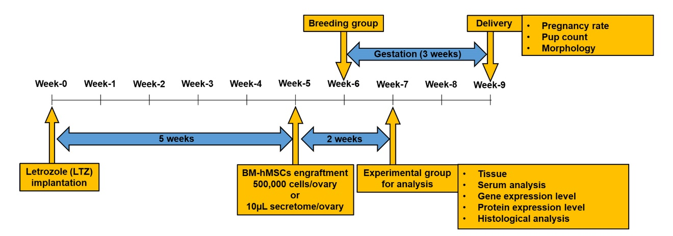
Fig S3: Timeline for in vivo experimental design.

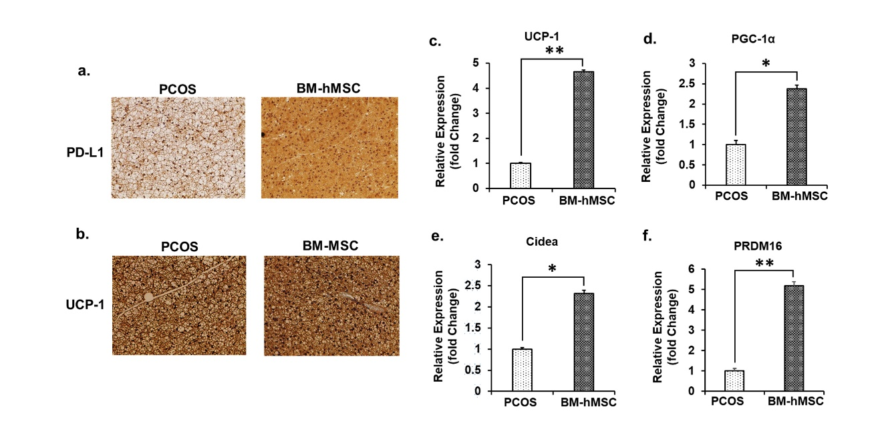
Fig S4: BM-hMSC reverse brown fat tissue phenotype in the LTZ-induced PCOS mouse. Immunohistochemistry of brown fat tissue by (a) PD-L1 and (b) UCP-1. (c) Relative gene expression of UCP-1 in brown fat of PCOS mice (1.0 ± 0.03 fold) and BM-hMSC-treated PCOS mice (4.66 ± 0.07 fold). (d) Relative gene expression of PGC-1α in brown fat of PCOS mice (1.0 ± 0.10 fold) and BM-hMSC-treated PCOS mice (2.38 ± 0.09 fold). (e) Relative gene expression of Cidea in brown fat of PCOS mice (1.0 ± 0.04 fold) and BM-hMSC-treated PCOS mice (2.31 ± 0.08 fold). (f) Relative gene expression of PRDM16 in the brown fat of PCOS mice (1.0 ± 0.12 fold) and BM-hMSC-treated PCOS mice (5.19 ± 0.19 fold). Data presented as the mean ± SD. *: p<0.05, **: p<0.005.

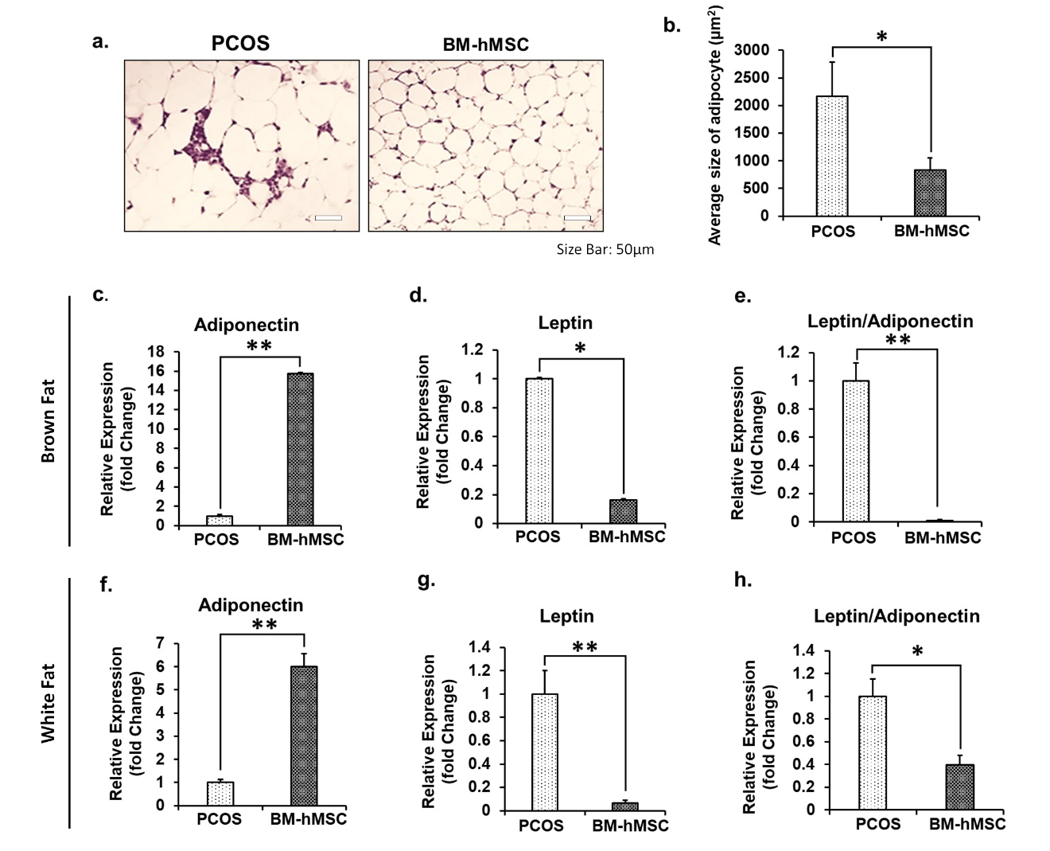
Fig S5: BM-hMSC reverse adipose tissue adipokines in LTZ-induced PCOS mouse model. (a) H&E staining of white gonadal fat, arrows indicate immune cells infiltrating adipocyte interstitial space in PCOS mice treated with BM-hMSC and untreated PCOS mice. (b) The average size of adipocytes in PCOS group (2172.7 ± 610.5 µm²) and BM-hMSC-treated PCOS group (828.7 ± 223.1 µm²). (c-h) Real-time PCR of brown and white gonadal fat comparing untreated PCOS group and BM-hMSC-treated PCOS group. (c) Relative gene expression of adiponectin in brown fat of PCOS mice (1.0 ± 0.13 fold) and BM-hMSC-treated PCOS mice (15.75 ± 0.12 fold). (d) Relative gene expression of leptin in brown fat of PCOS mice (1.0 ± 0.01 fold) and BM-hMSC-treated PCOS mice (0.16 ± 0.01 fold). (e) Ratio of leptin to adiponectin in the brown fat of PCOS mice (1.0 ± 0.13 fold) and BM-hMSC-treated mice (0.01 ± 0.01 fold). (f) Relative gene expression of adiponectin in white fat of PCOS mice (1.0 ± 0.14 fold) and BM-hMSC-treated mice (6.00 ± 0.57 fold). (g) Relative gene expression of adiponectin in white fat of PCOS mice (1.0 ± 0.20 fold) and BM-hMSC-treated mice (0.07 ± 0.02 fold). (h) Ratio of leptin to adiponectin in white fat of PCOS mice (1.0 ± 0.15 fold) and BM-hMSC-treated PCOS mice (0.4 ± 0.08 fold). Data presented as the mean ± SD. *: p<0.05, **: p<0.005.
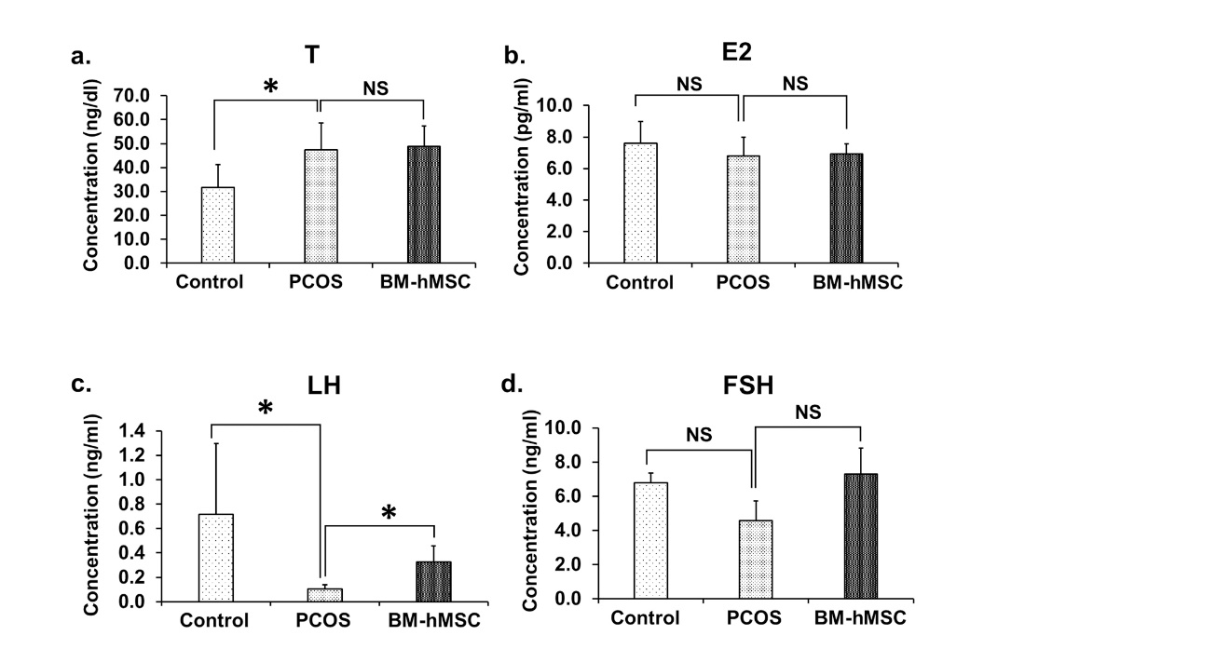
Fig S6: Hormonal analysis in the LTZ-induced PCOS mouse model. (a-d) Average serum hormone levels (n=8/group). (a) Level of serum testosterone (T) in control (31.8 ± 9.5 ng/dL), PCOS (47.3 ± 11.4 ng/dL), and BM-hMSC-treated PCOS groups (48.8 ± 8.4 ng/dL). (b) Level of serum estradiol (E2) in control (7.6 ± 1.4 pg/dL), PCOS (6.8 ± 1.2 pg/dL), and BM-hMSC-treated PCOS groups (6.9 ± 0.63 pg/dL). (c) Level of serum luteinizing hormone (LH) in control (0.7 ± 0.58 ng/dL), PCOS (0.1 ± 0.03 ng/dL), and BM-hMSC-treated PCOS groups (0.3 ± 0.13 ng/dL). (d) Level of serum follicle-stimulating hormone (FSH) in control (6.8 ± 0.6 ng/dL), PCOS (4.6 ± 1.1 ng/dL), and BM-hMSC-treated PCOS groups (7.3 ± 1.5 ng/dL). Data presented as the mean ± SD. *: p<0.05; NS: Not significant.

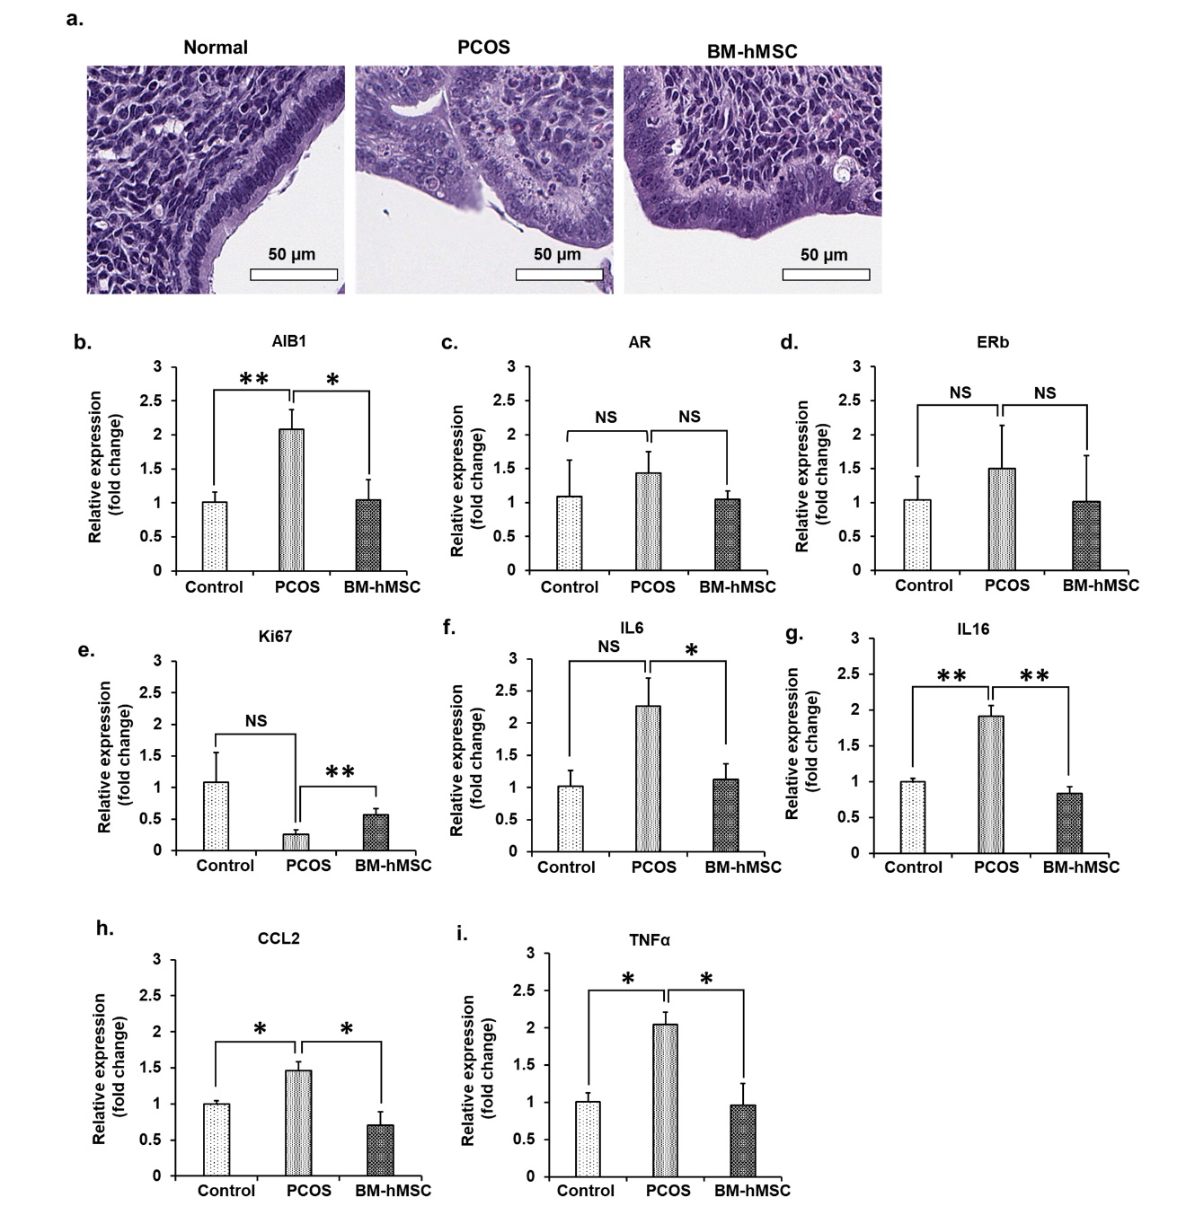
Fig S7: The effect of BM-hMSC on the endometrium in the LTZ-induced PCOS mouse model. (a) Morphology of mouse endometrium tissue in control, PCOS, and BM-hMSC-treated PCOS mice (H&E staining). (b) Comparison of relative AIB1 gene expression level in control (1.00 ± 0.15 fold), PCOS (2.08 ± 0.29 fold), BM-hMSC-treated PCOS (1.04 ± 0.30 fold) mouse endometrium. (c) Comparison of relative AR gene expression level in control (1.08 ± 0.54 fold), PCOS (1.44 ± 0.31 fold), and BM-hMSC-treated PCOS (1.05 ± 0.12 fold) mouse endometrium. (d) Comparison of relative ERβ gene expression level in control (1.03 ± 0.35 fold), PCOS (1.50 ± 0.63 fold), and BM-hMSC-treated PCOS (1.01 ± 0.68 fold) mouse endometrium. (e) Comparison of relative Ki67 gene expression level in control (1.08 ± 0.47 fold), PCOS (0.26 ± 0.07 fold), and BM-hMSC-treated PCOS (0.57 ± 0.09 fold) mouse endometrium. (f) Comparison of relative IL6 gene expression level in control (1.02 ± 0.24 fold), PCOS (2.26 ± 0.44 fold), and BM-hMSC-treated PCOS (1.13 ± 0.24 fold) mice endometrium. (g) Comparison of relative IL16 gene expression level in control (1.00 ± 0.04 fold), PCOS (1.91 ± 0.14 fold), and BM-hMSC-treated PCOS (0.83 ± 0.09 fold) mouse endometrium. (h) Comparison of relative CCL2 gene expression level in control (1.00 ± 0.04 fold), PCOS (1.46 ± 0.12 fold), and BM-hMSC-treated PCOS (0.70 ± 0.19 fold) mouse endometrium. (i) Comparison of relative TNFα gene expression level in control (1.00 ± 0.12 fold), PCOS (2.05 ± 0.16 fold), and BM-hMSC-treated PCOS (0.97 ± 0.29 fold) mouse endometrium. Data presented as the mean ± SD. *: p<0.05, **: p<0.005, ***: p<0.0005; NS: Not significant.

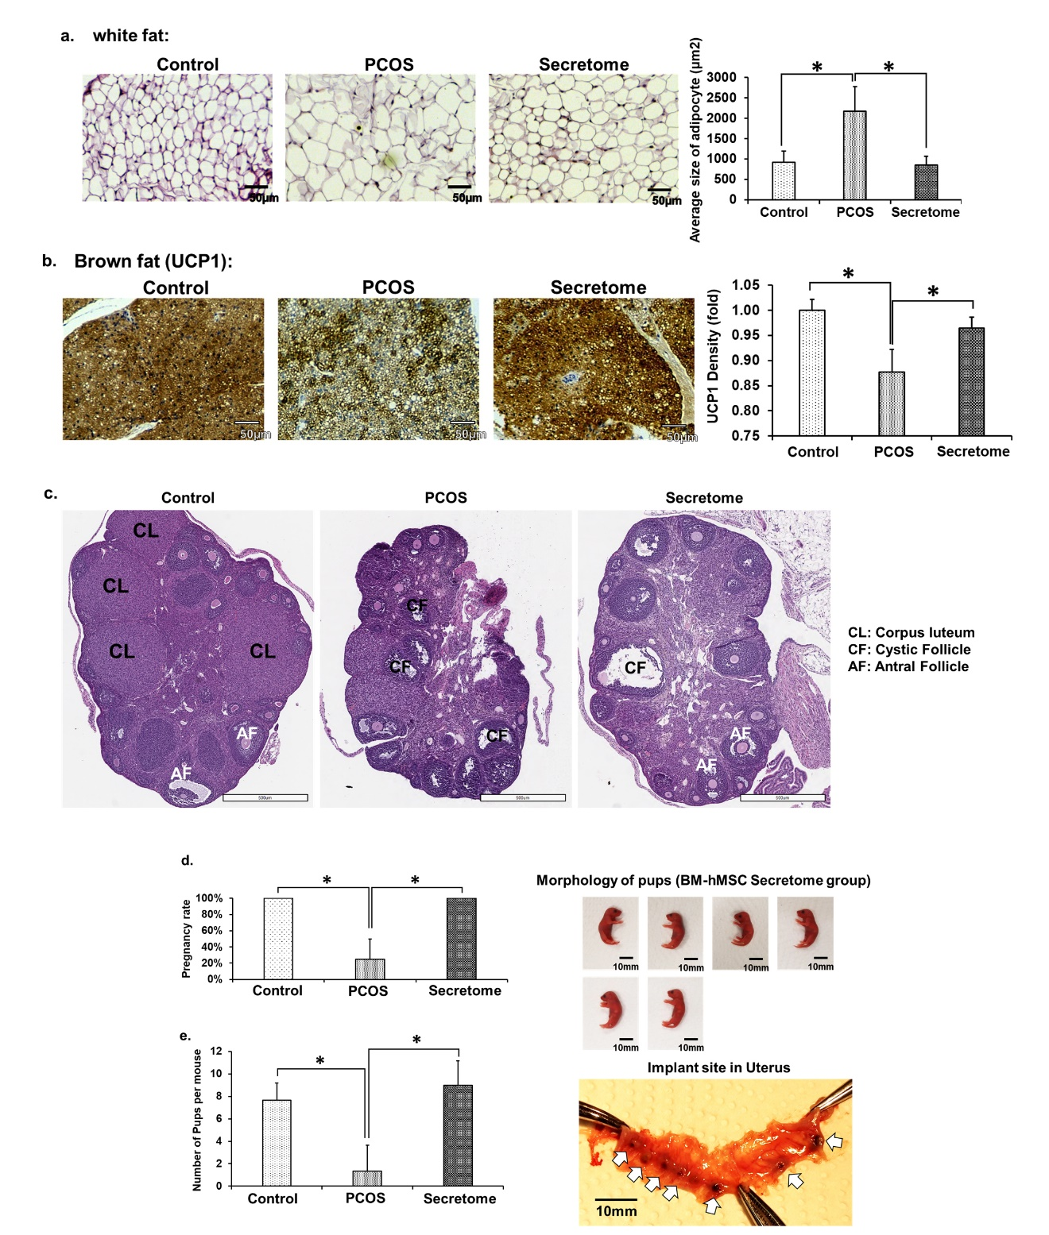
Fig S8: Effect of BM-hMSC secretome injection on the ovary, white fat, brown fat, and fertility in the LTZ-induced PCOS mouse model. (a) Morphology of ovary with H&E staining in control mice (Control), PCOS mice (PCOS), and BM-hMSC secretome-treated PCOS mice (Secretome). (b) Size of adipocyte in white fat tissue from the control group (926 ± 266 µm2), PCOS group (2173 ± 610 µm2), and Secretome group (829 ± 223 µm2). (c) Density of brown fat analyzed with UCP1 by immunohistochemistry. (d) Pregnancy rate of the control group (4 out of 4), the PCOS group (1 out of 4), and the Secretome group (4 out of 4). (e) Average number of pups from the control group (7.6 ± 1.5), PCOS group (1.3 ± 2.3), and the Secretome group (9.0 ± 2.2). Data presented as the mean ± SD. *: p<0.05.

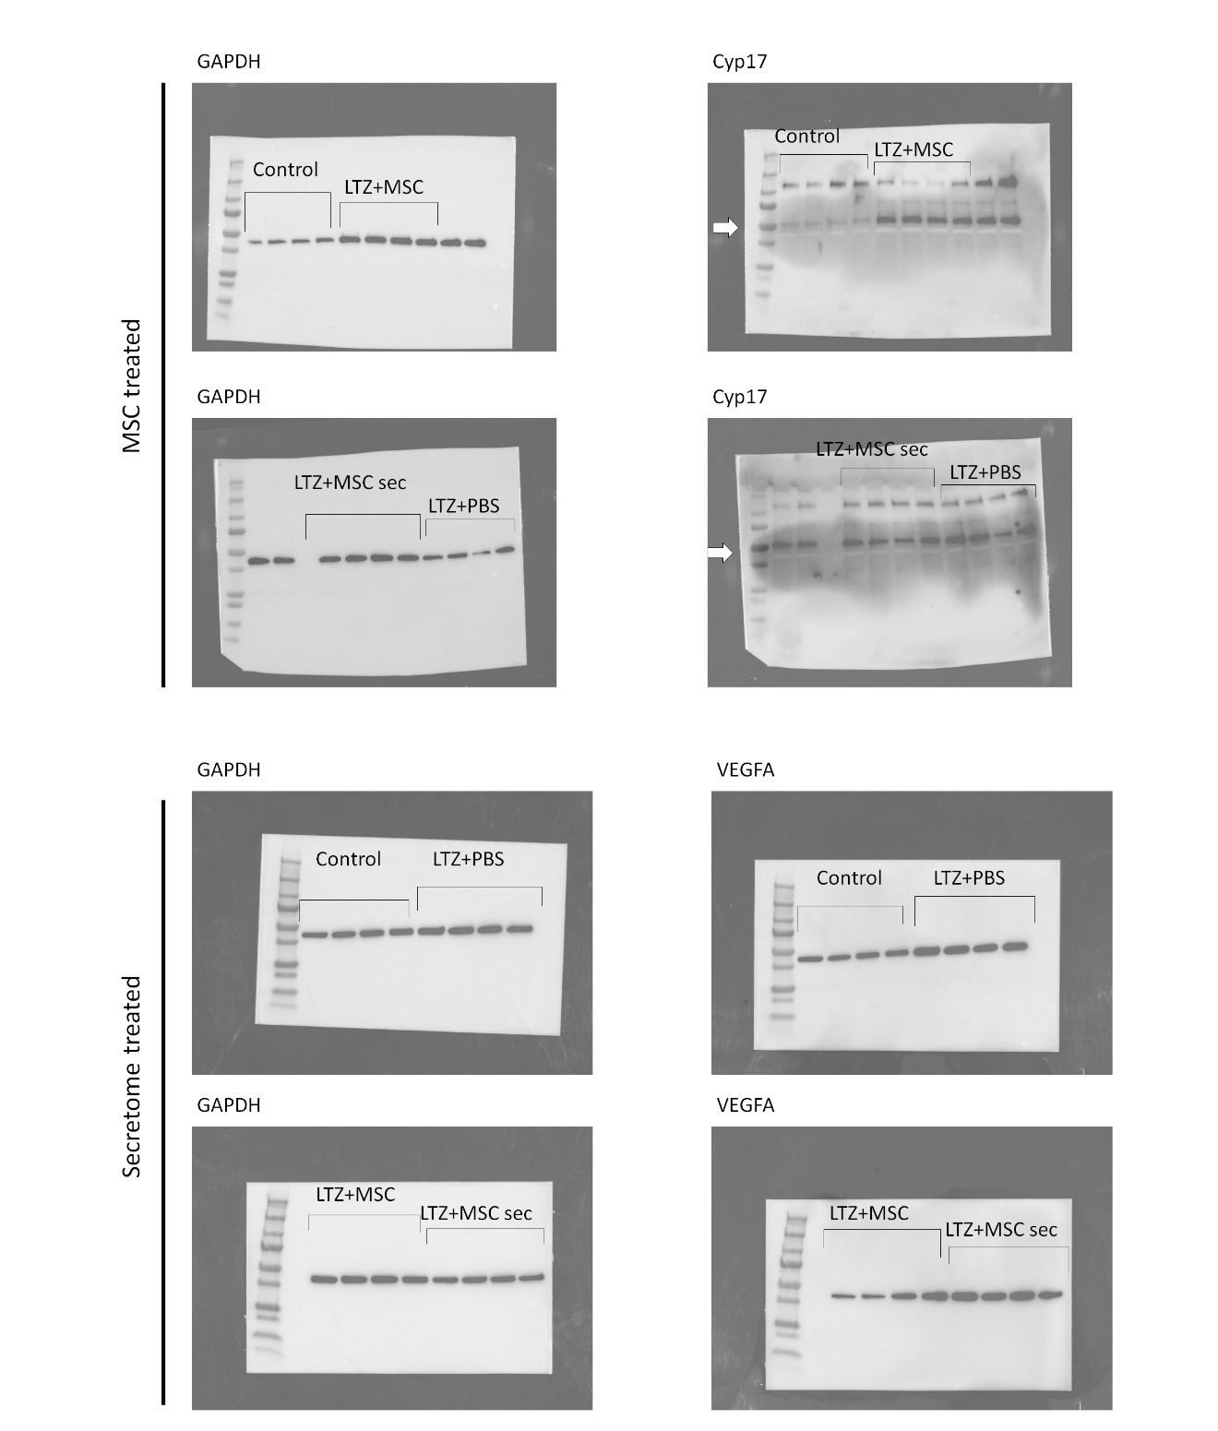
Fig S9: Raw data image of Western blot membranes

Table S1. List of Primers
Gene | Forward primer (5’-3’) | Reverse primer (5’-3’)
Human ACTB | TGGATCAGCAAGCAGGAGTATG | GCATTTGCGGTGGACGAT
Human CYP17A1 | GGCCTCAAATGGCAACTCTAGA | CTTCTGATCGCCATCCTTGAA
Human CYP11A1 | GAGGGAGACGGGCACACA | TGACATAAACCGACTCCACGTT
Human DENND1A | CAATTCCCGGAGGACTACAGT | AGCACGAATGTGAAGTTCTGG
Human IL6 | TGCACTTTATGACGCACTCAC | TGTCCAAAAACACGAAATCATGC
Human IL1B | ATGATGGCTTATTACAGTGGCAA | GTCGGAGATTCGTAGCTGGA
Human TNFA | AAGCACACTGGTTTCCACACT | TGGGTCCCTGCATATCCGTT
Mouse Gapdh | CACATTGGGGGTAGGAACAC | AACTTTGGCATTGTGGAAGG
Mouse Cyp17a1 | GAGTTTGCCATCCCGAAGGA | CCAGCTCCGAAGGGCAAATA
Mouse Cyp19a1 | TTTCGCTGAGAGACGTGGAG | AGGATTGCTGCTTCGACCTC
Mouse Fshr | GTGCATTCAACGGAACCCAG | TCTAAGCCATGGTTGGGCAG
Mouse Vegfa | GTACCTCCACCATGCCCAGT | GCATTCACATCTGCTGTGCT
Mouse Il1b | TTCAGGCAGGCAGTATCACTC | GAAGGTCCACGGGAAAGACAC
Mouse Il6 | ATCCAGTTGCCTTCTTGGGACTGA | TAAGCCTCCGACTTGTGAAGTGGT
Mouse Il10 | CGGGAAGACAATAACTGCACCC | CGGTTAGCAGTATGTTGTCCAGC
Mouse Ccl2 | AGATGCAGTTAACGCCCCAC | ACCCATTCCTTCTTGGGGTC
Mouse Cd11c | ACGTCAGTACAAGGAGATGTTGGA | ATCCTATTGCAGAATGCTTCTTTACC
Mouse Tnfa | TCCCAGGTTCTCTTCAAGGG | GGTGAGGAGCACGTAGTCGG
Mouse Ki67 | CTGCCTGCGAAGAGAGCATC | AGCTCCACTTCGCCTTTTGG
Mouse Erb | TTCCCGGCAGCACCAGTAACC | TCCCTCTTTGCGTTTGGACTA
Mouse Ar | TTGCAAGAGAGCTGCATCAGTT | ACTGTGTGTGGAAATAGATGGGC
Mouse Aib1 | GCCTGGCTTTGAAGACATAATCCG | TCTTGATAGTGACGCTTCTGGGAC
Mouse Adiponectin | GGCCCATCATGCTATGGAAC | GTGAGGGATCACTCGCCATC
Mouse Leptin | TTGCCATATTCCTCACCA | CCCACTCGATCAGATGTGCTC
Mouse Ucp1 | CAAAAACAGAAGGATTGCCGAAA | TCTTGGACTGAGTCGTAGAGG
Mouse Pgc1a | TATGGAGTGACATAGAGTGTG | GTCGCTACACCACTTCAATCC
Mouse Cidea | TGACATTCATGGGATTGCAGAC | CATGGTTTGAAACTCGAAAAGGG
Mouse Prdm16 | CCACCAGCGAGGACTTCAC | GGAGGACTCTCGTAGCTCGAA

