HPR friction traces
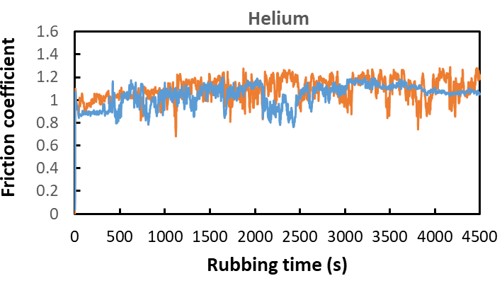
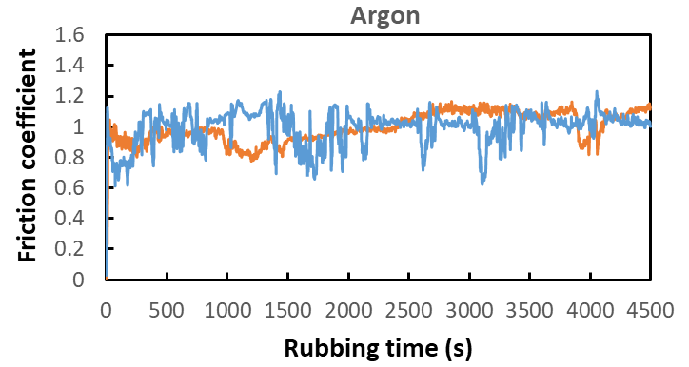
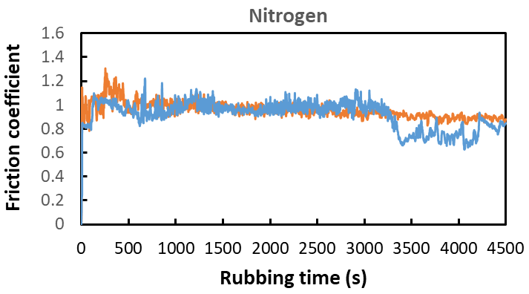
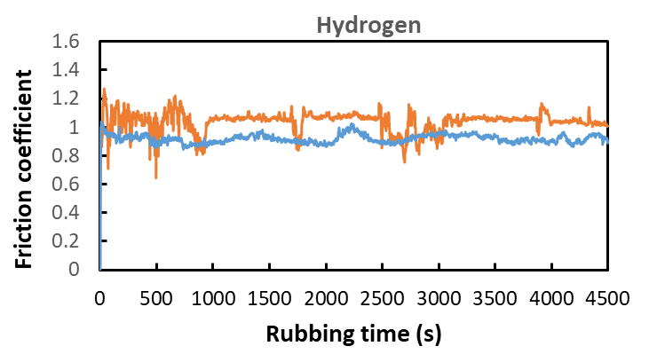
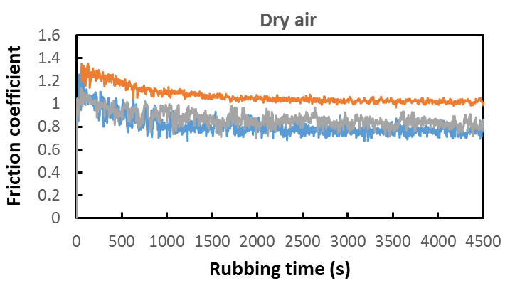
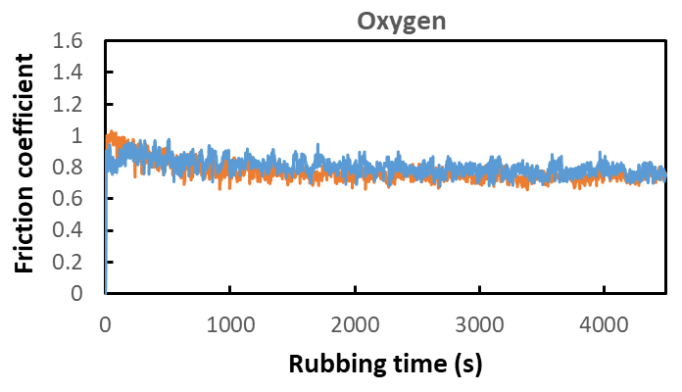
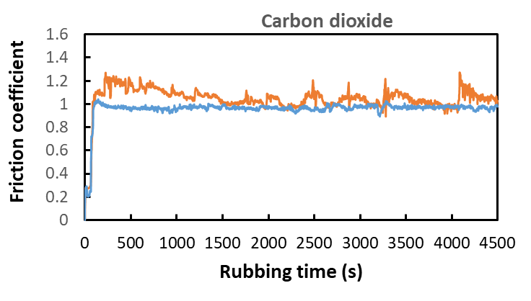
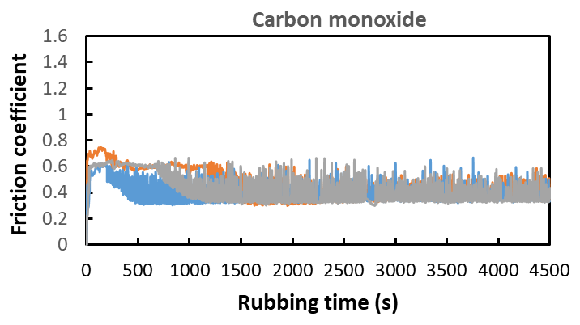
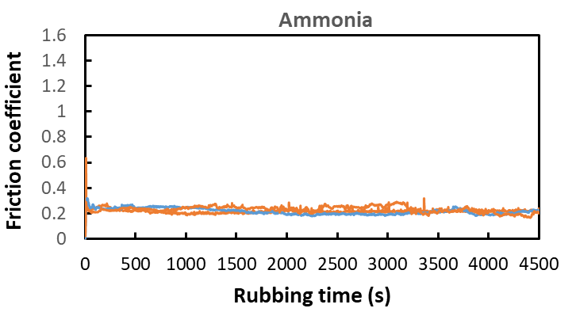
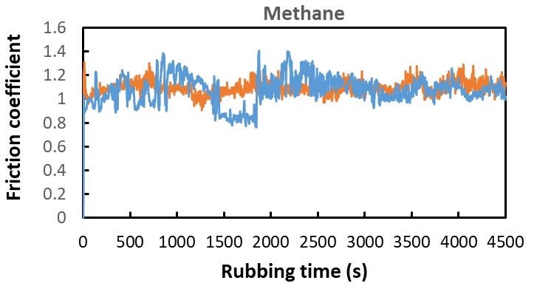
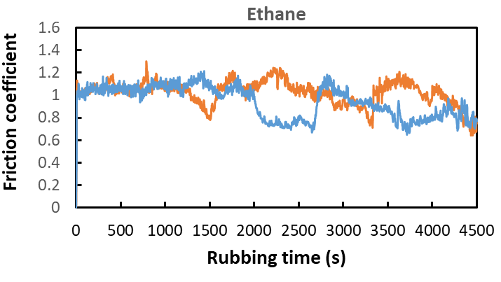
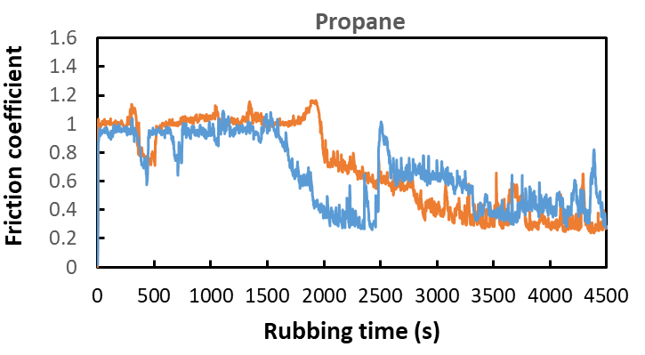
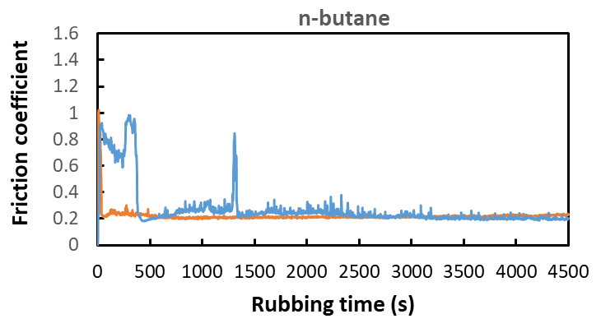
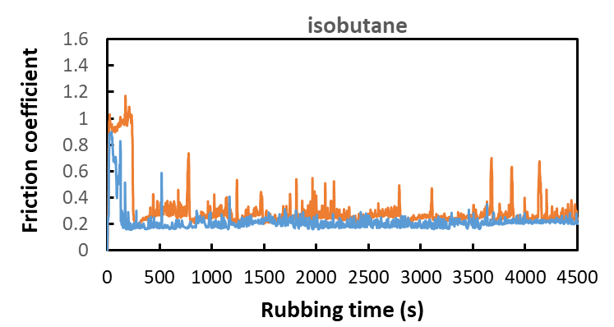
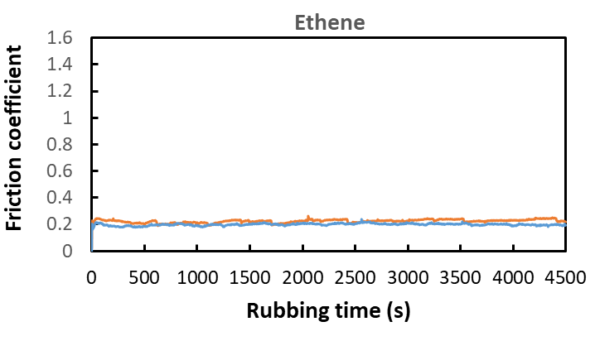
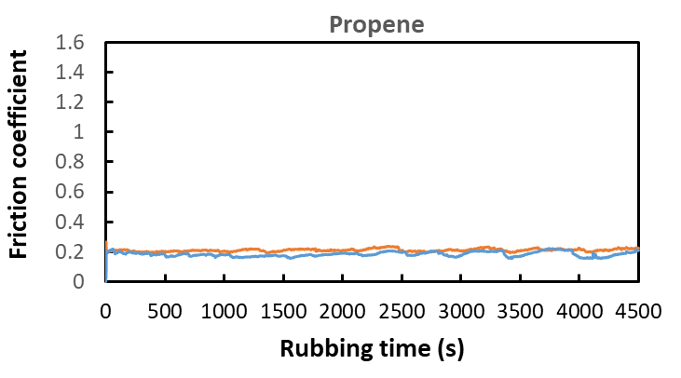
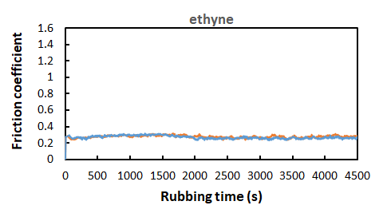
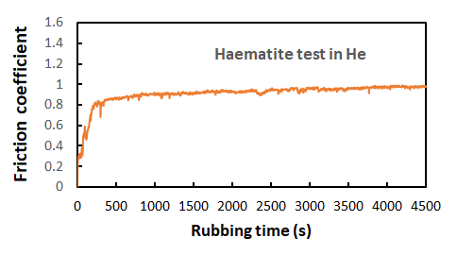

HPR tests friction and wear values

 | Wear x | Wear y | avg xy WSD (µm) | avg fric coeff µ
Dry Air-re | 1524.8 | 1457.41 | 1491.1 | 0.813
Dry Air-re1 | 1510.06 | 1459.52 | 1484.8 | 0.872
O2 | 1621.68 | 1537.44 | 1579.6 | 0.773
O2-re | 1619.58 | 1537.44 | 1578.5 | 0.803
N2 | 582.93 | 575.41 | 579.2 | 0.958
N2-re1 | 580.68 | 567.14 | 573.9 | 0.915
H2 | 526.52 | 530.28 | 528.4 | 1.036
H2-re | 595.72 | 558.11 | 576.9 | 0.917
argon | 609.26 | 601.74 | 605.5 | 0.992
argon-re | 525.02 | 511.48 | 518.3 | 0.994
Helium | 461.33 | 451.30 | 456.3 | 1.088
Helium-re | 514.49 | 491.92 | 503.2 | 1.043
Ammonia | 191.55 | 182.03 | 186.8 | 0.218
Ammonia-re | 138.40 | 167.28 | 152.8 | 0.216
Ammonia-re1 | 138.40 | 158.26 | 148.3 | 0.232
carbon dioxide-re | 568.64 | 543.07 | 555.9 | 1.047
carbon dioxide-re1 | 506.96 | 534.04 | 520.5 | 0.956
carbon monoxide | 331.56 | 294.85 | 313.2 | 0.456
carbon monoxide-re | 241.30 | 233.48 | 237.4 | 0.384
carbon monoxide-re1 | 270.78 | 238.29 | 254.5 | 0.418
Methane | 520.50 | 469.36 | 494.9 | 1.095
Methane-re | 568.64 | 534.04 | 551.3 | 1.072
Ethane | 546.58 | 540.31 | 543.4 | 1.026
Ethane-re | 506.96 | 502.45 | 504.7 | 0.940
Propane-re | 449.80 | 421.22 | 435.5 | 0.698
Propane-re1 | 473.87 | 454.31 | 464.1 | 0.659
N-Butane-re | 178.01 | 217.63 | 197.8 | 0.223
N-Butane-re1 | 303.88 | 273.79 | 288.8 | 0.278
Isobutane | 300.37 | 258.75 | 279.6 | 0.305
Isobutane-re | 256.34 | 247.92 | 252.1 | 0.215
Ethene | 116.84 | 125.36 | 121.1 | 0.224
Ethene-re | 112.53 | 124.56 | 118.5 | 0.199
Propene | 117.34 | 120.85 | 119.1 | 0.209
Propene-re | 114.93 | 121.55 | 118.2 | 0.185
Ethyne | 122.75 | 129.37 | 126.1 | 0.278
Ethyne-re | 116.14 | 132.38 | 124.3 | 0.274
Haematite (He) | 603.24 | 609.26 | 606.25 | 0.910

HPR switching tests

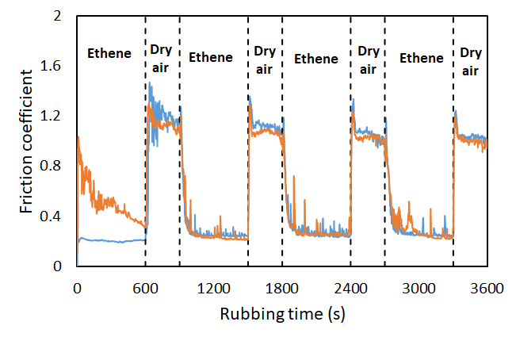

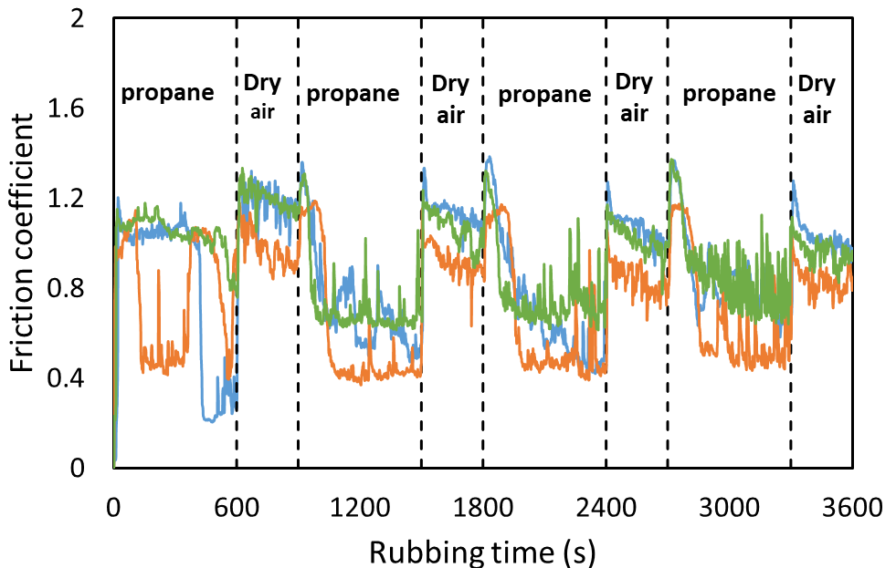

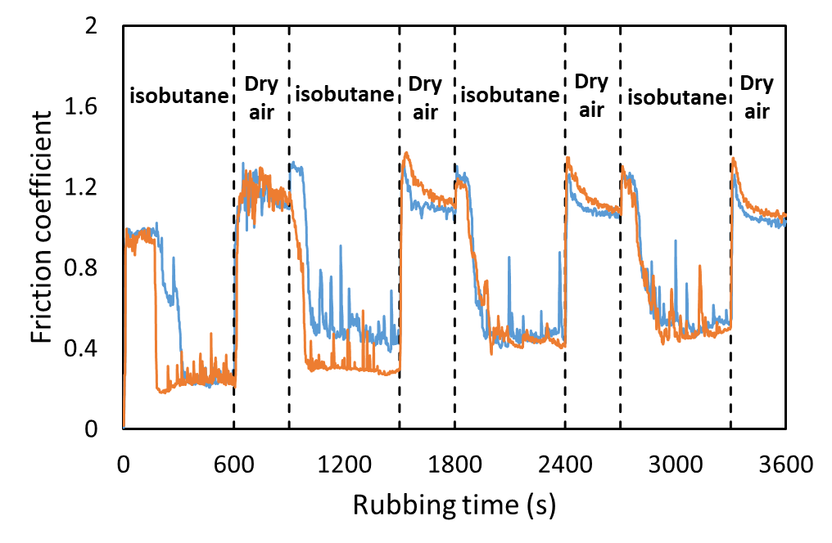
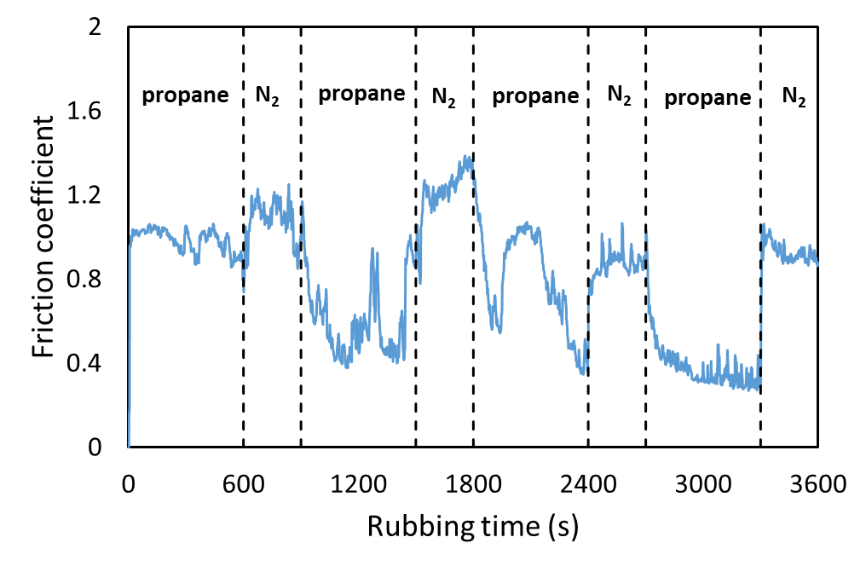

XPS survey spectra of worn surfaces
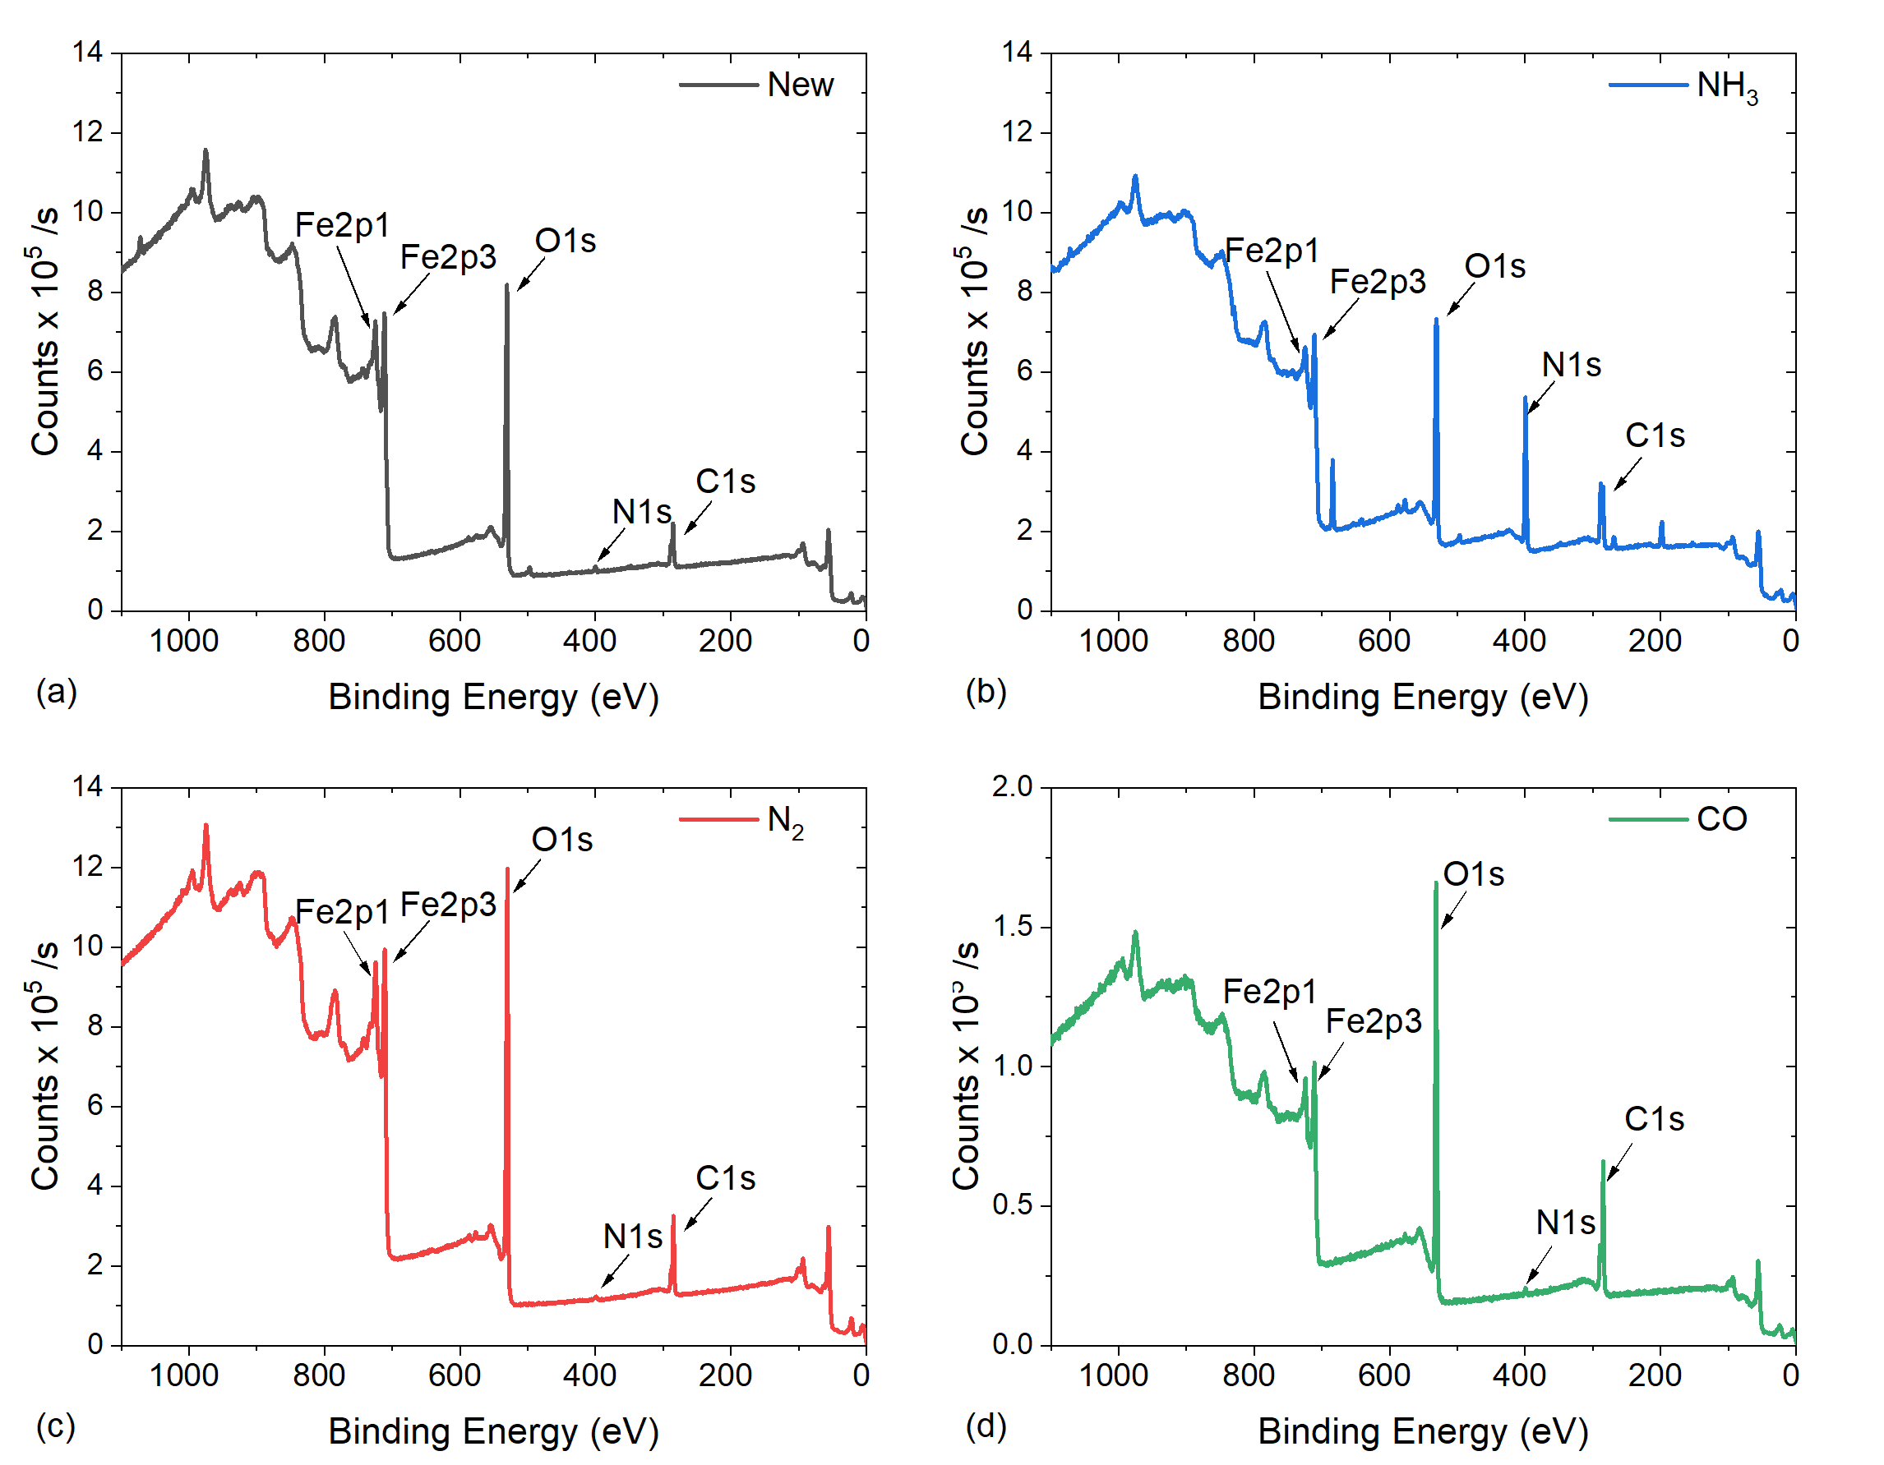

Supplementary Information: High resolution XPS spectra of clean steel surface
