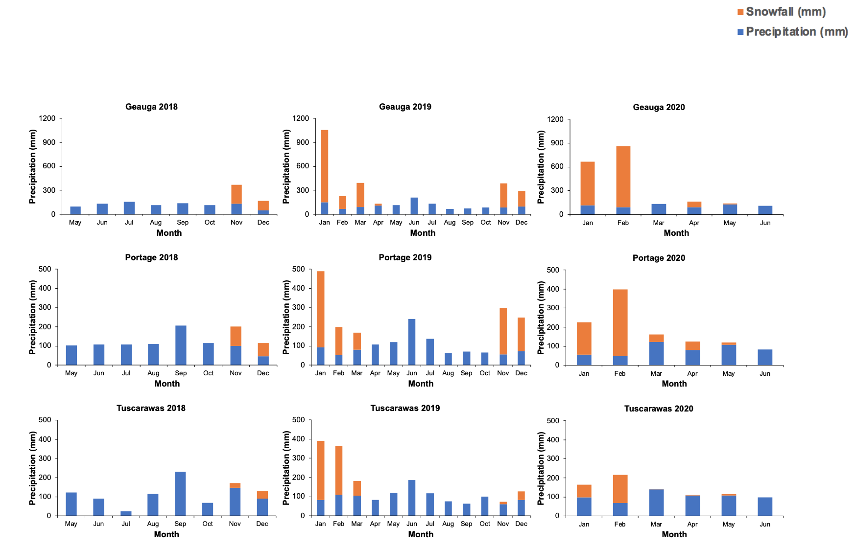Figure S1. Monthly accumulated rain and snowfall (mm) in 2018, 2019, and 2020 at each site.

