Extended data figures and tables
Extended Data Fig. 1 Comparison with independent soundings
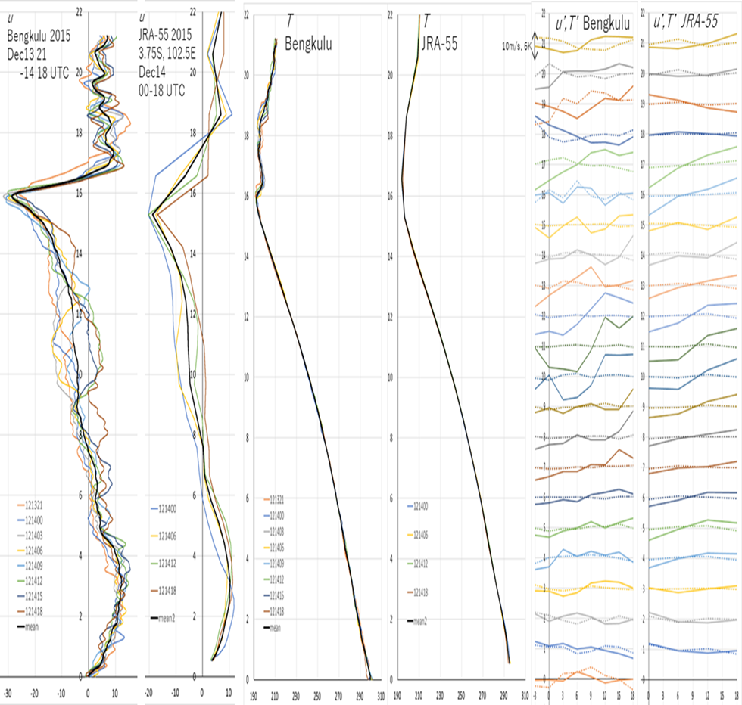
We compare vertical profiles of zonal wind u (left two) and temperature T (middle two) between 6-hourly JRA-55 data and 3-hourly radiosonde soundings carried out independently (not included in JRA-55) at Bengkulu, southwestern coast of Sumatera Island of IMC. We show examples on 14 (13–14 local date) December 2015 and plot daily means with thick black color. Temporal variations u’ and T’ of “SLBC waves” at each height 2015 are also compared (right two columns).

Extended Data Fig. 2 Global tidal waves
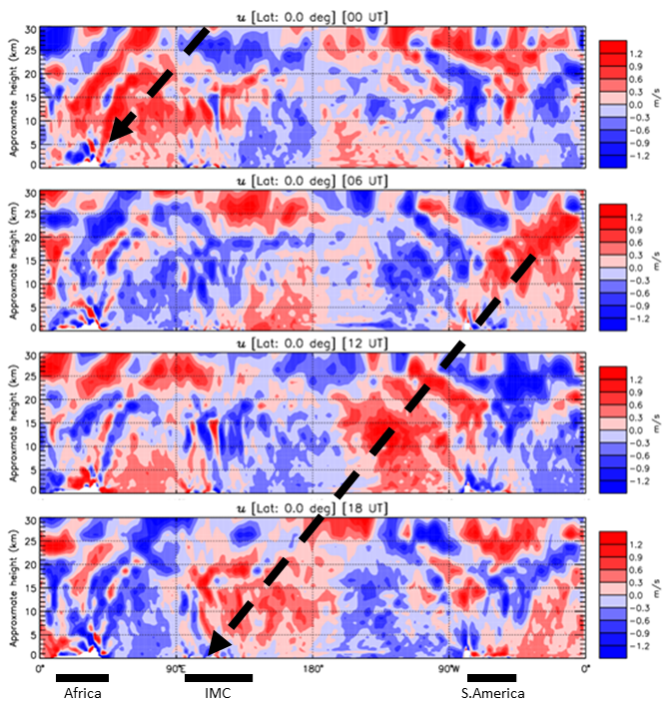
We show an example of monthly-mean zonal-vertical plot along the equator at each UTC of zonal wind anomaly from daily mean of JRA-55 data in January 2000. In addition to local diurnal cycles, a fast westward propagating diurnal tide with a peak at 06 LT (indicated by a thick dashed arrow).

Extended Data Fig. 3 QBO-composite troposphere-stratosphere
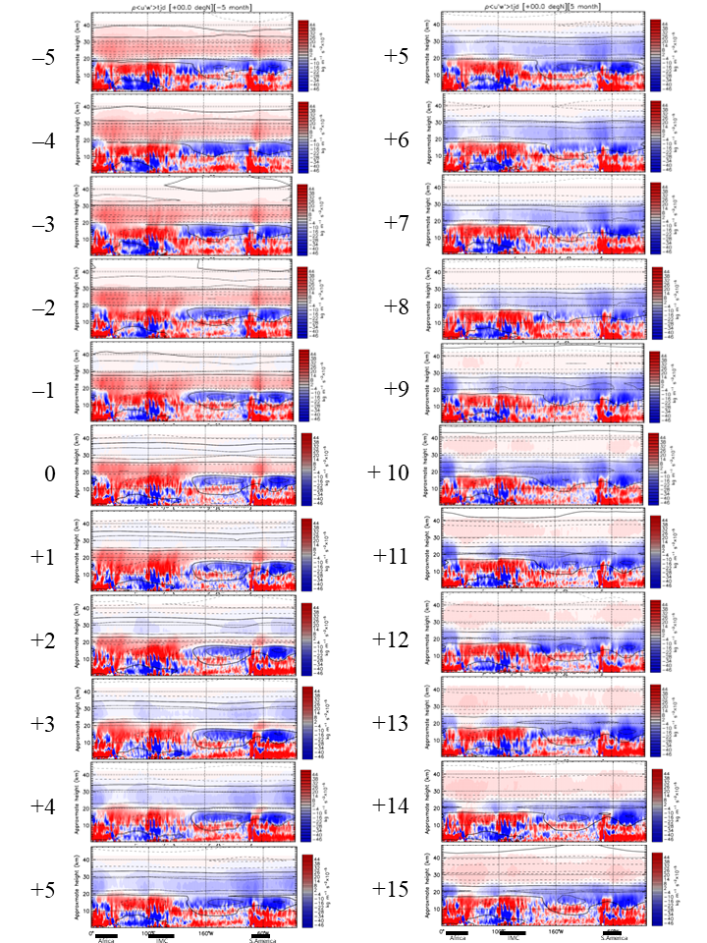
QBO-composite longitudinal-vertical sections along the equator of zonal flow (contours, every 10 m/s; solid: westerly) and vertical flux of zonal momenta associated with longitudinally 30°-high passed diurnal (“SLBC”) waves (color-codes) for 10 months from 5 months before the easterly-westerly transition (left column) and for 10 months from 5 months after the westerly-easterly transition (right column) at 20 hPa (about 26 km) level, analyzed from the 40-year (1981–2020) JRA-55 data. “Month 0” and “Month +10” are selected as Figs. 2(a) and (b) in Main.

Extended Data Fig. 3 (animation version, if it works) QBO-composite troposphere-stratosphere

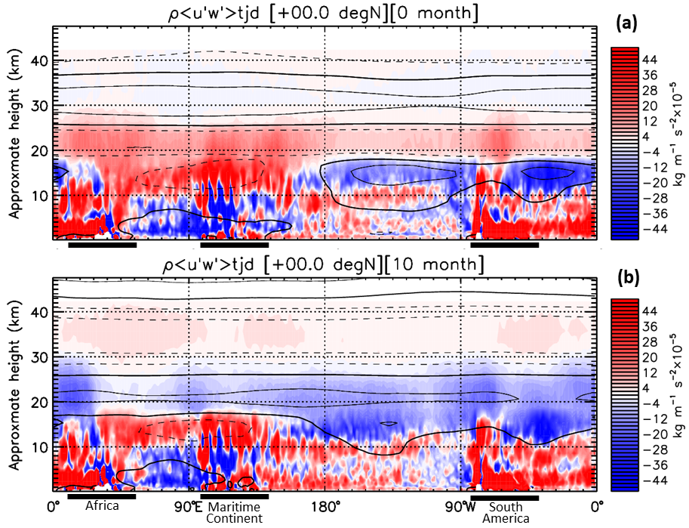
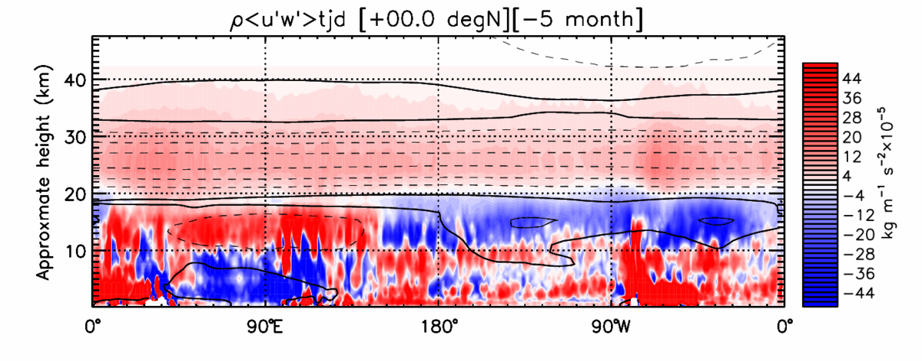
QBO-composite longitudinal-vertical sections along the equator of zonal flow (contours, every 10 m/s; solid: westerly) and vertical flux of zonal momenta associated with longitudinally 30°-high passed diurnal (“SLBC”) waves (color-codes) for 27 months from 5 months before the easterly-westerly transition at 20 hPa (about 26 km) level, analyzed from the 40-year (1981–2020) JRA-55 data. “Month 0” and “Month +10” are selected as Figs. 2(a) and (b) in Main.

