Supplementary
Supplemental table1
The basic information and platelet features of 42 healthy individuals
Accuracy assessment of the PRR method and the modified approach
The table consisted of age, gender, and platelet features. Based on the PRR2, the participants were separated into the PRR2-high group (PRR2 > 1.06, the median of PRR2), and the PRR2-low group (PRR2≤ 1.06, the median of PRR2). PLT-PRP was theoretical platelet counts extracted by the PRR method and PLT-modified was theoretical platelet counts extracted by the modified approach. PRR_bias and modified bias were calculated based on the theoretical platelet counts, which were extracted by the PRR method and the modified approach previously, compared with the authentic platelet counts which were presented by bPLT. The RE (residual error) and RSME (Root Mean Square Error) were also calculated based on the theoretical and authentic platelet counts.

Supplemental table2
Distribution of alignment regions
Based on the positions of the sequence alignment results on the reference genome and the genome annotation information, the proportions of Reads in UTR5, UTR3, CDS, ExonAll, Intron, InterGenic, IntraGenic region, and 1500 bp region above and below the Tss, Tes were counted, respectively. The proportion of the transcription start (Tss) and termination (Tes) regions was also calculated.

Supplemental table3
The Statistical analysis of reference genome alignment analysis results
The statistical results of the comparison between dPLT and uPLT within the NSCLC group, the comparison between dPLT and uPLT within the Healthy group, the comparison between NSCLC and Healthy within the dPLT group, and the comparison between NSCLC and Healthy within the uPLT group were displayed.

Supplemental table4
The results of the VEEN diagram
Veen diagram results demonstrate the overlap of differentially expressed genes among dPLT, uPLT, and GSE, with overlapping regions indicating differential genes shared among dPLT, uPLT, and GSE. The table shows the different intersection and concatenation results of the three groups of DEGs.

Supplemental figure1
When evaluating the accuracy of the PRR method and the modified approach based on their regression analyses with standard values, we can summarize that the modified approach is slightly superior to the PRR method in terms of statistical significance, correlation strength, and precision of estimation. However, both methods show strong correlations and statistical significance with the standard values, indicating that they are both accurate.
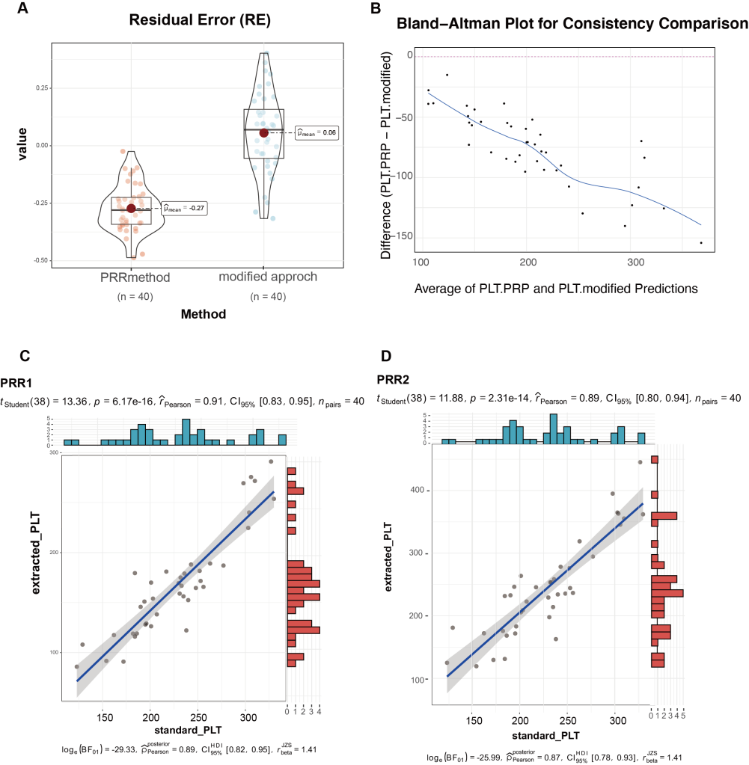
Supplemental Figure 1 The Accuracy comparison of the PRR method and the modified approach. (A) The residual error comparison of the PRR method and the modified approach. (B) The Bland-Altman plot shows the distribution of the difference between the PRR method and the modified approach. (C) The regression analysis of the PRR method. (D) The regression analysis of the modified approach.

Supplemental figure2
Based on the GEPIA platform and transcription results, the expression of MYC in healthy and LUAD individuals was not significantly different, both in the tissue and dPLT. However, the elevated expression of HIST1H2BC was significant between normal and stage 1 in the individuals’ tissue. The dwindling expression of JUN and FGFR1 was significant between normal and stage 1 in the individuals’ tissue.
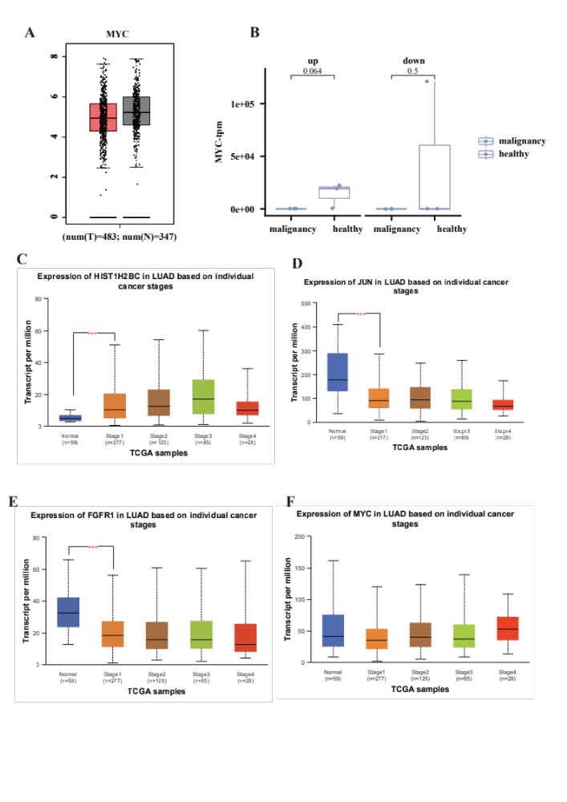
Supplemental Figure 2 The exploration of MAPK pathways enriched genes on the GEPIA and UALCAN platform. (A) The expression (TPM) of MYC in healthy and LUAD individuals based on the GEPIA platform. (B) The expression (TPM) of MYC in healthy and malignant individuals is based on our transcript sequencing results. (C-F) The expression (TPM) of HIST1H2BC (C), JUN (D), FGFR1 (E), and MYC (F) in healthy and LUAD individuals is based on cancer stages (UALCAN platform).

Supplemental figure3
Based on bio-information analysis and previous literature, it is hypothesized that platelet HIST1H2BC may be involved in the progression of LUAD through the MAPK pathway, undergoing changes in relevant gene expression in response to stimulation by tumor cells, and entering the peripheral blood to become large-volume platelets.
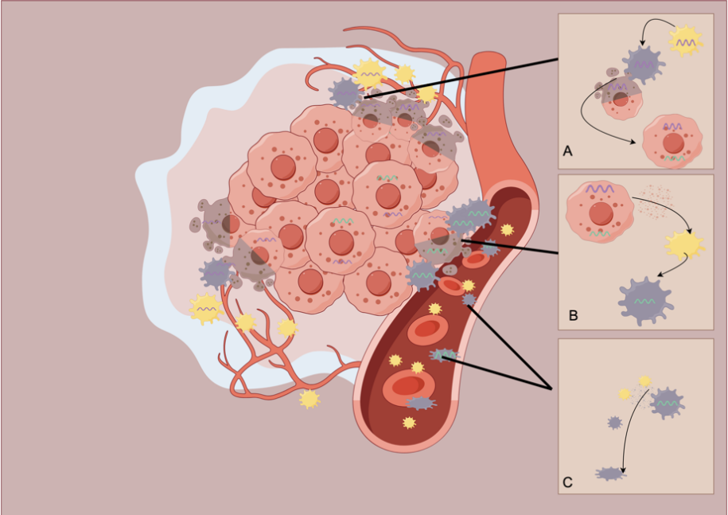
Supplemental figure3 (By Figdraw) The mechanism of which unknown TEPs becoming bulky platelets. (A) Highly expressed HIST1H2BC was intercepted by tumor cells in tumor tissues, and the MAPK pathway was activated after the tumor cells highly expressed HIST1H2BC, resulting in the low expression of genes such as JUN, MYC, and FGFR1; (B) Highly expressed HIST1H2BC and the MAPK pathway was activated tumor cells taught normal platelets in the tumor microenvironment to become TEPs and highly (C) Activated TEPs with high expression of JUN, MYC, and FGFR1 genes enter the peripheral blood, which increases the volume of platelets in contact with them and results in high expression of JUN, MYC, and FGFR1 genes, i.e., they become dPLTs that are deposited in the erythrocyte layer.

