Supplementary material

Appendix1: MIMIC preprocessing script
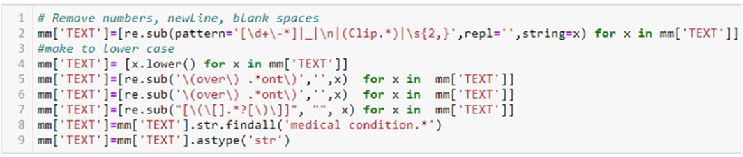

Appendix 2: BERT model plot

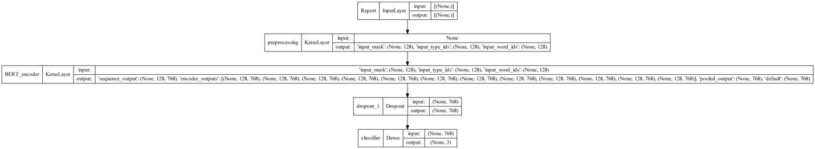

Appendix 3: ClinicalBERT model summary

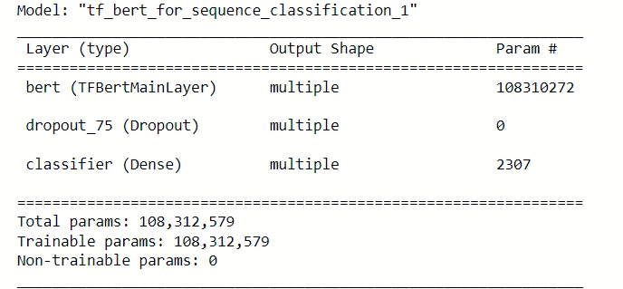

Appendix 4: Training with MIMIC dataset (BERT_{MIMIC} and ClinicalBERT_{MIMIC})
A stratified random train–test split (70:30) of the 542 reports in MIMIC dataset was performed and used for fine-tuning. Validation was performed using the Hospital test set as well as hospital hold-out set (for the sake of comparison) for both BERT and ClinicalBERT and compared.
The accuracy for BERT_{MIMIC} and ClinicalBERT_{MIMIC} models on MIMIC test set were 0.74 and 0.64, respectively. The accuracy for external validation for these models using the hospital hold-out set was 0.41 and 0.49 respectively and that using hospital test set was 0.45 and 0.35, respectively. The overall as well as individual class precision recall and F1-score for the 2 models is given in table A. Figure A shows the Precision-Recall Curve (PRC) for BERT_{MIMIC} and ClinicalBERT_{MIMIC}.
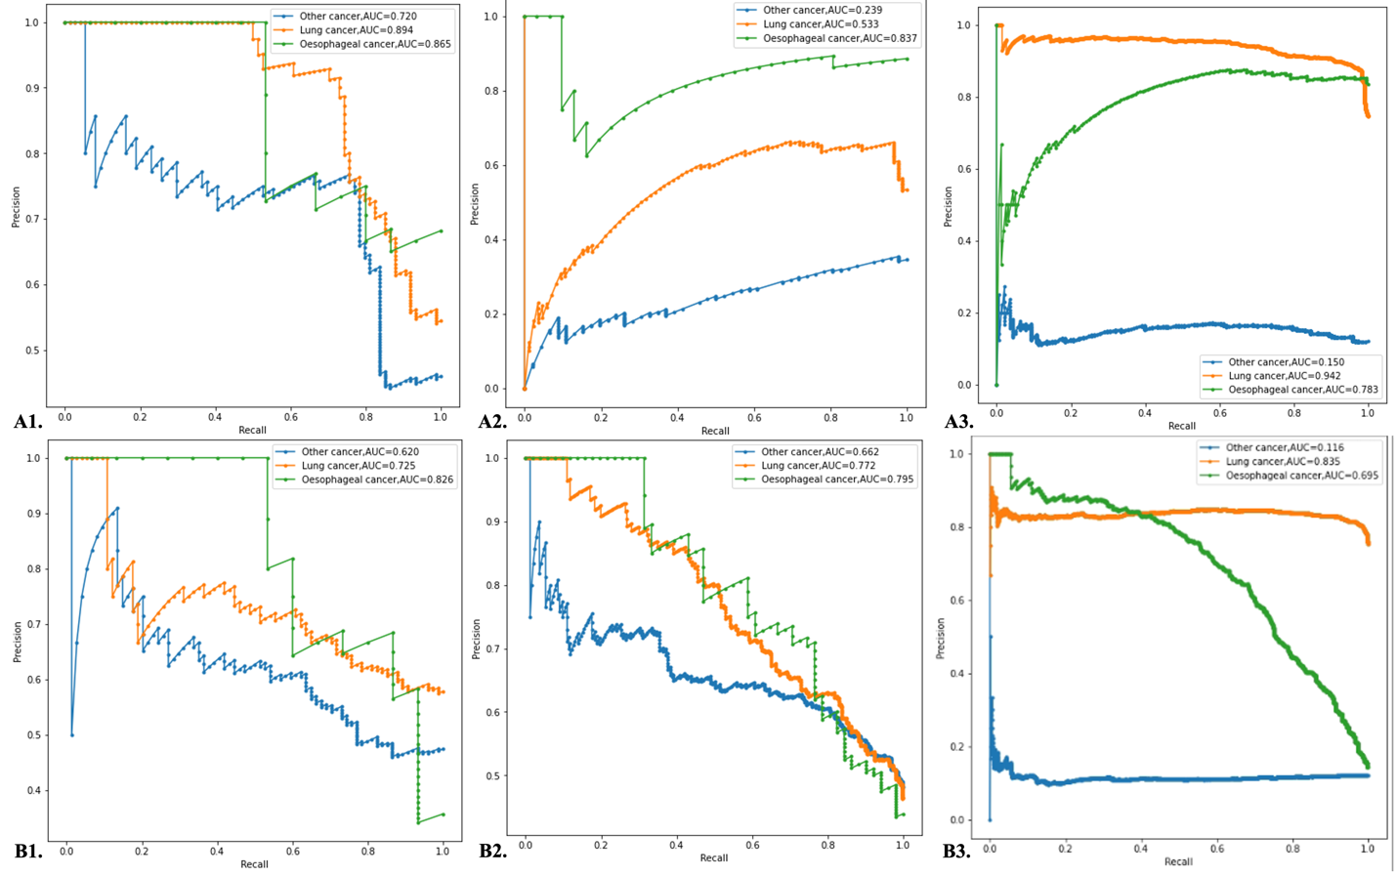
Figure A: Precision-Recall Curve (PRC) for BERT_{MIMIC} (A1. MIMIC test, A2. hospital hold-out set and A3. hospital test) and ClinicalBERT_{MIMIC} (B1. MIMIC test, B2. hospital hold-out set and B3. hospital test)

Table A: Precision, recall, F1-score, and AUC-ROC for BERT_{MIMIC}, and ClinicalBERT_{MIMIC} models where 0- other cancer, 1- lung cancer and 2- esophageal cancer
 | Hospital-test | Hospital-hold outset | MIMIC-test
 |  | Precision
BERT_{MIMIC} | Overall – 0.66  0 - 0.16  1 - 0.96  2 - 0.85 | Overall – 0.50  0 - 0.23  1 - 0.40  2 - 0.89 | Overall – 0.70  0 - 0.74  1 - 0.82  2 - 0.54
ClinicalBERT_{MIMIC} | Overall – 0.61  0 - 0.11  1 - 0.82  2 - 0.90 | Overall – 0.57  0 - 0.34  1 - 0.82  2 - 0.56 | Overall – 0.63  0 - 0.61  1 - 0.71  2 - 0.58
 |  | Recall
BERT_{MIMIC} | Overall – 0.71  0 - 0.85  1 - 0.28  2 - 0.99 | Overall – 0.54  0 - 0.41  1 - 0.20  2 - 1.00 | Overall – 0.81  0 - 0.68  1 - 0.74  2 - 1.00
ClinicalBERT_{MIMIC} | Overall – 0.39  0 - 0.61  1 - 0.33  2 - 0.22 | Overall – 0.46  0 - 0.76  1 - 0.47  2 - 0.16 | Overall – 0.72  0 - 0.62  1 - 0.61  2 - 0.93
 |  | F1 score
BERT_{MIMIC} | Overall – 0.54  0 - 0.27  1 - 0.44  2 - 0.92 | Overall – 0.50  0 - 0.29  1 - 0.27  2 - 0.94 | Overall – 0.73  0 - 0.70  1 - 0.78  2 - 0.70
ClinicalBERT_{MIMIC} | Overall – 0.34  0 - 0.19  1 - 0.47  2 - 0.36 | Overall – 0.44  0 - 0.47  1 - 0.60  2 - 0.25 | Overall – 0.66  0 - 0.61  1 - 0.66  2 - 0.72
 |  | AUC-ROC
BERT_{MIMIC} | 0 - 0.61  1 - 0.88  2 - 0.98 | 0 - 0.46  1 - 0.62  2 - 0.98 | 0 - 0.75  1 - 0.88  2 - 0.99
ClinicalBERT_{MIMIC} | 0 - 0.47  1 - 0.70  2 - 0.91 | 0 - 0.38  1 - 0.86  2 - 0.74 | 0 - 0.65  1 - 0.79  2 - 0.97

