Supplementary material
S1: Details on the electrical resistivity tomography and geochemistry
An electrical resistivity tomography (ERT) profile was carried out along the coring transect throughout the valley. The ERT survey was performed using an ARES II resistivity meter (AGICO s.r.o. Instruments), which was connected to a linear array of electrodes evenly spaced at intervals of 2.0m. Res2Dinv software (version 3.59.119, Geotomo Software) was used to convert the apparent electrical resistivity values into a 2-D model of the subsurface (Fig. 6A).
Altogether, 16 samples representing significant lithological horizons were taken from ZAH B core (Fig. 5) for geochemical analysis at intervals of 2–10cm. Atomic absorption spectroscopy was performed for K₂O, Na₂O, CaO, MgO, Fe₂O₃, TiO₂, Al2O₃, and SiO₂. Determination of total organic carbon (TOC) was carried out by indirect titration using the Walkley-Black method; estimation of total sulphur (TS) was performed by non-destructive energy-dispersive X-ray fluorescence (EDXRF). Powder X-ray diffraction data (XRD) of four samples were collected using a Bruker D8 Advance diffractometer equipped with a Lynx Eye XE detector and Soller slits (2.5°) in the primary and secondary beams; CoKα radiation was used. All chemical analyses were carried out at a laboratory of the Czech Geological Survey (CGS).
To observe sediment micromorphology, four oriented sediment samples of sediment were taken from the interval 420–480cm of the ZAH C core. After slow drying and subsequent impregnation with a polymer resin, thin sections were produced from samples at the laboratory of the CGS. The thin sections were studied under a polarizing microscope at a magnification of 16–800×.
Assessing the circumstances under which millet and a fingernail were deposited in the swamp requires knowledge of the environmental context during the particular time period. The horizon with millet (depth of 435–450cm, cores ZAH2004, ZAH2009, ZAH A–C, ZA1, ZA7, and ZA16) is part of sedimentary sequence composed of a dark organic-rich clay (lower part of LH_2, Fig 6). The absence of any coarse clastic material together with textural characteristics (Fig. S4) indicates accumulation from suspension and consequently a calm sedimentary environment of ponded standing water.
It is difficult to estimate the depth of the water table based on textural features alone. However, analysis of the invertebrate fauna provides a fairly detailed insight (see chapter 3.4). The enormously high content of both aluminium and iron together with elevated values of sulphur promote the formation of Fe-oxyhydroxides and aluminium bearing hydroxysulphate (Bigham and Nordstrom, 2000) such as goethite (α-Fe3+O(OH)) or basaluminite (Al₄(SO₄)(OH)10·4H₂O), both identified in the XRD record (Fig. S4). The formation of these minerals is further accelerated under an acid oxidized environment, resulting in successive layers of hard massive concretions precipitated around nuclei (organic remains and mineral clasts; Fig. S5) and/or occupying the pore spaces between them. Several such encrustation layers have been identified in the lower part of the sedimentary record, forming mechanically resistant horizons in the mushy organo-mineral sediment. The thickest such layer, which forms a quasi-continuous horizon across the entire swamp, is located at the base of sequence LH_2, i.e. directly beneath the horizon with millet and the nail (450–480cm in the core ZH_1). This layer stabilized the former bog surface sufficiently to allow safe access to its central part (despite the area being submerged at the time).
S2: Detail of the paleobotanical analyses
Samples for pollen analysis were prepared from 0.5cm³ according to a standard method described by Berglund and Ralska-Jasiewiczowa (2003), then stained with safranine and mounted into glycerol for storage. Pollen determinations follow a reference collection, available atlases (Reille, 1992; 1995; 1998) and the determination key by Beug (2004). A minimum number of 900 pollen grains were counted in each sample. Charcoal particles 10–100μm in size were counted in pollen slides using a point-count method described by Tinner et al. (2005). The results of pollen, microscopic charcoal and NPPs analyses are presented as a percentage diagram plotted on a linear depth axis. All percentage values were based on total terrestrial (AP and NAP) pollen sum, meaning that all wetland types (including Alnus glutinosa-type) and non-pollen objects (incl. fern spores) were excluded from this sum. A stratigraphic diagram is plotted in Tilia v. 1.7.16 (Grimm, 2011).
Ca. 250ml sediment samples were wet-sieved on a mesh size 0.25ml, and plant macrofossils were picked manually under a dissection microscope. The resulting plant macrofossil diagram (Fig. 7) shows absolute counts of all determined remains and again is plotted in Tilia v. 1.7.16 (Grimm, 2011).
S3: Details of the analysis of aquatic invertebrate remains
All samples (core ZAH B, depth interval 419–471cm, volume of each sample 3cm³) were washed with distilled water through a 100μm sieve and transferred into a Sedgewick-Rafter counting cell. All insect remains, mainly chironomid (Diptera: Chironomidae) head capsules (HCs), were picked one by one with either fine forceps or a steel needle using a dissecting optical microscope (15× magnification). Insect remains were then dehydrated in ethyl alcohol (~96 %) and mounted on glass microscope slides in Euparal® mounting medium. For taxa identification, we used an optical microscope (100–400× magnification) and followed several identification keys – mainly Brooks et al. (2007) and Szeroczyńska and Sarmaja-Korjonen (2007). Because of the low number of zoological remains in the lower part of the analysed depth interval, we show concentrations of individual (morpho)taxa per 1.0g of dry sediment in a stratigraphic diagram (Fig. 9). Cladoceran remains were counted in the counting cell and identified under the optical microscope. In the case of the very abundant Chydorus sphaericus, we counted its shells using a semiquantitative scale (0 = absence; 1 = from 1 to 9 individuals per sample; 2 = from 10 to 100 individuals per sample; 3 = from 100 to 999 individuals per sample; 4 = ≥ 1000 individuals per sample). Due to the low variability in the size of the 4th lateral tooth of mentum observed in our samples (the 4th lateral tooth projecting past the 5th lateral tooth or both teeth ending on the same level), we do not distinguish the Chironomus morphotypes defined by Brooks et al. (2007). Such a low variability may be intraspecific (Orendt and Spies, 2012).
S4: Detail of DNA analysis of the human nail (A044 project report)
Sampling of material, DNA extraction from samples, and preparation of sequencing libraries were performed by the SciLifeLab Ancient DNA facility. The sequencing of libraries was performed by SciLifeLab SNP&SEQ Technology Platform. Data analysis was performed by the SciLifeLab Ancient DNA facility.
DNA was extracted from one sample, from which two DNA sequencing libraries were prepared. While some DNA data generated mapped to the human reference genome, the level was extremely low and highly clonal; similar to the no-sample controls. In conclusion, it is unlikely that any endogenous human DNA was extracted from the sample.
Prior to DNA extraction, the sample was decontaminated by wiping with 0.5 % sodium hypochlorite solution followed by UV-irradiated Milli-QR water using sterile cotton swabs. A clean paper towel was used to gently remove remaining traces of water and the sample was allowed to air-dry for 5 mins at room temperature.
DNA was extracted from the sample following a modified Campos & Gilbert protocol2 using a lysis buffer containing 10 mM Tris hydrochloride pH 8, 10 mM sodium chloride, 5 mM calcium chloride, 2.5 mM EDTA pH 8, 2.00 % sodium dodecyl sulphate, 40 mM dithiothreitol (DTT) and 2.0mg/ml proteinase K. Extraction blanks, using only lysis buffer or water, were included as the negative controls and carried along throughout the whole process. Briefly, the sample was first pre-treated with 1.0ml of lysis buffer without the addition of DTT and proteinase K and incubated with rotation at 37°C for 30 mins. The buffer was removed and another 1.0ml of lysis buffer with DTT and proteinase K was freshly added and incubated with rotation at 55°C for 22–23 hours. The supernatant, which is also the DNA extract, was collected from the digested sample and concentrated using an Amicon Ultra-4 filter unit (Millipore). The remaining pellet from the sample, i.e. A044-002, was stored at -20°C and later re-extracted with 1.0ml lysis buffer and concentrated. The DNA extract was purified with a MinElute PCR purification kit (QIAGEN) according to the manufacturer’s instructions and eluted in a total volume of 110 μl EB buffer.
Four dual-indexed DNA libraries (including 2 extraction blanks) from this project were pooled in equimolar ratios and sequenced on a lane of an Illumina NovaSeq SP flow cell using v1.5 chemistry and 150 bp paired-end reads, at SciLifeLab SNP&SEQ Technology Platform at Uppsala University, Dept. of Medical Sciences, Uppsala Biomedical Centre (BMC), D11:2, Box 1432, 751 44 Uppsala, Sweden.

Supplementary Figures

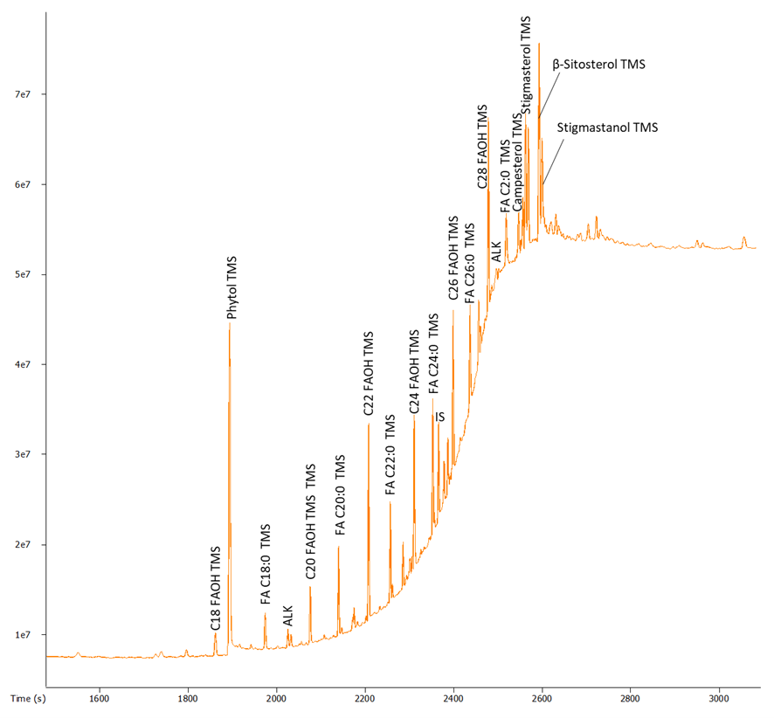
Fig. S1. Partial ion chromatogram of neutral fraction of a sediment in the ZAH A core. FA – fatty acid; FAOH – fatty alcohol; ALK – n-alkane; IS – internal standard (5α-Cholestane); TMS – trimethyl silyl group.
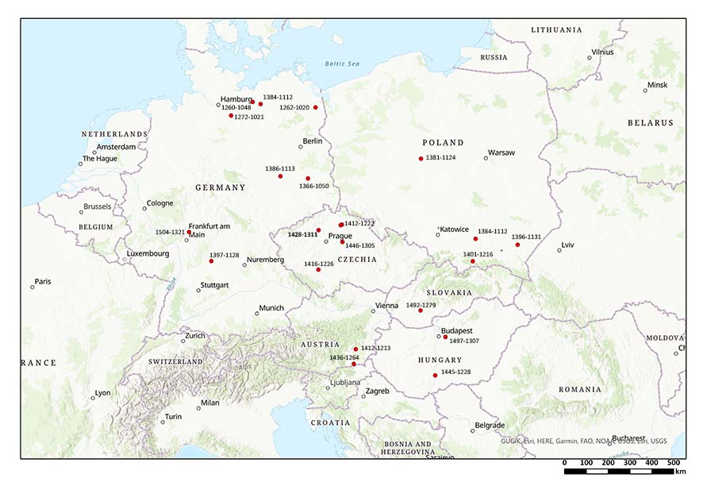
Fig. S2. Spread of the earliest finds of millet in central Europe. All data (after Filipović et al. 2020, modified. with permission of the authors) are in BC, the date for Zahájí is highlighted in red.

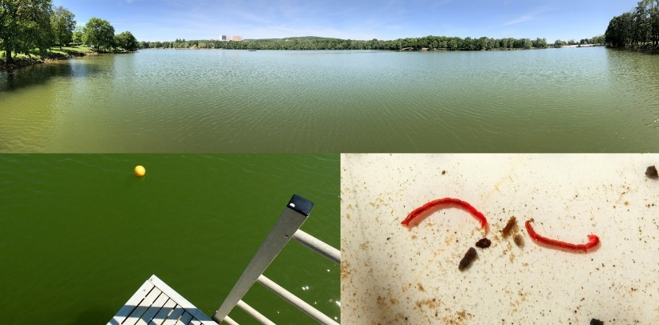
Fig. S3. Top: Kamencové jezero, an artificial lake with uniquely high content of dissociated potassium alum in May 2022. Bottom left: Green water colour of Kamencové jezero. Bottom right: Two chironomid larvae of the genus Chironomus, the dominant insect taxon of the lake bottom. Photos: D. Vondrák.
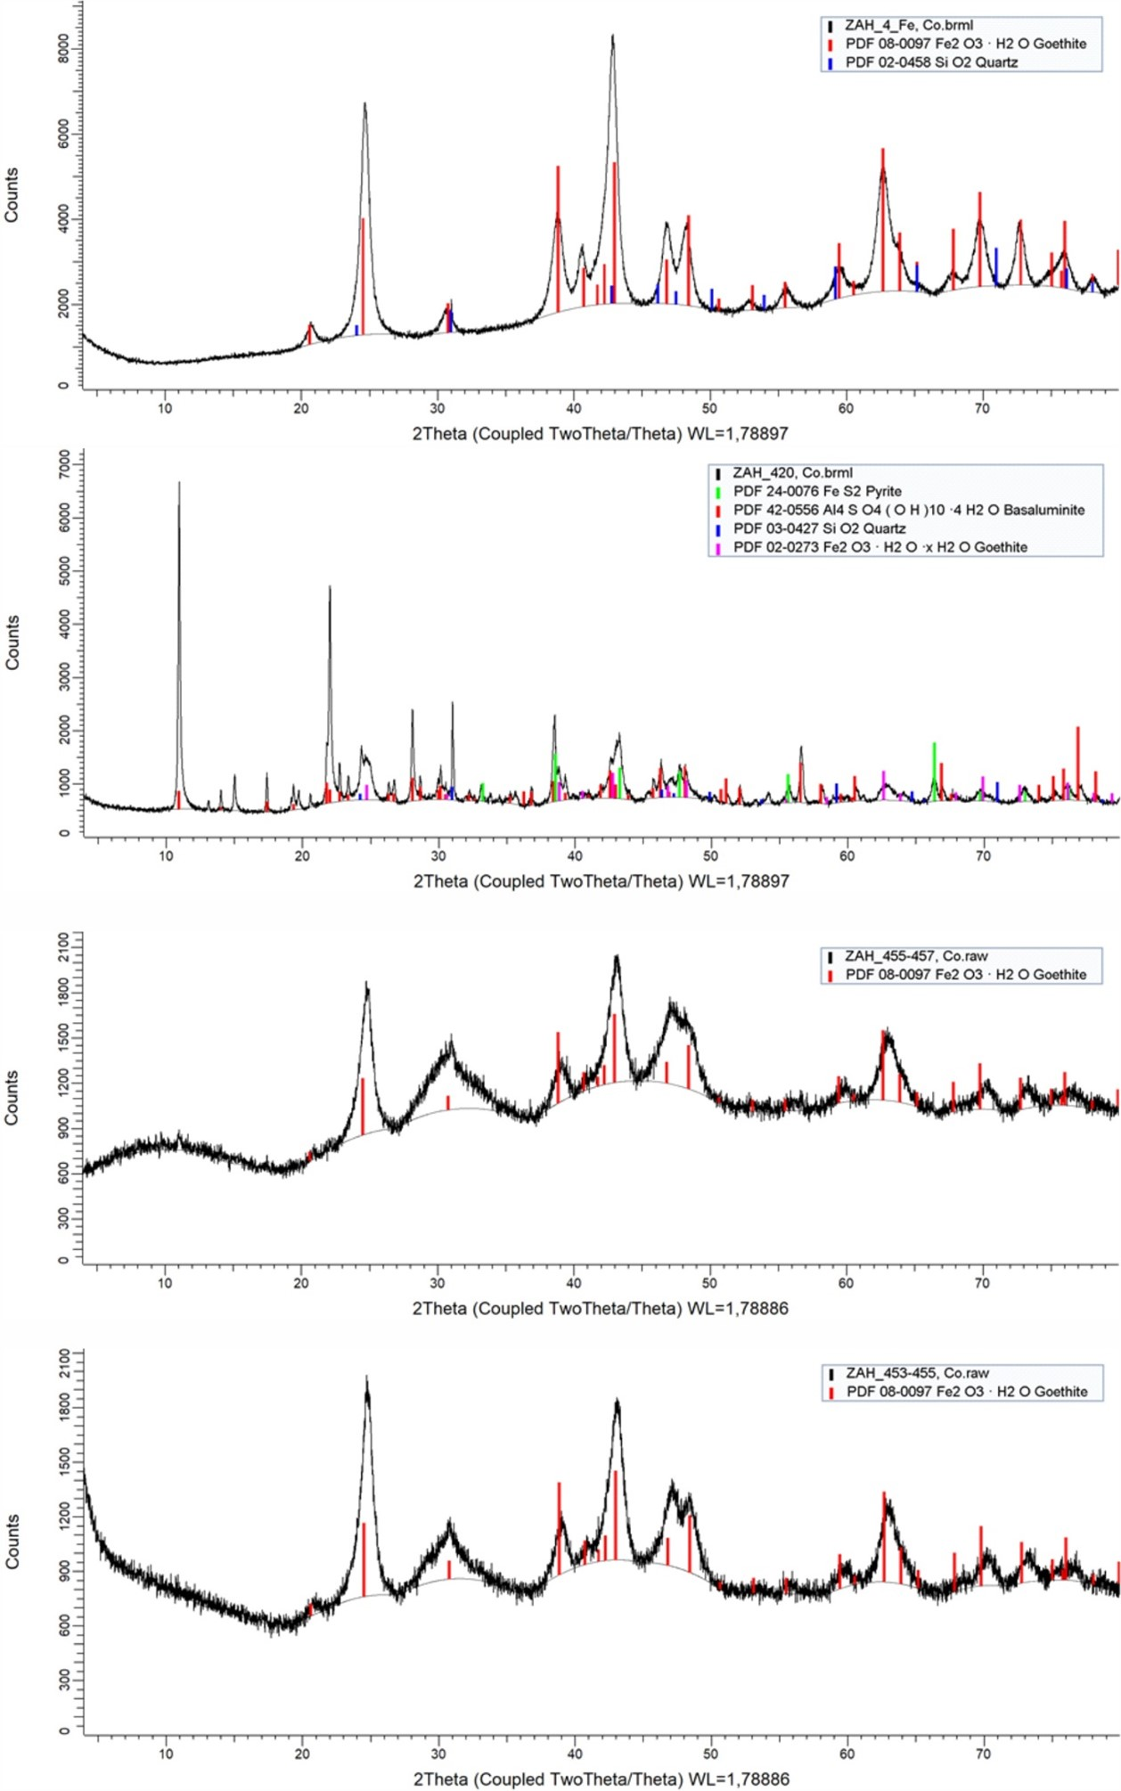
Fig. S4. Powder X-ray diffraction pattern of concretions sampled from core ZH_1 in the interval 410–740cm.
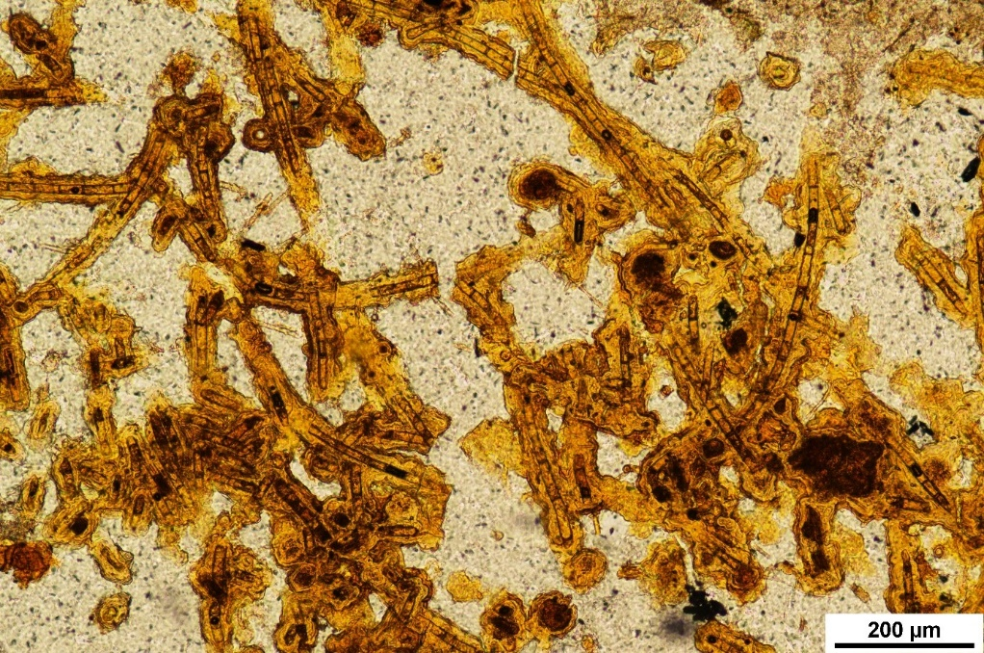
Fig. S5. Thin section showing Fe-hydroxide concretions precipitated around well-preserved filaments of aquatic algae. Photo: J. Hošek.

Supplementary references
Berglund, B.E., Ralska-Jasiewiczowa, M., 2003. The Handbook of Holocene Palaeoecology and Palaeohydrology. Blackburn Press.
Beug, H.J., 2004. Leitfaden der Pollenbestimmung für Mitteleuropaund angrenzende Gebiete. München: Verlag Dr. Friedrich Pfeil.
Bigham, J. M., Nordstrom D. K., 2000. Iron and Aluminum Hydroxysulfates from Acid Sulfate Waters. Reviews in Mineralogy and Geochemistry 40: 351-403. https://doi.org/ 10.2138/rmg.2000.40.7
Brooks, S.J., Langdon, P.G., Heiri, O., 2007. The identification and use of Palaearctic Chironomidae larvae in palaeoecology. Technical guide no. 10. Quaternary Research Association, London.
Carrero, S., Fernandez-Martinez, A., Pérez-López, R., Poulain, A., Salas-Colera, E., Nieto, J. M., 2016. Arsenate and selenate scavenging by basaluminite: insights into the reactivity of aluminum phases in acid mine drainage. Environ Sci Technol 51:28–37.
Espana, S.J., 2003. Acid Mine Drainage in the Iberian Pyrite Belt: An Overview with special emphasis on generation mechanisms, aqueous composition and associated mineral phases. Madrid, Spain: Geological and mining institute of Spain.
Filipović, D., Meadows, J., Corso, M.D. et al. 2020: New AMS ¹⁴C dates track the arrival and spread of broomcorn millet cultivation and agricultural change in prehistoric Europe. Sci Rep 10, 13698 (2020). https://doi.org/10.1038/s41598-020-70495-z
Grimm, E.C., 2011. Tilia Software 1.7.16. Springfield, IL: Illinois State Museum, Research and Collection Center.
Orendt, C., Spies, M. 2012. Chironomus Meigen (Diptera: Chironomidae). Key to the larvae of importance to biological water analysis in Germany and adjacent areas. Leipzig. Reille, M. 1998. Pollen et spores d’Europe et d’Afrique du Nord – supplement 2. Marseille: Laboratoire de Botanique historique et Palynologie.
Reille, M. 1995. Pollen et spores d’Europe et d’Afrique du Nord – supplement 1. Marseille: Laboratoire de Botanique historique et Palynologie.
Reille, M. 1992. Pollen et spores d’Europe et d’Afrique du Nord. Marseille: Laboratoire de Botanique historique et Palynologie.
Szeroczyńska, K., Sarmaja-Korjonen, K., 2007. Atlas of subfossil Cladocera from Central and Northern Europe. Friends of Lower Vistula Society, Świecie.
Tinner, W., Conedera, M., Ammann, B. et al., 2005. Fire ecology north and south of the Alps since the last ice age. The Holocene 15: 1214–1226.

