Supporting Information

Predicting current and future habitats of Adjutants under climate change for implementing strategic conservation measures in South and Southeast Asian landscapes
Imon Abedin^{a,b}, Tanoy Mukherjee^{c}, Hilloljyoti Singhaª, Yunji Go^{d}, Hye-Eun Kang^{e}, Hyun-Woo Kim^{f,g*}, Shantanu Kundu^{h*}
ª Department of Zoology, Bodoland University, Assam 783370, India.
^{b} Elephant Research & Conservation Division, Aaranyak, Assam 781028, India.
^{c} Agricultural and Ecological Research Unit, Indian Statistical Institute, Kolkata 700108, India.
^{d} Industry 4.0 Convergence Bionics Engineering, Pukyong National University, Busan 48513, Republic of Korea.
^{e} Institute of Marine Life Science, Pukyong National University, Busan 48513, Republic of Korea.
^{f} Department of Marine Biology, Pukyong National University, Busan 48513, Republic of Korea.
^{g} Research Center for Marine Integrated Bionics Technology, Pukyong National University, Busan, 48513, Republic of Korea.
^{h} Institute of Fisheries Science, College of Fisheries Sciences, Pukyong National University, Busan 48513, Republic of Korea.

*Corresponding author: kimhw@pknu.ac.kr (H.-W.K), shantanu1984@pknu.ac.kr and shantanu1984@gmail.com (S.K.)

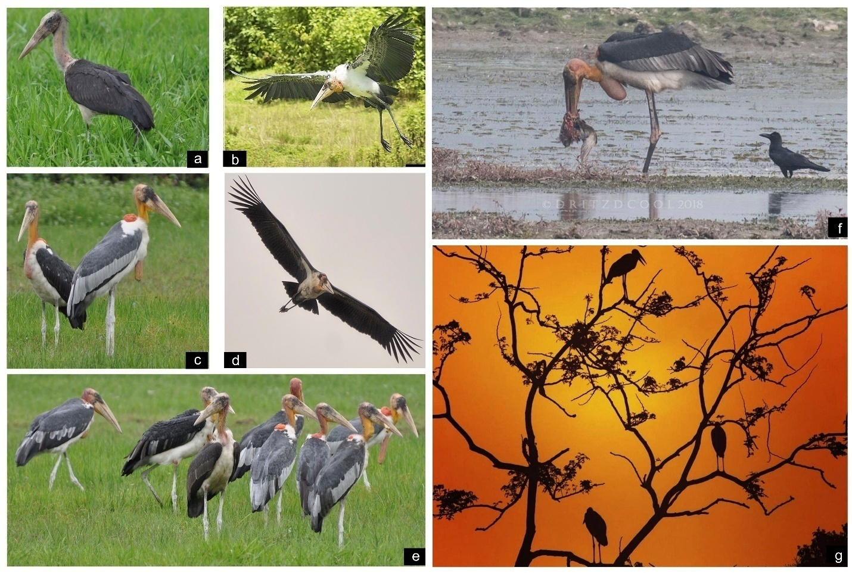
Supplementary Figure S1. Photographic records of Greater Adjutant (GA) from the survey areas: (a) Pobitora Wildlife Sanctuary, (b) Dibru-Saikhowa National Park, (c) Sadiya/Chapakhowa/Santipur, (d) Dholla-Dadumpather Area, (e) Sivasagar, (f) Deepor Beel, and (g) Kaziranga National Park.

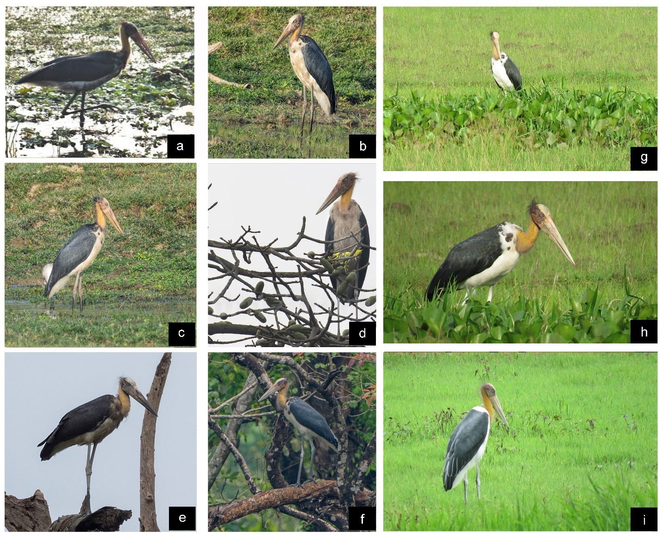
Supplementary Figure S2. Photographic records of Lesser Adjutant (LA) from the survey areas. (a) Dibru-Saikhowa National Park, (b) Pobitora Wildlife Sanctuary (c) Deepor Beel (d) Manas National Park, (e) Kaziranga National Park, (f) Raimona National Park, (g) Dholla/Dadumpather Area, (h) Sadiya/Chapakhowa/Santipur, and (i) Jorhat and Sivasagar

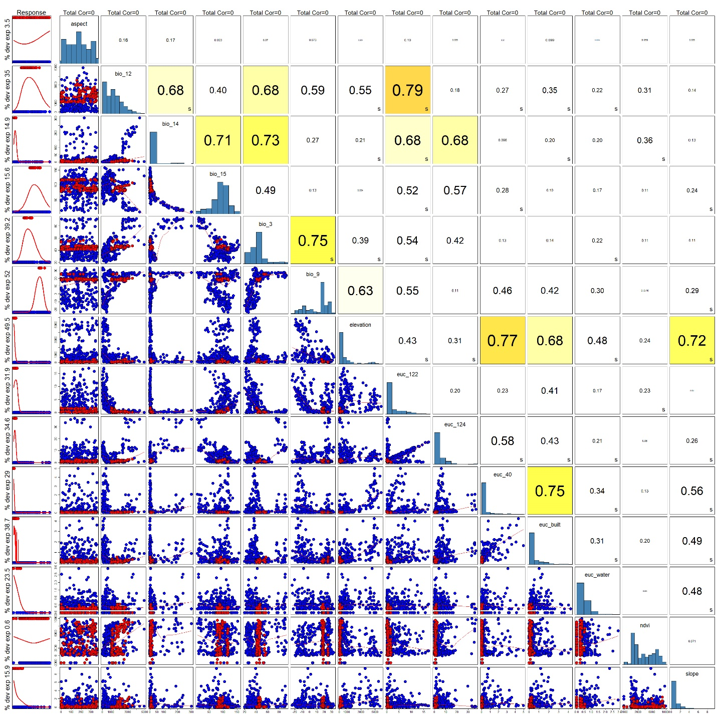
Supplementary Figure S3. Figure showing the correlation between the covariates chosen for final model for GA.

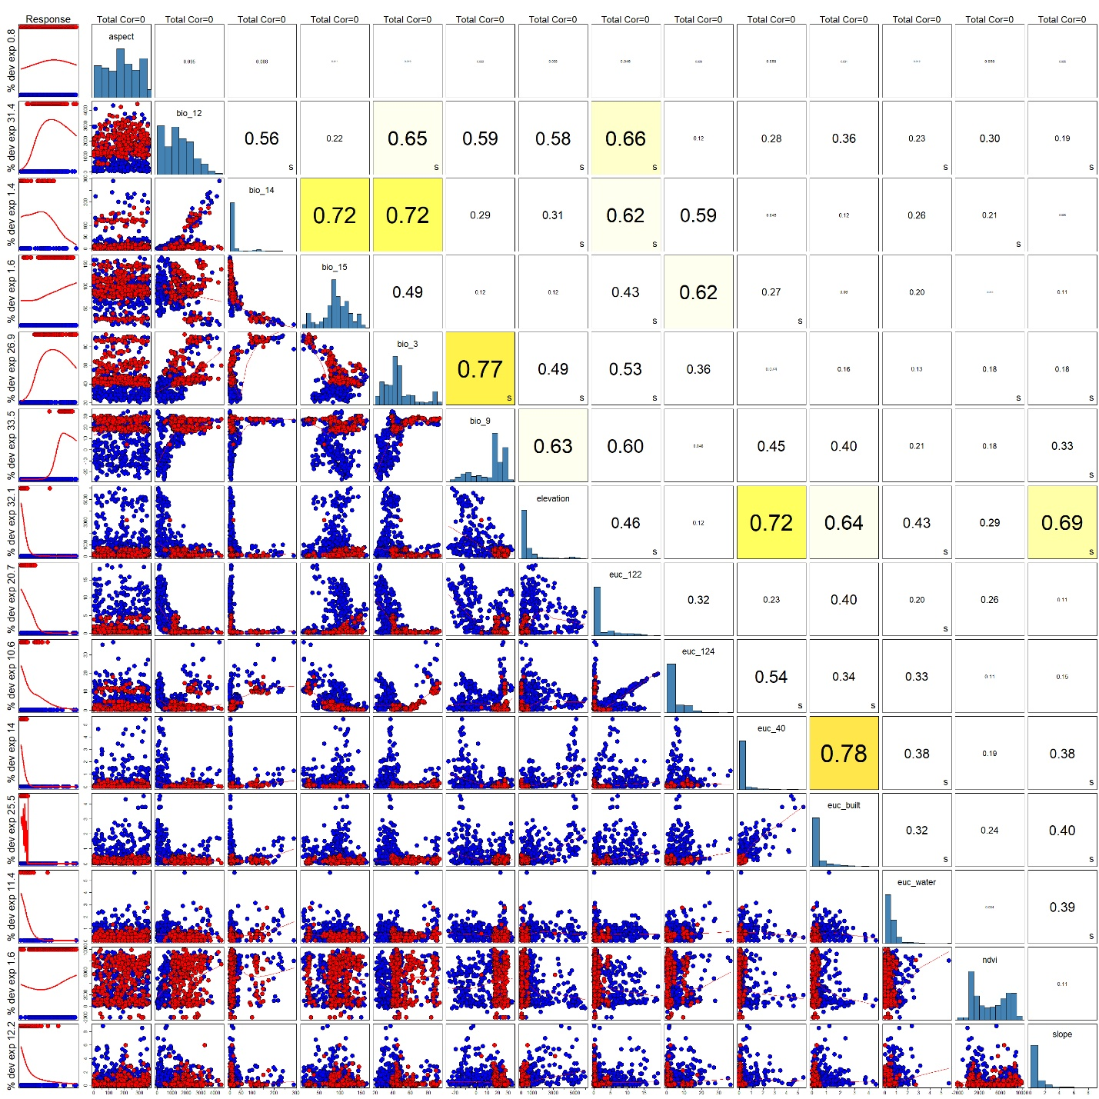
Supplementary Figure S4. Figure showing the correlation between the covariates chosen for final model for LA.

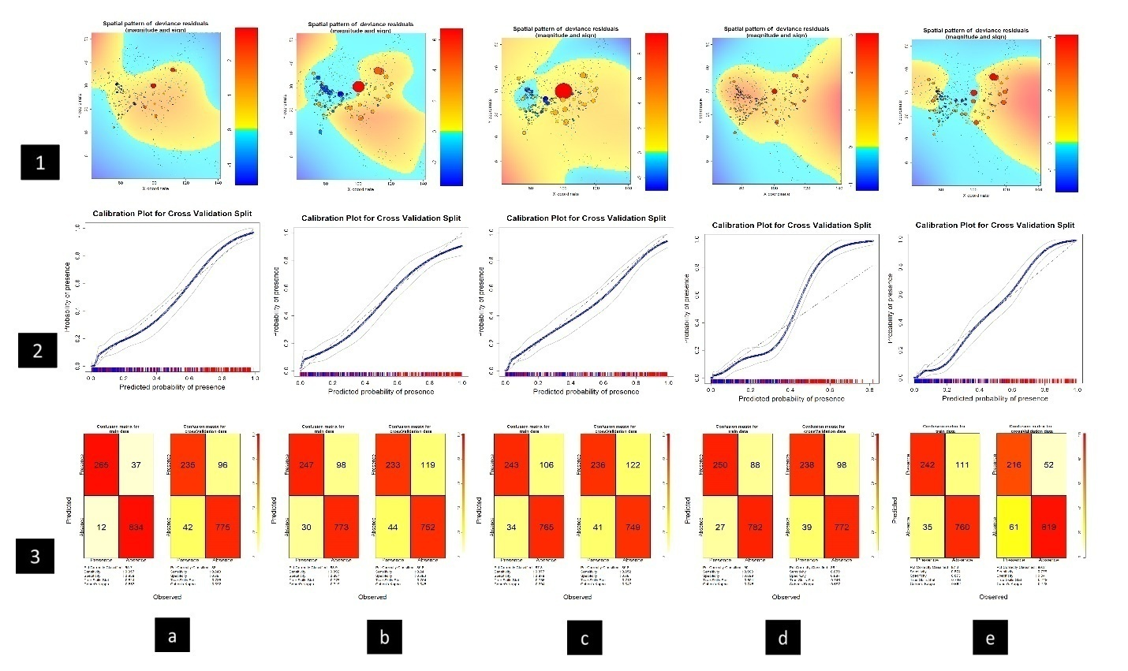
Supplementary Figure S5. Confusion matrixes, Model Calibration plots and Residual plots for GA. Row 1 represents spatial pattern of residuals where colour ramp indicates the magnitude of deviance and size represents the quantity. Row 2 represents model calibration plot across all 5 different model for cross-validation split. Row 3 represents confusion matrix for all 5 models, plotted by observed vs. predicted where colour ramp from lowest value 0% (white) to 100% (red) indicates the quantification of particular pair types. Column a. represents plots for BRT, Column b. represents plots for GLM, Column c. represents plots for MARS, Column d. represents plots for MaxEnt and Column e. represents plots for RF.

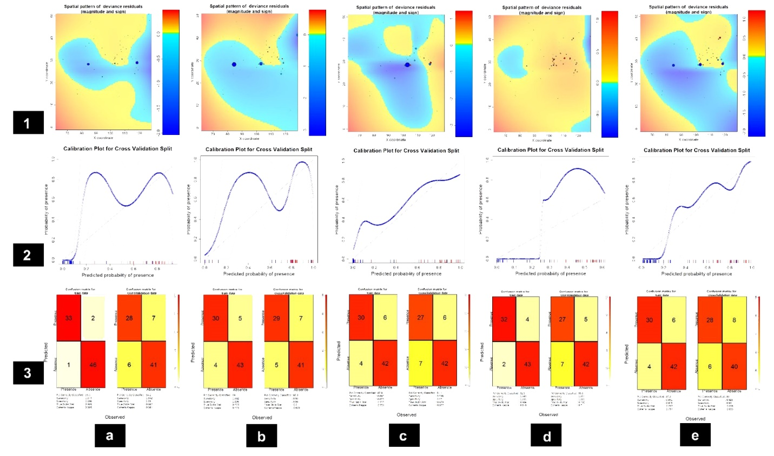
Supplementary Figure S6. Confusion matrixes, Model Calibration plots and Residual plots for LA. Row 1 represents spatial pattern of residuals where colour ramp indicates the magnitude of deviance and size represents the quantity. Row 2 represents model calibration plot across all 5 different model for cross-validation split. Row 3 represents confusion matrix for all 5 models, plotted by observed vs. predicted where colour ramp from lowest value 0% (white) to 100% (red) indicates the quantification of particular pair types. Column a. represents plots for BRT, Column b. represents plots for GLM, Column c. represents plots for MARS, Column d. represents plots for MaxEnt and Column e. represents plots for RF.

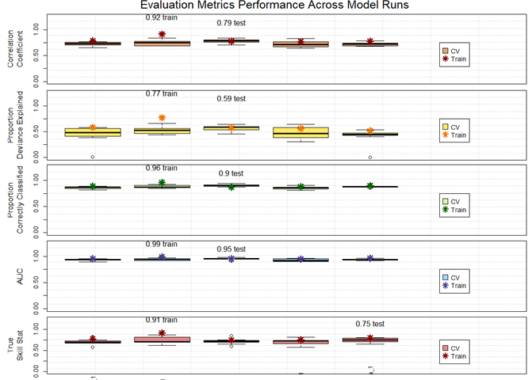
Supplementary Figure S7. Evaluation Matrix performance across model runs for GA. Brown - represents the correlation coefficient among the 5 different models. Yellow - represents the proportion of deviance explained; Green - represents the Proportion of correctly classified; Blue - represents Area under curve (AUC) and Pink - represents true skill statistics.

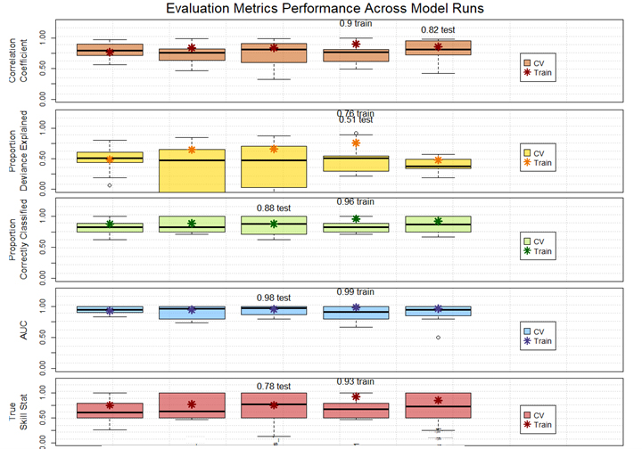
Supplementary Figure S8. Evaluation Matrix performance across model runs for LA. Brown - represents the correlation coefficient among the 5 different models. Yellow - represents the proportion of deviance explained; Green - represents the Proportion of correctly classified; Blue - represents Area under curve (AUC) and Pink - represents true skill statistics.

Supplementary Table S1. Percentage of area change in Km² for both the adjutants (GA and LA) in South and Southeast Asia. The area loss is denoted by ‘-’.
Species | Present (in sq. Km.) | SSP 245 (2041-2060) (in sq. Km.) | % change from Present | SSP 245  (2061-2080) (in sq. Km.) | % change from Present | SSP 585 (2041-2060) (in sq. Km.) | % change from Present | SSP 585 (2061-2080) (in sq. Km.) | % change from Present
GA  (Leptoptilos dubuis) | 38686 | 2475 | -93.60 | 401 | -98.96 | 590 | -98.48 | 270 | -99.30
LA  (Leptoptilos javanicus) | 239490 | 190084.5 | -20.63 | 184500 | -22.96 | 185940 | -22.36 | 171000 | -28.60

