Exploring the Impact of Mechanical Power on Mortality and Phenotypes in ARDS Patients: A Retrospective Analysis
Qi Zhang^{1,2}; Na Liu⁴; Fan Wang⁵; Huiyong Wang^{2,7}; Renshuang Ding^{2,7}; Yan Li^{1,2}; Zhiyong Wang^{1,2}; Yan Li⁶; Mingxing Fang^{1,2,3}
¹Department of Critical Care Medicine, Hebei Medical University Third hospital, Hebei, China.
²Critical Disease Data Analysis and Intelligent Diagnosis and Treatment Engineering Research Center of Hebei Province, Hebei Medical University Third hospital, Hebei, China.
³Department of emergency and internal medicine, The People’s hospital of Tiemenguan, Tiemenguan, China.
⁴Department of emergency, The Fourth hospital of Hebei Medical University, Hebei, China.
⁵School of Public Health，Hebei Medical University, Hebei, China.
⁶Department of Critical Care Medicine, The Second Affiliated Hospital of Xi 'an Medical University, Shanxi Province, China.
⁷School of Information Science and Engineering, Hebei University of Science and Technology,Hebei, China.
* Correspondence:
Mingxing Fang
m18533112886@hebmu.edu.cn

Additional file
Figure S1. The distribution of missing data.
Figure S2. ROC curve and Youden Index for mechanical power and 28-day mortality.
Figure S3. The relationship between SMD and covariates before and after the propensity score matching.
Figure S4. Causal mediation analysis in hospital mortality. A. CMA for PF ratio. B. CMA for arterial PH.
Figure S5. Causal mediation analysis for arterial PH in ICU mortality.
Figure S6. The consensus matrix heat map of consensus cluster analysis illustrates the agreement values for each cluster (k) in patients with ARDS, represented on a white to blue color scale.
Figure S7. The bar plot of consensus cluster analysis.
Figure S8. The PAC values using the predetermined boundary of (0.1, 0.9) as the definition for ambiguously clustered pairs.
Figure S9. Line plot visualization of phenotype characteristics by consensus clustering.
Figure S10. Sensitivity analyses of causal mediation analysis in 28-day mortality. A. CMA for arterial PH. B. CMA for PF ratio.
Figure S11. Sensitivity analyses of causal mediation analysis in hospital mortality. A. CMA for arterial PH. B. CMA for PF ratio.
Figure S12. Sensitivity analyses of causal mediation analysis for arterial PH in ICU mortality.
Table S1. Distribution transformation
Table S2. Characteristics of the three phenotypes.
Abbreviations
Figure S1 The distribution of missing data
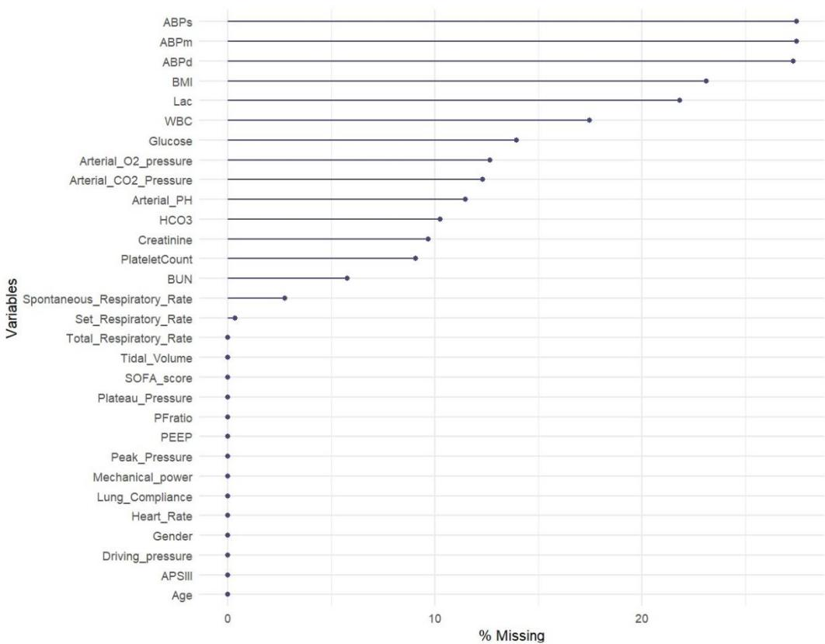

Figure S2. ROC curve and Youden Index for mechanical power and 28-day mortality.

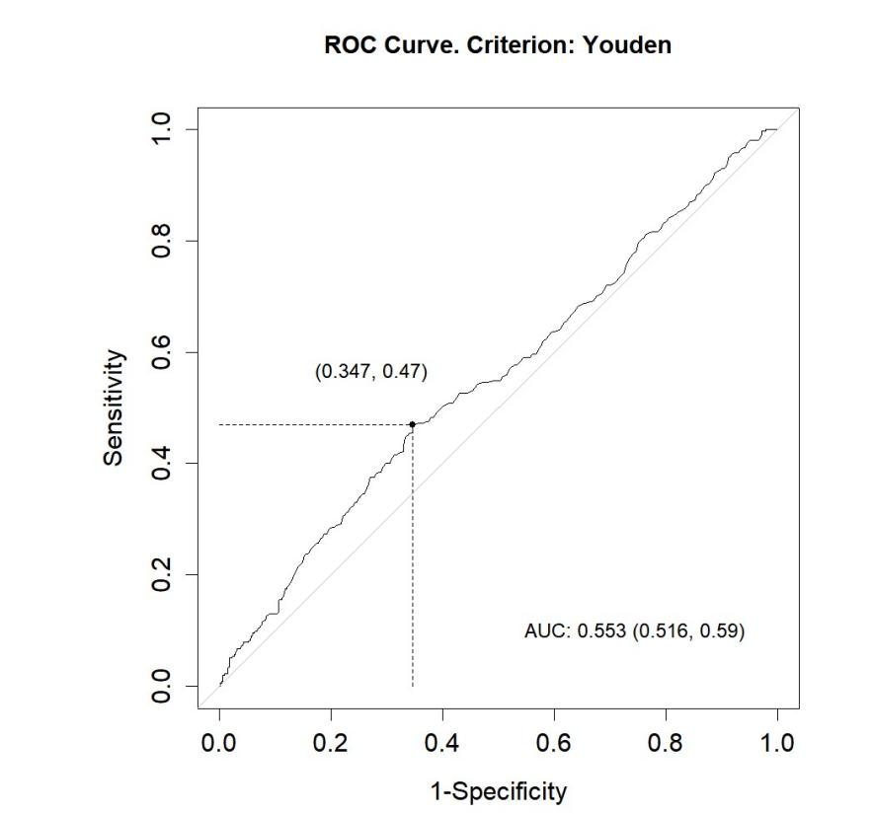
Figure S3. The relationship between SMD and covariates before and after the propensity score matching.

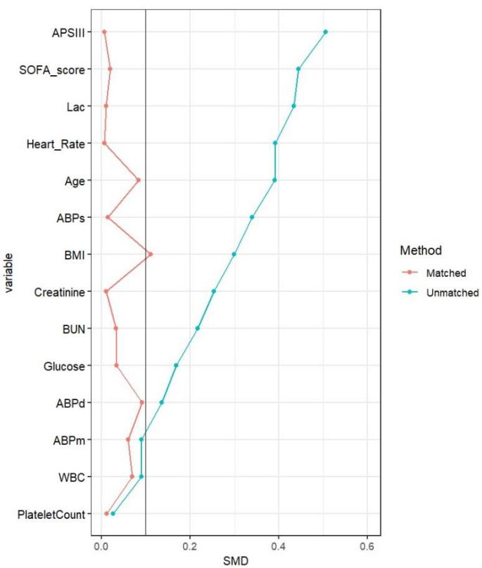
Figure S4. Causal mediation analysis in hospital mortality. A. CMA for PF ratio. B. CMA for arterial PH.
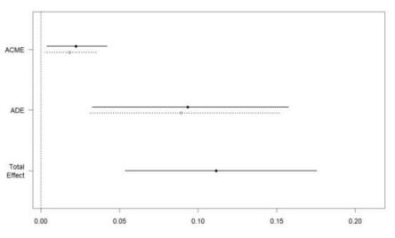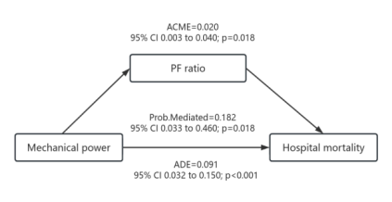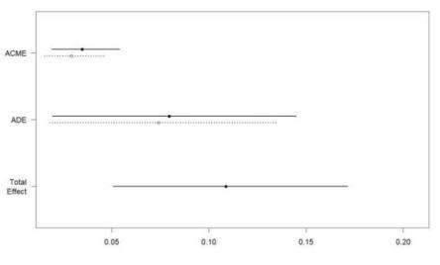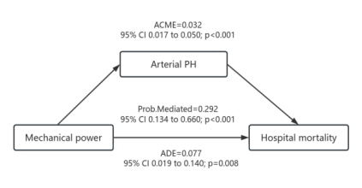
A
B
Figure S5. Causal mediation analysis for arterial PH in ICU mortality.
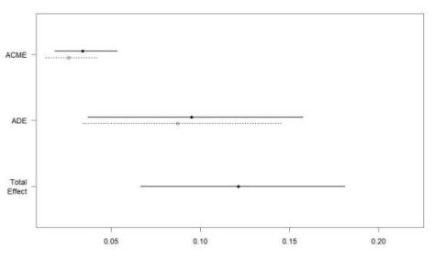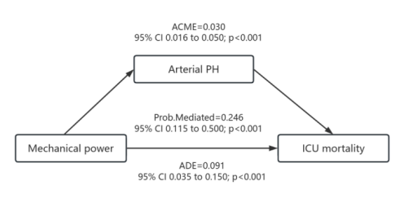
Figure S6. The consensus matrix heat map of consensus cluster analysis illustrates the agreement values for each cluster (k) in patients with ARDS, represented on a white to blue color scale.

Figure S7. The bar plot of consensus cluster analysis.
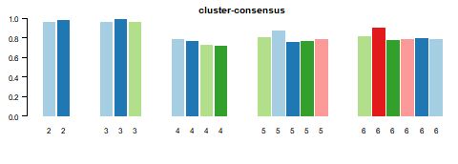
Figure S8. The PAC values using the predetermined boundary of (0.1, 0.9) as the definition for ambiguously clustered pairs.
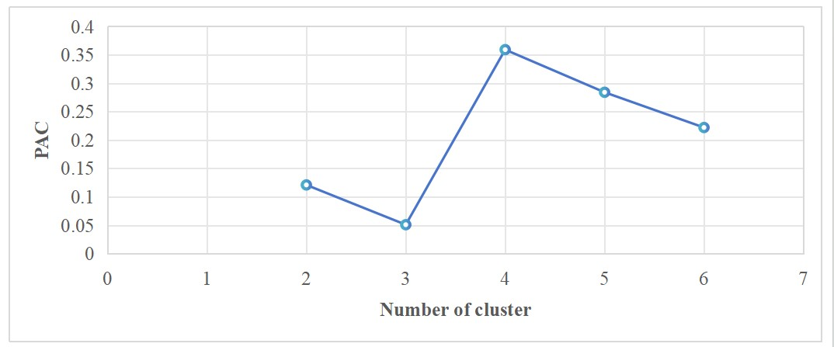

Figure S9. Line plot visualization of phenotype characteristics by consensus clustering.
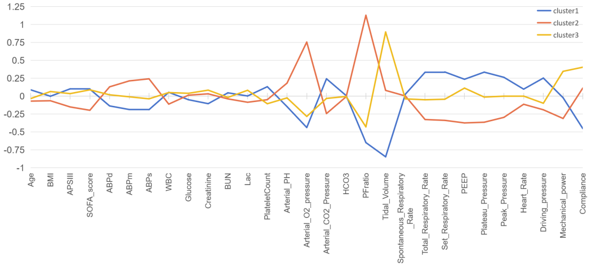

Figure S10. Sensitivity analyses of causal mediation analysis in 28-day mortality. A. CMA for arterial PH. B. CMA for PF ratio.
A
B

Figure S11. Sensitivity analyses of causal mediation analysis in hospital mortality. A. CMA for arterial PH. B. CMA for PF ratio.
A
B

Figure S12. Sensitivity analyses of causal mediation analysis for arterial PH in ICU mortality.
Table S1. Distribution transformation

Variable | Transformation | Variable | Transformation
Age |  | Arterial PH
BMI | log | Arterial O2 pressure
APSIII |  | Arterial CO2 Pressure
SOFA score |  | HCO3
ABPd |  | PFratio
ABPm | log | Tidal Volume
ABPs | log | Spontaneous Respiratory Rate
WBC |  | Total Respiratory Rate
Glucose | log | Set Respiratory Rate
Creatinine | log | PEEP
BUN | log | Plateau Pressure
Lac | log | Peak Pressure
PlateletCount | log | Mechanical power | log
Heart Rate |  | Lung Compliance
Driving pressure

Table S2. Characteristics of the three phenotypes.
 | Overall | Phenotype-I | Phenotype-II | Phenotype-III | P
n | 1333 | 483 | 434 | 416
Demographic characteristics
Age (median [IQR]) | 63.00 [51.80, 73.70] | 65.10 [53.30, 75.75] | 61.85 [50.52, 73.70] | 62.05 [52.50, 70.70] | 0.037
BMI (median [IQR]) | 28.60 [24.90, 33.40] | 28.50 [23.90, 33.50] | 27.90 [24.70, 31.98] | 29.80 [25.78, 34.52] | <0.001
The severity of illness
APSIII (median [IQR]) | 72.00 [53.00, 93.00] | 74.00 [57.00, 96.50] | 68.00 [51.00, 86.75] | 73.50 [53.00, 95.25] | 0.001
SOFA score (median [IQR]) | 7.50 [5.30, 9.90] | 7.90 [5.80, 10.10] | 6.60 [4.80, 9.00] | 7.60 [5.60, 10.40] | <0.001
Vital signs
ABPd (median [IQR]) | 57.90 [54.00, 61.90] | 57.00 [53.70, 60.00] | 58.45 [54.20, 63.00] | 58.00 [54.00, 62.00] | <0.001
ABPm (median [IQR]) | 75.10 [72.00, 79.00] | 74.70 [72.00, 77.00] | 76.00 [72.93, 81.58] | 75.00 [72.07, 79.00] | <0.001
ABPs (median [IQR]) | 111.00 [105.50, 118.00] | 109.40 [104.95, 115.10] | 112.85 [107.00, 122.18] | 110.90 [105.00, 117.00] | <0.001
Heart Rate (median [IQR]) | 87.40 [75.20, 100.20] | 89.80 [76.25, 102.00] | 85.65 [73.93, 96.57] | 87.30 [75.18, 102.20] | 0.01
Laboratory test
WBC (median [IQR]) | 10.70 [8.30, 14.00] | 10.90 [8.70, 14.35] | 10.30 [8.03, 13.10] | 11.10 [8.40, 14.50] | 0.009
Glucose (median [IQR]) | 127.00 [112.00, 152.00] | 123.50 [107.40, 150.25] | 128.00 [114.32, 153.00] | 129.00 [113.07, 153.00] | 0.114
Creatinine (median [IQR]) | 1.10 [0.80, 1.90] | 1.10 [0.70, 1.80] | 1.00 [0.70, 1.80] | 1.20 [0.90, 2.00] | <0.001
BUN (median [IQR]) | 22.00 [15.30, 35.30] | 23.80 [15.60, 36.00] | 21.10 [14.35, 35.38] | 22.80 [16.48, 34.05] | 0.318
Lac (median [IQR]) | 1.90 [1.40, 2.70] | 1.90 [1.40, 2.80] | 1.90 [1.40, 2.50] | 2.00 [1.50, 2.90] | 0.036
PlateletCount (median [IQR]) | 173.00 [112.00, 225.70] | 190.80 [126.05, 236.75] | 168.90 [103.25, 225.28] | 164.75 [111.00, 218.00] | 0.001
Blood gas analysis parameters
Arterial PH (median [IQR]) | 7.40 [7.30, 7.40] | 7.30 [7.30, 7.40] | 7.40 [7.30, 7.40] | 7.40 [7.30, 7.40] | <0.001
PaO2 (median [IQR]) | 110.70 [94.30, 129.20] | 100.00 [87.20, 112.30] | 131.35 [117.00, 148.23] | 104.90 [91.30, 117.53] | <0.001
PaCO2 (median [IQR]) | 39.90 [35.60, 44.10] | 41.20 [37.00, 46.60] | 38.00 [34.62, 42.10] | 39.75 [35.60, 43.50] | <0.001
HCO3 (median [IQR]) | 21.80 [19.00, 24.60] | 21.50 [19.00, 24.75] | 21.75 [19.00, 24.48] | 21.90 [18.50, 24.70] | 0.991
PFratio (median [IQR]) | 197.10 [146.00, 257.00] | 152.60 [124.85, 187.40] | 278.30 [255.75, 305.80] | 174.55 [136.50, 205.35] | <0.001
Respiratory characteristics
Tidal Volume (mean (SD)) | 465.58 (71.98) | 404.69 (48.18) | 471.44 (57.07) | 530.15 (44.78) | <0.001
Spontaneous Respiratory Rate (median [IQR]) | 0.40 [0.00, 3.30] | 0.30 [0.00, 3.05] | 0.40 [0.00, 3.58] | 0.60 [0.00, 3.30] | 0.564
Total Respiratory Rate (median [IQR]) | 21.30 [18.10, 25.00] | 23.00 [19.70, 27.05] | 19.95 [17.30, 22.70] | 21.40 [18.10, 24.50] | <0.001
Set Respiratory Rate (median [IQR]) | 19.80 [16.00, 23.10] | 21.70 [18.00, 25.40] | 18.00 [16.00, 20.80] | 19.55 [16.00, 22.90] | <0.001
PEEP (median [IQR]) | 7.30 [5.00, 9.70] | 8.00 [5.00, 10.00] | 5.00 [5.00, 8.00] | 8.00 [5.00, 10.00] | <0.001
Plateau Pressure (median [IQR]) | 20.50 [17.40, 23.80] | 22.10 [18.55, 26.10] | 19.00 [16.30, 21.70] | 20.50 [17.78, 23.72] | <0.001
Peak Pressure (median [IQR]) | 24.00 [20.50, 27.80] | 25.60 [21.80, 29.50] | 22.40 [19.50, 25.70] | 24.10 [20.70, 27.80] | <0.001
Driving pressure (median [IQR]) | 13.00 [10.80, 15.40] | 14.00 [11.60, 16.40] | 12.30 [10.30, 14.67] | 12.50 [10.45, 15.20] | <0.001
Mechanical power (median [IQR]) | 16.60 [12.60, 22.20] | 16.30 [12.15, 22.30] | 14.40 [11.40, 18.10] | 19.30 [15.07, 24.50] | <0.001
Compliance (median [IQR]) | 35.90 [28.70, 45.20] | 29.40 [24.20, 36.20] | 38.35 [31.22, 46.70] | 41.60 [34.95, 51.60] | <0.001
Outcomes
Mechanical ventilation hour (median [IQR]) | 63.00 [37.20, 111.00] | 74.00 [41.85, 132.95] | 52.20 [34.00, 85.38] | 63.80 [40.00, 112.00] | <0.001
ICU staydays (median [IQR]) | 8.75 [4.98, 14.69] | 9.13 [5.14, 14.70] | 7.81 [4.67, 13.78] | 8.98 [5.21, 15.07] | 0.041
ICU mortality (%) | 276 (20.71) | 127 (26.29) | 71 (16.36) | 78 (18.75) | 0.001
28-day mortality (%) | 315 (23.63) | 141 (29.19) | 89 (20.51) | 85 (20.43) | 0.002
Hospital mortality (%) | 334 (25.06) | 146 (30.23) | 96 (22.12) | 92 (22.12) | 0.005

Abbreviations
MP Mechanical power
ARDS Acute respiratory distress syndrome
PEEP Positive end-expiratory pressure
BMI Body mass index
SOFA score Sequential organ failure assessment
APS-III Acute physiology score-III
ABPs Systolic blood pressure
ABPm Mean arterial pressure
ABPd Diastolic blood pressure
WBC White blood cell
PLT Platelet
BUN Blood urea nitrogen
Lac Lactate level
P/F ratio Oxygenation index on the first day
PaO2 Arterial partial pressure of oxygen
PaCO2 Arterial partial pressure of carbon dioxide
SQL Structured Query Language
Vt Tidal volume
Ppeak Peak airway pressure
RR Total respiratory rate
ΔP Driving pressure
CMA Causal mediation analysis
ADE Average direct effect
ACME Average causal mediation effect
CC Consensus clustering
CM Consistency Matrix
CDF Cumulative Distribution Function
PAC Proportion of ambiguously clustered pairs

