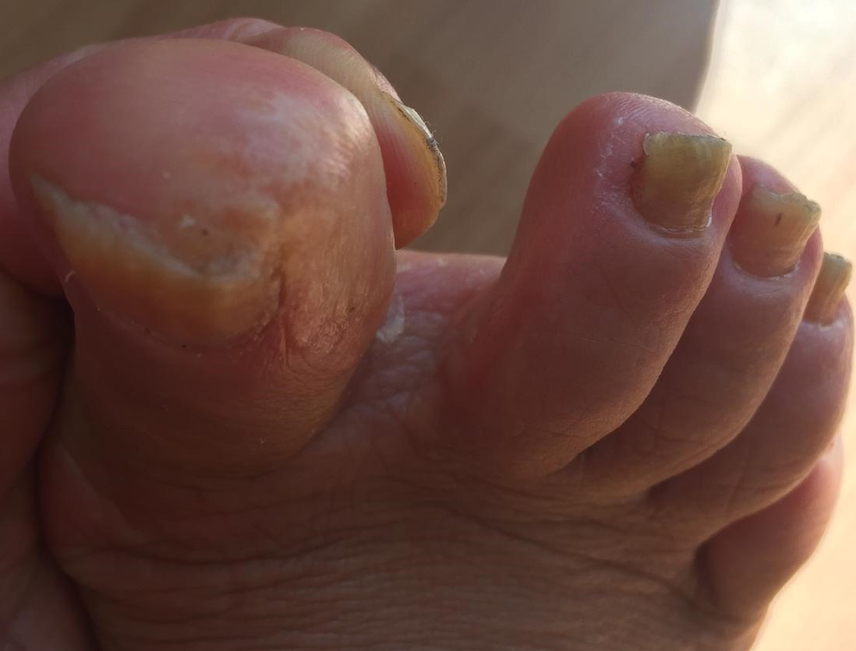
Photograph 1: White macular lesion on Hallux 2 days after symptoms started

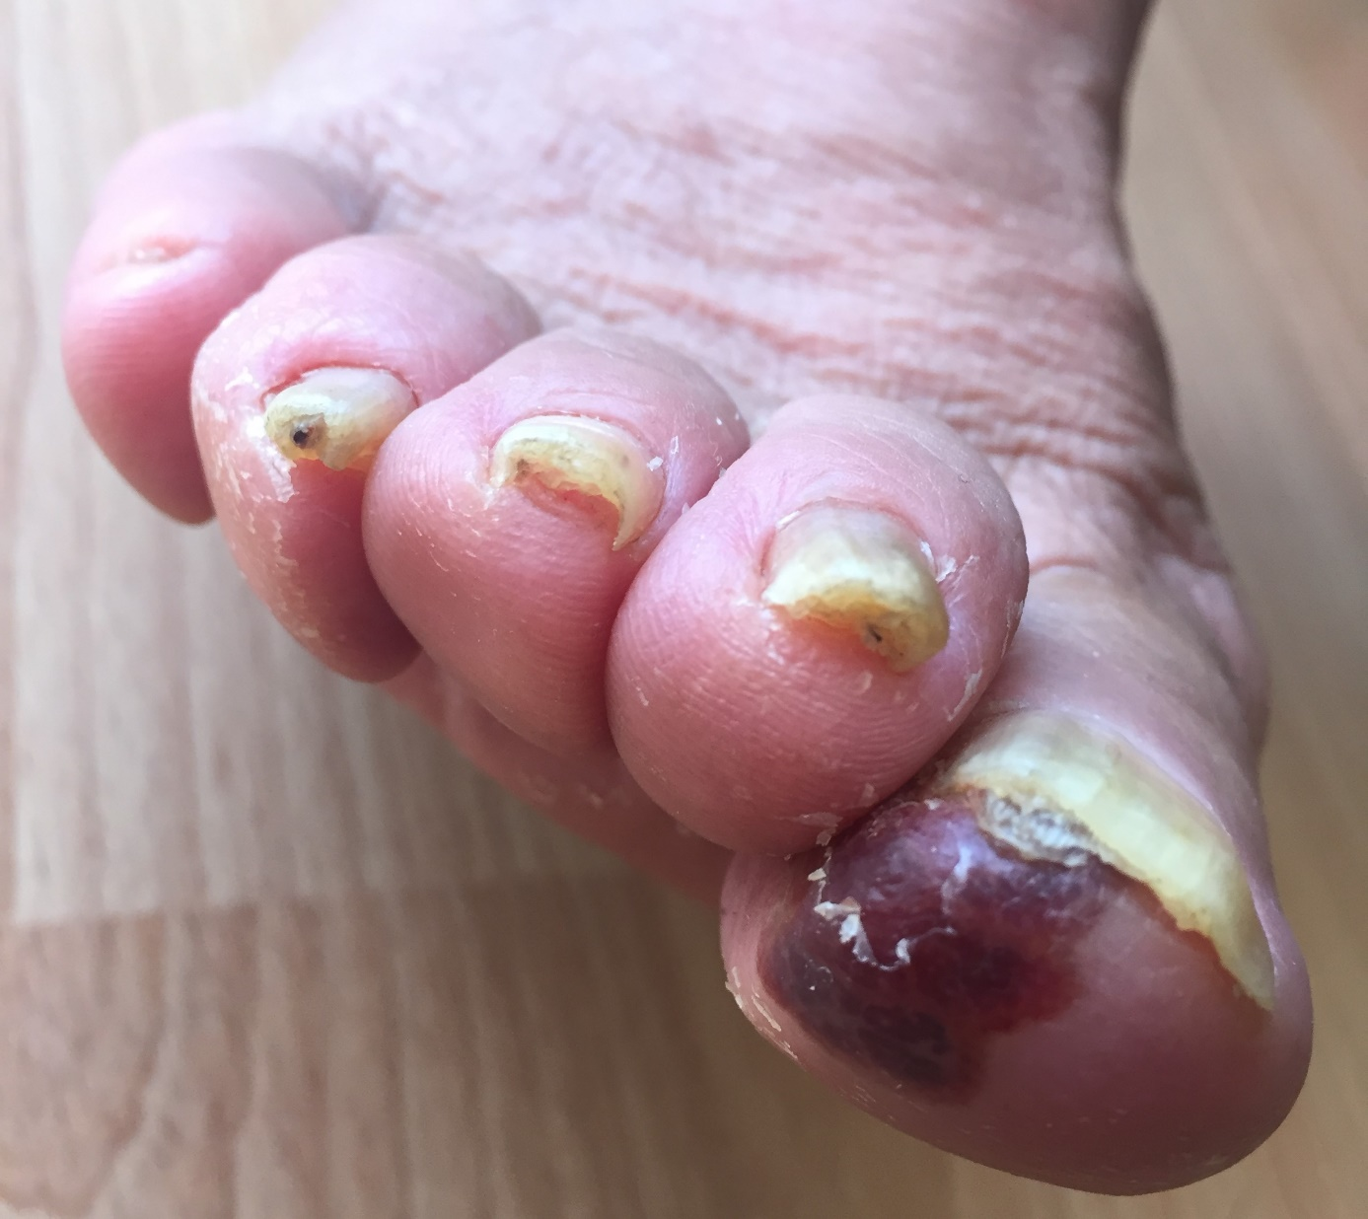
Photograph 2: After 10 days of topical acyclovir treatment-15. Days after symptoms started

