Supplementary Material for ‘Deforestation and human development in the Brazilian tropical dry forest’

Supplementary Table 1. List of potential confounding variables used to perform propensity score matching within a Generalized Linear Model (GLM) in order to evaluate the effect of changing native vegetation cover (treatment) on development indicators.
Confounding variable | Reasoning | source
Municipality area | Area is an important aspect of a municipality, since the large ones can hold more forest and other natural resources that could boom economic activities | (IBGE, 2017)
Percentage of population occupied in agricultural activities | As most Caatinga’s municipalities are considered rural, more people engage in agricultural activities can denote more economic activity in the municipality and hence higher income and low poverty than municipalities with less agricultural activities | (IBGE, 2020)
Percentage municipality population living in urban areas | Higher population in urban centres can indicate a higher share of the municipality's economy from industries and services. Furthermore, this reduces pressure on forest cover from conversion to plantation or pasture, but higher from urban expansion | (IBGE, 2020)
Percentage of producers associated in cooperatives or unions | This is an important aspect of rural economy and can influence municipality economy | (IBGE, 2020)
Percentage of rural properties with springs protected by forests | Affect directly the total amount of forest cover but also the size of legal rural activities | (IBGE, 2020)
Percentage of rural properties with riversides protected by forests | Affect directly the total amount of forest cover but also the size of legal rural activities | (IBGE, 2020)
Percentage or rural properties with irrigation systems | Irrigation systems implicate higher agricultural productivity, but also denotes the purchasing power of producers. It can also affect the size of arable lands | (IBGE, 2020)
Coefficient of rainfall variation | Staple food production and pasture in Caatinga is mostly rainfed. The rainfall variation can indicate places with more or less agricultural production, which in turn can affect the economic activity and total forest cover | (Fick and Hijmans, 2017)
Percentage of rural properties classified as small | Threshold size for being classified as small in Brazil varies according to municipality size. Land structure can affect poverty and inequality in rural places and also forest cover, since large properties are obligated by law to preserve more land to forest protection | (Freitas et al., 2018)
Gross domestic product per capita from agriculture | GDP from agriculture is a direct measure of agricultural activities with implications to forest cover | (IBGE, 2012)
Gross domestic product per capita from industry | GDP from industry is a direct measure of municipality’s industrialization level and can liberate land for forests | (IBGE, 2012)
Gross domestic product per capita from public services | GDP from public services is an indirect measure of urban activity and can denote more urbanized municipalities with more diverse economic matrix; with implications to forest cover | (IBGE, 2012)
Charcoal production | Industry in Caatinga is very dependent on charcoal produced with native trees. Therefore, the production of charcoal can indicate higher economic activity and is also directly related to forest cover | (IBGE, 2019)
Firewood production | Firewood consumption is very common among Caatinga’s inhabitants. Therefore, production of firewood can be related to socio-economic conditions and is also directly related to forest cover | (IBGE, 2019)

Supplementary Table 2. Spatial autocorrelation test of residuals from GLMs models for each outcome evaluated
Model | Moran’s I | p-value
HDI - Education | 0.42 | 0
HDI - Longevity | 0.18 | 0
HDI - Income | 0.18 | 0
Extreme poverty | 0.35 | 0
Gini index | 0.24 | 0
Under five mortality | 0.21 | 0

Supplementary Table 3. Municipalities change from one deforestation stage to another between 1991 and 2010 and the respective vegetation cover change and standard deviations for each group of municipalities.

Deforestation Stage 1991 | Deforestation Stage 2010 | Number of municipalities | % of the total | Vegetation cover change mean (%) | Vegetation cover change SD
Initial | Initial | 432 | 35.79 | -2.65 | 5.38
Initial | Intermediate | 76 | 6.29 | -11.94 | 6.59
Initial | Advanced | 0 | 0
Intermediate | Initial | 58 | 4.80 | 11.00 | 6.04
Intermediate | Intermediate | 330 | 27.34 | -1.96 | 8.09
Intermediate | Advanced | 85 | 7.04 | -14.81 | 7.92
Advanced | Initial | 0 | 0
Advanced | Intermediate | 11 | 0.91 | 12.92 | 8.47
Advanced | Advanced | 215 | 17.81 | -4.09 | 5.66
Total |  | 1207 | 100 | -3.36 | 8.38

Supplementary Table 4. Results of repeated-measures ANOVA comparing the effect of time and deforestation stage on socio-economic outcomes for municipalities in Caatinga Dry Forest based on Type II Wald chi-square tests. Values are chi-square values. * - p-value < 0.1; ** - p-values < 0.05; *** - p-values < 0.001.
Models | Deforestation stage | Time | Def.stage:Time
HDI - Education | 16.48*** | 97185.56*** | 141.23***
HDI - Longevity | 7.00** | 33437.96*** | 49.35***
HDI - income | 15.09*** | 22004.65*** | 77.23***
Extreme poverty | 47.97*** | 13511.73*** | 69.20***
Gini index | 31.09*** | 614.99*** | 8.28*
Under five mortality | 8.41** | 29820.78*** | 46.96***

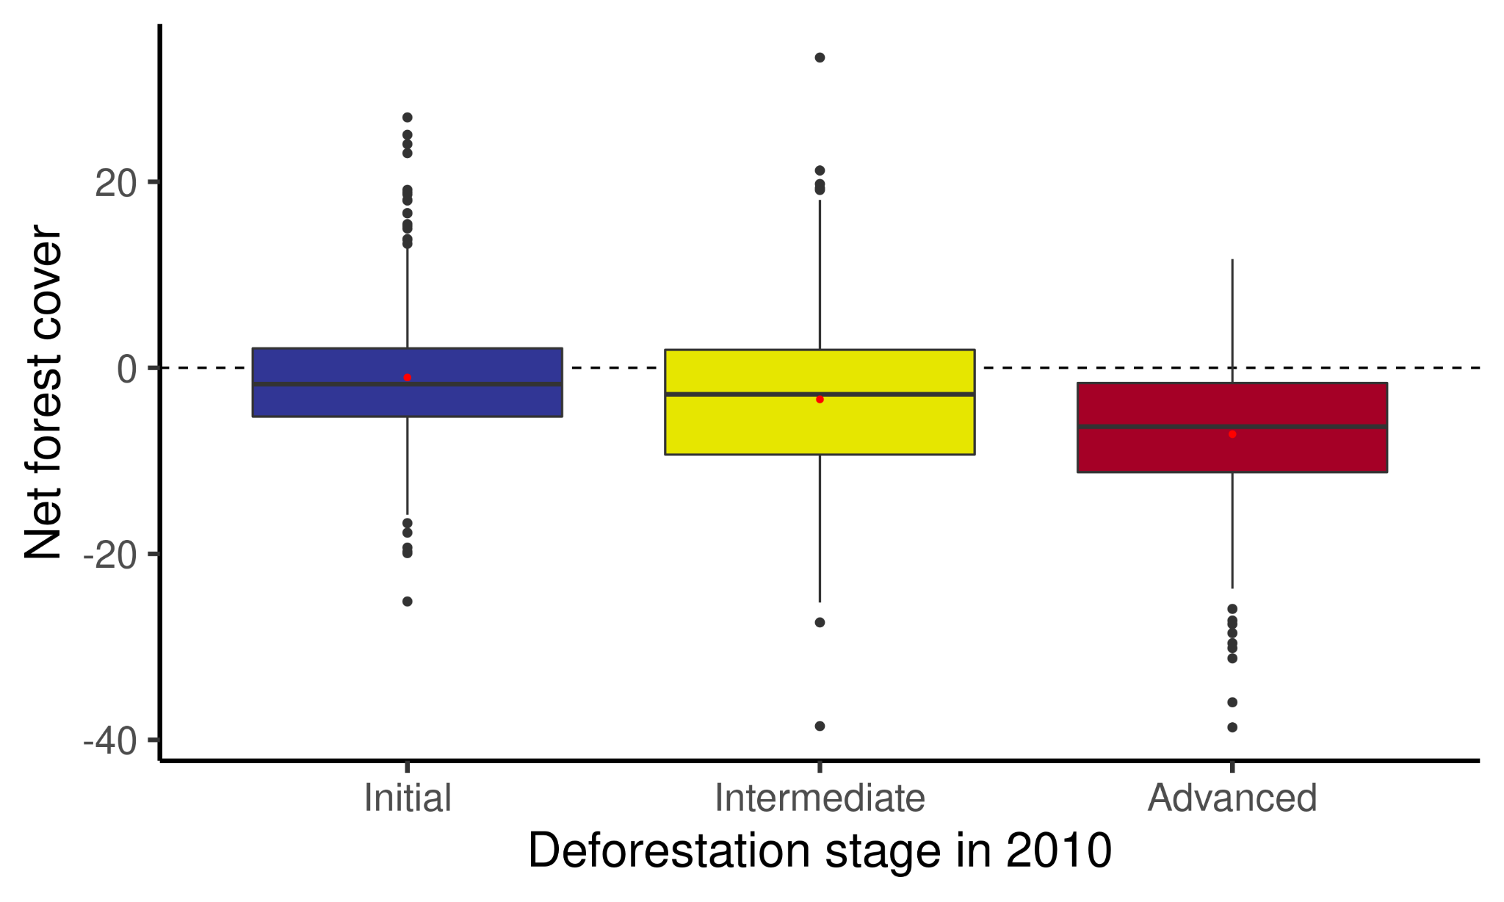
Supplementary Figure 1. Net forest cover change for each municipality from 1991 to 2010, grouped by their respective deforestation stage in 2010. Red dots inside the boxplots are the mean for each group.

Supplementary Table 5. Regression table of covariate balancing generalized propensity score model used to create the weights to reduce the correlation between the treatment (deforestation) and confounding variables.
Variable | Estimate | Standard Error | Z-value | p-value
Municipality area | -4.94 | 2.22 | -2.23 | 0.0257
Percentage of population occupied in agricultural activities | 2.11 | 0.865 | 2.44 | 0.0147
Percentage municipality population living in urban area | 5.45 | 1.13 | 4.83 | 1.38e-06
Percentage of producers associated in cooperatives or unions | -0.696 | 1.03 | -0.675 | 0.5
Percentage of rural properties with springs protected by forests | -1.51 | 1.39 | -1.09 | 0.278
Percentage of rural properties with riversides protected by forests | -3.04 | 1.01 | -3.01 | 0.00257
Percentage or rural properties with irrigation systems | 1.55 | 0.816 | 1.9 | 0.0576
Coefficient of rainfall variation | -17.4 | 1.11 | -15.7 | 0.000
Percentage of rural properties classified as small | 3.46 | 1.05 | 3.3 | 0.00097
Gross domestic product per capita from agriculture | 1.05 | 1.19 | 0.888 | 0.375
Gross domestic product per capita from industry | -0.904 | 1.34 | -0.677 | 0.499
Gross domestic product per capita from public services | 3.72 | 0.927 | 4.01 | 6.04e-05
Charcoal production | -1.47 | 0.86 | -1.71 | 0.088
Firewood production | -1.4 | 1.41 | -0.988 | 0.323

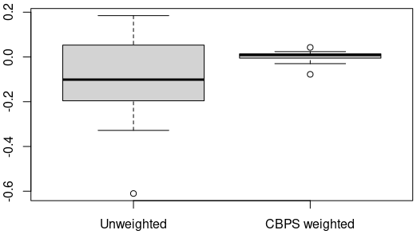
Supplementary Figure 2. Correlation differences between the unweighted model of treatment effect (total deforestation) and a set of 14 confounding variables and after CBPS weighting (covariate balancing propensity score) method. This graph shows a reduction in the absolute Pearson correlation among covariates and the treatment which could otherwise mask or create a false correlation between deforestation and development outcomes

Supplementary Table 6. Regression results of deforestation (def) and its quadratic term (def^2) on human development indicators. Note that this regression is weighted by covariate balancing generalised propensity scores.
Model | Variable | Estimate | Std. Error | t value | p-value
HDI - Education
 | Def | 6.503e-04 | 3.635e-04 | 1.789 | 0.0739
 | Def^2 | -5.590e-06 | 3.959e-06 | -1.412 | 0.1583
HDI - Longevity
 | Def | 4.977e-04 | 1.568e-04 | 3.174 | 0.0015
 | Def^2 | -5.046e-06 | 1.708e-06 | -2.954 | 0.0032
HDI - Income
 | Def | 8.933e-04 | 2.046e-04 | 4.366 | 1.39e-05
 | Def^2 | -7.956e-06 | 2.229e-06 | -3.570 | 0.0003
Extreme poverty
 | Def | -0.2892 | 0.0459 | -6.298 | 4.44e-10
 | Def^2 | 0.0025 | 0.0005 | 5.082 | 4.42e-07
Gini index
 | Def | -1.163e-03 | 2.789e-04 | -4.171 | 3.29e-05
 | Def^2 | 9.884e-06 | 3.038e-06 | 3.254 | 0.0011
Under five mortality
 | Def | -0.1172 | 0.0317 | -3.688 | 0.0002
 | Def^2 | 0.0012 | 0.0003 | 3.477 | 0.0005

Supplementary Table 7. Result of Spearman’s Rho correlation test between model residuals and deforestation.
Model | GLM with propensity score | Spatial model
HDI - Education | -0.229 | -0.026
HDI - Longevity | -0.066 | -0.004
HDI - Income | -0.019 | 0.005
Extreme poverty | -0.033 | -0.010
Gini index | -0.011 | -0.024
Under five mortality | 0.095 | 0.002

Supplementary Table 8. Model averaging of repeated measures ANOVA models with lag deforestation data explaining several development indicators (Dev. indicator). Lag 0 is the 1991, 2000 and 2010 deforestation data, lag 1 is the 1990, 1999 and 2009 deforestation data, and so on until lag 5, which is 1986, 1995 and 2005. This table shows only the best models selected by a cut-off of ΔAICc < 2. The column Years of deforestation data represents the series of years used for that lag period. The weights were recalculated after the selection of best models. HDI - Human Development Index.
Dev. indicator | Lag | Years of deforestation data | ΔAICc | Weight
HDI - Education | 2 | 1989-1998-2008 | 0.00 | 1.00
HDI - Longevity | 4 | 1987-1996-2006 | 0.00 | 1.00
HDI - Income | 0 | 1991-2000-2010 | 0.00 | 0.68
 | 1 | 1990-1999-2009 | 1.48 | 0.32
Extreme poverty | 0 | 1991-2000-2010 | 0.00 | 0.57
 | 1 | 1990-1999-2009 | 0.58 | 0.43
Gini income inequality index | 0 | 1991-2000-2010 | 0.00 | 0.51
 | 1 | 1990-1999-2009 | 1.27 | 0.27
 | 2 | 1989-1998-2008 | 1.75 | 0.21
Under five mortality | 3 | 1988-1997-2007 | 0.00 | 1.00

Supplementary Table 9. Weighted averaged coefficients and Standard Errors of model averaging between a set of repeated measures ANOVA models with lag deforestation data. Lag 0 is the 1991, 2000 and 2010 deforestation data; lag 1 is the 1990, 1999 and 2009 deforestation data; lag 2 is 1989, 1998 and 2008, lag 3 is 1988, 1997 and 2007; lag 4 is 1987, 1996 and 2006; lag 5 is 1986, 1995 and 2005. Lag of def. data column represents the set of lagged deforestation data used in the model averaging to weight the coefficients and Standard Error. Dev. indicator column is the Development indicator analysed; Dev. indicator date is the date of census derived data; x - non-significant; * - p < 0.1; ** - p < 0.05; *** - p < 0.001.
 |  |  | Comparison between years (weighted coefficient, Standard Errors & significance) |  |  |  | Comparison between deforestation stages (weighted coefficient, Standard Errors & significance)
 |  |  | Deforestation stage |  |  |  | Deforestation stage
Dev. indicator | Dev. indicator date | Lag of def. data | Initial | Intermediate | Advance | Dev. indicator date | Initial vs Intermediate | Initial vs Advanced | Intermediate vs Advanced
HDI - Education | 1991 - 2000 | 2 | -0.1352  (0.0020)  *** | -0.1329  (0.0019)  *** | -0.1280  (0.0025)  *** | 1991 | -0.0195  (0.0028)  *** | -0.0220  (0.0037)  *** | -0.0024  (0.0032)  x
 | 2000 - 2010 | 2 | -0.2557  (0.0020)  *** | -0.2407  (0.0020)  *** | -0.2277  (0.0024)  *** | 2000 | -0.0172  (0.0029)  *** | -0.0148  (0.0037)  *** | 0.0023  (0.0032)  x
 | 1991 - 2010 | 2 | -0.3909  (0.0020)  *** | -0.3736  (0.0020)  *** | -0.3558  (0.0025)  *** | 2010 | -0.0022  (0.0028)  x | 0.0131  (0.0035)  *** | 0.0153  (0.0031)  ***
HDI - Longevity | 1991 - 2000 | 4 | -0.0925  (0.0017)  *** | -0.0961  (0.0017)  *** | -0.1038  (0.0023)  *** | 1991 | 0.0099  (0.0022)  *** | 0.0198  (0.0028)  *** | 0.0099  (0.0025)  ***
 | 2000 - 2010 | 4 | -0.0945  (0.0018)  *** | -0.0996  (0.0017)  *** | -0.1026  (0.0022)  *** | 2000 | 0.0063  (0.0023)  x | 0.0085  (0.0028)  * | 0.0022  (0.0025)  x
 | 1991 - 2010 | 4 | -0.1871  (0.0017)  *** | -0.1958  (0.0017)  *** | -0.2065  (0.0022)  *** | 2010 | 0.0012  (0.0023)  x | 0.0004  (0.0028)  x | -0.0007  (0.0024)  x
HDI - Income | 1991 - 2000 | 0 and 1 | -0.0682  (0.0016)  *** | -0.0660  (0.0015)  *** | -0.0539  (0.0021)  *** | 1991 | -0.0120  (0.0023)  *** | -0.0201  (0.0029)  *** | -0.0081  (0.0025)  **
 | 2000 - 2010 | 0 and 1 | -0.0862  (0.0016)  *** | -0.0807  (0.0016)  *** | -0.0775  (0.0020)  *** | 2000 | -0.0099  (0.0023)  *** | -0.0058  (0.0029)  x | 0.0040  (0.0025)  x
 | 1991 - 2010 | 0 and 1 | -0.1544  (0.0016)  *** | -0.1468  (0.0016)  *** | -0.1314  (0.0020)  *** | 2010 | -0.0044  (0.0023)  x | 0.0028  (0.0028)  x | 0.0072  (0.0024)  x
Extreme poverty | 1991 - 2000 | 0 and 1 | 15.9570  (0.4448)  *** | 15.6388  (0.4166)  *** | 11.3321  (0.5714)  *** | 1991 | 4.0809  (0.5840)  *** | 6.7543  (0.7427)  *** | 2.6734  (0.6613)  ***
 | 2000 - 2010 | 0 and 1 | 16.6909  (0.4498)  *** | 15.3064  (0.4334)  *** | 15.9043  (0.5387)  *** | 2000 | 3.7627  (0.5934)  *** | 2.1294  (0.7293)  * | -1.6332  (0.6462)  x
 | 1991 - 2010 | 0 and 1 | 32.6480  (0.4487)  *** | 30.9452  (0.4328)  *** | 27.2365  (0.5538)  *** | 2010 | 2.3782  (0.5932)  *** | 1.3429  (0.6969)  x | -1.0353  (0.6295)  x
Gini income inequality index | 1991 - 2000 | 0, 1 and 2 | -0.0528  (0.0035)  *** | -0.0379  (-0.0379)  *** | -0.0514  (0.0045)  *** | 1991 | 0.0017  (0.0038)  x | 0.0094  (0.0094)  x | 0.0077  (0.0044)  x
 | 2000 - 2010 | 0, 1 and 2 | 0.0455  (0.0036)  *** | 0.0435  (0.0034)  *** | 0.0482  (0.0043)  *** | 2000 | 0.0166  (0.0039)  *** | 0.0109  (0.0045)  x | -0.0057  (0.0043)  x
 | 1991 - 2010 | 0, 1 and 2 | -0.0073  (0.0036)  x | 0.0056  (0.0034)  x | -0.0031  (0.0044)  x | 2010 | 0.0146  (0.0039)  *** | 0.0135  (0.0043)  ** | -0.0011  (0.0042)  x
Under five mortality | 1991 - 2000 | 3 | 36.0017  (0.6566)  *** | 39.4287  (0.6322)  *** | 42.1811  (0.8686)  *** | 1991 | -2.9303  (0.8041)  *** | -7.1391  (0.9869)  *** | -4.2088  (0.9306)  ***
 | 2000 - 2010 | 3 | 29.9545  (0.6785)  *** | 29.4403  (0.6285)  *** | 30.1090  (0.8257)  *** | 2000 | 0.4966  (0.8136)  x | -0.9597  (1.0036)  x | -1.4564  (0.9230)  x
 | 1991 - 2010 | 3 | 65.9562  (0.6649)  *** | 68.8691  (0.6473)  *** | 72.2902  (0.8400)  *** | 2010 | -0.0174  (0.8188)  x | -0.8051  (0.9672)  x | -0.7877  (0.8956)  x
Supplementary Table 10. Number of municipalities (total n = 1207) that change the deforestation stage when comparing the lag 0 deforestation data (years 1991, 2000 and 2010) with lagged deforestation data. Nº of switches includes municipalities that changed to high forested stages through regeneration (e.g. from advanced to intermediate).

year | Lag | nº of municipalities at initial stage | nº of municipalities at intermediate stage | nº of municipalities at advanced stage | Nº of switches | % of municipalities that switched
1991 | 0 | 434 | 512 | 261 | - |  | -
1990 | 1 | 442 | 511 | 254 | 47 |  | 4
1989 | 2 | 465 | 480 | 262 | 90 |  | 7
1988 | 3 | 469 | 478 | 260 | 110 |  | 9
1987 | 4 | 480 | 472 | 255 | 134 |  | 11
1986 | 5 | 494 | 478 | 235 | 160 |  | 13
2000 | 0 | 425 | 502 | 280 | - |  | -
1999 | 1 | 428 | 494 | 285 | 66 |  | 5
1998 | 2 | 426 | 488 | 293 | 96 |  | 8
1997 | 3 | 426 | 514 | 267 | 96 |  | 8
1996 | 4 | 439 | 504 | 264 | 127 |  | 10
1995 | 5 | 442 | 502 | 263 | 137 |  | 11
2010 | 0 | 430 | 449 | 328 | - |  | -
2009 | 1 | 425 | 457 | 325 | 56 |  | 5
2008 | 2 | 421 | 460 | 326 | 77 |  | 6
2007 | 3 | 418 | 484 | 305 | 123 |  | 10
2006 | 4 | 419 | 490 | 298 | 121 |  | 10
2005 | 5 | 425 | 486 | 296 | 125 |  | 10

Supplementary Table 11. Results of model averaging on the effect of lagged deforestation data on several development indicators (Dev. indicator), serving as a sensitivity analysis for our cross-sectional analysis using propensity scores weighting. Bold lines are the models with ΔAICc below 2 that were used to calculate the averaged coefficients (Avg. coef.) and Standard Error (Avg. SE). Weights were recalculated after selecting the models with ΔAICc below 2. As we expected a quadratic relationship between deforestation and development (see main text), we built a linear model including the quadratic term of our predictor variable (deforestation). DEF - single term for total deforestation; DEF² - quadratic term of total deforestation.
Dev. indicator | Year | Lag | ΔAICc | Weight | Variable | Avg. coef. | Avg. SE | p-value
HDI - Education | 2005 | 5 | 0.00 | 1.0
 | 2008 | 2 | 2.21 | 0.00
 | 2009 | 1 | 2.95 | 0.00
 | 2006 | 4 | 3.87 | 0.00
 | 2007 | 3 | 4.85 | 0.00
 | 2010 | 0 | 10.24 | 0.00
 |  |  |  |  | DEF | 6.306e-04 | 3.785e-04 | 0.096
 |  |  |  |  | DEF² | -3.045e-06 | -0.747 | 0.455
HDI - Longevity | 2006 | 4 | 0.00 | 0.39
 | 2007 | 3 | 0.54 | 0.30
 | 2005 | 5 | 1.73 | 0.16
 | 2008 | 2 | 1.96 | 0.15
 | 2009 | 1 | 2.40 | 0.00
 | 2010 | 0 | 3.46 | 0.00
 |  |  |  |  | DEF | 5.734e-04 | 1.663e-04 | 0.0005
 |  |  |  |  | DEF² | -5.511e-06 | 1.776e-06 | 0.0019
HDI - Income | 2008 | 2 | 0.00 | 0.29
 | 2007 | 3 | 0.23 | 0.26
 | 2006 | 4 | 0.44 | 0.23
 | 2009 | 1 | 0.65 | 0.21
 | 2005 | 5 | 2.82 | 0.00
 | 2010 | 0 | 15.40 | 0.00
 |  |  |  |  | DEF | 9.854e-04 | 2.458e-04 | 6.18e-05
 |  |  |  |  | DEF² | -7.696e-06 | 2.742e-06 | 0.0050

Extreme poverty | 2008 | 2 | 0.00 | 0.39
 | 2009 | 1 | 0.77 | 0.27
 | 2006 | 4 | 1.62 | 0.18
 | 2007 | 3 | 1.78 | 0.16
 | 2005 | 5 | 6.18 | 0.00
 | 2010 | 0 | 10.85 | 0.00
 |  |  |  |  | DEF | -0.2595 | 0.0620 | 2.93e-05
 |  |  |  |  | DEF² | 0.0019 | 0.0007 | 0.0067
Gini income inequality index | 2010 | 0 | 0.00 | 1.00
 | 2005 | 5 | 2.33 | 0.00
 | 2006 | 4 | 4.99 | 0.00
 | 2009 | 1 | 6.80 | 0.00
 | 2008 | 2 | 7.25 | 0.00
 | 2007 | 3 | 8.20 | 0.00
 |  |  |  |  | DEF | -1.163e-03 | 2.789e-04 | 3.29e-05
 |  |  |  |  | DEF² | 9.884e-06 | 3.038e-06 | 0.0011
Under five mortality | 2006 | 4 | 0.00 | 0.45
 | 2007 | 3 | 0.51 | 0.35
 | 2005 | 5 | 1.70 | 0.19
 | 2008 | 2 | 2.60 | 0.00
 | 2010 | 0 | 3.06 | 0.00
 | 2009 | 1 | 3.34 | 0.00
 |  |  |  |  | DEF | -0.1316 | 0.0335 | 8.71e-05
 |  |  |  |  | DEF² | 0.0012 | 0.0003 | 0.0003

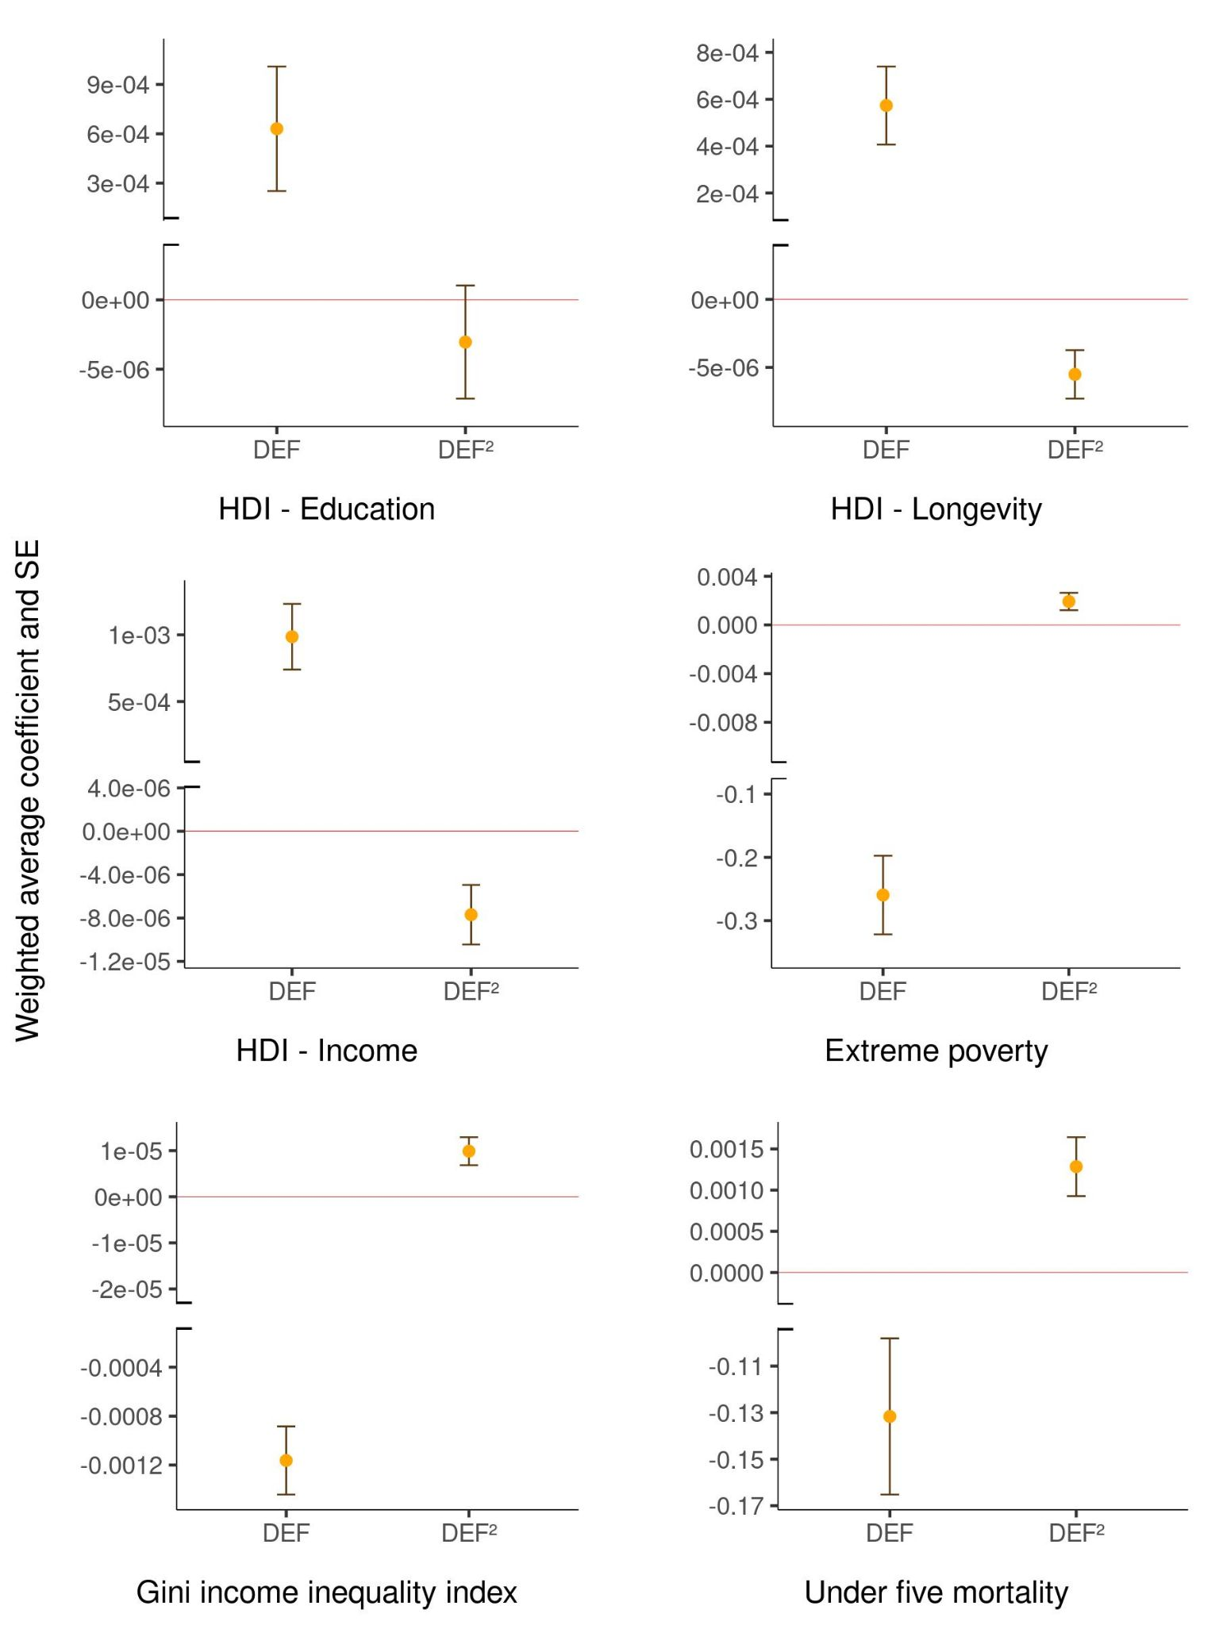
Supplementary Figure 3. Weighted average coefficient and Standard Errors (SE) of models with different lagged deforestation (DEF) and its quadratic term (DEF²) on several development indicators. Lagged deforestation data goes from 0 (year of 2010) to 5 (year of 2005), but only the models with ΔAICc below 2 were included in this figure. Except for the DEF² in HDI (Human Development Index) - Education, all effects were robust to lagged data on deforestation differing from zero.
Supplementary Table 12. Average deforestation rate (1991-2000-2010) by deforestation stage and standard deviation of each group.
Deforestation stage | Mean annual deforestation rate (%) | Standard deviation (%)
Initial | 0.41 | 0.30
Intermediate | 0.83 | 0.47
Advanced | 1.07 | 0.67

