Supplementary Information
Integrated Multi-omics Reveals Different Host Crosstalk of Atopic Dermatitis-Enriched Bifidobacterium longum Strains
Authors: Hoon Je Seong^{1†}, Yoon Mee Park^{2†}, Bong-Soo Kim³, Hyun Ju Yoo⁴, Taeyune Kim⁵, Sun Mi Yoon⁶, Jeong-Hyun Kim⁷, So-Yeon Lee⁸, Yun Kyung Lee⁹, Dong-Woo Lee¹⁰, Myung Hee Nam¹¹, Soo-Jong Hong^{8*}
Affiliations
¹Korean Medicine Data Division, Korea Institute of Oriental Medicine, Daejeon, Korea
²Asan Institute for Life Sciences, University of Ulsan College of Medicine, Seoul, Korea
³Department of Life Science, Hallym University, Chuncheon 24252, Republic of Korea
⁴Department of Convergence Medicine, Asan Institute for Life Sciences, Asan Medical Center, University of Ulsan College of Medicine, Seoul, Korea
⁵Bioinformatics Institute, Macrogen, Inc., Seoul, South Korea
⁶Meta Analysis Team, Macrogen, Inc., Seoul, South Korea
⁷Department of Medicine, University of Ulsan College of Medicine, Seoul, Republic of Korea
⁸Department of Pediatrics, Childhood Asthma Atopy Center, Humidifier Disinfectant Health Center, Asan Medical Center, University of Ulsan College of Medicine, Seoul, South Korea.
⁹Department of Integrated Biomedical Science, Soonchunhyang Institute of Medi-Bioscience, Soonchunhyang University, Cheonan, Republic of Korea;
¹⁰Department of Biotechnology, Yonsei University, Seoul, Republic of Korea
¹¹Seoul Center, Korea Basic Science Institute, Seoul, Republic of Korea;

*Corresponding author. Email: sjhong@amc.seoul.kr
†:authors contributed equally

This file contains:
1. Supplementary Text: Additional text is included regarding human transcriptome analysis.
Co-expressed human transcript module changes in atopic dermatitis
Although the differential gene expression analysis revealed no significant differences between AD and healthy control groups, we aimed to identify distinct host transcript patterns from the perspective of co-expressed modules. For further WGCNA analysis, we selected a soft-threshold parameter, β = 5, to ensure scale-free topology and mean connectivity (Fig. S3). The block-wise cluster dendrogram analysis generated 15 modules, each containing an average of 231.87 transcripts. Upon analyzing differentially co-expressed modules, we identified four modules that were significantly altered between groups. Out of the four modules, three modules (ME3, ME6, and ME9) were highly expressed on AD, and the other ME10 was in the healthy control group. To elucidate the functional implications of these differentially co-expressed modules on atopic dermatitis, we conducted a KEGG pathway enrichment analysis.
The enrichment analysis revealed that although each module was associated with distinct pathways, there was considerable gene overlap across pathways within each module. Nevertheless, ME3, ME6, and ME9, which were increased in the AD group, were commonly associated with neurodegeneration pathways, while ME10 in healthy controls was associated with neuroactive ligand-receptor interactions and several other signaling pathways. ME9 was also associated with immune response pathways, including JAK-STAT, T-cell receptor signaling, and Th1 and Th2 cell differentiation pathways. These findings align with the expression patterns related to Bifidobacterium longum subsp. infantis subtypes described in the main manuscript, indicating a potential involvement of neurological signaling and immune response mechanisms within epithelial cells in the pathogenesis of AD.

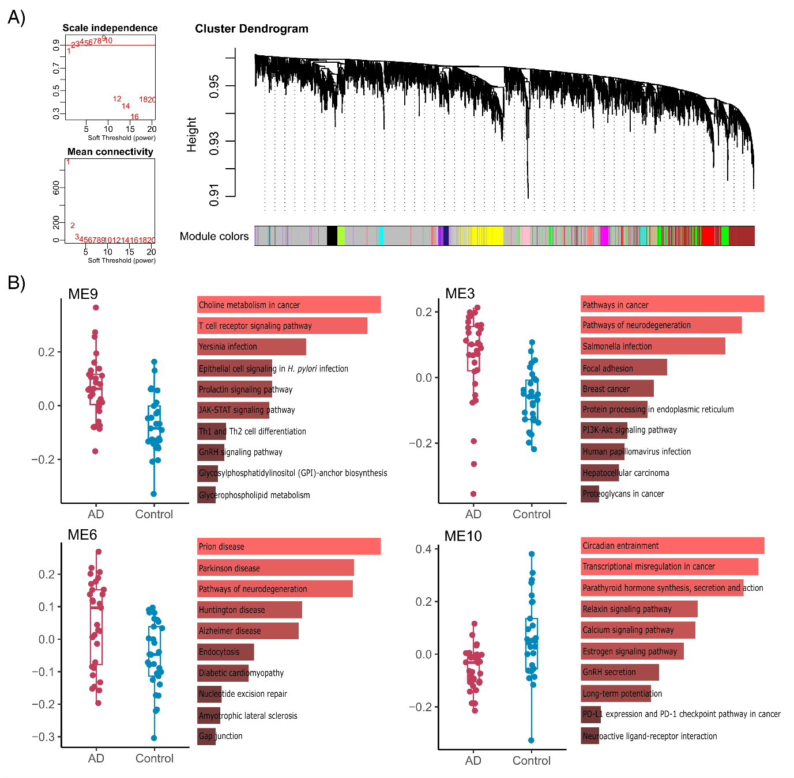
Supplementary Fig. 3. Different co-expressed human transcript modules between AD and healthy controls. A) WGCNA analysis for identifying transcript modules. The transcript module dendrogram was generated based on the scale-free fit index and mean connectivity cut-off. B) Gene modules differentially expressed between AD and healthy controls were assessed using the Wilcoxon rank-sum test (P < 0.05). The top ten enrichment pathways are ranked by P value, with the significance of the pathway annotated at q < 0.05.

