Supporting Information
Identification of Phytomolecules as Isoform and Mutation specific PI3K-α inhibitor for protection against Breast Cancer using e-Pharmacophore modeling and Molecular dynamics simulations.
Authors: Ajay Mili ª, Sumit Birangal ^{b}, Jyothi Giridhar ^{b}, Krishnadas Nandakumar ^{c}, Richard Lobo ^{a,} *
ªDepartment of Pharmacognosy, Manipal College of Pharmaceutical Sciences, Manipal Academy of Higher Education, Manipal, Karnataka-576104, India.
^{b}Department of Pharmaceutical Chemistry, Manipal College of Pharmaceutical Sciences, Manipal Academy of Higher Education, Manipal, Karnataka-576104, India.
^{c}Department of Pharmacology, Manipal College of Pharmaceutical Sciences, Manipal Academy of Higher Education, Manipal, Karnataka-576104, India.

* Corresponding author
Dr. Richard Lobo
Email id: richard.lobo@manipal.edu
Contact no: +91-9448104090

Table of Contents
Page no | Information
S3 | Table S1: Active set
S4-S11 | Table S2: 2D interaction image of Ligand and 25 selected Compounds
S12-S17 | Table S3: IFD score and 3D interaction image of the 25 selected Compounds
S18 | Figure S1: Cross-correlation of the Complexes.

Table no S1: Actives Set
Sl no | PubChem ID | Smiles | Ki (nM)
 | 58204997 | C[C@@H](C(N)=O)OC(C=C1)=CC2=C1C3=NC(C4=NC=NN4C(C)C)=CN3CCO2 | 0.346
 | 58205016 | C[C@@H](C(N)=O)OC(C=C1)=CC2=C1C3=NC(C4=NC=NN4CC(F)(F)F)=CN3CCO2 | 0.188
 | 168297753 | C[C@@H](C(N)=O)OC(C=C1)=CC2=C1C3=NC(C4=NC(CO)=NN4CC(F)(F)F)=CN3CCO2 | 0.062
 | 168297494 | NC([C@H](CCC1)N1C(C=C2)=CC3=C2C4=NC(C5=NC(N)=NN5C(C)C)=CN4CCO3)=O | 0.026
 | 168282983 | CC1(C(=O)NC(=O)N1c2cn3c(n2)-c4ccc(cc4OCC3)N5CCC[C@H]5C(=O)N)C | 0.681
 | 168272875 | NC([C@H](CCC1)N1C(C=C2)=CC3=C2C4=NC(N5CCCOCC5=O)=CN4CCO3)=O | 0.32
 | 165430683 | NC([C@H](CCC1)N1C(C=C2)=CC3=C2C4=NC(N5[C@H](C(C)C)COC5=O)=CN4CCO3)=O | 0.042
 | 124169471 | NC([C@H](CCC1)N1C(C=C2)=CC3=C2C4=NC(N5[C@H](C(F)(F)F)COC5=O)=CN4CCO3)=O | 0.15
 | 124169052 | c1cc-2c(cc1N3CCC[C@H]3C(=O)N)OCCn4c2nc(c4)N5[C@@H](COC5=O)C(F)F | 0.053
 | 124169085 | c1cc-2c(cc1N3CCC[C@H]3C(=O)N)OCCn4c2nc(c4)N5[C@@H](COC5=O)CF | 0.043
 | 168274763 | O=C1OC[C@@H](C(F)(F)F)N1C2=CN(CCOC3=C4C=CC(N5[C@H](C(N)=O)[C@H](OC)CC5)=C3)C4=N2 | 0.097
 | 168295138 | O=C1OC[C@@H](C(F)(F)F)N1C2=CN(CCOC3=C4C=CC(N[C@H](C(N)=O)C)=C3)C4=N2 | 0.095
 | 165430682 | O=C1OC[C@@H](C(F)(F)F)N1C2=CN(CCOC3=C4C=CC(N[C@H](C(N)=O)C5CC5)=C3)C4=N2 | 0.1
 | 124173720 | O=C1OC[C@@H](C(F)([H])F)N1C2=CN(CCOC3=C4C=CC(N[C@H](C(N)=O)C)=C3)C4=N2 | 0.034
 | 124173719 | O=C1OC[C@@H](C(F)([H])F)N1C2=CN(CCOC3=C4C=CC(N[C@H](C(N)=O)C5CC5)=C3)C4=N2 | 0.06

Table no S2: 2D interaction image of Ligand and 25 selected Compounds
Sl no | Compound id | 2D interaction image | Interaction with protein
 | Inavolisib | 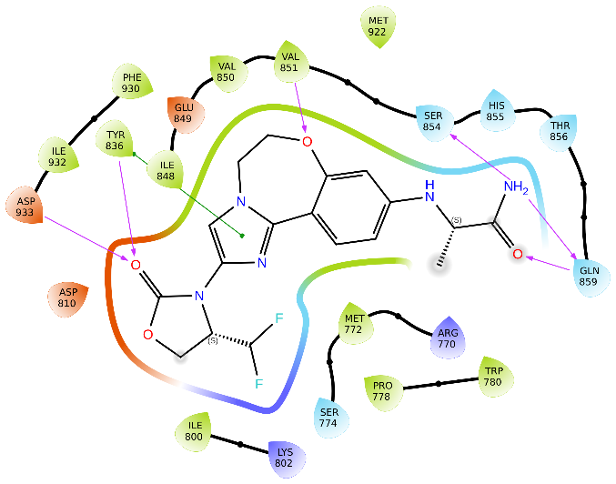 | H-bond: TYR836, VAL851, GLN859 & ASP933.  π-π stacking: TRP780 & TYR836.
 | STOCK1N-113116 | 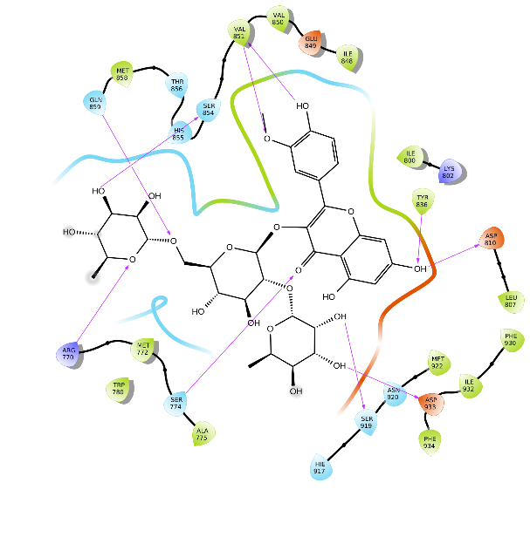 | H-bond: ARG770, SER774, ASP810, TYR836, VAL851, SER854, GLN859, SER919 & ASP933.
 | STOCK1N-81073 | 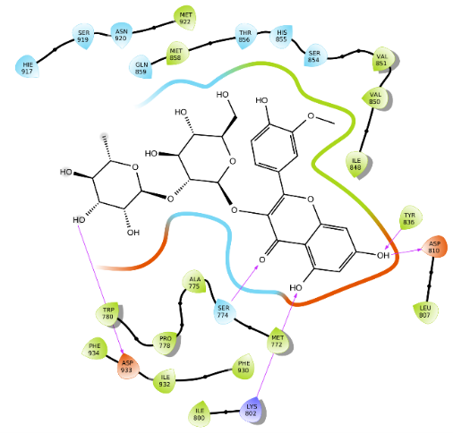 | H-bond: SER774, LYS802, ASP810, TYR836 & ASP933.
 | STOCK1N-51145 | 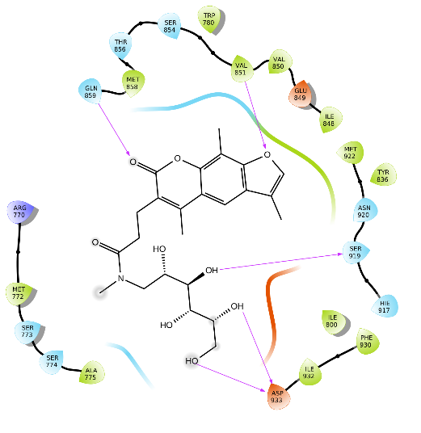 | H-bond: VAL851, GLN859, SER919 & ASP933.
 | STOCK1N-59405 | 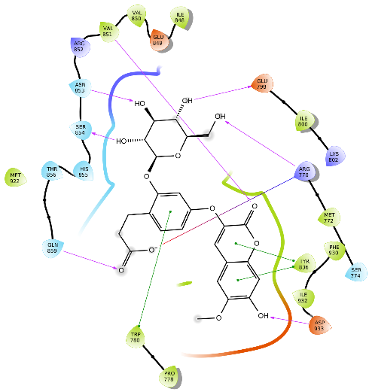 | H-bond: ARG770, TRP780, GLU798, VAL851, ASN853, SER854, GLN859 & ASP933.  Salt bridge: ARG770.  π-π stacking: TRP780 & TYR836.
 | STOCK1N-84648 | 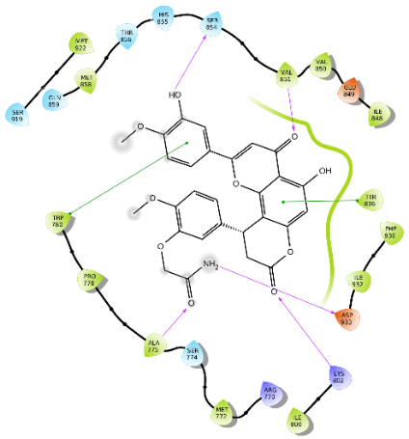 | H-bond: ALA775, LYS802, VAL851, SER854 & ASP933.  π-π stacking: TRP780 & TYP836.
 | STOCK1N-46158 | 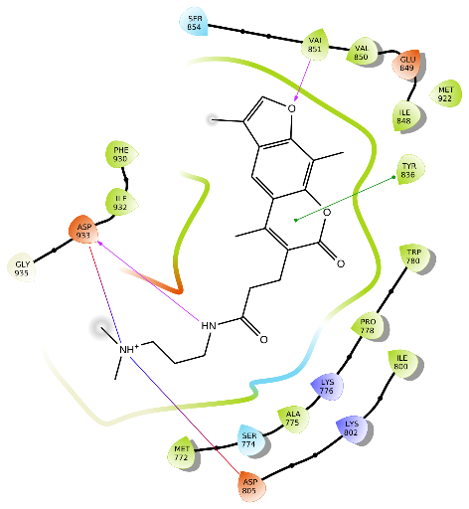 | H-bond: VAL851 & ASP933  Salt bridge: ASP805 & ASP933.  π-π stacking: TYR836
 | STOCK1N-85097 | 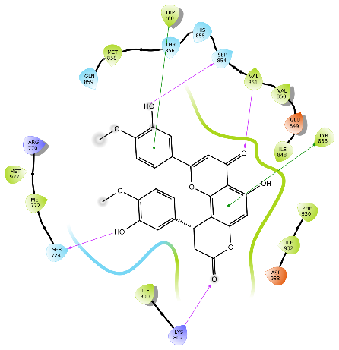 | H-bond: SER774, LYS802, VAL851 & SER854.  π-π stacking: TRP780 & TYR836.
 | STOCK1N-84443 | 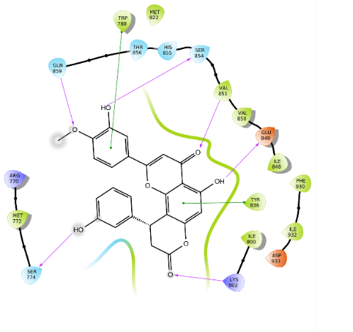 | H-bond: SER774, LYS802, GLU849, VAL851, SER854 & GLN859.  π-π stacking: TRP780 & TYR836.
 | STOCK1N-64228 | 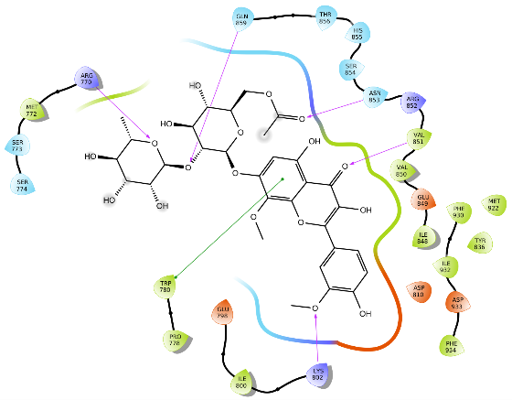 | H-bond: ARG770, VAL851, ASN853, GLN859 & LYS802.  π-π stacking: TRP780.
 | STOCK1N-84098 | 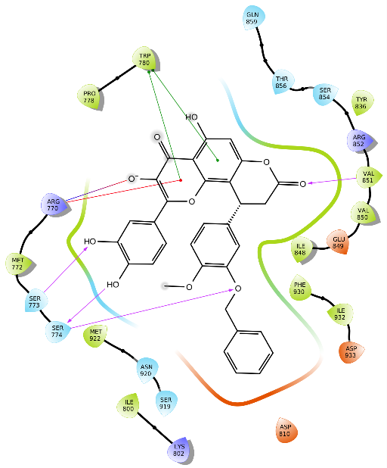 | H-bond: SER773, SER774 & VAL851  Salt bridge: ARG770  π-cation stacking: ARG770
 | STOCK1N-85873 | 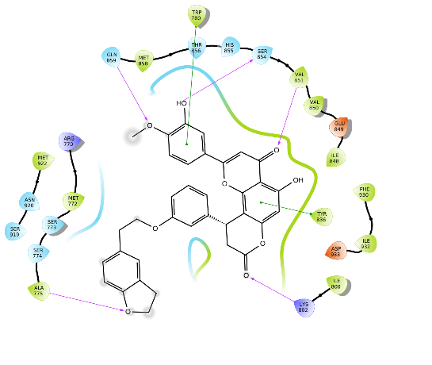 | H-bond: ALA775, LYS802, VAL851, SER854 & GLN859.  π-π stacking: TRP780 & TYR836.
 | STOCK1N-92951 | 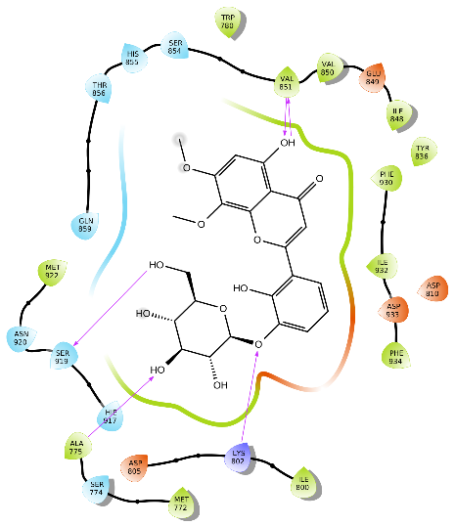 | H-bond: ALA775, LYS802, VAL851 & SER919.
 | STOCK1N-92949 | 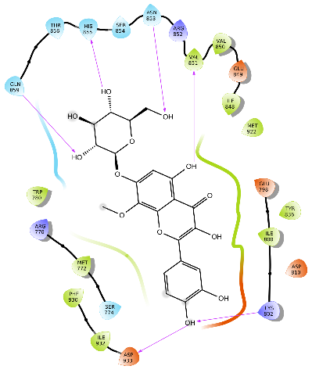 | H-bond: LYS802, VAL851, ASN853, HIS855, GLN859 & ASP933.
 | STOCK1N-40367 | 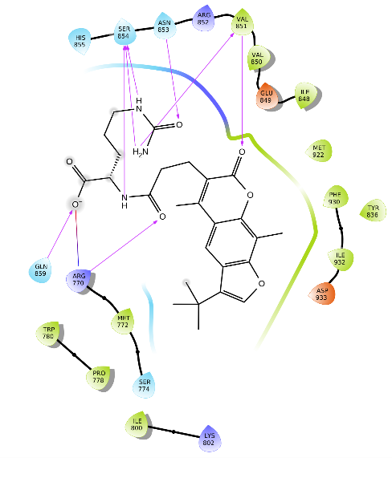 | H-bond: ARG770, VAL851, ASN853, SER854 & GLN859.  Salt bridge: ARG770
 | STOCK1N-85433 | 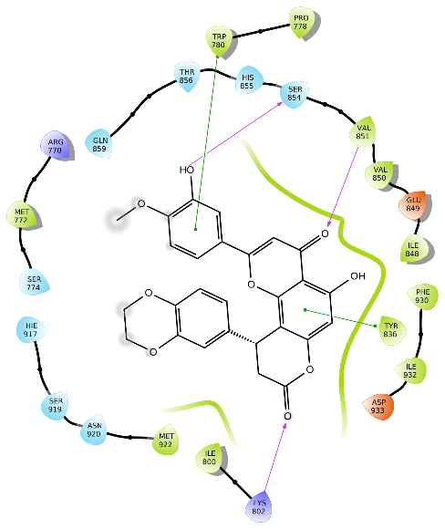 | H-bond: LYS802, TYR836, VAL851 & SER854.  π-π stacking: TRP780.
 | STOCK1N-1935 | 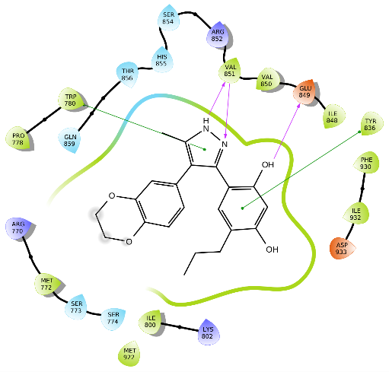 | H-bond: GLU849 & VAL851  π-π stacking: TRP780 & TYR836
 | STOCK1N-81980 | 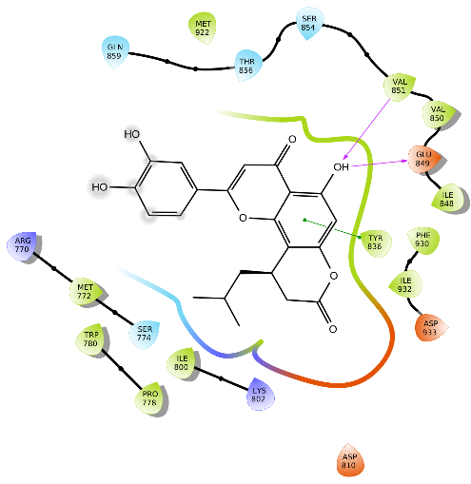 | H-bond: GLU849, VAL851 & ASP933  π-π stacking: TYR836
 | STOCK1N-85851 | 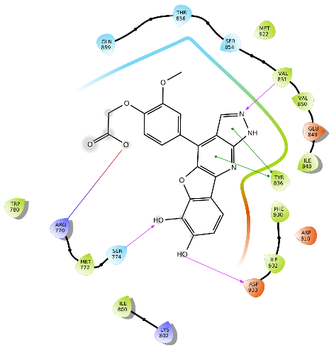 | H-bond: SER774  π-π stacking: TYR836  Salt bridge: ARG770
 | STOCK1N-84154 | 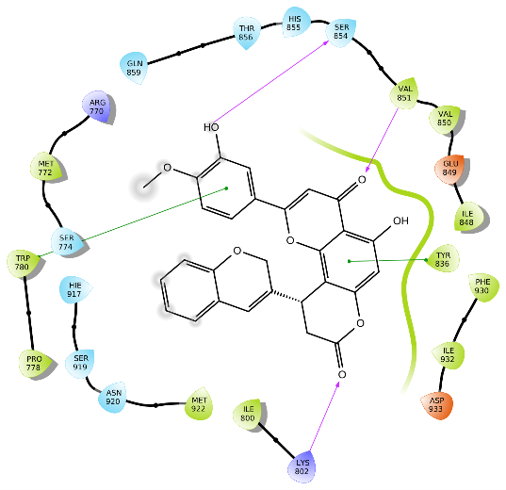 | H-bond: LYS802, VAL851 & SER854  π-π stacking: TRP780 & TYR836
 | STOCK1N-85998 | 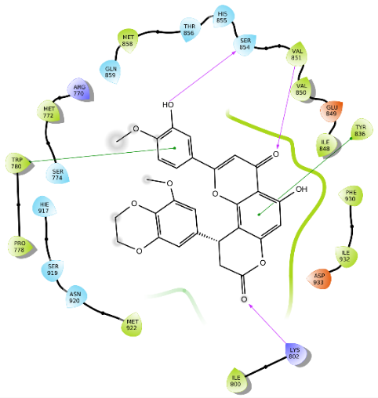 | H-bond: LYS802, VAL851, SER854 & GLN859  π-π stacking: TRP780 & TYR836
 | STOCK1N-86351 | 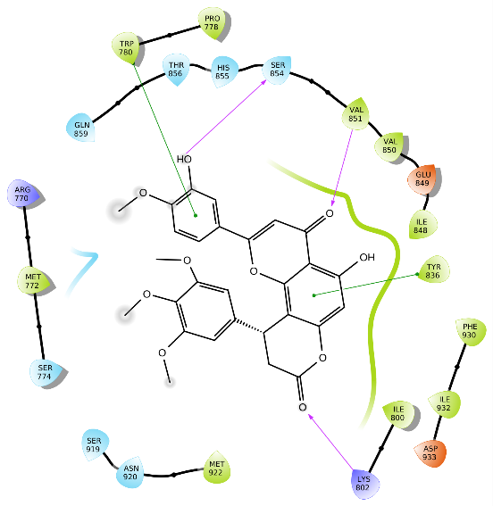 | H-bond: VAL851, SER854 & LYS802  π-π stacking: TRP780 & TYR836
 | STOCK1N-88743 | 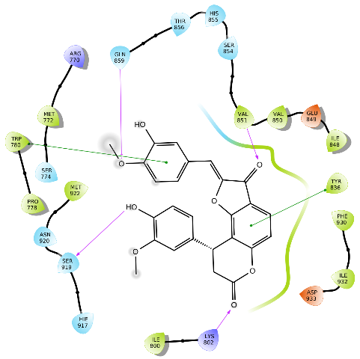 | H-bond: VAL851, GLN859 & SER919  π-π stacking: TRP780 & TYR836
 | STOCK1N-42002 | 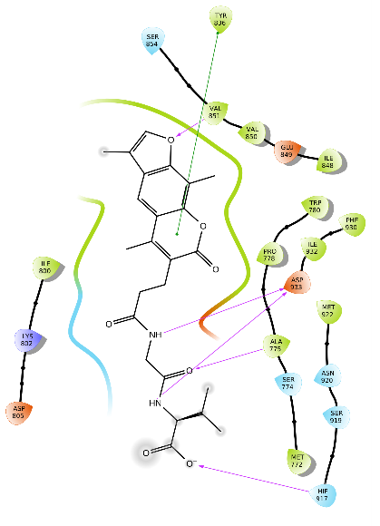 | H-bond: ALA775, VAL851 & ASP933  π-π stacking: TYR836
 | STOCK1N-86060 | 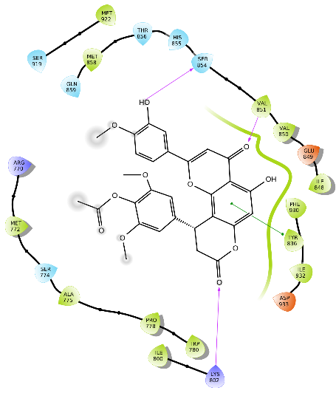 | H-bond: LYS802, VAL851, SER854 & GLN859  π-π stacking: TRP780 & TYR836
 | STOCK1N-83010 | 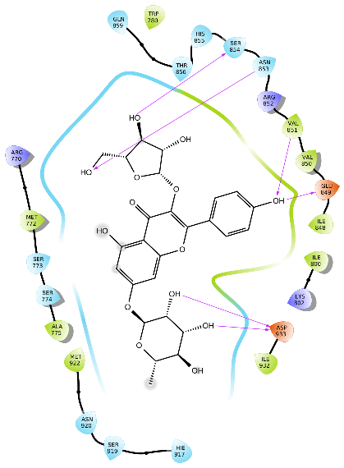 | H-bond: ALA775, GLU849, ASN853, SER854, GLN859 & ASP933

Table S3: IFD score and 3D interaction image of the 25 selected Compounds
Sl no | Compound | IFD score (kcal/mol) | 3D structure of Best pose
 | STOCK1N-113116 | -1924.09 | 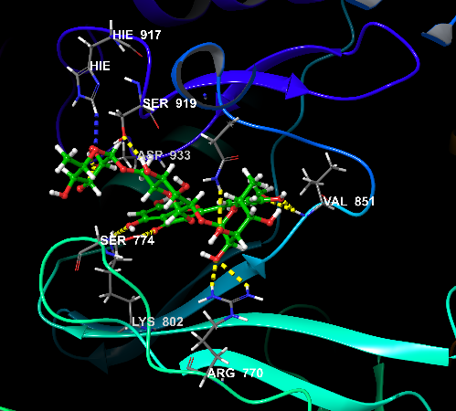
 | STOCK1N-81073 | -1925.56 | 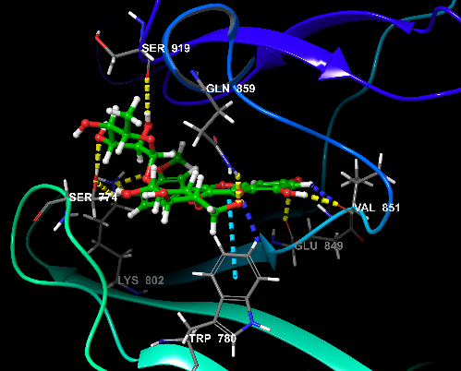
 | STOCK1N-51145 | -1916.56 | 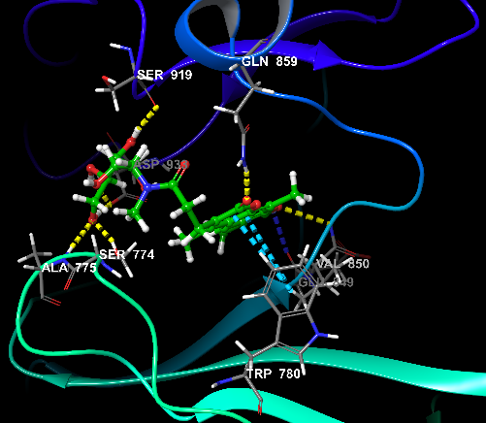
 | STOCK1N-59405 | -1987.21 | 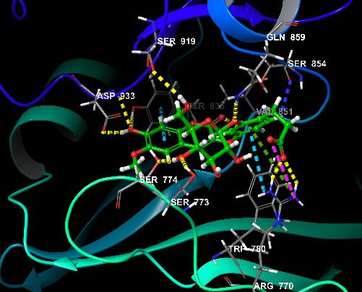
 | STOCK1N-84648 | -1929.37 | 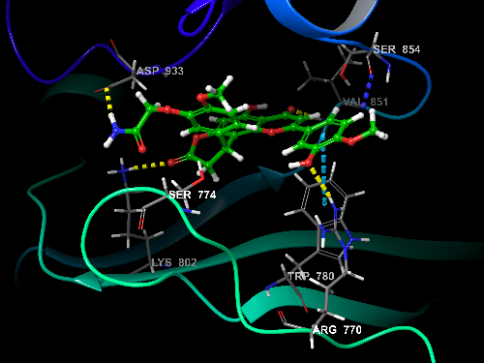
 | STOCK1N-46158 | -1915.39 | 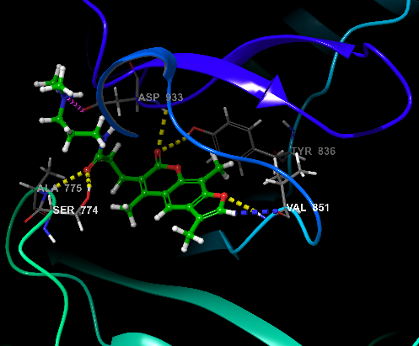
 | STOCK1N-85097 | -1927.92 | 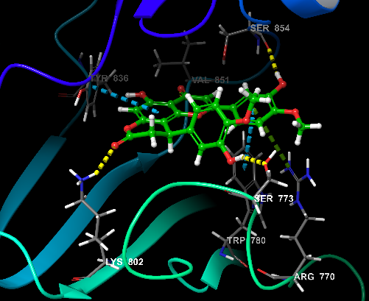
 | STOCK1N-84443 | -1928.66 | 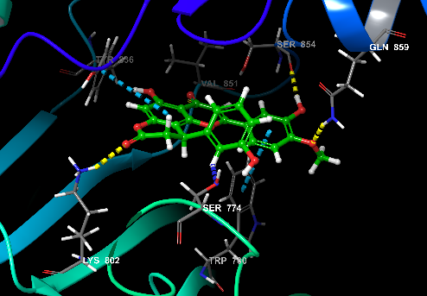
 | STOCK1N-64228 | -1918.18 | 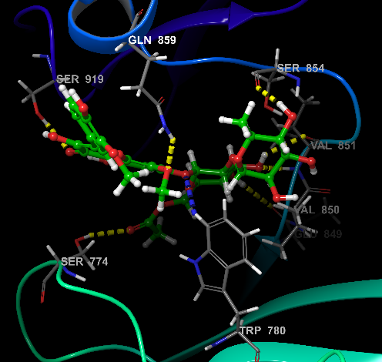
 | STOCK1N-84098 | -1922.98 | 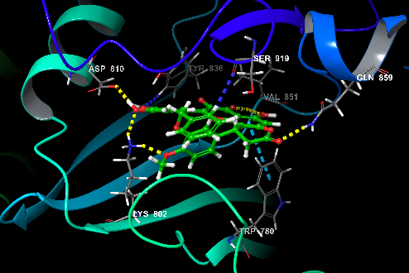
 | STOCK1N-85873 | -1927.31 | 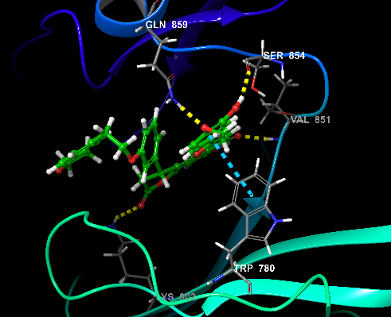
 | STOCK1N-92951 | -1920.80 | 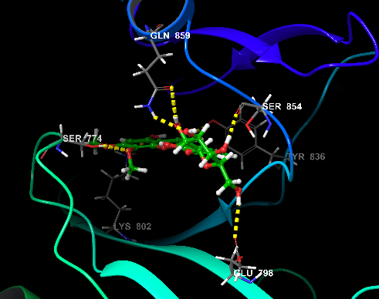
 | STOCK1N-92949 | -1917.19 | 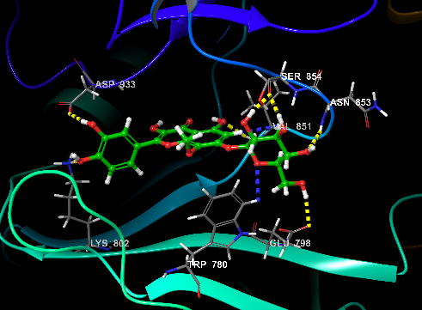
 | STOCK1N-40367 | -1921.24 | 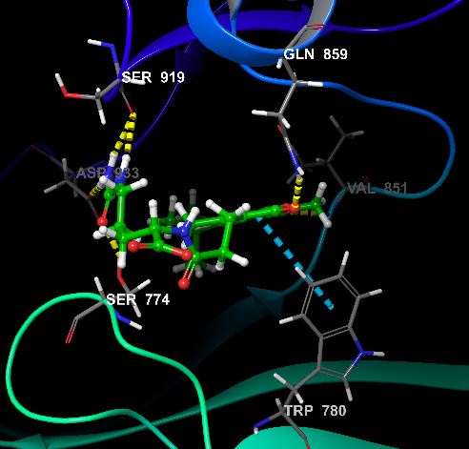
 | STOCK1N-85433 | -1927.41 | 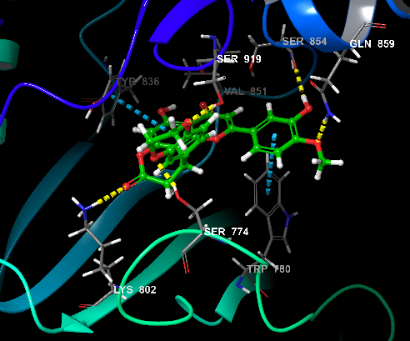
 | STOCK1N-1935 | -1916.43 | 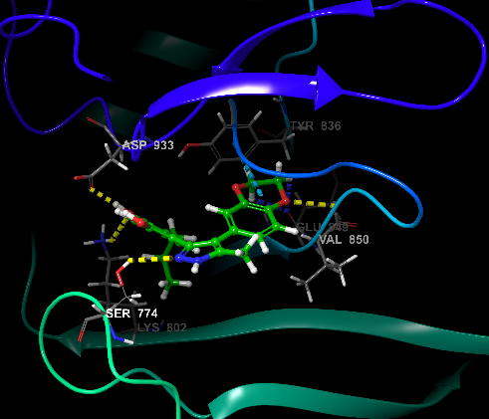
 | STOCK1N-81980 | -1926.11 | 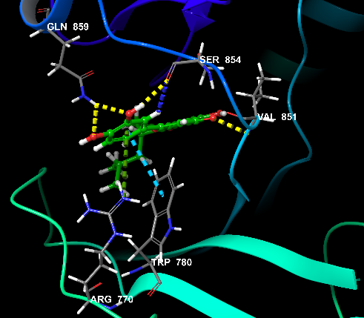
 | STOCK1N-85851 | -1917.63 | 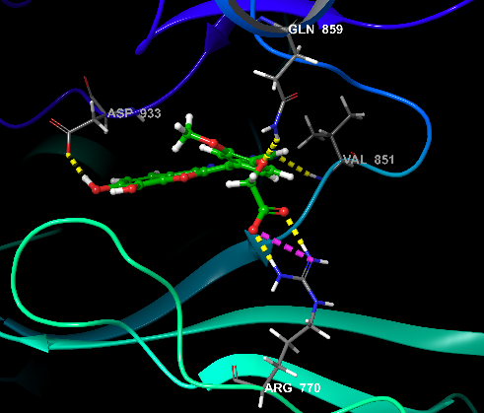
 | STOCK1N-84154 | -1929.87 | 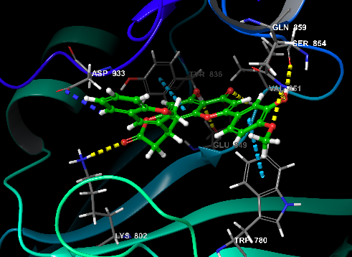
 | STOCK1N-85998 | -1926.33 | 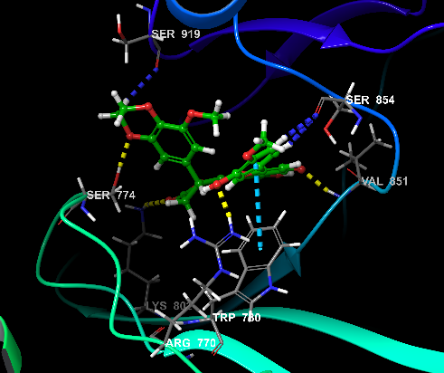
 | STOCK1N-86351 | -1927.94 | 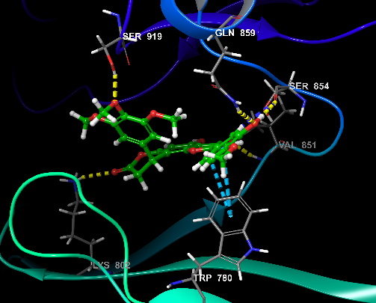
 | STOCK1N-88743 | -1915.68 | 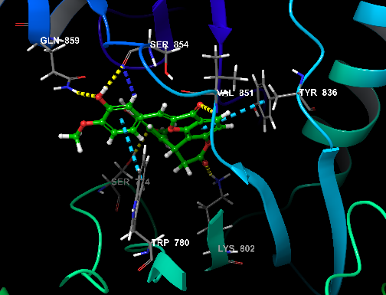
 | STOCK1N-42002 | -1915.41 | 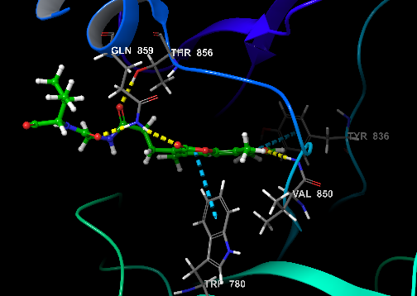
 | STOCK1N-86060 | -1929.06 | 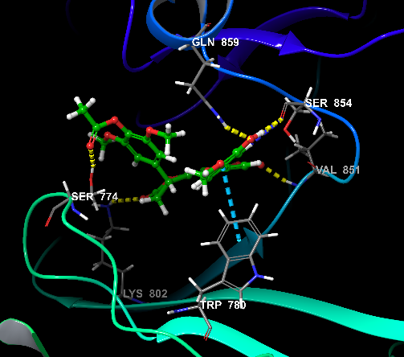
 | STOCK1N-83010 | -1922.78 | 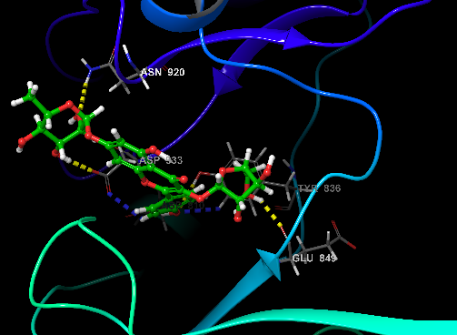

Figure S1: Cross-correlation of the Complexes.

