Table 2: Docking score, MMGBSA and interaction with protein of the 25 selected hits and the Co-crystalized Ligand
Compound ID | Structure | MM-GBSA (kcal/mol) | Docking score (kcal/mol)
Inavolisib | 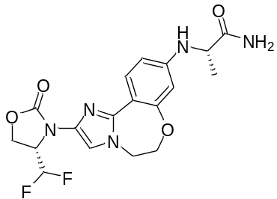 | – 102.74 | – 13.007
STOCK1N-113116 | 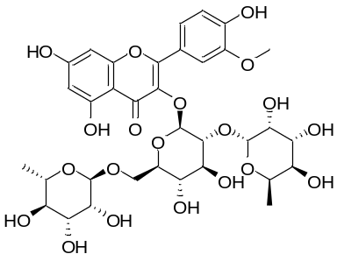 | – 72.85 | – 16.683
STOCK1N-81073 | 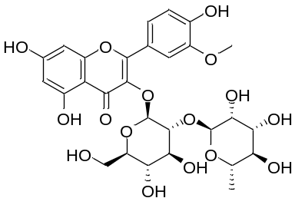 | – 53.4 | – 14.446
STOCK1N-51145 | 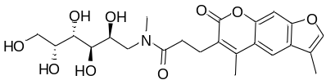 | – 57.47 | – 13.683
STOCK1N-59405 | 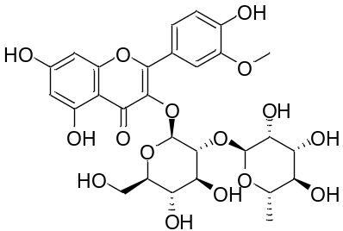 | – 60.74 | – 13.614
STOCK1N-84648 | 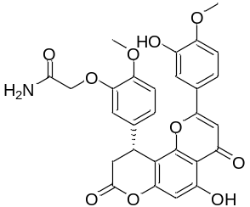 | – 65.78 | – 13.536
STOCK1N-46158 | 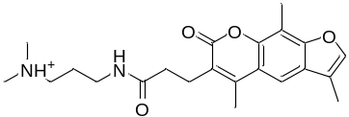 | – 37.92 | – 13.513
STOCK1N-85097 | 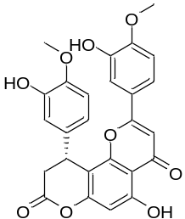 | – 53.02 | – 13.458
STOCK1N-84443 | 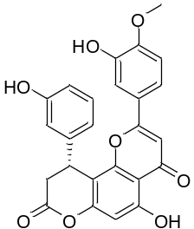 | – 48.34 | – 13.32
STOCK1N-64228 | 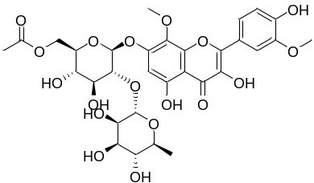 | – 55.47 | – 13.183
STOCK1N-84098 | 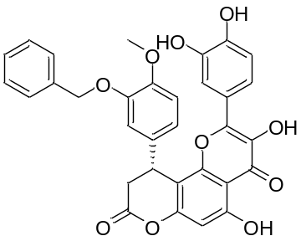 | – 59.56 | – 12.857
STOCK1N-85873 | 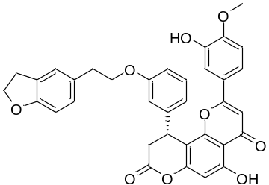 | – 55.74 | – 12.773
STOCK1N-92951 | 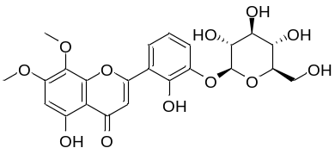 | – 54.55 | – 12.667
STOCK1N-92949 | 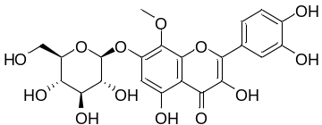 | – 65.7 | – 12.641
STOCK1N-40367 | 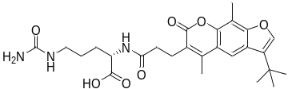 | – 58.95 | – 12.596
STOCK1N-85433 | 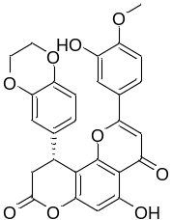 | – 58.48 | – 12.371
STOCK1N-1935 | 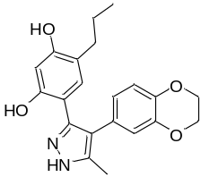 | – 48.91 | – 12.348
STOCK1N-81980 | 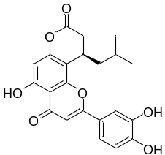 | – 46.92 | –12.337
STOCK1N-85851 | 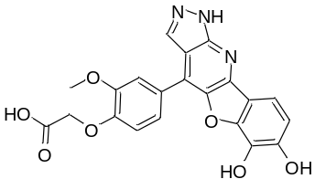 | – 41.61 | – 12.292
STOCK1N-84154 | 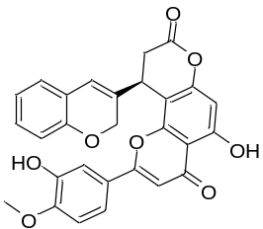 | – 56.81 | – 12.289
STOCK1N-85998 | 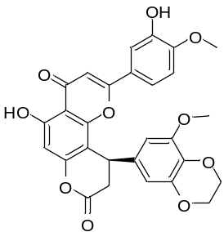 | – 59.22 | – 12.273
STOCK1N-86351 | 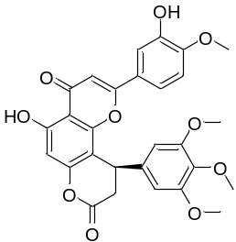 | – 53.71 | – 12.241
STOCK1N-88743 | 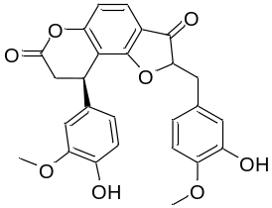 | – 72.47 | – 12.183
STOCK1N-42002 | 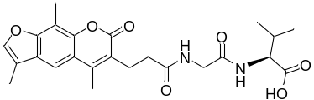 | – 50.58 | – 12.166
STOCK1N-86060 | 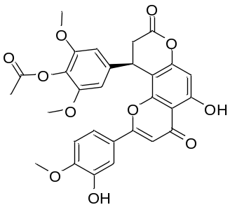 | – 58.79 | – 12.152
STOCK1N-83010 | 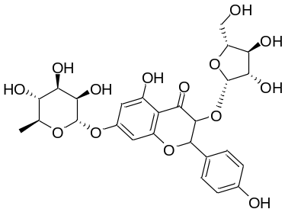 | – 67.11 | – 12.144

