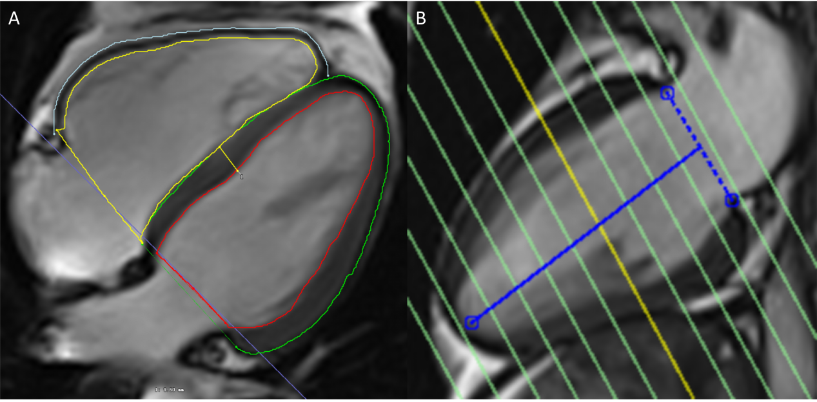
Additional fle1：The IVS thickness was measured on each patient's CMR using the four-chamber long-axis view at the midway (A) between the base and the apex of the left ventricle (B) at enddiastole. IVS, interventricular septum.(Cite location: Page 6, line 115)
Reference:
Siddiqui AM, Samad Z, Crowley ALC, Hakacova N, Harrison JK, Wagner GS: Relationships between cardiac magnetic resonance imaging abnormalities in the inter-ventricular septum and Selvester QRS scoring criteria for anterior–septal myocardial infarction in patients with right ventricular volume overload. Journal of Electrocardiology 2013, 46(3):256-262.

