Synthesis, physicochemical and antimicrobial properties of novel imidazolium based ionic liquids

Vuyolwethu Tokoyiª, Charlene Pillay^{b}, Bakusele Kabane^{a,} *, Saheed Sabiu^{b}, Nirmala Deenadayalu^{a,} *

ª Physical Chemistry laboratory, Faculty of Applied Sciences, Durban University of Technology, Durban – 4001, South Africa
^{b} Department of Biotechnology and Food Science, Faculty of Applied Sciences, Durban University of Technology, P.O. Box 1334, Durban 4000, South Africa
*Corresponding authors: Bakuselek@dut.ac.za; nirmalad@dut.ac.za

Table 1: List of chemicals, purity and suppliers
Chemicals/Solvents | Purity | Supplier
1-allyl-3-methylimidazolium Chloride | ≥ 97% (HLPC) | Sigma Aldrich-Merck
Sodium Acetate (Anhydrous) | Extra pure | SRL Chemicals
Potassium Trifluoromethanesulfonate | 98% | Sigma Aldrich-Merck
Sodium Salicylate | Reagent Plus®, ≥ 99.5% | Sigma Aldrich-Merck
Sodium Tetrafluoroborate | For synthesis | Sigma Aldrich-Merck
Chloroform | AR | Lichro Chemicals
Acetonitrile | AR | Lichro Chemicals
Methanol | AR | Lichro Chemicals

A  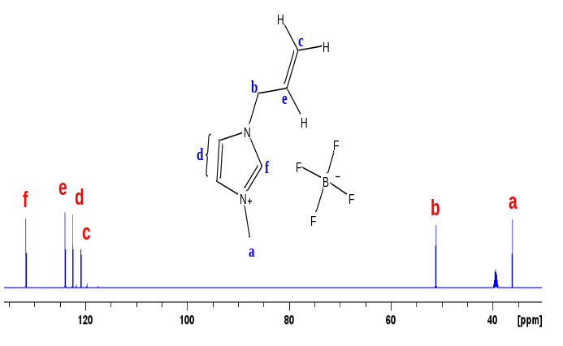 | 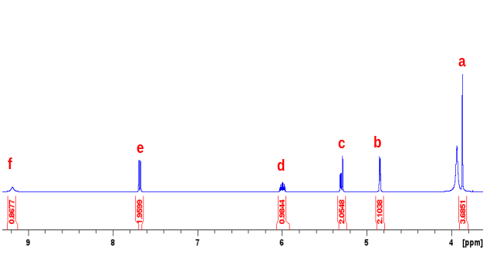  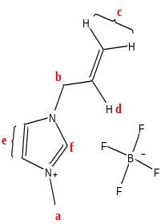  B

S. Figure 1: ¹³C-NMR (A) and ¹H-NMR (B) for ionic liquid 1-allyl-3-methylimidazolium tetrafluoroborate [1-allyl-3-mim]⁺[BF₄] ̅.
Color: Pale yellow liquid. ¹ H-NMR: δH (600 MHz, DMSO, ppm) 3.86 (a, 3H, J = 7.4 Hz), 4.84 (b, 2H), 5.28 (c, 2H), 5.99 (d, 1H), 7.67 (e, 2H), 9.19 (f, 1H). ¹³ C-NMR: δC (600 MHz, DMSO, ppm) 36.3 (a), 51.3 (b), 121 (c), 122.7 (d), 124.1 (e), 131.8 (f).

A  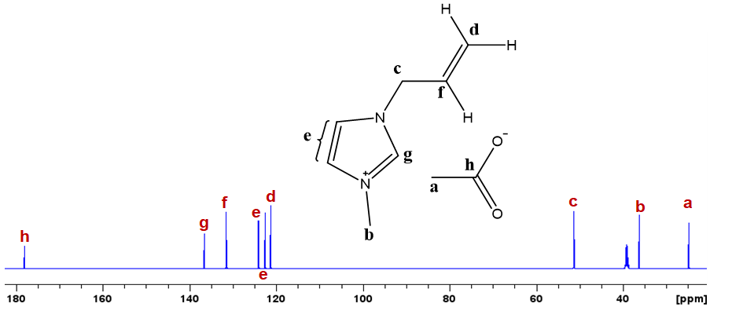 | B  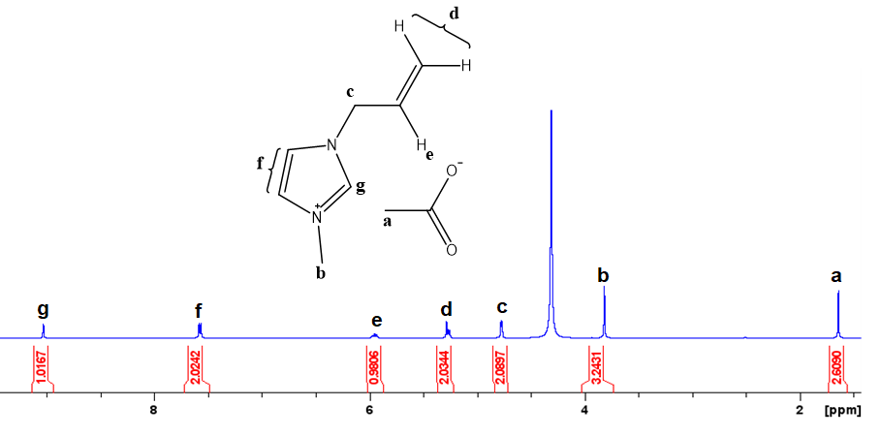

S. Figure 2: ¹³C-NMR (A) and ¹H-NMR (B) for ionic liquid 1-allyl-3-methylimidazolium acetate [1-allyl-3-mim]⁺[OAc] ̅.
Color: Pale yellow liquid.¹ H-NMR: δH (600 MHz, DMSO, ppm) 1.65 (a, 3H), 3.88 (b, 3H), 4.78 (c, 2H), 5.30 (d, 2H), 5.94 (e, 1H), 7.61 (f, 2H), 9.04 (g, 1H). ¹³ C-NMR: δC (600 MHz, DMSO, ppm) 24.7 (a), 36.3 (b), 51.6 (c), 121.5 (d), 122.6 and 124.3 (e), 131.5 (f), 136.6 (g), 178.3

A  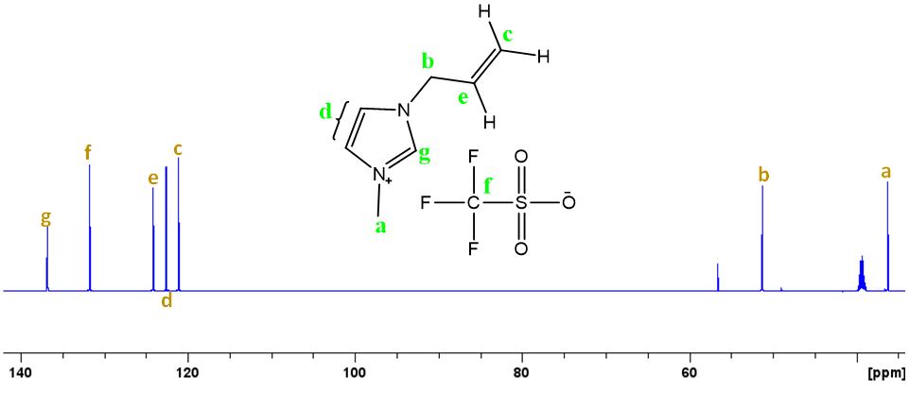 | B  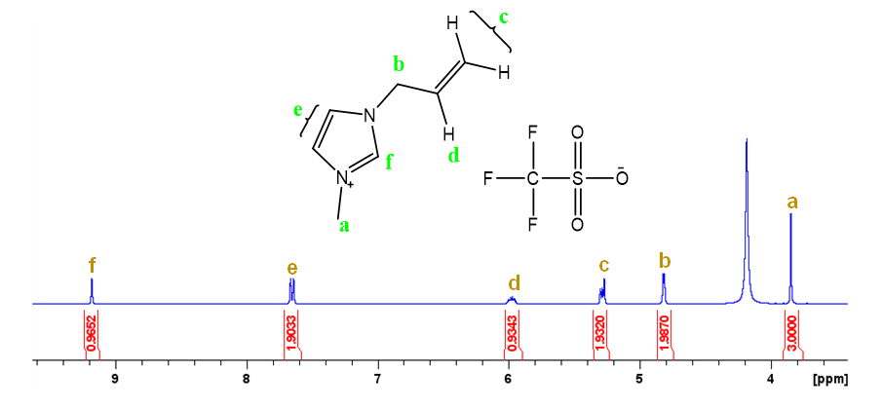

S. Figure 3: ¹³C-NMR (A) and ¹H-NMR (B) for ionic liquid 1-allyl-3-methylimidazolium triflate [1-allyl-3-mim]⁺[OTf] ̅.
Color: Pale yellow liquid. ¹ H-NMR: δH (600 MHz, DMSO, ppm) 3.86 (a, 3H, J = 7.4 Hz), 4.82 (b, 2H), 5.29 (c, 2H), 5.99 (d, 1H), 7.65 (e, 2H), 9.18 (f, 1H). ¹³ C-NMR: δC (600 MHz, DMSO, ppm) 36.2 (a), 51.0 (b), 121.3 (c), 122.6 (d), 124.3 (e), 131.9 (f), 136.9 (g).

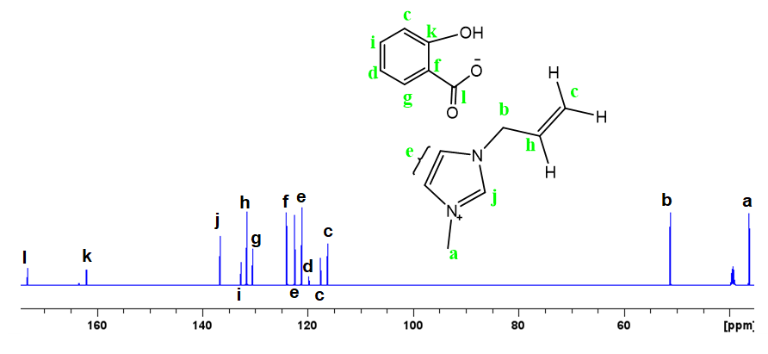  A | B  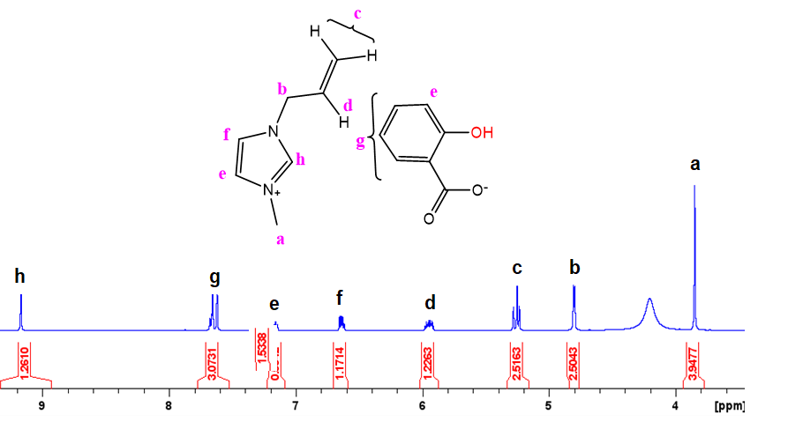

S. Figure 4: ¹³C-NMR (A) and ¹H-NMR (B) for ionic liquid 1-allyl-3-methylimidazolium salicylate [1-allyl-3-mim]⁺[SaL] ̅.
Color: Pale yellow liquid. ¹ H-NMR: δH (600 MHz, DMSO, ppm) 3.86 (a, 3H, J = 7.4 Hz), 4.81 (b, 2H), 5.25 (c, 2H), 5.95 (d, 1H), 7.16 (e, 2H), 6.65 (f, 1H), 7.65 (g, 3H), 9.13 (h, 1H). ¹³ C-NMR: δC (600 MHz, DMSO, ppm) 36.3 (a), 51.2 (b), 116.5 and 117.6 (c), 120 (d), 121.2 and 122.6 (e), 124.1 (f), 130.5 (g), 131.6 (h), 132.8 (i), 136.8 (j), 161.9 (k), 173.3 (l).

S. Figure 5: DTG spectrum of the synthesized ionic liquids showing changes in weigh of the ionic liquids.

