Additional Files
CONTENT
Additional Content 1 Functionality Requirements of Each Component 2
Additional Content 2 The international and national data standards used to develop the SMART system 5
Additional Content 3 The assigned specific tasks and detailed usability testing process for older individuals 6
Figure S1. The overall functional modules of the SMART system 7
Figure S2. Examples of user interfaces of the Care Receiver App 8

Additional Content 1 Functionality Requirements of Each Component
 | Module | Functionality requirements
Cloud Platform | 1. Account management | 1.1 Provide system managers and professional care providers with access to set personal identity information and choose roles.
Cloud Platform | 2. System management | 2.1 Resource management: Support editing and adding functional modules.
Cloud Platform | 2. System management | 2.2 Role management: Support management and allocation of administrators, older people, caregivers, and professional care providers.
Cloud Platform | 2. System management | 2.3 Organization management.
Cloud Platform | 2. System management | 2.4 Module management: Allow access to different sections of health assessment among older people.
Cloud Platform | 2. System management | 2.5 Rule management: Match care problems with corresponding codes.
Cloud Platform | 2. System management | 2.6 Package management: Organize all iterated versions of the Older People App.
Cloud Platform | 2. System management | 2.7 Prize management: Match the points earned by older people with redeemable prizes.
Cloud Platform | 2. System management | 2.8 Device management.
Cloud Platform | 3. Personnel management | 3.1 User management: Organize the basic information of all users of the SMART system.
Cloud Platform | 3. Personnel management | 3.2 Medical assistance allocation: Assign a professional care provider to each older individual.  Assign each older individual for people and their primary caregivers.
Cloud Platform | 3. Personnel management | 3.3 Care allocation: Combine information about each older adult and their main caregivers.
Cloud Platform | 4. Health management | 4.1 Information management: Modify and update the categories and content involved in the health information module.
Cloud Platform | 5. Dictionary management | 5.1 Systematically organize and manage the diseases, drugs, and care problems involved in the SMART system.
Cloud Platform | 6. Older people  management | 6.1 Health assessment: Viewing the health assessment results of older individuals.
Cloud Platform | 6. Older people  management | 6.2 Intervention review: Viewing the automatically generated care problems by the system and making adjustments.
Cloud Platform | 6. Older people  management | 6.3 Vital signs: Access monitoring data uploaded by older people or their main caregivers.
Cloud Platform | 6. Older people  management | 6.4 Delivery history: View the personalized interventions and implementation approaches for older people and make modifications to any inappropriate aspects.
Cloud Platform | 6. Older people  management | 6.5 Temporary delivery: View the temporary recommendations for older people and make adjustments as needed.
Care Receiver App | - Home page | 1.1 Use diverse icons to present different functional modules.
Care Receiver App | - Home page | 1.2 Present information in a dynamic scrolling format.
Care Receiver App | - Home page | 1.3 Include account functions (registration, quick login, password retrieval, password modification, and logout).
Care Receiver App | - Comprehen-sive geriatric assessment | 2.1 Assess older people’s basic information, admission information, current medical information, cognitive status, emotion and pain, impairment, functional status, overall care plan, and discharge status.
Care Receiver App | - Comprehen-sive geriatric assessment | 2.2 Automatically or click to generate and update assessment results.
Care Receiver App | - Daily monitoring | 3.1 Collect older people’s vital signs by using wearable devices and upload them to the Cloud Platform.
Care Receiver App | - Daily monitoring | 3.2 Collect older people’s symptoms and health-related behaviors and upload them to the Cloud Platform.
Care Receiver App | - Daily monitoring | 3.3 Allow uploading in the form of text, images, and videos.
Care Receiver App | - Daily monitoring | 3.4 Allow viewing data (e.g., present change trajectory based on date, display current abnormal data items).
Care Receiver App | - Health management | 4.1 Based on the data uploaded to the Cloud Platform, a pre-embedded knowledge base is used to generate care problems and match personalized interventions, which are subsequently transmitted to both the Older People App and the Caregiver App.
Care Receiver App | - Health management | 4.2 The Cloud Platform sends emergencies or older people’s care needs to the corresponding service providers.
Care Receiver App | - Health management | 4.3 Allow viewing older people’s latest health records in the form of charts and marking abnormal data with corresponding explanations (e.g., high/low, precautions, measures).
Care Receiver App | - Health information | 5.1 Include health information including health education, medication education, and die and exercise education.
Care Receiver App | - Health information | 5.2 Support storing and viewing text, images, and videos.
Care Receiver App | - Health information | 5.3 Generate intelligent recommendations according to older people’s diseases and physical condition.
Care Receiver App | - Health information | 5.4 Allow older people to choose the content that they care about.
Care Receiver App | - Health information | 5.5 Support full-text search.
Care Receiver App | - Health information | 5.6 Support reading text aloud.
Care Receiver App | - Other | 6.1 Provide feedback to the Cloud Platform and healthcare professionals.
Care Receiver App | - Other | 6.2 Add message notifications (e.g., system notifications, nurse reminders).
Care Receiver App | - Other | 6.3 Check for updates.
Professional Care Provider App | 1. Information inquiry and management  of the care recipient | 1.1 Allow viewing information uploaded by older people and their main caregivers through manual input and wearable devices.
Professional Care Provider App | 1. Information inquiry and management  of the care recipient | 1.2 Allow viewing of all the information delivered to the Healthcare Professional App.
Professional Care Provider App | 1. Information inquiry and management  of the care recipient | 1.3 Support managing all older people and viewing their latest health records in the form of charts.
Professional Care Provider App | 1. Information inquiry and management  of the care recipient | 1.4 Allow timely responses to abnormal data to both the older people and their main caregivers. Only the responses confirmed by the caregivers are considered valid.
Professional Care Provider App | 1. Information inquiry and management  of the care recipient | 1.5 Add login function similar to that of the Older People App.
Professional Care Provider App | 2. Feedback management | 2.1 Provide feedback based on older people’s health information in addition to automatic feedback from the system.
Professional Care Provider App | 3. Other | 3.1 Involve general functions (e.g., feedback, message notifications, check for updates).

Additional Content 2 The international and national data standards used to develop the SMART system
No. | Standard Name | Standards | Standards number
1 | Transport Layer Security (TLS) protocol | International Standard | RFC 8446
2 | Classified criteria for security protection of computer information systems | National Standard | GB 17859-1999
3 | Common Criteria for Information Technology Security Evaluation | National Standard | GB/T 18336-2001
4 | US Trusted Computer System Evaluation Criteria | National Standard | TCSEC
5 | Information technology-Security techniques - Evaluation criteria for IT security | National Standard | ISO/IEC 15408

Additional Content 3 The assigned specific tasks and detailed usability testing process for older individuals
The tasks assigned for older adults included viewing health reports independently at least once, inputting medication information independently at least once, recording blood sugar or blood pressure independently at least once, recording diet or exercise independently at least once, and accessing health information independently at least once. After receiving approval from the relevant departments, we screened older individuals according to the predetermined inclusion and exclusion criteria. After providing a comprehensive explanation of the study’s purpose, significance, and procedures, we assisted the older participants in downloading and installing the SMART system (Care Receiver App). Training materials, including instructional videos and user manuals, were made available to the older adults until they felt confident in using the Older People App for conducting health assessments, viewing health reports, inputting health indicators, setting medication reminders, and accessing health information. Subsequently, the older participants were encouraged to use the Older People App for 24 hours to complete the assigned tasks before filling out the Health Information Technology Usability Evaluation Scale (Older People Version). For paper questionnaires, we conducted thorough checks to identify any omissions and verify incomplete or ambiguous information on the spot, thereby ensuring data integrity. In the case of electronic questionnaires, data completeness was verified within 12 hours.
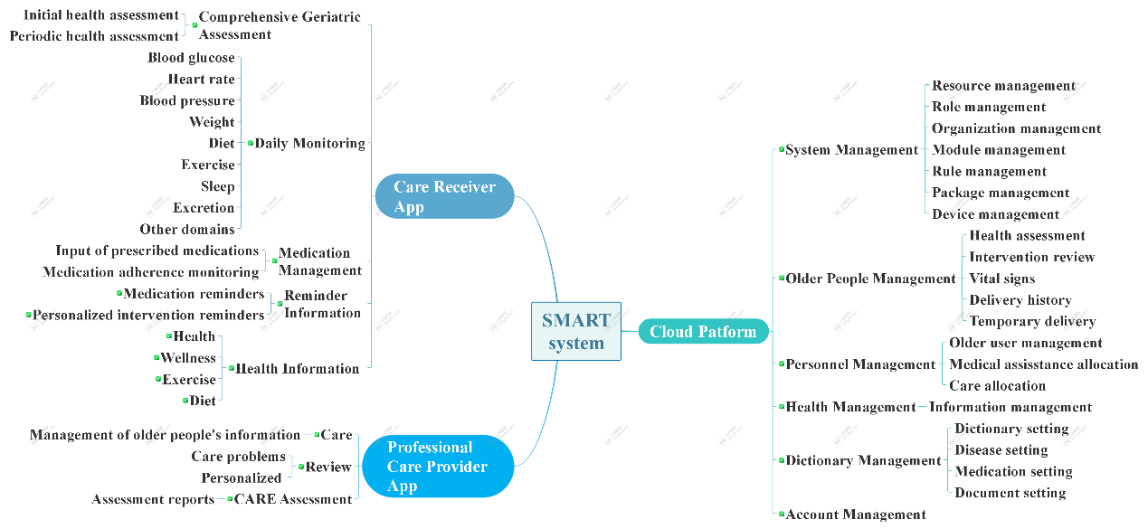

Figure S1. The overall functional modules of the SMART system

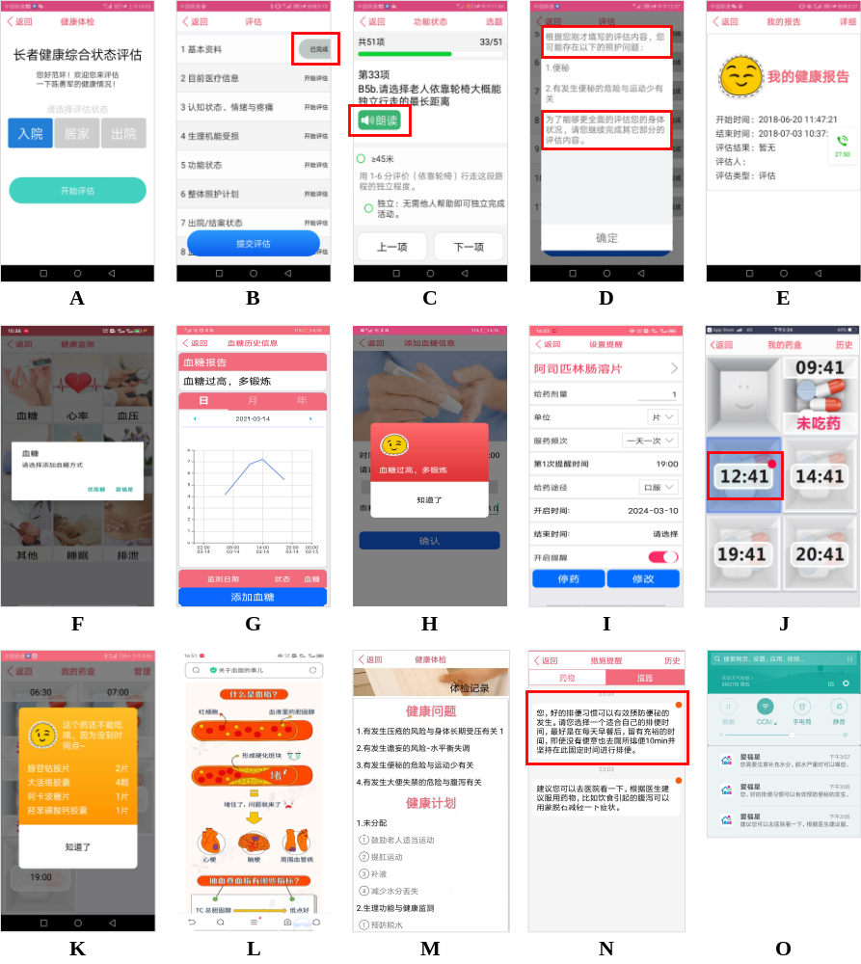

Figure S2. Examples of user interfaces of the Care Receiver App. (A) Assessment using the Continuity Assessment Record and Evaluation tool; (B) Distinct assessment sections with clear assessment statuses; (C) Read-out mode; (D) Care problems; (E) Health records; (F) Options to upload blood glucose monitoring data; (G) Historical monitoring data of blood glucose; (H) Explanation of abnormal monitoring data; (I) Input of the prescribed medications; (J) List of medication reminders; (K) Detailed medication reminders; (L) Figure format; (M) Comprehensive health problems and care plans; (N) Personalized implementation approaches with a red dot to denote the execution status; (O) The daily message reminder feature.

