Therapeutic efficacy of a synthetic brain-targeted H₂S donor cross-linked nanomicells in ASD rats via aerobic glycolysis

Changmei Zhang^{1,2}, Lingyuan Yang¹, Feng Wang¹, Mingyuan Liu, Zehui Liu, Zibo Shen³, Mingyang Zou¹, Lijie Wu^{1*}
- Department of Children’s and Adolescent Health, Public Health College, Harbin Medical University, Harbin, 150086, China
- Department of Pharmaceutics, Harbin Medical University-Daqing Campus, 1 Xinyang Rd Daqing, 163319, China
- Biomedical and life science faculty, King‘s College London, Strand, London WC2R 2LS, United Kingdom

*Corresponding author.
Lijie Wu. E-mail: wulijiehyd@126.com

- Materials and methods
1.1 Materials
DMEM/F12 cell culture medium and fetal bovine serum were purchased from Gibco; PrimeScript™ RT reagent Kit (Perfect Real Time) kit was purchased from Takara; Valproate (VPA) was purchased from Sigma Aldrich; Nissl dye solution and MTT kit were purchased from Beyotime Biotechnolog;; Primary NeuN antibody, GFAP antibody were purchased from Proteintech, 3,3'-Dioctadecyloxacarbocyanine perchlorate (DiO) and DiR were purchased from Macklin. GLUT1(E4S6l) rabbit mAB#73015 antibody, anti-rabbit IgG (H+L), F(ab)₂ Fragment (Alexa Fluor 594) #8889 were purchased form Cell Signaling Technology.
1.2 Methods
1.2.1 Synthesis of nanomicelles
Scheme 1. Synthesis route of cross-linked nanomicelles Man-LA (3) and PEG-LA (5).

Synthesis of compound 1
The synthesis of all compounds was illustrated in Scheme 1. Thiourea (1 g, 5 mmol), N-hydroxysuccinimide (575 mg, 5 mmol), 1-(3-dimethylaminopropyl)-3-ethylcarbodiimide (960 mg, 5 mmol), and dichloromethane (20 mL) were successively added to a 100 mL single-neck flask under argon protection at room temperature for 30 minutes. Then, compound 6, azido-PEG600-amine (2.3 g, 3.8 mmol), was added and the reaction was left overnight at room temperature. After complete reaction, the mixture was diluted with dichloromethane, washed with saturated sodium chloride solution three times, and then purified by silica gel column chromatography (eluting with ethyl acetate first, followed by dichloromethane/methanol = 10/1). This yielded a yellow oily compound 1.
Synthesis of compound 2
Compound 1 (500 mg, 0.62 mmol) was dissolved in tert-butanol (10 mL), and compound 7, propargyl glucoside (431 mg, 1.86 mmol), was dissolved in water (10 mL). To this mixture, 0.5 mmol/mL copper sulfate (380 μL, 0.19 mmol) and 0.5 mmol/mL sodium ascorbate (1.24 mL, 0.62 mmol) were successively added to a 100 mL single-neck flask. The reaction proceeded at 50°C overnight. After complete reaction, the solvent was removed under reduced pressure, and dichloromethane was added for dissolution by sonication. The solution was filtered, and the filtrate was purified by silica gel column chromatography (eluting with dichloromethane/methanol = 10/1 to 10/2). This yielded a pale yellow oily compound 2 (270 mg, 42.6% yield).
Synthesis of compound 3
Compound 2 (32 mg, 0.03 mmol) was added to a 50 ml single-neck flask along with dithiothreitol (5 mg, 0.03 mmol), ethanol (2 mL), and water (4 mL), under argon protection. The reaction proceeded overnight at room temperature. After complete reaction, the mixture was purified by passing through a dextran gel column to yield a pale yellow oily compound 3.
Synthesis of compound 4
Thioglycolic acid (500 mg, 2.5 mmol), N-hydroxysuccinimide (288 mg, 2.5 mmol), 1-(3-dimethylaminopropyl)-3-ethylcarbodiimide (480 mg, 2.5 mmol), and dichloromethane (20 ml) were successively added to a 100 ml single-neck flask under argon protection at room temperature for 30 minutes. Then, compound 8, amino-PEG1200-monomethyl ether (2.3 g, 1.9 mmol), was added, and the reaction was allowed to proceed overnight at room temperature. After complete reaction, the mixture was diluted with dichloromethane, washed with saturated sodium chloride solution three times, and then purified by silica gel column chromatography (eluting with ethyl acetate first, followed by dichloromethane/methanol = 10/1). This process yielded a yellow oily compound 4.
Synthesis of compound 5
Compound 4 (100 mg, 0.07 mmol) was added to a 50 mL single-neck flask along with dithiothreitol (11 mg, 0.07 mmol), ethanol (2 mL), and water (4 mL), under argon protection. The reaction proceeded overnight at room temperature. After complete reaction, the mixture was purified by passing through a Sephadex LH-20 gel column to yield a pale yellow oily compound 5 (81 mg, 81% yield). HRMS (ESI) calculated for C(13+2n)H(27+4n)NO(3+n)S2 [M+2H]+: 639.9, 683.9, 727.9, etc.; found: 639.9, 683.9, 727.9, etc.
All compounds and intermediates were analyzed by 1H NMR spectroscopy using a Bruker AVANCE III 400M spectrometer, with deuterated chloroform as the main solvent.
1.2.2 Primer design and synthesis
Primers were designed using Primer5 software and referenced against NCBI online primer design tools, including Primer-BLAST (http://www.ncbi.nlm.nih.gov/tools/primer-blast) and the NCBI Basic Local Alignment Search Tool. The design and synthesis were commissioned to Ruiboxing Biotechnology Co., Ltd. The specific sequences of the primers used are as follows:
Table S1. The specific sequences of the primers.
Primer | Sequence (5' to 3')
HK1-F | ATTGGACTCATCGTGGGGAC
HK1-R | TCACCCAGGTACATCCCACT
HK2-F | TTCCCCTGCCACCAGACA
HK2-R | AGTGCCCACAATGAGACCAATC
HK3-F | GATGGGCCTCATTGTCGGAA
HK3-R | TCCACGCTAGCATCAAAGCA
HK4-F | TGTCACAAGTGGAGAGCGAC
HK4-R | AGCTTGTACACGGAGCCATC
PKM2-F | TCTACGTGGACGATGGGCT
PKM2-R | AGGAAGACCTTCTCTGCCGGA
LDHA-F | TTCCACCATGATTAAGGGTCTCTAT
LDHA-R | CCTTCACAACATCTGAGATTCCATT
Aldh3b1-F  -F | TGAACCTGACACTCGTGCCT
Aldh3b1-R  -R | GCCATGACGATCTTGCCTA
β-actin-F | CCAACCGTGAAAAGATGACCCAGAT
β-actin-R | TACGACCAGAGGCATACAGGGACA
GAPDH-F | CCTCAAGATTGTCAGCAATG
GAPDH-R | CAGTCTTCTGAGTGGCAGTG

- Results
2.1 Synthesis of Man-LA and PEG-LA
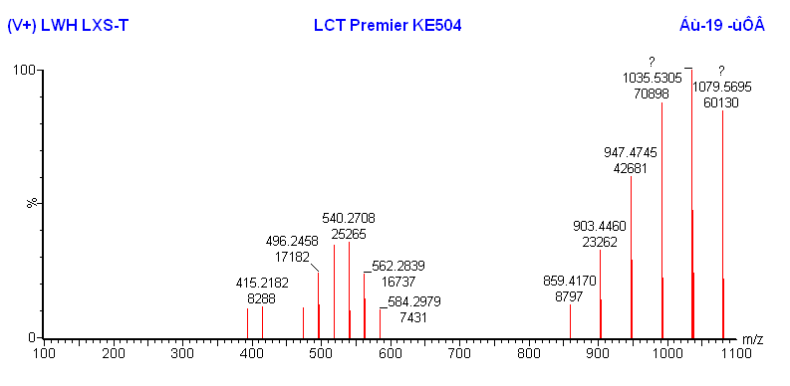
Figure S1. Mass spectra of Man-LA.

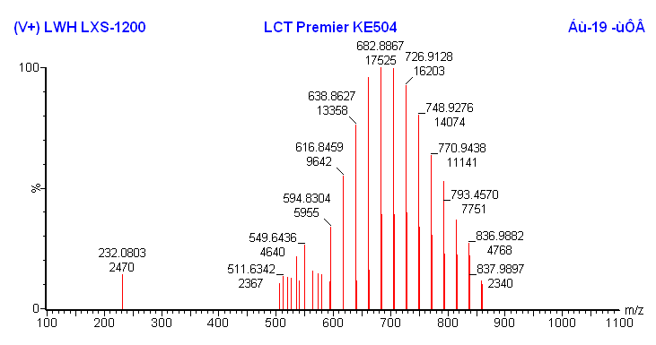
Figure S2. Mass spectra of PEG-LA.

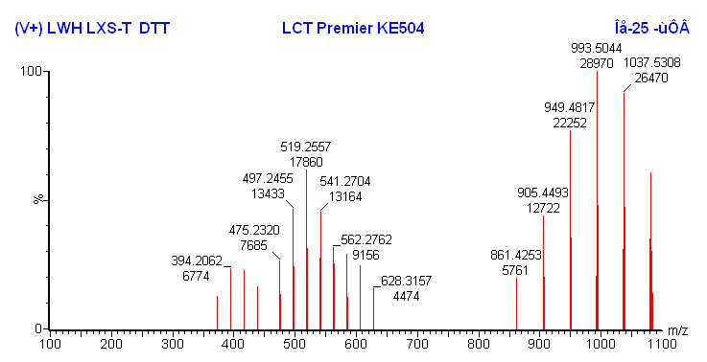
Figure S3. Mass spectra of Man-LA after cross-linking.

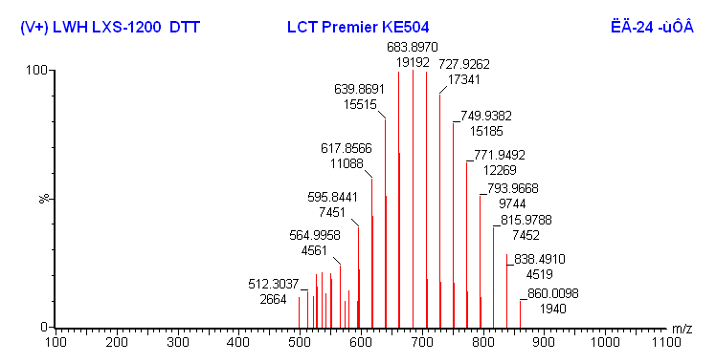
Figure S4. Mass spectra of PEG-LA after cross-linking.

Figure S5. H₂S release of Man-LA and PEG-LA under the action of different concentrations of GSH.

2.2 Expression of aerobic glycolytic key enzymes
The ASD model induced by VPA showed significant tail folding phenomenon in rat, as shown in Figure S6A. The mRNA levels of HK1, HK2, HK3, HK4, and PKM2 in the cerebral cortex of control rats were significantly higher than those in the hippocampus, but there was no difference in LDHA, as shown in Figure S6B. The mRNA levels of HK1, HK2, HK3, PKM2, and LDHA in the cerebral cortex of VPA mice were significantly higher than those in the hippocampus, as shown in Figure S6C. Comparing the expression of aerobic glycolytic enzymes in the cerebral cortex of control and VPA group rats, the mRNA levels of HK2, HK3, HK4, PKM2, and LDHA in the cortex of VPA model rats were significantly reduced, with statistical differences, as shown in Figure S6D.
Figure S6. A: Tail fold photos of 21 day normal rats and VPA induced ASD model rats; B: mRNA expression of aerobic glycolytic enzymes in the hippocampus and cortex of normal rats; C: mRNA expression of aerobic glycolytic enzymes in the hippocampus and cortex of VPA rats; D: mRNA expression of aerobic glycolytic enzymes in the cortex of control and VPA rats; Comparison between two groups: *P＜0.05，**P＜0.01，***P＜0.001，****P＜0.0001.
2.3 Standard curve
Figure S7. Draw a standard curve for DNS Az in a solvent of NaCl: methanol=1:1.5.
2.4 Transcriptome sequencing
Transcriptome sequencing of normal astrocytes and ASD model astrocytes identified 37 genes related to aerobic glycolysis, including 12 upregulated genes: UIns2, Enpp1, UIns2, Enpp1, Gale, Slc2a4, Nup188, Actn3, Slc4a4, Pfkfb1, Galt, Fbp1, Adh6, Pck2; and 25 downregulated genes: Hdac4, Prkag2, Slc2a1, Ldhb, Esrrb, P2rx7, Eno3, Ldha, Aldoc, Htr2a, Nup210, Slc2a6, Pfkfb3, Slc4a1, Lipa, Mlxipl, Prkaa2, Eno4, Gpd1, Zbtb20, Ppargc1a, Kat2b, Aldh1b1, Aldh3b1, Acss1, as shown in Figure S8. Overall analysis indicates that downregulation of genes related to aerobic glycolysis predominates in ASD model astrocytes, suggesting differences in aerobic glycolysis compared to normal astrocytes.

Figure S8. A: Volcano map; B: The number of screening different expressed genes; C: Heatmap of partial aerobic glycolysis related gene.
Figure S9. H₂S standard curve in cell culture medium DMEM/F12.

2.5 Molecular docking and SPR detection

Table S2. Protein coupling values.
Protein coupling value | Ligand | KD（M） | ka（1/Ms） | kd(1/s)
10495.5 RU | Nano micelles | 9.44e-07 | 5.20e+02 | 4.91e-04
1621.2 RU | Nano micelles | 9.64e-07 | 6.94e+02 | 6.69e-04
KD: dissociation constant. It reflects the affinity of the compound to the target, and the smaller the value, the stronger the affinity;
Ka: association rate constant. It represents the speed of intermolecular binding;
Kd: dissociation rate constant. It represents the speed of intermolecular dissociation.

