Electronic Supplementary Material 2
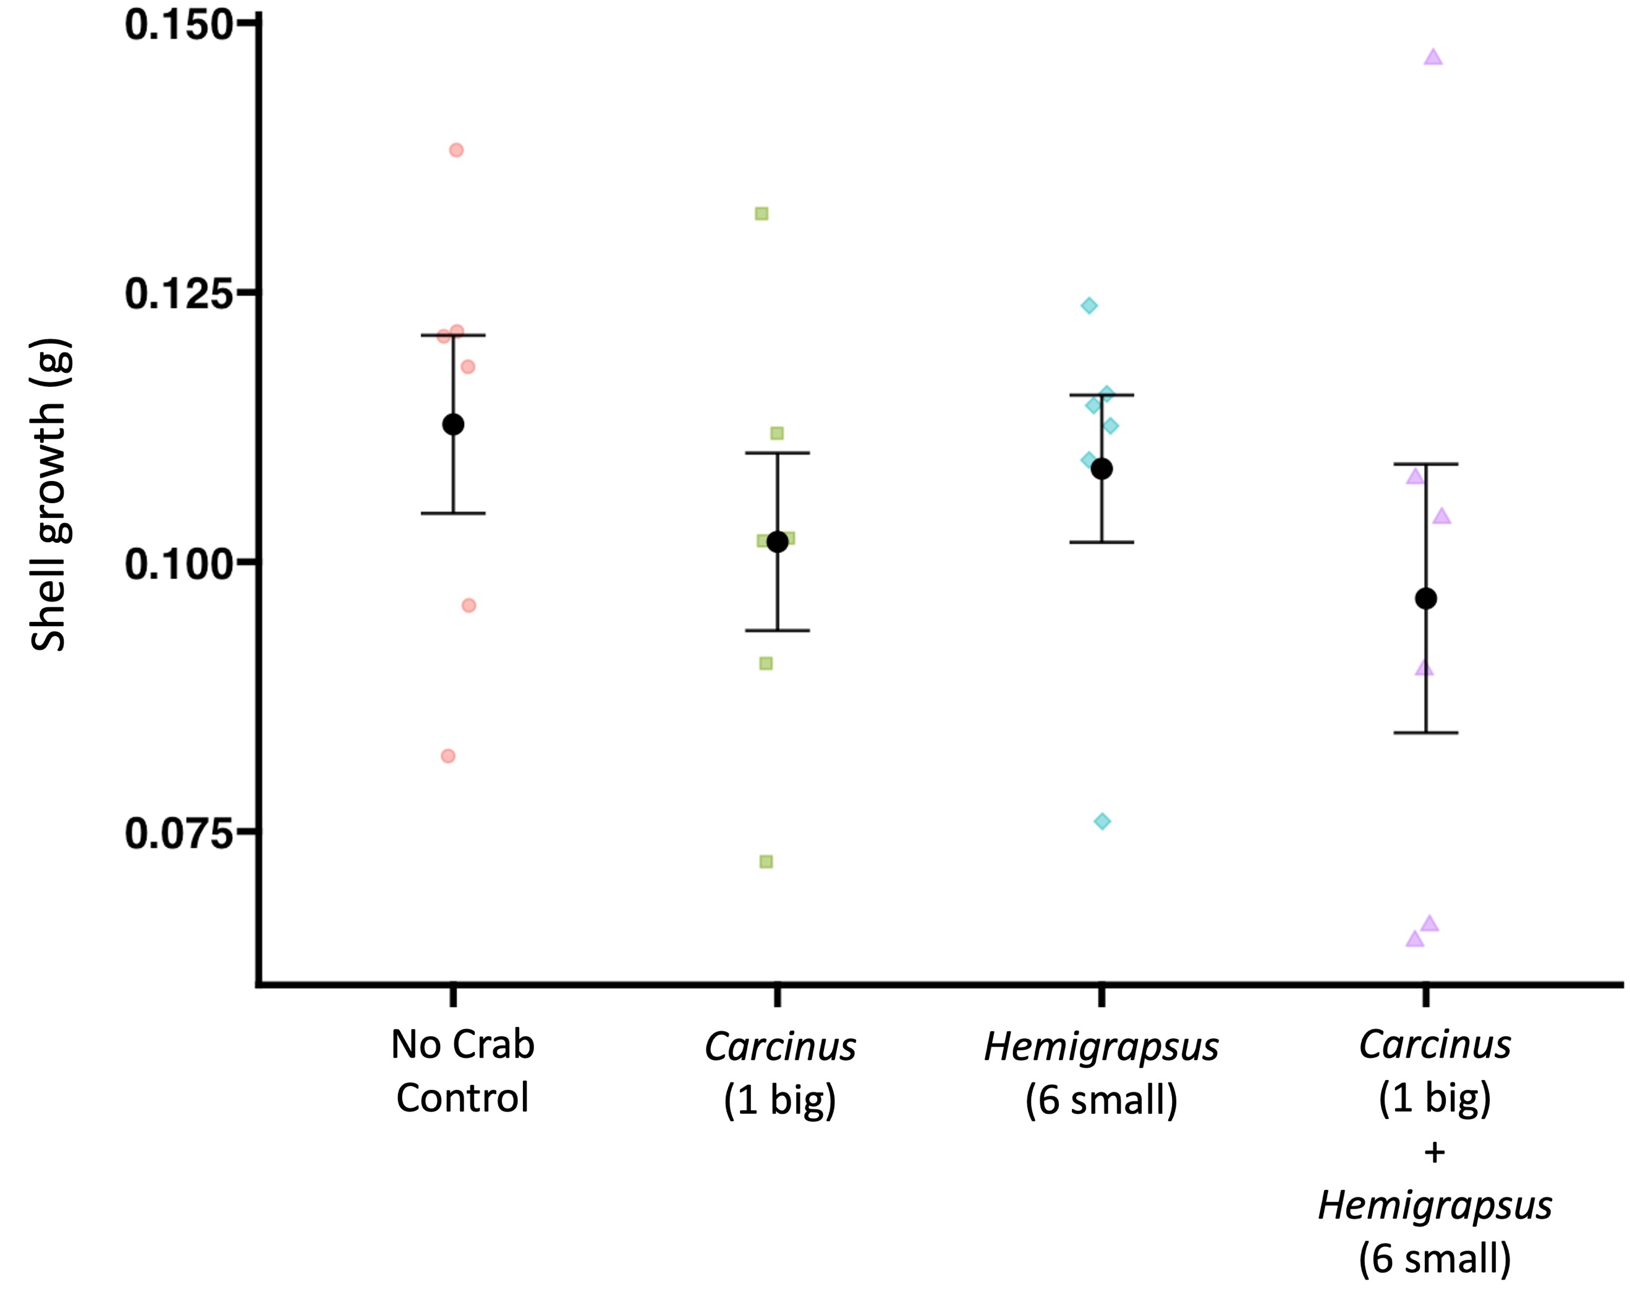
Fig. 4 Nucella shell growth in response to predation risk cues from Carcinus, a resident crab predator, and Hemigrapsus, a non-native species that can act as a predator to Nucella. Treatments with Carcinus had one male crab while treatments with Hemigrapsus had 6 male crabs to standardize for crab biomass. Large data points are treatment mean ± SE overlayed on the average refuge score per bin.

