SUPPLEMENTARY MATERIALS

Socio-ecological tradeoffs between household wealth and water stress in global mining areas

Authors: Humayoun Akram*^{,1}, Amir Meydani¹, Bhoktear Khan¹, Kyle Frankel Davis^{1,2,}*, Saleem Ali^{1,3,4}

Affiliations:
1 – Department of Geography and Spatial Sciences, University of Delaware, United States
2 – Department of Plant and Soil Sciences, University of Delaware, United States
3 – Sustainable Minerals Institute, University of Queensland, Brisbane Australia
4 – United Nations University, Institute for Water, Environment and Health, Richmond Hills ON, Canada

*Corresponding authors: humayoun@udel.edu; kfdavis@udel.edu

Table S1. Summary of Blue Water Stress (BWS) by mineral. Values show the number of mines of for each mineral that are exposed to different water stress values. 1 = BWS index ‘Low’; 2 = BWS index ‘Low to medium’; 3 = BWS index ‘Medium to high’; 4 = BWS index ‘High’; 5 = BWS index ‘Extremely high’; 6 = BWS index ‘Arid conditions’.

Sr. No. | Mining Material | BWS Index | Count | Percentage
1 | Cobalt | 1 | 15 | 83
 | Cobalt | 3 | 1 | 6
 | Cobalt | 6 | 2 | 11
2 | Graphite | 1 | 6 | 86
 | Graphite | 4 | 1 | 14
3 | Lanthanides | 1 | 8 | 40
 | Lanthanides | 2 | 5 | 25
 | Lanthanides | 5 | 3 | 15
 | Lanthanides | 6 | 4 | 20
4 | Lithium | 1 | 17 | 49
 | Lithium | 4 | 1 | 3
 | Lithium | 5 | 1 | 3
 | Lithium | 6 | 16 | 46
5 | Molybdenum | 1 | 9 | 22
 | Molybdenum | 2 | 2 | 5
 | Molybdenum | 3 | 2 | 5
 | Molybdenum | 4 | 1 | 2
 | Molybdenum | 5 | 22 | 54
 | Molybdenum | 6 | 5 | 12
6 | Bauxite | 1 | 41 | 45
 | Bauxite | 2 | 11 | 12
 | Bauxite | 3 | 4 | 4
 | Bauxite | 4 | 10 | 11
 | Bauxite | 5 | 21 | 23
 | Bauxite | 6 | 5 | 5
7 | Chromite | 1 | 10 | 11
 | Chromite | 2 | 20 | 23
 | Chromite | 3 | 15 | 17
 | Chromite | 4 | 33 | 38
 | Chromite | 5 | 4 | 5
 | Chromite | 6 | 6 | 7
8 | Coal | 1 | 1143 | 36
 | Coal | 2 | 542 | 17
 | Coal | 3 | 595 | 19
 | Coal | 4 | 348 | 11
 | Coal | 5 | 443 | 14
 | Coal | 6 | 64 | 2
9 | Copper | 1 | 344 | 45
 | Copper | 2 | 57 | 7
 | Copper | 3 | 52 | 7
 | Copper | 4 | 31 | 4
 | Copper | 5 | 118 | 16
 | Copper | 6 | 159 | 21
10 | Diamonds | 1 | 143 | 68
 | Diamonds | 2 | 23 | 11
 | Diamonds | 3 | 14 | 7
 | Diamonds | 4 | 7 | 3
 | Diamonds | 5 | 2 | 1
 | Diamonds | 6 | 22 | 10
11 | Gold | 1 | 966 | 43
 | Gold | 2 | 227 | 10
 | Gold | 3 | 87 | 4
 | Gold | 4 | 101 | 5
 | Gold | 5 | 328 | 15
 | Gold | 6 | 522 | 23
12 | Iron Ore | 1 | 265 | 42
 | Iron Ore | 2 | 78 | 12
 | Iron Ore | 3 | 44 | 7
 | Iron Ore | 4 | 29 | 5
 | Iron Ore | 5 | 152 | 24
 | Iron Ore | 6 | 70 | 11
13 | Lead | 1 | 19 | 37
 | Lead | 2 | 12 | 23
 | Lead | 3 | 5 | 10
 | Lead | 4 | 3 | 6
 | Lead | 5 | 6 | 12
 | Lead | 6 | 7 | 13
14 | Manganese | 1 | 21 | 39
 | Manganese | 2 | 5 | 9
 | Manganese | 3 | 8 | 15
 | Manganese | 5 | 5 | 9
 | Manganese | 6 | 15 | 28
15 | Phosphate | 1 | 20 | 32
 | Phosphate | 2 | 2 | 3
 | Phosphate | 3 | 8 | 13
 | Phosphate | 4 | 15 | 24
 | Phosphate | 5 | 10 | 16
 | Phosphate | 6 | 7 | 11
16 | Platinum | 1 | 10 | 12
 | Platinum | 2 | 4 | 5
 | Platinum | 3 | 28 | 33
 | Platinum | 4 | 40 | 48
 | Platinum | 5 | 2 | 2
17 | Silver | 1 | 39 | 25
 | Silver | 2 | 11 | 7
 | Silver | 3 | 34 | 22
 | Silver | 4 | 21 | 14
 | Silver | 5 | 35 | 23
 | Silver | 6 | 13 | 8
18 | U3O8 | 1 | 32 | 26
 | U3O8 | 2 | 12 | 10
 | U3O8 | 3 | 7 | 6
 | U3O8 | 4 | 6 | 5
 | U3O8 | 5 | 20 | 17
 | U3O8 | 6 | 44 | 36
19 | Zinc | 1 | 155 | 51
 | Zinc | 2 | 28 | 9
 | Zinc | 3 | 29 | 10
 | Zinc | 4 | 16 | 5
 | Zinc | 5 | 56 | 18
 | Zinc | 6 | 21 | 7

Table S2. Overview of household surveys. Values show the number of households surveyed for each study country, the DHS standard survey year, and the total number of households and clusters (typically comprised of approximately 15 households) for each year.

Sr. No. | Country | DHS Standard Survey Year | No. of Rural Households | No. of Clusters
1 | Albania | 2008 | 3598 | 205
 |  | 2017 | 7896 | 351
2 | Armenia | 2010 | 1947 | 87
 |  | 2015 | 3087 | 121
3 | Burkina Faso | 2003 | 6900 | 308
 |  | 2010 | 1017 | 370
4 | Dominican Republic | 2007 | 13823 | 598
 |  | 2013 | 11464 | 524
5 | DRC | 2007 | 5013 | 169
 |  | 2013 | 11339 | 335
6 | Ethiopia | 2005 | 10055 | 384
 |  | 2011 | 11590 | 408
 |  | 2016 | 11418 | 420
7 | Gabon | 2012 | 4406 | 149
 |  | 2019 | 4480 | 148
8 | Ghana | 2003 | 3734 | 236
 |  | 2008 | 6603 | 225
 |  | 2014 | 5896 | 207
9 | Guatemala | 2015 | 11853 | 472
10 | Guinea | 2005 | 4564 | 191
 |  | 2012 | 4606 | 193
 |  | 2018 | 5211 | 263
11 | India | 2014 | 425564 | 19902
 |  | 2019 | 476561 | 22337
12 | Jordan | 2007 | 4610 | 293
 |  | 2012 | 4463 | 232
 |  | 2017 | 3858 | 201
13 | Kyrgyzstan | 2012 | 5169 | 203
14 | Lesotho | 2004 | 6357 | 277
 |  | 2009 | 7250 | 301
 |  | 2014 | 6604 | 281
15 | Liberia | 2007 | 4218 | 181
 |  | 2013 | 5883 | 203
 |  | 2019 | 5747 | 203
16 | Madagascar | 2008 | 13364 | 439
17 | Mali | 2006 | 8859 | 260
 |  | 2012 | 7341 | 297
 |  | 2018 | 6565 | 234
18 | Mauritania | 2019 | 6218 | 633
19 | Namibia | 2006 | 5307 | 283
 |  | 2013 | 5083 | 283
20 | Philippines | 2003 | 6369 | 375
 |  | 2008 | 6925 | 387
 |  | 2017 | 18475 | 776
21 | Rwanda | 2005 | 8096 | 348
 |  | 2011 | 10531 | 413
 |  | 2014 | 9804 | 379
 |  | 2019 | 10057 | 388
22 | Sierra Leone | 2008 | 4307 | 207
 |  | 2013 | 8060 | 277
 |  | 2019 | 8423 | 348
23 | South Africa | 2016 | 4527 | 282
24 | Tajikistan | 2012 | 3521 | 180
 |  | 2017 | 4326 | 200
25 | Tanzania | 2010 | 7196 | 348
 |  | 2015 | 8929 | 428
26 | Zambia | 2007 | 4470 | 203
 |  | 2013 | 8917 | 414
 |  | 2018 | 8117 | 339
27 | Zimbabwe | 2005 | 6178 | 269
 |  | 2010 | 6192 | 228
 |  | 2015 | 6193 | 234

Fig. S1. Correlation between rural wealth and mine proximity in Albania. Asterisks indicate statistical significance: *** (p < 0.001), ** (p < 0.01), and * (p < 0.05).

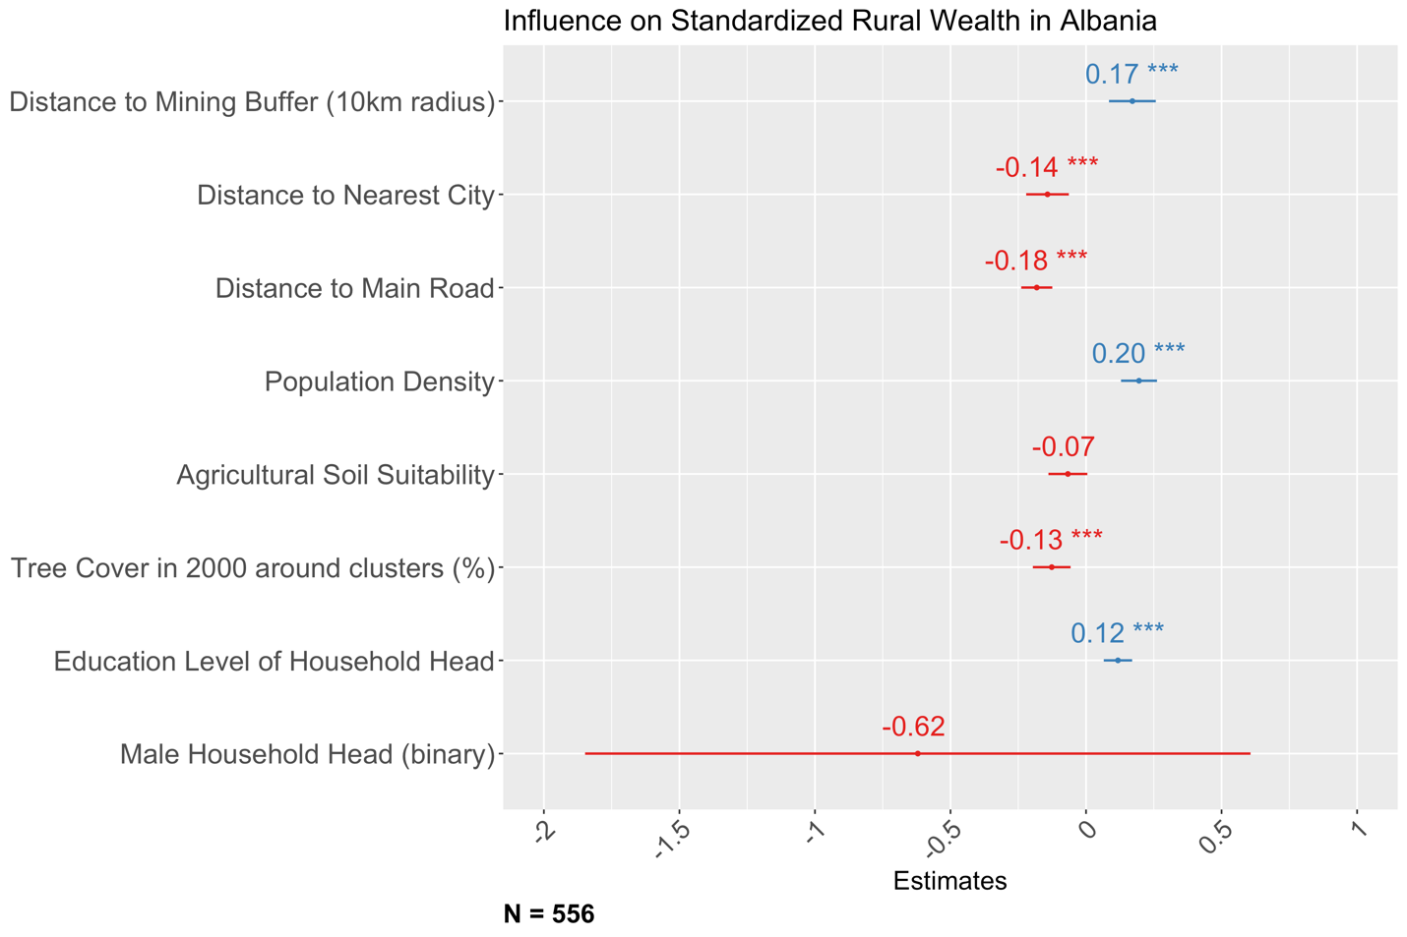

Fig. S2. Correlation between rural wealth and mine proximity in Armenia. Asterisks indicate statistical significance: *** (p < 0.001), ** (p < 0.01), and * (p < 0.05).

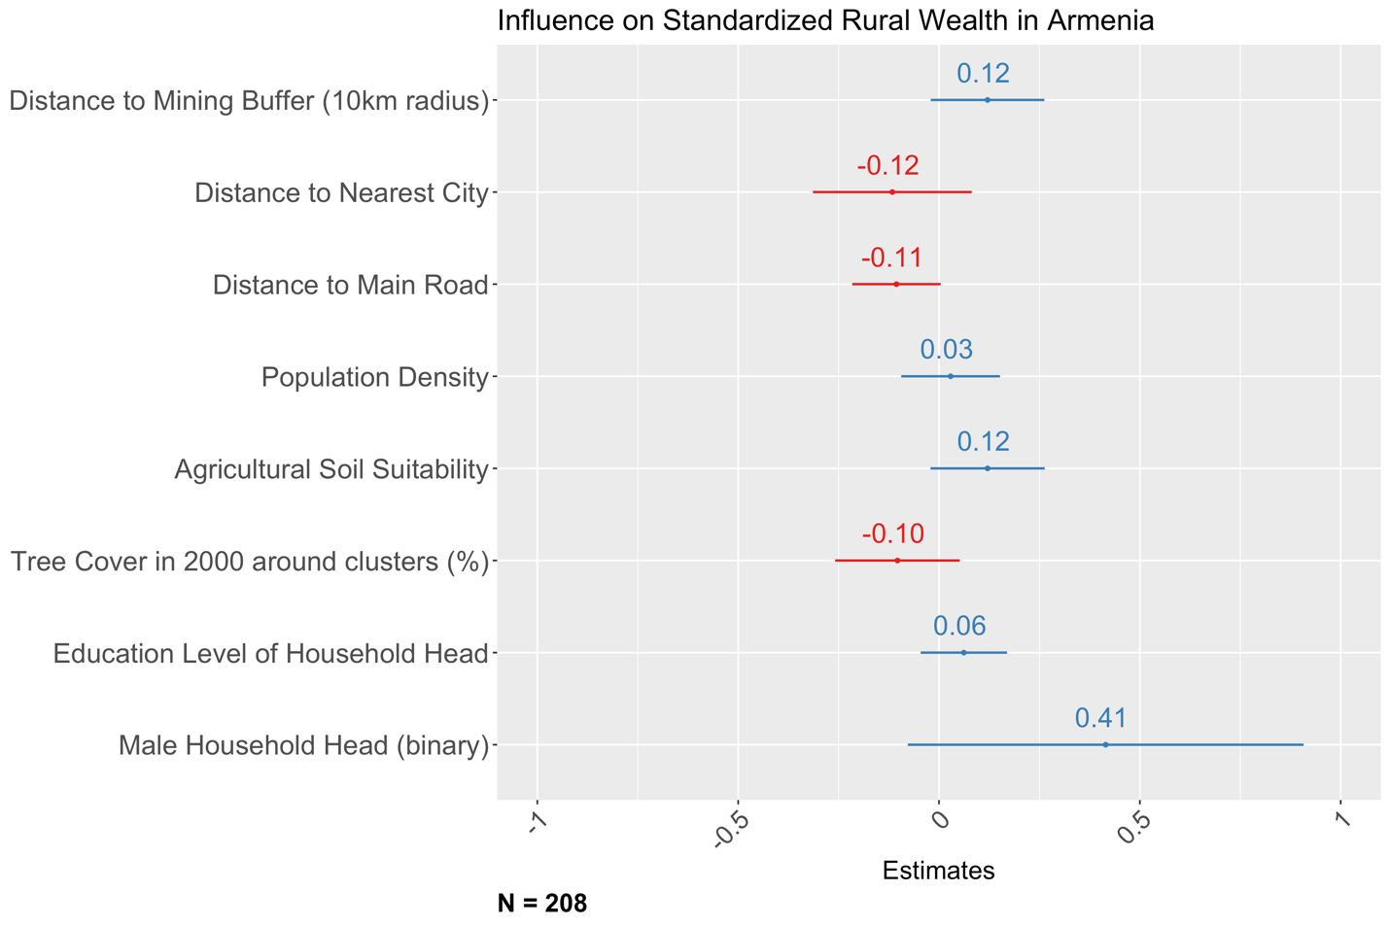

Fig. S3. Correlation between rural wealth and mine proximity in Burkina Faso. Asterisks indicate statistical significance: *** (p < 0.001), ** (p < 0.01), and * (p < 0.05).

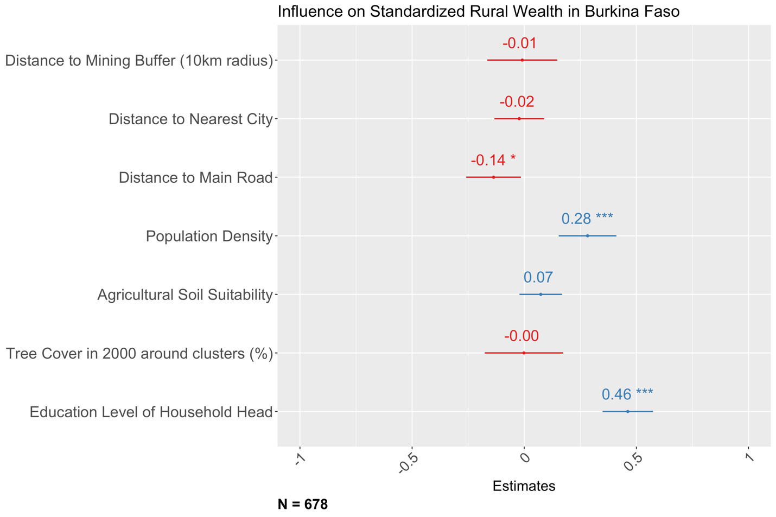

Fig. S4. Correlation between rural wealth and mine proximity in Dominican Republic. Asterisks indicate statistical significance: *** (p < 0.001), ** (p < 0.01), and * (p < 0.05).

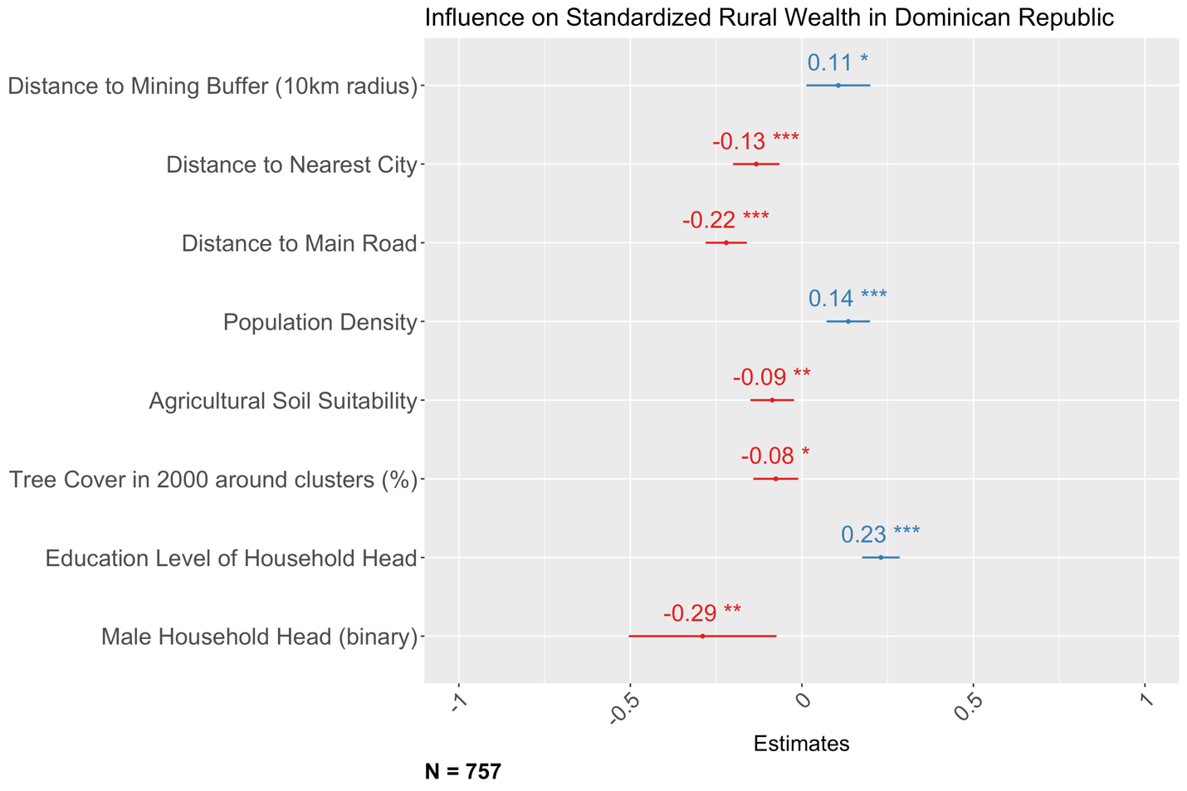

Fig. S5. Correlation between rural wealth and mine proximity in Democratic Republic of Congo. Asterisks indicate statistical significance: *** (p < 0.001), ** (p < 0.01), and * (p < 0.05).

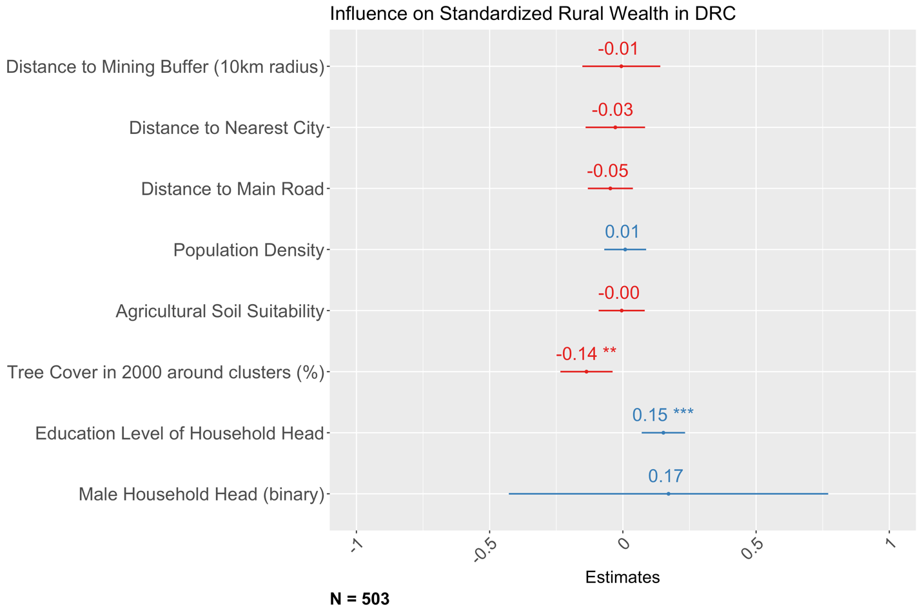

Fig. S6. Correlation between rural wealth and mine proximity in Ethiopia. Asterisks indicate statistical significance: *** (p < 0.001), ** (p < 0.01), and * (p < 0.05).

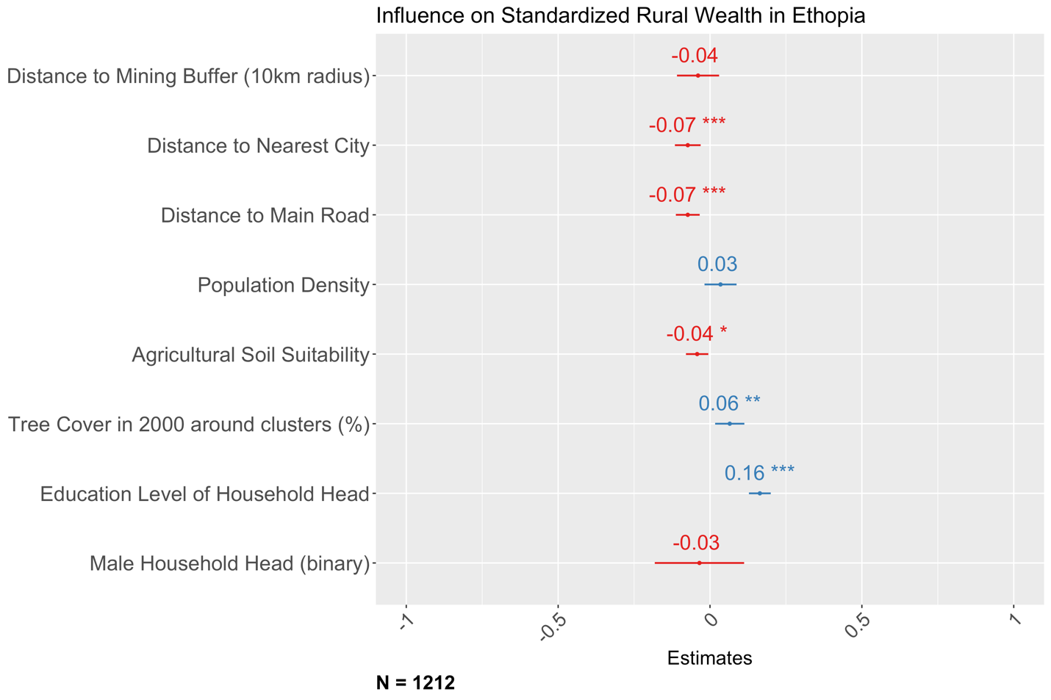

Fig. S7. Correlation between rural wealth and mine proximity in Gabon. Asterisks indicate statistical significance: *** (p < 0.001), ** (p < 0.01), and * (p < 0.05).

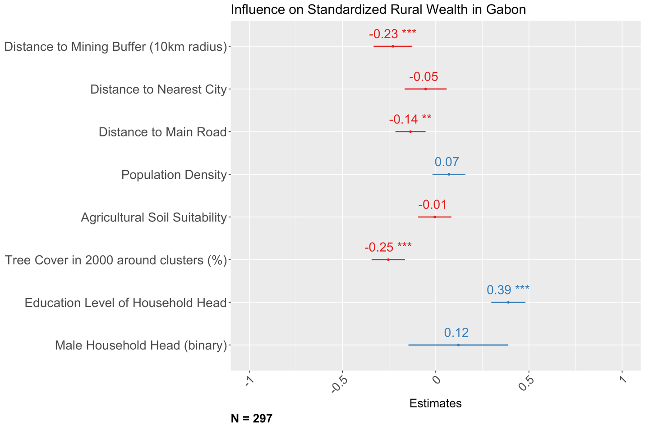

Fig. S8. Correlation between rural wealth and mine proximity in Ghana. Asterisks indicate statistical significance: *** (p < 0.001), ** (p < 0.01), and * (p < 0.05).

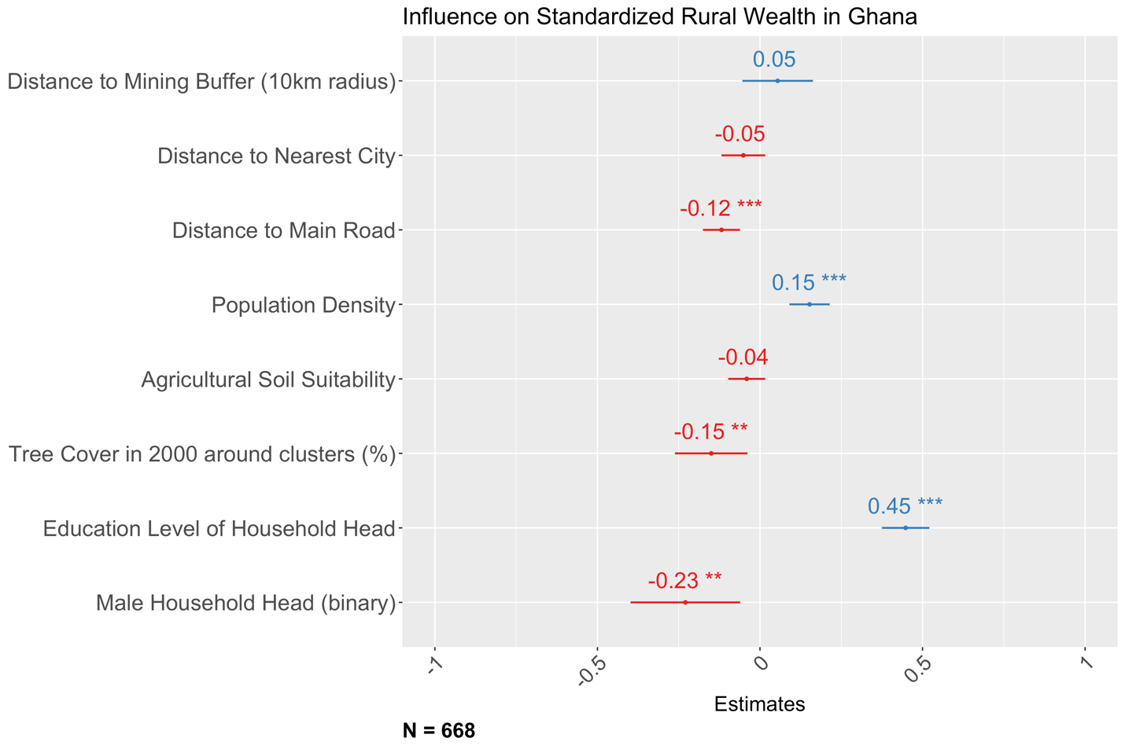

Fig. S9. Correlation between rural wealth and mine proximity in Guatemala. Asterisks indicate statistical significance: *** (p < 0.001), ** (p < 0.01), and * (p < 0.05).

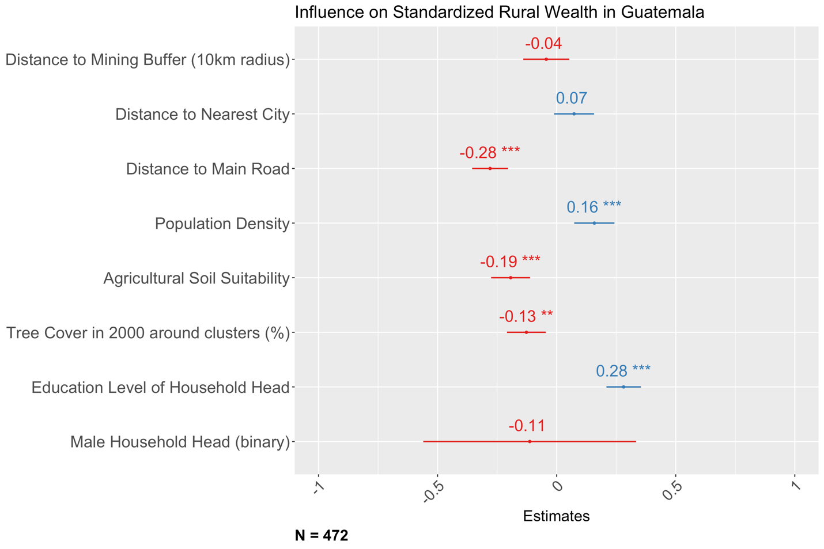

Fig. S10. Correlation between rural wealth and mine proximity in Guinea. Asterisks indicate statistical significance: *** (p < 0.001), ** (p < 0.01), and * (p < 0.05).

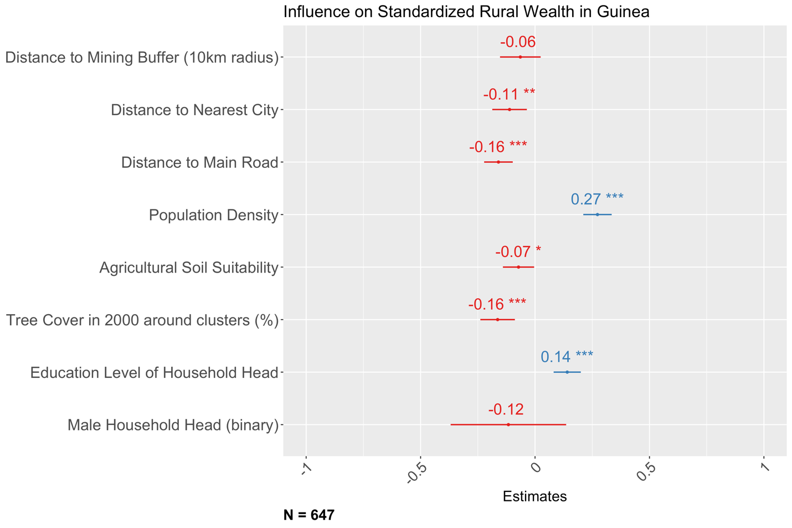

Fig. S11. Correlation between rural wealth and mine proximity in India. Asterisks indicate statistical significance: *** (p < 0.001), ** (p < 0.01), and * (p < 0.05).

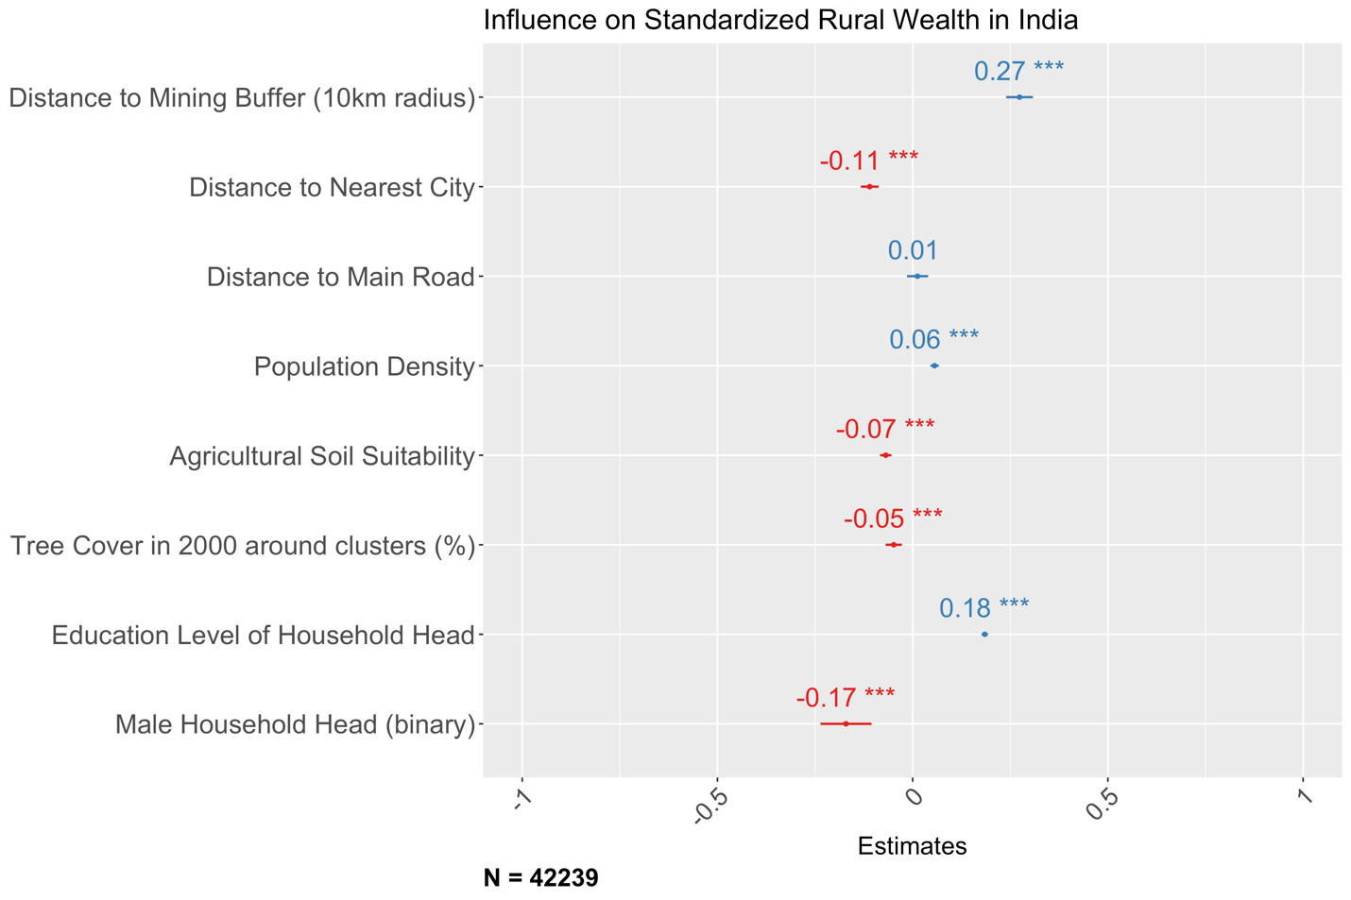

Fig. S12. Correlation between rural wealth and mine proximity in Jordan. Asterisks indicate statistical significance: *** (p < 0.001), ** (p < 0.01), and * (p < 0.05).

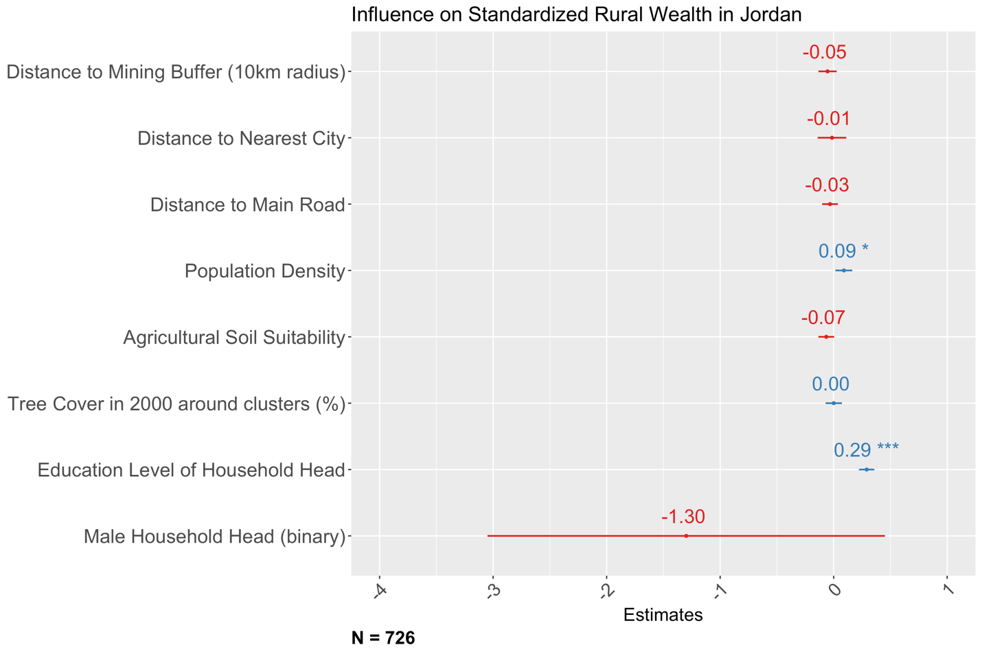

Fig. S13. Correlation between rural wealth and mine proximity in Kyrgyzstan. Asterisks indicate statistical significance: *** (p < 0.001), ** (p < 0.01), and * (p < 0.05).

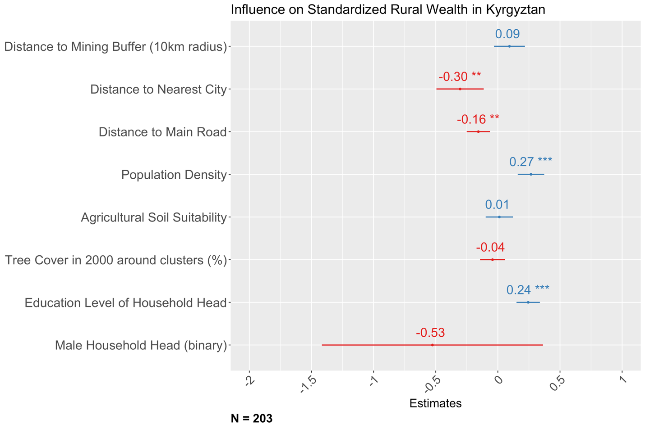

Fig. S14. Correlation between rural wealth and mine proximity in Lesotho. Asterisks indicate statistical significance: *** (p < 0.001), ** (p < 0.01), and * (p < 0.05).

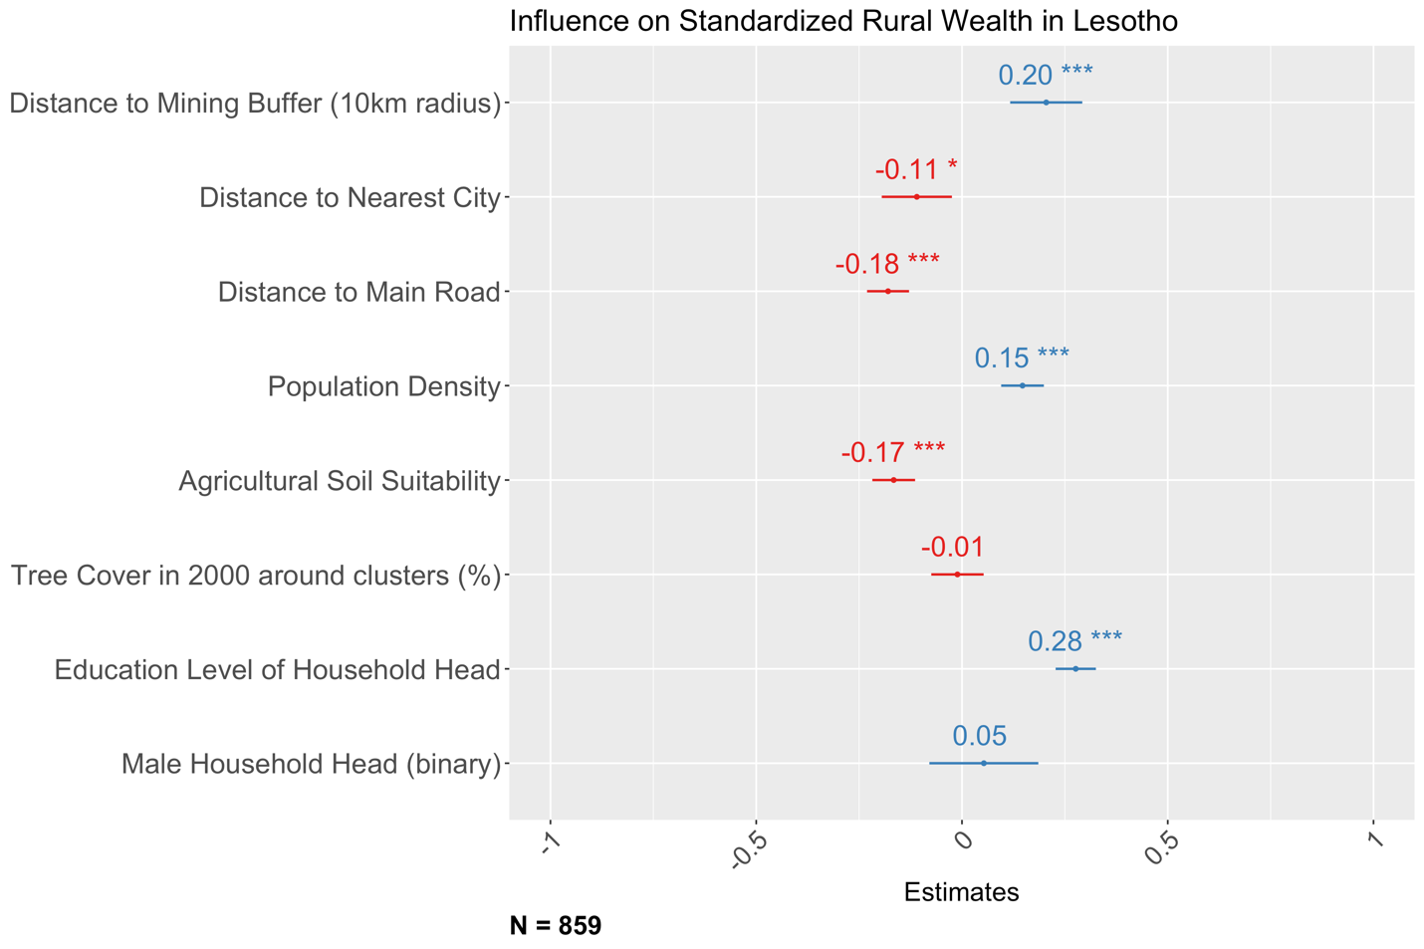

Fig. S15. Correlation between rural wealth and mine proximity in Liberia. Asterisks indicate statistical significance: *** (p < 0.001), ** (p < 0.01), and * (p < 0.05).

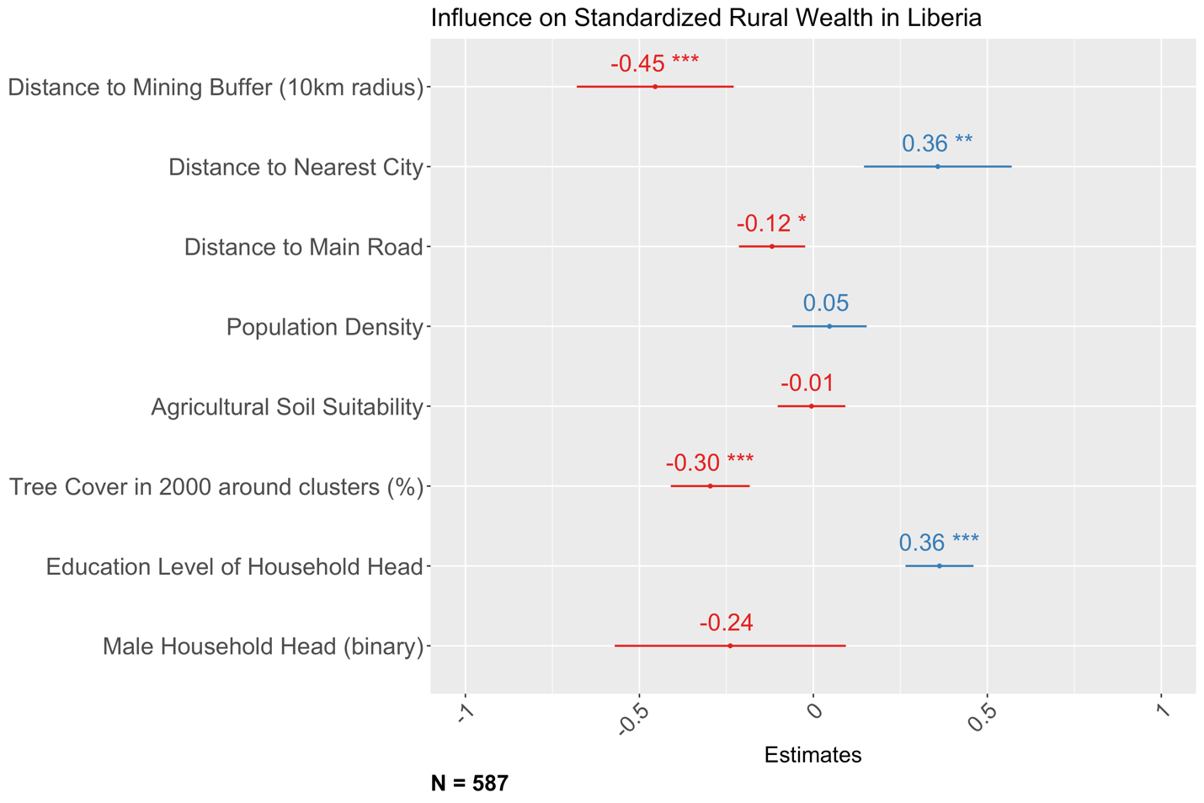

Fig. S16. Correlation between rural wealth and mine proximity in Madagascar. Asterisks indicate statistical significance: *** (p < 0.001), ** (p < 0.01), and * (p < 0.05).

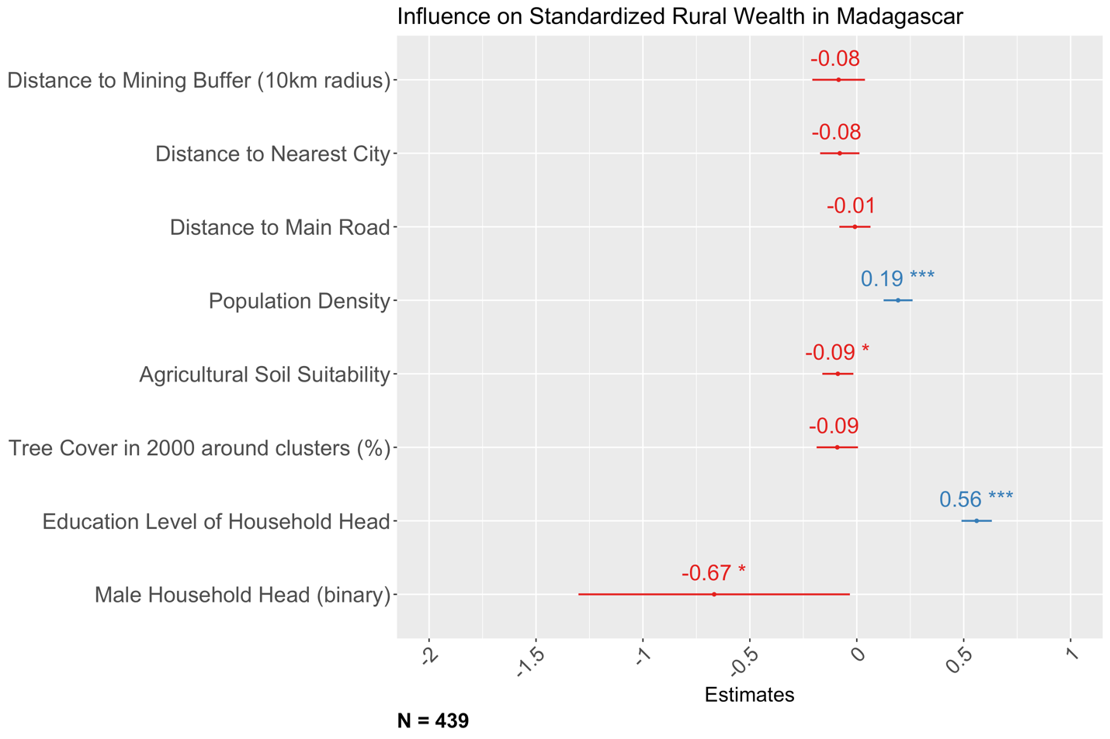

Fig. S17. Correlation between rural wealth and mine proximity in Mali. Asterisks indicate statistical significance: *** (p < 0.001), ** (p < 0.01), and * (p < 0.05).

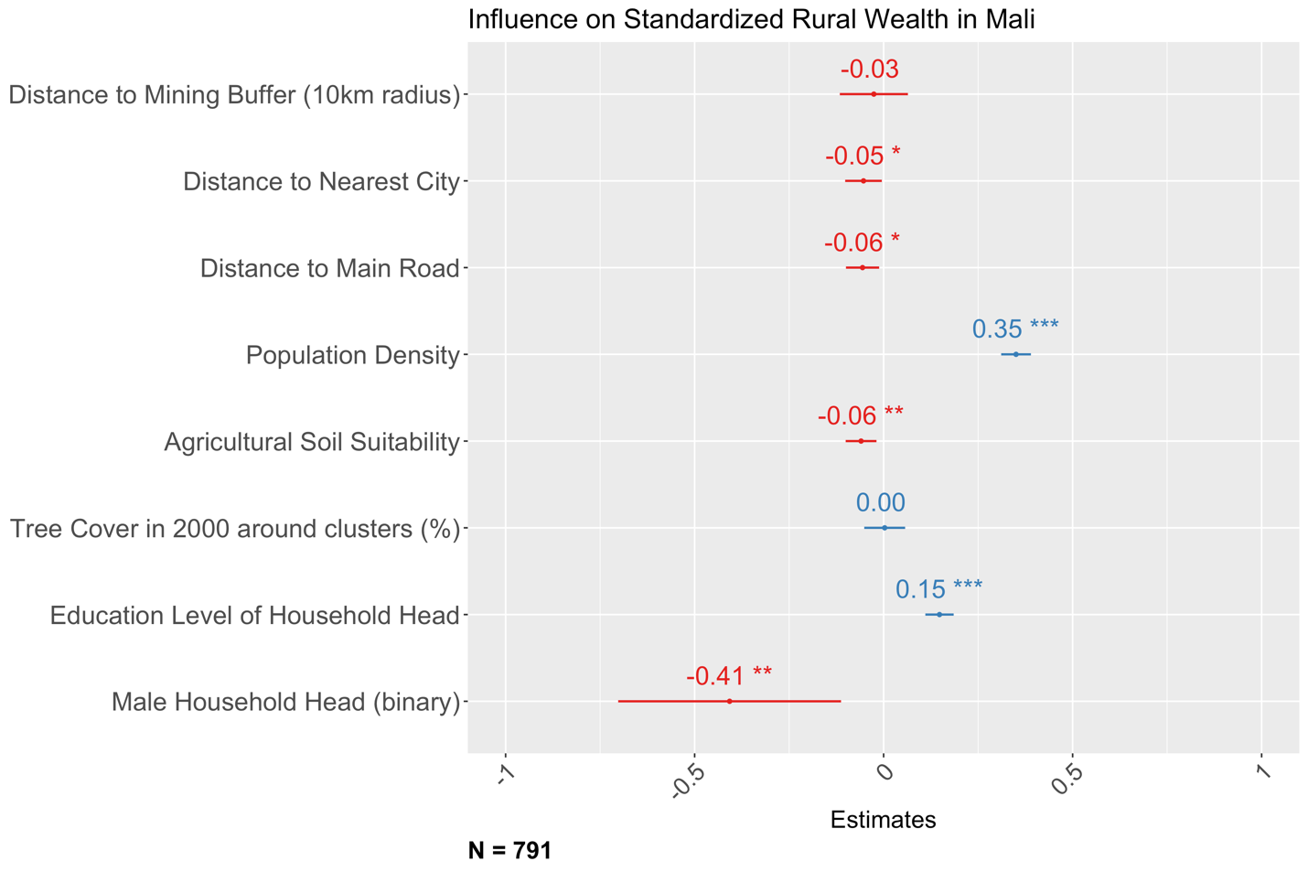

Fig. S18. Correlation between rural wealth and mine proximity in Mauritania. Asterisks indicate statistical significance: *** (p < 0.001), ** (p < 0.01), and * (p < 0.05).

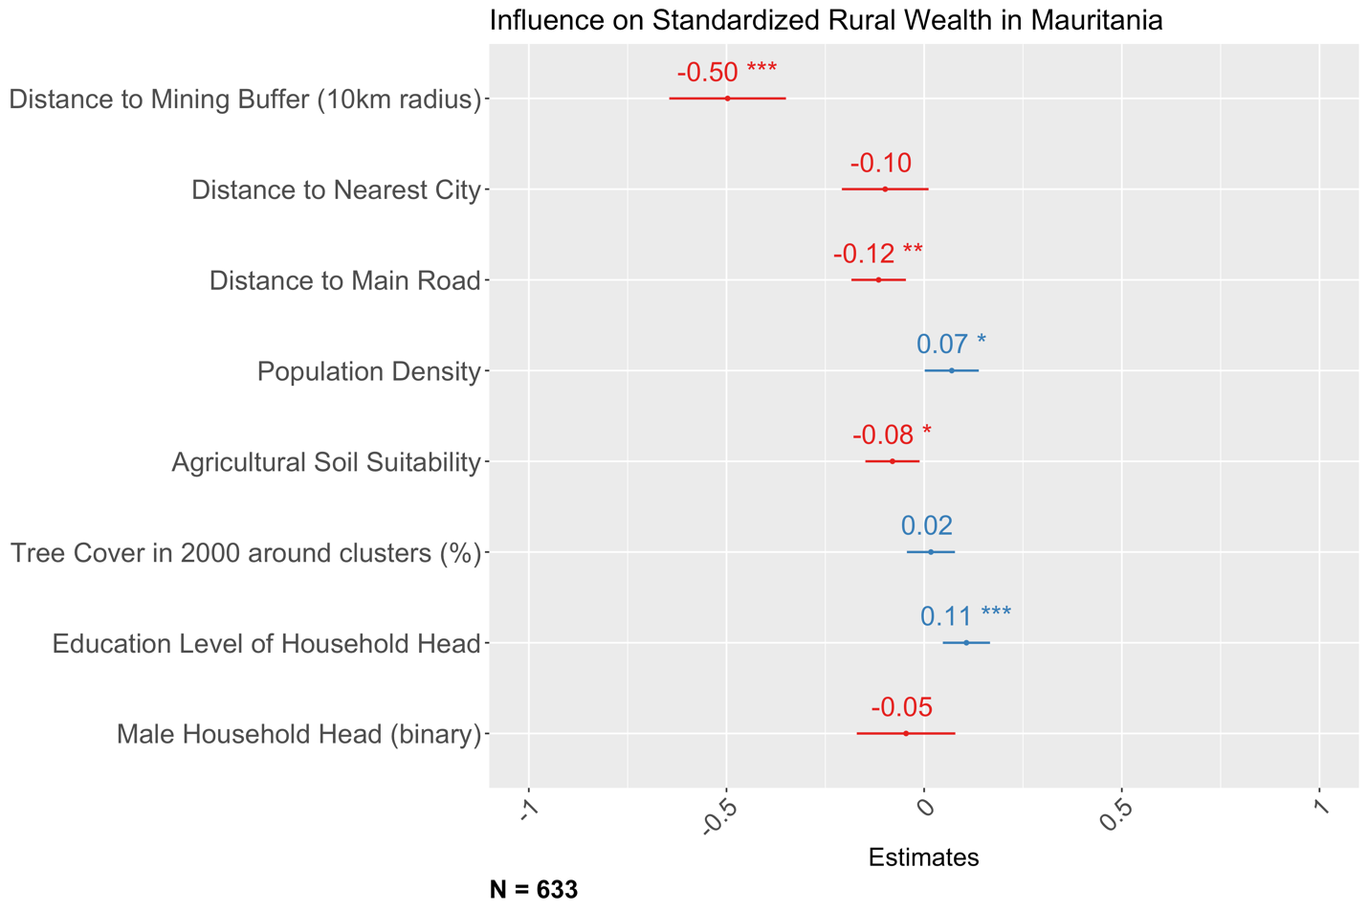

Fig. S19. Correlation between rural wealth and mine proximity in Namibia. Asterisks indicate statistical significance: *** (p < 0.001), ** (p < 0.01), and * (p < 0.05).

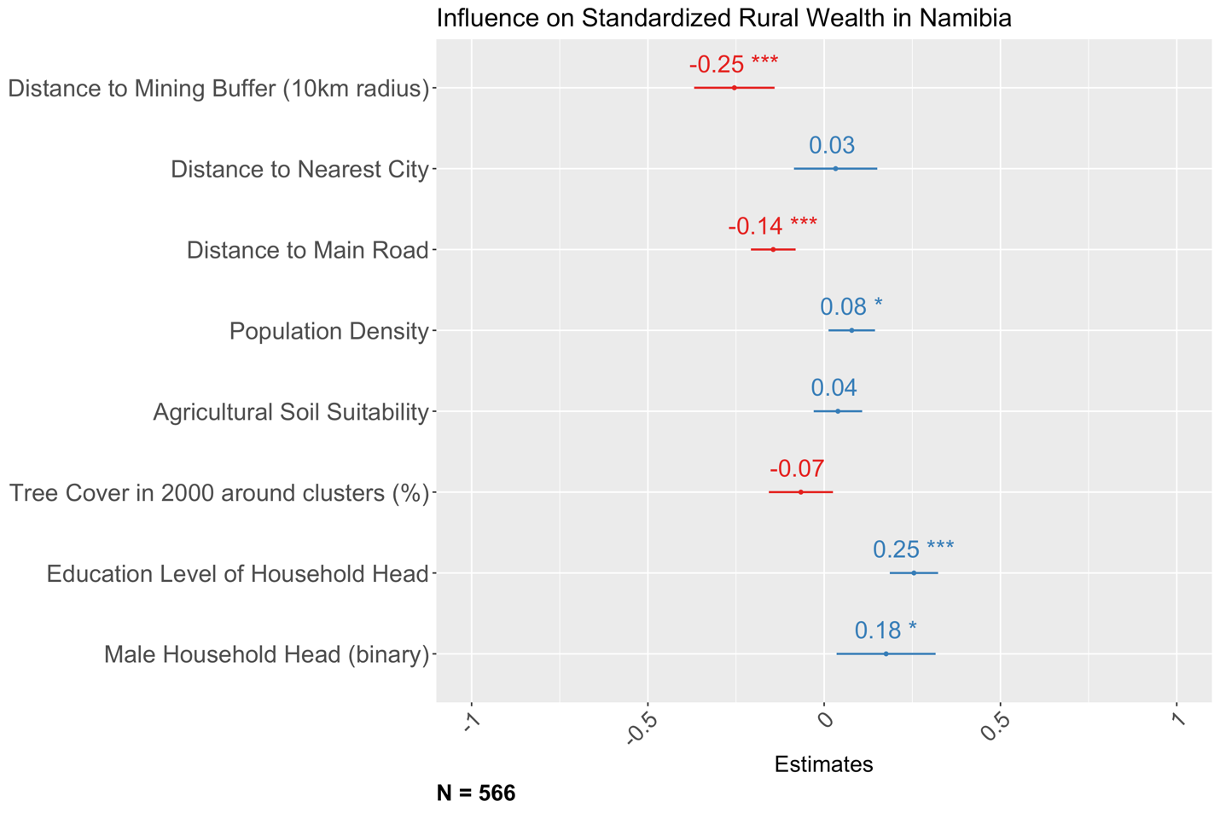

Fig. S20. Correlation between rural wealth and mine proximity in Philippines. Asterisks indicate statistical significance: *** (p < 0.001), ** (p < 0.01), and * (p < 0.05).

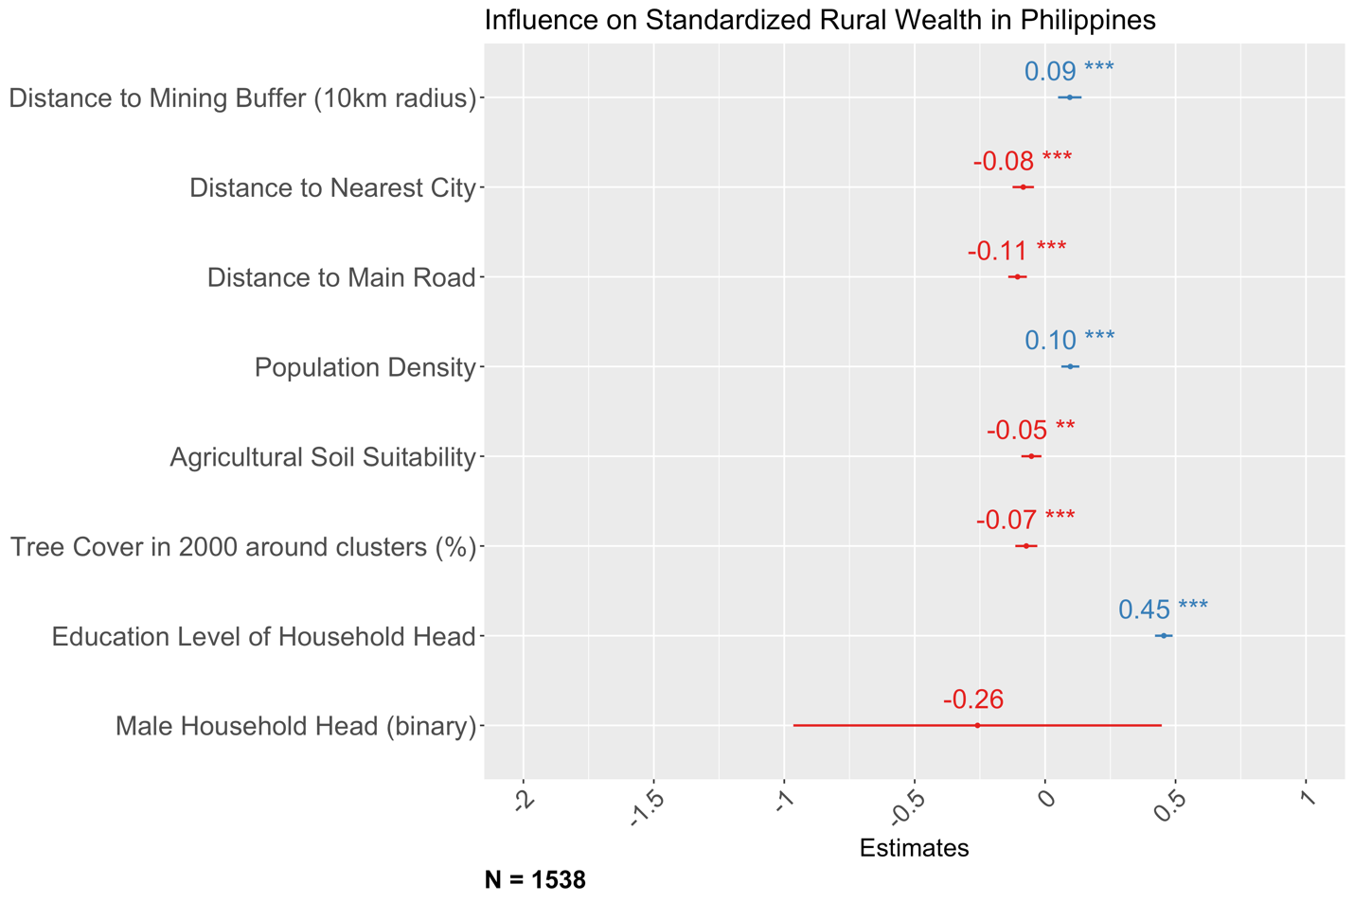

Fig. S21. Correlation between rural wealth and mine proximity in Rwanda. Asterisks indicate statistical significance: *** (p < 0.001), ** (p < 0.01), and * (p < 0.05).

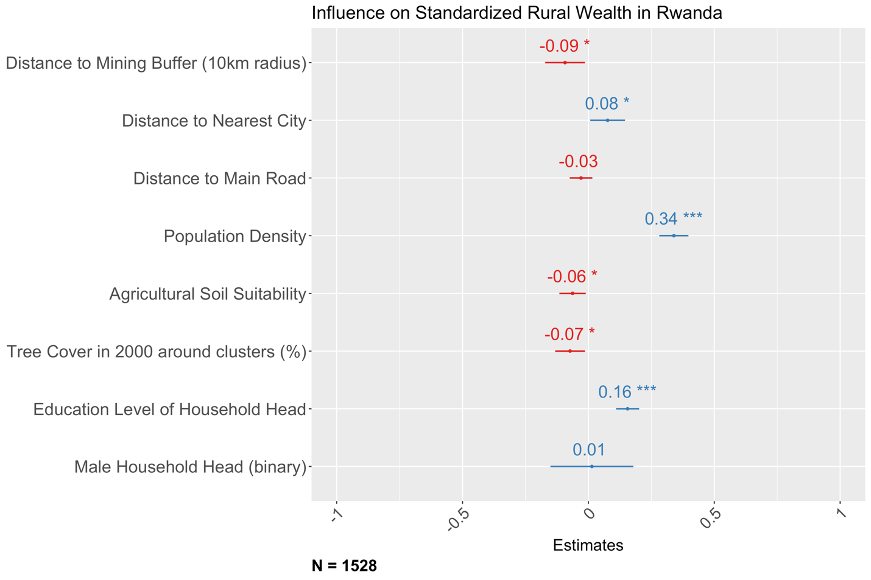

Fig. S22. Correlation between rural wealth and mine proximity in Sierra Leone. Asterisks indicate statistical significance: *** (p < 0.001), ** (p < 0.01), and * (p < 0.05).

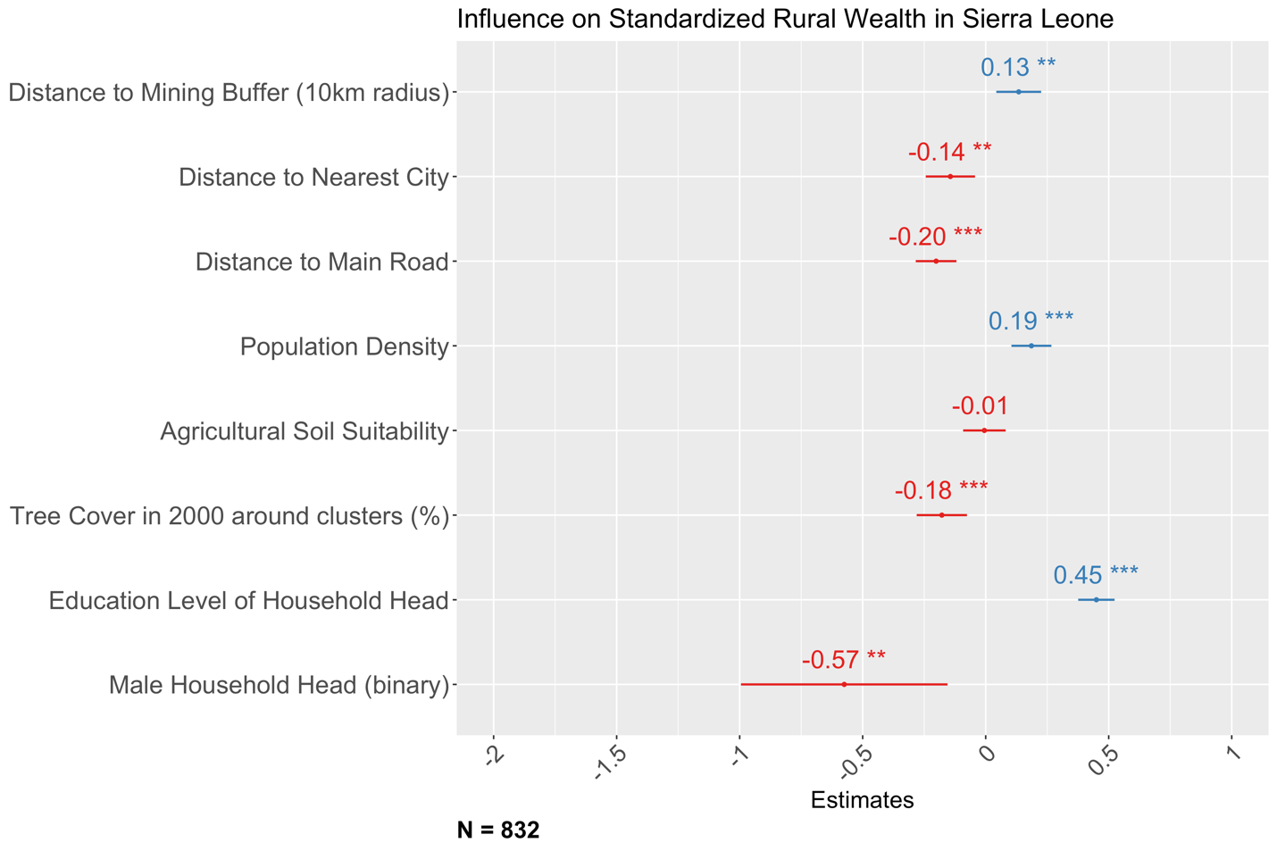

Fig. S23. Correlation between rural wealth and mine proximity in South Africa. Asterisks indicate statistical significance: *** (p < 0.001), ** (p < 0.01), and * (p < 0.05).

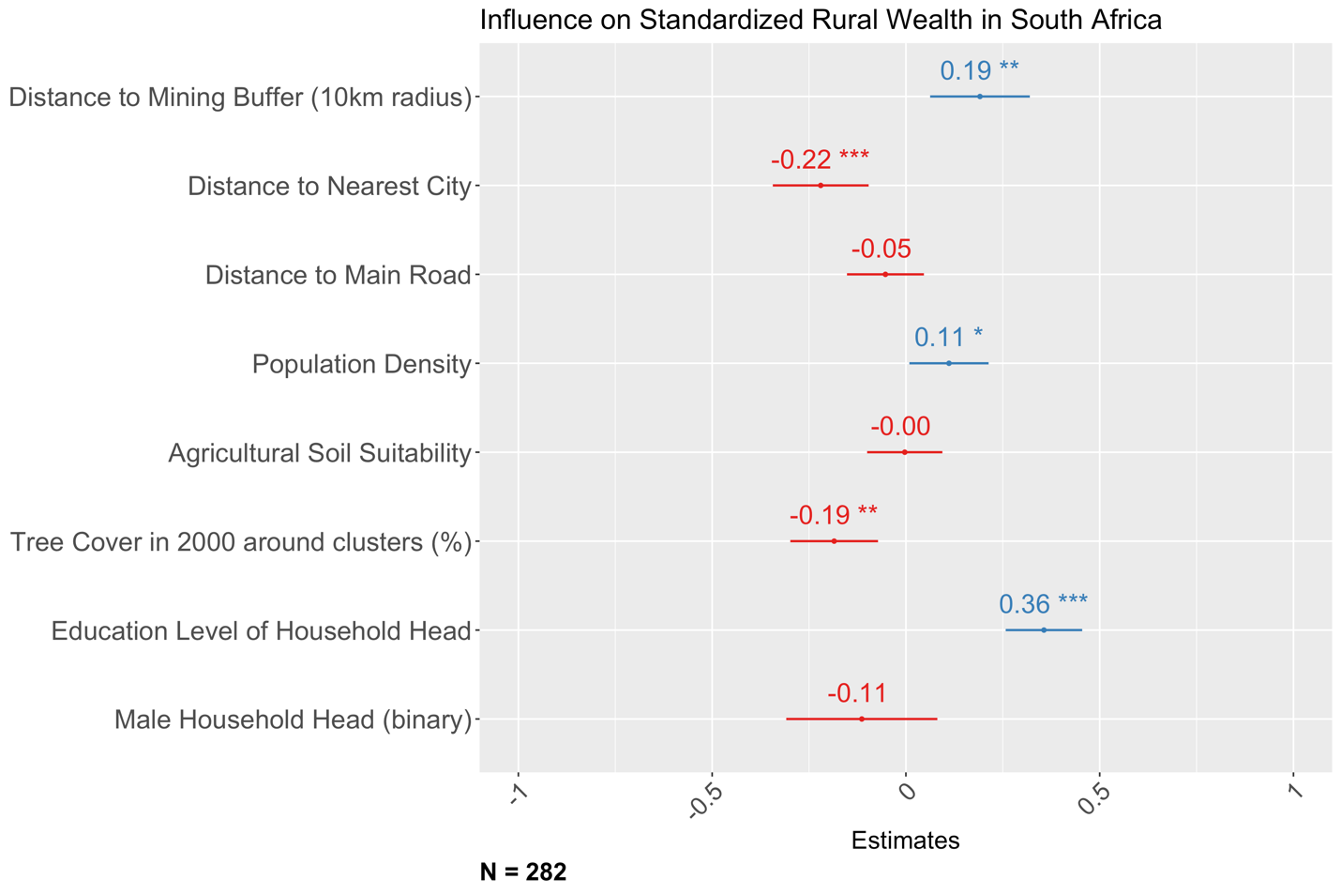

Fig. S24. Correlation between rural wealth and mine proximity in Tajikistan. Asterisks indicate statistical significance: *** (p < 0.001), ** (p < 0.01), and * (p < 0.05).

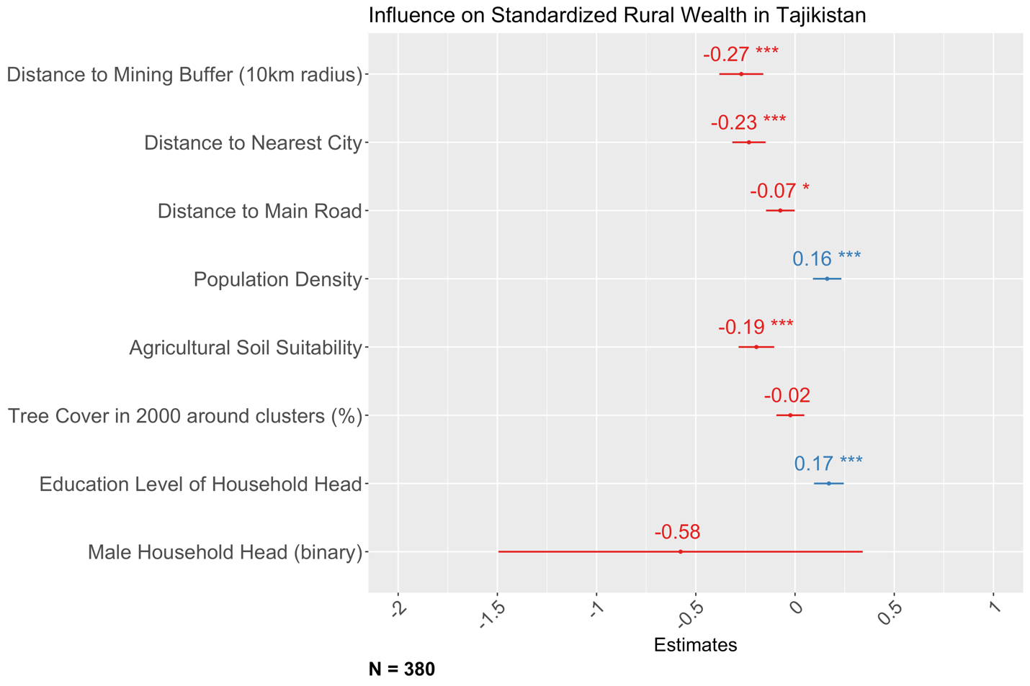

Fig. S25. Correlation between rural wealth and mine proximity in Tanzania. Asterisks indicate statistical significance: *** (p < 0.001), ** (p < 0.01), and * (p < 0.05).

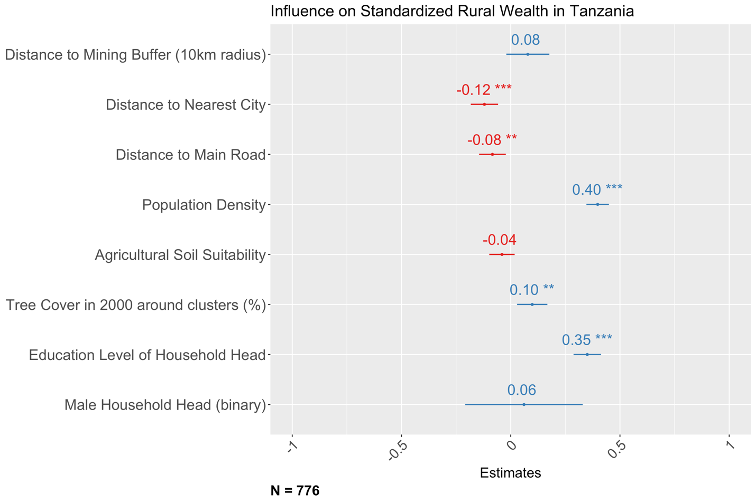

Fig. S26. Correlation between rural wealth and mine proximity in Zambia. Asterisks indicate statistical significance: *** (p < 0.001), ** (p < 0.01), and * (p < 0.05).

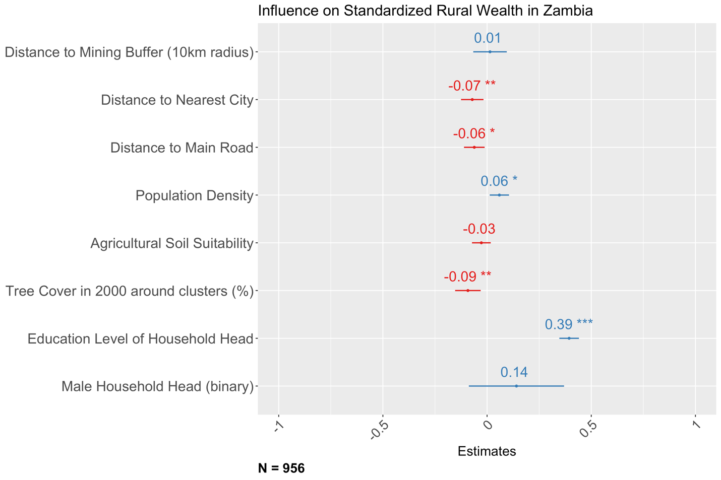

Fig. S27. Correlation between rural wealth and mine proximity in Zimbabwe. Asterisks indicate statistical significance: *** (p < 0.001), ** (p < 0.01), and * (p < 0.05).

