Supplementary Material

S1. Kaplan-Meier cumulative risk curve: DHS 2011

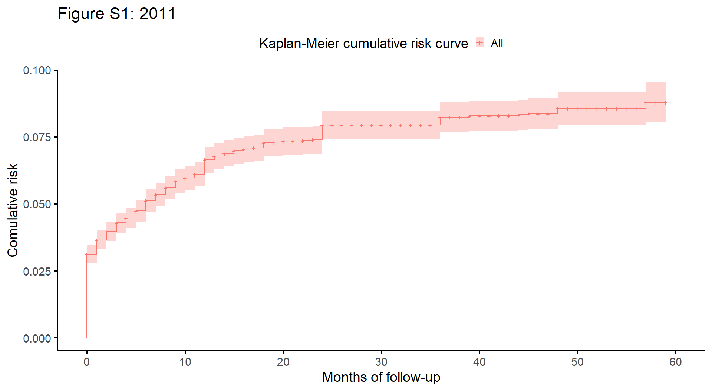

S2. Kaplan-Meier cumulative risk curve: DHS 2022/23

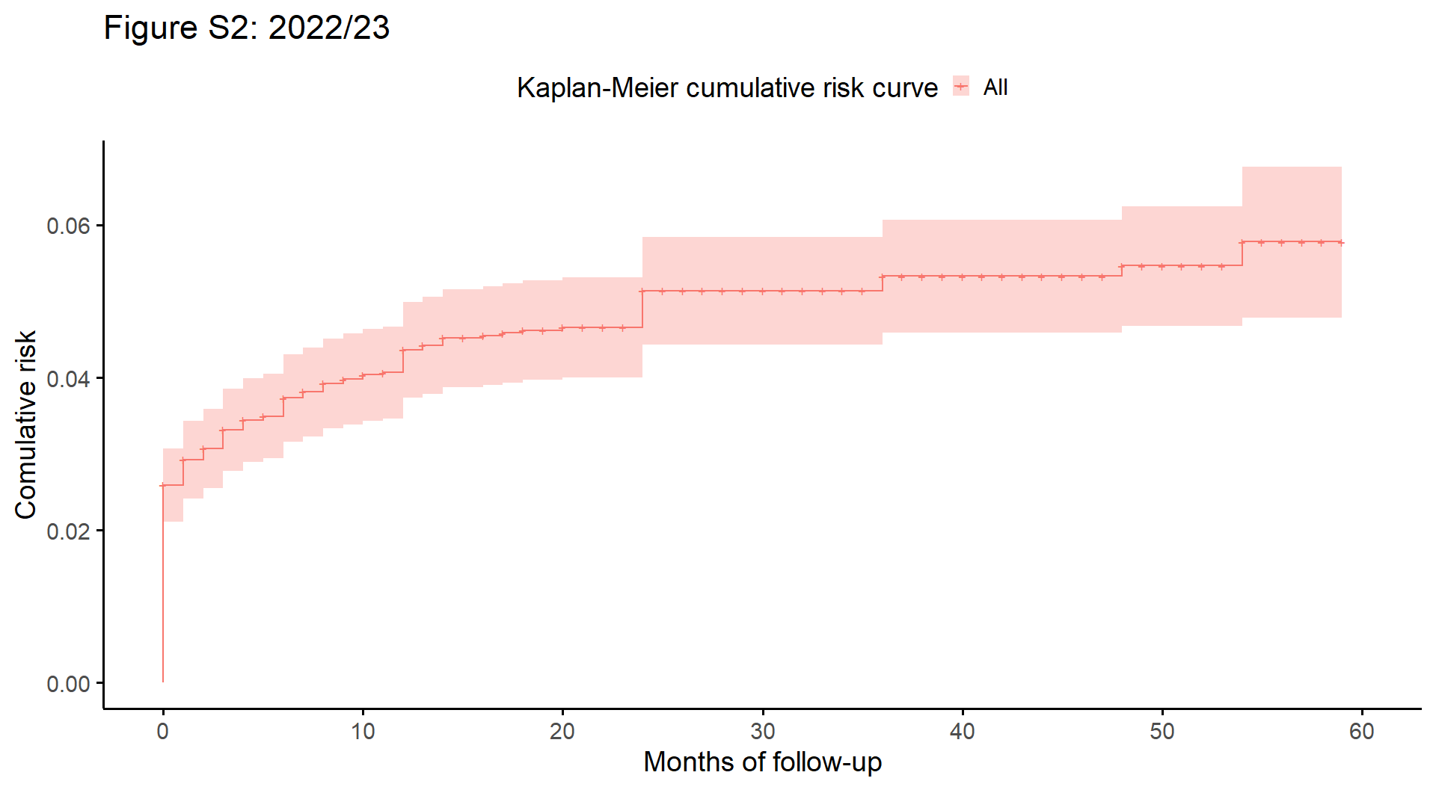

S3. Forest graphic: DHS 2011
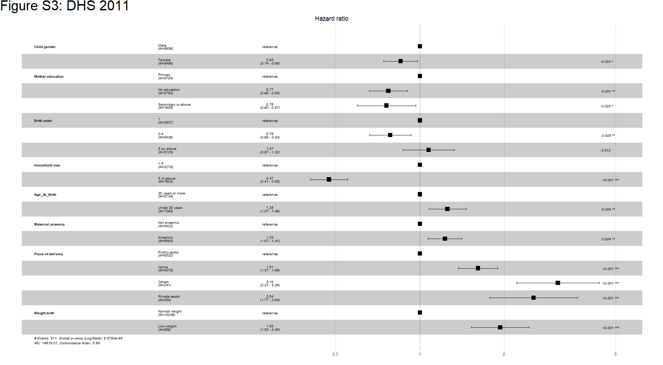
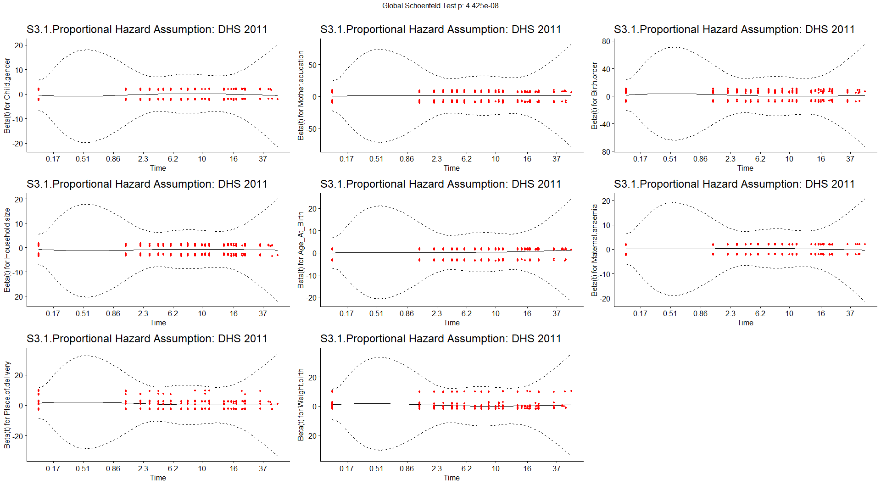
S4. Forest graphic: DHS 2022/23

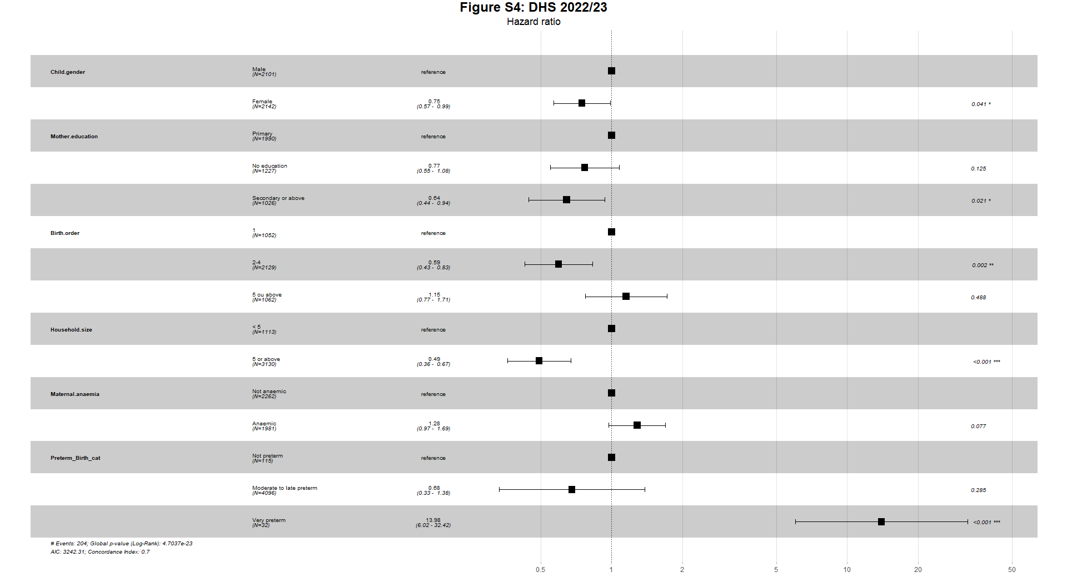
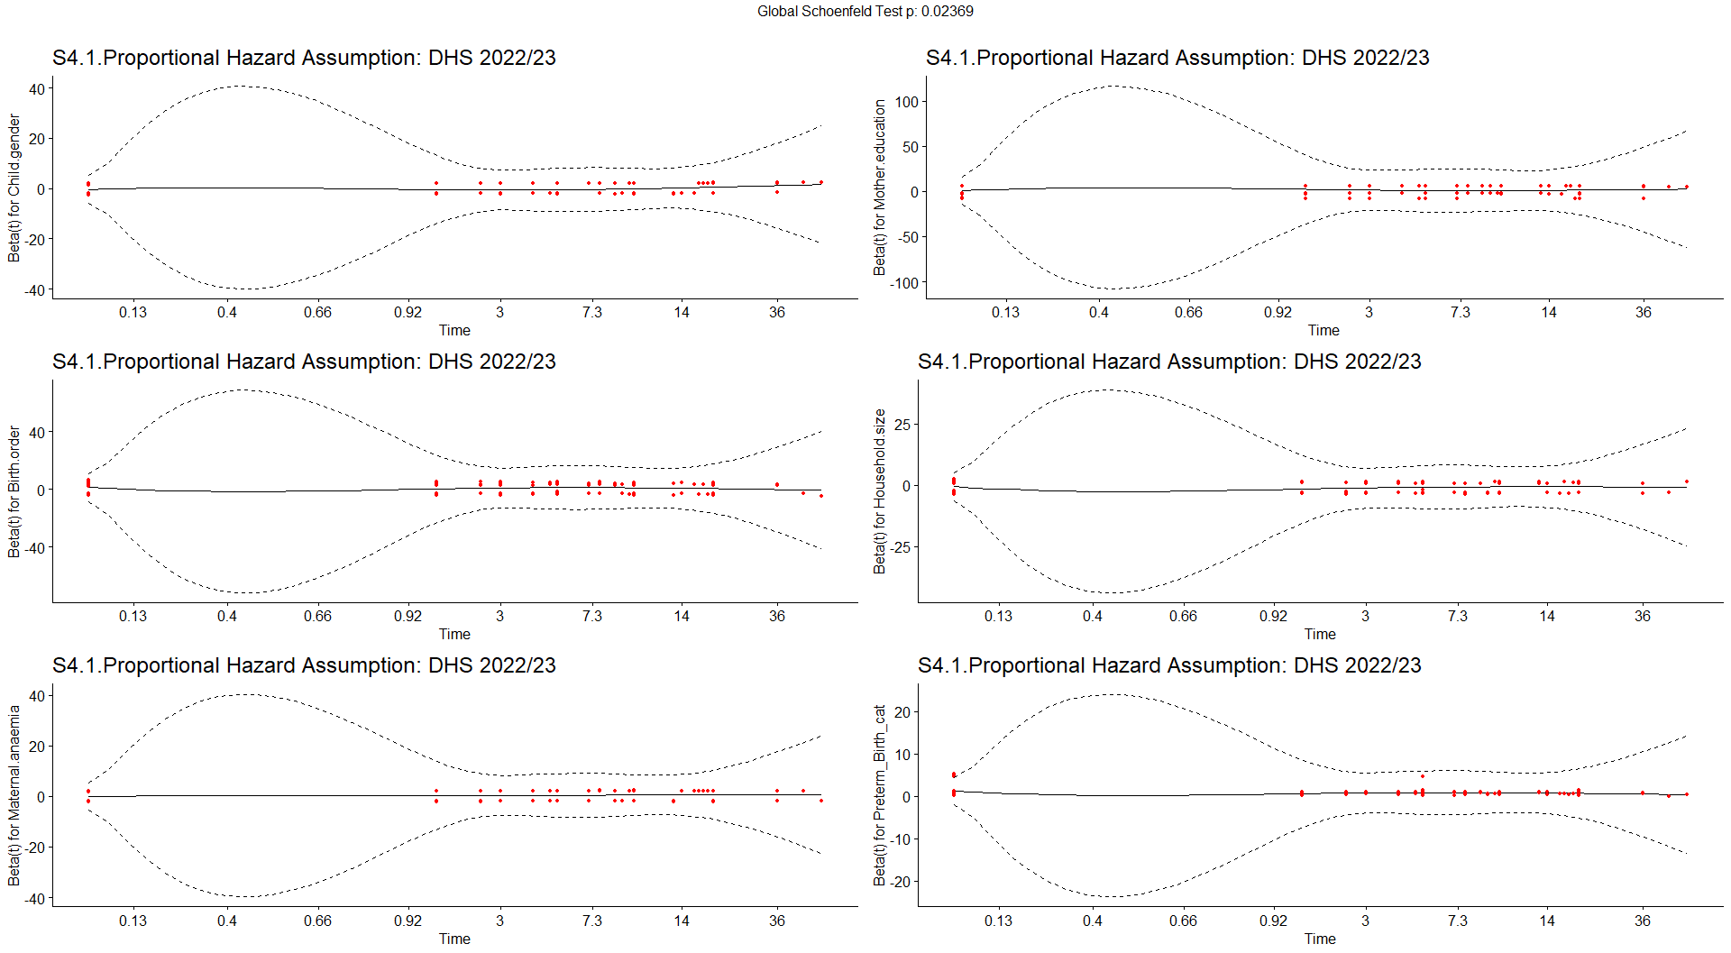

S1 Table.
Time table: DHS 2011
time (in months) | n.risk | n.event | survival | std.err | Lower 95% CI | upper 95% CI
0 | 11102 | 347 | 0.969 | 0.00165 | 0.966 | 0.972
1 | 10661 | 58 | 0.963 | 0.00178 | 0.960 | 0.967
2 | 10383 | 35 | 0.960 | 0.00186 | 0.957 | 0.964
3 | 10171 | 33 | 0.957 | 0.00193 | 0.953 | 0.961
4 | 9937 | 19 | 0.955 | 0.00197 | 0.951 | 0.959
5 | 9741 | 27 | 0.953 | 0.00203 | 0.949 | 0.957
6 | 9513 | 38 | 0.949 | 0.00211 | 0.945 | 0.953
7 | 9272 | 22 | 0.947 | 0.00216 | 0.942 | 0.951
8 | 9065 | 25 | 0.944 | 0.00222 | 0.940 | 0.948
9 | 8835 | 23 | 0.942 | 0.00227 | 0.937 | 0.946
10 | 8612 | 10 | 0.940 | 0.00230 | 0.936 | 0.945
11 | 8389 | 13 | 0.939 | 0.00233 | 0.934 | 0.944
12 | 8187 | 47 | 0.934 | 0.00244 | 0.929 | 0.938
13 | 7923 | 12 | 0.932 | 0.00247 | 0.927 | 0.937
14 | 7710 | 9 | 0.931 | 0.00250 | 0.926 | 0.936
15 | 7513 | 7 | 0.930 | 0.00252 | 0.925 | 0.935
16 | 7318 | 5 | 0.930 | 0.00253 | 0.925 | 0.935
17 | 7114 | 3 | 0.929 | 0.00254 | 0.924 | 0.934
18 | 6903 | 14 | 0.927 | 0.00258 | 0.922 | 0.932
19 | 6686 | 2 | 0.927 | 0.00259 | 0.922 | 0.932
20 | 6517 | 3 | 0.927 | 0.00260 | 0.921 | 0.932
22 | 6190 | 1 | 0.926 | 0.00260 | 0.921 | 0.932
23 | 6021 | 2 | 0.926 | 0.00261 | 0.921 | 0.931
24 | 5857 | 35 | 0.921 | 0.00276 | 0.915 | 0.926
36 | 3814 | 12 | 0.918 | 0.00287 | 0.912 | 0.923
39 | 3306 | 2 | 0.917 | 0.00290 | 0.911 | 0.923
44 | 2452 | 1 | 0.917 | 0.00292 | 0.911 | 0.923
45 | 2299 | 1 | 0.916 | 0.00295 | 0.911 | 0.922
48 | 1825 | 4 | 0.914 | 0.00311 | 0.908 | 0.920
57 | 412 | 1 | 0.912 | 0.00381 | 0.905 | 0.920

S2 Table.
Time table: DHS 2022/23
time (in months) | n.risk | n.event | survival | std.err | lower 95% CI | upper 95% CI
0 | 4243 | 110 | 0.974 | 0.00244 | 0.969 | 0.979
1 | 4097 | 14 | 0.971 | 0.00259 | 0.966 | 0.976
2 | 4007 | 6 | 0.969 | 0.00265 | 0.964 | 0.975
3 | 3921 | 10 | 0.967 | 0.00276 | 0.961 | 0.972
4 | 3833 | 5 | 0.966 | 0.00281 | 0.960 | 0.971
5 | 3733 | 2 | 0.965 | 0.00283 | 0.960 | 0.971
6 | 3651 | 9 | 0.963 | 0.00294 | 0.957 | 0.968
7 | 3580 | 3 | 0.962 | 0.00297 | 0.956 | 0.968
8 | 3508 | 4 | 0.961 | 0.00302 | 0.955 | 0.967
9 | 3429 | 2 | 0.960 | 0.00304 | 0.954 | 0.966
10 | 3346 | 2 | 0.960 | 0.00307 | 0.954 | 0.966
11 | 3274 | 1 | 0.959 | 0.00308 | 0.953 | 0.965
12 | 3212 | 10 | 0.956 | 0.00321 | 0.950 | 0.963
13 | 3137 | 2 | 0.956 | 0.00324 | 0.949 | 0.962
14 | 3058 | 3 | 0.955 | 0.00328 | 0.948 | 0.961
16 | 2916 | 1 | 0.954 | 0.00329 | 0.948 | 0.961
17 | 2843 | 1 | 0.954 | 0.00331 | 0.948 | 0.961
18 | 2769 | 1 | 0.954 | 0.00333 | 0.947 | 0.960
20 | 2619 | 1 | 0.953 | 0.00335 | 0.947 | 0.960
24 | 2368 | 12 | 0.949 | 0.00361 | 0.942 | 0.956
36 | 1503 | 3 | 0.947 | 0.00376 | 0.939 | 0.954
48 | 692 | 1 | 0.945 | 0.00400 | 0.938 | 0.953
54 | 302 | 1 | 0.942 | 0.00506 | 0.932 | 0.952

