Supplementary Information

Global hotspots of butterfly diversity in a warming world

Index
Supplementary Tables (1-2)
Supplementary Figures (1-10)

Supplementary Table 1 | Literature sources and data repositories of distribution data.

Title | Author & Year | Records | Access
Data repositories
Butterfly species distribution models | Pinkert et al. 2024 | 6,650 species | Single species maps: https://mol.org/species/; Dataset: https://doi.org/10.48600/56x3-dx56
Ant species richness and rarity | Kass et al. 2022 | 14,324 (sub-) species | DataDryad:1748244; Files: ant_sp_richness_poly_msk.tif & ant_sp_rarity_poly_msk.tif (in results_species/richness_predictions_irs60K)
Plant species richness predictions | Kreft & Jetz, 2008 | >10.000 species | Available from authors upon request
Amphibians | IUCN.org and Birdlife International | 6,437 species | iucnredlist.org/resources/spatial-data-download
Reptiles | Roll et al. 2017 | 10,063 species | Available from authors upon request
Mammals | Marsh et al. 2022 | 6,360 species | https://doi.org/10.48600/mol-48vz-p413
Birds | Jetz et al. 2012 | 9,991 species | Available from authors upon request
Butterfly occurrence records
Global Biodiversity Information Facility |  | 10,661 species (>26 Mio. raw records) | GBIF.org (01 July 2021) GBIF Occurrence Download https://doi.org/10.15468/dl.7radyr
Occasional photographic records of butterflies (Lepidoptera, Papilionoidea) in Cambodia. 1. The coastal Cardamom foothills (SW Cambodia), 2010-2018 | Kosterin (2019a) | 151 species (140 records) | Acta Biologica Sibirica 5(1):84-105. DOI: 10.14258/abs.v5.i1.5196
Occasional photographic records of butterflies (Lepidoptera, Hesperioidea and Papilionoidea) in Cambodia. 2. Ratanakiri and Mondulkiri Provinces of Eastern Cambodia, 2013-2018. | Kosterin (2019b) | 118 species (216 records) | Acta Biologica Sibirica 5(4):21-37. DOI: 10.14258/abs.v5.i4.6816
The Butterflies of Iran and Iraq | Tshikolovets, Naderi & Eckweiler (2014) | 412 species (11,483 records) | dd8f3af2-7bd6-460c-9ea0-f55fa5444015
The Butterflies of Thailand Vol. 1 | Kimura, Aoki, Yamaguchi Uémura & Saito (2011) | 342 species (3,381 records) | bf98e89a-6372-447d-b88e-8e3576b3f1c3
The Butterflies of Thailand Vol. 2 | Kimura, Aoki, Yamaguchi Uémura & Saito (2014) | 373 species (3,001 records) | 1f59a825-4e54-456d-b621-2c7bea07eb37
Butterfly expert range maps
Mariposas – Butterflies – Argentina | Klimaitis et al. (2018) | 1189 species | eca9eec5-e2fd-4228-ad61-3a95d18544e3
Sequel to ''The Life Histories of Asian Butterflies Vols. I & II'' | Igarashi & Harada (2014) | 194 species | f02f73d6-3ff5-4034-9094-1da6f91d24e9
The Life Histories of Asian Butterflies Vol. 1 | Igarashi & Fukuda (1997) | 299 species | 32955004-1f1a-422d-b27f-975c88fc765c
The Life Histories of Asian Butterflies Vol. 2 | Igarashi & Fukuda (2000) | 380 species | 142c08aa-7093-44cd-9ab8-d828e0643d7e
The complete field guide to butterflies of Australia | Braby (2016) | 408 species | b37beb0e-9f6a-4e5d-a1f0-3163303ad1fa
Butterflies of Chile | Peña & Ugarte (1996) | 165 species | 822051c1-8543-43fa-b641-be3da923aab8
The Nymphalidae of China: Part I | Lang (2012) | 423 species | ccf57b78-639f-4138-9662-2d1275e39f3d
An illustrated list of the Genus Delias Hübner of the world. | Yagishita, Nakano & Morita (1993) | 107 species | 6c08fa74-ab27-43a8-91d1-394296681a48
An illustrated checklist of the genus Elymnias Hübner, 1818 (Nymphalidae, Satyrinae) | Wei et al. (2017) | 52 species | DOI: 10.3897/zookeys.676.12579
Butterflies of Britain and Europe | Tolman (2008) | 411 species | fedd5e4d-d469-49ee-a58a-eb206a2afe02
Butterflies of the Fiji Islands | Prasad & Waqa-Sakiti (2007) | 35 species | b522a6b2-ed14-4694-9708-2bf28d446260
Life histories of Korean butterflies | Kim & Ho (2012) | 218 species | edf51b87-34ba-442b-b98b-5a080f00ded1
The Butterflies of Kyrgyzstan | Tshikolovets (2005) | 274 species | 3428f989-e644-45c5-9320-7d032fa498dc
The Butterflies of Ladak (N.-W. India) | Tshikolovets (2005) | 87 species | f33371ca-1480-4387-a6e2-91f5fc933712
Butterflies of Mexico and Central America | Glassberg (2007) | 1,594 species | f072f6ea-20ab-43c0-96f6-5edef46669db
The Butterflies of Mongolia | Tshikolovets (2009) | 268 species | d08260ae-09b7-42c9-a597-3ee29874a59a
Kaufman field guide to butterflies of North America | Brock & Kaufman (2006) | 607 species | 8f316f82-7356-44ee-823d-8f830f241fab
New Zealand Butterflies | Gibbs (1980) | 23 species | f2fc7933-fd26-41a2-846d-f3ed89a3973f
Guide to the Butterflies of the Palearctic Region, Nymphalidae part I, Tribe Argynnini: Argynnis, Issoria, Brenthis, Argyreus | Tuzov & Vozano (2003) | 31 species | 62f163d2-fff4-42c4-9a61-c55c62904817
Guide to the Butterflies of the Palearctic Region, Nymphalidae part II, Tribe Argynnini: Boloria, Proclossiana, Clossiana | Tuzov & Vozano (2006) | 39 species | 25cef51d-ab01-4390-86de-e03e2f3f7ea3
Guide to the Butterflies of the Palearctic Region, Nymphalidae part III. Subfamily Limenitidinae. Tribe Neptini | Bozano (2008) | 53 species | 88b436d9-9941-4d19-99bc-2644d046950e
Guide to the Butterflies of the Palearctic Region, Nymphalidae part VI, Family Limenitidinae, Tribes Limenitidini and Chalingini | Gallo & Della Bruna (2013) | 37 species | 05d432ad-3c74-477d-95f9-f048ed47332f
Guide to the Butterflies of the Palearctic Region, Satyrinae part V, Tribe Satyrini: Satyrus, Minois, Hipparchia | Sbordoni et al. (2018) | 53 species | 89229591-6e24-4787-ac3b-034bf8795bde
Butterflies of the South East Asian Islands, Volume I: Papilionidae | Tsukada & Nishiyama (1982) | 123 species | ff1ef946-95b5-46d4-b9f2-9918a62918fe
Butterflies of the South East Asian Islands, Volume II: Pieridae and Danaidae | Yata & Morishita (1985) | 235 species | 049d0544-50b3-4408-8941-f6988c72f6e5
Butterflies of the South East Asian Islands, Volume III: Satyridae, Amathusiidae & Libytheidae | Aoki, et al. (1982) | 214 species | dd9fe10d-c191-49d3-83e6-ea8134646072
Butterflies of the South East Asian Islands, Vol. IV: Nymphalidae | Tsukada (1985) | 194 species | e0f7ad44-375b-4c4f-bae6-c31401a6f57a
Butterflies of the South East Asian Islands, Vol. V: Nymphalidae | Tsukada (1991) | 160 species | d73946d2-9ad1-480d-b26b-4afec6052266
The butterflies of Russia: classification, genitalia, keys for identification (Lepidoptera: Hesperioidea and Papilionoidea) | Gorbunov (2001) | 469 species | afabd30f-96cd-460f-82a1-7197f83e2d9e
Butterflies of Eastern Europe, Urals and Caucasus | Tshikolovets (2003) | 291 species | fe4b9fd2-7da6-46b8-8bef-754044461210
Butterflies of South Africa | Woodhall (2005) | 652 species | 79361741-0668-4e77-933c-1eac68316fd9
The Butterflies of Altai, Sayans and Tuva (South Siberia) | Tshikolovets et al. (2009) | 243 species | 08653f6b-4204-4ac3-84a8-68ac2b52a4e4
The Butterflies of Tajikistan | Tshikolovets (2003) | 281 species | 531b17f2-4185-4d32-b95b-a2c5a3863e53
Butterflies of Transbaikal Siberia | Tshikolovets (2002) | 214 species | 269074a8-8a8b-4ad4-9896-6639085a3207
The Butterflies of Caucasus and Transcaucasia (Armenia, Azerbaijan, Georgia, and Russian Federation) | Tshikolovets (2012) | 291 species | c26746e9-a77c-4caa-a74e-b5dc1608690d

Supplementary Table 2 | Dissimilarity in species composition of biogeographical realms. Dissimilarities were calculated using Chao’s dissimilarity index based on the aggregated number of grids per species and biogeographical realm (for n see Fig. 2).
 | Afrotropic | Australasia | Indomalayan | Nearctic | Neotropic | Oceania
Afrotropic
Australasia | 0.949
Indomalayan | 0.955 | 0.731
Nearctic | 0.992 | 0.987 | 0.988
Neotropic | 0.947 | 0.993 | 0.993 | 0.735
Oceania | 0.976 | 0.878 | 0.952 | 0.970 | 0.989
Palearctic | 0.952 | 0.957 | 0.741 | 0.882 | 0.994 | 0.966

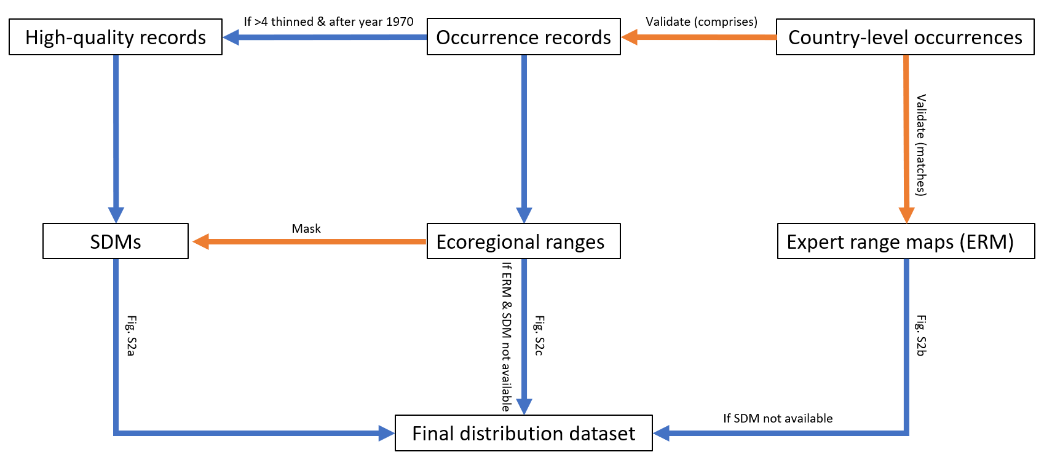
Supplementary Fig.1 | Data integration scheme. The core product is a composite of 6,650 species distribution models, expert range maps for additional 881 species and ecoregional range maps for additional 5,137 species. Orange arrows in the scheme are informative and blue are processing links. Ecoregional range maps are intersections of cleaned occurrence data and the terrestrial ecoregions of the world. SDMs use high-quality (cleaned) records and the binary predictions are masked by ecoregional ranges of species. If there were too few data or the quality of the species distribution model was not sufficient, expert range maps were used. If no expert range map was available or the available map did not cover all checklist countries, ecoregional ranges were used.
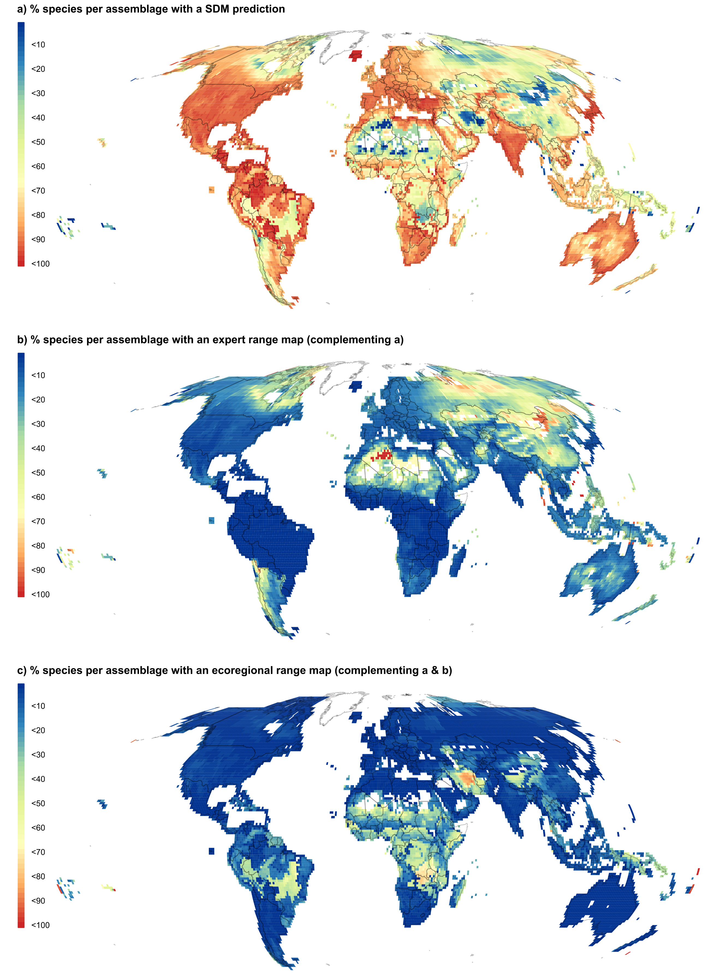
Supplementary Fig.2 | Data availability of different types of distributional data. Maps show the proportion of butterfly species for with a, species distribution models (6,650 species) b, expert range maps (additional 881 species) or c, ecoregional range maps (additional 5,137 species) were used.

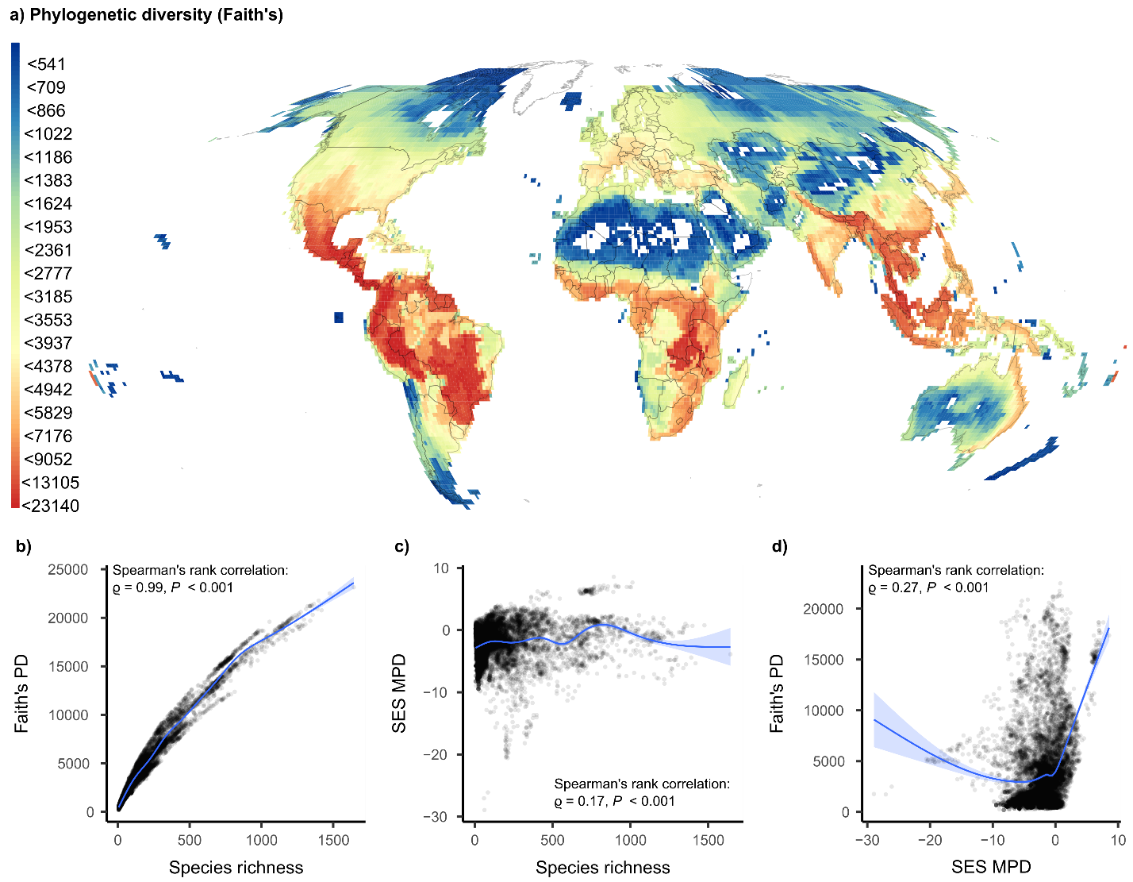

Supplementary Fig.3 | Global pattern of phylogenetic diversity (Faith’s PD). Phylogenetic diversity calculated as the sum of branch lengths of the minimal spanning tree butterfly species co-occurring in a grid (110 km ×110 km). In all main analysis an alternative measure of PD (standardized effect sizes of mean pairwise distances) was used because of the strong dependence of Faith’s PD is technically strongly correlated to species richness. The relationship of species richness and Faith’s PD is shown in the inset scatterplot.

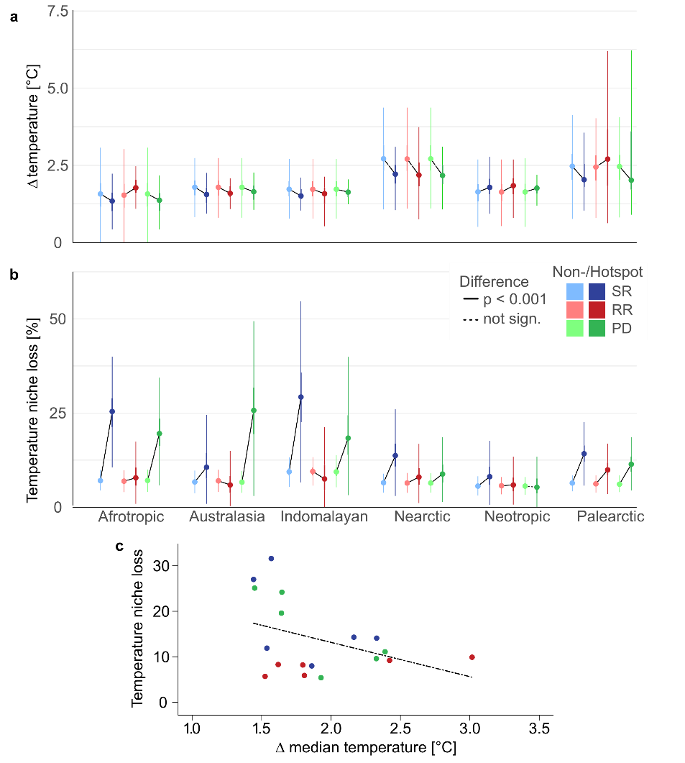
Supplementary Fig.4 | Projected future temperature niche loss and temperature difference in non-hotspots and hotspots. a, Temperature difference and b, temperature niche loss for non-hotspots and hotspots (for n and location see Fig. 2) across realms and aspects of butterfly diversity under global warming (RCP 8.5). c, Relationship of temperature niche loss and temperature difference until the year 2070 among realm-level hotspots of species richness, range rarity, and phylogenetic diversity under an ensemble model for the scenario RCP 4.5. Plots in (a) and (b) show median values and the inner interquartile range of values and its 1.5-fold (dots, thick/thin bars). Notably, projected future temperature niche loss and temperature difference appear unrelated (Spearman’s ρ = –0.43; P = 0.072; n = 18). Further analyses comparing temperature niche loss and temperature difference between non-hotspots and hotspots can be found in Extended Data Fig. 1 and 3.

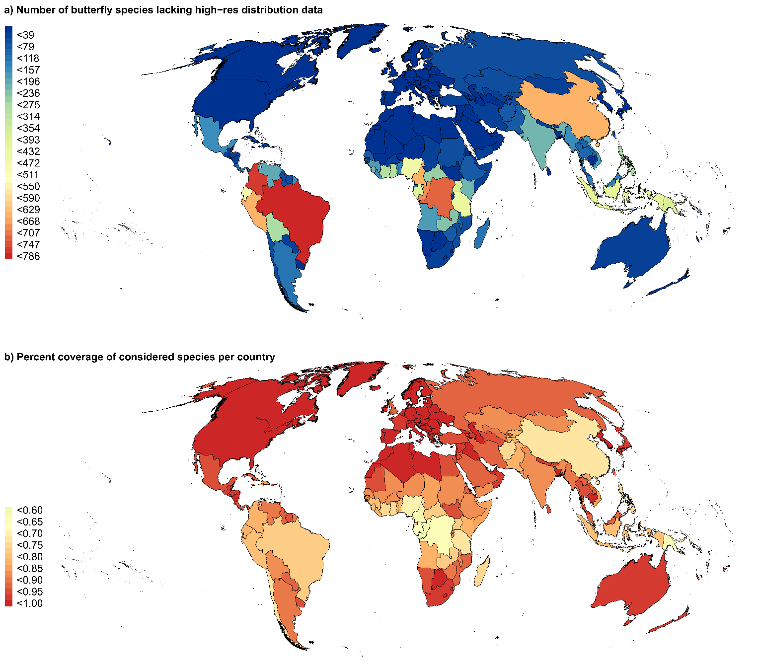
Supplementary Fig.5 | National coverage of distribution data. a, Absolute count of species without high resolution distribution data (SDMs, expert range maps or ecoregional range maps), b, Species count relative to the total of formally described species in a country (proportion; 19,317 species total; 13 species were lacking country-level distribution information). Color class intervals are scaled to equally wide classes for (a) and to equal frequency classes for (b). The maps are shown in a Mollweide equal-area projection. The proportion of included species was negatively associated with the number of accepted species per country (Spearman’s rank correlation: ρ = –0.59, n = 248, P < 0.001).
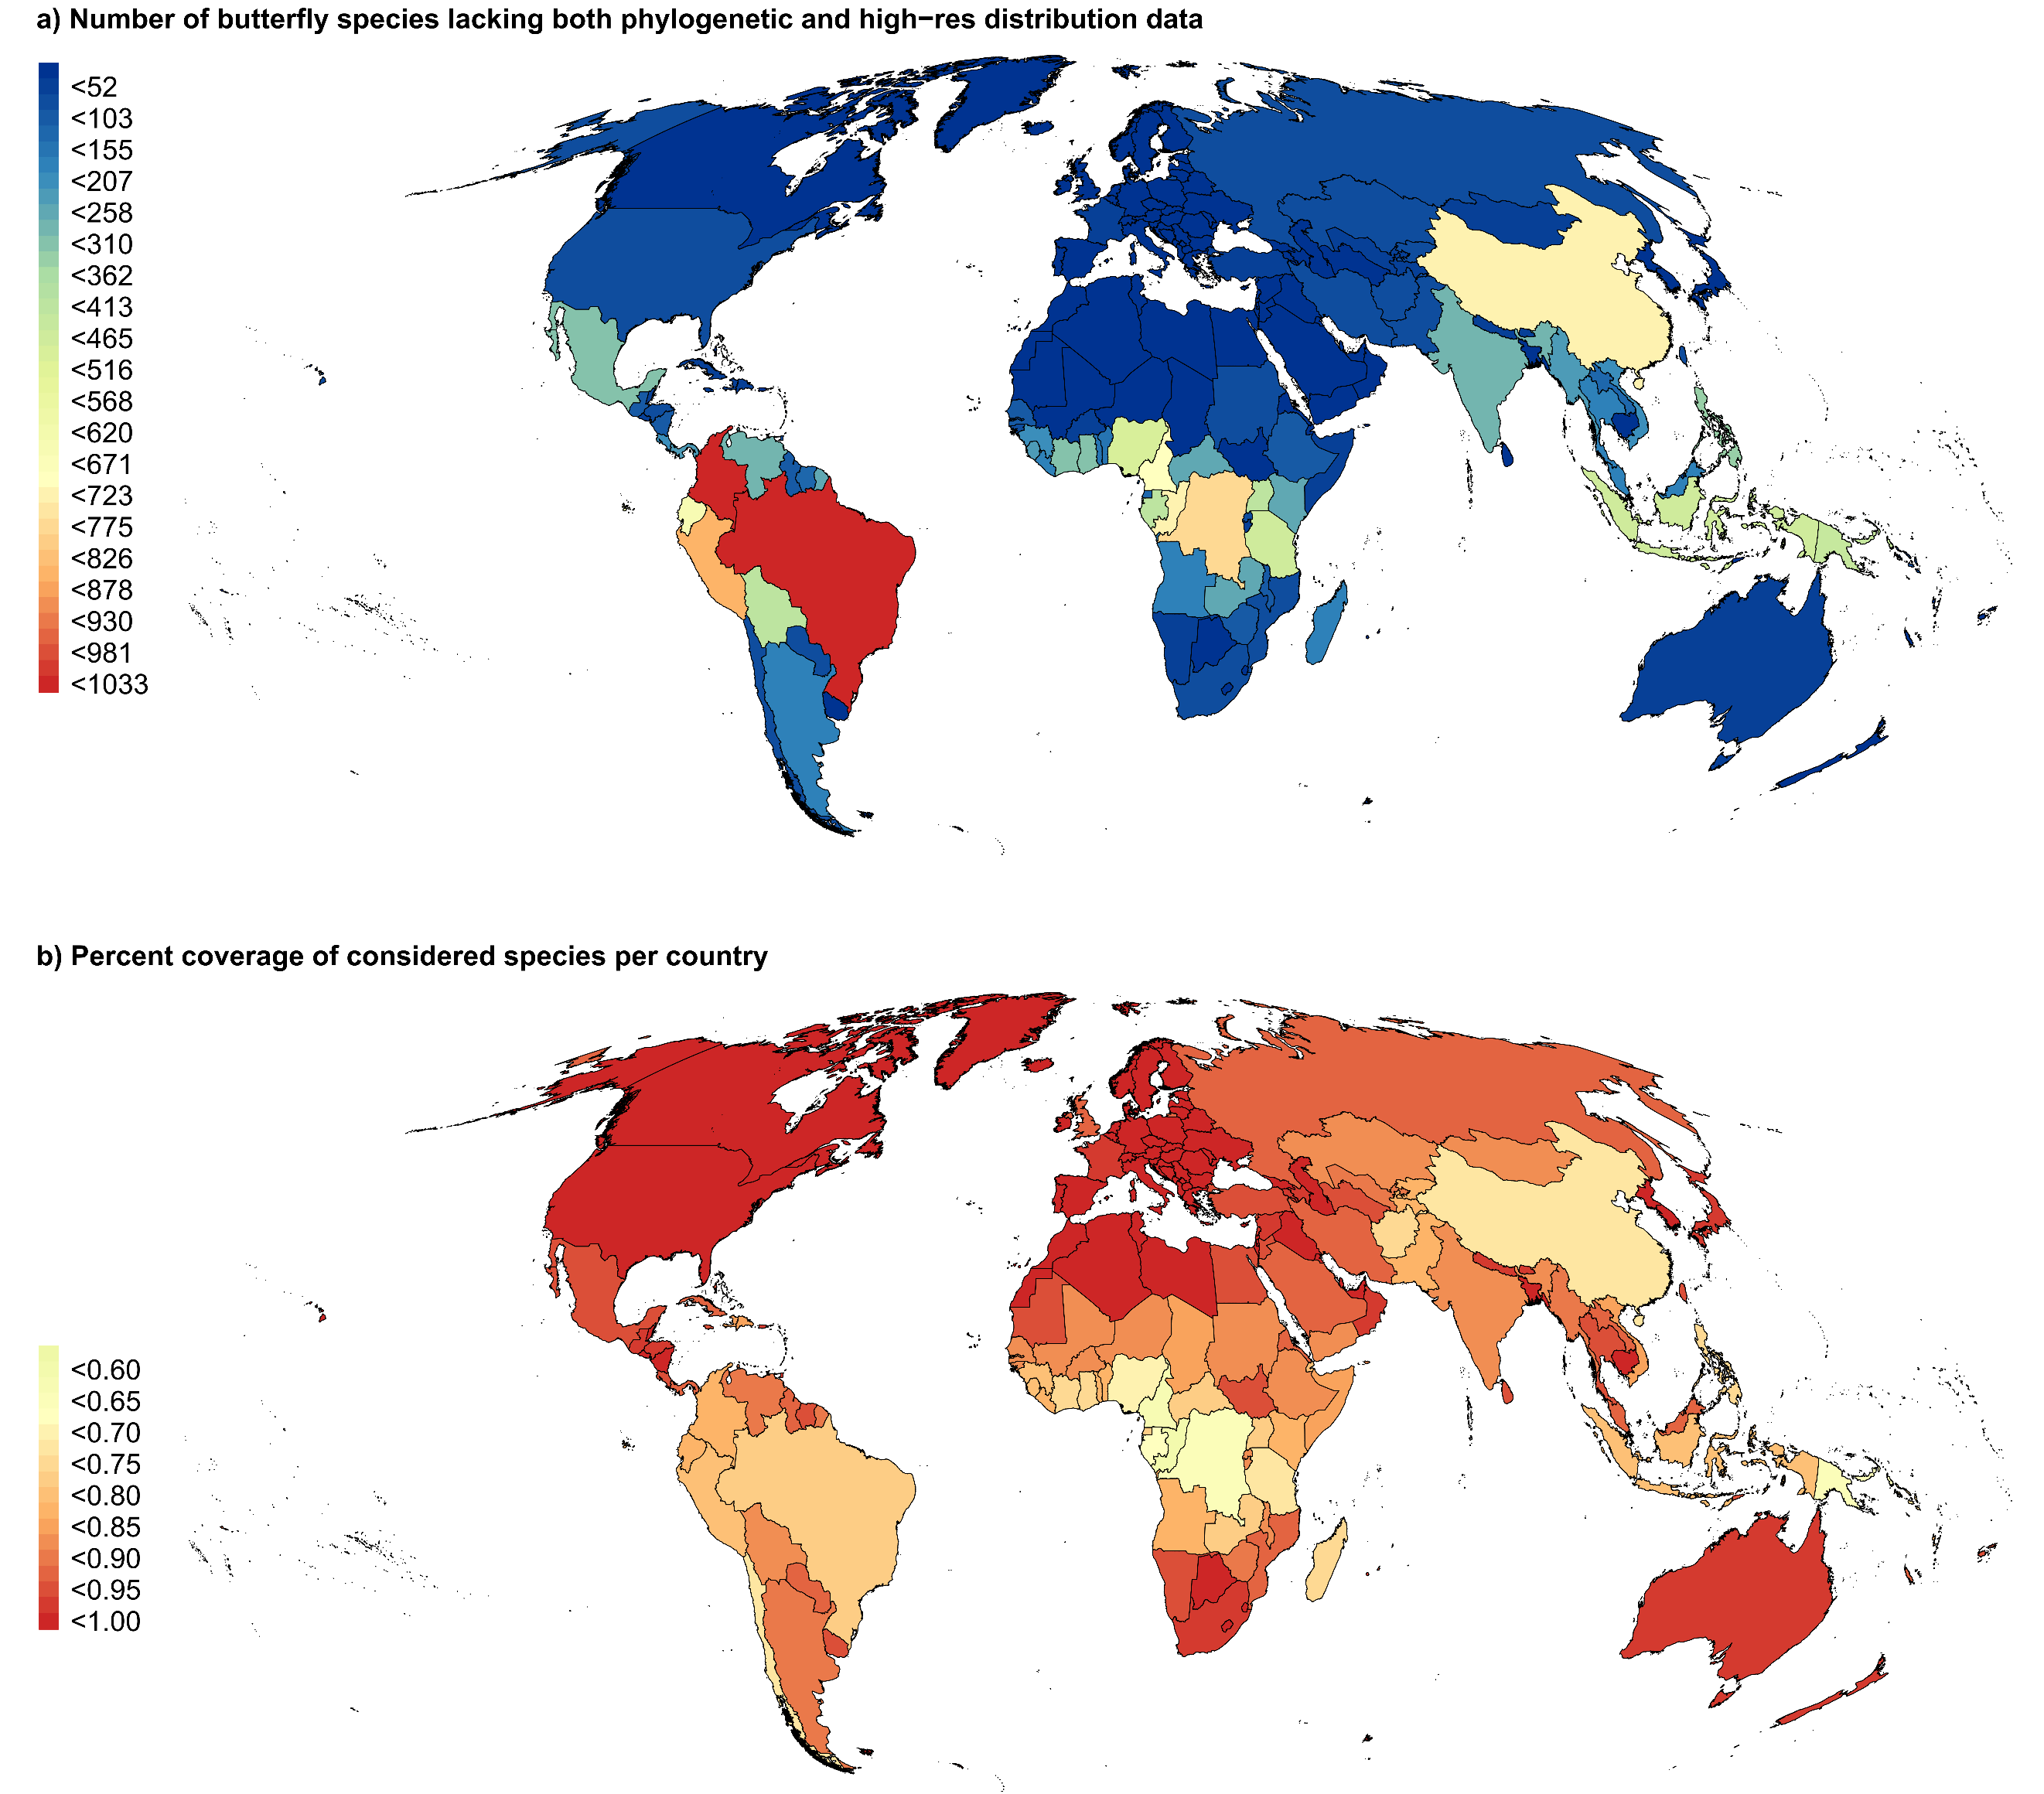
Supplementary Fig.6 | National coverage of combined phylogenetic and distribution data. a, Absolute count of excluded species, b, Species count relative to the total of formally described species in a country (proportion; 19,317 species total; 13 species were lacking country-level distribution information). Color class intervals are scaled to equally wide classes for (a) and to equal frequency classes for (b). Maps are shown in a Mollweide equal-area projection. The proportion of included species was negatively associated with the number of accepted species per country (Spearman’s rank correlation: ρ = –0.53, n = 248).

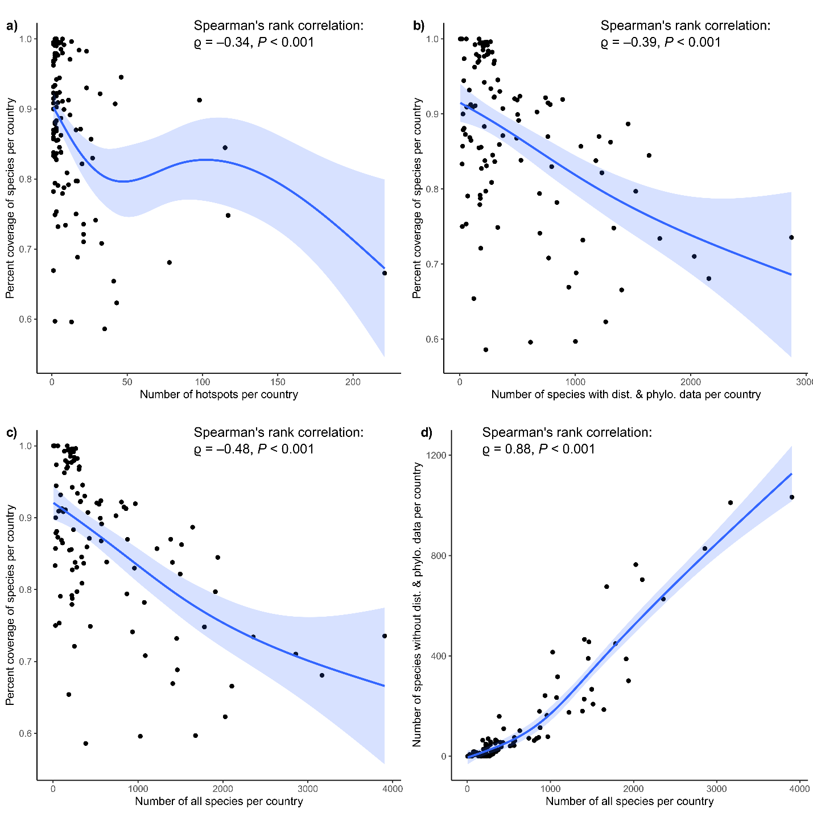

Supplementary Fig.7 | Data coverage. Relationships of the percentage of species with phylogenetic and distribution data relative to total number of accepted butterfly species with the number of identified hotspots (any: SR, rarity, or PD) (a), the number of species with both phylogenetic and distribution data (b) and the number of accepted species per country (c). d, Relationship of the number of species without phylogenetic or distribution data and the number of all accepted species per country (n = 128 countries with at least one hotspot). Spline-based smoothed regressions are only provided for visualizing trends. Statistics in the inset of each figure provide results from Spearman’s rank correlations of the relationships. If the availability of data would have biased the hotspot identification, more hotspots should be found in countries with greater coverage. Our results show the opposite (a) and suggest this is results from lesser covered countries having a greater number of species (b, c) and there top-ranked position does not change even when adding hundreds of currently missing species (d, i.e. the number of included species is monotonically positively related to the number of all accepted species). For maps of the species coverage per country refer to Supplementary Fig. 6

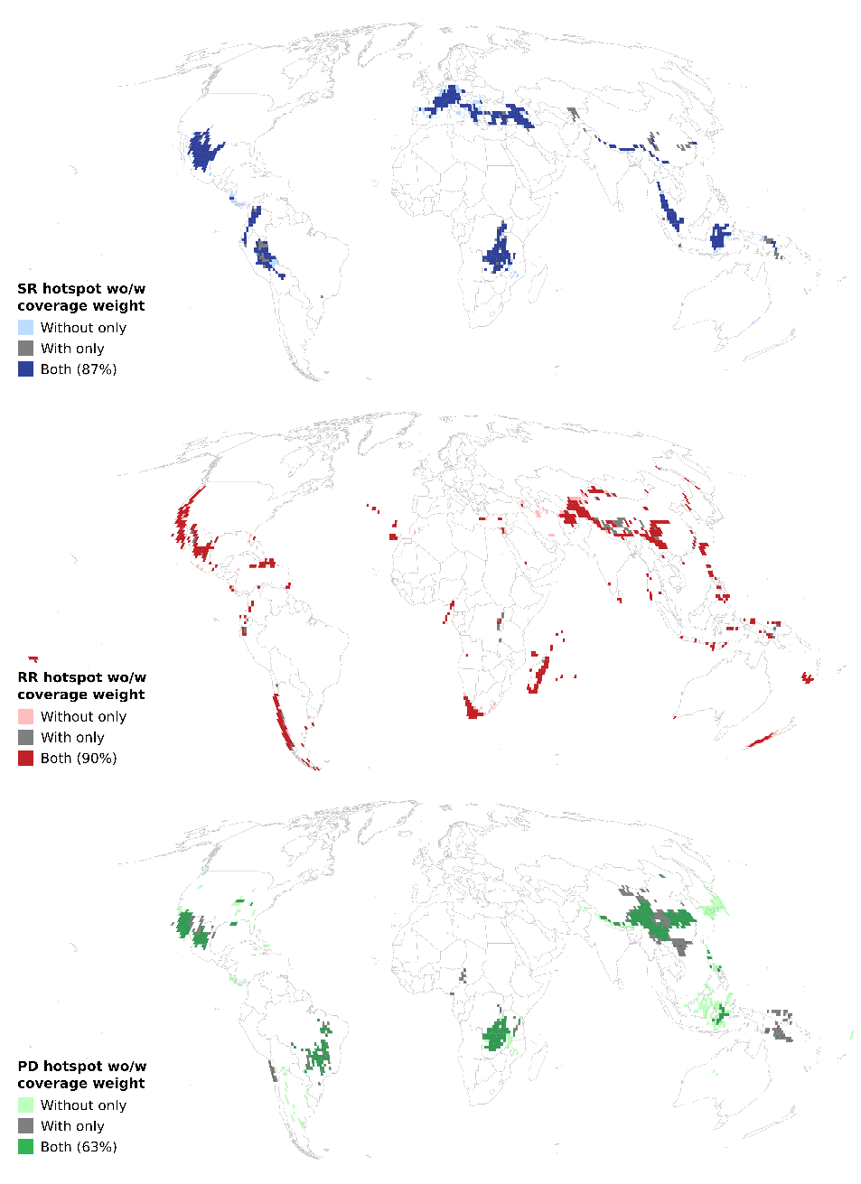
Supplementary Fig.8 | Robustness of hotspot locations against missing data. Hotspots (top 5%) of butterfly species richness, range rarity, and phylogenetic diversity across realms, with adjustments made for the diversity value of cells based on country-specific species coverage (see Supplementary Fig. 2, 3) as inverse weight. Hotspots robust to weighting are depicted in full colors, while hotspots identified only prior to weighting are shown as light-colored cells. Hotspots newly identified following the coverage-weighting are shown as dark gray cells.

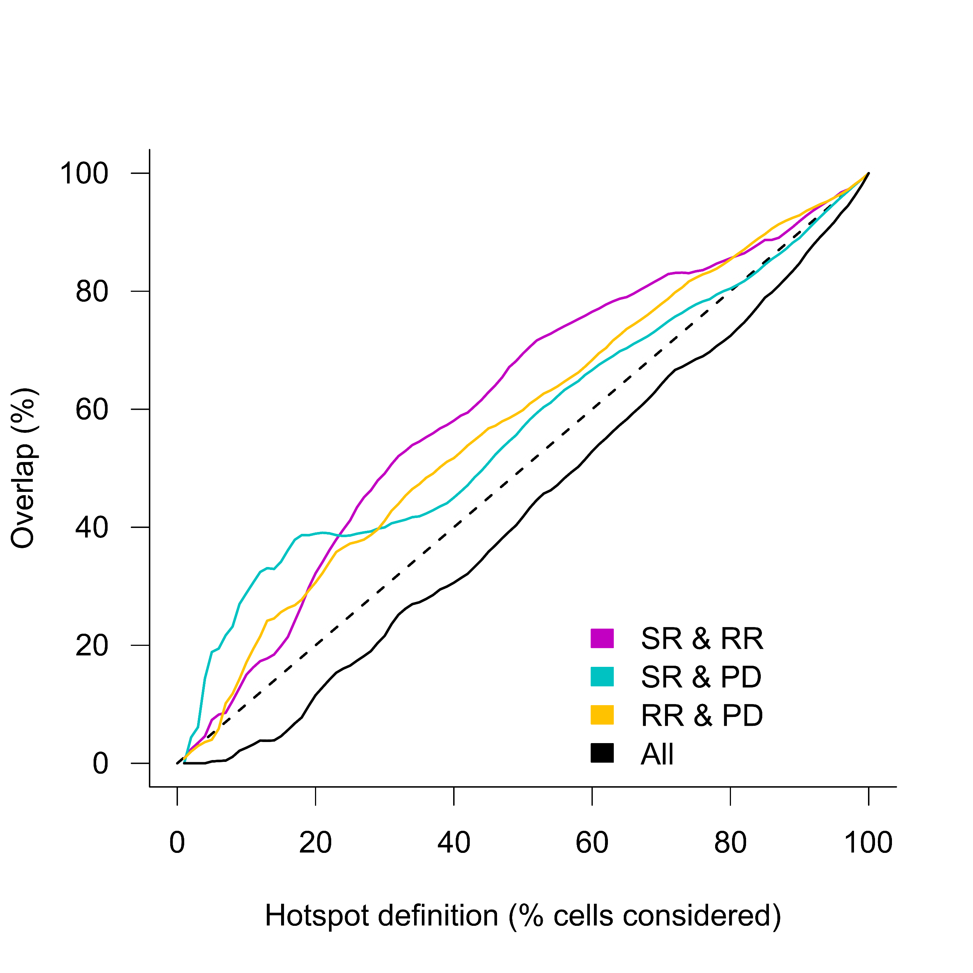
Supplementary Fig.9 | Robustness of congruence among diversity aspects to an expanded hotspot definition. Overlap of among hotspots of species richness, range rarity and phylogenetic diversity (SR, RR, PD) across varying hotspot definitions, ranging from 1% to 100% of the total number of cells (12,515), in 1% increments.

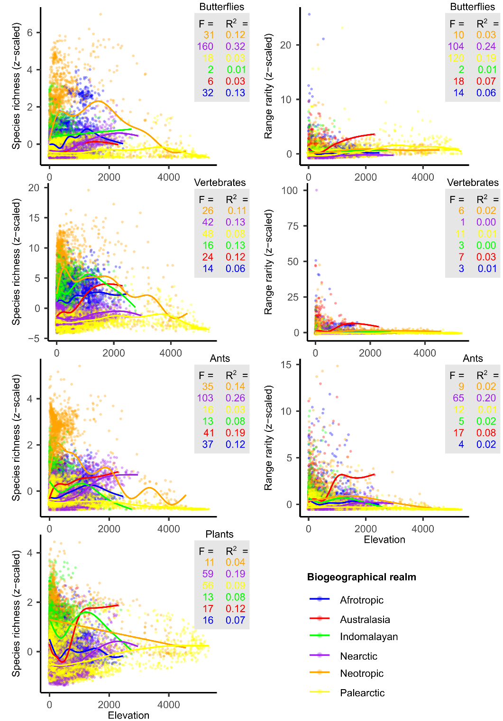
Supplementary Fig.10 | Relationships of species richness and range rarity with elevation for realms and taxa. Elevational gradients of standardized (z-scaled) species richness and range rarity of butterfly, vertebrate, ant, and plant assemblages (spline-based smoothed regression). F-values and explained variance (R²) of spline-based smoothed regressions per realm and taxon are shown in inset boxes. Values for vertebrates were individually standardized and subsequently summed up for each assemblage.

