EXTENDED DATA

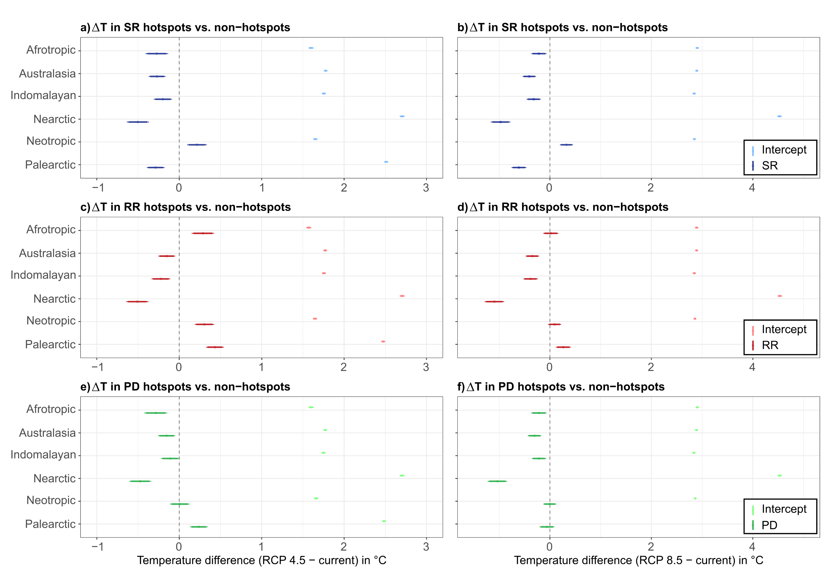

Extended Data Fig.1 | Tests for differences in projected future warming between non-hotspots and hotspots. Standardized coefficients and 95%-CI (dots and bars) from single regressions of differences in temperature change (projected future minus current mean annual temperatures) in non-hotspots and hotspots per realm. Results are provided for hotspots of species richness, range rarity, and phylogenetic diversity (SR – blue, RR – red, PD – green) under ensemble models for the scenarios RCP 4.5 (a, c, e) and RCP 8.5 (b, d, f). Sample sizes (n, i.e. grids) per realm: Afrotropic = 1,901; Australasia = 1,182; Indomalayan = 977; Nearctic = 2,023; Neotropic = 1,873; Palearctic = 4,559. For instance, in (a) the Afrotropic hotspots of species richness are estimated to show an on average 0.3° C lesser increase in temperature compared to the average increase in non-hotspots (1.6 degree) by 2070 under RCP 4.5.

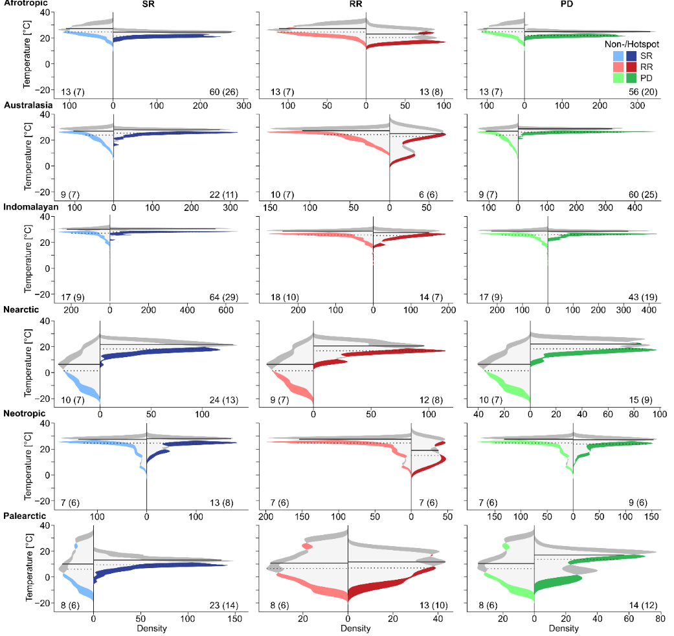

Extended Data Fig.2 | Change of current temperature niches in non-hotspots and hotspots under global warming. Density curves based on 1000 samples of current and projected future temperatures for pairs of non-hotspot and hotspot region per realm and diversity aspect. Losses of current temperatures for species richness (blue), range rarity (red), and phylogenetic diversity (green), are highlighted by semi-transparent colors for non-hotspots and full colors for hotspots, respectively. Light grey areas show the density overlap between current and projected future temperature niches and areas in dark grey show novel temperature conditions. Dashed lines indicate the median of current and solid black lines the median of projected future mean annual temperatures for each subset. Numbers at the lower corners of each plot indicate the percentage of projected temperature niche loss under ensemble models for the scenarios RCP 4.5 (in brackets) and RCP 8.5. Corresponding probability distributions of the temperature loss as well as probability distributions for null models of randomly selected areas per realm and scenario can be found in Extended Data Fig. 4. Hotspot locations are shown in Fig. 2.

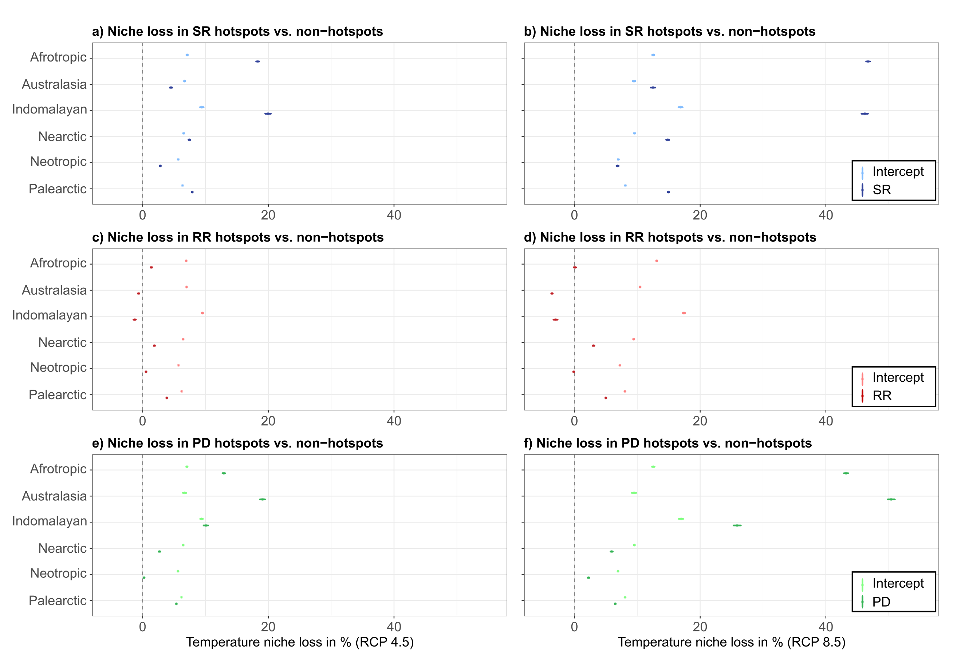

Extended Data Fig.3 | Tests for differences in projected future temperature niche loss between non-hotspots and hotspots. Standardized coefficients and 95%-CI (dots and bars) from single regressions of differences in the projected future niche loss between non-hotspots and hotspots per realm. Results are provided for the niche loss in non-/hotspots of butterfly species richness, range rarity and phylogenetic diversity (SR – blue, RR – red, PD – green) under temperatures from ensemble models for the scenarios RCP 4.5 (a,c,e) and RCP 8.5 (b,d,f). Comparisons are based on 1000 samples each for non-hotspots and hotspots per realm that were drawn from their specific frequency distributions (see Methods).
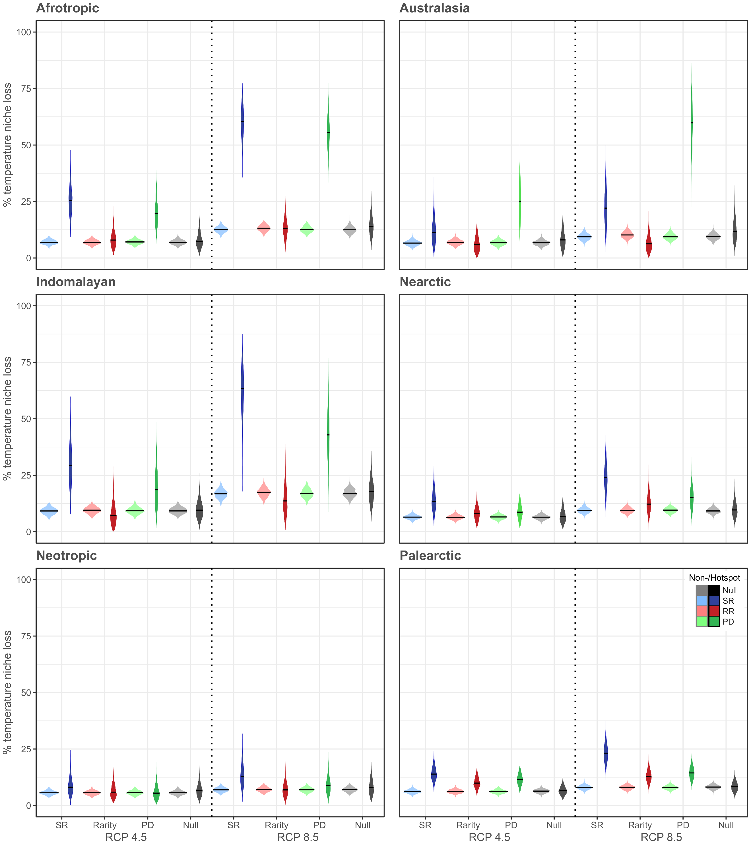
Extended Data Fig.4 | Loss of current temperature niches for non-hotspots and hotspots under projected global warming. Probability distributions for the percentage of projected niche loss of current temperatures in non-hotspot areas (lighter colored violines) and hotspot areas (darker colored violines) for six biogeographical realms and species richness (SR), range rarity (RR) and phylogenetic diversity (PD vertical panels). In addition, results for a null model of the same number of assemblages as the hotspots, randomly selected from all assemblages of the respective biogeographical realm (including hotspots) are provided. Solid horizontal lines in violines indicate the median percent of temperature niche loss. Niche loss estimates are based on projected future temperatures under ensemble models for the scenarios RCP 4.5 and RCP 8.5. For corresponding density curves of current and projected future temperatures see Extended Data Fig. 2. Hotspot locations are shown in Fig. 2.
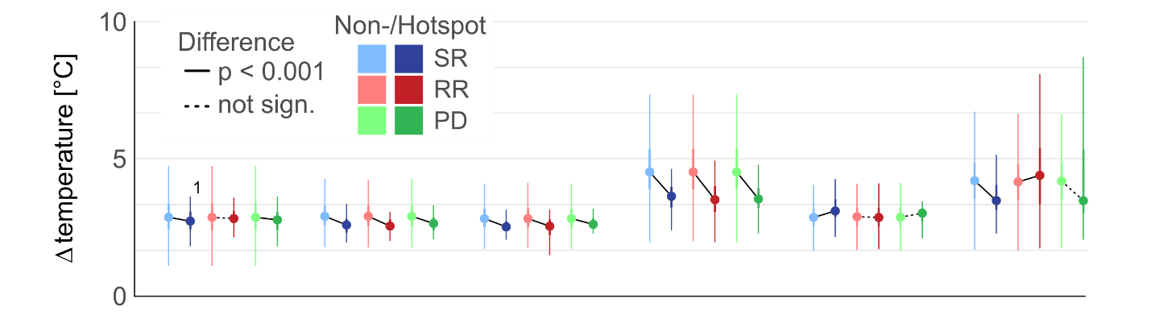

Extended Data Fig.5 | Projected future temperature difference in non-hotspots and hotspots. Temperature difference for non-hotspots and hotspots (for n and location see Fig. 2) across realms and aspects of butterfly diversity under global warming (RCP 8.5) until the year 2070. Plots in show median values and inner interquartile range/ its 1.5-fold (dots, thick/thin bars). Further analyses comparing projected temperature difference and temperature niche loss between non-hotspots and hotspots can be found in Fig. 6 and Extended Data Fig. 3.

