Supplementary Figure
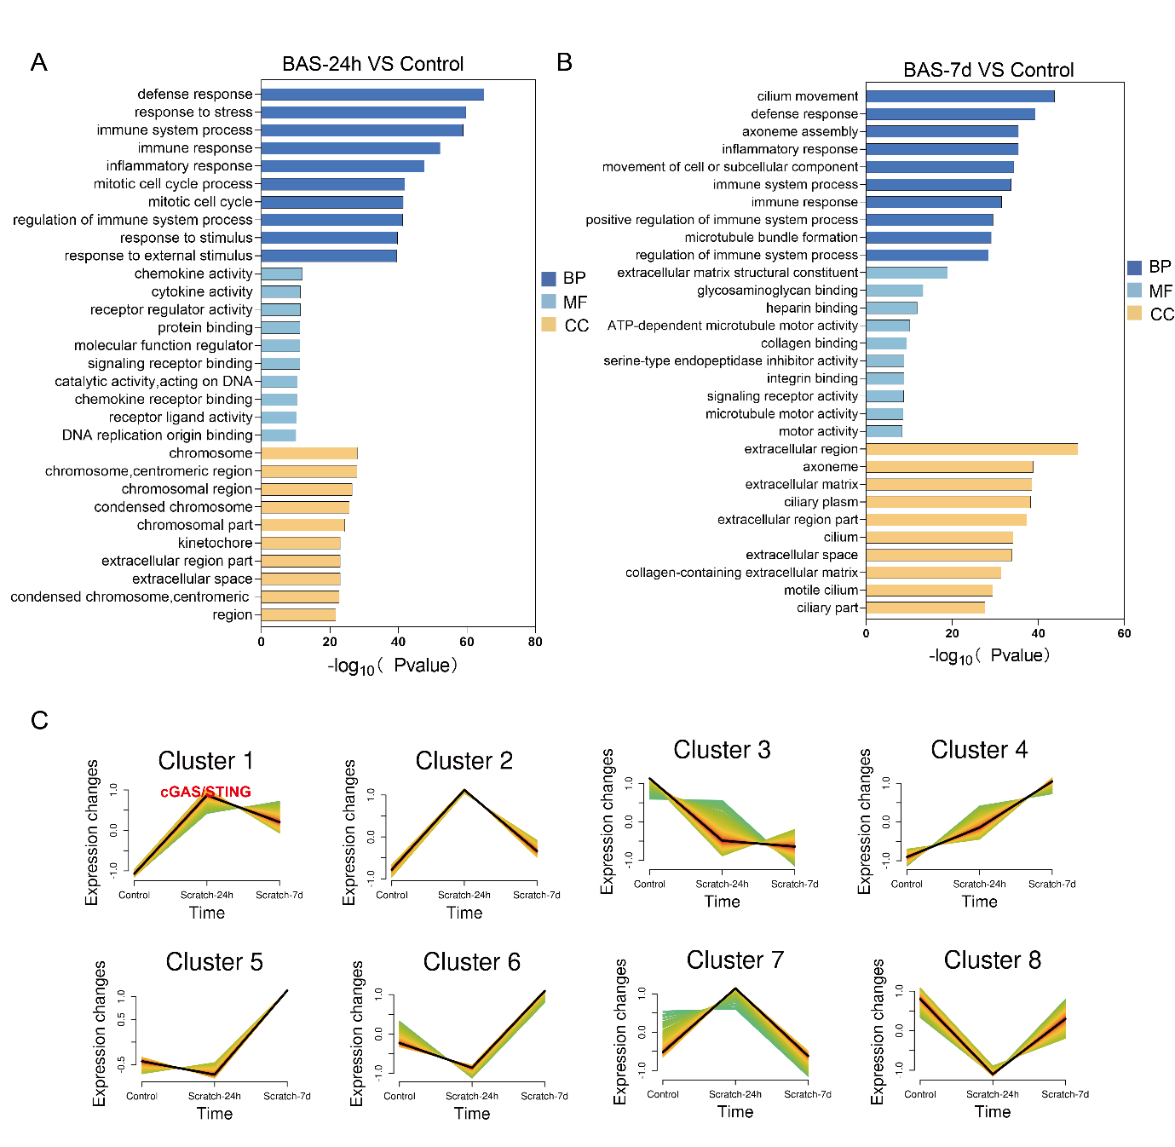
Supplementary Figure1 A,B. Gene ontology (GO) analysis showing the upregulated biological process,Molecular Function and Cell Component in BAS group at 24h and 7d compare to control group(n=3 mice per group). C. Mfuzz time series analysis in mice with benign airway stenosis at different stages.

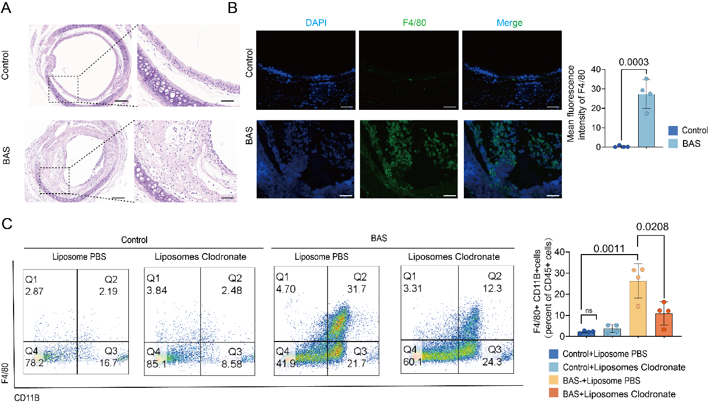
Supplementary Figure2 A. Representative Hematoxylin and eosin (H&E) staining images in the control group and BAS group at 24h after tracheal injury. Scale bars indicate 200μm and 50μm. B. Representative tracheal immunofluorescence images of F4/80.Mean fluorescence intensity of F4/80 in BAS group were higher than control group (n=4 mice per group).Scale bars indicate 200μm and 50μm. C. Flow cytometry plots demonstrate percentage of macrophages(marked with F4/80 and CD11B) in leukocytes (CD45+ cells),and the results showed that Clodronate Liposomes can reduce the percentage of macrophages in the trachea of mice in the inflammatory stage of BAS(n=4 mice per group). Data are presented as the mean ± SEM. A student’s T-test was used to determine P values for comparisons.

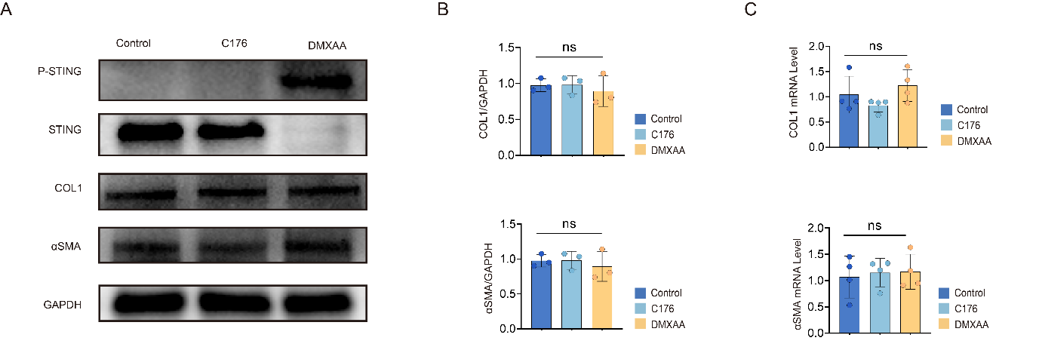
Supplementary Figure3 A-C Mouse tracheal fibroblasts were treated with C176(1μm, Selleck, USA) and DMXAA (75μg/ml, Selleck, USA) for 6 hours, and samples were collected at 24 hours. A,B. Western blot analysis showing that αSMA and COL1 expression did not differ among the three groups. C. qPCR showing that the mRNA levels of αSMA and COL1 were no difference among the three groups. Data are presented as the mean ± SEM. One-way ANOVA analysis was used to determine P values for comparisons.

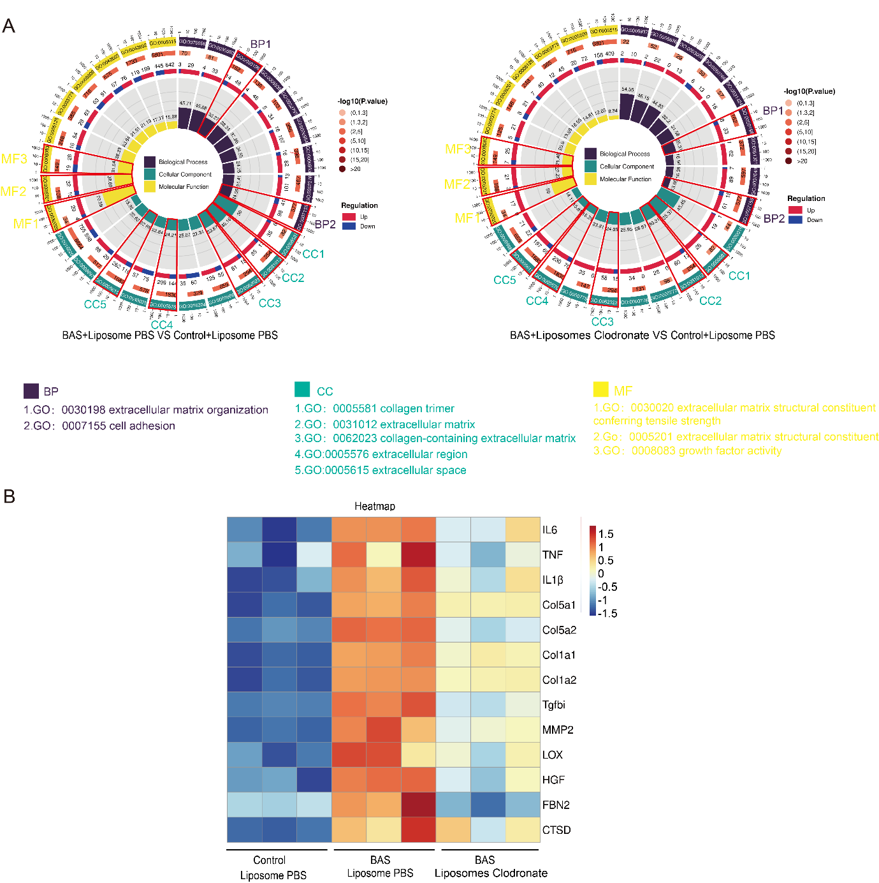
Supplementary Figure4 A,B. Mice were treated or untreated with Clodronate Liposomes on 4 hours before modeling（200µl） ,days 2（150µl）, 4（150µl） and 6（150µl） after modeling. A. Gene ontology (GO) analysis showing the upregulated biological process,Molecular Function and Cell Component in BAS group with PBS and BAS group with Clodronate Liposomes compare to control group (n=3 mice per group). Red boxes mark enrichment of genes associated with fibrosis. B. Heatmap showing that expression of fibrosis-related genes within the three groups (n=3 mice per group).

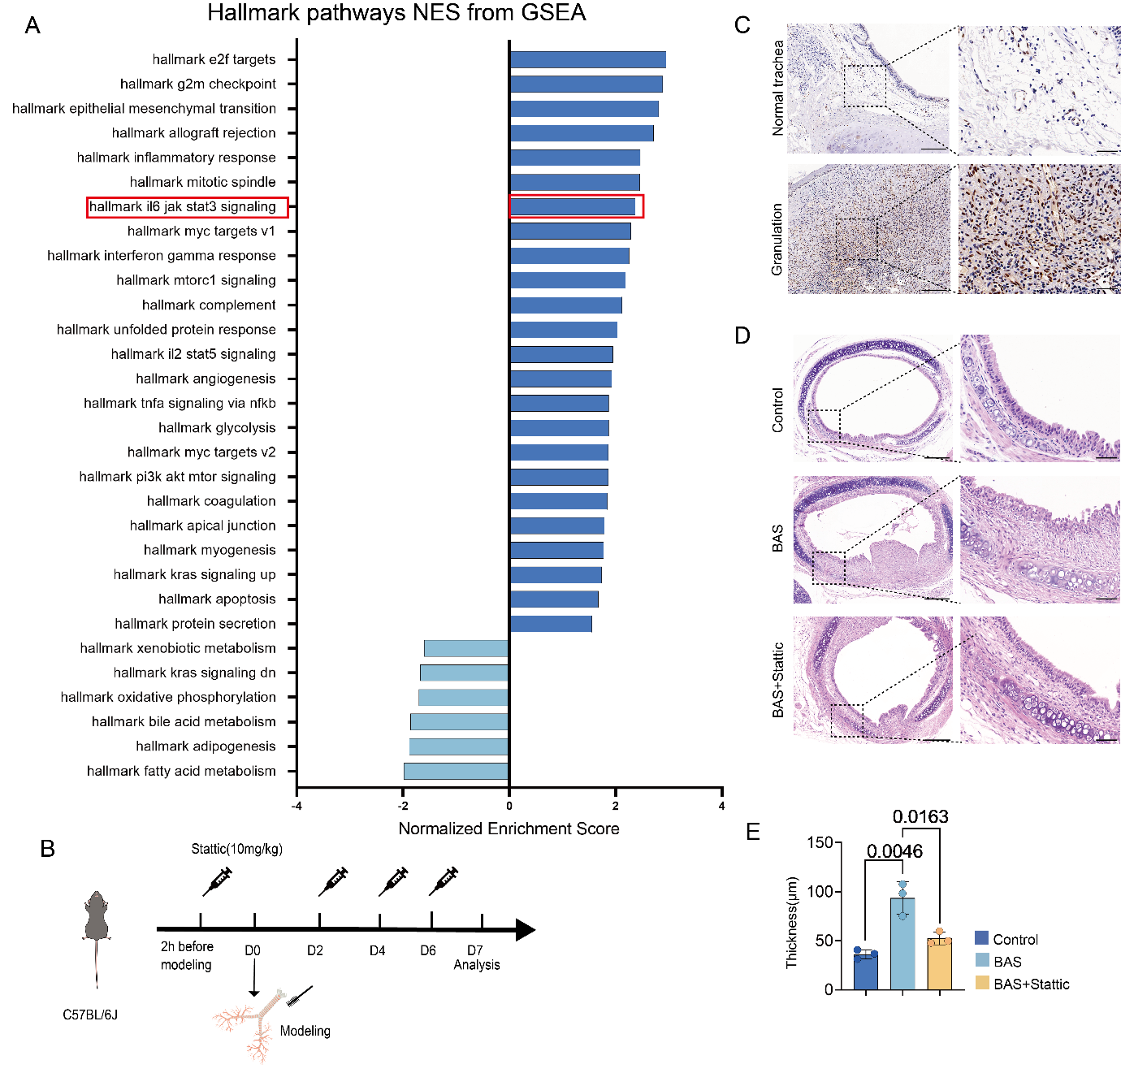
Supplementary Figure5 A. Gene set enrichment analysis employing the Hallmark pathways for mouse trachea within control group and BAS group at 24h after tracheal injury (n=3 mice per group). C.Immunohistochemical results suggested that P-STAT3 were expression in fibroblasts within granulation tissue of the human trachea (n=3 sample per group). Scale bars indicate 200μm and 50μm. B,D,E Mice were treated or untreated with Stattic(10mg/kg) on 2 hours before modeling ,days 2, 4 and 6 after modeling, trachea were collected at 7th day after modeling. B. Schematic of Stattic administration in mice and experimental strategies after modeling of mice treated or untreated with Stattic. D. Hematoxylin and eosin (H&E) staining showing Intratracheal and LP conditions in control group,BAS group with PBS and BAS group with Stattic. Scale bars indicate 200μm and 50μm. E. Quantitative analysis demonstrated decreased lamina propria thickness in BAS group with Stattic compared to BAS group with PBS (n=3 mice per group). Data are presented as the mean ± SEM. A student’s T-test was used to determine P values for comparisons.

