Supplementary material
Appendix S1: Detailed workflow on the modelling of species current and projected future distribution under climate change scenarios.
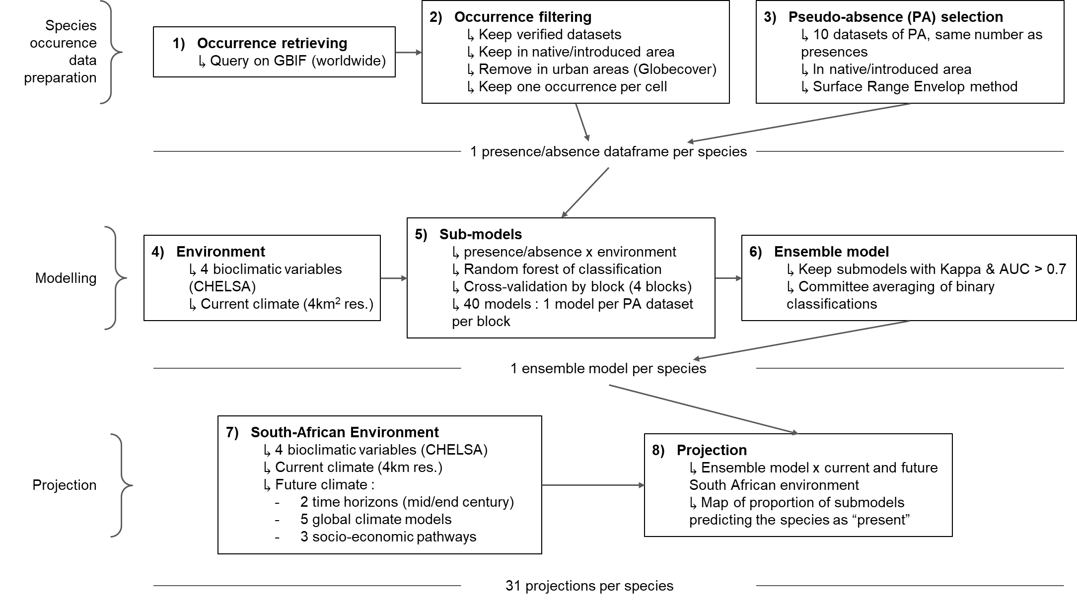

Appendix S2: Potential richness and impact predictions and uncertainty formulas. The formulas can be found in a separate file. Codes are available on GitHub under https://github.com/LysandreJ/SA_acacia_impacts

Appendix S3:
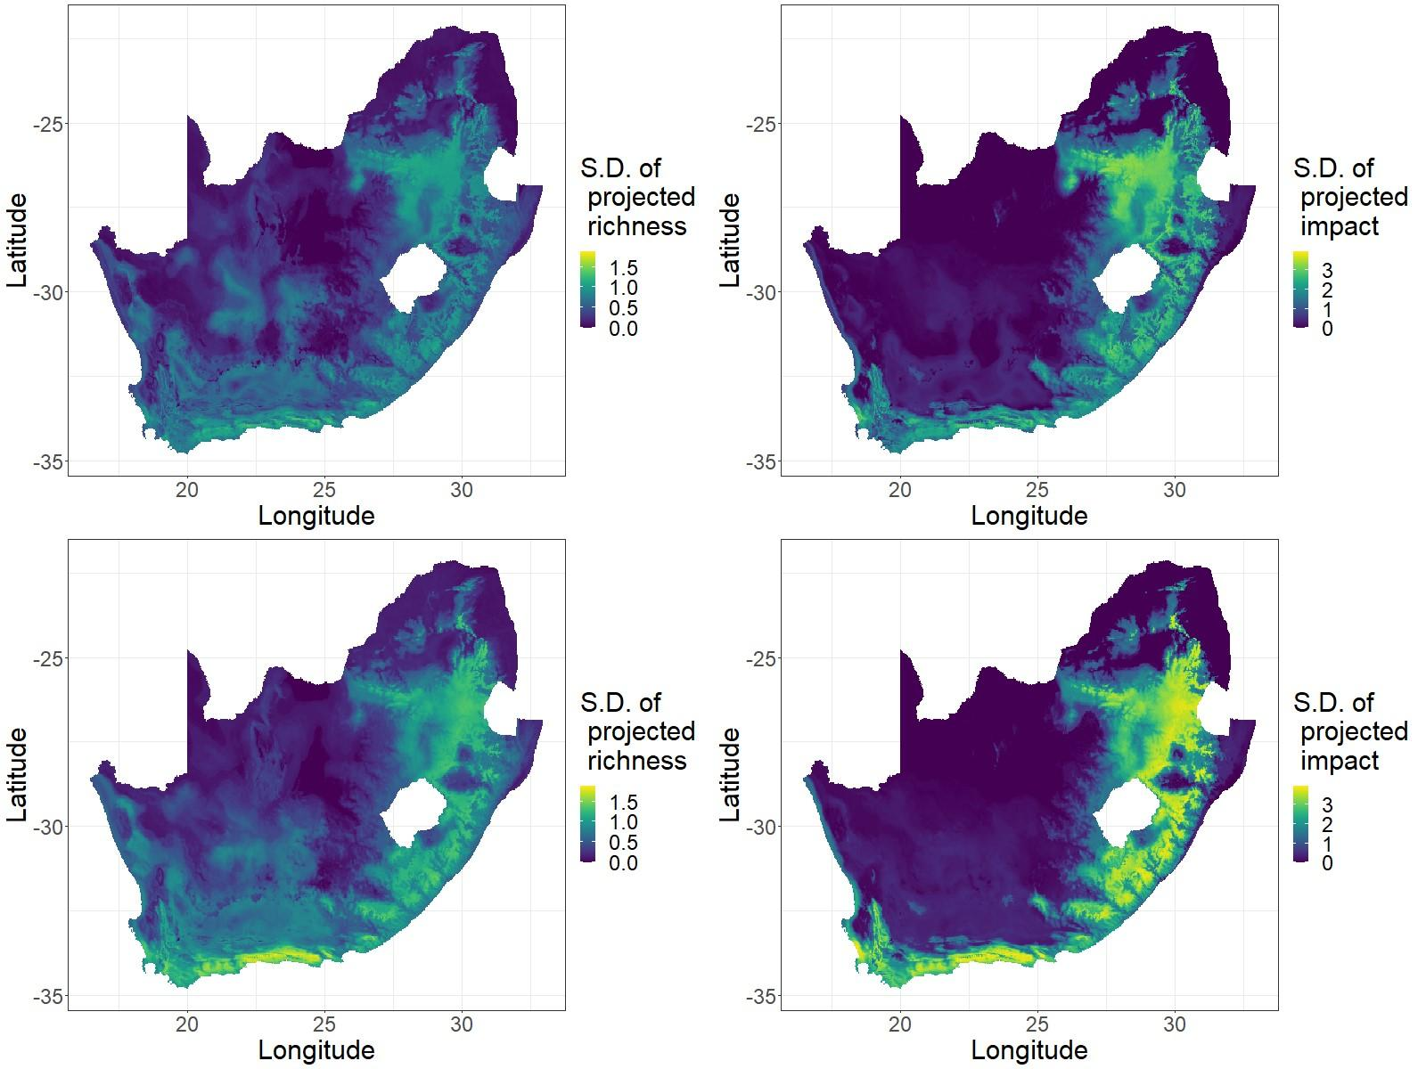

Figure S3. Maps of uncertainty in the projections of Acacia species richness and impact risk (top is mid century, bottom is end century). The values are the standard deviation of the projected richness and impact risk across the climate models and pathways. It assumes statistical independence between species. Both are based on the standard deviation of the presence probability per species.

Appendix S4:
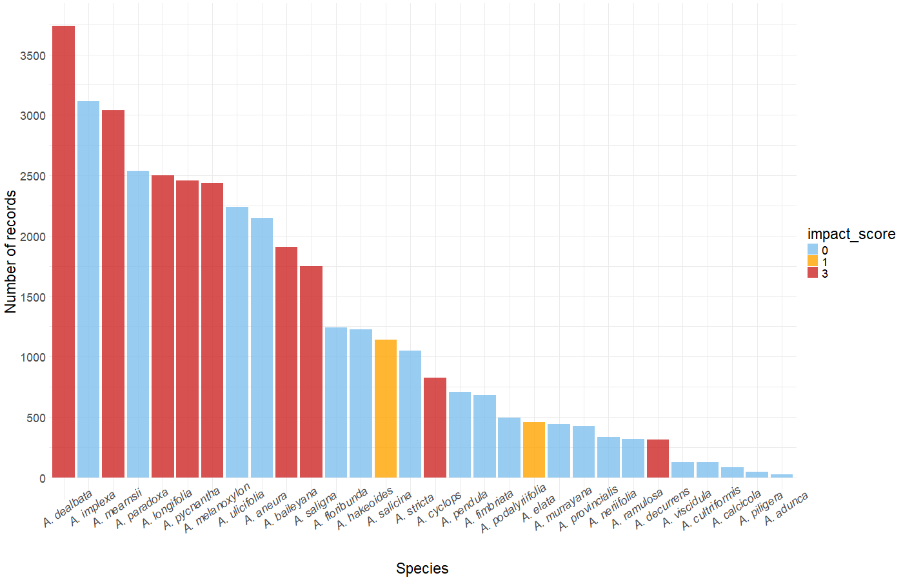
Figure S4.1. Number of filtered records per Acacia species used to fit the SDMs. We kept only the records from trusted datasets, outside urban areas, in native or known countries of introduction for each species.

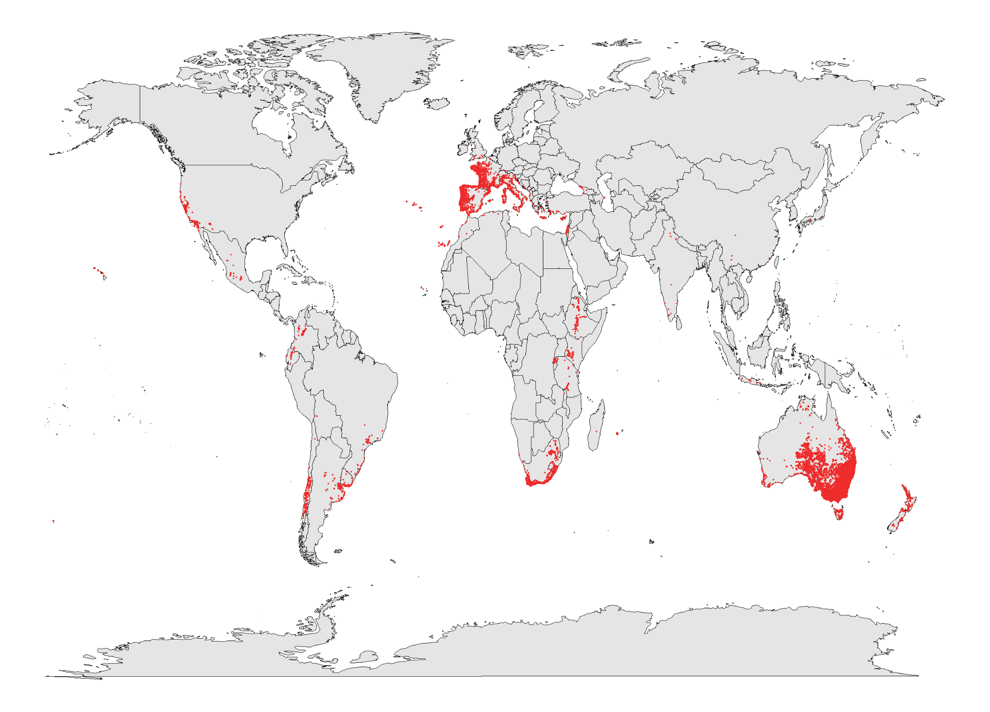
Figure S4.2. Global map of filtered records of the 30 Acacia species alien to South Africa and considered in this study.

