Heterologous expression of banana MaDREB16 gene in Arabidopsis increases tolerance to dehydration and combined dehydration plus heat stress through stomatal regulation and root elongation

Table S1. List of primers. All primers were designed by using Primer3 web version 4.0.0 (http://primer3.ut.ee/)
Sr. N. | Gene name | Locus | Oligo name | 5' to 3' sequence | Purpose/References
1 | MaDREB16 | Ma07_g16880 | MaDRFEB16(F) | CACCATGGGACCTCAGGAGAAG | To amplify banana MaDREB16
1 | MaDREB16 | Ma07_g16880 | MaDRFEB16(R) | TTAAGAATACGATGACACTTG | To amplify banana MaDREB16
2 | pK2GW7 vector primers |  | CaMV35S (F) | AAAAGGACAGTAGAAAAGGAAGGTG | For transgene detection
2 |  |  | 35S Ter | CCCTAATTCCCTTATCTGGGA | For transgene detection
3 | MaDREB16 | Ma07_g16880 | MaDERB16-F1 | GGCCTCTACAGTTTCGACGA | qRT-PCR primers
3 | MaDREB16 | Ma07_g16880 | MaDERB16-R1 | GAACTGTGTGTCGAGCTCCT | qRT-PCR primers
4 | banana elongation factor (MaEF1) | Ma10_g22900 | MaEF-F1 | CGGAGCGTGAAAGAGGAAT | Banana housekeeping qRT-PCR primers  Chen et al., 2011  Podevin et al., 2012
4 | banana elongation factor (MaEF1) | Ma10_g22900 | MaEF-R1 | ACCAGCTTCAAAACCACCAG
5 | Small ribosomal protein | Ma01_p15210 | MaRPS-F1 | TAGGGATTCCGACGATTTGTTT
5 | Small ribosomal protein | Ma01_p15210 | MaRPS-R1 | TAGCGTCATCATTGGCTGGGA
6 | responsive to desiccation/ RD29B | At5g52300 | AtRD29B (F) | AGGGGAAAGGACATGGTGAG | Sakuma et al., 2006
6 | responsive to desiccation/ RD29B | At5g52300 | AtRD29B (R) | TTCCCCACCATTCCTTCTCC | Sakuma et al., 2006
7 | heat shock transcription factor A-3(HsfA-3) | At5g03720 | AtHsfA3 (F) | TTCGCTAACGAGGCTTTCC | Guo et al., 2015
7 | heat shock transcription factor A-3(HsfA-3) | At5g03720 | AtHsfA3 (R) | CCTCAGTAGGTGACCCTT | Guo et al., 2015
8 | xyloglucan endotransglucosylase family protein (TCH4) | At5g57560 | AtTCH ( F) | GGTCTAAAGCTCCTTTCACTGC | Lim et al., 2007
8 | xyloglucan endotransglucosylase family protein (TCH4) | At5g57560 | AtTCH ( R) | AGCCAGTAGTAGTCCCCTGTTT | Lim et al., 2007
9 | indole-3-acetic acid inducible (IAA1) | At4g14560 | AtIAA1 (F) | GGAGATTGGATGTTGGTCGG | Shani et al., 2017
9 | indole-3-acetic acid inducible (IAA1) | At4g14560 | AtIAA1 (R) | ATAAGGCAGTAGGAGCTTCG | Shani et al., 2017
10 | actin 8 (AtAct8) | At1g49240 | AtActin8 (F) | TGCAGACCGTATGAGCAAAG | Guo et al., 2015
10 | actin 8 (AtAct8) | At1g49240 | AtActin8 (R) | CCGTCATGGAAACGATGTCT | Guo et al., 2015
11 | Alpha-tubulin | At1g50010 | AtTub (F) | GATGTACCGTGGTGATGTC | Liu et al., 2015
11 | Alpha-tubulin | At1g50010 | AtTub (R) | GAGCCTCTGAAAATTCTCC | Liu et al., 2015

Table S2. Transgene segregation analysis in T2 generation by Chi-square (χ2). KanR -Kanamycin resistant, KanS- kanamycin sensitive, “*” represent significant transgenic lines at P<0.05.
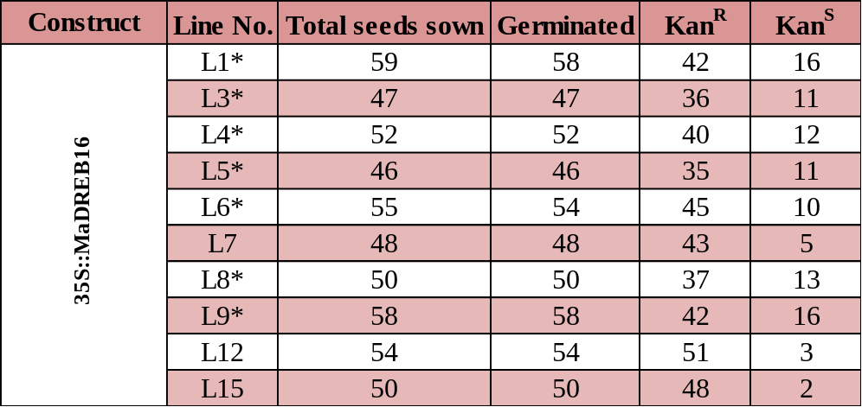

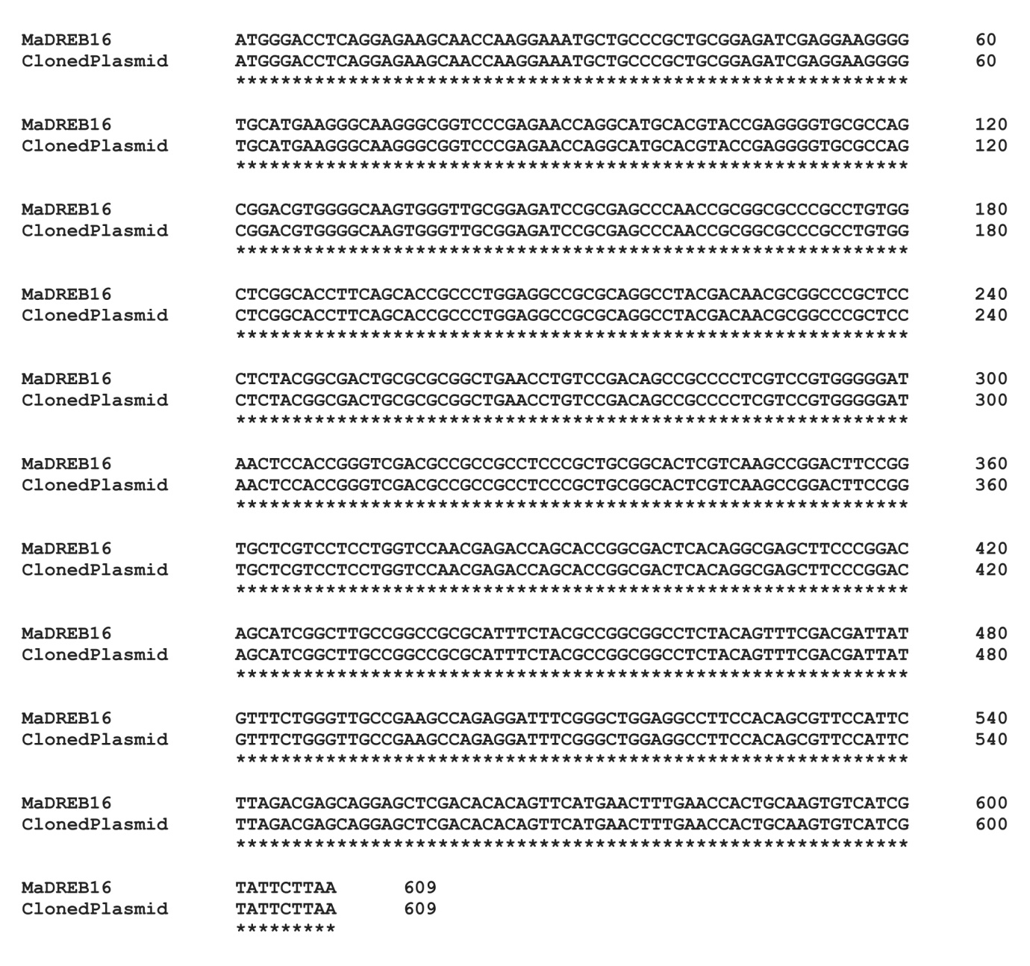

Figure S1. Sequence alignment of MaDREB16 genes. CDS sequence of cloned plasmid was aligned with that of MaDREB16 available on banana genome hub database showing exact matching. Sequence alignment was performed using web tool Clustal Omega (https://www.ebi.ac.uk/Tools/msa/clustalo/).

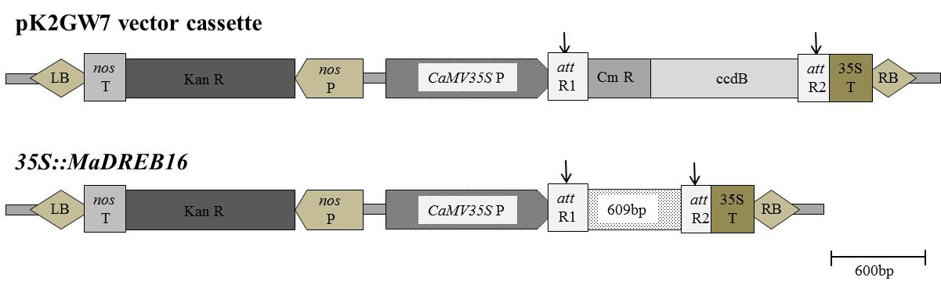
Figure S2. Schematic representation of vector and MaDREB16 gene. Schematic of over-expression vector, pK2GW7 and of MaDREB16 in pK2GW7.

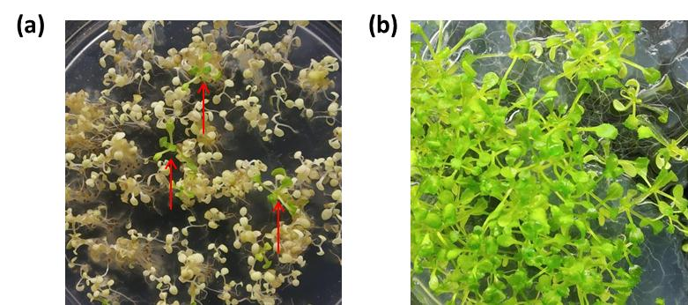
Figure S3. Selection and testing of true transformed Arabidopsis plants. (a) Selection of 35S::MaDREB16 Arabidopsis plants in T1 generation on selective MS medium. Red arrow indicates true Arabidopsis transformants that produce green leaves and roots on MS agar plate supplemented with kanamycin (50 ug/ml) as selecting agent. (b) Homozygocity test for T3 generation seeds, all producing kanamycin resistant plantlets on MS agar plate supplemented with kanamycin (50 ug/ml).

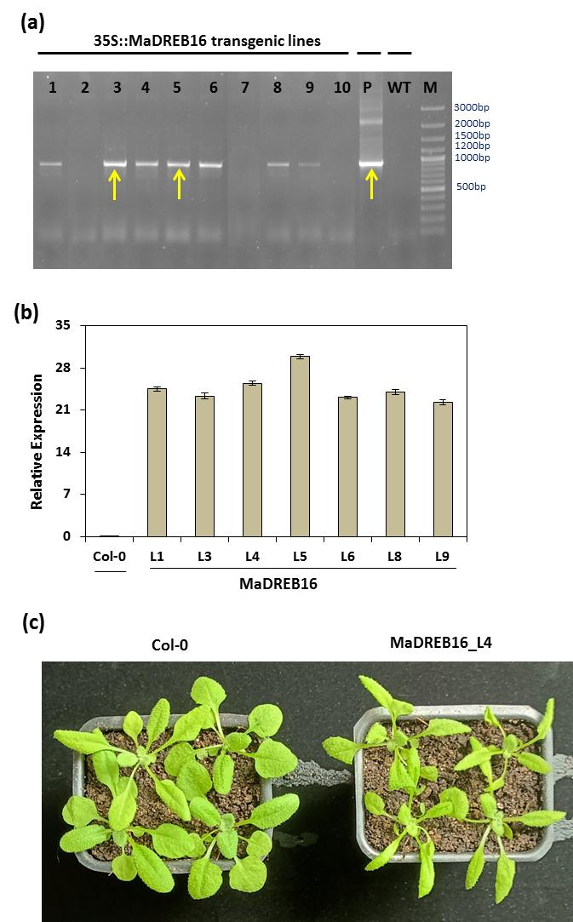
Figure S4. Confirmation and characterisation of transformants. (a) PCR analysis performed to check integration in transformants in T1 generation. 35S (F) and 35S Ter were used as a forward and reverse primer respectively for confirmation of transformation. In PCR assay, DNA from wild-type Arabidopsis thaliana Col-0 (WT) leaf was used as the negative control, LR plasmid of MaDREB16 was used as a positive control and extracted DNA of 35S::MaDREB16 transgenic lines 1-10 were used as test. Yellow arrow indicates expected size band in transgenic plant as in positive control, P. M, 3000kb DNA marker. (b) Transcript levels of the MaDREB2C gene in T3 transgenic lines tested by quantitative real-time PCR. Arabidopsis actin 8 (ACT8 ) (At1g49240) gene was used as internal standard. Data is represented with the mean ± SD value of three biological replicates (n=15). (c) Close view of Col-0 and MaDREB16_L4 Arabidopsis plants. Transgenic plants showing narrow and elongated leaves as compared to wild-type plants.
References:
Guo W, Zhang J, Zhang N, Xin M, Peng H, Hu Z et al (2015). The wheat NAC transcription factor TaNAC2L is regulated at the transcriptional and post-translational levels and promotes heat stress tolerance in transgenic Arabidopsis. PloS one 10: e0135667. https://doi.org/10.1371/journal.pone.0135667
Lim CJ, Hwang JE, Chen H, Hong JK, Yang KA, Choi MS et al (2007). Over-expression of the Arabidopsis DRE/CRT-binding transcription factor DREB2C enhances thermotolerance. Biochemical and Biophysical Research Communications 362: 431–436. https://doi.org/10.1016/j.bbrc.2007.08.007
Liu, Y., Ji, X., Nie, X., Qu, M., Zheng, L., Tan, Z., ... & Wang, Y. (2015). Arabidopsis Atb HLH 112 regulates the expression of genes involved in abiotic stress tolerance by binding to their E‐box and GCG‐box motifs. New Phytologist, 207(3), 692-709.
Sakuma Y, Maruyama K, Osakabe Y, Qin F, Seki M, Shinozaki K, Yamaguchi-Shinozaki K ( 2006). Functional analysis of an Arabidopsis transcription factor, DREB2A, involved in drought responsive gene expression. The Plant Cell 18: 1292–1309. https://doi.org/10.1105/tpc.105.035881
Shani E, Salehin M, Zhang Y, Sanchez SE, Doherty C, Wang R et al (2017). Plant stress tolerance requires auxin sensitive Aux/IAA transcriptional repressors. Current Biology 27:437–444. https://doi.org/10.1016/j.cub.2016.12.016

