Monitoring priority substances in biota under the Water Framework Directive: How effective is a tiered approach based on caged invertebrates? A proof of concept study targeting PFOS in French rivers.
Authors: Marc BABUTª, Benoit J.D. FERRARI^{b}, Patrick JAME^{c}, Azziz ASSOUMANI^{d}, François LESTREMAU^{d}, Nicolas HETTE-TRONQUART^{e}, Cécile MIEGEª and Olivier PERCEVALe
Affiliations
ª INRAE, RIVERLY, F-69625, Villeurbanne, France
^{b} Swiss Centre for Applied Ecotoxicology, EPFL ENAC IIE-GE, Station 2, CH-1015 Lausanne, Switzerland
^{c} Université de Lyon, CNRS, Université Claude Bernard Lyon 1, Institut des Sciences Analytiques, UMR 5280, 5 rue de la Doua, F-69100 Villeurbanne, France
^{d} INERIS, Unité Méthodes et développements en analyses pour l’environnement, F-60550, Verneuil-en-Halatte, France
^{e} OFB (Office français de la biodiversité, Direction de la recherche et de l'appui scientifique), F-94300 Vincennes, France

Supplementary information
Table of contents
I. Sampling 2
I.1 Site characteristics 2
I.2 Fish samples 2
II. Analysis – determination of the limits of detection (LD) and quantification (LQ) 3
II.1 Isotopic ratios 3
II.2 Perfluorooctane sulfonate (PFOS): Aquaref MA46 method (Aquaref 2014) 3
III. Fillet to whole fish conversion factors 4
III.1 Estimation of whole-body concentrations 4
III.2 Regression 4
IV. Literature review: TMFs for PFOS 5
V. Isotopic ratio values for caged gammarids; trophic levels of wild gammarids and fish 7
V.1 Caged gammarids 7
V.2 Trophic levels of wild gammarids (Gammarus spp.) 9
V.3 Trophic levels for fish 10
VI. PFOS concentrations in caged gammarids and fish 11

Sampling

Site characteristics
Site # | River | Site | Site code # | Latitude | Longitude
01 | Rhône | Ruffieux | 06072400 | 46.8423137 | 4.3371638
02 | Rhône | Brégnier-Cordon | 06079050 | 45.6245871 | 5.6158993
03 | Bourbre | Cessieu | 06080975 | 45.5663557 | 5.3711297
04 | Fure | Tullins Le Verney | 06147140 | 45.293499 | 5.521982
05 | Gier | Givors | 06097000 | 45.587502 | 4.7611898
06 | Helpe mineure | Maroilles | 01006000 | 50.1323717 | 3.758921
07 | Rhône | Donzère | 06113000 | 44.4519561 | 4.6982017
08 | Auvézère | Ségur le Château | 05042080 | 45.4288102 | 1.3078842
09 | Aurence | Aixe sur Vienne | 04079700 | 45.7986484 | 1.1549409
10 | Ternin | Chissey en Morvan | 04016800 | 47.1029188 | 4.2310872
11 | Mesvrin | St Symphorien de Marmagne | 04017250 | 46.8423137 | 4.3371638
12 | Loire | Decize | 04024000 | 46.8280126 | 3.457744
13 | Allier | Villeneuve sur Allier | 04044000 | 46.65951 | 3.228365
14 | Loire | St Mathurin sur Loire | 04103200 | 47.406623 | -0.3186415
15 | Serein | Vieux Château | 03034720 | 47.4660636 | 4.1283806
Table S 1 - Site characteristics (site codes point to registries of river monitoring sites: the first two digits correspond to regions/basins where sites are located)

Fish samples
Site # | Species | Sample size | Fish size (min-max, mm) | Fish mass (min-max, g) | MS (%) - muscle | MS (%) - ROB | Weighted mean MS (%)
01 | S. cephalus | 10 | 220 - 264 | 107 - 183 | 20.9 | 26.8 | 21.29
02 | B. barbus | 8 | 271 - 320 | 159 - 267 | 22.9 | 32.2 | 26.16
03 | S. cephalus | 8 | 227 - 288 | 101 - 308 | 20.9 | 26.5 | 21.61
04 | S. cephalus | 8 | 168 - 304 | 56 - 330 | 20.3 | 25.6 | 20.41
05 | S. cephalus | 10 | 190 - 265 | 65 - 256 | 20.6 | 24.7 | 20.12
06 | S. cephalus | 8 | 204 - 288 | 81 - 221 | 20.4 | 27.7 | 21.03
07 | S. cephalus | 11 | 196 - 319 | 70 - 346 | 21.3 | 26.7 | 21.56
08 | S. cephalus | 8 | 224 - 312 | 105 - 314 | 20.4 | 26.9 | 20.27
09 | S. cephalus | 8 | 199 - 270 | 72 - 186 | 21.1 | 25.9 | 22.03
10 | S. cephalus | 9 | 183 - 280 | 70 - 243 | 20.6 | 27.5 | 20.62
11 | S. cephalus | 10 | 179 - 351 | 69 - 493 | 21.6 | 27.9 | 23.20
12 | R. rutilus | 8 | 205 - 270 | 103 - 292 | 23.5 | 34.2 | 23.96
13 | S. cephalus | 8 | 224 - 297 | 104 - 288 | 22.0 | 26.4 | 22.95
14 | S. cephalus | 9 | 220 - 370 | 96 - 458 | 21.5 | 25.3 | 25.13
15 | S. cephalus | 9 | 203 - 296 | 94 - 262 | 20.3 | 28.9 | 22.33
Table S 2 – Characteristics of fish pool samples: number of individuals in the pool (sample size), individual size and mass ranges, dry weight content (MS %) for muscle, rest of body (ROB) and whole fish (weighted mean MS%)

Analysis – Determination of the limits of detection (LD) and quantification (LQ)

Isotopic ratios
Finely ground gammarid samples of about 0.5 mg dry weight (dw) each were weighed in tin capsules (Säntis Analytical AG, Teufen, Switzerland) then injected into a helium flow with a limited quantity of oxygen into a combustion unit (950°C). Gases passed first through a copper oven (650°C) to reduce nitrogen oxides into N₂ and capture the excess O₂, and then into a cold tube containing magnesium perchlorate to trap the remaining water. N₂ and CO₂ gases were finally separated on a chromatographic column (NC 3m Thermo Fisher Scientific) and injected into a Delta V+ Plus isotopic mass spectrometer via an Conflo IV interface (both from Thermo Fisher Scientific, Bremen, Germany).
Results are expressed as δ¹³C or δ¹⁵N, according to the following equation:
$$δ({{}_{}^{13}C}/{{}_{}^{12}C)}= \left[\frac{R ({{}_{}^{13}C}/{{}_{}^{12}C)}sample}{R ({{}_{}^{13}C}/{{}_{}^{12}C)}standard}-1\right]×1000$$
where R is the ratio of [¹³C]/[¹²C] (or [¹⁵N]/[¹⁴N]) in the sample to that of a reference sample. The reference for δ¹³C is Vienna Pee Dee Belemnite, and the reference for δ¹⁵N is atmospheric nitrogen isotopic ratio.
International certified standards (IAEA CH7: polyethylene foil: δ¹³C −31.82 ‰; USGS 40: L-glutamic acid: δ¹³C -26.39 ‰, δ¹⁵N -4.52 ‰; High Organic Sediments standard B2151: δ¹³C -28.85 ‰, δ¹⁵N + 4.32 ‰) from Elemental Microanalysis Ltd were injected periodically in order to check the accuracy of the measurements. Overall, measurement uncertainty was estimated at 0.3 ‰.
Isotopic ratio measurement in fish samples (i.e. fillets) followed the same procedure as for caged gammarids.

Perfluorooctane sulfonate (PFOS): Aquaref MA46 method (Aquaref 2014)
Samples are first freeze-dried and finely ground. Internal standards and methanol (10 mL) are then added to an aliquot (1 g) of the resulting powder, mixed for 30 min and centrifuged (3000 RPM, 20 min). The supernatant (≈ 7.5 mL) is concentrated to 1 mL under a nitrogen flux. The purification step involves the addition of 50 mg activated carbon and 50 µL acetic acid, followed by further mixing (1 min at 2500 RPM) and centrifugation (5 min at 3000 RPM). The supernatant is then evaporated under a nitrogen flux at 35 °C. The residues are dissolved in 100 µL of acetonitrile, followed by mixing (15 seconds at 2500 TPM), and centrifugation (10 min at 3000 RPM / -5°C). The supernatant is finally transferred into an injection vial for analysis. PFOS is analyzed by high-pressure liquid chromatography on an Xbridge® C18 column followed by tandem mass spectrometry (electro-spray ionization, negative mode).
QA/QC
Before the analysis of tissue samples, two injection blanks (vials filled with methanol) were analyzed to check for the absence of system contamination. Then, after the injection of the standard solutions to build the calibration curve, one calibration control prepared in advance at 25% of the highest concentration of the calibration range was injected to make sure the calibration standards were correctly prepared on the day of analysis. One method blank, i.e. freeze-dried sand spiked at 50 % of the highest concentration of the calibration range that underwent the same extraction and purification steps as the tissue samples, was analyzed to check for trueness of the analysis. Then, two method blanks, i.e. freeze-dried sand blanks that underwent the same extraction / purification process as the tissue samples, were analyzed to make sure of no contamination form the analytical method. Two standard solutions were injected into every six to nine fish and gammarid samples to make sure that the signal intensity did not drift significantly (relative signal drift had to be lower than or equal to 25%).
The limit of quantification (LQ) was first determined on the basis of signal-to-noise ratio (S/N), and then validated following French Standard NF T90-210. Briefly, two candidate LQ values were determined as S/N ratios of approximately 10 and 20. Then, 20 samples of blank fish or gammarids were spiked at the concentration level of the two candidate LQ (10 samples for each candidate LQ), then analyzed. The candidate LQ was validated if the average determined concentration, including its uncertainty, was between 40% and 160% of the nominal concentration.

Fillet to whole fish conversion factors

Estimation of whole-body concentrations
Fish were dissected prior to analysis; fillet (dorsal muscle) and rest of body (ROB) were then processed for analysis, while the scales were discarded. The whole-body concentration was defined as the weighted mean of concentrations in fractions:
$$C_{WB}=\frac{\sum{(C_{i}*F_{i})}}{\sum{F_{i}}}$$
where C_{i} and F_{i} correspond to the concentration in and mass of the fraction i respectively, and C_{WB} is the weighted mean concentration in whole fish.
Three options could be applied for the denominator: (i) fresh weight, as recorded prior to dissection; (ii) summed weights of the fractions, including scales; (iii) summed weights of the fractions analyzed.
Option (i) clearly underestimates the whole-body concentrations, due to the losses during the dissection process. Options (ii) and (iii) are presumably closer to the actual whole-body concentration; as scales were not analyzed, and option (ii) assumes that there is no PFOS accumulated in this compartment.
In the present set of samples, scales represented between 1% and 6% of the summed weights of the fractions (mean 4%), which is clearly much less than the analytical error, and so this fraction was ignored.

Regression
The regression was performed without fixing the intercept at 0; if one compartment, such as the dorsal muscle (X), accumulated more than another (viscera, ROB), the intercept would presumably be negative, because the compound studied would be measurable in that compartment while being still undetected in the other. The intercept would be positive if the dorsal muscle accumulated less than viscera (or ROB), which uses to be the case for PFOS (Houde et al. 2011; Houde et al. 2006b; Wu et al. 2019).
As the dataset included both censored (<LQ) values and uncensored values in fillets and ROB, which meant that several whole-body concentrations could not be determined, we used the non-parametric Theil-Sen approach. This method can compute a robust slope as the median of the slopes of all lines through pairs of values. As there were non-detects in the set of explanatory variable values, we used ranks for this variable.
The Theil-Sen approach is considered insensitive to outliers; we nevertheless applied this approach with and without one data point (site 04) characterized by extremely high PFOS concentrations in fillet and ROB. Results are reported in Table S 2 below, along with regression parameters obtained in other studies from Western Europe.

Method, condition | Size (spp.) | Slope | Intercept | p-value | Reference
Theil-Sen regression, outlier included | 15 | 2.20 [1.80 – 2.73] | -1.67 | ≈ 0.00003 | This study
Theil-Sen regression, outlier excluded | 14 | 2.30 [1.78 – 3.01] | -1.55 | ≈ 0.0001 | This study
Ordinary least square regression | 7 (roach)  7 (burbot) | 1.71 ± 0.21  1.72 ± 0.27 | 1.96 ± 2.38  1.49 ± 2.36 | ≈ 0.0004  0.001 | (Babut et al. 2019)
Theil-Sen regression | 7 (roach)  7 (burbot) | 1.83 [0.89 – 2.12]  1.70 [1.00 – 3.27] | -3.01  0.92 | 0.003  0.008 | Data from (Babut et al. 2019)
Ordinary least square regression | 14 (chub and barbel) | 2.16 ± 0.16 (*) | - | <0.0001 | (Simonnet-Laprade et al. 2019a)
Table S 3 – Compilation of fillet-to-WB regression parameters from various datasets (values between brackets point to the 95% confidence level bounds)
(*) slope value for linear PFOS isomers; the slope value amounts 2.77 ± 0.19 for branched isomers.
The coefficients of determination (R²) for OLS regressions were 0.92 and 0.87 in Lake Geneva for roach and burbot respectively (Babut et al. 2019), and 0.89 for a pool of species in French riverine sites in Simonnet-Laprade et al. (2019a).

Literature review: TMFs for PFOS
The first set of TMFs used in this study were obtained by Simonnet-Laprade et al. (2019a), on a few riverine sites in France. They were derived using a general linear mixed effects model (GLMM) regression and are reported in Table S 3 below, along with the median and third quartile applied in prediction trials.
Site | TMF [confidence interval] | TMF₇₅ | TMF₅₀
1 | 2.4 [0.92 – 3.9] | Third quartile:  2.98 | Median value:  2.60
2 | 2.6 [2.4 – 2.7] | Third quartile:  2.98 | Median value:  2.60
3 | 3.1 [2.5 – 3.7] | Third quartile:  2.98 | Median value:  2.60
4 | 4.1 [2.7 – 5.4] | Third quartile:  2.98 | Median value:  2.60
5 | 2.6 [2.5 – 2.7] | Third quartile:  2.98 | Median value:  2.60
6 | 1.5 [1.4 – 1.6] | Third quartile:  2.98 | Median value:  2.60
Table S 4 - TMFs for PFOS at French riverine sites

Table S 4 and Figure S 1 below result from the compilation of other available TMF values in the scientific literature, which we screened according to Kidd et al. (2019) and compared against the range of TMF values in Table S 3.
Screening criteria point to:
- A minimum trophic level (TL) range of 2.0;
- Fish whole-body residue measurements;
- Appropriate normalization;
- Inclusion of several lower TL non-vertebrate taxa (zooplankton, several benthic invertebrate groups);
- Reasonable balance with respect to sample numbers of lower- versus higher-TL organisms;
- Adequate and balanced representation of samples for each TL;
- δ¹⁵N and δ¹³C stable isotope ratio data available, and adequate baseline organism used;
- Measured contaminant concentrations in all biota samples above the limit of detection, and appropriate analytical data quality reported;
- All organisms collected within an appropriate or similar sampling period.
Furthermore, TMFs obtained in similar ecosystems and in studies including fish species presenting similar ecological traits should be preferred.
Not all these criteria could be checked for all studies, as some pieces of information were not systematically reported, and few datasets are made available in on-line repositories.

Ecosystem, food-web | TL range | TMF | Reference | Selection
Temperate lake; macroinvertebrates, fish | 3.2 – 5.0 | 5.88 | (Martin et al. 2004) | yes
Arctic, marine; zooplankton, clam, fish, beluga whale tissue | 2.0 – 6.0 | 3.1 | (Tomy et al. 2004) | no
Temperate, marine; zooplankton, fish, bottlenose dolphin tissues | NR | 1.8 ± 1.2  6.3 ± 5.9 | (Houde et al. 2006a) | yes
Temperate lake; macroinvertebrates (incl. benthic organisms), fish | 1.0 – 4.0 | 3.8 ± 0.98 | (Houde et al. 2008) | yes
Arctic, marine; zooplankton, fish, seal, beluga whale | NR, but δ¹⁵N values available | 6.3 (2.4 – 16.6) | (Tomy et al. 2009) | no
Subtropical, salt marsh; zooplankton, fish | 0.7 – 5.0 | 1.30 | (Loi et al. 2011) | yes
Arctic, terrestrial food-web (lichen-caribou-wolf) | 1 - 4 | 2.3 – 2.6 | (Müller et al. 2011) | no
Temperate lake; zooplankton, invertebrates, fish | ≈1 - ≈3.5 | 3.46 (2.53 – 4.72) | (Fang et al. 2014) | yes
Temperate lake; zooplankton, invertebrates, fish, piscivorous bird | 1.1 – 4.61 | 2.9 | (Xu et al. 2014) | no
Temperate estuary; benthic and pelagic invertebrates, fish | NR, but δ¹⁵N values available | 2.5 – 3.9 | (Munoz et al. 2017) | yes
Table S 5 – Other TMF values for PFOS retrieved from the literature (NR: not reported)
The studies by Tomy et al. (Tomy et al. 2004; Tomy et al. 2009) were not selected because the results at the top of the food web were for liver and not whole-body, and because these studies dealt with a marine Arctic ecosystem, which is far from optimal here. This argument is less convincing, as the influence of ecosystem type on TMF values for PFOS has not yet been established.
Müller et al. (2011) published a study on a typical terrestrial food-web in the Arctic: this study was discarded because the ecosystems in this study are obviously far from French rivers.
Fang et al. (2014) proposed two different TMF values, i.e. 3.46 and 3.74, depending on whether or not invertebrates were included: the rationale for excluding invertebrates was not very clear, and so we therefore kept the first of the two values (based on the whole dataset).
The study by Xu et al. (2014) was discarded, as only tissues had been analyzed at the higher trophic levels, including for fish. Although focused on essentially different ecosystems from temperate freshwater systems, studies by Houde et al. (2006a), Loi et al. (2011), Munoz et al. (2017) and Simonnet-Laprade et al. (2019b) were deemed acceptable, as they fulfilled most other screening criteria, and again the actual influence of ecosystem type on TMF values for PFOS has not been established. Munoz et al. (2017) reported two TMFs for PFOS, one for branched isomers, and one for linear isomers; we kept the latter value, as linear isomers were the most abundant.
Note that another recent publication (Ballutaud et al. 2019) also proposed a TMF for PFOS; nevertheless, the purpose of this study focused on methodological aspects, while the data used were the same as those presented in Munoz et al. (2017). The resulting TMF value consequently cannot be considered as an original/new value and was not included in the selection.
In Figure S 1, we compare the TMFs selected in the review against the TMFs in Table S 4. Note that the TMFs obtained for freshwater systems in temperate regions (green plot) were all derived for lakes, where food webs are presumably longer and more stable than in rivers.
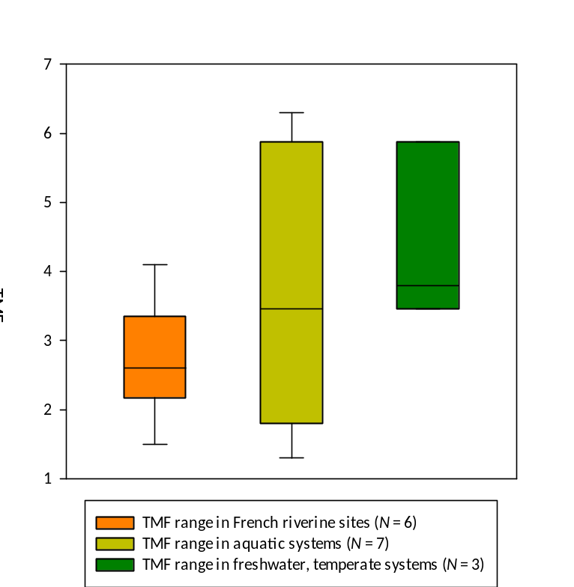

Figure S 1 – Box-plots of TMF values for PFOS: comparison of TMF values The orange plot from Simonnet-Laprade et al. (2019a; 2019b); studies selected from the literature review: light green plot, all aquatic systems; green plot, only freshwater systems in temperate regions.

Isotopic ratio values for caged gammarids; trophic levels of wild gammarids and fish

Caged gammarids
δ¹³C and δ¹⁵N were measured in gammarids before they were disposed in cages in the field, and so these values were then used to determine the respective variations during field exposure. Initial (T0) values were as follows:
- June-July: δ¹³C = -30.23 ± 0.18 ‰; δ¹⁵N = 5.02 ± 0.00 ‰
- September: δ¹³C = -30.04 ± 0.01 ‰; δ¹⁵N = 5.04 ± 0.01 ‰
- November: δ¹³C = -30.12 ± 0.03 ‰; δ¹⁵N = 5.39 ± 0.03 ‰

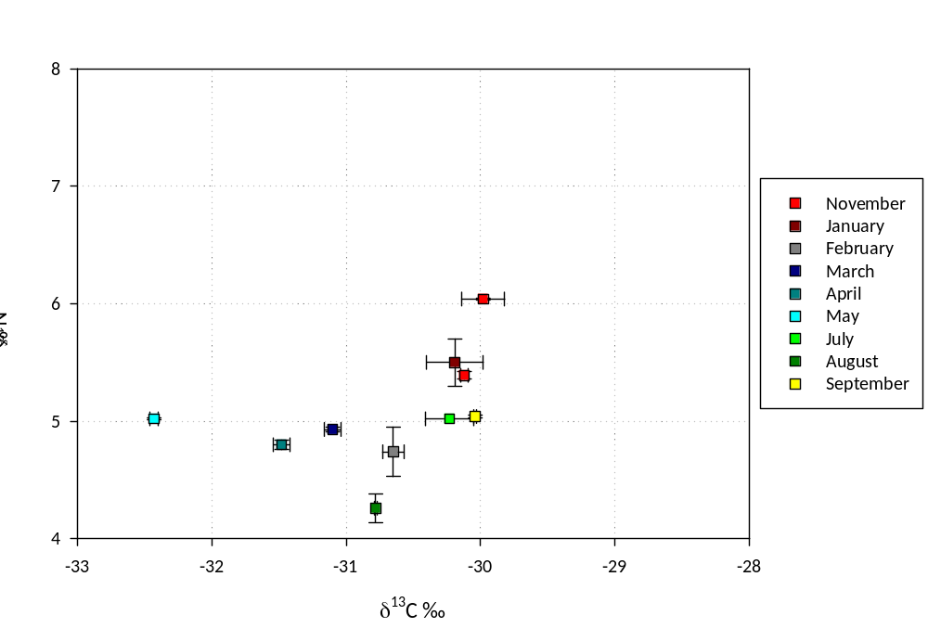
Figure S 2 – Variations in gammarid isotope ratios during a one-year cycle. Gammarids originated from a pristine site that provides organisms for caging studies

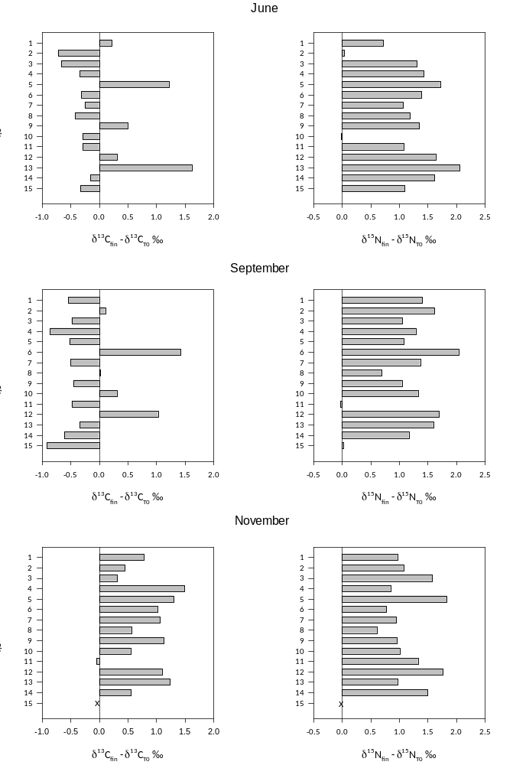

Figure S 3 - Variations of δ¹³C and δ¹⁵N during field exposure (the subscript T0 points to measurements before exposure, while the subscript fin points to measurements at the end of field exposure)

Trophic levels of wild gammarids (Gammarus spp.)
The distribution of TLs in wild gammarids was based on δ¹⁵N measurements in pools of Gammarus spp. individuals and local baseline species from 93 sites in French rivers (Hette-Tronquart and Belliard 2018).
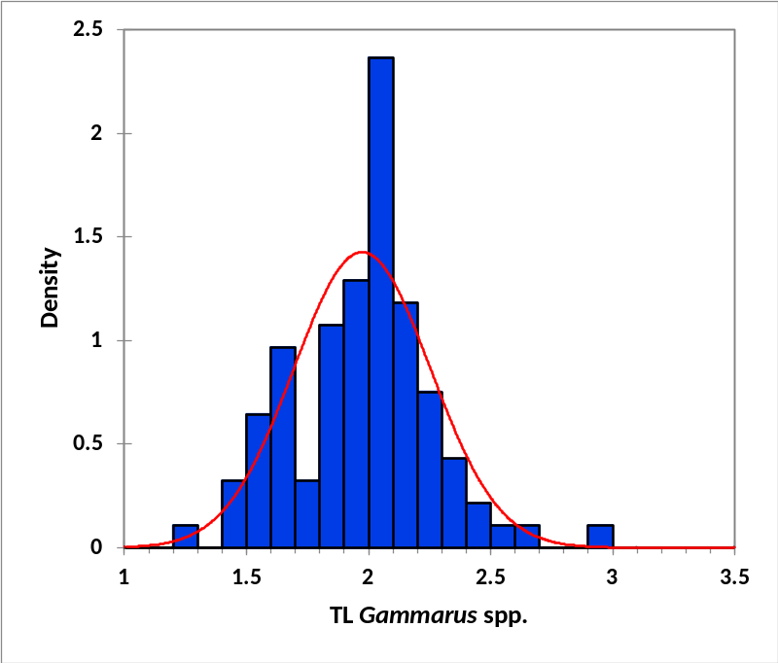
Figure S 4 – Nationwide distribution of TLs estimated in Gammarus spp. (1 pool per site, N=93 sites)

Percentile | TL
0% | 1.257
10% | 1.594
25% | 1.849
50% | 2.007
75% | 2.124
90% | 2.287
95% | 2.393
100% | 2.914
Table S 6 – Summary of TL distribution in Gammarus spp. (1 pool per site, N=93 pools)

Trophic levels for fish
Distributions computed with the script developed in a report on the trophic functioning in freshwater systems in France (Hette-Tronquart and Belliard 2018) and data from the related database.
Species | N (indiv.) | P (sites) | min | 25% | median | 75% | 90% | max
B. barbus | 154 | 21 | 2.37 | 3.14 | 3.41 | 3.64 | 3.89 | 4.36
S. cephalus | 341 | 45 | 2.02 | 2.78 | 3.05 | 3.33 | 3.63 | 4.56
R. rutilus | 258 | 30 | 2.36 | 3.09 | 3.33 | 3.50 | 3.66 | 3.89
Table S 7 – Nationwide TL distribution of selected fish species

PFOS concentrations in caged gammarids and fish

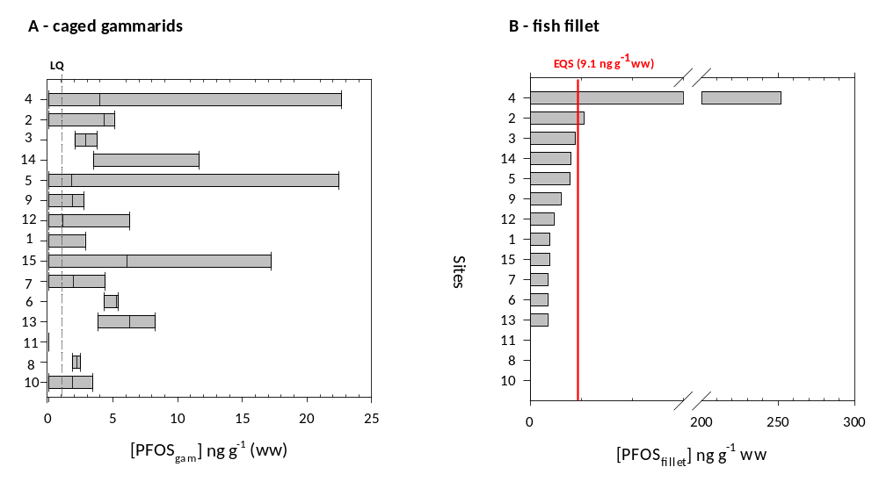
Figure S 5 - PFOS concentrations in (A) caged gammarids (three campaigns: sites are ordered following the same decreasing rank order as for fish in panel B) and (B) fish fillet

References
Aquaref (2014) Composés perfluorés (chaine linéaire en C8) - Méthode d'analyse dans les biotes.
Babut M, Cattaneo F, Raymond J-C, Ferrari B, Venisseau A, Veyrand B, Marchand P (2019) Micropolluants organiques dans les poissons du Léman vol Campagne 2018. Commission Internationale pour la Protection des Eaux du Léman Changins (Nyon, CH)
Ballutaud M et al. (2019) EStimating Contaminants tRansfers Over Complex food webs (ESCROC): An innovative Bayesian method for estimating POP's biomagnification in aquatic food webs Sci Tot Environ 658:638-649 doi:10.1016/j.scitotenv.2018.12.058
Fang S, Chen X, Zhao S, Zhang Y, Jiang W, Yang L, Zhu L (2014) Trophic magnification and isomer fractionation of perfluoroalkyl substances in the food web of Taihu Lake, China Environ Sci Technol 48:2173–2182 doi:10.1021/es405018b
Hette-Tronquart N, Belliard J (2018) Indicateurs du fonctionnement trophique des cours d'eau - approche par l'analyse des isotopes stables vol action 20.
Houde M et al. (2006a) Biomagnification of perfluoroalkyl compounds in the bottlenose dolphin (Tursiops truncatus) food web Environ Sci Technol 40:4138-4144 doi:https://pubs.acs.org/doi/10.1021/es060233b
Houde M, Czub G, Small JM, Backus S, Wang X, Alaee M, Muir DCG (2008) Fractionation and Bioaccumulation of Perfluorooctane Sulfonate (PFOS) Isomers in a Lake Ontario Food Web Environ Sci Technol 42:9397-9403 doi:doi:10.1021/es800906r
Houde M, De Silva AO, Muir DCG, Letcher RJ (2011) Monitoring of Perfluorinated Compounds in Aquatic Biota: An Updated Review Environ Sci Technol 45:7962-7973 doi:10.1021/es104326w
Houde M, Martin JW, Letcher RJ, Solomon KR, Muir DCG (2006b) Biological monitoring of polyfluoroalkyl substances: A review Environ Sci Technol 40:3463-3473
Kidd KA et al. (2019) Practical Advice for Selecting or Determining Trophic Magnification Factors for Application Under the European Union Water Framework Directive Integr Environ Assess Manage 15:266-277 doi:10.1002/ieam.4102
Loi EIH, Yeung LWY, Taniyasu S, Lam PKS, Kannan K, Yamashita N (2011) Trophic Magnification of Poly- and Perfluorinated Compounds in a Subtropical Food Web Environ Sci Technol 45:5506-5513 doi:10.1021/es200432n
Martin JW, Whittle DM, Muir DCG, Mabury SA (2004) Perfluoroalkyl contaminants in a food web from lake Ontario Environ Sci Technol 38:5379-5385
Müller CE et al. (2011) Biomagnification of Perfluorinated Compounds in a Remote Terrestrial Food Chain: Lichen–Caribou–Wolf Environ Sci Technol 45:8665-8673 doi:10.1021/es201353v
Munoz G et al. (2017) Evidence for the Trophic Transfer of Perfluoroalkylated Substances in a Macrotidal Estuary Environ Sci Technol 51:8450–8459 doi:10.1021/acs.est.7b02399
Simonnet-Laprade C et al. (2019a) Evidence for the spatial variability of poly- and perfluoroalkyl substance (PFAS) trophic magnification in French rivers Sci Tot Environ 686:393-401
Simonnet-Laprade C et al. (2019b) Biomagnification of perfluoroalkyl acids (PFAAs) in the food web of an urban river: assessment of the trophic transfer of targeted and unknown precursors and implications Environ Sci-Proc Imp 21:1864-1874 doi:10.1039/c9em00322c
Tomy GT et al. (2004) Fluorinated organic compounds in an Eastern arctic marine food web Environ Sci Technol 38:6475-6481 doi:http://www.scopus.com/inward/record.url?eid=2-s2.0-10644276408&partnerID=40&md5=6e45cd6e986d97f0ea10b3d6a042ee75
Tomy GT et al. (2009) Trophodynamics of Some PFCs and BFRs in a Western Canadian Arctic Marine Food Web Environ Sci Technol 43:4076-4081 doi:doi:10.1021/es900162n
Wu J-Y, Liu W-X, He W, Xu F-L (2019) Comparisons of tissue distributions and health risks of perfluoroalkyl acids (PFAAs) in two fish species with different trophic levels from Lake Chaohu, China Ecotoxicol Environ Safe 185:109666 doi:https://doi.org/10.1016/j.ecoenv.2019.109666
Xu J, Guo C-S, Zhang Y, Meng W (2014) Bioaccumulation and trophic transfer of perfluorinated compounds in a eutrophic freshwater food web Environ Pollut 184:254-261 doi:http://dx.doi.org/10.1016/j.envpol.2013.09.011

