Supplementary Information for
Non-target screening for detecting the occurrence of plant metabolites in river waters
Mulatu Yohannes Nanusha^{1, 2}, Martin Krauss¹ and Werner Brack^{1, 2}
¹Helmholtz Centre for Environmental Research - UFZ, Department of Effect-Directed Analysis, Permoserstrasse 15, 04318 Leipzig, Germany
²Department of Evolutionary Ecology and Environmental Toxicology, Goethe University Frankfurt, Max-von-Laue Str. 13, 60438 Frankfurt (Main), Germany

Contents
Table of Tables
Table S1: Information on sampling site for river water and plant species Excel file
Table S2: Analytical standards used Excel file
Table S3: Internal standards used for the chemical analysis (ESIpos) Excel file
Table S4: Setting for MZmine data processing. 5
Table S5: Setting used in CSI:Finger ID for in-silico fragment pattern prediction. 6
Table S6: Setting used in MetFrag for in-silico fragment pattern prediction 7
Table S7: Setting used in CFM ID for in-silico fragment pattern prediction. 7
Table S8: Concentration of detected metabolites in both water samples and aqueous plant elutriates. 20
Table of Figures
Figure S1: Work flow for the non-target detection of SPMs in river waters. 6
Figure S2: Extracted ion chromatograms of adenine in reference standard, water sample and plant (Galanthus nivalis) elutriates. NL: signal intensity at 100%. 8
Figure S3: MS/MS spectra (HCD fragmentation at 55 a.u.) of adenine in a reference standard, water sample and plant (Galanthus nivalis) elutriates. 8
Figure S4: Extracted ion chromatograms of kaempferol in reference standard, water sample and plant (Galanthus nivalis) elutriates. (NL: signal intensity at 100%). 9
Figure S5: MS/MS spectra (HCD fragmentation at 55 a.u.) of kaempferol in a reference standard, water sample and plant (Galanthus nivalis) elutriates. 9
Figure S6: Extracted ion chromatograms of apiin in reference standard, water sample and plant (Digitalis purpurea) elutriates. NL: signal intensity at 100%. 10
Figure S7: MS/MS spectra (HCD fragmentation at 45 a.u.) of apiin in a reference standard, water sample and plant (Digitalis purpurea) elutriates. 10
Figure S8: Extracted ion chromatograms of hyperoside in reference standard, water sample and plant (Galanthus nivalis) elutriates. NL: signal intensity at 100%. 11
Figure S9: MS/MS spectra (HCD fragmentation at 55 a.u.) of hyperoside in a reference standard, water sample and plant (Galanthus nivalis) elutriates. 11
Figure S10: Extracted ion chromatograms of nicotiflorin in reference standard, water sample and plant (Fraxinus excelsior) elutriates. NL: signal intensity at 100%. 12
Figure S11: MS/MS spectra (HCD fragmentation at 45 a.u.) of nicotiflorin in a reference standard, water sample and plant (Fraxinus excelsior) elutriates. 12
Figure S12: Extracted ion chromatograms of cynaroside in reference standard, water sample and plant (Galanthus nivalis) elutriates. NL: signal intensity at 100%. 13
Figure S13: MS/MS spectra (HCD fragmentation at 45 a.u.) of cynaroside in a reference standard, water sample and plant (Galanthus nivalis) elutriates. 13
Figure S14: Extracted ion chromatograms of isofraxidin in reference standard, water sample and plant (Fraxinus excelsior) elutriates. NL: signal intensity at 100%. 14
Figure S15: MS/MS spectra (HCD fragmentation at 55 a.u.) of isofraxidin in a reference standard, water sample and plant (Fraxinus excelsior) elutriates. 14
Figure S16: Extracted ion chromatograms of kaempferitrin in reference standard and water sample. NL: signal intensity at 100%. 15
Figure S17: MS/MS spectra (HCD fragmentation at 45 a.u.) of kaempferitrin in a reference standard and water sample. 15
Figure S18: Extracted ion chromatograms of alpinetin in reference standard and water sample. NL: signal intensity at 100%. 16
Figure S19: MS/MS spectra (HCD fragmentation at 45 a.u.) of alpinetin in a reference standard and water sample. 16
Figure S20: Extracted ion chromatograms of quercetin in reference standard, water sample and plant (Fraxinus excelsior) elutriates. NL: signal intensity at 100%. 17
Figure S21: MS/MS spectra (HCD fragmentation at 55 a.u.) of quercetin in a reference standard, water sample and plant (Fraxinus excelsior) elutriates. 17
Figure S22: Extracted ion chromatograms of guanosine in reference standard, water sample and plant (Digitalis purpurea) elutriates. NL: signal intensity at 100%. 18
Figure S23: MS/MS spectra (HCD fragmentation at 45 a.u.) of guanosine in a reference standard, water sample and plant (Digitalis purpurea) elutriates. 18
Figure S24: Extracted ion chromatograms of trifolin in reference standard, water sample and plant (Galanthus nivalis) elutriates. NL: signal intensity at 100%. 19
Figure S25: MS/MS spectra (HCD fragmentation at 45 a.u.) of trifolin in a reference standard, water sample and plant (Galanthus nivalis) elutriates. 19
Figure S26: Distribution of detected metabolites in the aqueous plant elutriates 20

Table S4: Setting for MZmine data processing.
 | Parameters | Mass detection | Chromatogram building | Chromatogram deconvolution | Join aligner | Gap filling | Target annotation (identification)
Peak detection | Mass detector | Centroid
Peak detection | Noise level | 5.00E+3
Peak detection | MS level | 1.0
Peak detection | Group intensity threshold |  | 1.00E+4
Peak detection | Min height intensity |  | 5.00E+03
Peak detection | m/z tolerance |  | 0.001
Peak detection | Algorithm |  |  | Local minimum search
Peak detection | Chromatographic threshold (%) |  |  | 60.0
Peak detection | Search minimum in retention time range |  |  | 0.1
Peak detection | Minimum relative height (%) |  |  | 30
Peak detection | Minimum absolute height |  |  | 5.0E+4
Peak detection | Min ratio of peak top/edge |  |  | 2.3
Peak detection | Peak duration range (min) |  |  | 0.1-0.5
Peak alignment and identification | m/z tolerance |  |  |  | 0.001 | 0.001 | 0.001
Peak alignment and identification | Weight for m/z tolerance |  |  |  | 70
Peak alignment and identification | Retention time tolerance (absolute, min) |  |  |  | 0.3 | 0.15 | 0.5
Peak alignment and identification | Weight for RT |  |  |  | 30
Peak alignment and identification | Intensity tolerance (%) |  |  |  |  | 30.00
Peak alignment and identification | RT range
Peak alignment and identification | Adducts |  |  |  |  |  | M+H+, M+Na+, M+NH4+,

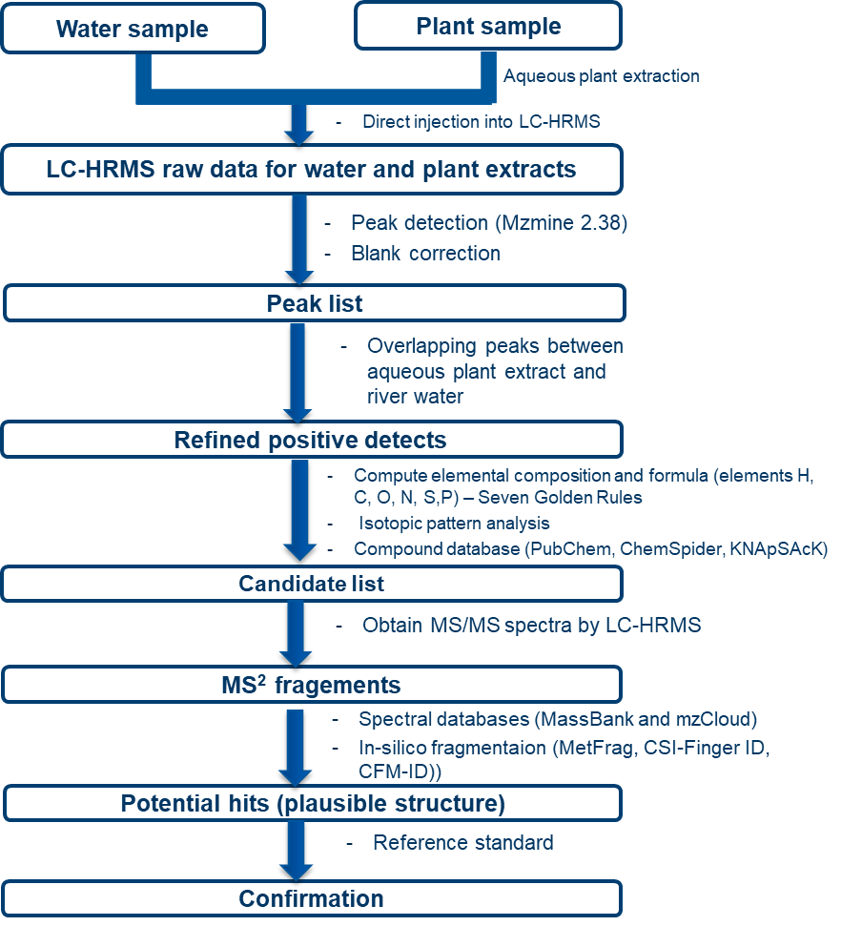
Figure S1: Work flow for the non-target detection of SPMs in river waters.
Table S5: Setting used in CSI:Finger ID for in-silico fragment pattern prediction.
 | Parameters | Inputs
Input data | Precursor mass | m/z of parent ion
Input data | Possible ionization | [M]⁺, [M+H]⁺, [M+NH₄]⁺, [M+Na]⁺
Input data | MS2 Spectrum | MS/MS Fragment ion mass extracted from Xcalibur (m/z and intensity
Elements allowed in Molecular formula | Elements | C,H,O,N,S,P
Elements allowed in Molecular formula | Mass tolerance | 5 ppm
CSIFingerID-Structure Elucidation | Search in (database) | PubChem, KEGG, Natural products, KNApSAcK
CSIFingerID-Structure Elucidation | Molecular formula | Computed formula for the precursor mass

Table S6: Setting used in MetFrag for in-silico fragment pattern prediction
 | Parameters | Inputs
Database setting | Parent ion (m/z) | Accurate mass (mu) of the unknown
Database setting | Database | PubChem / KEGG
Database setting | Adducts | [M]⁺, [M+H]⁺, [M+NH₄]⁺, [M+Na]⁺
Database setting | Mass tolerance | 5 ppm
Database setting | Formula | Molecular formula computed for the parent mass
Candidate filter and Score setting | Candidate filter | Element inclusion - C,H,N,O,P,S  Filter Type - Optional
Candidate filter and Score setting | MetFrag Scoring Terms | MetFrag score
Candidate filter and Score setting | MetFrag Scoring Terms | Spectral Similarity (MoNA) score
Candidate filter and Score setting | MetFrag Scoring Terms | Exact Spectral Similarity (MoNA) score
Fragmentation setting and processing | Relative mass deviation to match generated against MS/MS peaks | MZppm = 5  MZabs = 0.001
Fragmentation setting and processing | Tree depth | 2 (default value)
Fragmentation setting and processing | Mode (Adduct) | [M]⁺, [M+H]⁺, [M+NH₄]⁺, [M+Na]⁺
Fragmentation setting and processing | MS/MS Peak list | LC-HRMS recorded MS/MS fragment data

Table S7: Setting used in CFM ID for in-silico fragment pattern prediction.
 | Parameters | Inputs
Candidate | Spectra type | ESI
Candidate | Ion Mode | Positive
Candidate | Adduct Type | [M]⁺, [M+H]⁺, [M+NH₄]⁺, [M+Na]⁺
Candidate | Parent ion mass | Precursor mass (m/z)
Candidate | Mass tolerance | 5ppm
Candidate | Databases | MassBank, KEGG, DrugBank
Spectral | Input spectra text | MS/MS fragment data extracted from Xcalibur
Scoring | Default | DotProduct + Metadata
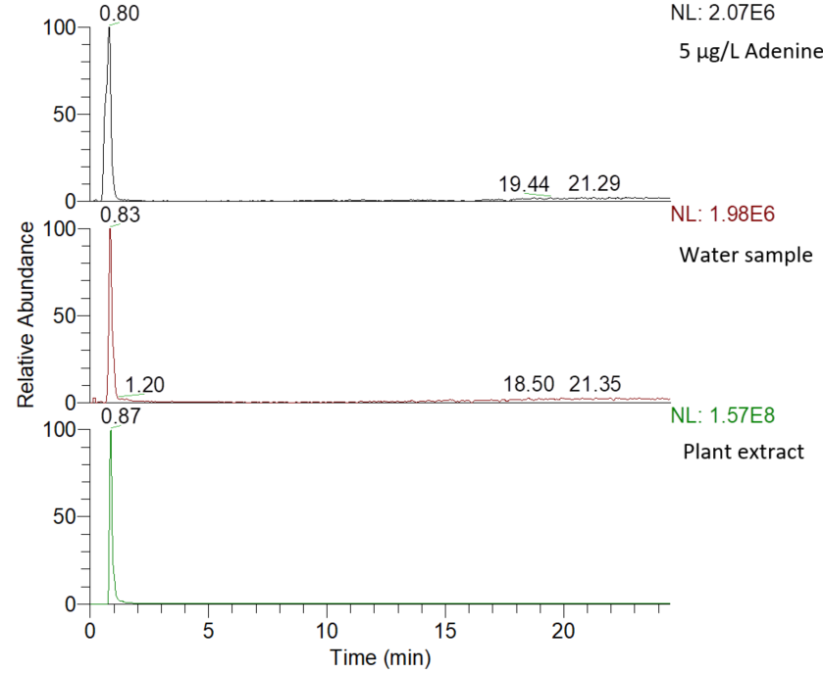
Figure S2: Extracted ion chromatograms of adenine in reference standard, water sample and plant (Galanthus nivalis) elutriates. NL: signal intensity at 100%.
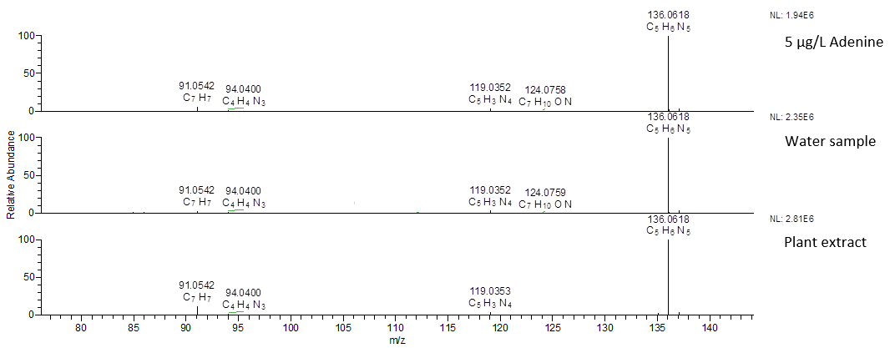Figure S3: MS/MS spectra (HCD fragmentation at 55 a.u.) of adenine in a reference standard, water sample and plant (Galanthus nivalis) elutriates.
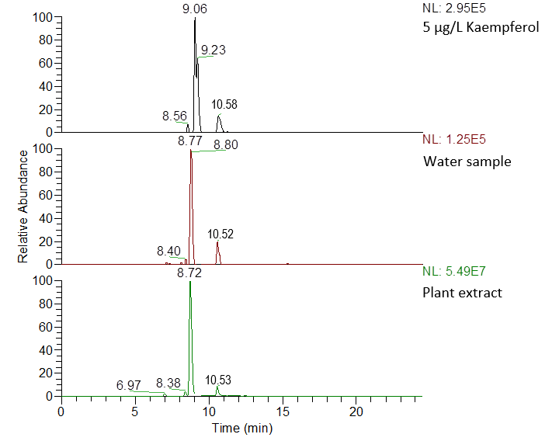
Figure S4: Extracted ion chromatograms of kaempferol (RT = 10.58 min) in reference standard, water sample and plant (Galanthus nivalis) elutriates. (NL: signal intensity at 100%).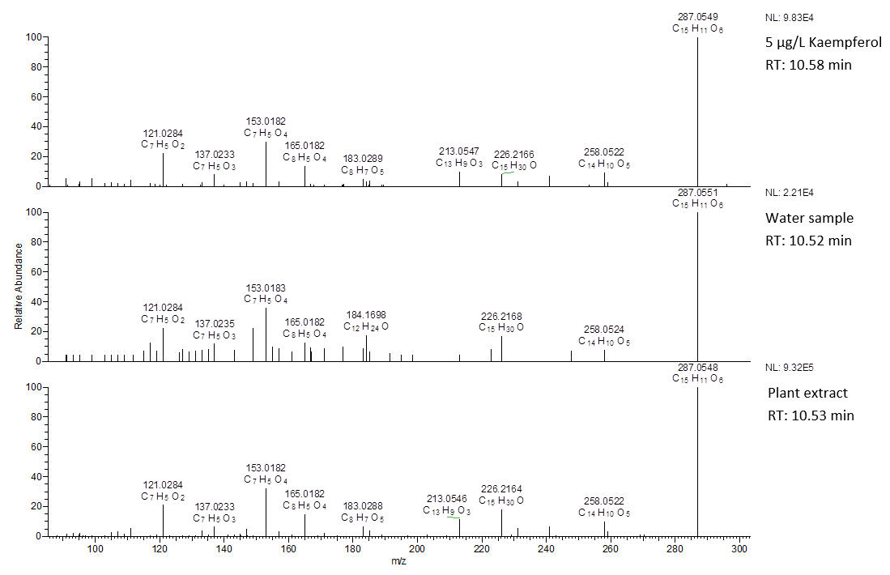
Figure S5: MS/MS spectra (HCD fragmentation at 55 a.u.) of kaempferol in a reference standard, water sample and plant (Galanthus nivalis) elutriates.
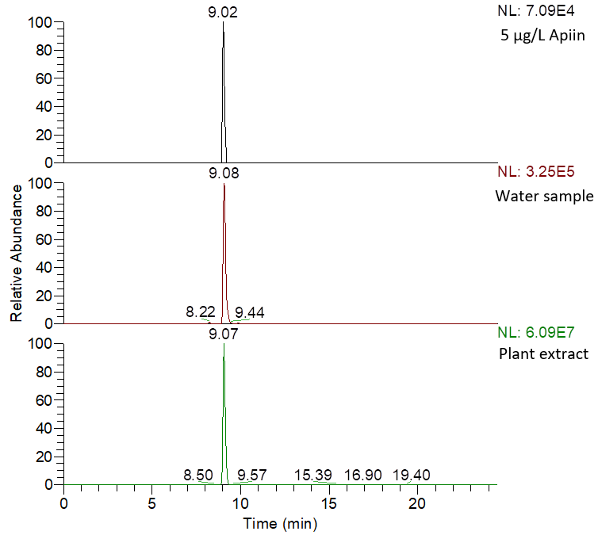
Figure S6: Extracted ion chromatograms of apiin in reference standard, water sample and plant (Digitalis purpurea) elutriates. NL: signal intensity at 100%.
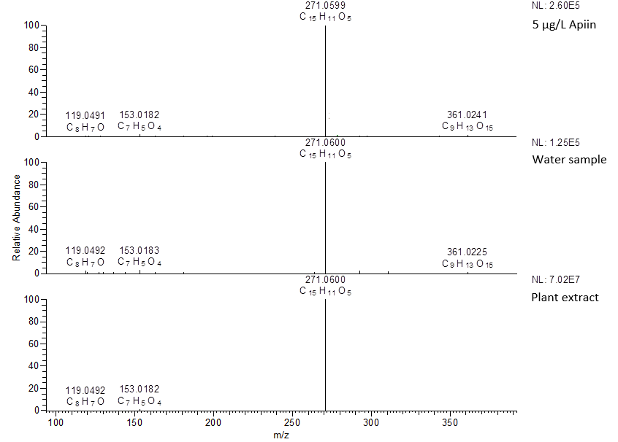
Figure S7: MS/MS spectra (HCD fragmentation at 45 a.u.) of apiin in a reference standard, water sample and plant (Digitalis purpurea) elutriates.
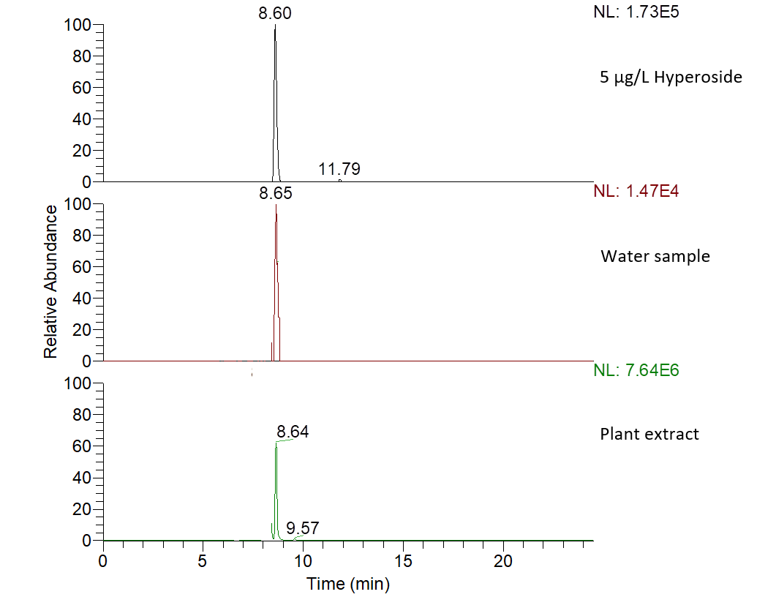
Figure S8: Extracted ion chromatograms of hyperoside in reference standard, water sample and plant (Galanthus nivalis) elutriates. NL: signal intensity at 100%.
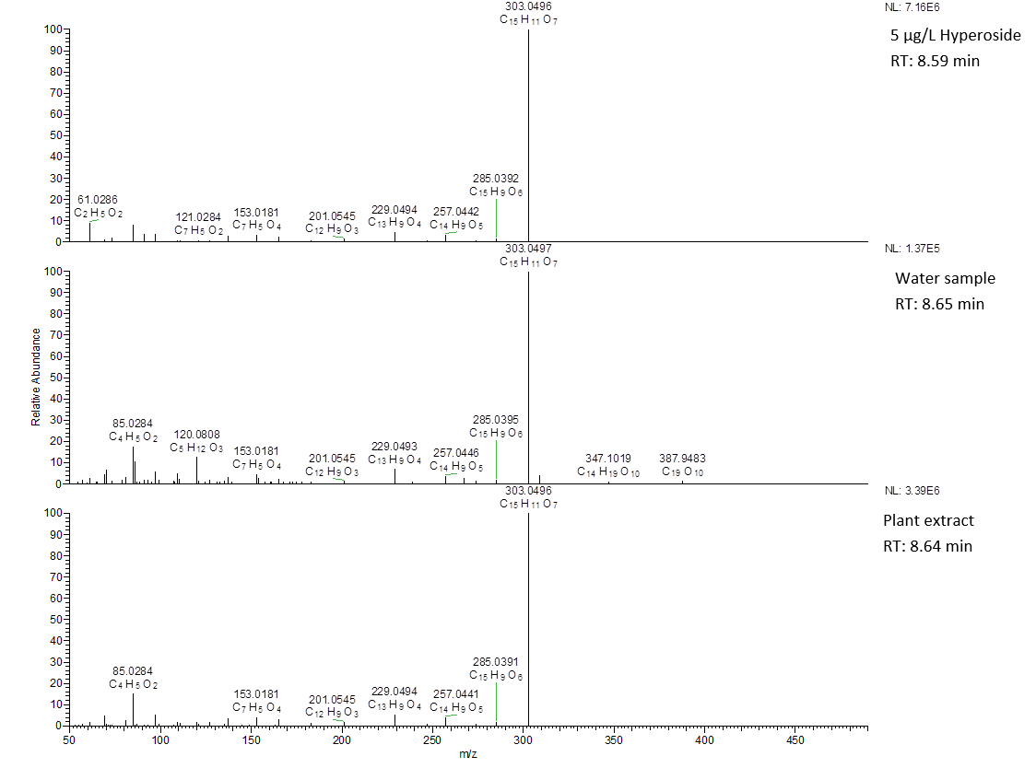Figure S9: MS/MS spectra (HCD fragmentation at 55 a.u.) of hyperoside in a reference standard, water sample and plant (Galanthus nivalis) elutriates.
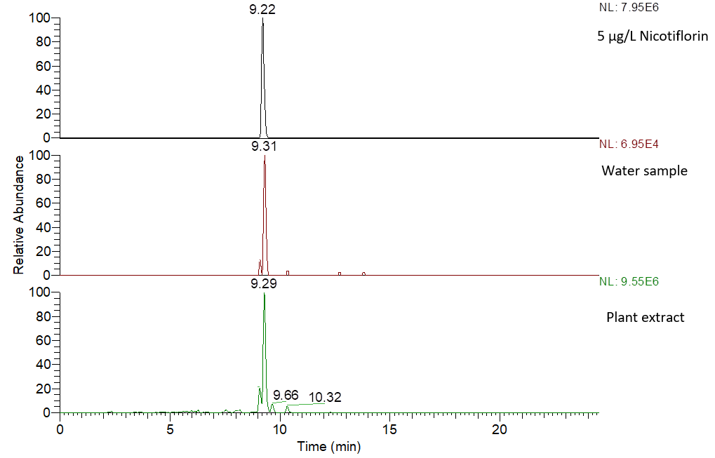
Figure S10: Extracted ion chromatograms of nicotiflorin in reference standard, water sample and plant (Fraxinus excelsior) elutriates. NL: signal intensity at 100%.
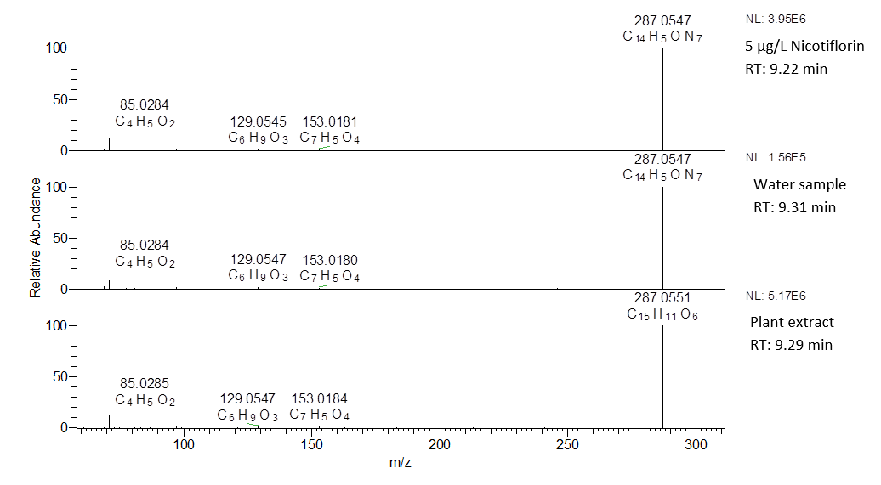Figure S11: MS/MS spectra (HCD fragmentation at 45 a.u.) of nicotiflorin in a reference standard, water sample and plant (Fraxinus excelsior) elutriates.
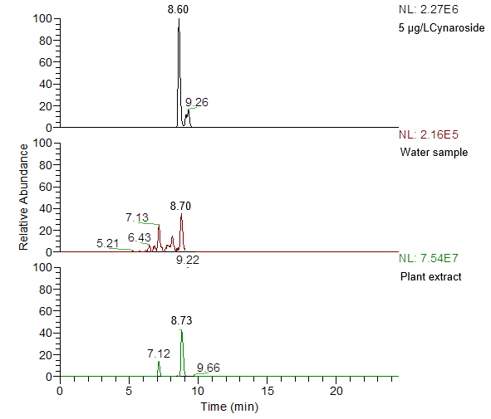
Figure S12: Extracted ion chromatograms of cynaroside in reference standard, water sample and plant (Galanthus nivalis) elutriates. NL: signal intensity at 100%.
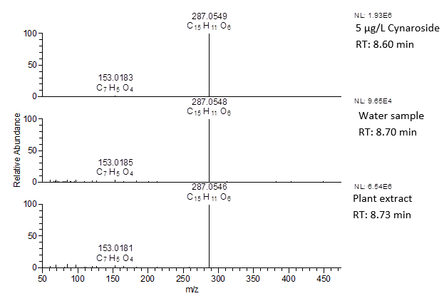
Figure S13: MS/MS spectra (HCD fragmentation at 45 a.u.) of cynaroside in a reference standard, water sample and plant (Galanthus nivalis) elutriates.

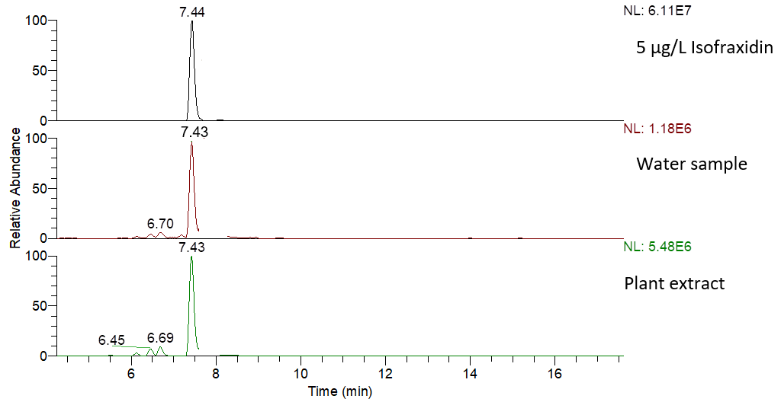
Figure S14: Extracted ion chromatograms of isofraxidin in reference standard, water sample and plant (Fraxinus excelsior) elutriates. NL: signal intensity at 100%.
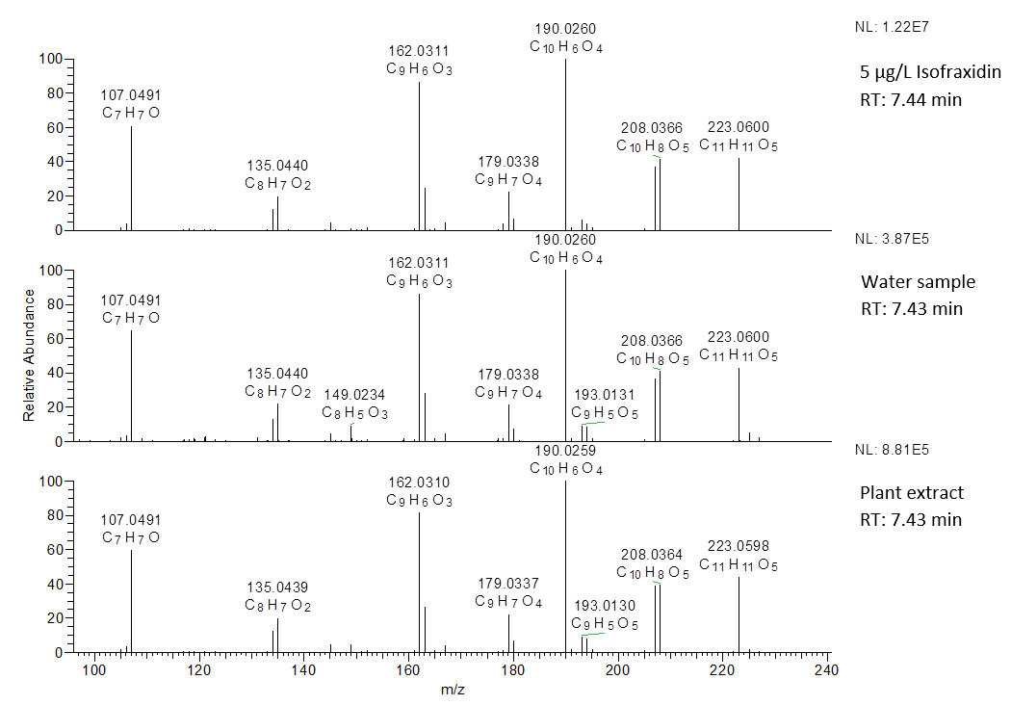Figure S15: MS/MS spectra (HCD fragmentation at 55 a.u.) of isofraxidin in a reference standard, water sample and plant (Fraxinus excelsior) elutriates.
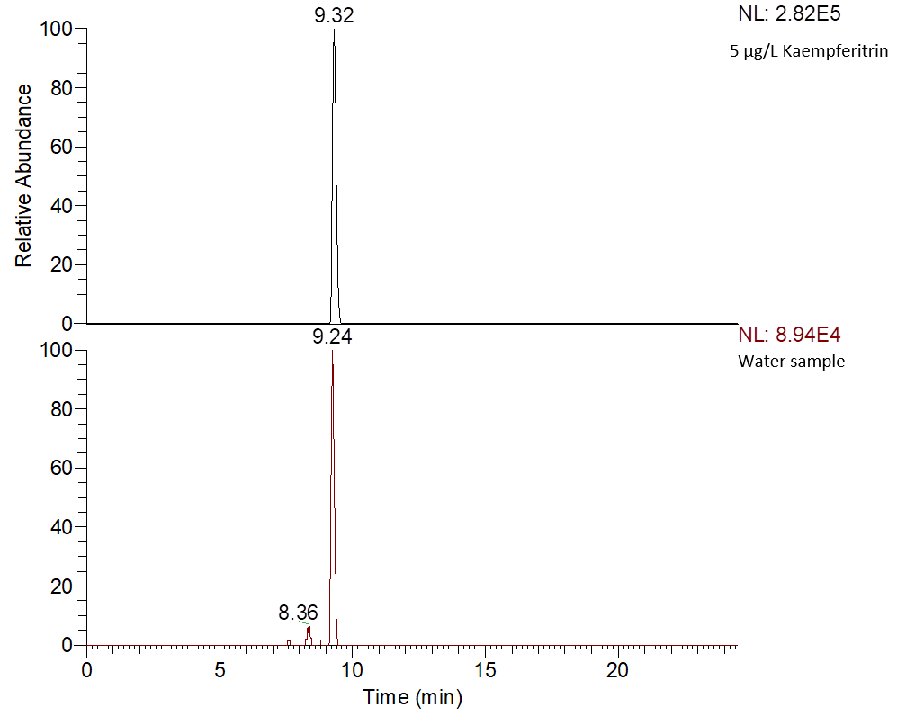
Figure S16: Extracted ion chromatograms of kaempferitrin in reference standard and water sample. NL: signal intensity at 100%.
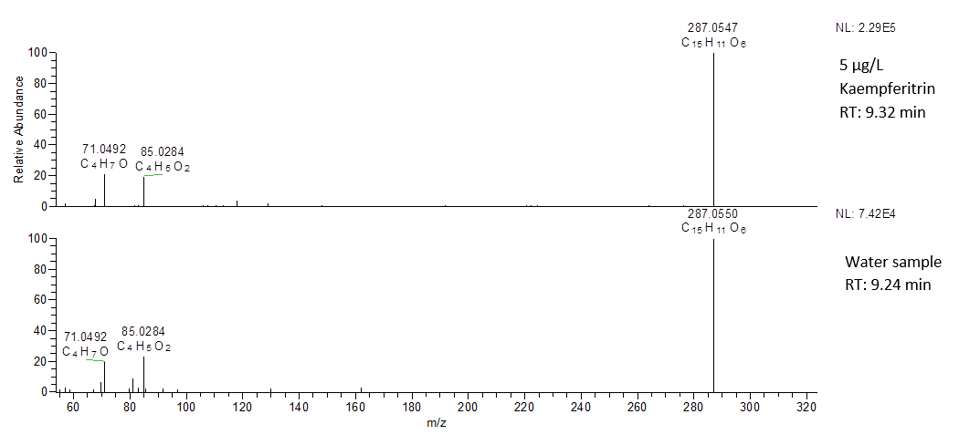
Figure S17: MS/MS spectra (HCD fragmentation at 45 a.u.) of kaempferitrin in a reference standard and water sample.
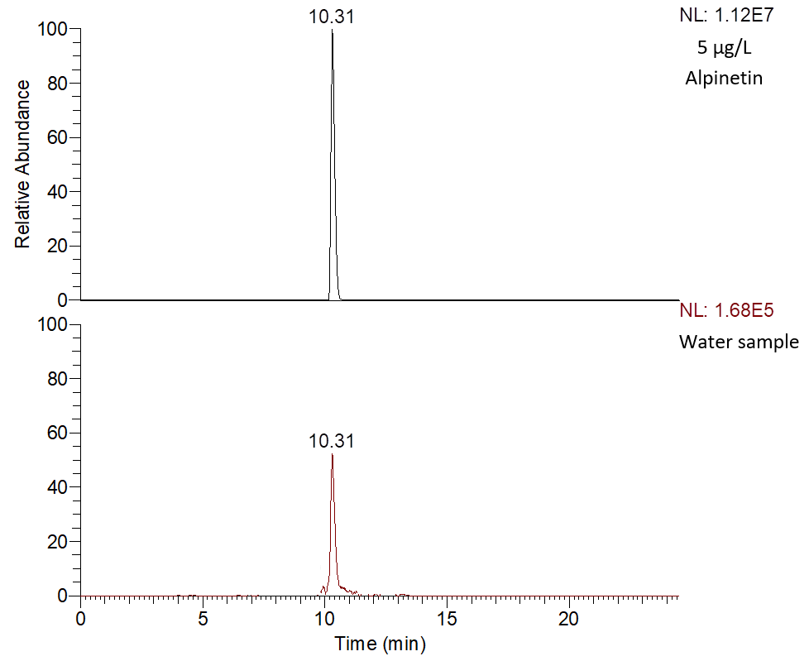
Figure S18: Extracted ion chromatograms of alpinetin in reference standard and water sample. NL: signal intensity at 100%.
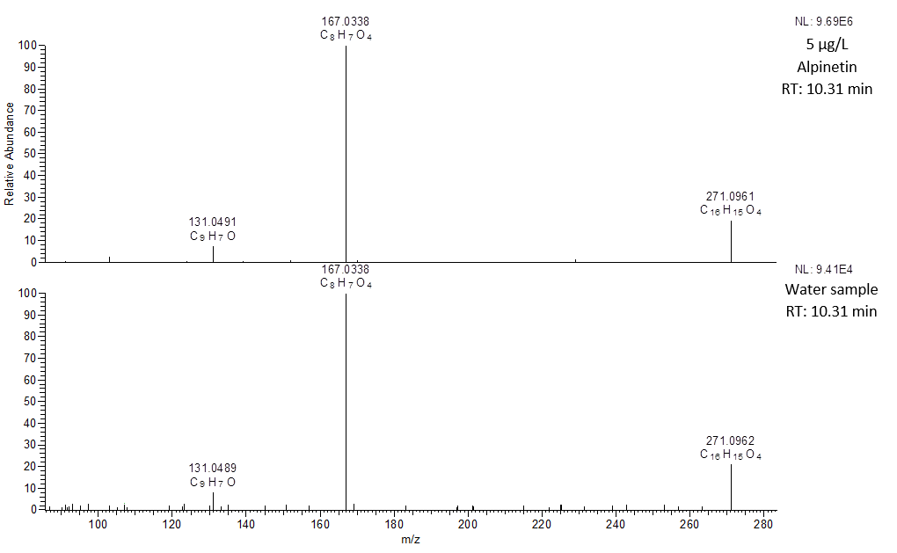
Figure S19: MS/MS spectra (HCD fragmentation at 45 a.u.) of alpinetin in a reference standard and water sample.
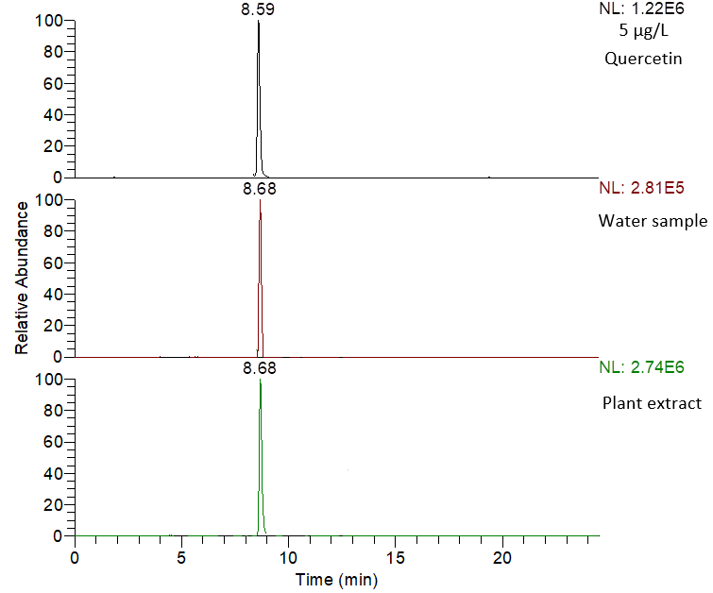
Figure S20: Extracted ion chromatograms of quercetin in reference standard, water sample and plant (Fraxinus excelsior) elutriates. NL: signal intensity at 100%.
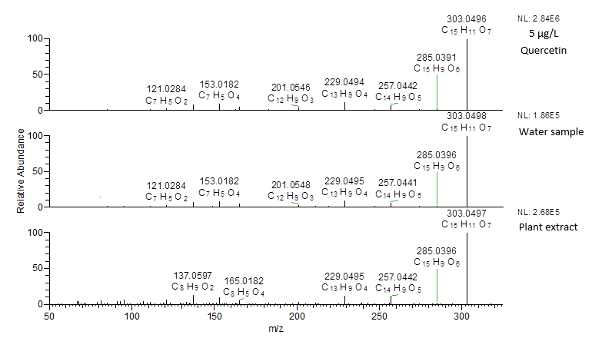
Figure S21: MS/MS spectra (HCD fragmentation at 55 a.u.) of quercetin in a reference standard, water sample and plant (Fraxinus excelsior) elutriates.
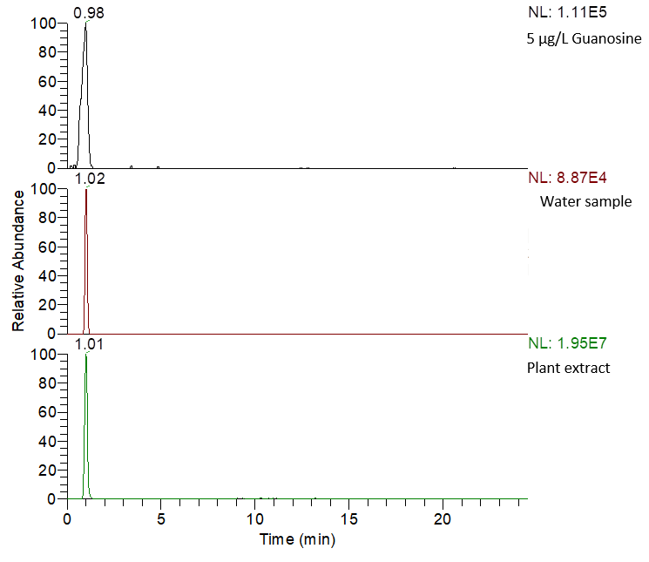
Figure S22: Extracted ion chromatograms of guanosine in reference standard, water sample and plant (Digitalis purpurea) elutriates. NL: signal intensity at 100%.
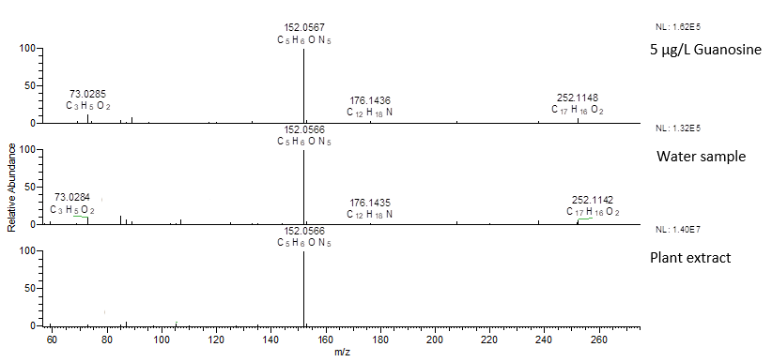
Figure S23: MS/MS spectra (HCD fragmentation at 45 a.u.) of guanosine in a reference standard, water sample and plant (Digitalis purpurea) elutriates.
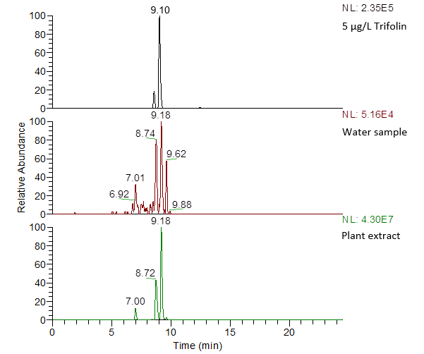
Figure S24: Extracted ion chromatograms of trifolin in reference standard, water sample and plant (Galanthus nivalis) elutriates. NL: signal intensity at 100%.
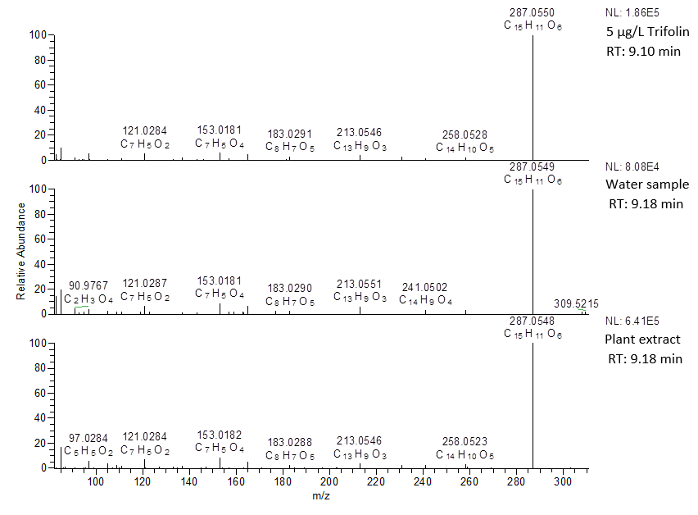

Figure S25: MS/MS spectra (HCD fragmentation at 45 a.u.) of trifolin in a reference standard, water sample and plant (Galanthus nivalis) elutriates.
Table S8: Concentration of detected metabolites in both water samples and aqueous plant elutriates.
Plant Metabolite | Concentration (µg/L) of metabolites detected in water samples |  |  |  |  |  |  |  | Water extractable concentration (µg/g) of metabolites in aqueous plant extract
Plant Metabolite | Leipzig |  |  |  |  | Bode catchment |  |  | Leipzig |  | Bode catchment
Plant Metabolite | Paußnitz-1 (ELP1) | Paußnitz-2 (ELP11) | Tributary to Elsterflutbett-1 (ELP2) | Tributary to Elsterflutbett-2 (ELP21) | Östliche Rietzchke (ELP3) | Barrenbach (BD1) | Getel (BD2) | Drangetalwasser (BD3) | Allium ursanium | Galanthus nivalis | Fraxinus exclsivor | Digitalis purpurea | Conium maculatum L
Adenine | 0.9 | 0.4 | 2.7 | 2.6 | ND | 1.5 | 0.9 | 2.4 | 47.8 | 9.2 | 59.3 | 47.5 | 35.0
Alpinetin | ND | 0.02 | ND | ND | 0.05 | ND | ND | ND | ND | ND | ND | ND | ND
Apiin | ND | ND | 2.9 | 3.0 | 1.2 | ND | ND | 5.1 | ND | ND | ND | 21.7 | ND
Cynaroside | 0.4 | ND | 2.0 | 2.1 | 0.2 | ND | ND | 1.0 | 17.3 | 50.6 | ND | 11.1 | ND
Guanosine | ND | ND | ND | 3.9 | ND | 2.4 | 1.1 | 4.0 | 42.8 | 55.7 | 189.5 | 56.1 | 71.7
Hyperoside | ND | ND | 4.0 | 3.8 | ND | ND | ND | ND | ND | 18.9 | 22.6 | ND | ND
Isofraxidin | 0.3 | 0.1 | 0.2 | 0.2 | 0.02 | 0.04 | 0.1 | ND | 0.1 | 0.01 | 16.8 | 0.1 | 0.04
Kaempferitrin | ND | ND | ND | ND | 0.9 | ND | ND | ND | ND | ND | ND | ND | ND
Nicotiflorin | ND | ND | 2.2 | 2.2 | ND | ND | 1.9 | ND | ND | ND | 88.0 | ND | ND
Quercetin | ND | ND | 2.5 | 1.9 | ND | ND | ND | ND | ND | 74.7 | 54.6 | ND | ND
Trifolin | ND | ND | 2.0 | 2.9 | ND | ND | 0.3 | ND | 25.0 | 27.4 | 36.0 | 27.4 | ND
ND – Not Detected

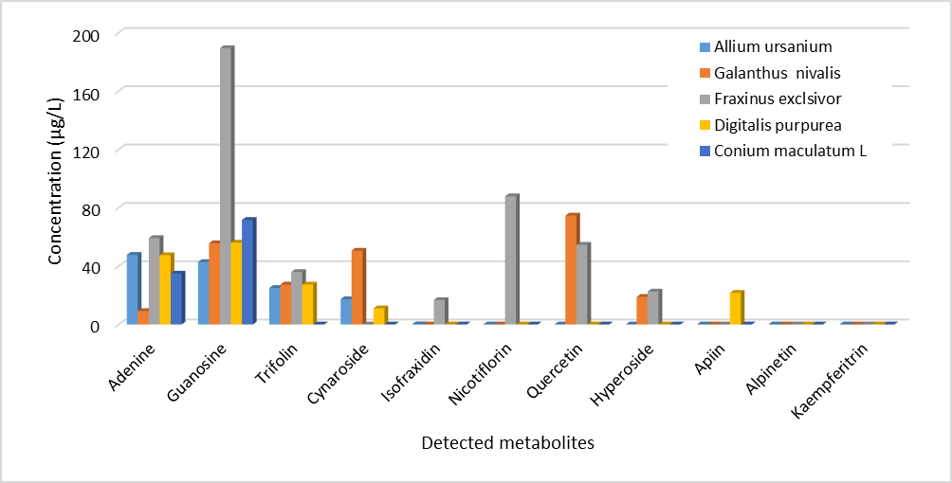
Figure S26: Distribution of detected metabolites in the aqueous plant elutriates

