Additional file 1
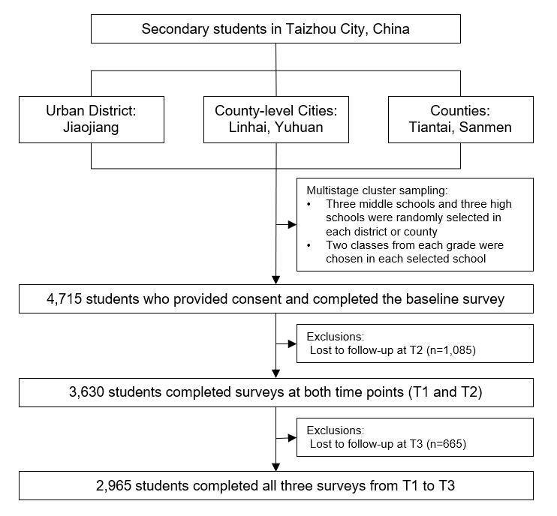

Figure S1 Flow chart showing sample size included in the study

Table S1 Effect size and standardized regression coefficients for the indirect effects for academic stress and study time on depressive symptoms and anxiety symptoms via measurement factors of the latent variables (loneliness, physical activity, and sleep)
 | Depressive symptoms |  |  | Anxiety symptoms
 | Indirect effects | Effect size |  | Indirect effects | Effect size
Model 1: measurement factors of loneliness (CFI 0.980, TLI 0.851, RMSEA 0.068, sRMR 0.026)
Academic stress
Via relational connectedness | 0.02 (0.01 to 0.03) * | 7.89% |  | 0.01 (0.01 to 0.02) * | 8.00%
Via social connectedness | 0.03 (0.02 to 0.04) * | 12.41% |  | 0.01 (0.01 to 0.02) * | 11.20%
Via self-perceived isolation | 0.04 (0.02 to 0.05) * | 13.53% |  | 0.01 (0.01 to 0.02) * | 9.60%
Study time
Via relational connectedness | 0.00 (-0.00 to 0.00) | - |  | 0.00 (-0.00 to 0.00) | -
Via social connectedness | 0.00 (-0.00 to 0.01) | - |  | 0.00 (-0.00 to 0.00) | -
Via self-perceived isolation | 0.00 (-0.00 to 0.00) | - |  | 0.00 (-0.00 to 0.00) | -
Model 2: measurement factors of physical activity (CFI 0.998, TLI 0.988, RMSEA 0.068, sRMR 0.025)
Academic stress
Via frequency of physical exercise per week | 0.007 (0.004 to 0.012) * | 2.63% |  | 0.002 (0.001 to 0.003) * | 1.60%
Via weekly physical activity level | -0.00 (-0.00 to 0.00) | - |  | 0.00 (-0.00 to 0.00) | -
Study time
Via frequency of physical exercise per week | -0.00 (-0.00 to 0.00) | - |  | -0.00 (-0.00 to 0.00) | -
Via weekly physical activity level | -0.00 (-0.00 to 0.00) | - |  | -0.00 (-0.00 to 0.00) | -
Model 3: measurement factors of sleep (CFI 0.981, TLI 0.742, RMSEA 0.068, sRMR 0.023)
Academic stress
Via sleep duration | 0.008 (0.006 to 0.01) * | 3.01% |  | 0.003 (0.001 to 0.005) * | 2.40%
Via sleep disturbances | 0.03 (0.02 to 0.04) * | 11.28% |  | 0.02 (0.01 to 0.02) * | 12.00%
Via sleep latency | 0.01 (0.01 to 0.02) * | 4.51% |  | 0.007 (0.003 to 0.01) * | 5.60%
Via daytime dysfunction | 0.04 (0.03 to 0.05) * | 14.66% |  | 0.02 (0.01 to 0.03) * | 16.00%
Via sleep efficiency | 0.00 (-0.00 to 0.01) | - |  | 0.00 (-0.00 to 0.00) | -
Via sleep quality | 0.01 (0.002 to 0.02) * | 4.14% |  | 0.00 (-0.00 to 0.01) | -
Via sleep medication | 0.00 (-0.00 to 0.01) | - |  | 0.00 (-0.00 to 0.00) | -
Study time
Via sleep duration | 0.00 (-0.00 to 0.00) | - |  | 0.00 (-0.00 to 0.00) | -
Via sleep disturbances | 0.00 (-0.00 to 0.00) | - |  | 0.00 (-0.00 to 0.00) | -
Via sleep latency | 0.00 (-0.00 to 0.00) | - |  | 0.00 (-0.00 to 0.00) | -
Via daytime dysfunction | -0.00 (-0.00 to 0.00) | - |  | -0.00 (-0.00 to 0.00) | -
Via sleep efficiency | 0.00 (-0.00 to 0.00) | - |  | 0.00 (-0.00 to 0.00) | -
Via sleep quality | -0.00 (-0.00 to 0.00) | - |  | -0.00 (-0.00 to 0.00) | -
Via sleep medication | 0.00 (-0.00 to 0.06) | - |  | 0.00 (-0.00 to 0.00) | -
* p value <0.05.

Figure S2 Standardized coefficients for the direct effects for model 1 (loneliness mediators). Note: Single-headed arrows indicate regression paths, and rectangles represent measured variables. Coefficients are shown for statistically significant paths, whereas paths with dashed lines were not significant.

Figure S3 Standardized coefficients for the direct effects for model 2 (physical activity mediators). Note: Single-headed arrows indicate regression paths, and rectangles represent measured variables. Coefficients are shown for statistically significant paths, whereas paths with dashed lines were not significant.

Figure S4 Standardized coefficients for the direct effects for the model 3 (sleep mediators) . Note: Single-headed arrows indicate regression paths, and rectangles represent measured variables. Coefficients are shown for statistically significant paths, whereas paths with dashed lines were not significant.

