Supplement
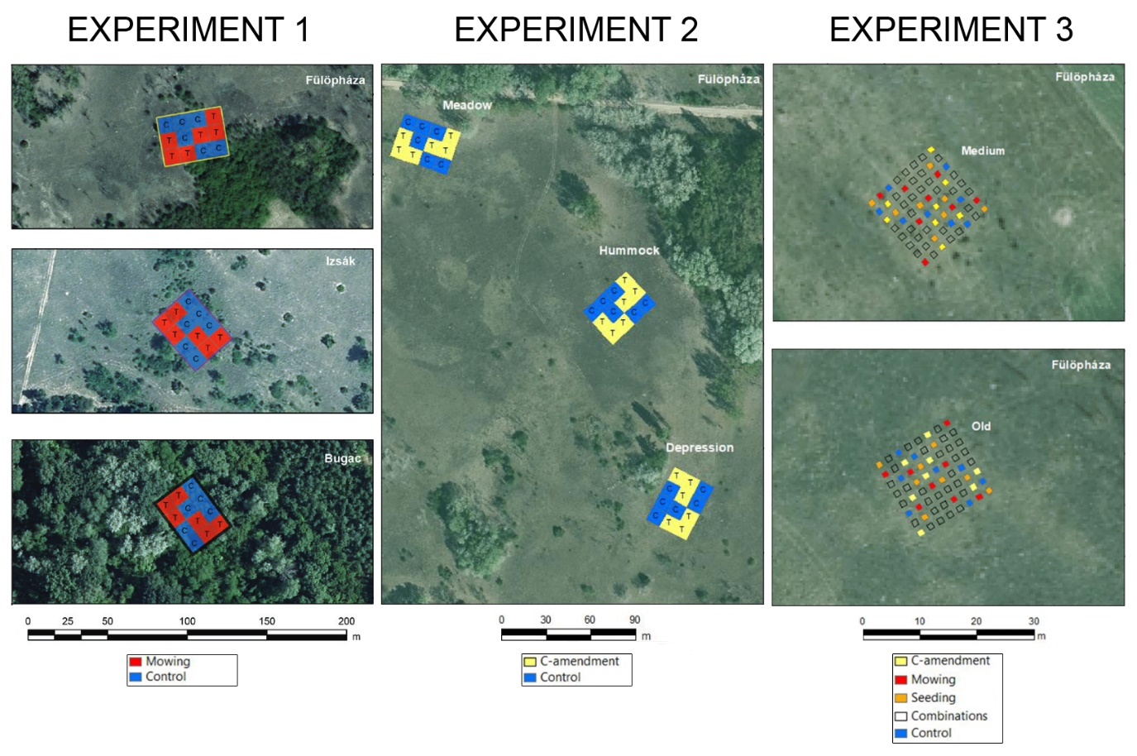
Figure S1. Schematic figure showing the experimental setups of the three experiments. The figure is based on the work of Reis (2021).

Table S1. List of neophyte species present within the three experiments in all years with average relative cover and life-form groups indicated.
Species | Life form groups | EXP 1 | EXP 2 | EXP 3
Acer negundo L. | Woody | 0.2%
Ailanthus altissima (Mill.) Swingle | Woody | 1%
Amaranthus albus L. | Annual | 0.5% | 0.03%
Amaranthus blitoides S. Watson | Annual | 0.01%
Amaranthus crispus  (Lesp. & Thévenau) N. Terracc. | Annual | 0.1%
Amaranthus retroflexus L. | Annual | 1% | 0.02%
Ambrosia artemisiifolia L. | Annual | 0.03% | 5% | 14%
Asclepias syriaca L. | Perennial | 2% | 4% | 0.14%
Celtis occidentalis L. | Woody | 0.4%
Cenchrus incertus M.A. Curtis | Annual | 0.01% | 0.1% | 0.01%
Chenopodium aristatum L. | Annual |  | 0.01% | 0.01%
Conyza canadensis (L.) Cronquist | Annual | 10% | 2% | 4%
Cuscuta campestris Yunck. | Annual |  | 0.01%
Erigeron annuus subsp. strigosus  (Muhl. ex Willd.) Wagenitz | Annual | 0.04% |  | 0.01%
Fraxinus pennsylvanica Marshall | Woody | 0.01%
Gleditsia triacanthos L. | Woody | 0.01% |  | 0.01%
Oenothera biennis L. | Perennial |  | 0.01% | 0.3%
Prunus serotina Ehrh. | Woody | 0.01 %
Robinia pseudoacacia L. | Woody | 3% | 0.01% | 0.01%
Senecio vernalis Waldst. & Kit. | Annual | 0.3% | 0.01% | 0.01%
Solidago canadensis L. | Perennial | 0.02%
Tragus racemosus (L.) All. | Annual | 1% | 0.01% | 0.01%

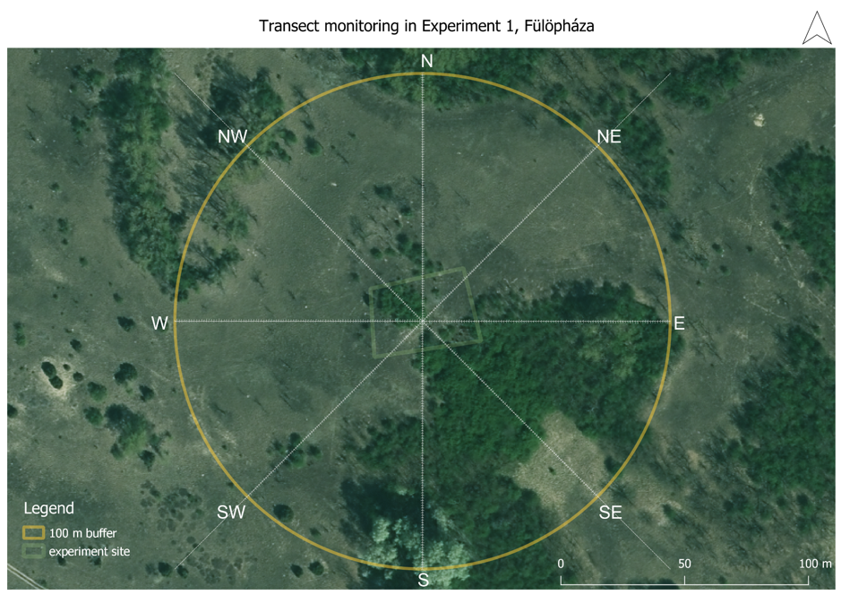
Figure S2. Monitoring arrangement for estimating invasive propagule pressure with the transect method (first experiment at the Fülöpháza site). We established eight 100-meter-long transects towards the eight cardinal directions. We recorded the number of shoots of each neophyte species in 1 m x 1 m adjacent plots along each transect (n=100 per transect). Projected coordinate system: EOV-1972. Map made in QGIS, orthophotos by the Lechner Knowledge Center, Budapest, 2019.

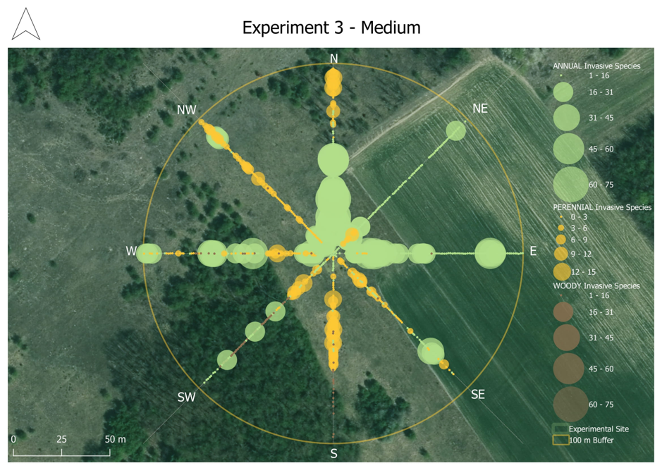
Figure S3. Example of heat map of invasion around the restoration experimental sites. The EXP3 Medium site had the largest average invasive species abundance. The presence of annual (green), perennial (yellow) and woody (brown) neophyte species are marked separately for each meter. Projected coordinate system: EOV-1972. Map made in QGIS, orthophotos by the Lechner Knowledge Center, Budapest, 2019.

Table S2. Anova results on the impact of treatment, elapsed time since restoration interventions and their interactions on the relative cover of annual and perennial neophytes of the three experiments separately. The significant values (p<0.05) are given in bold and highlighted with gray background color.
EXPERIMENT 1
Annual Neophytes
 | χ² | Df | P-value
Treatment | 8.8692 | 1 | 0.0029
Time | 0.7214 | 1 | 0.3957
Interaction | 0.0262 | 1 | 0.8714
Perennial Neophytes
 | χ² | Df | P-value
Treatment | 2.5255 | 1 | 0.1120
Time | 65.8614 | 1 | <0.001
Interaction | 3.3484 | 1 | 0.0672
EXPERIMENT 2
Annual Neophytes
 | χ² | Df | P-value
Treatment | 0.1308 | 1 | 0.7176
Time | 0.3939 | 1 | 0.5302
Interaction | 2.1165 | 1 | 0.1457
Perennial Neophytes
 | χ² | Df | P-value
Treatment | 1.1150 | 1 | 0.2909
Time | 0.2612 | 1 | 0.6093
Interaction | 11.8595 | 1 | 0.0005
EXPERIMENT 3
Annual Neophytes
 | χ² | Df | P-value
Treatment | 3.9724 | 1 | 0.0462
Time | 75.3081 | 1 | <0.001
Interaction | 0.5456 | 1 | 0.4601
Perennial Neophytes
 | χ² | Df | P-value
Treatment | 0.4304 | 1 | 0.5118
Time | 1.0007 | 1 | 0.3172
Interaction | 1.8100 | 1 | 0.1785

Table S3. Anova results of the effect of restoration intervention, time since interventions and invasive propagule pressure on the effect size of annual & perennial neophyte species within the restoration experiments. Significant values (p<0.05) are in bold and marked with asterisk.

Variables | Annual Neophytes
 | χ² | Df | P value
Time since treatment | 0.8116 | 1 | 0.3677
Treatments | 21.1660 | 2 | <0.001 ***
Invasion propagule pressure | 0.6851 | 1 | 0.4079
 | Perennial Neophytes
Time since treatment | 4.3332 | 1 | 0.03738 *
Treatments | 1.2011 | 2 | 0.54851
Invasion propagule pressure | 3.2039 | 1 | 0.07347

Table S4. The result of the Tukey pairwise comparison applied as a post hoc test for treatment in the case of annual neophyte species. Significant values ​​(p<0.05) are in bold.
Annual Neophytes – Emmeans Tukey pairwise comparisons
 | estimate | SE | df | t.ratio | p.value
Mowing - C-amendment | 0.230 | 0.230 | 99 | 1.002 | 0.5774
Mowing - Seeding | -0.714 | 0.229 | 99 | -3.119 | 0.0067
C-amendment - Seeding | -0.944 | 0.213 | 99 | -4.440 | 0.0001

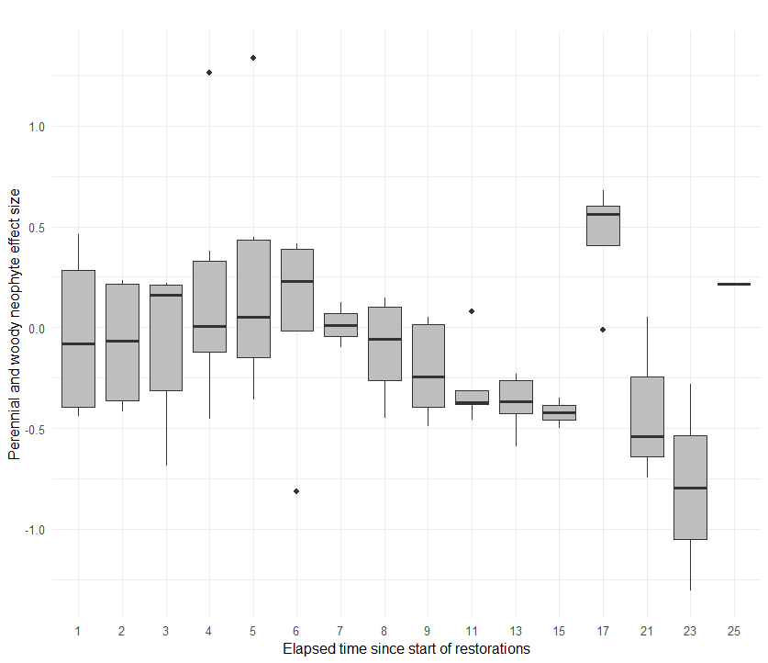
Figure S4. Effect of elapsed time since restoration interventions on the effect size of perennial neophyte species.

