A1 Statistical analysis of the Catalog_TM
In this electronic supplement, we describe in detail the methods adopted for the input parameters of our methods

A1.1 The completeness magnitude $m_{c}$
Immediately following a significant earthquake, numerous aftershocks are not detected. The waveforms produced by these aftershocks, many of which occur in close succession to the mainshock, overlap, making it challenging to differentiate between them accurately. Consequently, the completeness of the seismic catalog is assessed by establishing a minimum threshold, denoted as $m_{c}$. This threshold represents the magnitude beyond which all events are identified and included in the seismic catalog. The specific value of $m_{c}$ is influenced by the noise level in the seismic data and the distance between the earthquake's epicenter and the recording seismic stations (Mignan et al., 2011). Plotting the magnitude vs the earthquake index instead of the usual plot of the magnitude vs time (Fig.S1), we show that time-dependent incompleteness is present in the instrumental catalog, especially after the largest events. Furthermore, a clear periodicity is easily detected by calculating the histogram of the activity during the day, resulting in a higher sensitivity in the night hours, less noisy.
To estimate the completeness magnitude $m_{c}$, several methods have been proposed (Wiemer and Wyss, 2000; Cao and Gao, 2002; Ogata and Katsura, 1993; Godano, 2017; Godano, et al., 2023; Godano and Petrillo, 2023; Roberts et al., 2015).
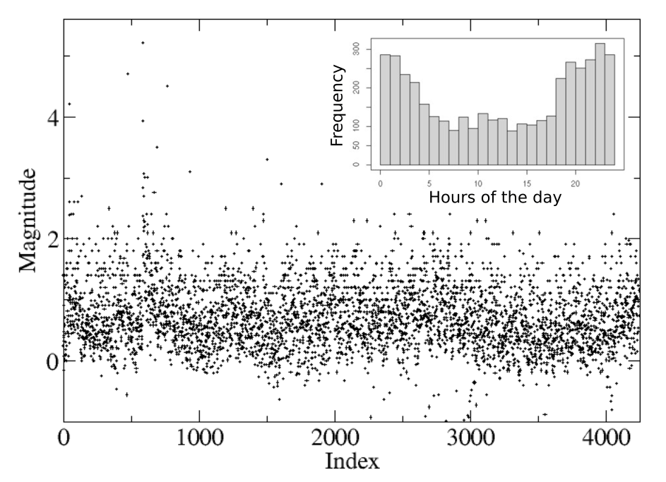
Figure S1 – (Main panel) The Catalog_TM plotted as a function of the earthquake index. (Inset) Histogram of the seismicity for the different hours of the day.

In the following, we employ the method introduced by Godano et al. (2023), representing a generalization of the b-stabilization method from Cao and Gao (2002). In the practice, we use a second-order statistics, observing that the variability coefficient of an exponential distribution assumes a value equal to 1. More precisely, for increasing values of the minimum magnitude m_{min} to be checked, we define the quantity m*=m-m_{min} where m is the events magnitude, and we evaluate its variability coefficient c_{v}=σ*/〈m*〉, where σ* is the standard deviation of m* and 〈m*〉 is its average value; m* will follow an exponential distribution where c_{v} assumes the value 1. The completeness magnitude m_{c} corresponds to the smallest value of m_{min} for which c_{v}≅1. With this method, we estimate for the magnitude of completeness a value m_{c}=1.5.

A1.2 Fractal analysis
A seismic catalog's fractal analysis allows for describing event distribution, such as clustering, using a single number. The non-integer value of the fractal dimension D can be understood by referring to the Euclidean dimensions that describe a point, a line, a plane, and a sphere with dimensions equal to 0, 1, 2, and 3, respectively. High levels of clustering around a point are, therefore, indicated by values close to zero. In contrast, increasing values show a propensity for a linear or planar distribution or even to fill the entire volume (Mandelbrot, 1977). We used the fixed-size Correlation Integral approach (Mandelbrot, 1977; Grassberger, 1983) to calculate the fractal dimension of the spatial distribution of the hypocentres since it is less sensitive to data number and shape of the spatial point distribution than other methods (e.g., Bressan et al., 2016). According to this method, the fractal dimension D is:
$$D=\frac{log C(L) }{log (L) }$$
where
$$C\left(L\right)=\frac{n}{N}$$
Here, n is the number of the couples of hypocentres separated by a distance less than L, progressively reduced and N is the total number of seismic events. Hence, D, is the slope of the curve of C(L) versus L in a bi-logarithmic diagram.
We considered the template-matching augmented catalog in a small area around the cluster (14.75-14.93° E; 41.80-41.93° N) (Figure 1 of the main document).

Before calculating the variation in time of the fractal dimension, to evidence possible clusters we calculated the fractal dimension of the catalogs as a whole: the machine learning augmented catalog in the zoomed area (zoom) and the original ISIDe catalog, limited to the events with a longitude greater than 14° (here below ISI14), to have a value representative of the whole region, for the neares neibor analysis (see main document). Table A1 summarises the results.

Table A1: Fractal dimension obtained considering the catalog as a whole (see text for the definition of the names).
Catalog | Fractal Dimension | Window used  (n. events)
zoom | 1.71 | 3866
ISI14 | 1.14 | 5958

It is interesting that if we consider the smaller area around San Giuliano, the fractal dimension is closer to a planar distribution (1.71), whereas it is close to 1 for the ISIDe catalog, as in other regions (Peresan and Gentili, 2018).

A 1.3 The b-value
The estimation of the b-value is intricate and often influenced by biases stemming from the biased estimation of mc. It is crucial to carefully assess this parameter, as it shows an inverse correlation with the stress state (Scholz, 1968; Wyss, 1973; Amitrano, 2003; Gulia & Wiemer, 2010) and a direct correlation with material heterogeneity (Bressan et al., 2021). Recent efforts have proposed an empirical framework linking the b-value to Anderson's faulting theory and differential stress, supported by numerical ( Lippiello et al., 2019; 2021; Petrillo et al., 2020; 2022) and experimental findings (Godano et al., 2022), suggesting a decrease in the b-value due to stress concentration induced by afterslip dynamics. Following the assumption that the b-value relates to the stress state, researchers aim to use its temporal and spatial evolution to identify stress changes triggered by significant foreshocks.
Van der Elst (2021) has introduced a groundbreaking solution to address this challenge with the b-positive method. This method examines only the positive differences in magnitude between consecutive earthquakes. Also, Lippiello and Petrillo (2024) confirm the method's robustness, as it remains largely unaffected by detection issues, thanks to the inherent properties of conditional probability.
We chose to employ the c_{v} method (Godano et al., 2023) and the b-positive approach for estimating the b-value because they specifically address biases stemming from short-term aftershock incompleteness. While other methods are equally valid (Cao & Gao, 2002; Godano 2017; Wiemer & Wyss, 2000; Ogata & Katsura, 1993), the studies by Godano et al. (2023) and Lippiello and Petrillo (2024) underscore the significance and efficiency of these approaches.

References
Amitrano D (2003). Brittle‐ductile transition and associated seismicity: Experimental and numerical studies and relationship with the b value. Journal of Geophysical Research: Solid Earth, 108(B1). https://doi.org/10.1029/2001JB000680.
Bressan G, Ponton M, Rossi G, Urban S, (2016). Spatial organization of seismicity and fracture pattern in NE-Italy and W-Slovenia, J. of Seismology, 20, I2, 511–534, https://doi.org/10.1007/s10950-015-9541-9.
Bressan G, Barnaba C, Peresan A, Rossi G (2021). Anatomy of seismicity clustering from parametric space-time analysis, Physics of the Earth and Planetary Interiors, 320, 106787. https://doi.org/10.1016/j.pepi.2021.106787.
Cao A,Gao S S (2002). Temporal variation of seismic b-values beneath northeastern Japan island arc, Geophys. Res. Lett. 29, 1334, https://doi.org/10.1029/2001GL013775.
Godano C (2017). A new method for the estimation of the completeness magnitude, Physics of the Earth and Planetary Interiors, Volume 263, 2017, Pages 7-11, ISSN 0031-9201,https://doi.org/10.1016/j.pepi.2016.12.003.
Godano C, Tramelli A, Petrillo G, Bellucci Sessa E, Lippiello E (2022). The Dependence on the Moho Depth of the b‐Value of the Gutenberg–Richter Law. Bulletin of the Seismological Society of America, 112(4), 1921-1934. https://doi.org/10.1785/0120210144.
Godano C, Petrillo G (2023). Estimating the Completeness Magnitude mc and the b-Values in a Snap, Earth Space Sci. 10, e2022EA002540, https://doi.org/10.1029/2022EA002540 .
Godano C, Petrillo G, Lippiello E (2024). Evaluating the incompleteness magnitude using an unbiased estimate of the b value. Geophysical Journal International, 236, 994-1001. https://doi.org/10.1093/gji/ggad466.
Grassberger P, (1983). Generalized dimensions of strange attractors. Phys. Lett. 97A, 227-230, https://doi.org/10.1016/0375-9601(83)90753-3.
Gulia L, Wiemer S (2010). The influence of tectonic regimes on the earthquake size distribution: A case study for Italy. Geophysical Research Letters, 37(10). https://doi.org/10.1029/2010GL043066.
Lippiello E, Petrillo G, Godano C, Tramelli A, Papadimitriou E, and Karakostas V (2019). Forecasting of the first hour aftershocks by means of the perceived magnitude. Nature communications. 10, 2953. https://doi.org/10.1038/s41467-019-10763-3.
Lippiello E, Petrillo G, Landes F, Rosso A (2021). The genesis of aftershocks in spring slider models. Statistical Methods and Modeling of Seismogenesis, 1, 131-151. https://doi.org/10.1002/9781119825050.ch5.
Lippiello E, Petrillo G (2024). b-more-incomplete and b-more-positive: Insights on a robust estimator of magnitude distribution. Journal of Geophysical Research: Solid Earth, 129, e2023JB027849. https://doi.org/10.1029/2023JB027849.
Mandelbrot B B (1977). Fractals: Form, Chance, and Dimension. W.H. Freeman & Company, New York.
Mignan A, Werner M J, Wiemer S, Chen C-C, Wu Y-M (2011). Bayesian Estimation of the Spatially Varying Completeness Magnitude of Earthquake Catalogs. Bulletin of the Seismological Society of America 101 (3): 1371–1385. https://doi.org/10.1785/0120100223.
Ogata Y, Katsura K, (1993). Analysis of temporal and spatial heterogeneity of magnitude frequency distribution inferred from earthquake catalogue. Geophys. J. Int. Geophysical Journal International 113 (3): 727–738. https://doi.org/10.1111/j.1365-246X.1993.tb04663.x
Peresan A, Gentili S (2018). Seismic clusters analysis in Northeastern Italy by the nearest-neighbor approach, Physics of the Earth and Planetary Interiors, 274, 87-104. https://doi.org/10.1016/j.pepi.2017.11.007.
Petrillo G, Lippiello E, Landes F P, Rosso A (2020). The influence of the brittle-ductile transition zone on aftershock and foreshock occurrence. Nature Communications, 11(1), 3010. https://doi.org/10.1038/s41467-020-16811-7.
Petrillo G, Rosso A, Lippiello E (2022). Testing of the seismic gap hypothesis in a model with realistic earthquake statistics. Journal of Geophysical Research: Solid Earth, 127(6), e2021JB023542. https://doi.org/10.1029/2021JB023542.
Roberts N S, Bell A F, Main I G (2015). Are volcanic seismic b-values high, and if so when?, Journal of Volcanology and Geothermal Research, Volume 308, 2015, Pages 127-141, ISSN 0377-0273, https://doi.org/10.1016/j.jvolgeores.2015.10.021
Scholz CH (1968) The frequency-magnitude relation of microfracturing in rock and its relation to earthquakes Bulletin of the seismological society of America, 1968, Volume 58, Num. 1, Pag. 399-415. https://doi.org/10.1785/BSSA0580010399.
van der Elst N J (2021). B‐positive: A robust estimator of aftershock magnitude distribution in transiently incomplete catalogs. Journal of Geophysical Research: Solid Earth, 126(2), e2020JB021027. https://doi.org/10.1029/2020JB021027.
Wiemer S, Wyss M (2000). Minimum Magnitude of Completeness in Earthquake Catalogs: Examples from Alaska, the Western United States, and Japan. Bulletin of the Seismological Society of America 2000; 90 (4): 859–869. https://doi.org/10.1785/0119990114
Wyss M (1973) Towards a physical understanding of the earthquake frequency distribution. Geophys. JR Astron. Soc, 31(4), 341-359. https://doi.org/10.1111/j.1365-246X.1973.tb06506.x.

