Supplementary Material

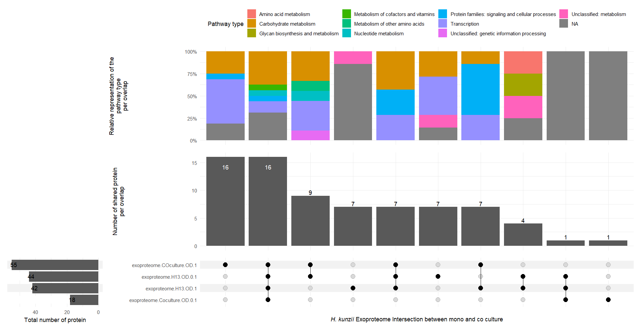
Figure S1: Helcococcus kunzii exoproteome protein distribution and their associated pathways. Comparison of H. kunzii exoproteome proteins identified at the exponential (OD=0.1) and stationary (OD=1) phases of growth in monoculture (H13) and coculture (Coculture). Data are visualized using the UpSet matrix layout and plotted horizontally. Each column contains the proteins of the sets represented by the dark circles and illustrates the associated pathways.

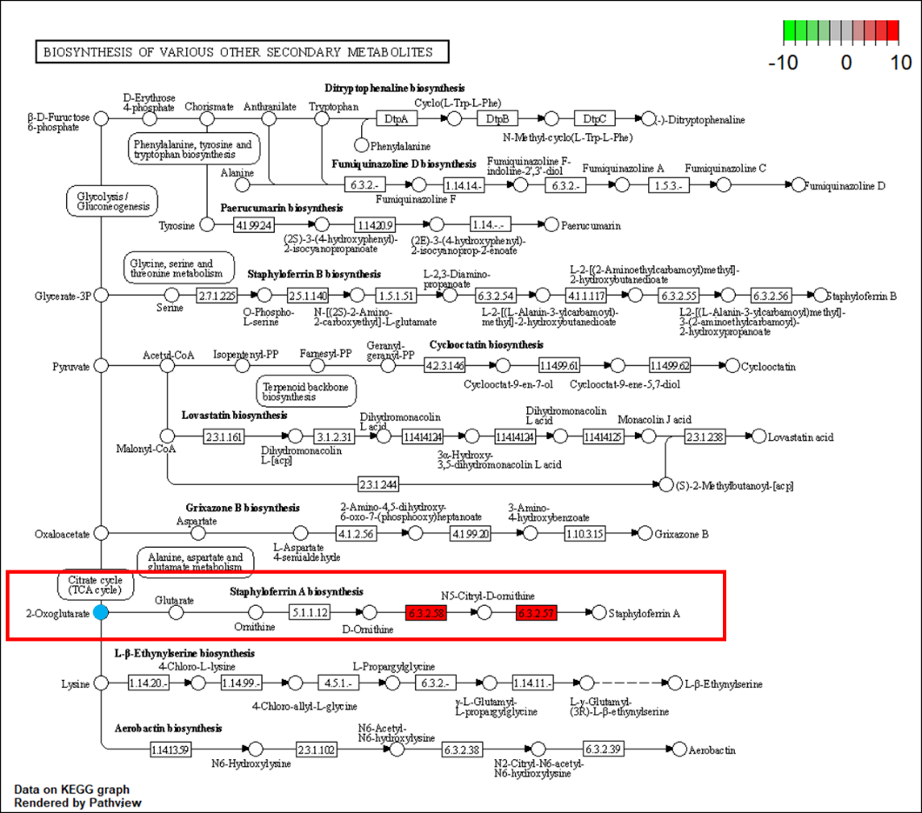
A

B.

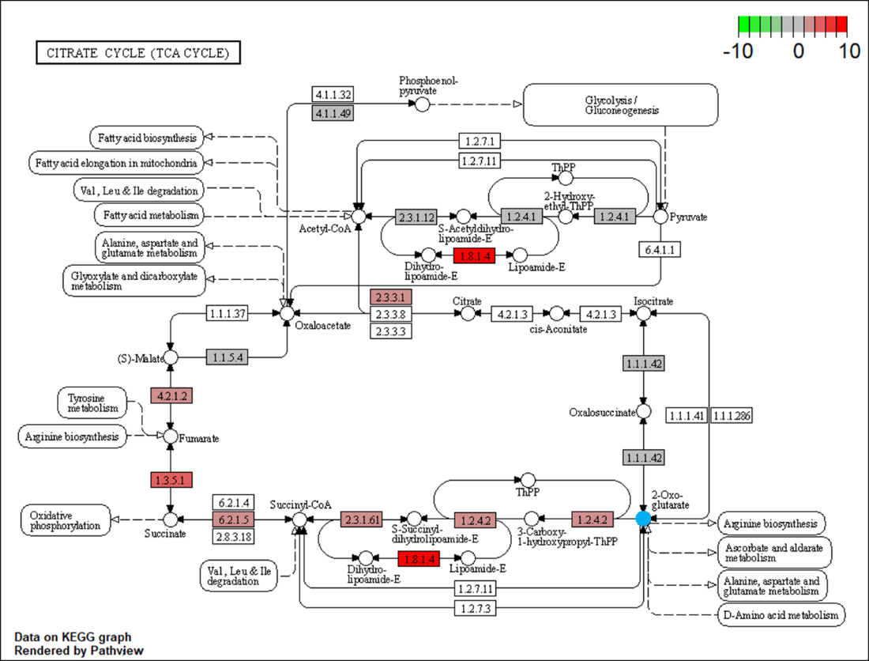
Figure S2: Fold change protein abundance profile for the biosynthesis pathway altering the production of staphyloferrin in coculture. A. Staphyloferrin biosynthetic pathway starting from 2-Oxaloglutarate and is framed in red and B. Citrate cycle resulting in 2-Oxaloglutarate production. Red represents overabundance in monoculture experiments relative to coculture ones, while green indicates the opposite, and gray represents marginal variations. 2-Oxaloglutarate is indicated by a light blue disk. Only significant and specific changes have been represented.

A
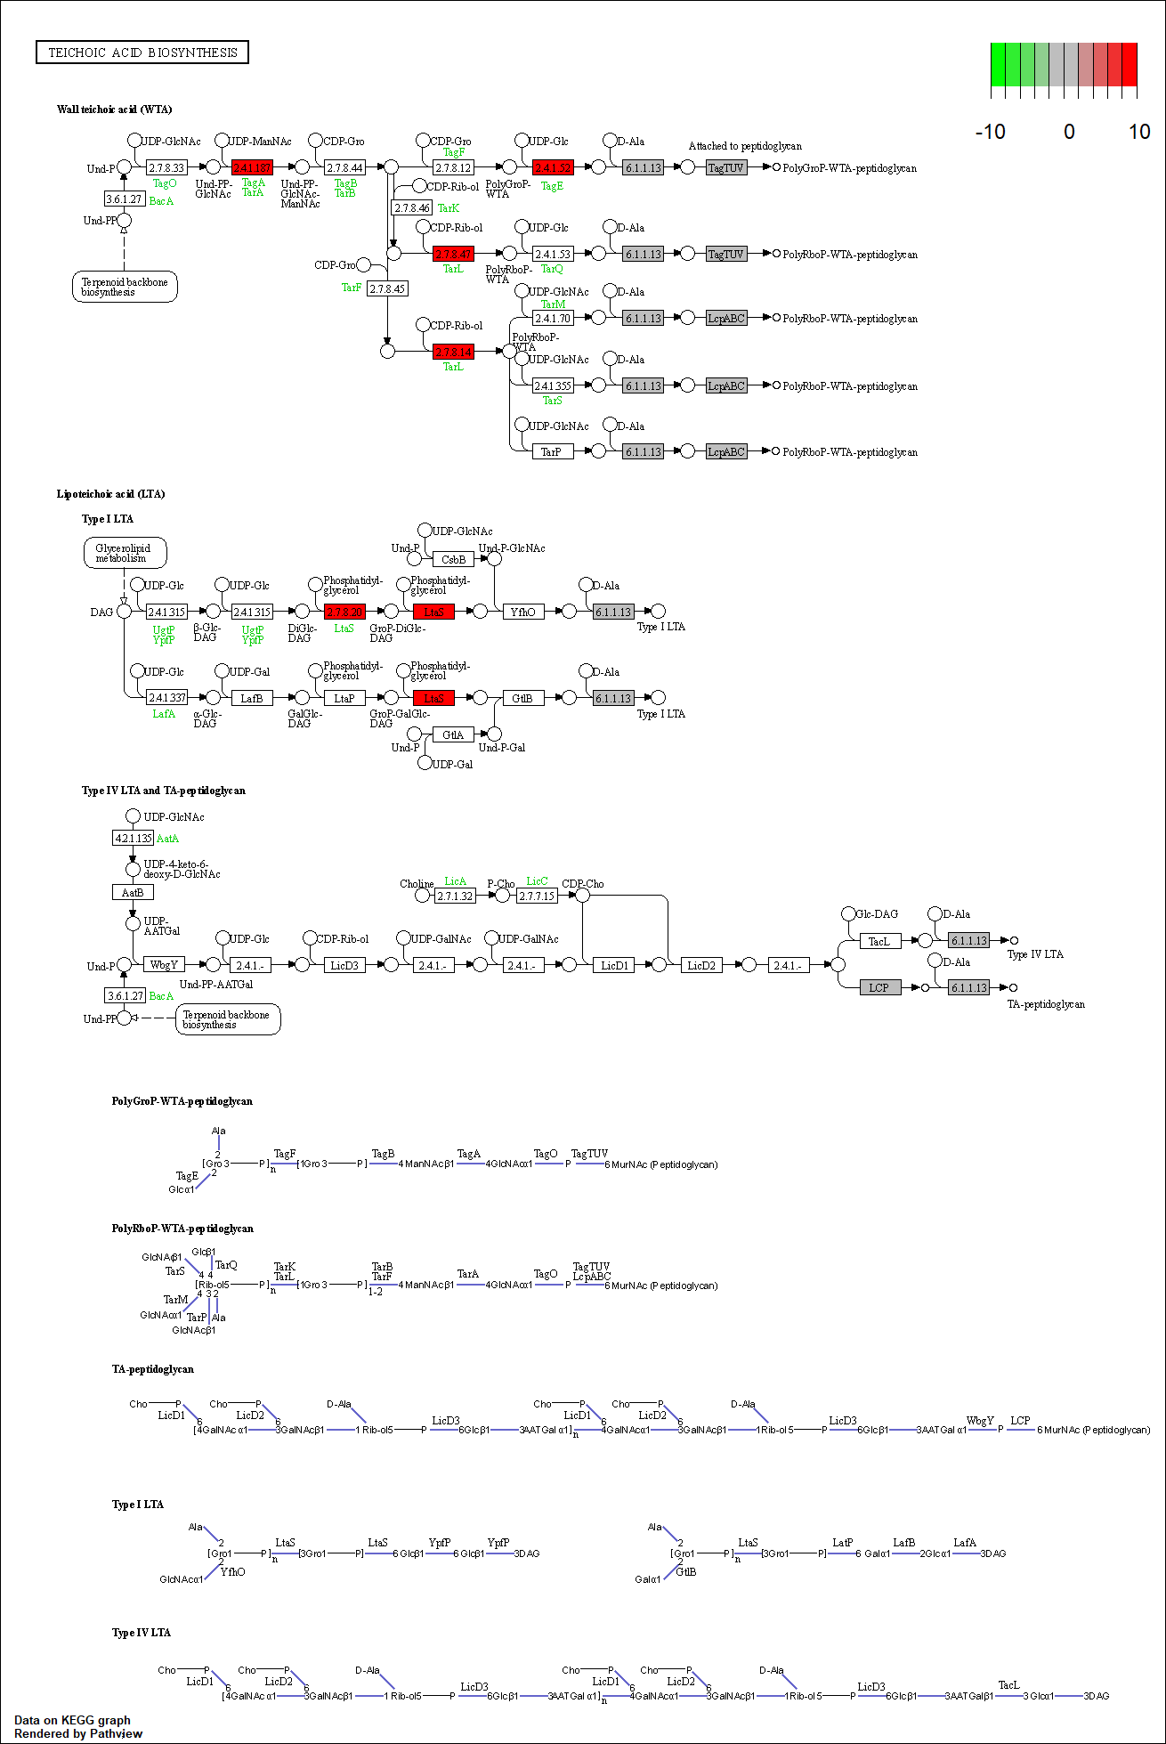
B
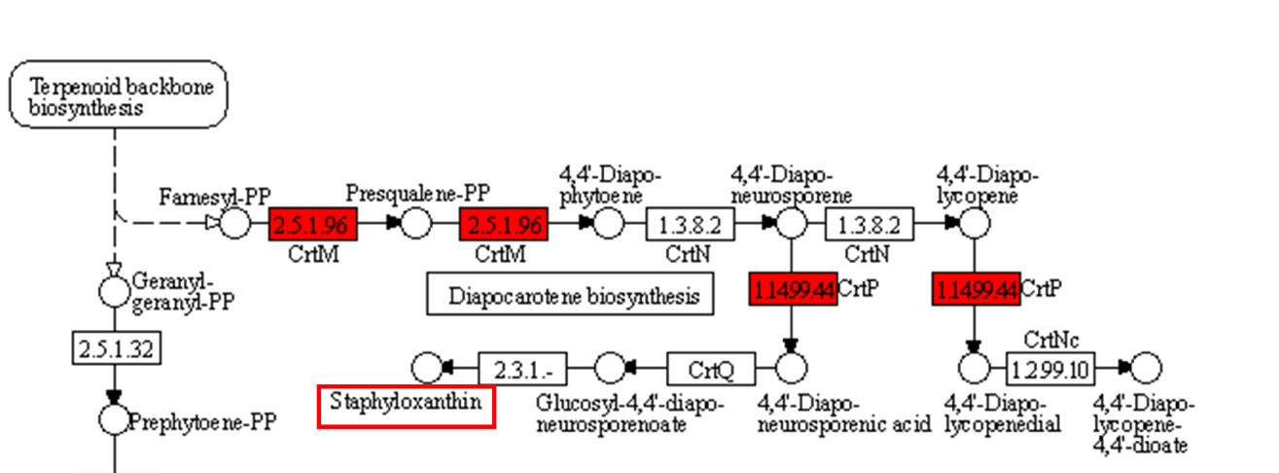

Figure S3: Fold change protein abundance profile for the biosynthetic pathways of A. wall (WTA) and lipoteichoic acid (LTA), and B. Staphyloxanthin (framed in red) production. Red represents overabundance in monoculture experiments relative to coculture ones, while green indicates the opposite, and gray indicates marginal variations. Only significant and specific changes have been represented.

