Supplemental Data
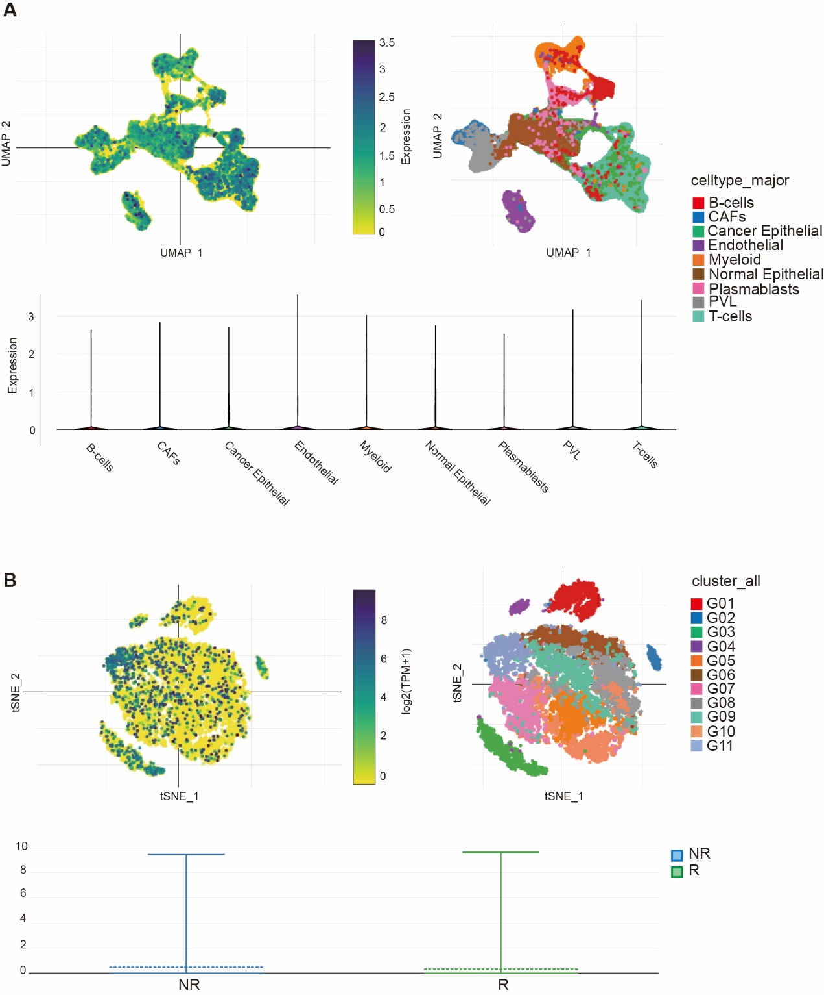
Figure S1. WDR5 expression profiles in human breast cancer and melanoma. A. UMAP of major cell subpopulations (right panel) and WDR5 expression level (left panel) in the indicated cell subpopulations in human breast cancer. The bottom panel shows violin plot of WDR5 expression level in the indicated major cell subpopulations as in the upper left panel. B. UMAP of cell subpopulations showing WDR5 expression level in responders and non-responders to checkpoints immunotherapy in melanoma patients.

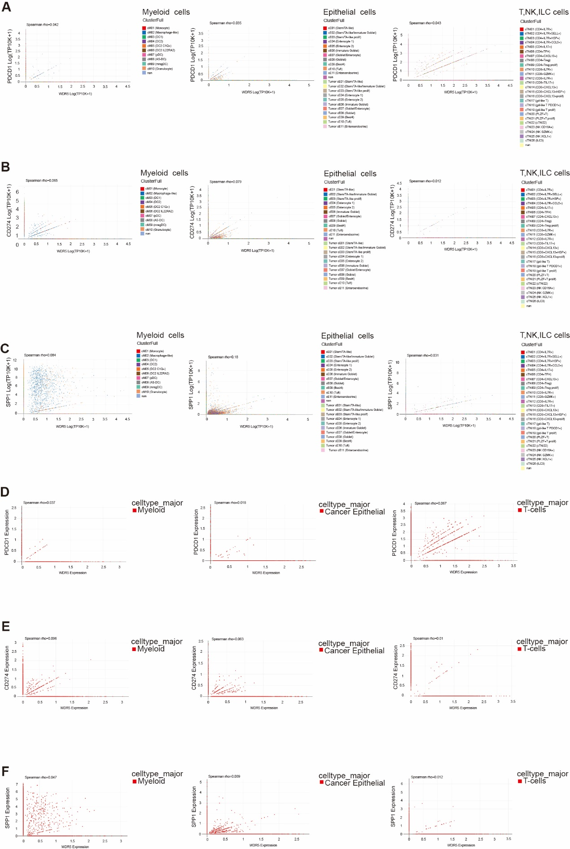

Figure S2. Correlation between WDR5 and PDCD1, CD274, SPP1 in human colon cancer and breast cancer patients. A-C. Correlation between WDR5 and PDCD1 (A), CD274 (B), SPP1(C) in myeloid cells (left panel), epithelial cells (middle panel), T, NK and ILC cells (right panel) in colon cancer patients. D-E. Correlation between WDR5 and PDCD1 (D), CD274 (E), SPP1(F) in myeloid cells (left panel), epithelial cells (middle panel) and T cells (right panel) in breast cancer patients.

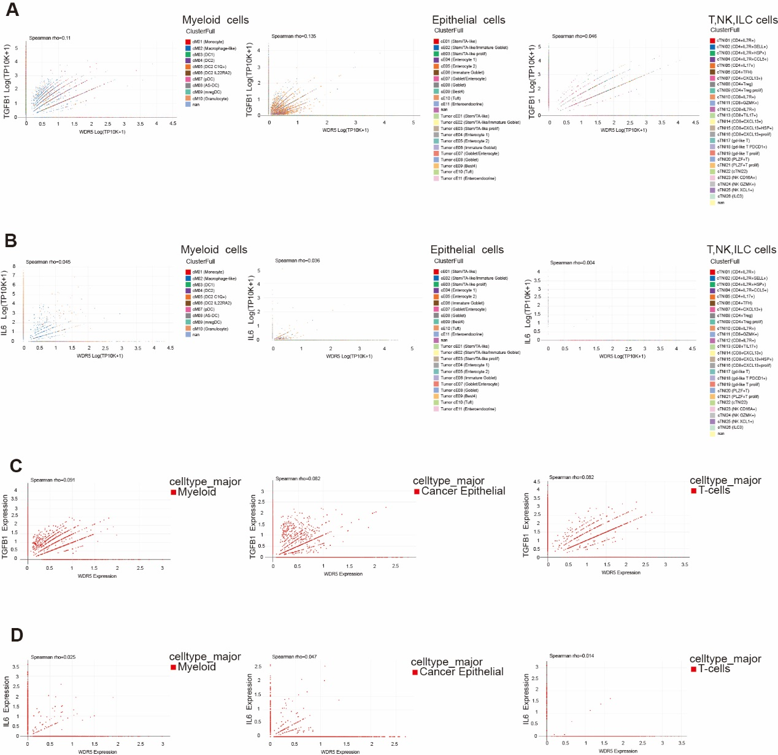
Figure S3. Correlation between WDR5 and TGFB1, IL6 in human colon cancer and breast cancer patients. A-B. Correlation between WDR5 and TGFB1 (A), IL6 (B) in myeloid cells (left panel), epithelial cells (middle panel), T, NK and ILC cells (right panel) in colon cancer patients. C-D. Correlation between WDR5 and TGFB1 (C), IL6 (D) in myeloid cells (left panel), epithelial cells (middle panel) and T cells (right panel) in breast cancer patients.

Table S1. Antibodies
Name | Company | Catlog# | Application
WDR5(G-9) Mouse mAb | SANTA CRUZ | sc-393080 | IHC
TriMethyl-Histone H3-K4 Rabbit mAb | Abclonal | A22146 | WB, ChIP
Histone H3(D1H2) XP Rabbit mAb | Cell Signaling | 4499 | WB
FITC anti-mouse H-2K^{b}/H-2D^{b} Antibody | BioLegend | 114605 | Flow Cytometry
PerCP anti-mouse CD8a Antibody | BioLegend | 100732 | Flow Cytometry
APC anti-mouse CD4 Antibody | BioLegend | 100411 | Flow Cytometry
Normal mouse IgG | SANTA CRUZ | sc-2025 | ChIP

Table S2. Primers
Gene | Forward primer | Reverse primer
mWDR5 | TTGCCAACTTCTCCGTGACA | TTCTCTAACGCTGCTGAGGC
mH2Kb | TCTTGTACCTGTCCTTCCCAGA | CTCTGCCCTTTCCTACCTGTG
mH2Db | AGCAGAGTTTCCGAGTGGAC | TTCAGGTCTTCGTTCAGGGC
mCD4 | CCTCAAGATACCCCAGGTCTCG | CAAGGAAACCCAGAAAGCCG
mCD8 | ACCTGGACATCAGAGCCCCTTG | AATCCTACGCTTTGCCCACC
mFas | ATGCTGTGGATCTGGGCT | TCACTCCAGACATTGTCC
mFasL | CTTGGGCTCCTCCAGGGTCAGT | TCTCCTCCATTAGCACCAGATCC
mPD-1 | CCGCCTTCTGTAATGGTTTGAG | CGATTTTTGCCTTGGGGTGC
mPD-L1 | ATTGCTCCTTGACTGCTGGCTG | TTCTGGGTTCCTCCTCCTTTCC
mSpp1 | GCCTGTTTGGCATTGCCTCCTC | CACAGCATTCTGTGGCGCAAGG
mGZMB | GCCCACAACATCAAAGAACAGG | CCAACCAGCCACATAGCACAC
mPRF-1 | CCTATGGCACGCACTTTATCACG | TTCACTGGAGACGCTGGCTTGG
mIL21 | AAGAGGCAAGGGTGTAGTAAGAAGC | GGAAAGGATGTGGGAGAGGAGAC
mIFNα1 | CTGAAGGACAGGAAGGACTTTGG | CTGCTGGTGGAGGTCATTGC
mIFNβ | CTGCGTTCCTGCTGTGCTTC | TCTTCTCCGTCATCTCCATAGGG
mTbX21 | TGTTCCCATTCCTGTCCTTCAC | TGCTGCCTTCTGCCTTTCC
mIFNγ | CCATCAGCAACAACATAAGCGTC | TCTCTTCCCCACCCCGAATCAGCAG
mCXCL9 | TCATTGCTACACTGAAGAACGGAG | ACGACGACGACTTTGGGGTG
mCXCL10 | TCTCTCCATCACTCCCCTTTACC | CTTGCTTCGGCAGTTACTTTTGTC
mTGFβ | ACTGGAGTTGTACGGCAGTG | GGGGCTGATCCCGTTGATTT
mIL6 | CCCCAATTTCCAATGCTCTCC | CGCACTAGGTTTGCCGAGTA
hWDR5 | ACACCAAAGCAGTGTCCTCC | ATTTCCCATCATACGCGCCC
mH2K1-ChIP1 | GTGTCGCCATTGTATTCCCG | TGGCGACTAAGACTTTGCCT
mH2K1-ChIP2 | GGTTCGGGAACAGAACGGAC | GTCGGACCCCACTTCACAG
mH2K1-ChIP3 | AGGACCGGAAGTCTCCTTACC | CCCCACAGACAGGGAGGGAT
mH2K1-ChIP4 | GTTACAGTGCTCCCTCCCGC | CCTGACTCTGGGGGACAAGG

