A colorimetric smartphone-based sensor for on-site AA detection
based on MCTs nanocomposite materials
Food Analytical Methods
Huanhuan She^{1 a} · Chaoling Wu^{1 a} · Ruotong He¹ · Weihong Xie¹ · Yi Zhang¹ *
¹ School of Life and Health Sciences, Hubei University of Technology, Wuhan 430068, China
* Corresponding author (Yi Zhang)
E-mail addresses: zhangyi@hbut.edu.cn
ª These authors contributed equally to this work.
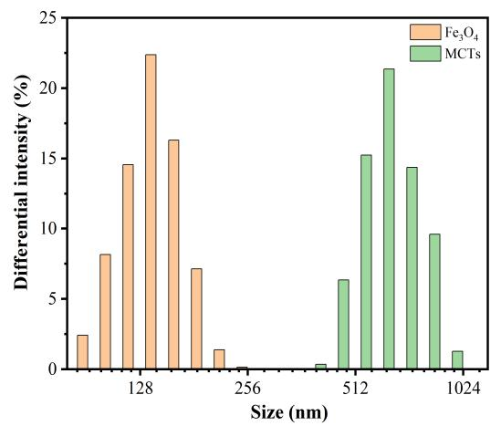
Fig. S1 The particle size distribution diagram of Fe₃O₄ and MCTs.

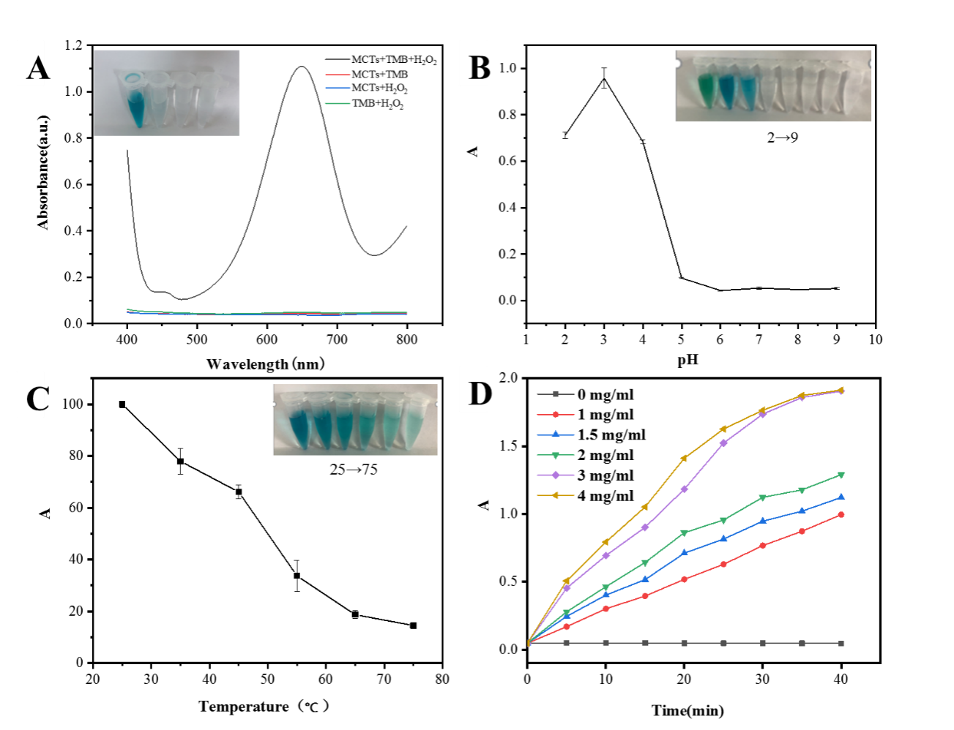
Fig. S2 (A) UV-vis absorbance values at 400~800 nm for various systems. (B) Effect of pH on the peroxidase activity of MCTs. (C) Effect of temperature on the peroxidase activity of MCTs. (D) Effect of material dosage on the peroxidase activity of MCTs.

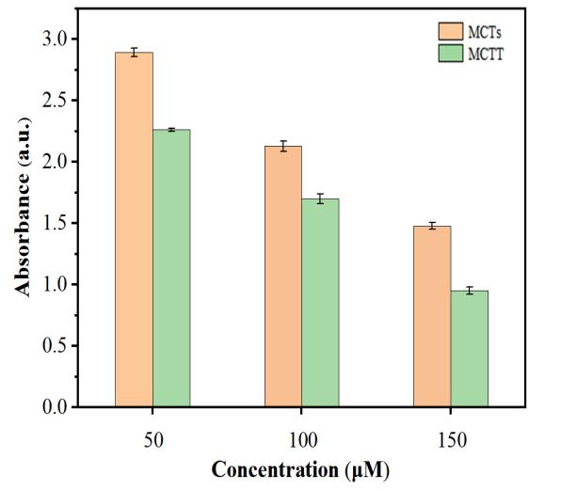
Fig. S3 The influence of MCTs and MCTT on absorbance at different concentrations (50 μM/100 μM/150 μM)

Table S1 The kinetic parameters of MCTs and some other peroxidase mimetics with TMB and H₂O₂ as substrates.
catalys | substrate | Km (mM) | Vmax (10-8 M·s-1) | Reference
HRP | TMB | 0.43 | 10.0 | (Gao et al. 2007)
HRP | H₂O₂ | 3.70 | 8.7 | (Gao et al. 2007)
Pd-Ir cubes | TMB | 0.13 | 6.50 | (Xia et al. 2015)
Pd-Ir cubes | H₂O₂ | 340 | 5.10 | (Xia et al. 2015)
PBMNPs3 | TMB | 0.307 | 1.06 | (Zhang et al. 2010)
PBMNPs3 | H₂O₂ | 323.6 | 1.17 | (Zhang et al. 2010)
CNPs | TMB | 26.06 | 4.27 | (Yadav et al. 2019)
CNPs | H₂O₂ | 0.05 | 6.06 | (Yadav et al. 2019)
Citrate-CuNPs | TMB | 1.63 | 4.90 | (Chen et al. 2021)
Citrate-CuNPs | H₂O₂ | 83.69 | 2.50 | (Chen et al. 2021)
MCTs | TMB  H₂O₂ | 0.87  185 | 1.65  1.27 | This work

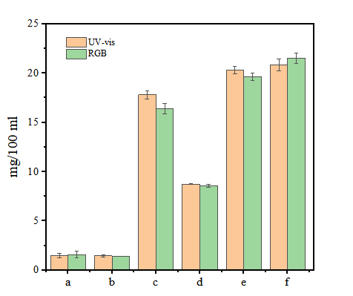
Fig. S4 Ascorbic acid content in 6 commercial beverages, a for Master Kong Daily C Sunshine Sweet Orange, b for Master Kong Daily C Sunshine Grape Juice, c for Farmer's Orchard (50% mixed fruit and vegetables), d for Farmer's Orchard (30% mixed fruit and vegetables), e for Water Soluble C100 (grapefruit flavour) and f for Water Soluble C100 (lemon flavour).
Reference
Gao LZ, Zhuang J, Nie L et al (2007) Intrinsic peroxidase-like activity of ferromagnetic nanoparticles. Nat Nanotechnol 2(9):577-583.
https://doi.org/10.1038/nnano.2007.260
Xia XH, Zhang JT, Lu N et al (2015) Pd-Ir Core-Shell Nanocubes: A Type of Highly Efficient and Versatile Peroxidase Mimic. ACS Nano 9(10):9994-10004. https://doi.org/10.1021/acsnano.5b03525
Zhang XQ, Gong SWY, Zhang Y et al (2010) Prussian blue modified iron oxide magnetic nanoparticles and their high peroxidase-like activity. J Mater Chem 20(24):5110-5116. https://doi.org/10.1039/c0jm00174k
Yadav PK, Singh VK, Chandra S et al (2019) Green Synthesis of Fluorescent Carbon Quantum Dots from Azadirachta indica Leaves and Their Peroxidase-Mimetic Activity for the Detection of H₂O₂ and Ascorbic Acid in Common Fresh Fruits. ACS Biomater Sci Eng 5(2):623-632. https://doi.org/10.1021/acsbiomaterials.8b01528
Chen SH, Li Z, Huang ZZ et al (2021) Investigation of efficient synergistic and protective effects of chitosan on copper nanoclusters: Construction of highly active and stable nanozyme for colorimetric and fluorometric dual-signal biosensing. Sens Actuators B 332:129522.
https://doi.org/10.1016/j.snb.2021.129522

