Supporting Information
A PEG-PLGA-based polymeric capsule as theranostic nanoplatform for active targeting atherosclerosis

1. Determination of curcumin content
1.1. Drawing of standard curve
Curcumin was prepared into a 100 mg / mL solution with DMSO, and then diluted with anhydrous ethanol to 0.1 μg / mL, 1 μg / mL, 2 μg / mL, 5 μg / mL, and 10 μg / mL.
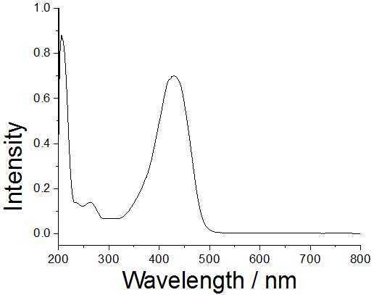
Fig.S1. Curcumin absorption curve (left) and linear curve of curcumin concentration associated with absorbance (right).
1.2. Determination of curcumin encapsulation efficiency and drug loading
100 μL of purified drug-loaded nanoparticles were dried and weighed to obtain the weight of the nanoparticles, followed dissolved with 0.5 mL of ethanol solution, placed at 4 °C overnight. The content of curcumin in PLGA capsules was determined by UV.
Table S1. Experimental operating dose for determination.

Number | Blank tube (g) | Tube with sample  (g) | Volume (mL) | Concentration  (mg/mL) | Mean concentration  (mg/mL) | Absorbance | Concentration of Cur  (μg/mL) | Mean concentration of Cur  (μg/mL)
1 | 0.9747 | 0.9759 | 0.1 | 12 | 13 | 1.5633 | 113.0 | 116.9 μg/mL
2 | 0.9657 | 0.9669 | 0.1 | 12 | 13 | 1.6345 | 118.3 | 116.9 μg/mL
3 | 0.9659 | 0.9673 | 0.1 | 14 | 13 | 1.6511 | 119.5 | 116.9 μg/mL

Table S2. Investigation in DLC and DLE of PC_{SV}.
Designed DLC(%) | Measured DLC(%) | DLE(%)
1.54 | 0.90 | 58.5

2. Determination of CCR-siRNA content
CCR2-siRNAs were prepared with DEPC water and diluted into at 100 μmol / L, 50 μmol / L, 25 μmol / L, 12.5 μmol / L, 6.25 μmol / L, 3.125 μmol / L, 1.562 μmol / L, 0.781 μmol / L, 0.39 μmol / L, and 0.1 μmol / L. The absorbance at 260 nm and 280 nm was measured with a micro spectrophotometer.

Fig.S2. Linear curve of diluted concentration associated with tested concentration.

Table S3. Experimental items for determination.
TPGS and PVA solution | Absorbance at  260 nm | Absorbance at  280 nm | Tested concentration (ng/μL) | Volume  (μL)
IR780 | 0.025 | 0.003 | 1.032 | 54
IR780+siRNA | 0.024 | 0.015 | 0.995 | 34
Comparing the ultrafiltration supernatant of PLGA-PEG-COOH nanoparticles loaded with IR780 and IR780 with siRNA, it can be judged that there was no siRNA in the supernatant, and the input siRNA was encapsulated in the nanoparticles. The absorption in the supernatant of siRNA nanoparticle can be considered as background absorption. The content of siRNA nanoparticle can be calculated to be 0.228%.

3. Stability assessment of PC_{SV}
Fig.3 Size change tendency of PC_{SV} (n = 3).

4. Cytotoxicity assays of blank nanoparticles
Fig.S4. Cytotoxicity assays evaluated by the CCK-8 assay of BPC. Data are expressed as mean±SD (n = 3).

