Supplementary data

- Flower horn | 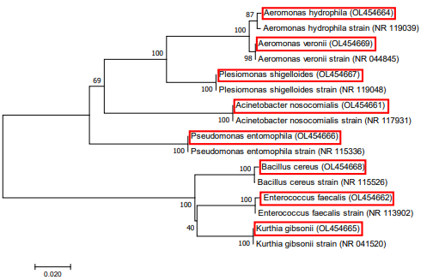
- Kadango | 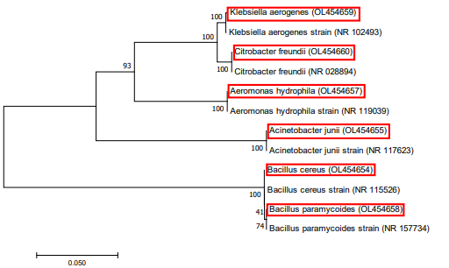
Fig.S1. Phylogenetic analysis of the 16S rRNA gene sequences of bacteria isolated from ornamental fish samples (a&b) collected from Chennai (highlighted) using MEGA 7.0 software

- Sailfin molly | 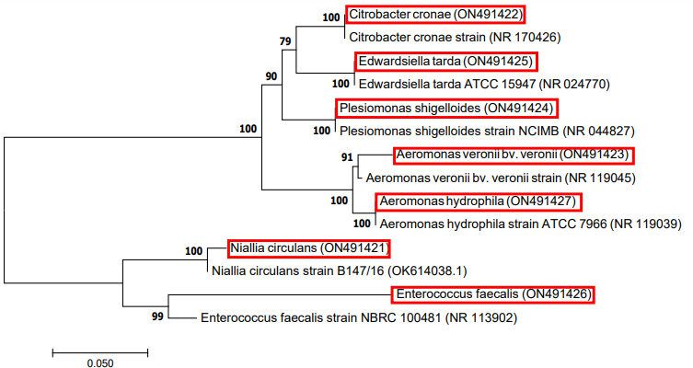
- Swordtail | 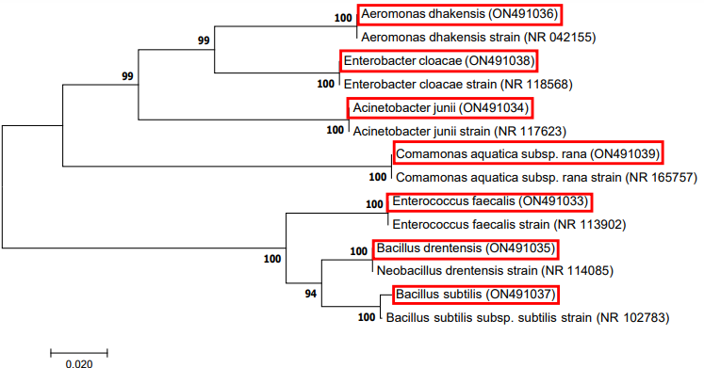
- Koi carp | 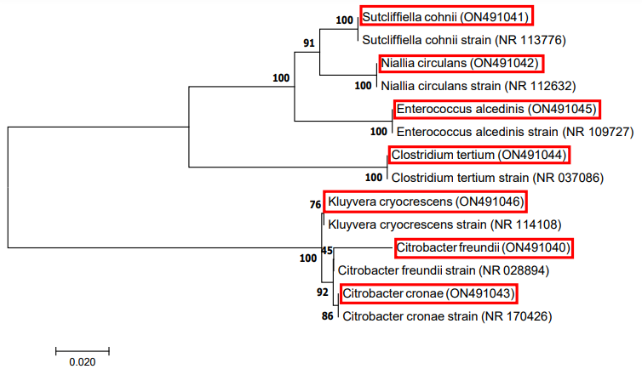
- Angelfish | 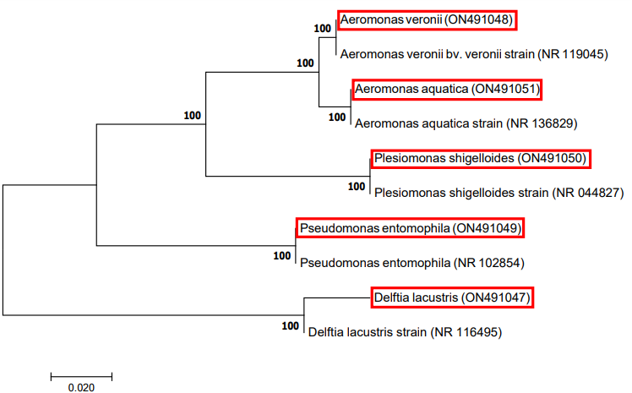
- Tiger barb | 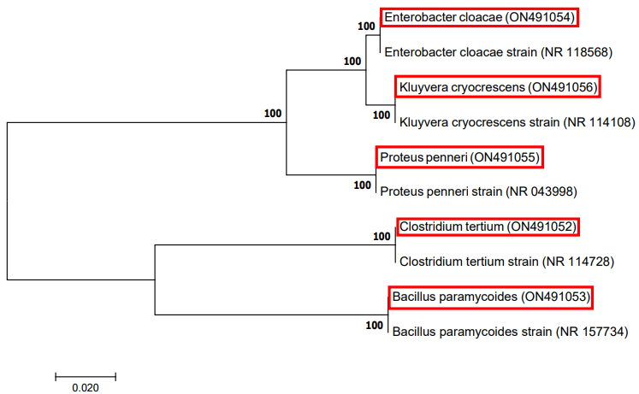
- Longfin tetra | 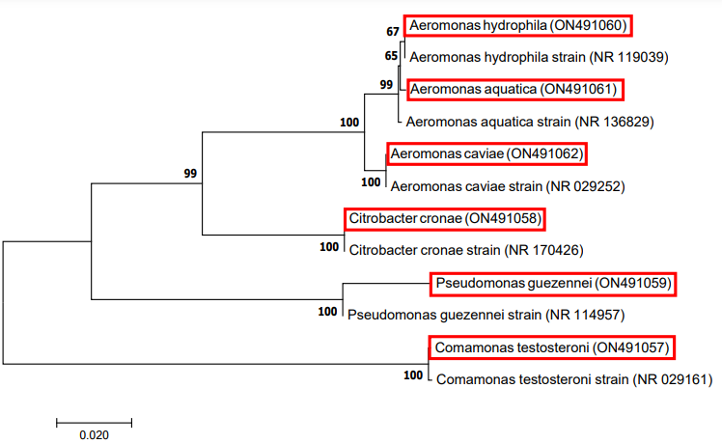
Fig.S2. Phylogenetic analysis of the 16S rRNA gene sequences of bacteria isolated from ornamental fish samples (a-f) collected from Madurai (highlighted) using MEGA 7.0 software

- Goldfish | 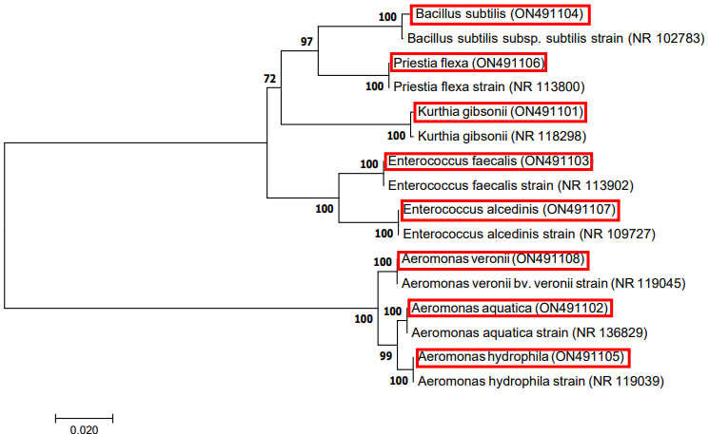
- Koi carp | 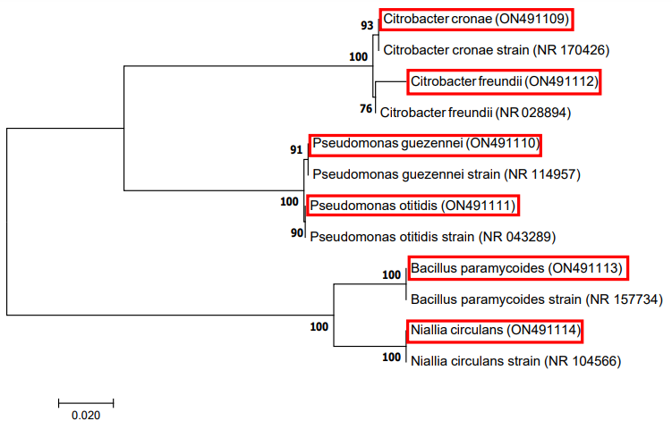
- Guppy | 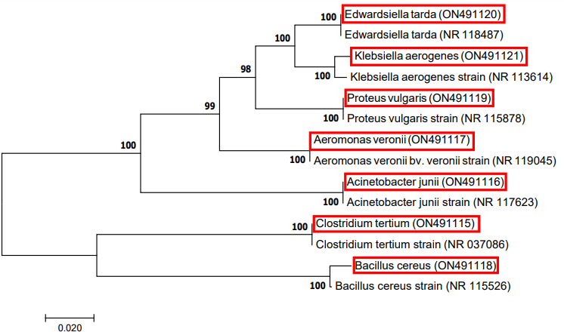
- Cichlid | 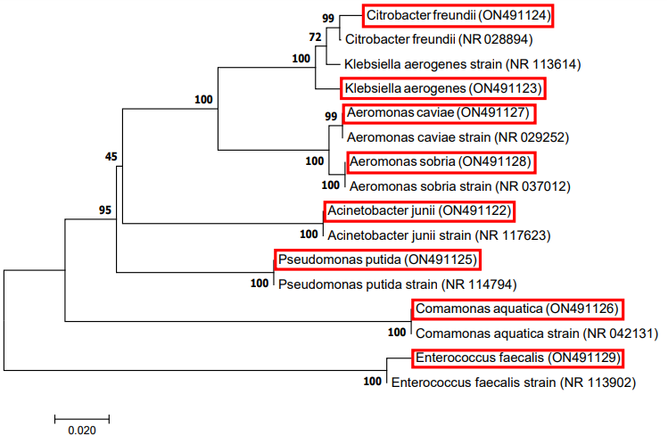
- Platy | 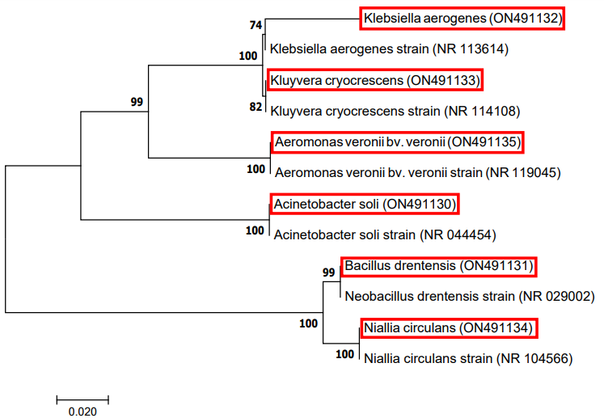
Fig.S3. Phylogenetic analysis of the 16S rRNA gene sequences of bacteria isolated from ornamental fish samples (a-e) Collected from Tiruvarur (highlighted) using MEGA 7.0 software

