Supplemental
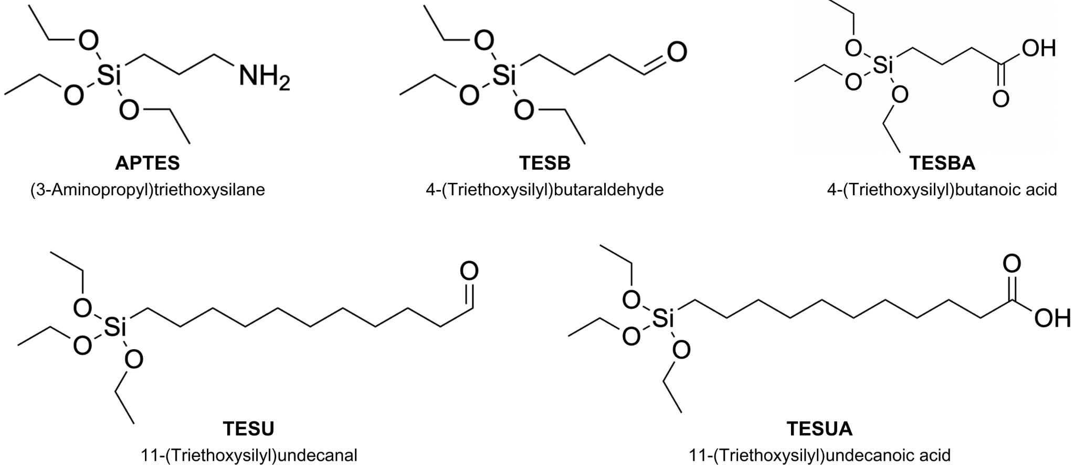
Figure S1. Structures of the silicon-based functionalizing agents 3-(aminopropyl)triethoxysilane (APTES), 4-triethoxysilylbutyraldehyde (TESB), 4-triethoxysilylbutanoic acid (TESBA), 11-triethoxysilylundecanal (TESU), and 11-triethoxysilylundecanoic acid (TESUA).

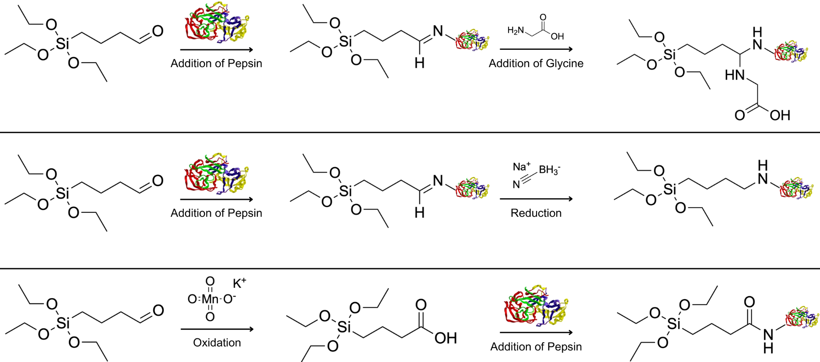
Figure S2. Schematic of the three reactions utilized to form the IEPs.

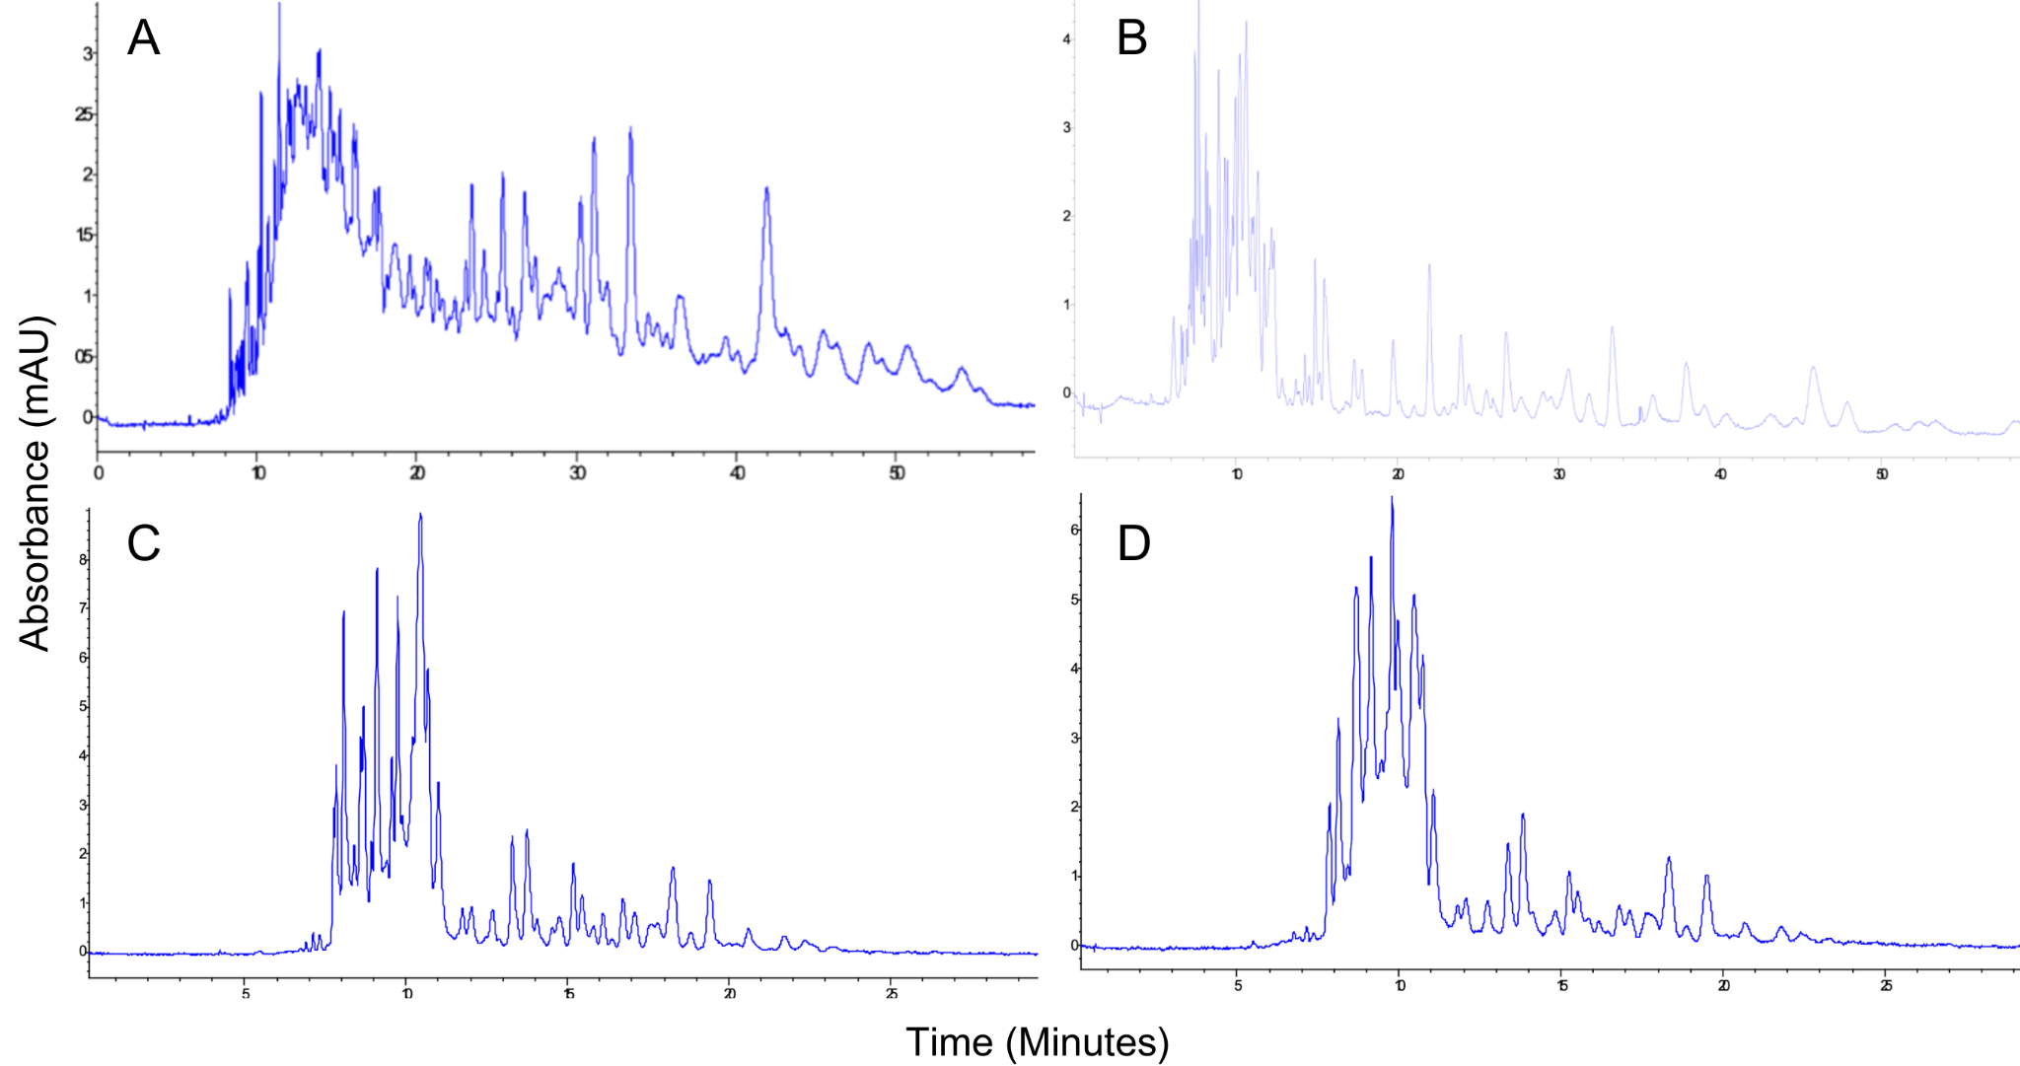
Figure S3. Effect of denaturation conditions of BSA on the digestion via pepsin IEP for 4 hours at a 1:0.1 enzyme:substrate ratio (mass:mass). (A) Classical denaturation conditions employing urea, DTT, and IDA. (B) Acidic denaturation employing formic acid (0.44% v/v, pH 2.0). (C) Thermal denaturation. (D) Thermal and acidic denaturation employing phosphate buffer (50 mM, pH 2.0). Separations were performed using CE at +15 kV using phosphate buffer (50 mM, pH 2.5) as BGE with detection at 200 nm for A, C, and D, and with formic acid (0.44% v/v, pH 2.0) as BGE for B.

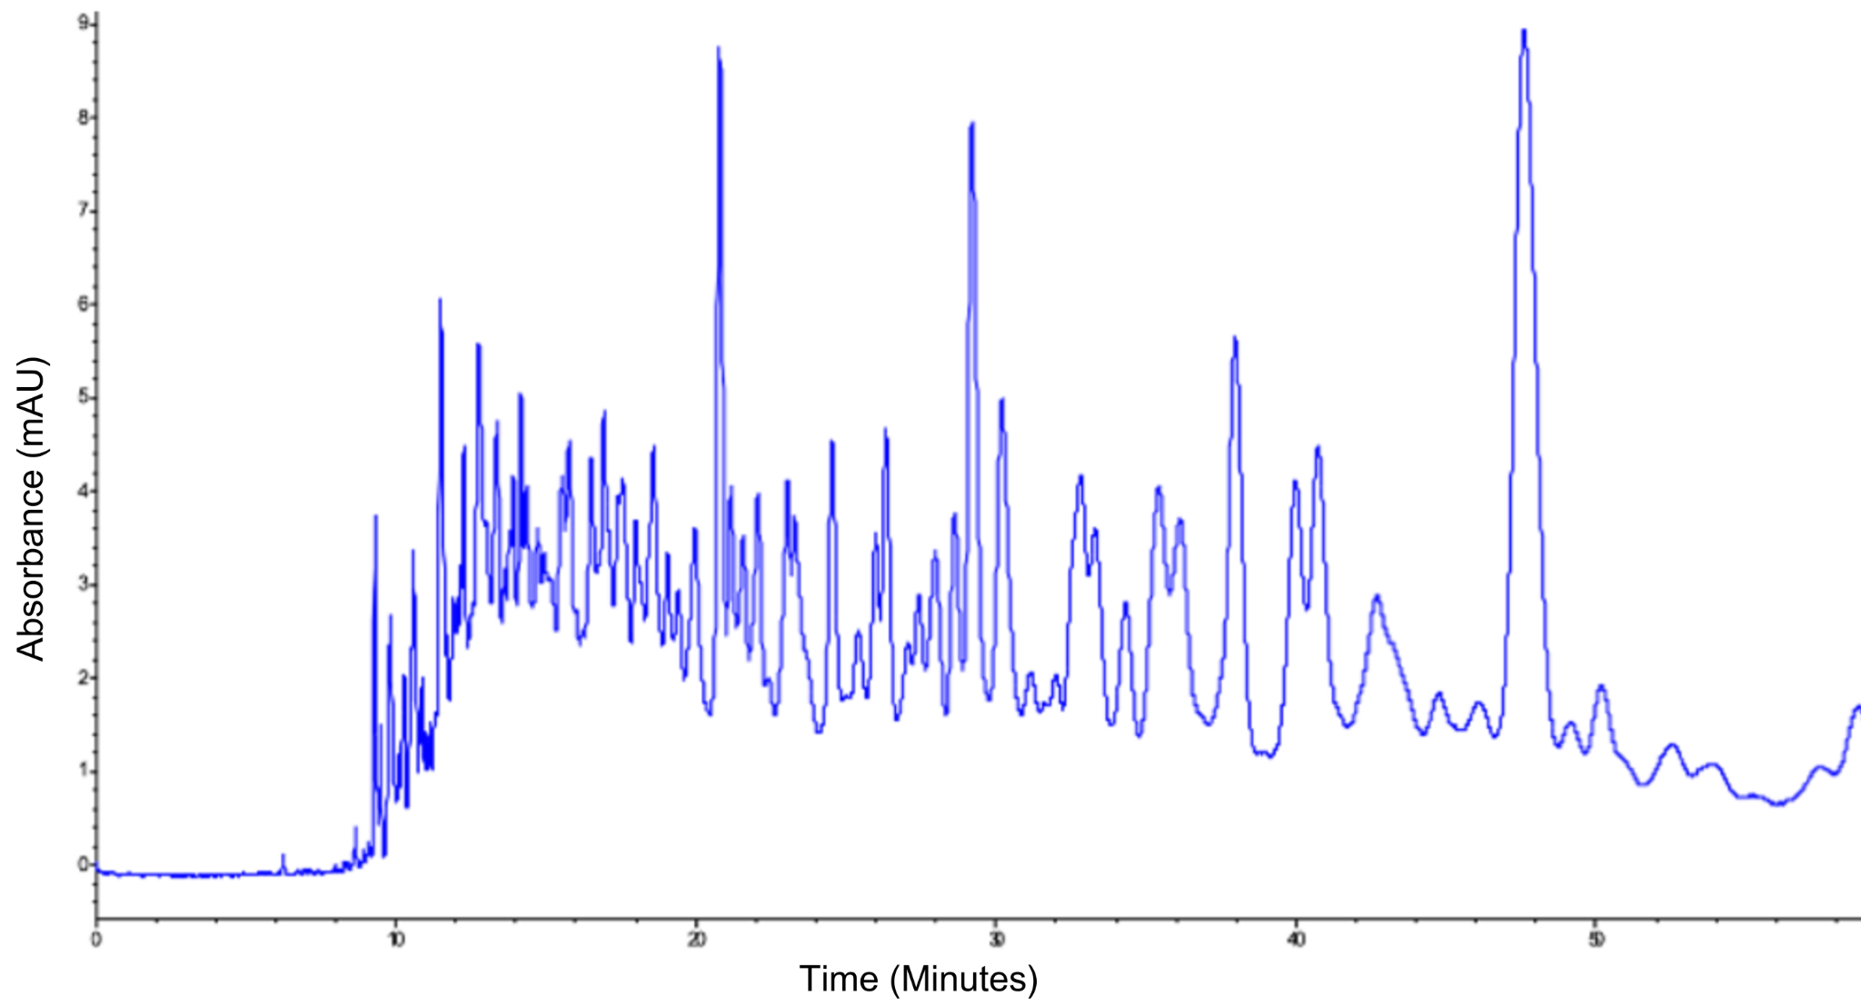
Figure S4. CE-UV peptide map of in-solution digestion of denatured BSA (7.01 μg/μL) at an enzyme-to-substrate of 1:0.1 (mass:mass). Separations were performed using CE at +15 kV using phosphate buffer (50 mM, pH 2.5) as BGE with detection at 200 nm.

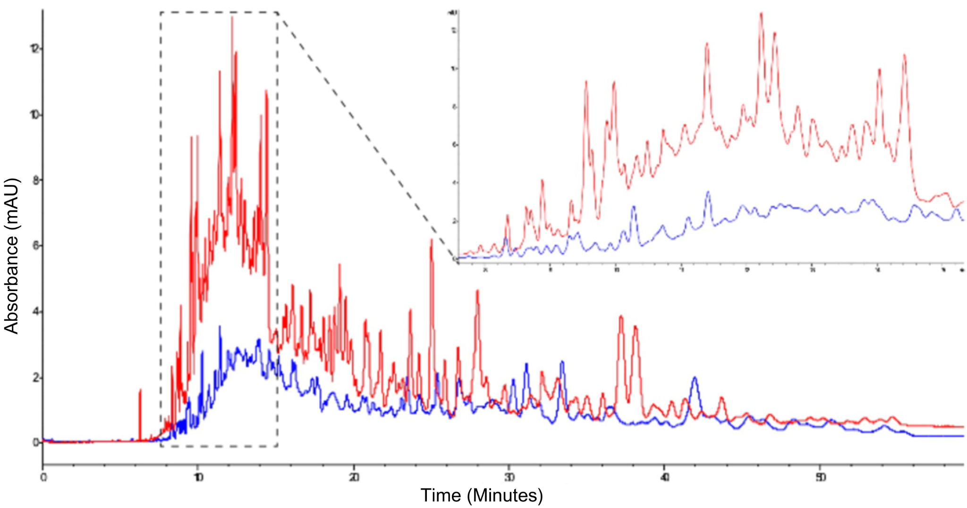
Figure S5. Peptide map of digestion of denatured BSA using the phosphate buffer IEP at a 1:0.1 enzyme-to-substrate ratio (blue) and the pepsin phosphate buffer IMER flowing substrate for 240 minutes at 50 mbar (red). The phosphate buffer IMER has a sequence coverage of 31% by LC-MS/MS analysis, compared to 36% for the off-line digestion. The IEP only used 20 µL of BSA while 942 µL of BSA passed through the IMER over the 240-minute flow, hence the discrepancy in peak height. Separations were performed using CE at +15 kV using phosphate buffer (50 mM, pH 2.5) as BGE with detection at 200 nm.

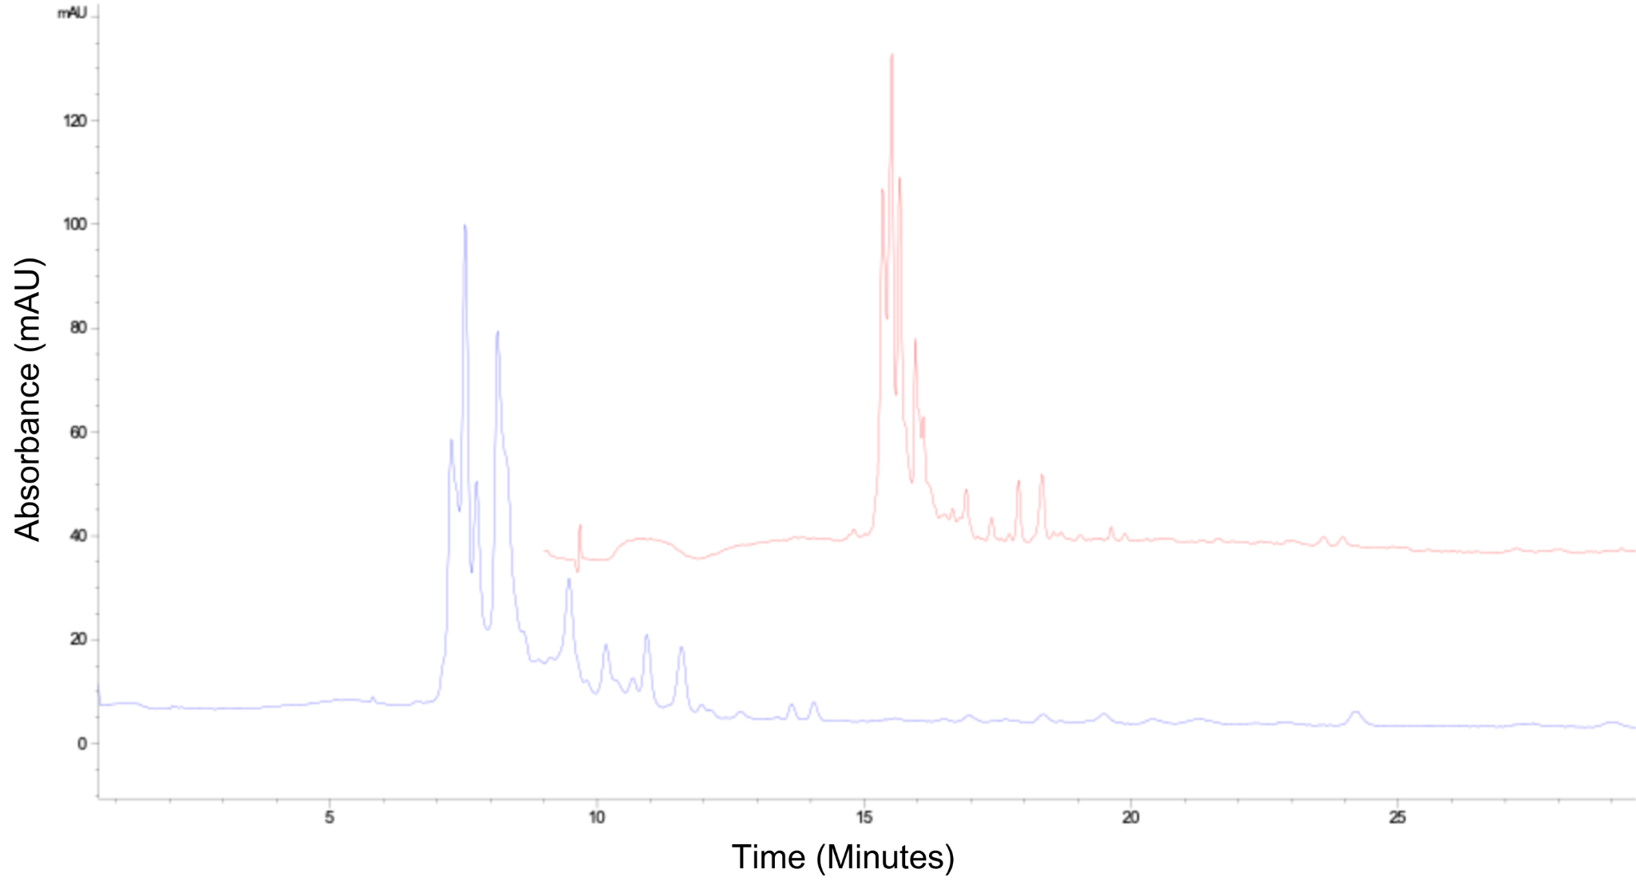
Figure S6. The first digestion in blue and the tenth digestion in red. BSA sequence coverage from the LC-MS/MS analysis on the digest from the pepsin IMER. Separations were performed using CE at +15 kV using formic acid (0.44% v/v, pH 2.0) as BGE with detection at 200 nm.

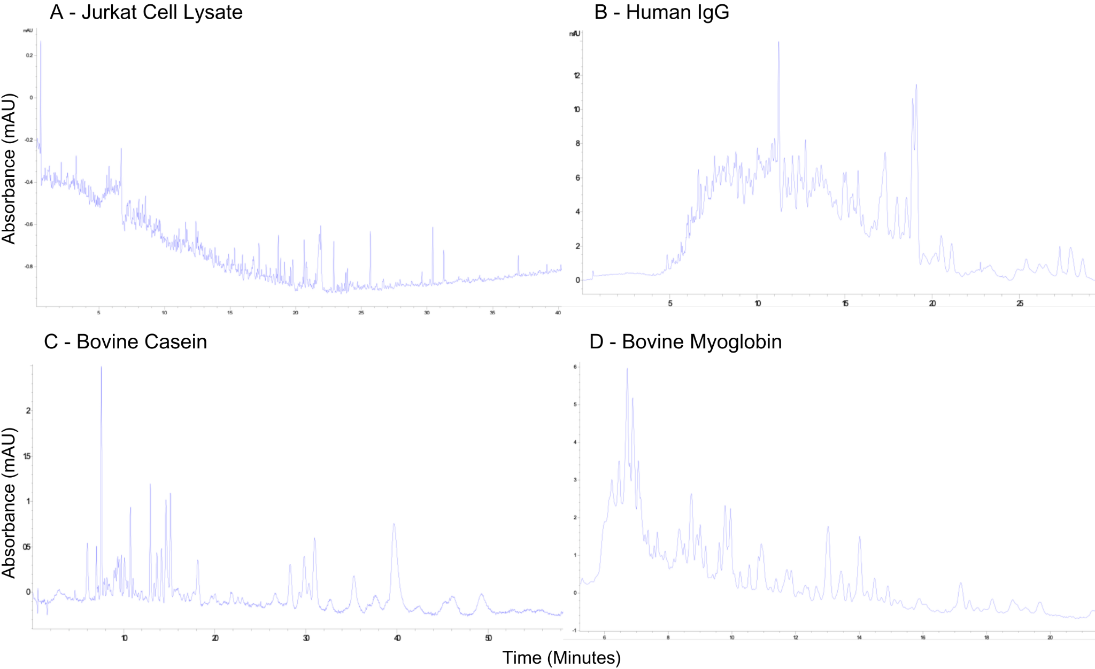
Figure S7. Peptide maps of the 15-minute pepsin formic acid IMER digestions of various substrates denatured in FA (0.44%, pH 2.0). (A) Jurkat cell lysate (20µL of 1.8mg/200µL in 50 mM Tris, 50 mM KCl and 50 mM NaOAc, pH 7.3). (B) Human immunoglobulin G (26µL of 8mg/1140µL). (C) ɑ-Casein from bovine milk (26µL of 8mg/1140µL). (D) Myoglobin from bovine heart (26µL of 8mg/1140µL). Separations were performed using CE at +15 kV using formic acid (0.44% v/v, pH 2.0) as BGE with detection at 200 nm.

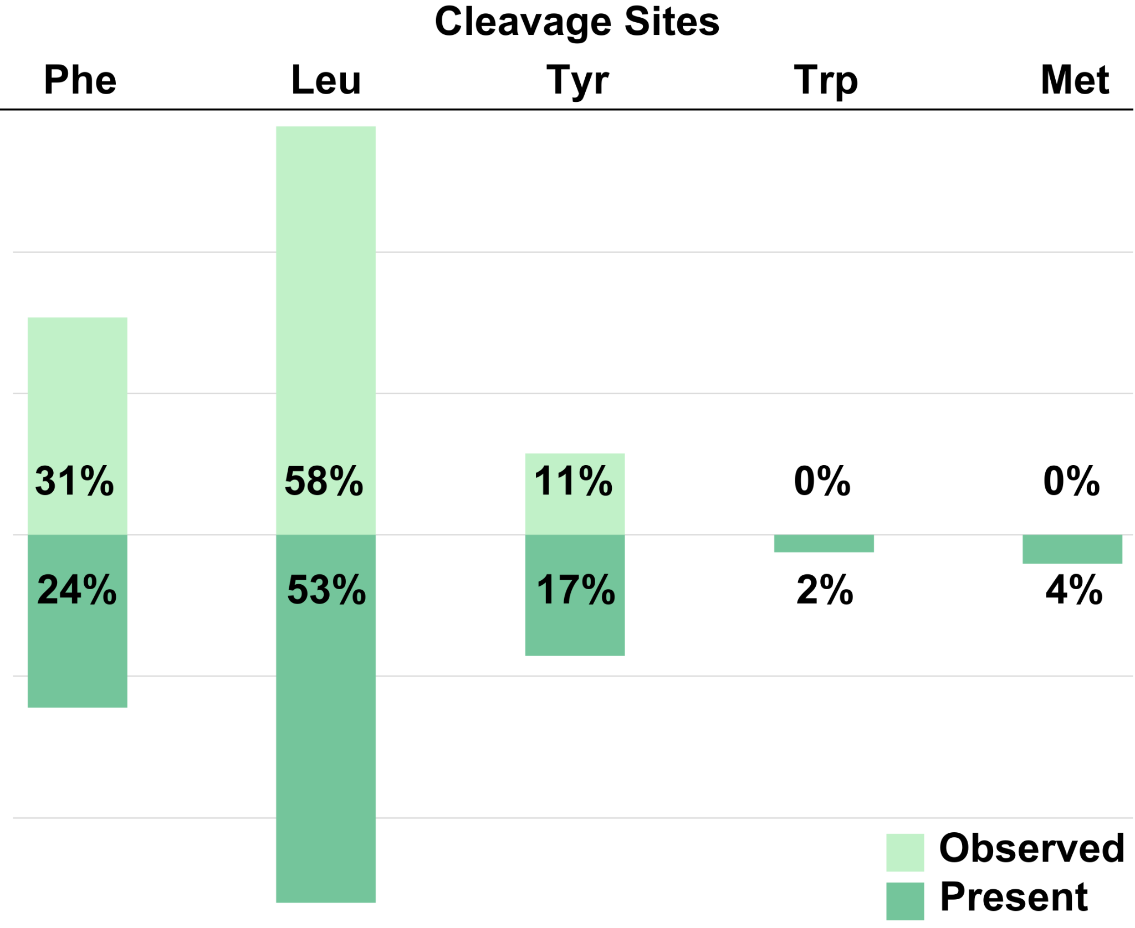

Figure S8. Comparison of the observed pepsin cleavage residues (Top) with the amino acid distribution of BSA (Bottom). Cleavage sites were averaged between all pepsin IEP and IMER digestions of BSA that were analyzed by LC-MS/MS.

