Supplementary File
Figure S1
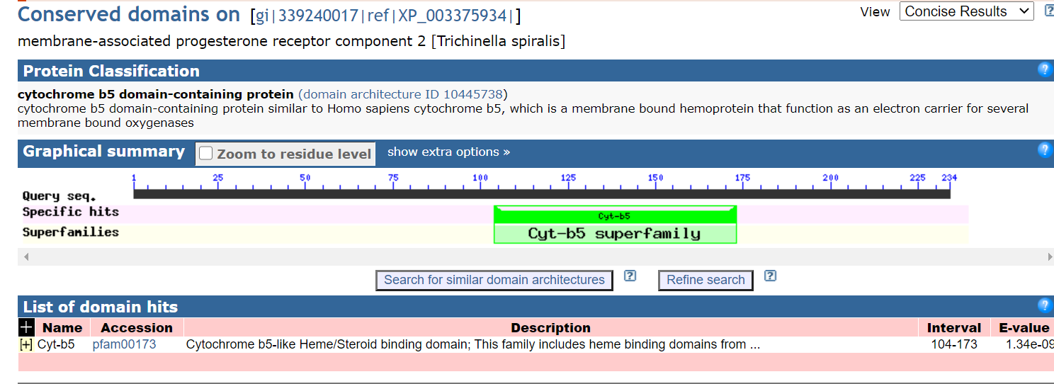
Figure S1. Identified conserved domain Ts-MAPRC2 amino acid (aa) located in the complete gene.

Supplementary File
Figure S2
(A)
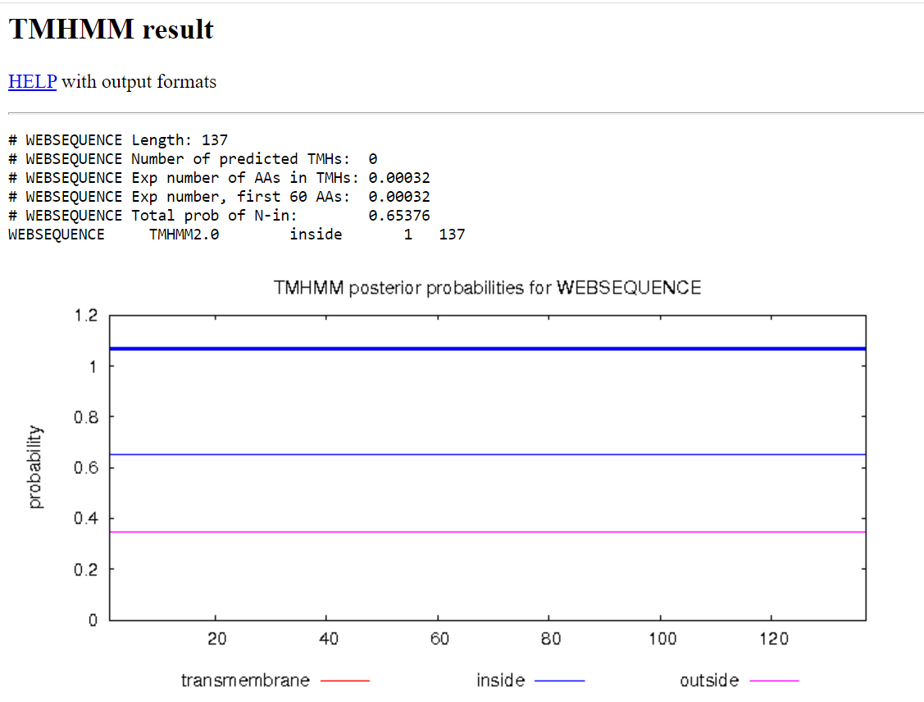
(B)
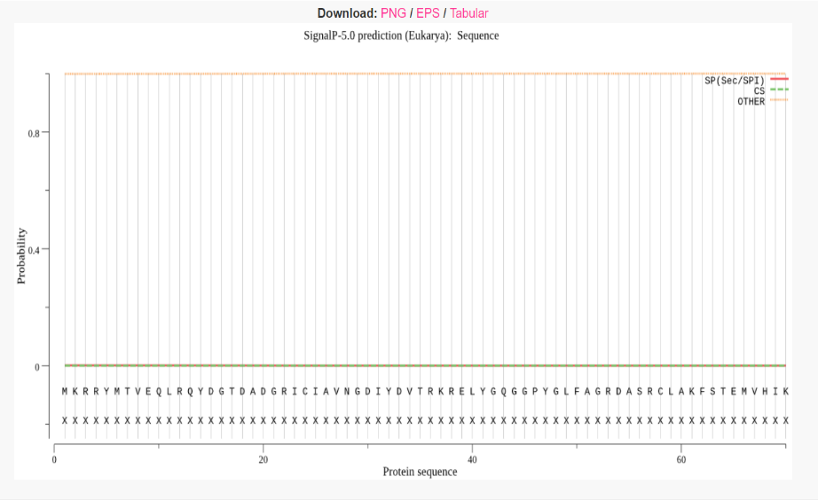
(C)

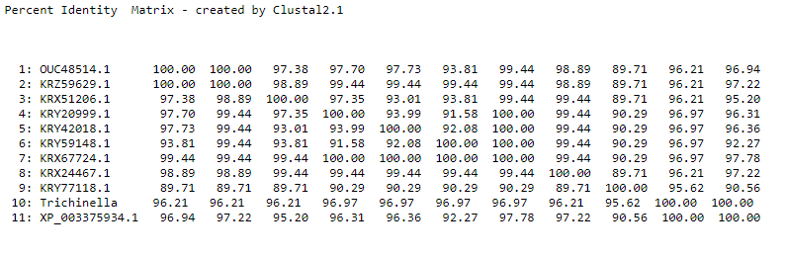
Figure S2. Membrane protein prediction, Percent index matrix, and N-terminal Signal peptide prediction of Ts-MAPRC2. (A) The result predicted by online tools TMHMM showed that no transmembrane was found in Ts-MAPRC2. (B) Signal peptides predicted that no signal peptides were found in Ts-MAPRC2. (C) Percent matrix index showed the more similarity present between the Ts-MAPRC2 and other strain of trichinella species

