eTable
eTable 1. 5-year survival and comparison of the survival rates between the variables of the osteosarcoma patients after PSM
eTable 2. Competitive risk analysis for cancer-specific survival of the osteosarcoma patients after PSM
eTable 3. Comparisons of baseline characteristics of patients in Radioterapy and Non-Radiotherapy groups before and after PSM in complete dataset
eTable 4. Univariate and Multivariate Cox regression analyses for overall survival of the osteosarcoma patients after PSM in complete dataset
eTable 5. Univariate and Multivariate Cox regression analyses for cancer-specific survival of the osteosarcoma patients after PSM in complete dataset
eFigure
eFigure 1. The love plot before and after PSM
eFigure 2. The love plot before and after PSM in complete dataset
eFigure 3. The graph of the changing HR coefficient relative to the time-dependent variable Radiation over time in overall survival
eFigure 4. Forest plot of Hazard Radio for overall survival in subgroups of Radiotherapy and Non-radiotherapy groups after PSM
eFigure 5. Forest plot of Hazard Radio for cancer-specific survival in subgroups of Radiotherapy and Non-radiotherapy groups after PSM
eFigure 6. Kaplan-Meier method to compare the survival rates between the Radiation and Non-Radiation groups in complete dataset

eTable 1. 5-year survival and comparison of the survival rates between the variables of the osteosarcoma patients after PSM
Factor | Overall survival |  |  | Cancer-specific survival
 | 5-year survival rate | χ² | p | 5-year survival rate | χ² | p
Age |  | 45.926 | 0.000 |  | 22.878 | 0.000
≤50y | 54.9% |  |  | 57.0%
>50y | 28.0% |  |  | 34.5%
Sex |  | 5.702 | 0.017 |  | 7.439 | 0.006
Male | 37.5% |  |  | 41.4%
Female | 50.4% |  |  | 56.5%
Race |  | 0.573 | 0.751 |  | 1.258 | 0.533
White | 43.5% | Ref |  | 48.3% | Ref
Black | 43.0% | 0.521 | 0.470 | 51.2% | 1.031 | 0.310
Others | 39.7% | 0.022 | 0.883 | 44.2% | 0.127 | 0.721
PS |  | 0.007 | 0.935 |  | 0.800 | 0.371
Extremity | 42.9% |  |  | 44.9%
Axial | 43.3% |  |  | 49.6%
Grade |  | 13.342 | 0.000 |  | 10.536 | 0.001
I/II | 72.0% |  |  | 74.1%
III/IV | 40.3% |  |  | 45.6%
Size |  | 22.291 | 0.000 |  | 23.899 | 0.000
≤54mm | 57.3% |  |  | 63.2%
>54mm | 33.8% |  |  | 37.8%
Stage |  | 48.878 | 0.000 |  | 56.049 | 0.000
Localized | 57.4% | Ref |  | 64.2% | Ref
Reginal | 46.5% | 7.402 | 0.007 | 51.5% | 7.355 | 0.007
Distance | 22.2% | 40.516 | 0.000 | 25.1% | 44.618 | 0.000
MP |  | 9.596 | 0.002 |  | 0.288 | 0.592
No | 46.4% |  |  | 48.0%
Yes | 34.6% |  |  | 49.4%
Resection |  | 0.472 | 0.492 |  | 0.130 | 0.719
Incomplete | 43.3% |  |  | 51.2%
Complete | 43.0% |  |  | 45.9%
Chemotherapy |  | 2.713 | 0.100 |  | 0.104 | 0.747
No | 43.8% |  |  | 50.4%
Yes | 43.1% |  |  | 47.4%
Radiation |  | 2.029 | 0.154 |  | 0.826 | 0.323
No | 47.5% |  |  | 51.9%
Yes | 39.1% |  |  | 44.9%
PS: Primary Site; MP: Multiple Primary tumor

eTable 2. Competitive risk analysis for cancer-specific survival of the osteosarcoma patients after PSM
Factor | Univariate |  | Multivariate
 | Statistics | p | HR(95%CI) | p
Age | 11.914 | 0.000 | 1.790(1.322-2.423) | 0.000
Sex | 7.754 | 0.005 | 0.703(0.532-0.930) | 0.014
Race | 1.354 | 0.508 | Not selected
PS | 1.793 | 0.181 | 1.083(0.781-1.501) | 0.630
Grade | 9.097 | 0.003 | 1.496(0.799-2.800) | 0.210
Size | 21.432 | 0.000 | 1.432(1.030-1.992) | 0.033
Stage | 50.611 | 0.000 | 1.907(1.493-2.436) | 0.000
MP | 0.238 | 0.626 | Not selected
Resection | 0.833 | 0.361 | 0.867(0.636-1.183) | 0.370
Radiation | 0.915 | 0.339 | 1.204(0.922-1.573) | 0.170
Chemotherapy | 0.000 | 0.988 | 0.956(0.688-1.33) | 0.790
PS: Primary Site; MP: Multiple Primary tumor

eTable 3. Comparisons of baseline characteristics of patients in Radioterapy and Non-Radiotherapy groups before and after PSM in complete dataset
Factor | Before PSM |  |  |  | After PSM
 | RT (n=136) | NRT (n=1926) |  | SMD | RT (n=136) | NRT (n=136) | SMD
Age | 43.5(32.75)ª | 18(22)ª |  | 0.855 | 43.5(32.75)ª | 45(39.5)ª | 0.045
Sex |  |  |  | 0.052 |  |  | 0.090
Male | 78(57.35%) | 1055(54.78%) |  |  | 78(57.35%) | 78(57.35%)
Female | 58(42.65%) | 871(45.22%) |  |  | 58(42.65%) | 58(42.65%)
Race |  |  |  | 0.033 |  |  | 0.095
White | 101(74.26%) | 1434(74.45%) |  |  | 101(74.26%) | 103(75.74%)
Black | 19(13.97%) | 283(14.69%) |  |  | 19(13.97%) | 15(11.03%)
Others | 16(11.76%) | 209(10.85%) |  |  | 16(11.76%) | 18(13.24%)
PS |  |  |  | 1.336 |  |  | 0.001
Extremity | 39(28.68%) | 1614(83.80%) |  |  | 39(28.68%) | 39(28.68%)
Axial | 97(71.32%) | 312(16.20%) |  |  | 97(71.32%) | 97(71.32%)
Grade |  |  |  | 0.187 |  |  | 0.052
I/II | 11(8.09%) | 268(13.91%) |  |  | 11(8.09%) | 13(9.56%)
III/IV | 125(91.91%) | 1658(86.09%) |  |  | 125(91.91%) | 123(90.44%)
Size | 60(45)ª | 87(60)ª |  | 0.479 | 60(45)ª | 61(61)ª | 0.001
Stage |  |  |  | 0.282 |  |  | 0.141
Localized | 35(25.74%) | 711(36.92%) |  |  | 35(25.74%) | 27(19.85%)
Reginal | 68(50.00%) | 913(47.40%) |  |  | 68(50.00%) | 74(54.41%)
Distance | 33(24.26%) | 302(15.68%) |  |  | 33(24.26%) | 35(25.74%)
MP |  |  |  | 0.246 |  |  | 0.105
No | 108(79.41%) | 1702(88.37%) |  |  | 108(79.41%) | 102(75.00%)
Yes | 28(20.59%) | 224(11.63%) |  |  | 28(20.59%) | 34(25.00%)
Resection |  |  |  | 0.544 |  |  | 0.046
Incomplete | 49(36.03%) | 258(13.40%) |  |  | 49(36.03%) | 52(38.24%)
Complete | 87(63.97%) | 1668(86.60%) |  |  | 87(63.97%) | 84(61.76%)
Chemotherapy |  |  |  | 0.354 |  |  | 0.032
No | 42(30.88%) | 310(16.10%) |  |  | 42(30.88%) | 44(32.35%)
Yes | 94(69.12%) | 1616(83.90%) |  |  | 94(69.12%) | 92(67.65%)
RT: Radiotherapy; NRT: Non-Radiotherapy; PS: Primary Site; MP: Multiple Primary tumor; a: Abnormal distribution Quantitative data, M (IQR)

eTable 4. Univariate and Multivariate Cox regression analyses for overall survival of the osteosarcoma patients after PSM in complete dataset
Factor | Univariate |  | Multivariate
 | HR(95%CI) | p | HR(95%CI) | p
Age | 1.018(1.010-1.026) | 0.000 | 1.022(1.014-1.030) | 0.000
Sex | NA | 0.397 | Not selected
Sex*Ln(T) | 0.853(0.769-0.946) | 0.003 | Not selected
Race |  | 0.927 | Not selected
White | Ref
Black | 1.038(0.659-1.636) | 0.871
Others | 0.923(0.569-1.498) | 0.746
PS | 1.178(0.833-1.666) | 0.354 |  | 0.200
Grade | 3.691(1.631-8.352) | 0.002 | 3.144(1.382-7.153) | 0.006
Size | 1.007(1.003-1.011) | 0.000 | NA | 0.065
Stage |  | 0.000 |  | 0.000
Localized | Ref |  | Ref
Reginal | 8.487(2.721-26.470) | 0.000 | 6.270(2.010-19.563) | 0.002
Distance | 56.405(8.317-382.545) | 0.000 | 45.652(6.762-308.218) | 0.000
Stage*Ln(T) | 0.635(0.474-0.851) | 0.002 | 0.686(0.510-0.921) | 0.012
MP | NA | 0.655 | Not selected
MP*Ln(T) | 1.151(1.036-1.279) | 0.009 | Not selected
Resection | 1.203(0.872-1.660) | 0.261 | NA | 0.781
Chemotherapy | 0.964(0.693-1.342) | 0.830 | NA | 0.897
Radiation | NA | 0.279 | NA | 0.464
Radiation*Ln(T) | 1.140(1.034-1.258) | 0.009 | 1.122(1.016-1.239) | 0.023
PS: Primary Site; MP: Multiple Primary tumor; NA: In Univariate analysis, α = 0.1, while in Multivariate analysis, α = 0.05.

eTable 5. Univariate and Multivariate Cox regression analyses for cancer-specific survival of the osteosarcoma patients after PSM in complete dataset
Factor | Univariate |  | Multivariate
 | HR(95%CI) | p | HR(95%CI) | p
Age | 1.015(1.006-1.023) | 0.001 | 1.019(1.011-1.027) | 0.000
Sex | NA | 0.597 | Not selected
Sex*Ln(T) | 0.863(0.769-0.968) | 0.012 | Not selected
Race |  | 0.976 | Not selected
White | Ref
Black | 0.950(0.568-1.587) | 0.844
Others | 1.019(0.617-1.682) | 0.943
PS | 1.095(0.756-1.588) | 0.631 |  | 0.253
Grade | 3.624(1.482-8.860) | 0.005 | 2.965(1.207-7.284) | 0.018
Size | 1.008(1.004-1.012) | 0.000 | NA | 0.054
Stage |  | 0.000 |  | 0.000
Localized | Ref |  | Ref
Reginal | 14.580(3.668-57.955) | 0.000 | 11.180(2.824-44.260) | 0.001
Distance | 133.698(13.043-1370.475) | 0.000 | 108.702(10.719-1102.368) | 0.000
Stage*Ln(T) | 0.577(0.403-0.826) | 0.003 | 0.619(0.431-0.888) | 0.009
MP | 1.067(0.715-1.592) | 0.752 | Not selected
Resection | 1.268(0.891-1.806) | 0.187 | NA | 0.849
Chemotherapy | 1.005(0.701-1.442) | 0.977 | NA | 0.901
Radiation | NA | 0.361 | NA | 0.525
Radiation*Ln(T) | 1.132(1.015-1.264) | 0.026 | 1.124(1.007-1.256) | 0.038
PS: Primary Site; MP: Multiple Primary tumor; NA: In Univariate analysis, α = 0.1, while in Multivariate analysis, α = 0.05.

eFigure 1. The love plot before and after PSM

eFigure 2. The love plot before and after PSM in complete dataset

eFigure 3. The graph of the changing HR coefficient relative to the time-dependent variable Radiation over time in overall survival
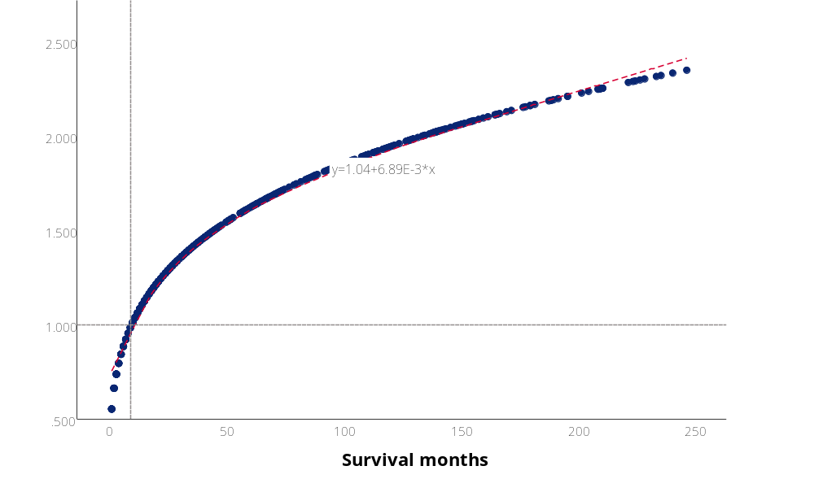

eFigure 4. Forest plot of Hazard Radio for overall survival in subgroups of Radiotherapy and Non-radiotherapy groups after PSM (*, Radiation as a time-dependent variable)
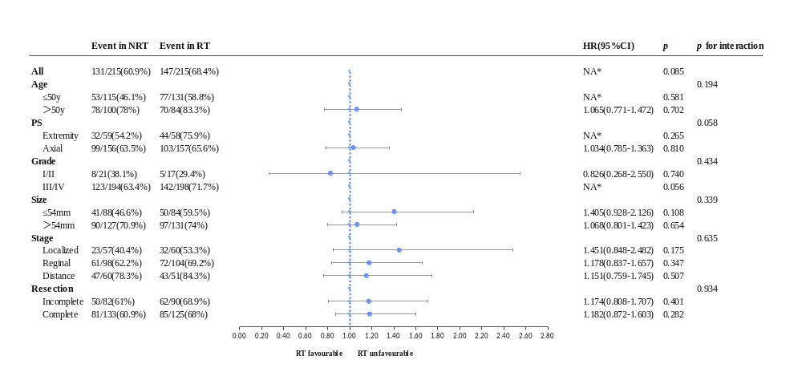

eFigure 5. Forest plot of Hazard Radio for cancer-specific survival in subgroups of Radiotherapy and Non-radiotherapy groups after PSM
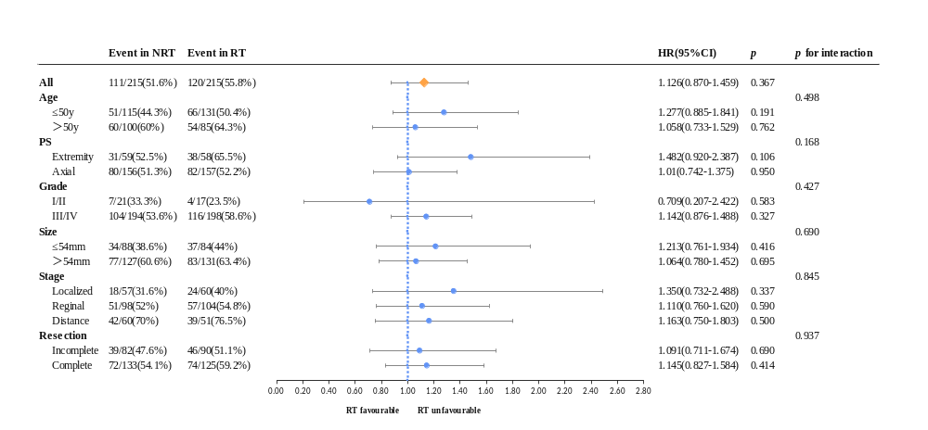

eFigure 6. Kaplan-Meier method to compare the survival rates between the Radiation and Non-Radiation groups in complete dataset. a, For Overall survival; b, For Cancer-specific survival
