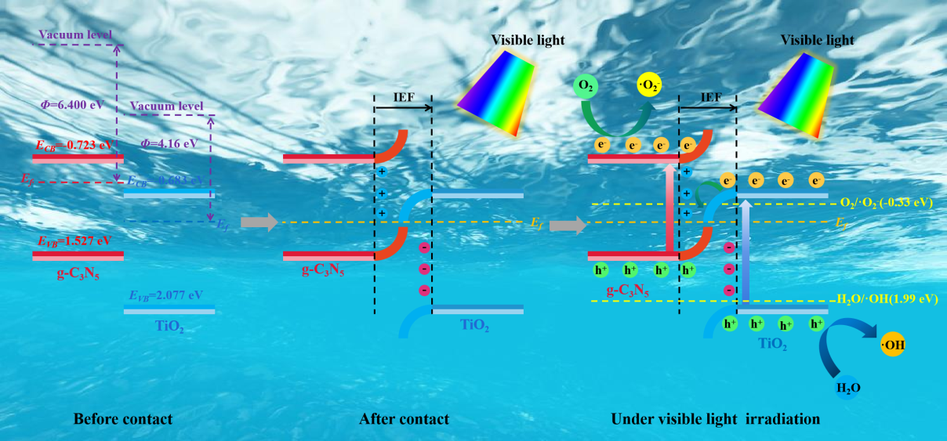
Fig. S scheme charge transfer mechanism of TiO₂/g-C₃N₅ heterojunction catalyst under visible light irradiation

