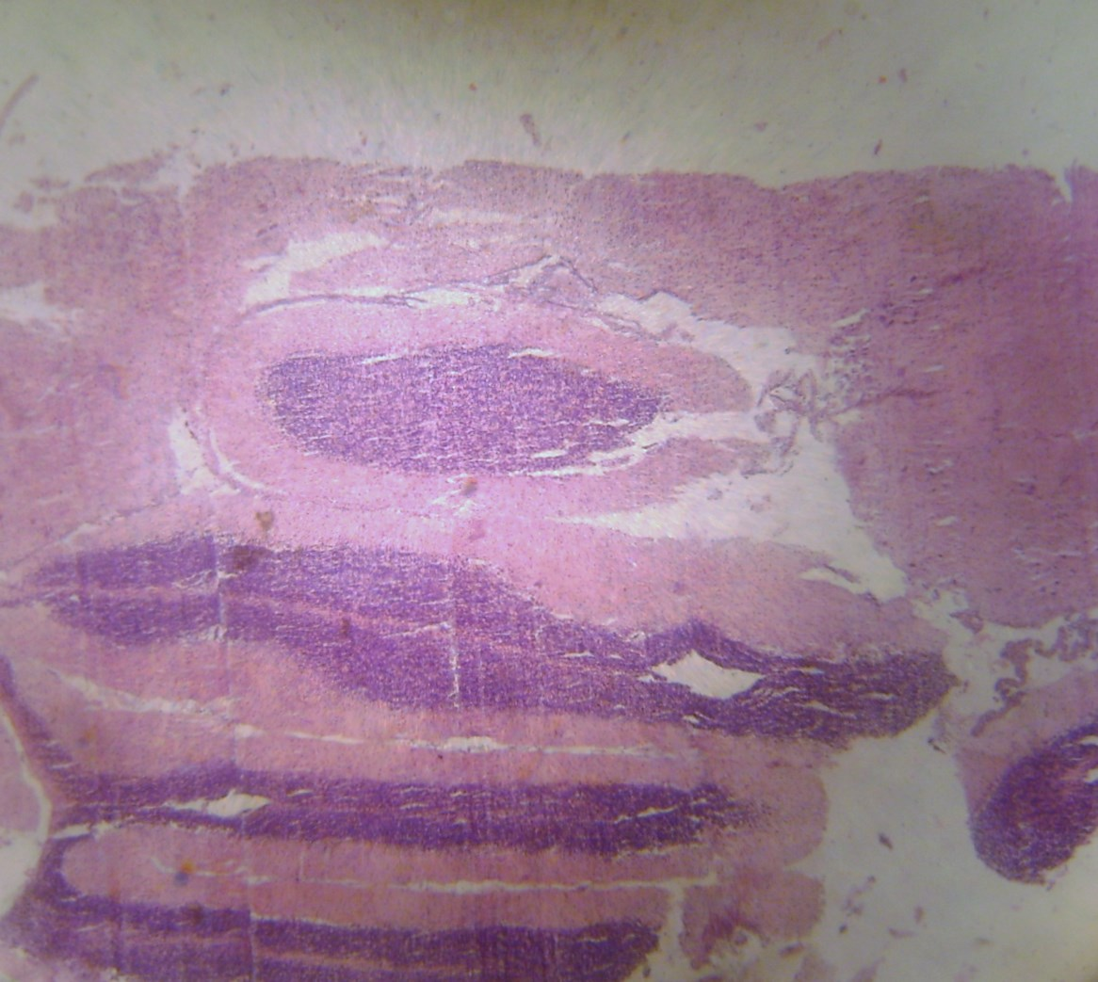
PLATE I: Photomicrograph of cerebrum of Rats treated with distilled water showing no apparent histopathological changes (H and E X100).

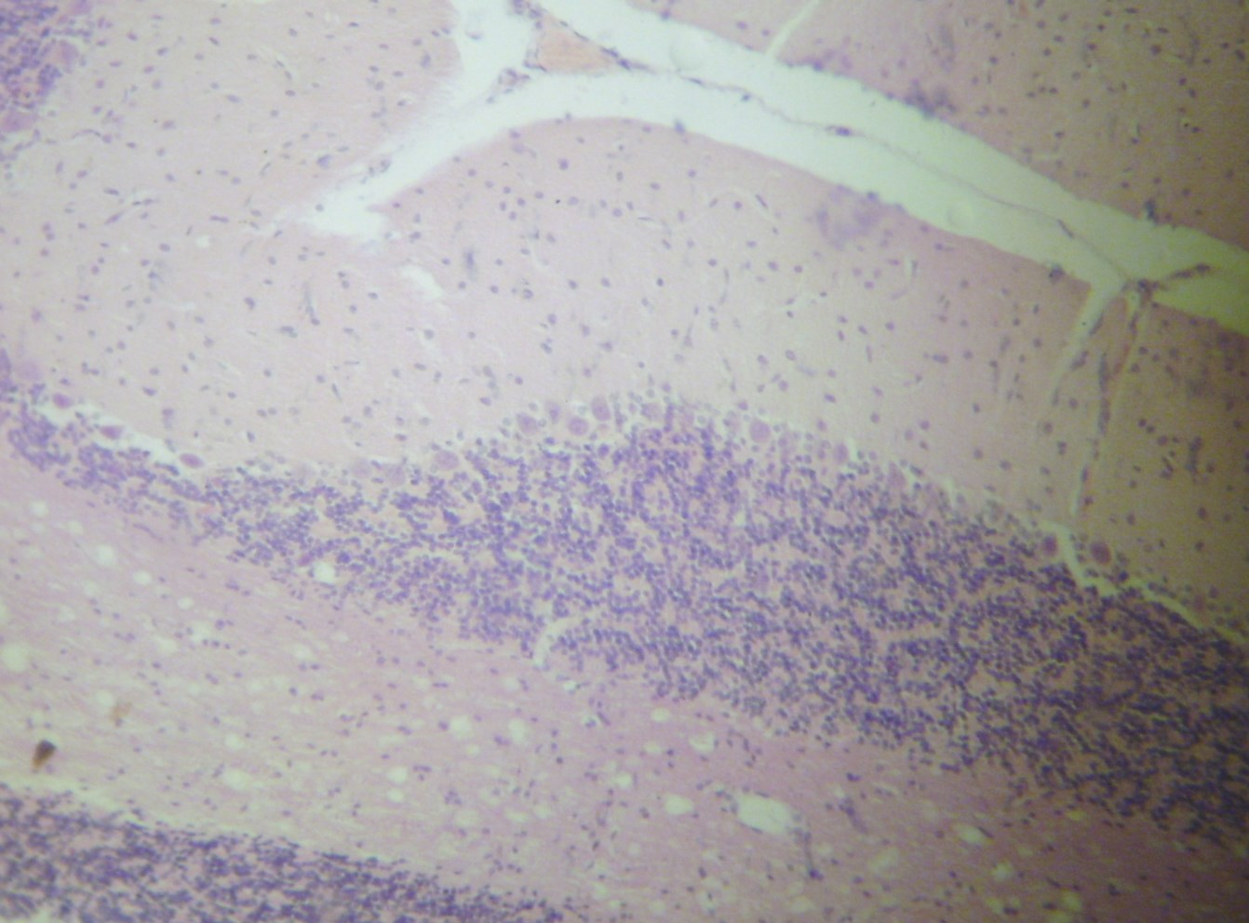
PLATE II: Photomicrograph of cerebrum of rats treated with cypermethrin showing vacuoles (arrows) (H and E X400).
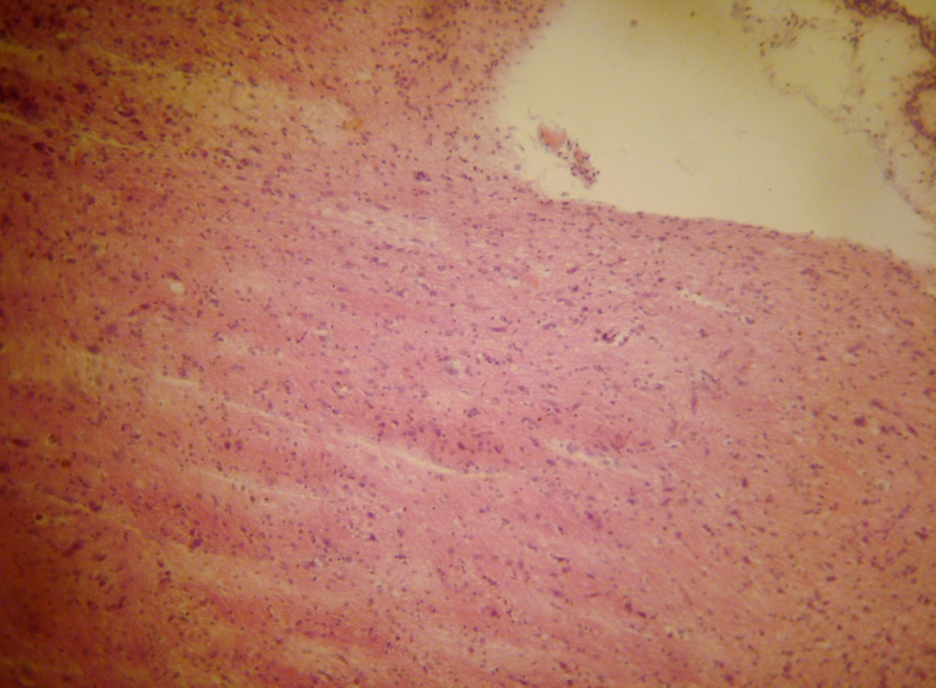
PLATE III: Photomicrograph of cerebrum rats treated with Vitamin C showing no apparent histopathological changes (H and E X400).
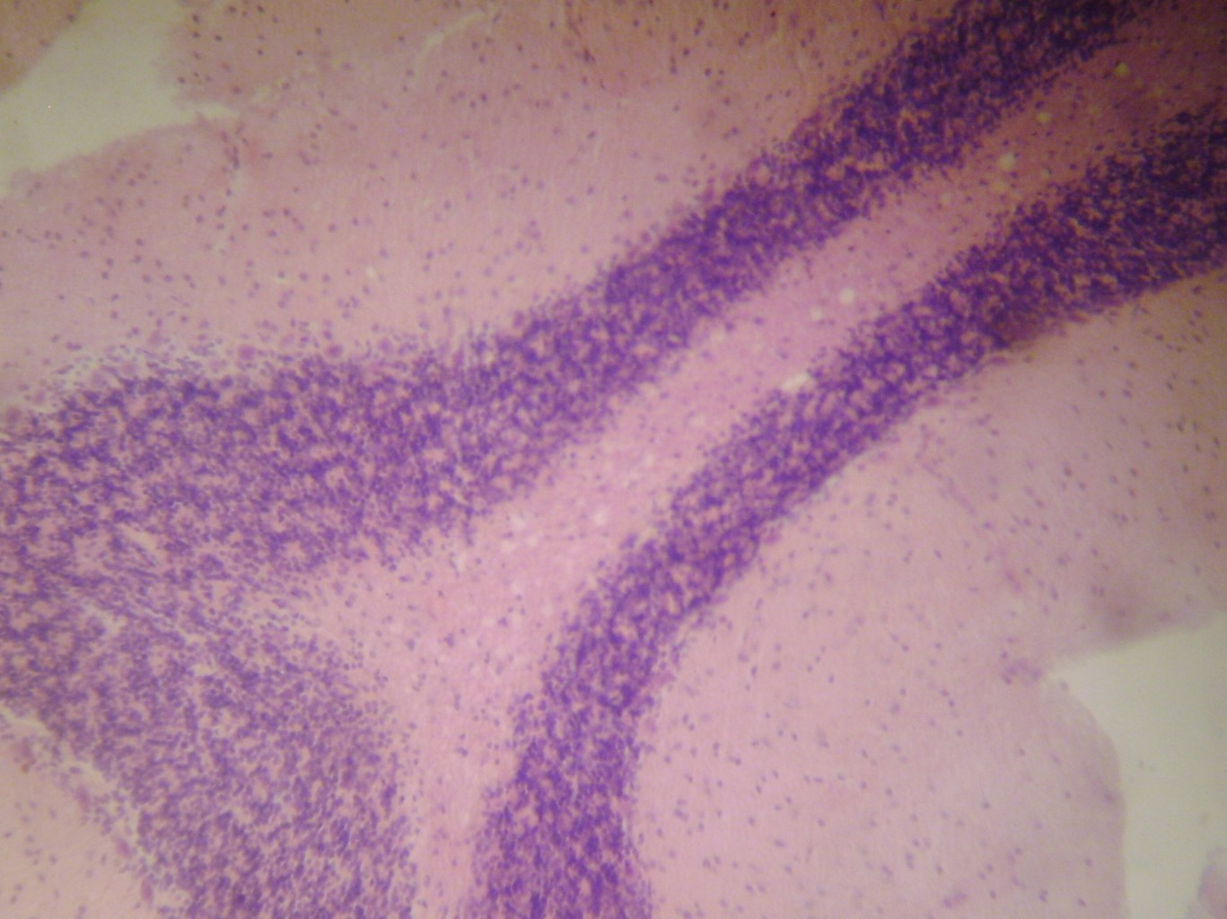
PLATE IV: Photomicrograph of cerebrum rats treated with Cypermethrin and Vitamin C, showing vacuoles (arrows) (using H and E X100).

