LAND USE SCENARIOS VALIDATION WORKSHOP
Coastal landscapes of Ghana’s Western region are undergoing rapid transformation through the development of new industrial infrastructure linked to the oil and gas sector, expansion of plantation agriculture and over-exploitation of forests and wetland resources among other threats. The impacts of these activities on biodiversity and ecosystem services (ES) cannot be over-emphasized. Yet, few scientific analysis of land use impacts on ES have been conducted to inform coastal landscape planning in this region.
The purpose of this workshop is to validate or otherwise, proposed land use scenarios and their impacts on ES supply in the coastal landscapes of Southwest Ghana. To this end, you are required to provide feedback by drawing on your lived experiences as land management experts using the questionnaire below.
Section A: Individual Assessment of Scenarios
Scenario | Current Transition |  | Accept/Reject | Iteration Period
Future as Usual  Definition:  Urban infrastructure and settlement development are unrestricted in all areas except swamp forests. Illegal gold mining operations are indiscriminate and have the potential to displace all other land uses. | Mangrove swamp  Mixed swamp forest  Palm swamp forest  Bog plain  Shrubland  Rubber  Coconut  Oil Palm  Bare surface  Built up  Water  Food crop | Mangrove swamp  Mixed swamp forest  Palm swamp forest  Bog plain  Shrubland  Rubber  Coconut  Oil Palm  Bare surface  Built up  Water  Food crop | Accept  Reject | Actual Iteration (10 years)
Ecological Restoration  Definition:  Swamp forests are strictly protected using zoning and planning instruments while shrublands and mangroves increase to provide ecological functions. | Mangrove swamp  Mixed swamp forest  Palm swamp forest  Bog plain  Shrubland  Rubber  Coconut  Oil Palm  Bare surface  Built up  Water  Food crop | Mangrove swamp  Mixed swamp forest  Palm swamp forest  Bog plain  Shrubland  Rubber  Coconut  Oil Palm  Bare surface  Built up  Water  Foodcrop | Accept  Reject | Actual Iteration (10 years)
Regional Planning  Definition:  Urbanization is driven by investments in oil and gas development and plantation agriculture and also the need to meet increasing food demands considering the current regional planning context. Urbanization is continuous and rapid with high settlement and infrastructure growth rates in response to development. | Mangrove swamp  Mixed swamp forest  Palm swamp forest  Bog plain  Shrubland  Rubber  Coconut  Oil Palm  Bare surface  Built up  Water  Food crop | Mangrove swamp  Mixed swamp forest  Palm swamp forest  Bog plain  Shrubland  Rubber  Coconut  Oil Palm  Bare surface  Built up  Water  Food crop | Accept  Reject | Actual Iteration (10 years)
Urban Greening  Definition:  Green spaces are introduced into existing urbanized areas | Mangrove swamp  Mixed swamp forest  Palm swamp forest  Bog plain  Shrubland  Rubber  Coconut  Oil Palm  Bare surface  Built up  Water  Food crop | Mangrove swamp  Mixed swamp forest  Palm swamp forest  Bog plain  Shrubland  Rubber  Coconut  Oil Palm  Bare surface  Built up  Water  Food crop | Accept  Reject | Actual Iteration (10 years)

Overall Confidence Rating:
Highly Confident | Confident | Moderately Confident | Somewhat Confident | Not Confident

Section B: Individual Assessment of Land Use Transitions. Use the arrow to express a positive ( ), negative ( ), and ( )no impacts of the transition matrix on any or all of the ecosystem services.
Current Scenario | Transition Matrix |  | Target Ecosystem Service Impact | Iteration Period (in years) | Confidence Rating
Future as Usual | Mangrove swamp  Mixed swamp forest  Palm swamp forest  Bog plain  Shrubland  Rubber  Coconut  Oil Palm  Bare surface  Built up  Water  Food crop | Mangrove swamp  Mixed swamp forest  Palm swamp forest  Bog plain  Shrubland  Rubber  Coconut  Oil Palm  Bare surface  Built up  Water  Food crop | Food  Recreation  Fuelwood  Carbon  Sequestration | 10 – 20  20 – 50
  Highly Confident
  Confident
  Moderately Confident
  Somewhat Confident
  Not Confident
Ecological Restoration | Mangrove swamp  Mixed swamp forest  Palm swamp forest  Bog plain  Shrubland  Rubber  Coconut  Oil Palm  Bare surface  Built up  Water  Food crop | Mangrove swamp  Mixed swamp forest  Palm swamp forest  Bog plain  Shrubland  Rubber  Coconut  Oil Palm  Bare surface  Built up  Water  Food crop | Food  Recreation  Fuelwood  Carbon  Sequestration | 10 – 20  20 – 50
  Highly Confident
  Confident
  Moderately Confident
  Somewhat Confident
  Not Confident
Regional Planning Scenario | Mangrove swamp  Mixed swamp forest  Palm swamp forest  Bog plain  Shrubland  Rubber  Coconut  Oil Palm  Bare surface  Built up  Water  Food crop | Mangrove swamp  Mixed swamp forest  Palm swamp forest  Bog plain  Shrubland  Rubber  Coconut  Oil Palm  Bare surface  Built up  Water  Food crop | Food  Recreation  Fuelwood  Carbon  Sequestration | 10 – 20  20 – 50
  Highly Confident
  Confident
  Moderately Confident
  Somewhat Confident
  Not Confident
Urban Green Scenario | Mangrove swamp  Mixed swamp forest  Palm swamp forest  Bog plain  Shrubland  Rubber  Coconut  Oil Palm  Bare surface  Built up  Water  Food crop | Mangrove swamp  Mixed swamp forest  Palm swamp forest  Bog plain  Shrubland  Rubber  Coconut  Oil Palm  Bare surface  Built up  Water  Food crop | Food  Recreation  Fuelwood  Carbon  Sequestration | 10 – 20  20 – 50
  Highly Confident
  Confident
  Moderately Confident
  Somewhat Confident
  Not Confident

Overall Confidence Rating:
Highly Confident | Confident | Moderately Confident | Somewhat Confident | Not Confident

Section C: Group Assessment and Transition Development. Use the arrow to express a positive ( ), negative ( ), and ( )no impacts of the transition matrix on any or all of the ecosystem services.
Current Scenario | Transition Matrix |  | Target Ecosystem Service Impact | Iteration Period (in years) | Confidence Rating
Future as Usual | Mangrove swamp  Mixed swamp forest  Palm swamp forest  Bog plain  Shrubland  Rubber  Coconut  Oil Palm  Bare surface  Built up  Water  Food crop | Mangrove swamp  Mixed swamp forest  Palm swamp forest  Bog plain  Shrubland  Rubber  Coconut  Oil Palm  Bare surface  Built up  Water  Food crop | Food  Recreation  Fuelwood  Carbon  Sequestration | 10 – 20  20 – 50
  Highly Confident
  Confident
  Moderately Confident
  Somewhat Confident
  Not Confident
Ecological Restoration | Mangrove swamp  Mixed swamp forest  Palm swamp forest  Bog plain  Shrubland  Rubber  Coconut  Oil Palm  Bare surface  Built up  Water  Food crop | Mangrove swamp  Mixed swamp forest  Palm swamp forest  Bog plain  Shrubland  Rubber  Coconut  Oil Palm  Bare surface  Built up  Water  Food crop | Food  Recreation  Fuelwood  Carbon  Sequestration | 10 – 20  20 – 50
  Highly Confident
  Confident
  Moderately Confident
  Somewhat Confident
  Not Confident
Regional Planning Scenario | Mangrove swamp  Mixed swamp forest  Palm swamp forest  Bog plain  Shrubland  Rubber  Coconut  Oil Palm  Bare surface  Built up  Water  Food crop | Mangrove swamp  Mixed swamp forest  Palm swamp forest  Bog plain  Shrubland  Rubber  Coconut  Oil Palm  Bare surface  Built up  Water  Food crop | Food  Recreation  Fuelwood  Carbon  Sequestration | 10 – 20  20 – 50
  Highly Confident
  Confident
  Moderately Confident
  Somewhat Confident
  Not Confident
Urban Green Scenario | Mangrove swamp  Mixed swamp forest  Palm swamp forest  Bog plain  Shrubland  Rubber  Coconut  Oil Palm  Bare surface  Built up  Water  Food crop | Mangrove swamp  Mixed swamp forest  Palm swamp forest  Bog plain  Shrubland  Rubber  Coconut  Oil Palm  Bare surface  Built up  Water  Food crop | Food  Recreation  Fuelwood  Carbon  Sequestration | 10 – 20  20 – 50
  Highly Confident
  Confident
  Moderately Confident
  Somewhat Confident
  Not Confident

Overall Confidence Rating on Transition Matrix to Scenario: Overall Confidence Rating of Inputs:
Highly Confident
Confident
Moderately Confident
Somewhat Confident
Not Confident
Highly Confident
Confident
Moderately Confident
Somewhat Confident
Not Confident

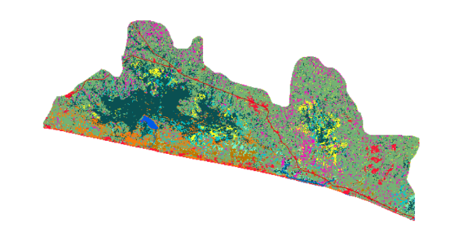
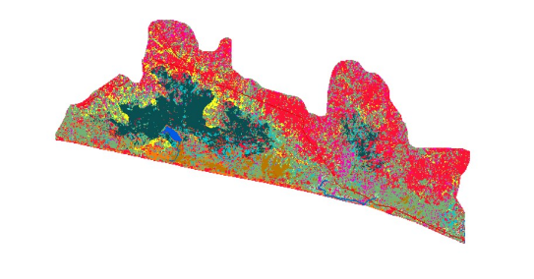
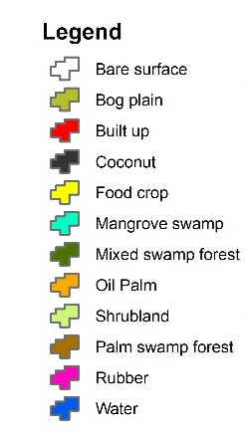
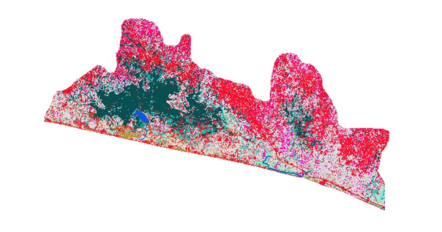
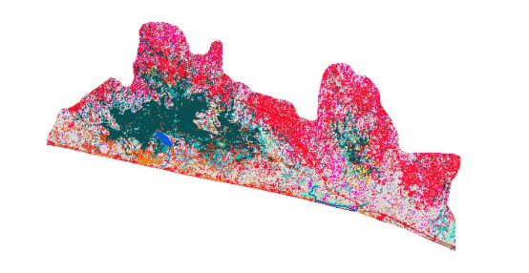
Landscape Restoration
Plantation Agriculture
A
a
Urbanization
Urban Greening
Carbon Sequestration
Food
Recreation
Fuelwood

