Supplementary Materials
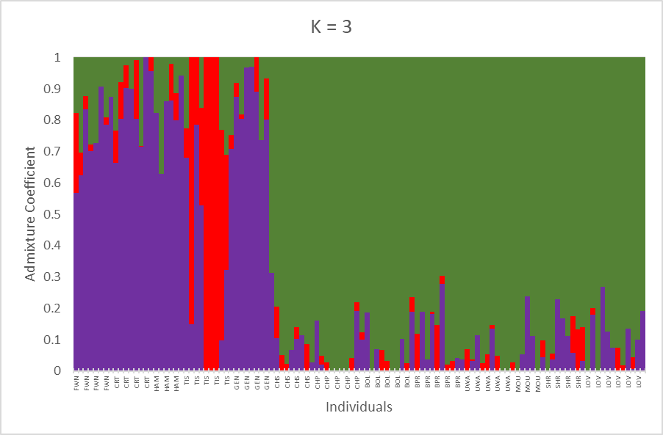
Fig. S1 Results from admixture analyses from the R package LEA for K = 3

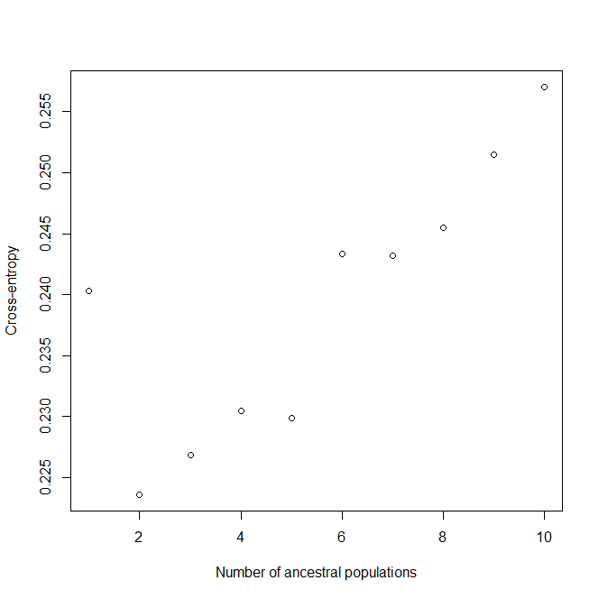

Fig. S2 Cross entropy plot of admixture analysis from the R package LEA

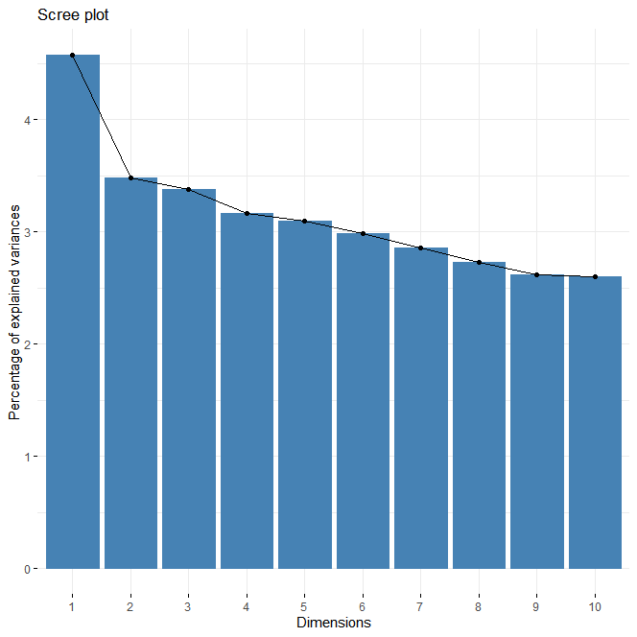
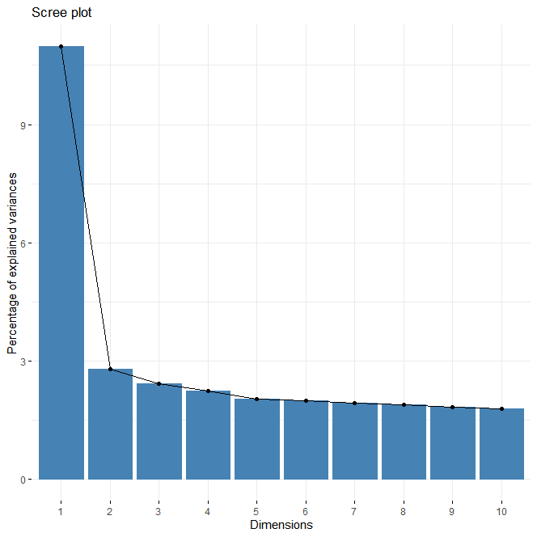
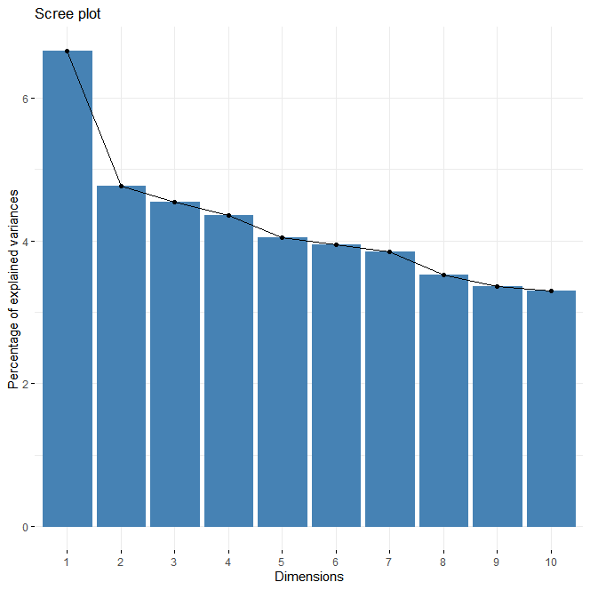
Fig. S3 Scree plots from the PCA for a) the full dataset, b) the eastern (Mississippi and Alabama) populations, and c) the western (Texas and Oklahoma) populations. Note that the flatter histograms of the regional datasets (b & c) is due to little remaining variance within regions, however scree plots still support retention of two axes for each regional subset (Lozier, pers. comm 2023
c
a
b

Table S1 Tetraopes texanus sampling site information
State | Property | Bio-informatic Code | Latitude | Longitude
AL | Shirley Prairie | SHR | 32.86449 | -88.0728
AL | University of West Alabama Prairie | UWA | 32.60988 | -88.1978
AL | Mouron Prairie | MOU | 32.79854 | -88.1435
AL | Lovinggood Prairie | LOV | 32.71921 | -87.7913
MS | Black Prairie WMA | BPR | 33.33696 | -88.5568
MS | Chickaaw Preserve | CHP | 34.25235 | -88.8166
MS | Chickasaw WMA | CHS | 33.92568 | -88.8456
MS | Burnt Oak Lodge | BOL | 33.34627 | -88.6625
OK | Tishomingo NWR, Rock Creek | TIS | 34.12996 | -96.619
OK | Crosstimbers WMA | CRT | 33.99705 | -97.4435
TX | Hagerman NWR | HAM | 33.73868 | -96.7522
TX | Gus Engeling WMA | GEN | 31.91141 | -95.9063
TX | Fort Worth Nature Center | FWN | 32.83146 | -97.4756

Table S2 Pairwise F_{st} matrix
 | HAM | GEN | TIS | BPR | CRT | UWA | CHP | MOU |  | FWN | CHS | LOV | SHR
GEN | 0.049
TIS | 0.089 | 0.052
BPR | 0.218 | 0.184 | 0.199
CRT | 0.040 | 0.000 | 0.061 | 0.195
UWA | 0.207 | 0.193 | 0.213 | 0.010 | 0.203
CHP | 0.252 | 0.220 | 0.245 | 0.058 | 0.232 | 0.061
MOU | 0.194 | 0.158 | 0.184 | 0.008 | 0.170 | 0.000 | 0.033
FWN | 0.044 | 0.001 | 0.067 | 0.165 | 0.012 | 0.169 | 0.198 | 0.140
CHS | 0.217 | 0.173 | 0.202 | 0.027 | 0.183 | 0.040 | 0.062 | 0.037 |  | 0.146
LOV | 0.226 | 0.197 | 0.220 | 0.035 | 0.203 | 0.030 | 0.067 | 0.023 |  | 0.171 | 0.049
SHR | 0.197 | 0.178 | 0.197 | 0.024 | 0.189 | 0.009 | 0.078 | 0.020 |  | 0.161 | 0.048 | 0.022
BOL | 0.217 | 0.197 | 0.213 | 0.020 | 0.211 | 0.016 | 0.066 | 0.027 |  | 0.175 | 0.034 | 0.025 | 0.026

