Supporting Information for
Source appointment and health risk assessment for atmospheric carbonyls in hot tropical city, Vietnam
Duong Huu Huy^{1,*}, Nguyen Thao Nguyen^{2,3}, Nguyen Doan Thien Chi^{2,3}, Norimichi Takenaka⁴ and, To Thi Hien^{2,3}
¹Faculty of Food Science and Technology, Ho Chi Minh City University of Industry and Trade, Ho Chi Minh City, Vietnam
²Faculty of Environment, University of Science, Ho Chi Minh City, Vietnam
³Vietnam National University, Ho Chi Minh City, Vietnam
⁴Graduate School of Humanities and Sustainable System Sciences, Osaka Metropolitan University

*Corresponding author: Tel.: (+84) 8 3816 1673; email: huydh@huit.edu.vn
Faculty of Food Science and Technology, Ho Chi Minh City University of Industry and Trade, 140 Le Trong Tan Street, Tan Phu District, Ho Chi Minh City, Vietnam

Table S captions
Table S1. Input parameters for risk assessment
Table S2. Meteorological conditions
Table S3. The mixing ratios of carbonyls at each sampling sites (in ppb)

Table S1. Input parameters for different age groups used for risk assessment
 | Infants | Children |  | Adult
 | Birth - 2 | 2 to <6 | 6 to <18 | 18 to <61 | > 61
Inhalation rate (IR, m³ day⁻¹) | 5.4 | 10.1 | 15.2 | 16.3 | 14.2
Exposure frequency (EF, days year⁻¹) | 350 | 350 | 350 | 350 | 350
Exposure duration (ED, years) | 2 | 6 | 17 | 40 | 52
Averaging time* (AT, days) | 730  (25550) | 2190  (25550) | 6205  (25550) | 14600  (25550) | 18980  (25550)
Body weight (BW, kg) | 11.4 | 18.6 | 56.8 | 80 | 80
* AT: ED*365 for non-carcinogen (70*365 for carcinogen)

Table S2. Meteorological conditions during rainy and dry campaigns
 | Rainy | Dry
Temperature, °C | 29.3 ± 3.7 | 30.5 ± 4.1
Relative humidity, % | 80 ± 3 | 64 ± 4
Wind speed, km/h | 6.0 ± 1.6 | 10.5 ± 2.1
Wind direction * | E(25%), ESE(26%), SE(16%) | SE(56%), SSE(20%), ESE(16%)
Cloud cover, % | 32 ± 12 | 27 ± 11
PBL height, m | 389 ± 369 | 769 ± 503
Rainfall (mm/month) | 191.4 | 30.6
(*) prevailing wind directions

Table S3. The mixing ratios of carbonyls at each sampling sites (in ppb)
No | Sites (n)  Compounds | BC  (14) | D3  (14) | TD  (13) | TB  (14) | BTh  (14) | D10  (14) | BT  (14) | D1  (14) | GV  (14) | PN  (14) | D11  (14) | D5  (14)
1 | Formaldehyde | 5.17 ± 3.23 | 6.70 ± 4.80 | 5.82 ± 3.39 | 7.33 ± 6.63 | 6.02 ± 4.47 | 7.94 ± 4.94 | 7.18 ± 5.15 | 7.26 ± 6.35 | 9.24 ± 8.65 | 10.7 ± 14.6 | 9.50 ± 9.30 | 9.45 ± 6.49
2 | Acetaldehyde | 3.73 ± 2.19 | 3.88 ± 2.36 | 4.05 ± 2.78 | 4.03 ± 1.87 | 4.36 ± 3.62 | 5.63 ± 3.02 | 5.16 ± 5.38 | 6.29 ± 7.11 | 5.32 ± 3.39 | 7.32 ± 14.2 | 7.79 ± 8.55 | 7.61 ± 8.92
3 | Acetone | 13.4 ± 13.3 | 13.4 ± 10.4 | 14.7 ± 11.2 | 13.8 ± 11.4 | 18.2 ± 16.0 | 15.6 ± 13.9 | 18.2 ± 20.2 | 17.0 ± 13.6 | 16.5 ± 12.1 | 16.6 ± 14.1 | 16.6 ± 15.4 | 22.6 ± 13.8
4 | Acrolein | 0.16 ± 0.17 | 0.12 ± 0.10 | 0.43 ± 0.63 | 0.31 ± 0.46 | 0.19 ± 0.16 | 0.16 ± 0.12 | 0.18 ± 0.16 | 0.39 ± 0.60 | 0.21 ± 0.28 | 0.22 ± 0.38 | 0.19 ± 0.26 | 0.27 ± 0.27
5 | Propionaldehyde | 0.84 ± 0.93 | 0.67 ± 0.56 | 1.43 ± 1.97 | 1.03 ± 0.91 | 0.93 ± 1.10 | 1.18 ± 0.99 | 0.95 ± 1.27 | 0.44 ± 2.03 | 1.30 ± 1.52 | 0.92 ± 0.81 | 1.60 ± 2.28 | 1.16 ± 1.22
6 | Crotonaldehyde | 0.16 ± 0.37 | 0.08 ± 0.09 | 0.36 ± 0.48 | 0.16 ± 0.27 | 0.38 ± 0.79 | 0.04 ± 0.02 | 0.24 ± 0.36 | 0.09 ± 0.17 | 0.08 ± 0.15 | 0.22 ± 0.61 | 0.07 ± 0.08 | 0.33 ± 1.00
7 | Butyraldehyde | 0.58 ± 0.69 | 0.5 ± 0.38 | 0.69 ± 0.75 | 1.02 ± 2.06 | 0.41 ± 0.21 | 0.46 ± 0.29 | 0.42 ± 0.25 | 0.50 ± 0.54 | 0.65 ± 0.45 | 0.44 ± 0.30 | 0.72 ± 0.45 | 0.54 ± 0.31
8 | Benzaldehyde | 0.63 ± 0.36 | 0.79 ± 0.91 | 1.48 ± 1.25 | 0.77 ± 0.50 | 0.62 ± 0.46 | 0.84 ± 0.57 | 0.67 ± 0.37 | 0.70 ± 0.72 | 0.66 ± 0.50 | 0.77 ± 0.62 | 1.00 ± 0.84 | 1.20 ± 0.09
9 | Iso-valeraldehyde | 0.17 ± 0.17 | 0.06 ± 0.04 | 0.25 ± 0.27 | 0.26 ± 0.47 | 0.10 ± 0.08 | 0.11 ± 0.08 | 0.14 ± 0.12 | 0.12 ± 0.11 | 0.12 ± 0.08 | 0.16 ± 0.13 | 0.24 ± 0.36 | 0.12 ± 0.11
10 | Valeraldehyde | 0.23 ± 0.17 | 0.18 ± 0.15 | 0.28 ± 0.22 | 0.83 ± 1.61 | 0.26 ± 0.16 | 0.31 ± 0.19 | 0.24 ± 0.17 | 0.22 ± 0.12 | 0.29 ± 0.25 | 0.47 ± 0.68 | 0.47 ± 0.59 | 0.21 ± 0.10
11 | p-Tolualdehyde | 0.04 ± 0.01 | 0.05 ± 0.01 | 0.12 ± 0.09 | 0.05 ± 0.04 | 0.06 ± 0.04 | 0.04 ± 0.01 | 0.03 ± 0.01 | 0.10 ± 0.09 | 0.09 ± 0.13 | 0.04 ± 0.04 | 0.06 ± 0.01 | 0.05 ± 0.03
12 | m,o-Tolualdehyde | 0.16 ± 0.08 | 0.16 ± 0.12 | 0.29 ± 0.26 | 0.42 ± 0.48 | 0.16 ± 0.06 | 0.14 ± 0.09 | 0.16 ± 0.12 | 0.13 ± 0.09 | 0.12 ± 0.07 | 0.16 ± 0.16 | 0.14 ± 0.08 | 0.24 ± 0.23
13 | Hexaldehyde | 0.29 ± 0.24 | 0.28 ± 0.29 | 0.32 ± 0.38 | 0.79 ± 1.14 | 0.25 ± 0.27 | 0.41 ± 0.49 | 0.18 ± 0.09 | 0.25 ± 0.25 | 0.24 ± 0.37 | 0.21 ± 0.20 | 0.24 ± 0.25 | 0.31 ± 0.40
14 | 2,5-DMB (*) | 0.07 ± 0.04 | < LOD | 0.4 ± 0.21 | 0.13 ± 0.05 | < LOD | < LOD | 0.07 ± 0.06 | 0.14 ± 0.09 | 0.11 ± 0.06 | < LOD | < LOD | < LOD
15 | Σ15 Carbonyls | 25.3 ± 18.9 | 26.8 ± 13.6 | 30.0 ± 17.7 | 30.5 ± 18.7 | 31.7 ± 20.7 | 32.5 ± 17.4 | 33.6 ± 30.8 | 34.3 ± 22.8 | 34.7 ± 18.7 | 38.0 ± 41.2 | 38.4 ± 35.9 | 44.0 ± 31.1
(*) 2,5-Dimethylbenzaldehyde; (n) sampling size

Figure S captions
Figure S1. Distribution of 15 carbonyls during dry and rainy seasons in urban HCMC, Vietnam
Figure S2. Normalized to mean value diurnal variations of acetaldehyde, acetone, O₃ and CO during: (A) rainy (Sep – Nov, 2018), and (B) dry (Mar – Apr, 2019) seasons in HCMC, Vietnam (at the D5 site in this study). Source: Data adopted from Hien et al., (2022b)
Figure S3. The spatial distribution of formaldehyde, acetaldehyde, acetone and sum of carbonyls in HCMC, Vietnam during dry season
Figure S4. The spatial distribution of formaldehyde, acetaldehyde, acetone and sum of carbonyls in HCMC, Vietnam during rainy season
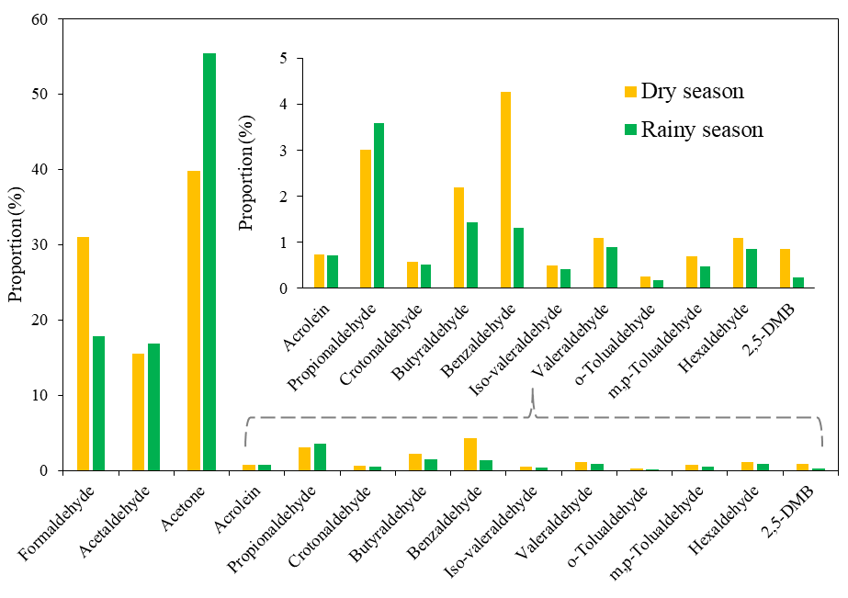
Figure S1. Distribution of 15 carbonyls during dry and rainy seasons in urban HCMC, Vietnam

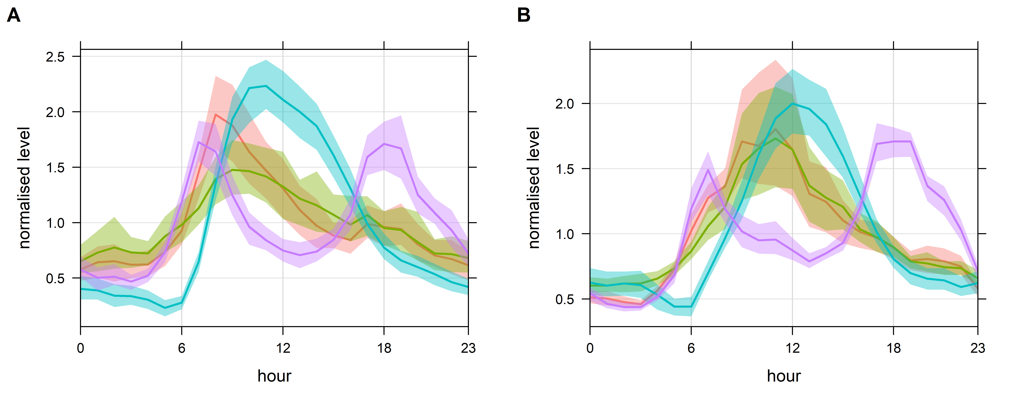
Figure S2. Normalized to mean value diurnal variations of acetaldehyde, acetone, O₃ and CO during: (A) rainy (Sep – Nov, 2018), and (B) dry (Mar – Apr, 2019) seasons in HCMC, Vietnam (at the D5 site in this study). Source: Data adopted from Hien et al., (2022)

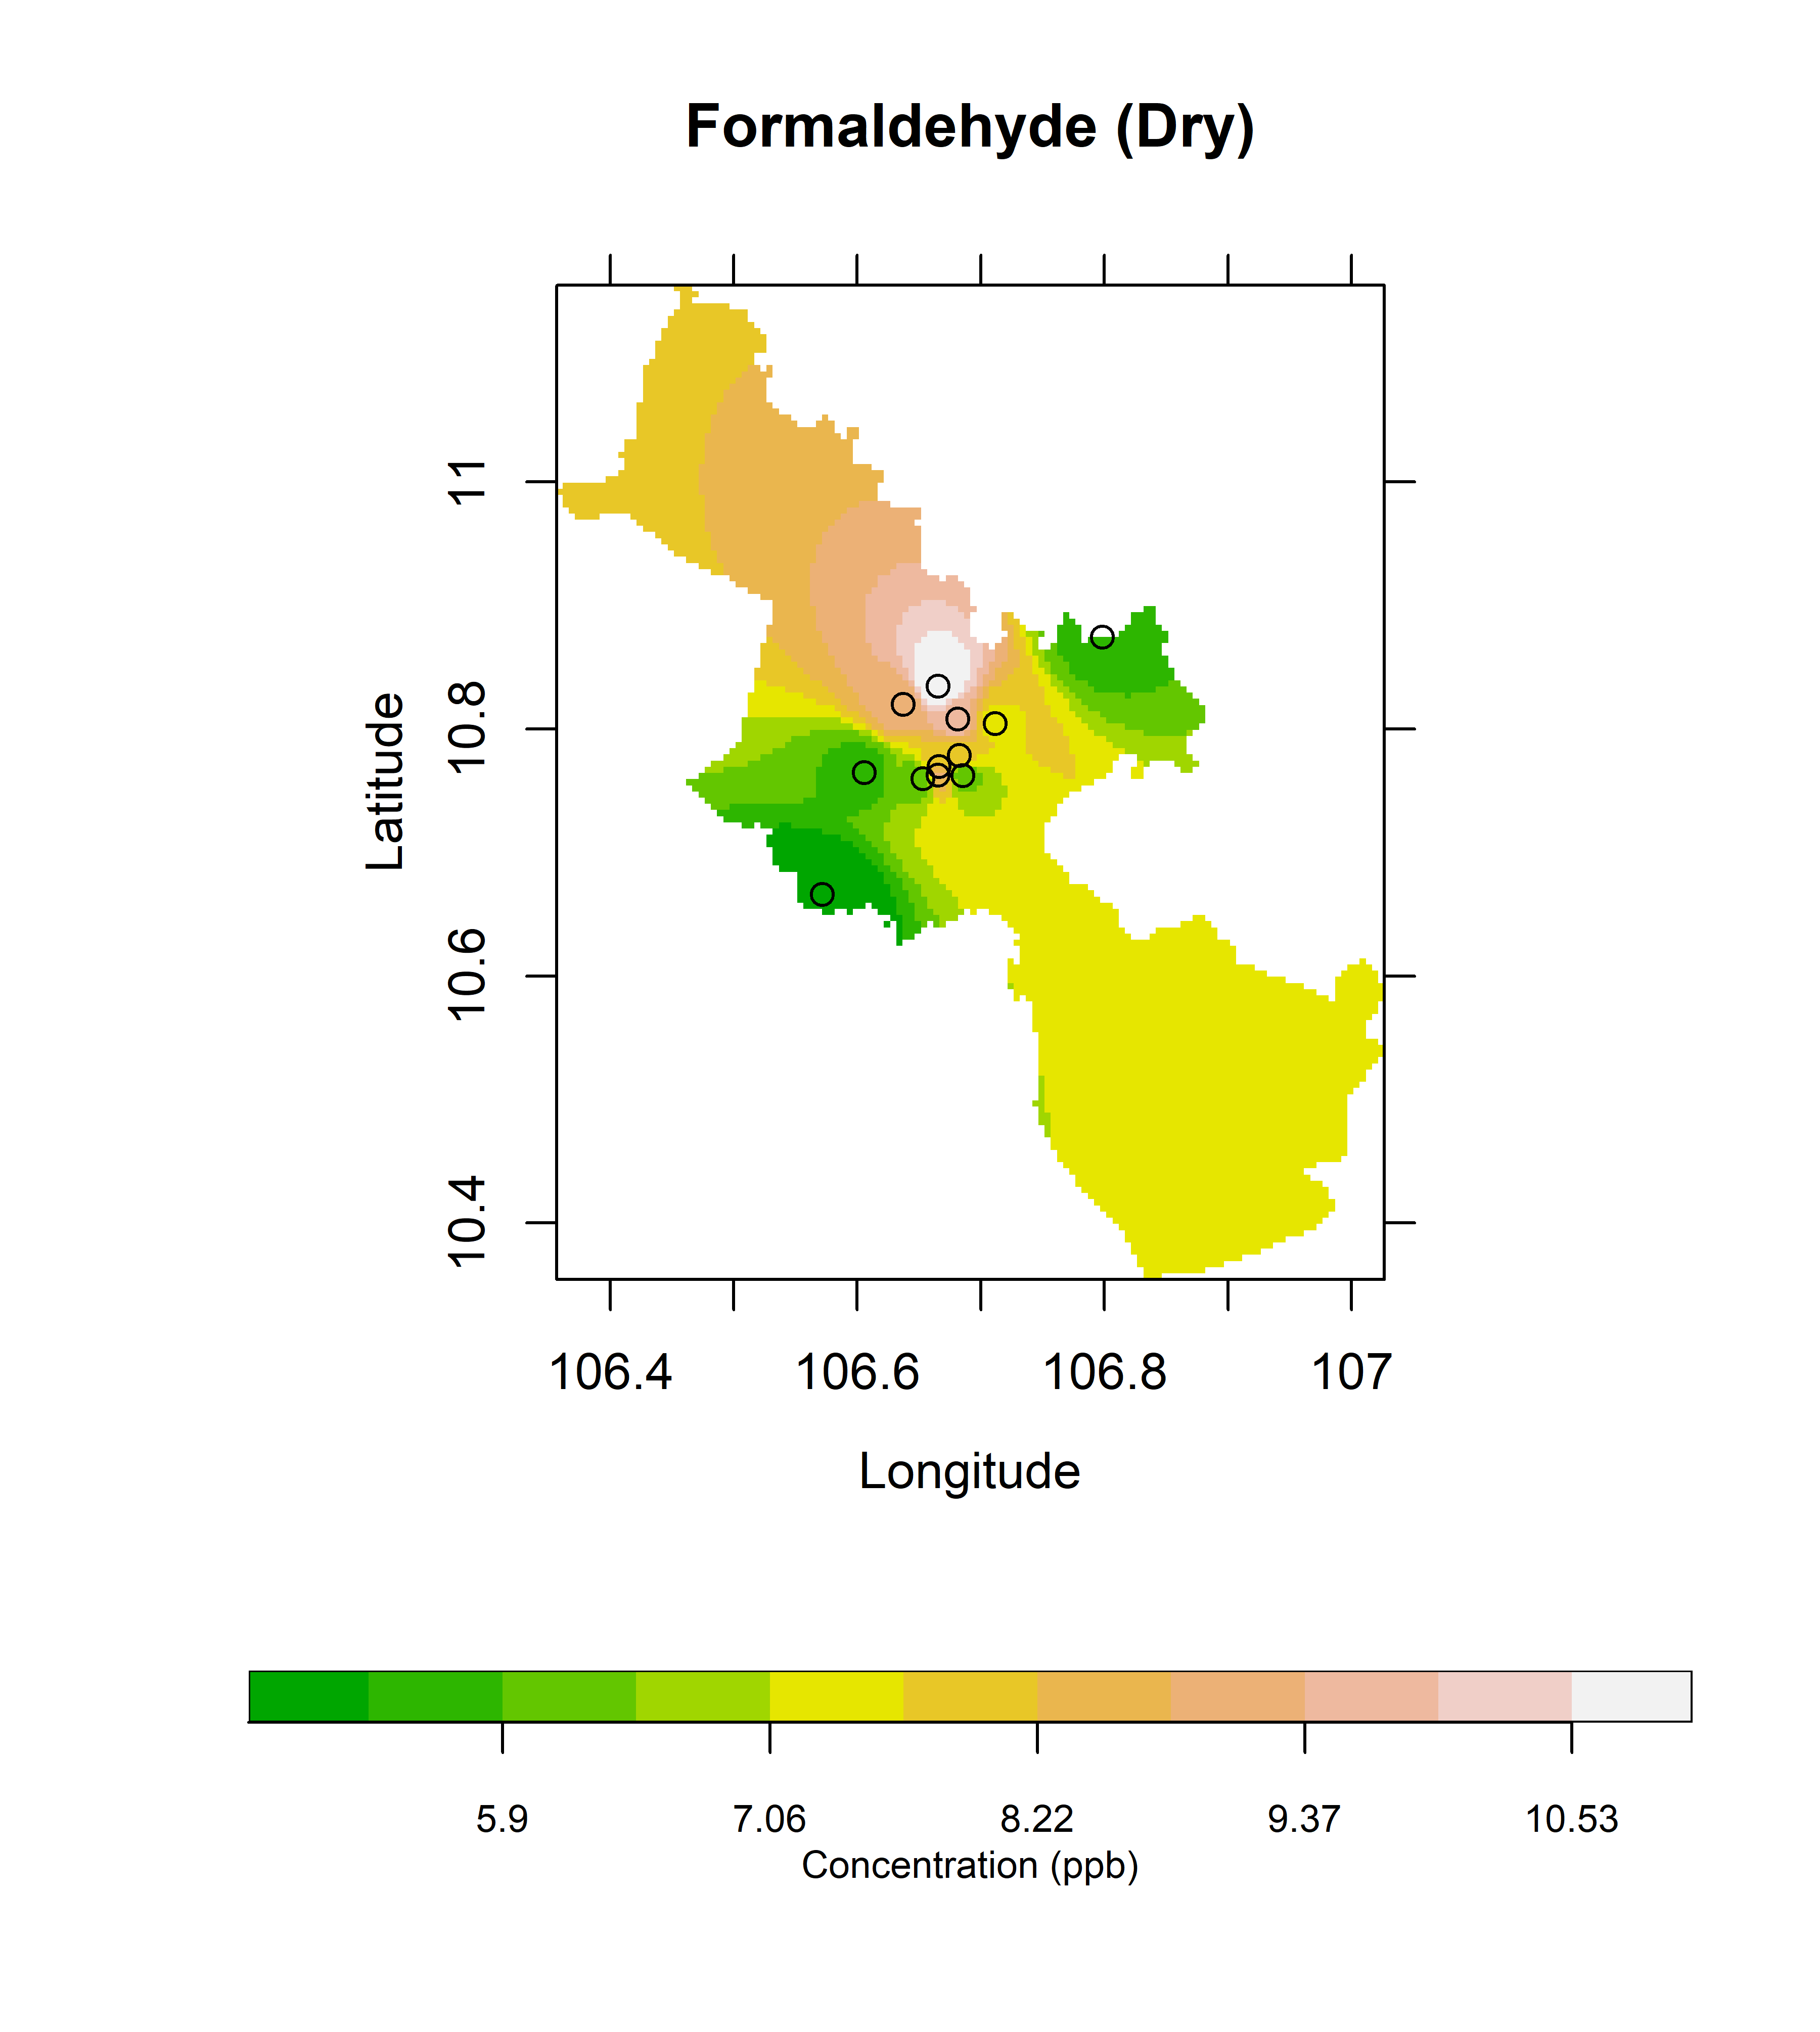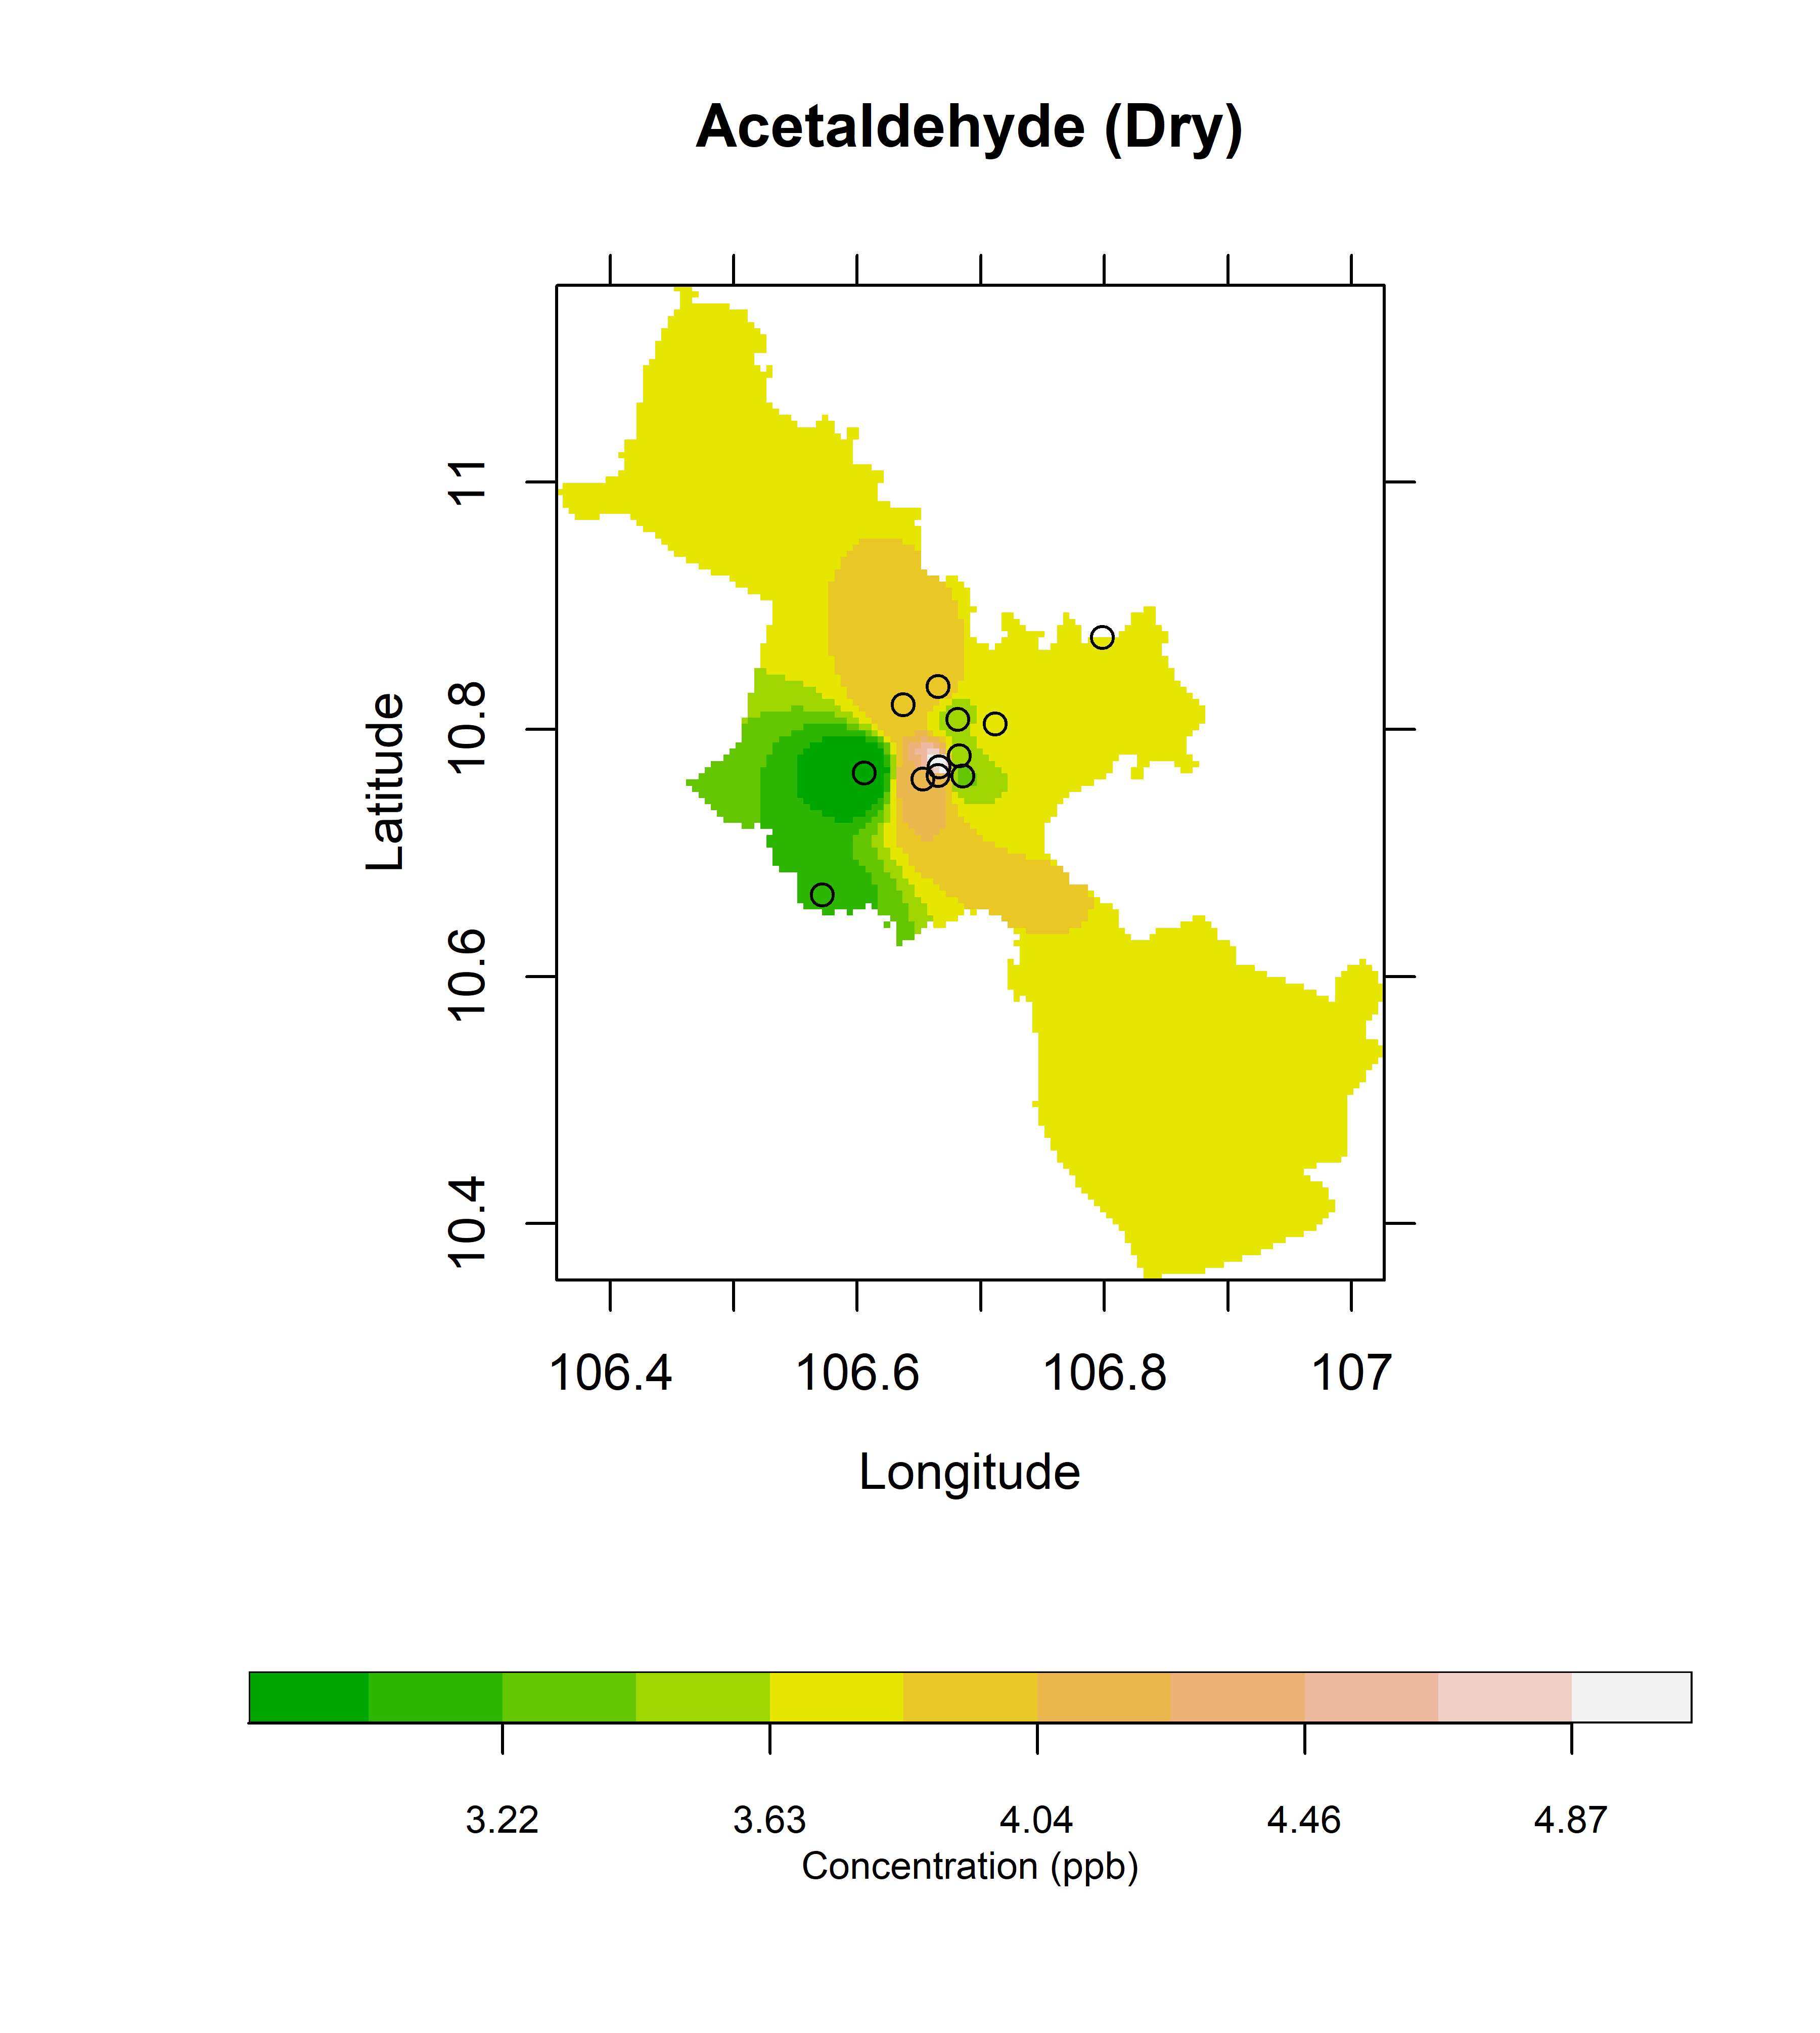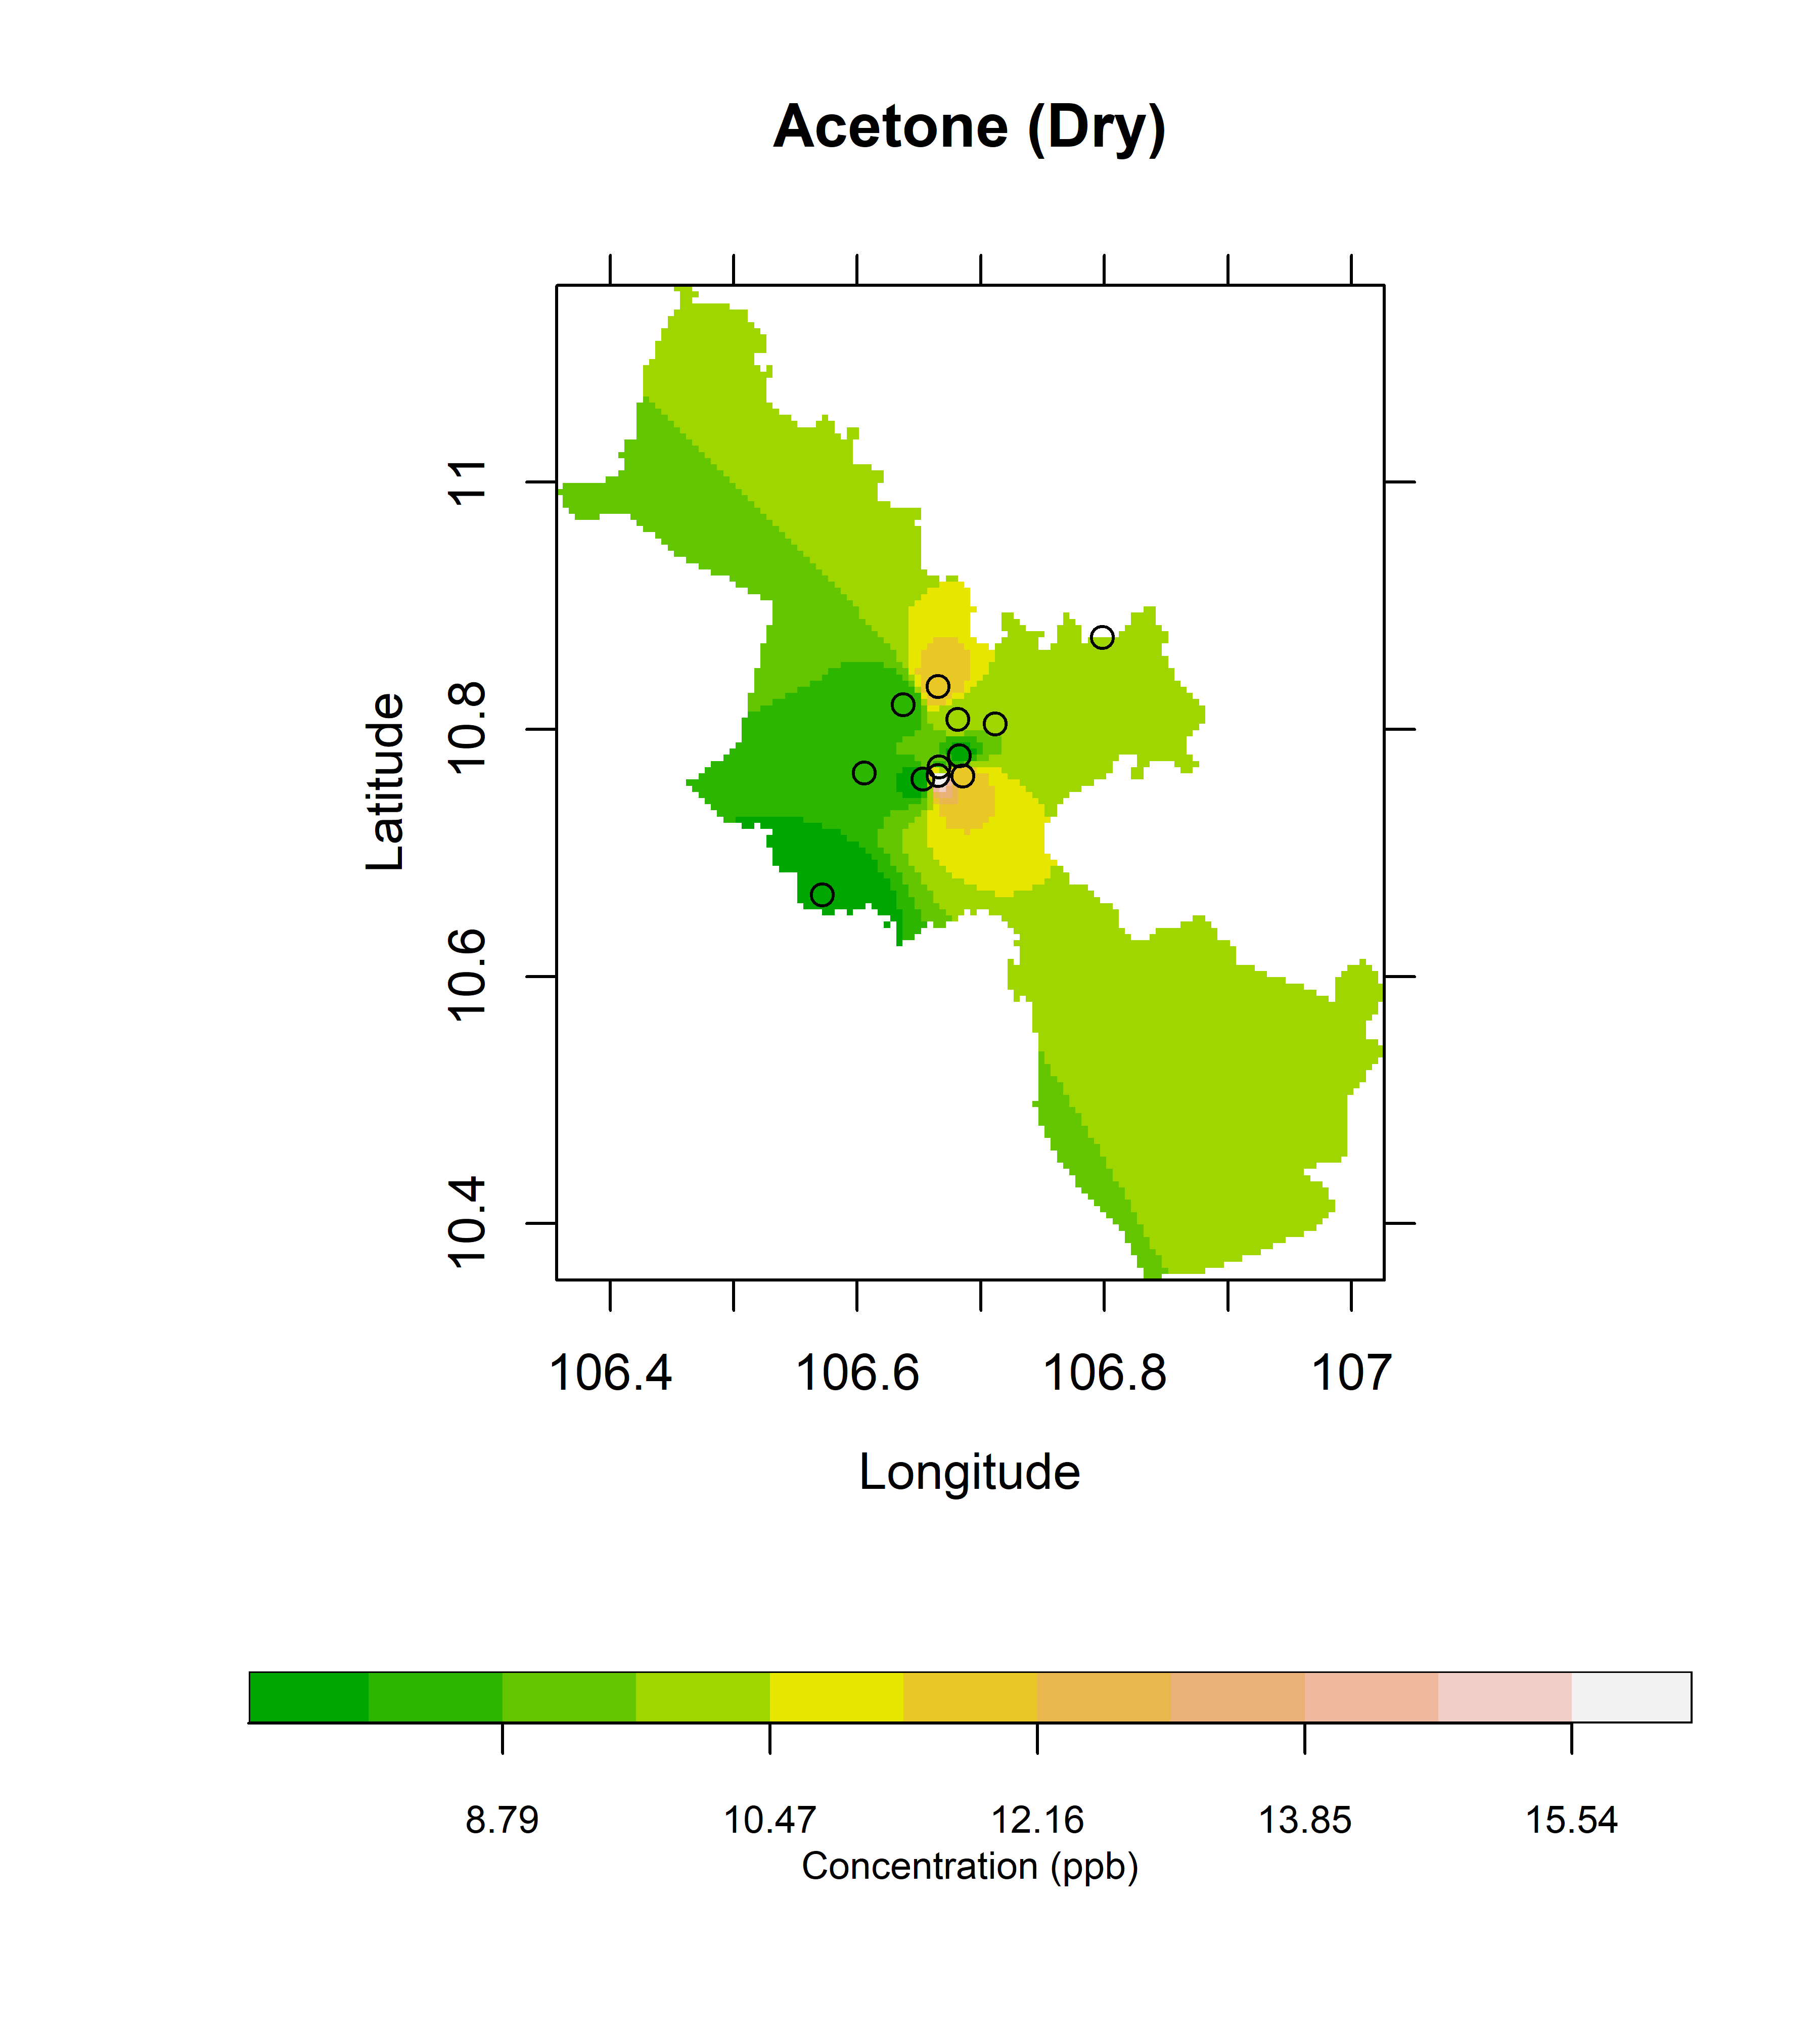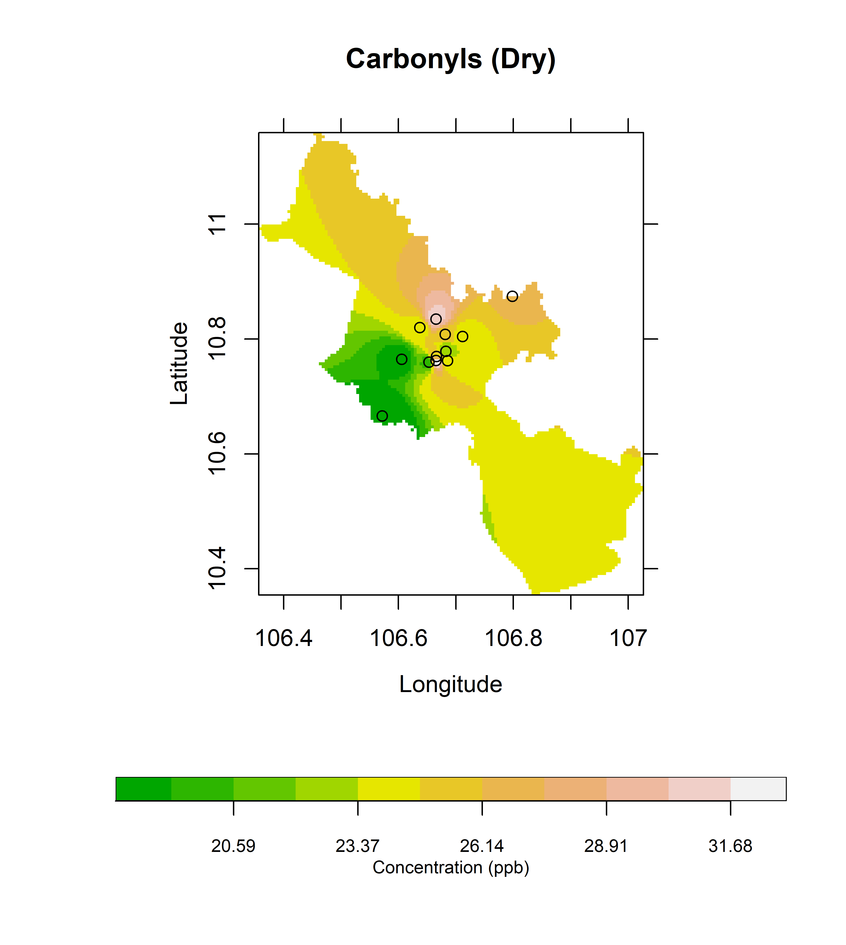
Figure S3. The spatial distribution of formaldehyde, acetaldehyde, acetone and sum of carbonyls in HCMC, Vietnam during dry season

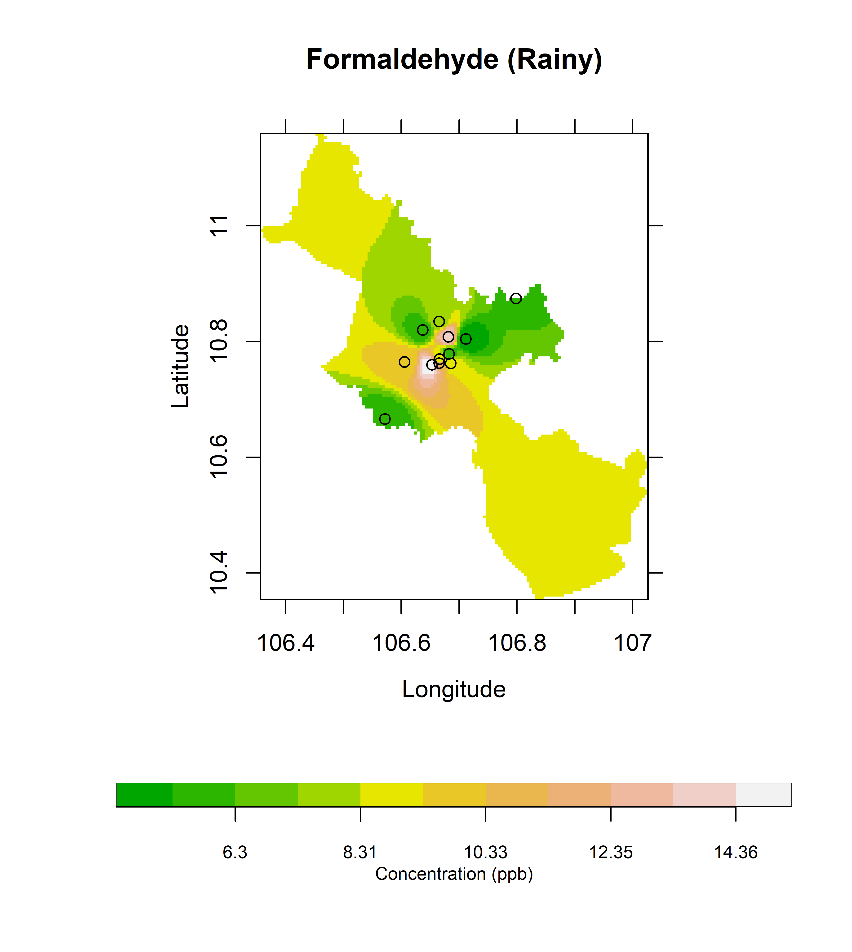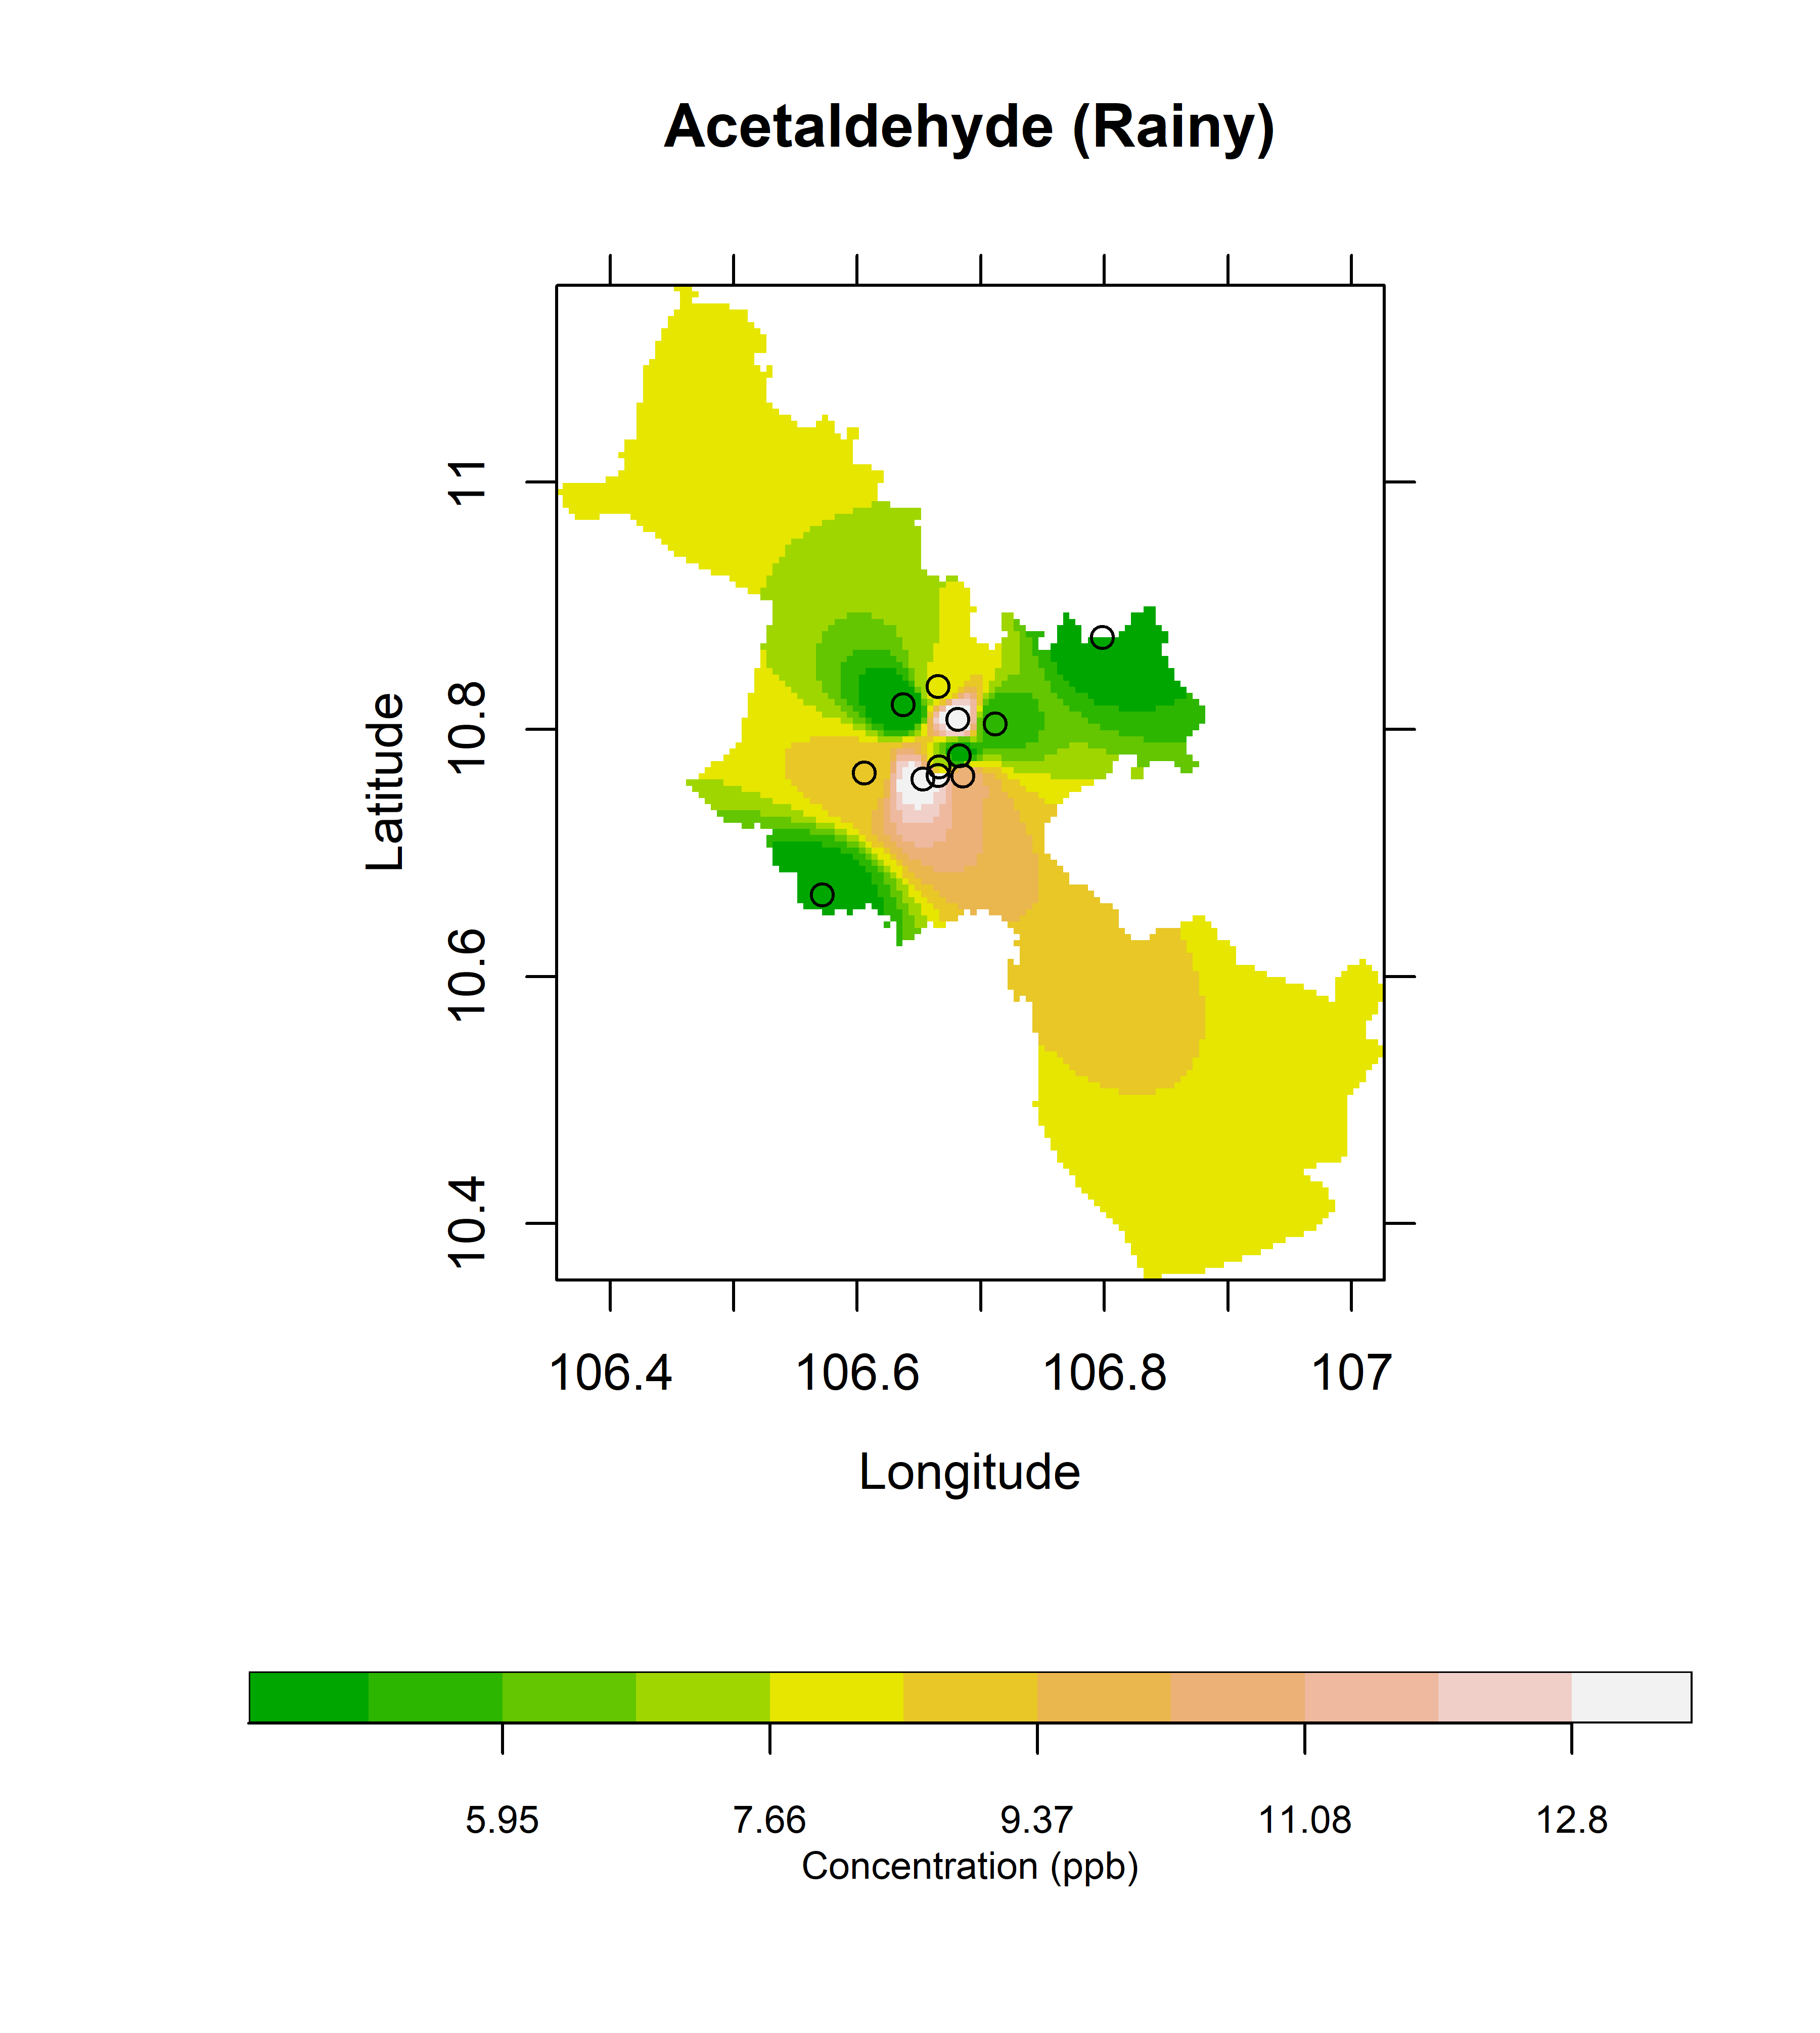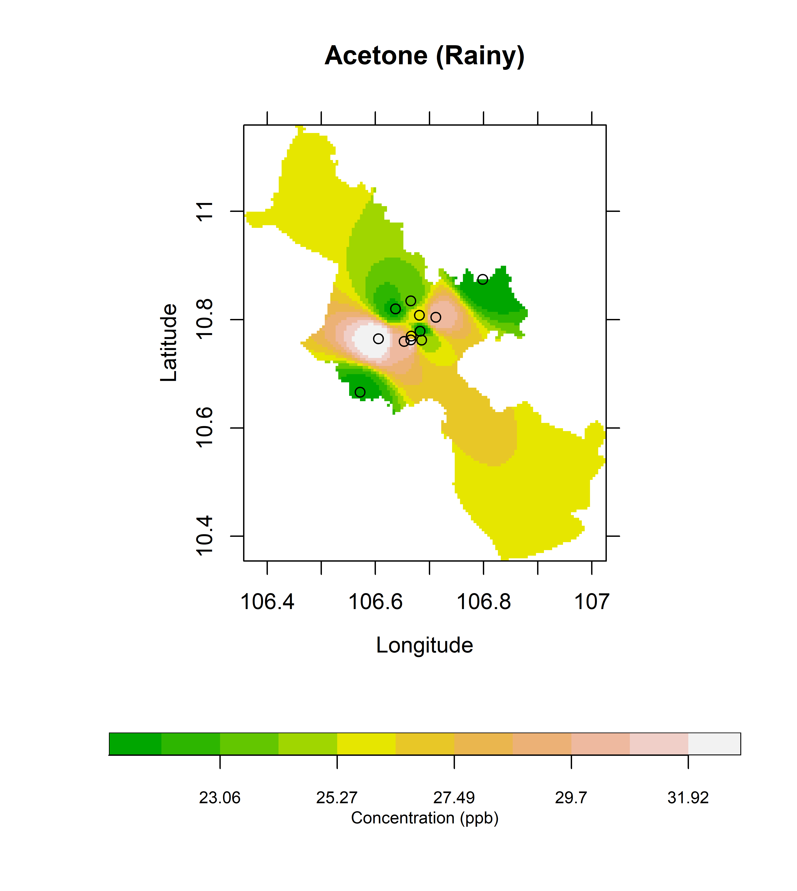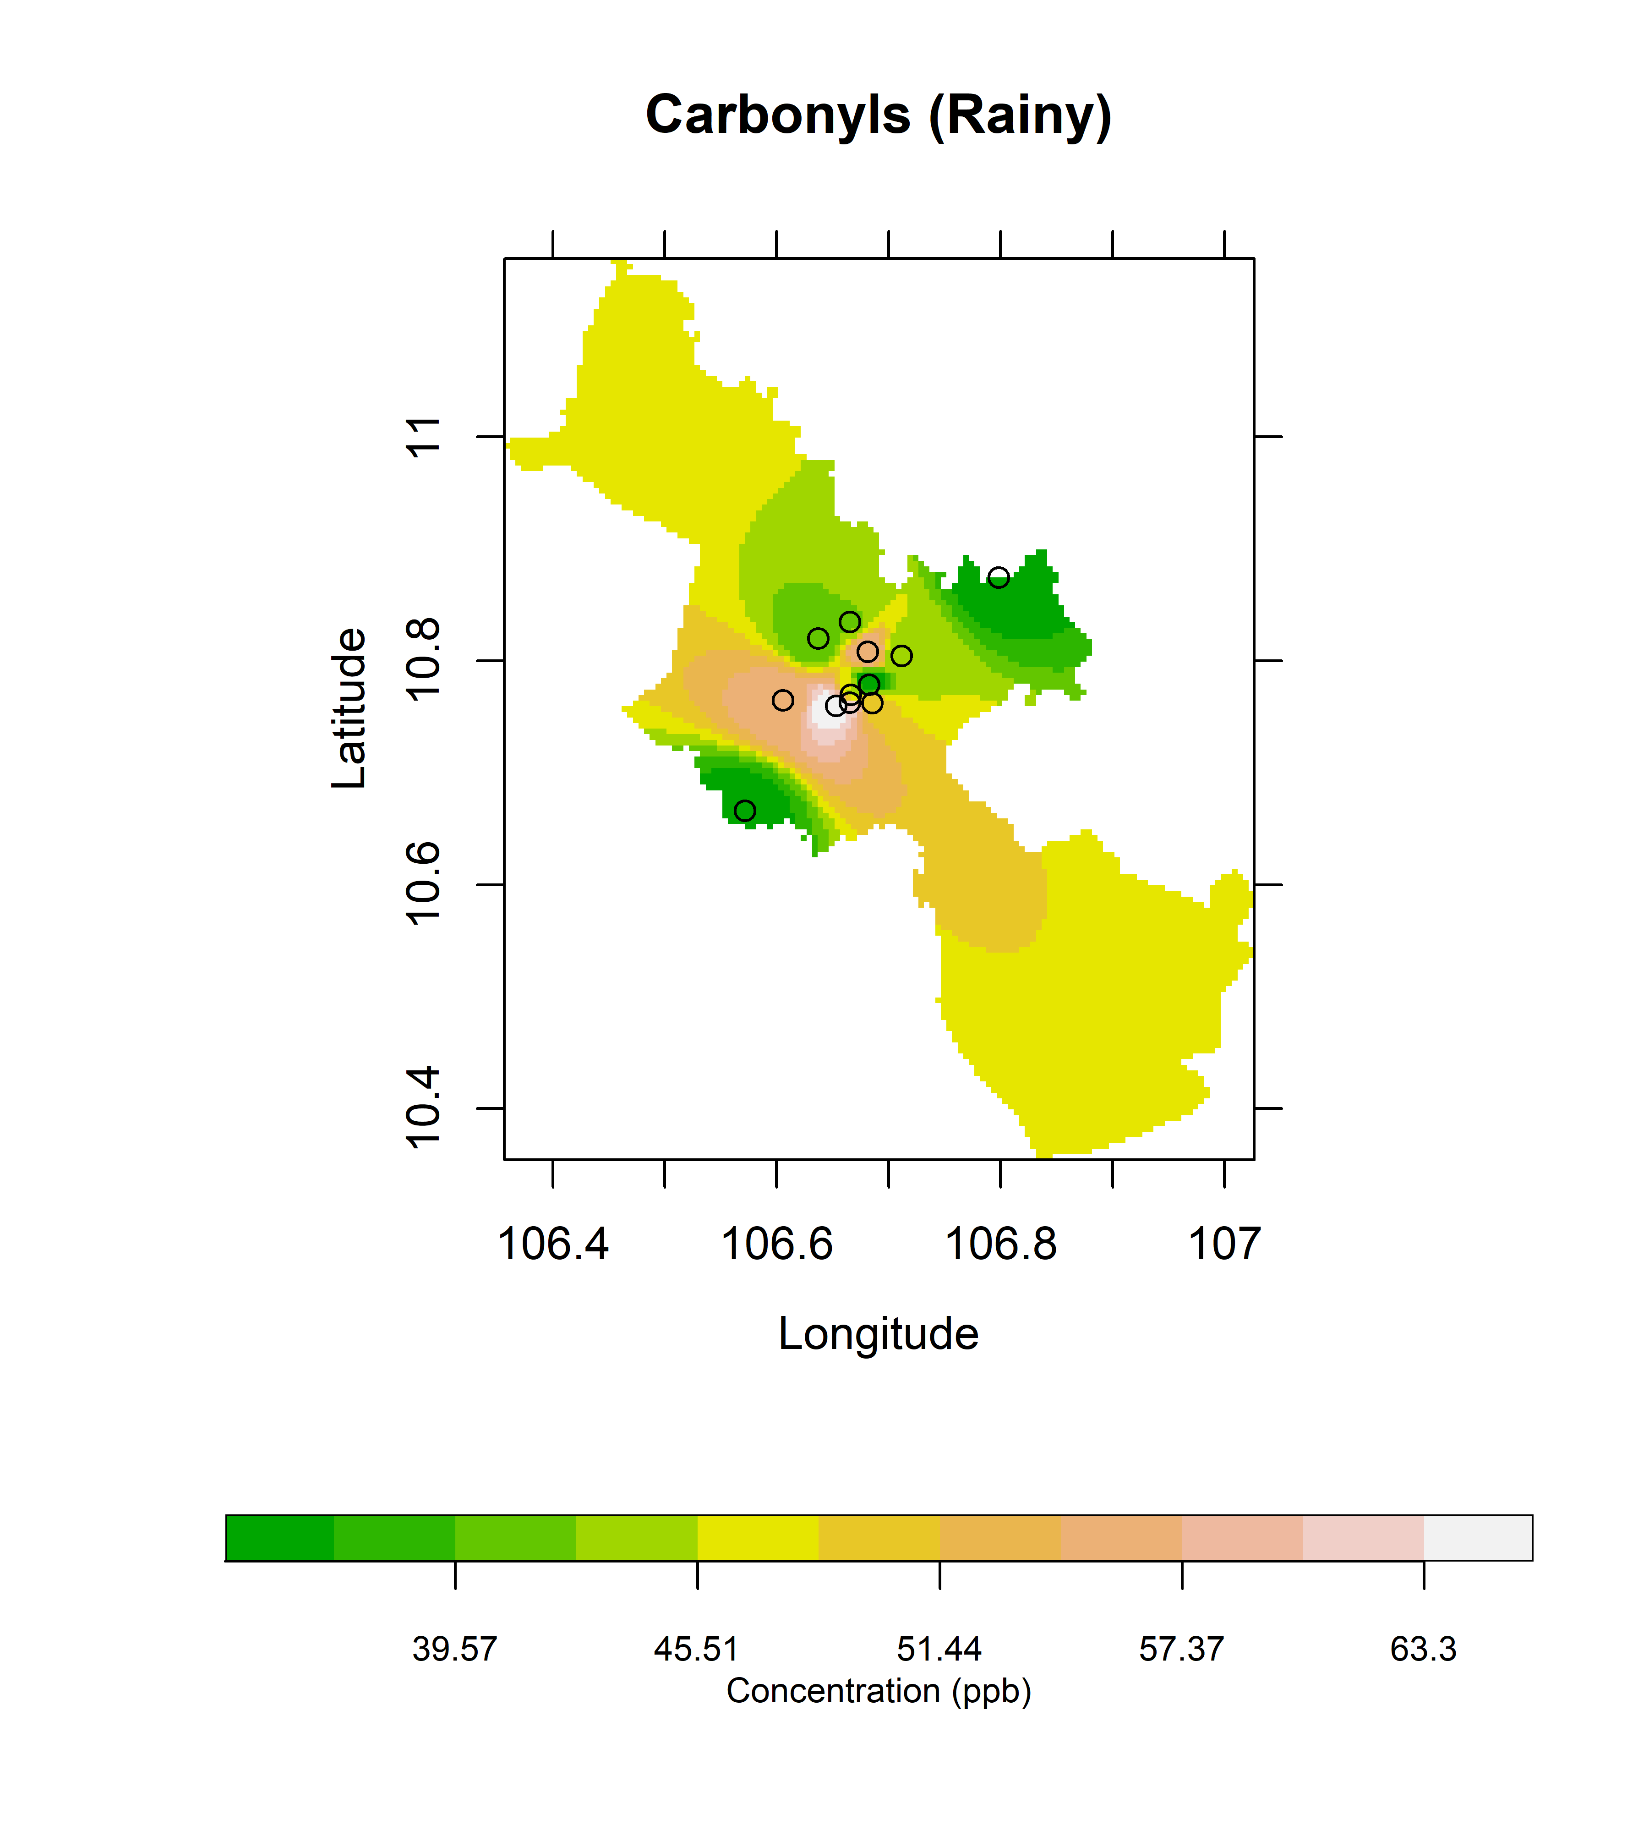
Figure S4. The spatial distribution of formaldehyde, acetaldehyde, acetone and sum of carbonyls in HCMC, Vietnam during rainy season

