Supplementary Information

Contents:
Supplementary Methods 1
Supplementary Methods 1 - Modified Probabilistic Automatic Outlier Detection (PAOD) algorithm 1
Supplementary Methods 2 – Demonstrating that the mean of CNEMC stations is similar to the population-weighted mean. 8
Supplementary Figures 9
References 13

Supplementary Methods

Supplementary Methods 1 - Modified Probabilistic Automatic Outlier Detection (PAOD) algorithm

The Python script to perform PAOD (PAOD.py) is available from in the paper’s repository. The full details of the original PAOD algorithm can be found in: ‘Probabilistic Automatic Outlier Detection for Surface Air Quality Measurements from the China National Environmental Monitoring Network’ by Wu et al. (2018)¹ (henceforth Wu et al.)
Wu et al. develop a method for screening the CNEMC monitoring data for five categories of commonly found outliers in the CNEMC data. For a given pollutant concentration observation, $f(i)$, the method estimates the probability, $P(i)$, that it is an outlier, using the following method:
- For each of the five types of outlier, a different consistency check is performed to produce an expected value, F(i), by computing a ‘rolling’ statistic using surrounding value. The statistic used to estimate F(i) differs for each outlier category, and each method will be discussed in detail below. The residual, R(i), is calculated as the difference between the estimated and expected values:
- The rolling standard deviation of the residuals, S(i), is calculated. Wu et al. do not disclose the span of the rolling window they use. For our version of PAOD we use a centred 30-day span. S(i) is used to calculate a rolling z-score, Z(i), i.e. the distance of a given residual from the mean residuals. By assuming that the rolling-mean residual ≈0, this allows us to calculate Z(i) by dividing R(i) by S(i).
- The probability of Z(i), P(i) is calculated assuming that the residuals are normally distributed. Calculating the probability allows for multiple categories of outlier to be combined. Then, if P(i) exceeds a probability threshold, which varies between outlier categories, f(i) is flagged.

Below we describe the modifications we make to calculating F(i) for each of the outlier categories. Other than the modifications mentioned, we follow the methodology as described by Wu et al.

Extreme outliers
We make two changes to the detection of extreme outliers.
When calculating extreme outliers, we calculate the S(i) of the residuals as normal (i.e. a rolling standard deviation, using Equation 2 from Wu et al. , rather calculating the rolling median absolute deviation (MAD) of residuals (i.e. Equation 8 in Wu et al.). In our sensitivity tests we found that using MAD combined with the P threshold of 10⁻¹⁵ resulted in false positives, where very high concentrations would be flagged as extreme even if they are surrounded by other high concentrations, which likely indicates a high pollution event.
The second modification is that in our version, we use a 90-day rolling window. In our tests, a 90-day window better detected extreme cases where a value is very improbable compared with values in the surrounding season, while avoiding false positives. We keep the threshold for P at 10⁻¹⁵. Overall, the modifications result in much fewer values being flagged as extreme.
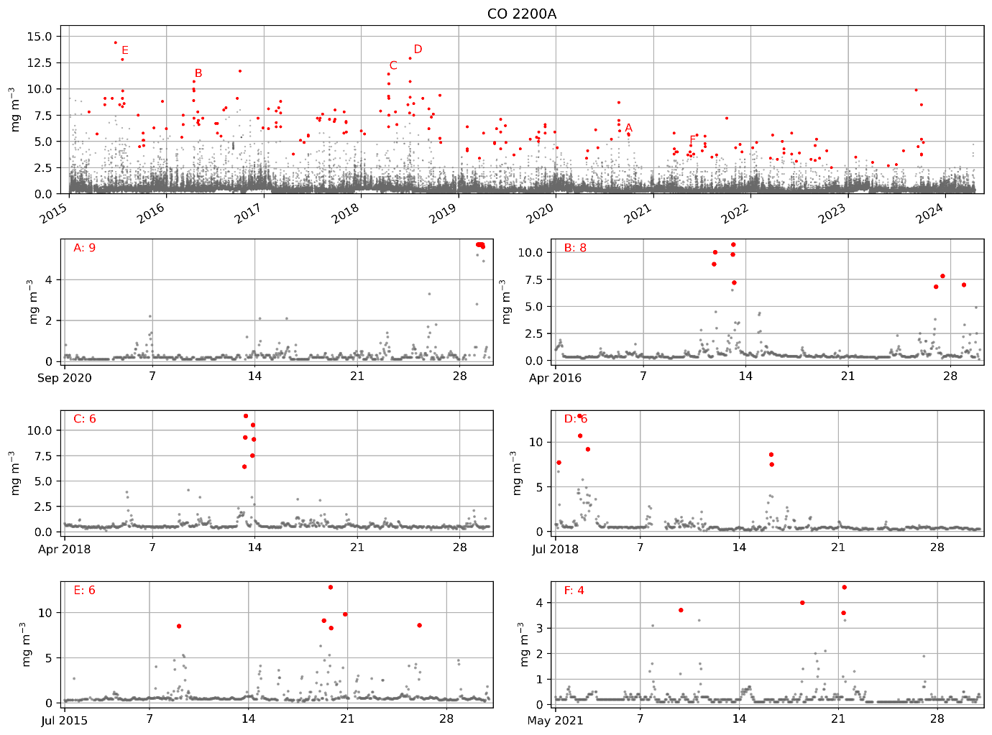
Example of data flagged as ‘extreme’ outlier by the Probabilistic Outlier Automated Detection screening.

Spatiotemporal outliers
This stage of PAOD involves calculating P(i) separately for temporal and spatial consistency, then combining both to get an overall estimate of spatiotemporal probability.
Temporal
For the temporal consistency estimate of P(i), P_{temp}, Wu et al. (2018) use a low-pass filter with coefficients from Karam and McClellan (1995) to estimate F_{temp}. Instead, we adopt a simpler approach and use a gaussian-weighted rolling mean. This method achieves similar results to the low-pass filter, but is more easily reproducible. The standard deviation of the gaussian is set to 3, and the window size is 30 hours.
Spatial
In this stage, the average of observations of neighbouring stations is used to estimate F for a given station. The average between neighbouring stations is weighted according to two factors, the inverse distance, and an agreement coefficient with f within a rolling window.
To obtain a distance-based weighting factor, Wu et al., use Gaspari and Cohn (1999)’s localisation method. However, they do not provide a full list of parameters for this function, or fully describe its implementation. Again, we simplify Wu et al. (2018)’s method by replacing their method of weighting with a gaussian function, where more distant sites are weighted less. We choose a gaussian with a standard deviation of ~35km to derive our inverse-distance weighting factor.
To derive the agreement weighting factor we calculate the Pearson correlation coefficient, where Wu et al. (2018) use the Index of Agreement.
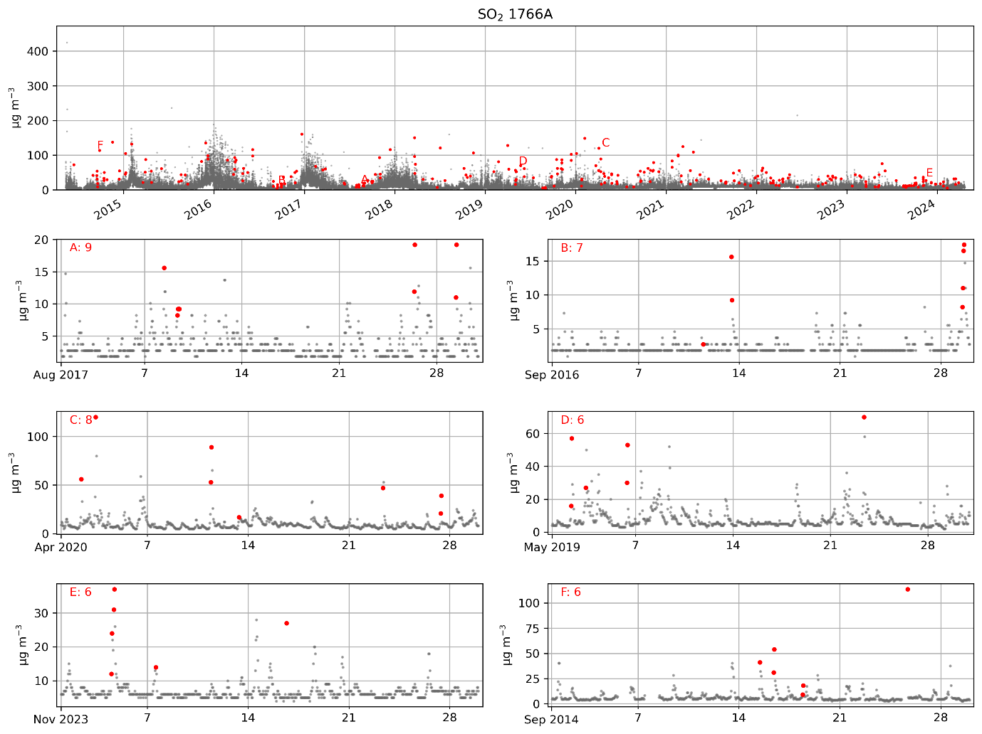
Example of data flagged as ‘spatiotemporal’ outlier by the Probabilistic Outlier Automated Detection screening.

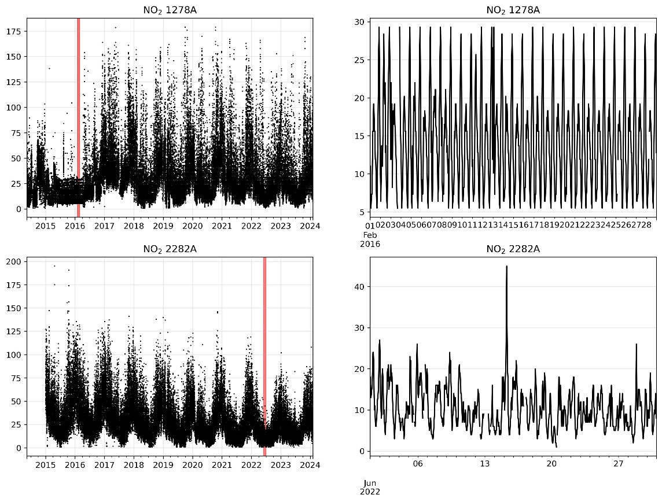
Low Variance
Example time series to illustrate the difficulty of distinguishing anomalous low variance periods. The left column shows the entire time series, while the right column shows a zoomed in area of interest. The top row shows an example with an anomalous period, the second row shows an example featuring a clean period with low variance.

To identify low variance periods, we adopt a different approach to Wu et al. (2018), again to avoid a high number of false positives we noticed when using their technique. Separating anomalous low-variance periods from genuine low variance periods is challenging because many time series naturally have very clean periods during which the relative precision of pollutant observations is low, resulting frequently repeated values and diurnal patterns. If all of these periods were removed, the mean of the timeseries would be positively skewed. However, in a genuinely anomalous low variance period (Figure 1a+b), an almost identical diurnal cycle is repeated each day. We use this aspect to identify low variance periods.
The first part of our method, which is similar to that used by Wu et al. (2018), is to identify periods with small gradients of change by calculating the first and second derivatives of the four day mean. This indicates the period could potentially be anomalous.
Then, to capture periods where the diurnal cycle varies has little day-to-day variation (e.g. Figure 1b), we identify instances where the pollutant concentration is the same for >=3 days in a row for a given hour of the day. Then, the average of these in a 7 day rolling period is calculated. Then Z(i) is calculated using the mean and standard deviation for the entire time series rather than for a rolling window. The reason for this is that low variance anomalies vary in length, so we cannot use a consistent rolling window span. Rather, we find instances when the variance is unusually low compared with the rest of the time series.
After calculating P, f(i) is marked as a low variance outlier if P < 10⁻⁷, AND it is in one of the low variance periods identified due to its low derivative.
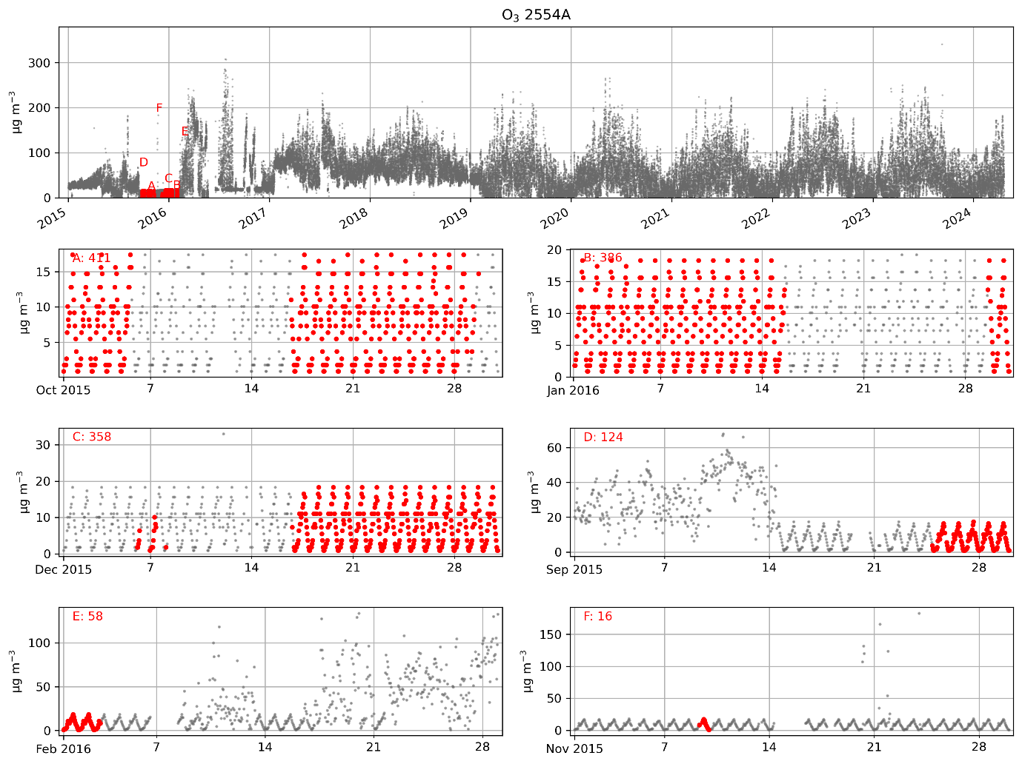
Example of data flagged as ‘low variance’ outlier by the Probabilistic Outlier Automated Detection screening.

Diurnal outliers
We adopt a different approach to Wu et al. (2018) to identify diurnal outliers caused by instrument calibration. These outliers manifest as an unusually high value at a consistent hour of the day (usually 4am) that occurs every few days.
Within a rolling 11 day window, we calculate the diurnal mean, i.e. the average value for each hour. Then, for a given hour, h, we estimate F_{h} as the average of the diurnal mean at h-1 and h+1. We also estimate the standard deviation for h (S_{h}) as the average of the standard deviation for h-1 and h+1. Then we calculate R(i) and Z(i) using F_{h} and S_{h}. In effect, we assume that non-anomalous values will have a similar mean and distribution those of their neighbouring hours of the day, within each 11 day window. Therefore, a sudden spike that is not consistent with neighbouring values will have a large Z value. We mark values as a diurnal outlier if P < 10⁻⁶.
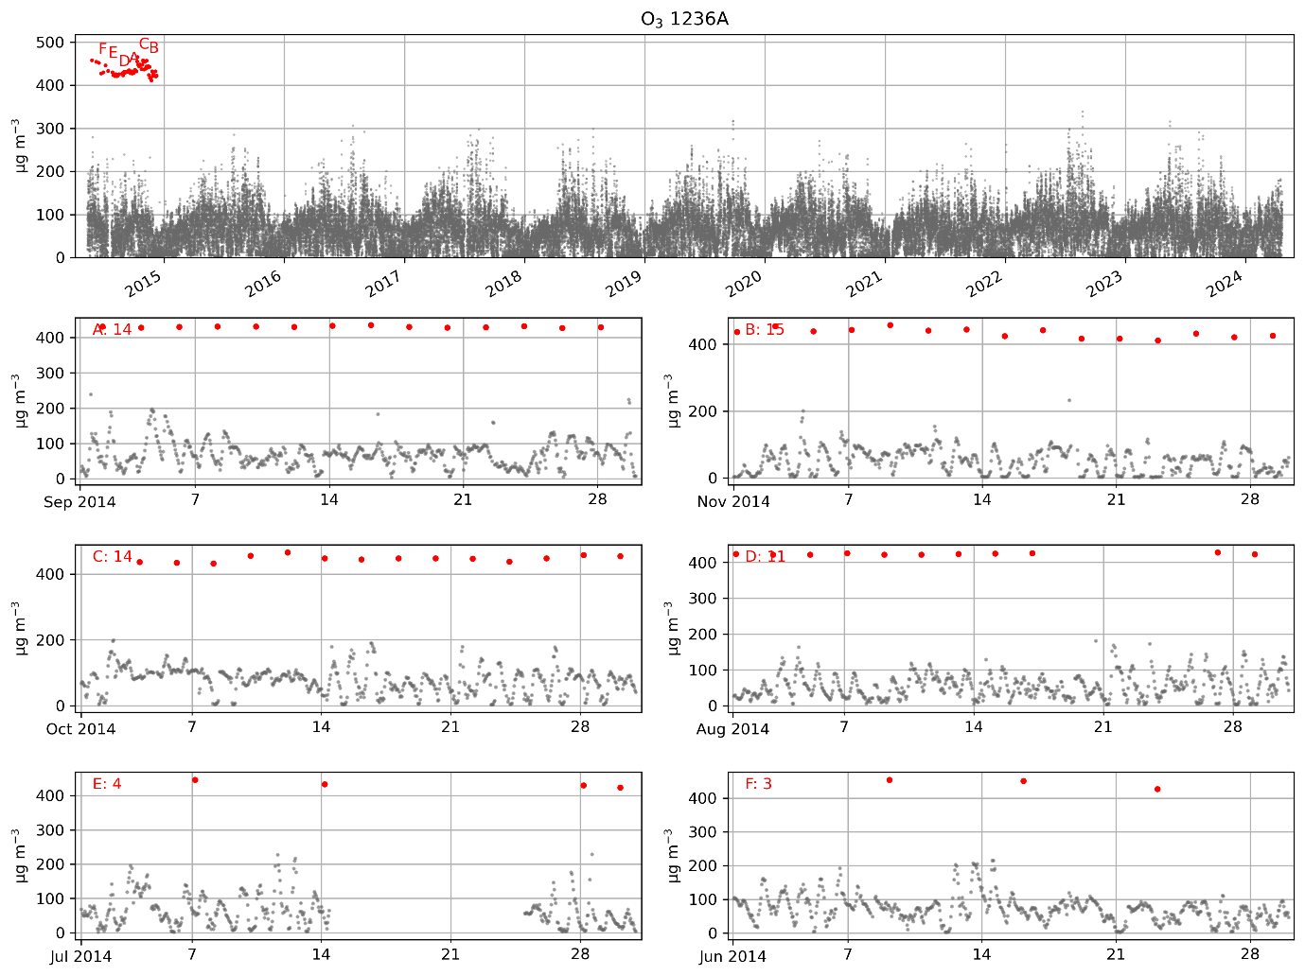
Example of data flagged as ‘calibration’ outlier by the Probabilistic Outlier Automated Detection screening.
We take advantage of the fact that the calibration time remains consistent (so the outliers always occur at the same hour), by only flagging the time series if the outlier count for the most flagged hour is >10 times larger than the second most flagged hour. If this is the case, we also remove all flags for hours other than the most flagged hour.

Supplementary Methods 2 – Demonstrating that the mean of CNEMC stations is similar to the population-weighted mean.

The CNEMC network’s main purpose is ensuring compliance of major cities with China’s air quality policies. Therefore, there are more stations in cities with larger populations. In health impact modelling studies that use gridded pollutant concentration data, the population-weighted mean is often used to compare the between countries, rather than an area-weighted mean, as it is more representative of the average exposure.
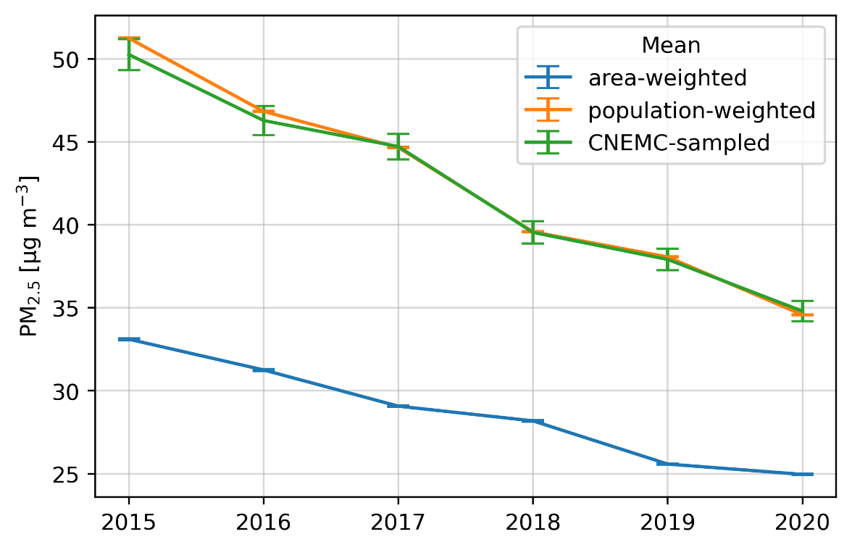
Here we use a gridded reanalysis dataset ‘global weighted regression PM_{2.5} (GWRPM_{2.5}; van Donkelaar et al., 2021) along with the Gridded Population of the World Data ³ to show that the mean of the CNEMC stations is very close to the population-weighted mean for PM_{2.5}. Figure 1 shows that the area weighted-mean PM_{2.5} is much lower than the population-weighted mean or the mean of the GWRPM_{2.5}. This is because large areas of China are sparely populated with few emission sources, and consequently have low PM_{2.5} concentrations, bringing down the area-weighted mean concentration. However, the population-weighted mean is very similar to the the mean of GWRPM_{2.5} sampled at the locations of the CNEMC network, demonstrating that the CNEMC network is evenly distributed with respect to population.

Supplementary Figures
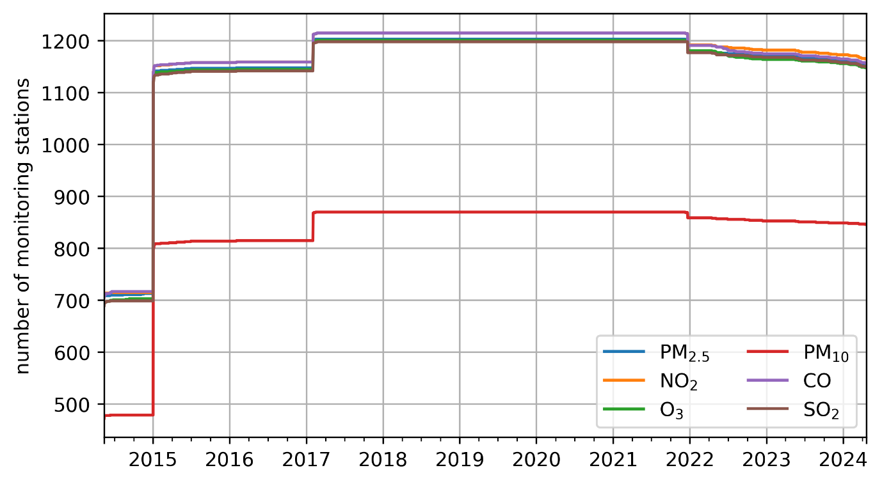
Supplementary Figure 1. The number of monitoring stations included within the average non-linear trends shown in Figure 2. The number of valid stations throughout the time series varies due to both new stations being added to or removed from the monitoring network. Only stations that pass data availability and quality control tests are included in the count.
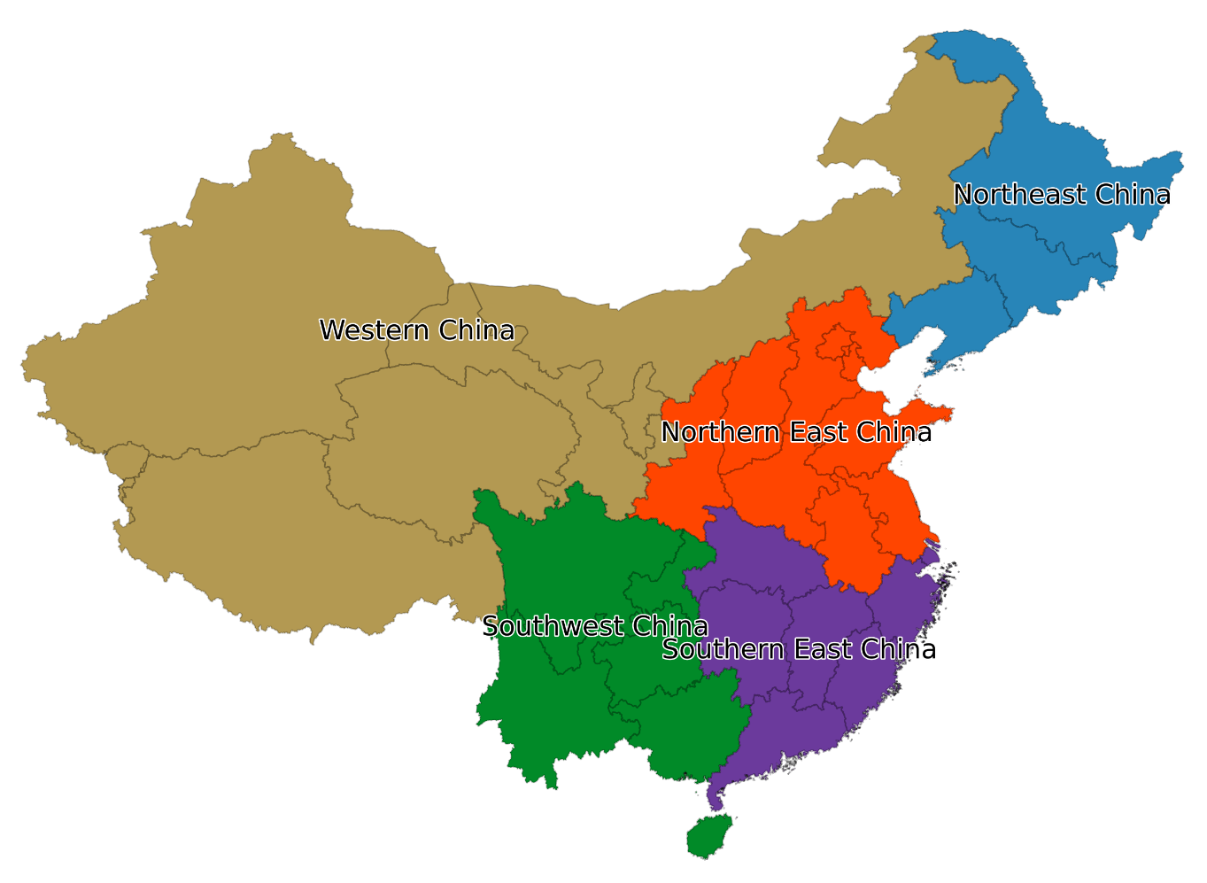
Supplementary Figure 2 Map showing the regional groupings of provinces
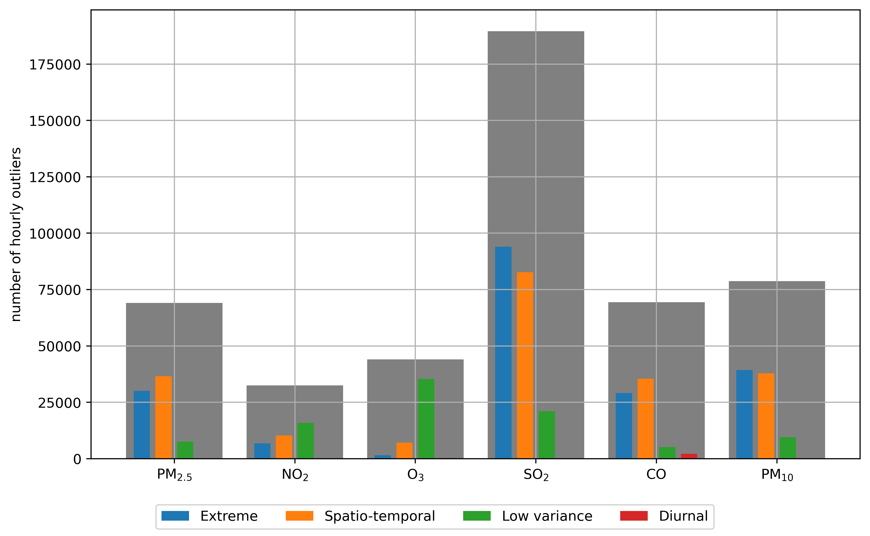
Supplementary Figure 3.Number of hourly outliers found for each pollutant by the PAOD algorithm. The grey bars represent the total number of outliers found for each pollutant, while the coloured bars represent the total for each outlier type.
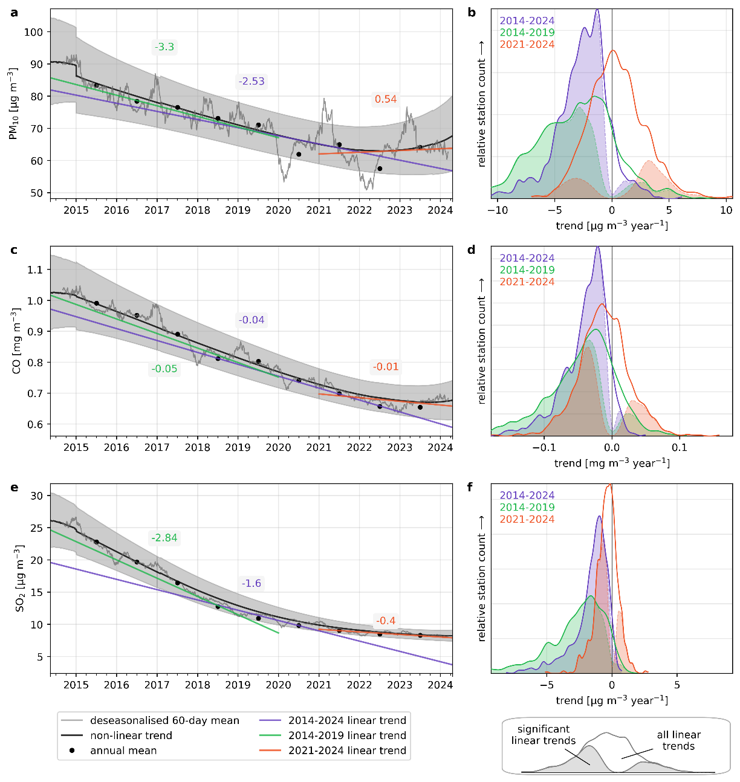
Supplementary Figure 4 Trends in PM₁₀ (a, b), CO (c, d)and SO₂ (e, f) respectively. The left-hand column shows the non-linear trend during the entire period of data, averaged across all the measurement stations which passed data quality checks, with the shaded area representing the average (across stations) 95% confidence interval. The black line is the average of the non-linear trend calculated using the deseasonalised data, while the grey line is the rolling 60-day mean of the deseasonalised data, which is included to show variability at a shorter temporal scale. The straight coloured lines show the average linear trends, calculated using the Theil-Sen estimator, for three periods of interest. The numbers correspond to the average linear trend (in µg m⁻³ year⁻¹) during the coloured period. The right-hand column (b, d, f) shows the frequency distribution for the linear trends during the three periods of interest across all stations meeting data quality checks.

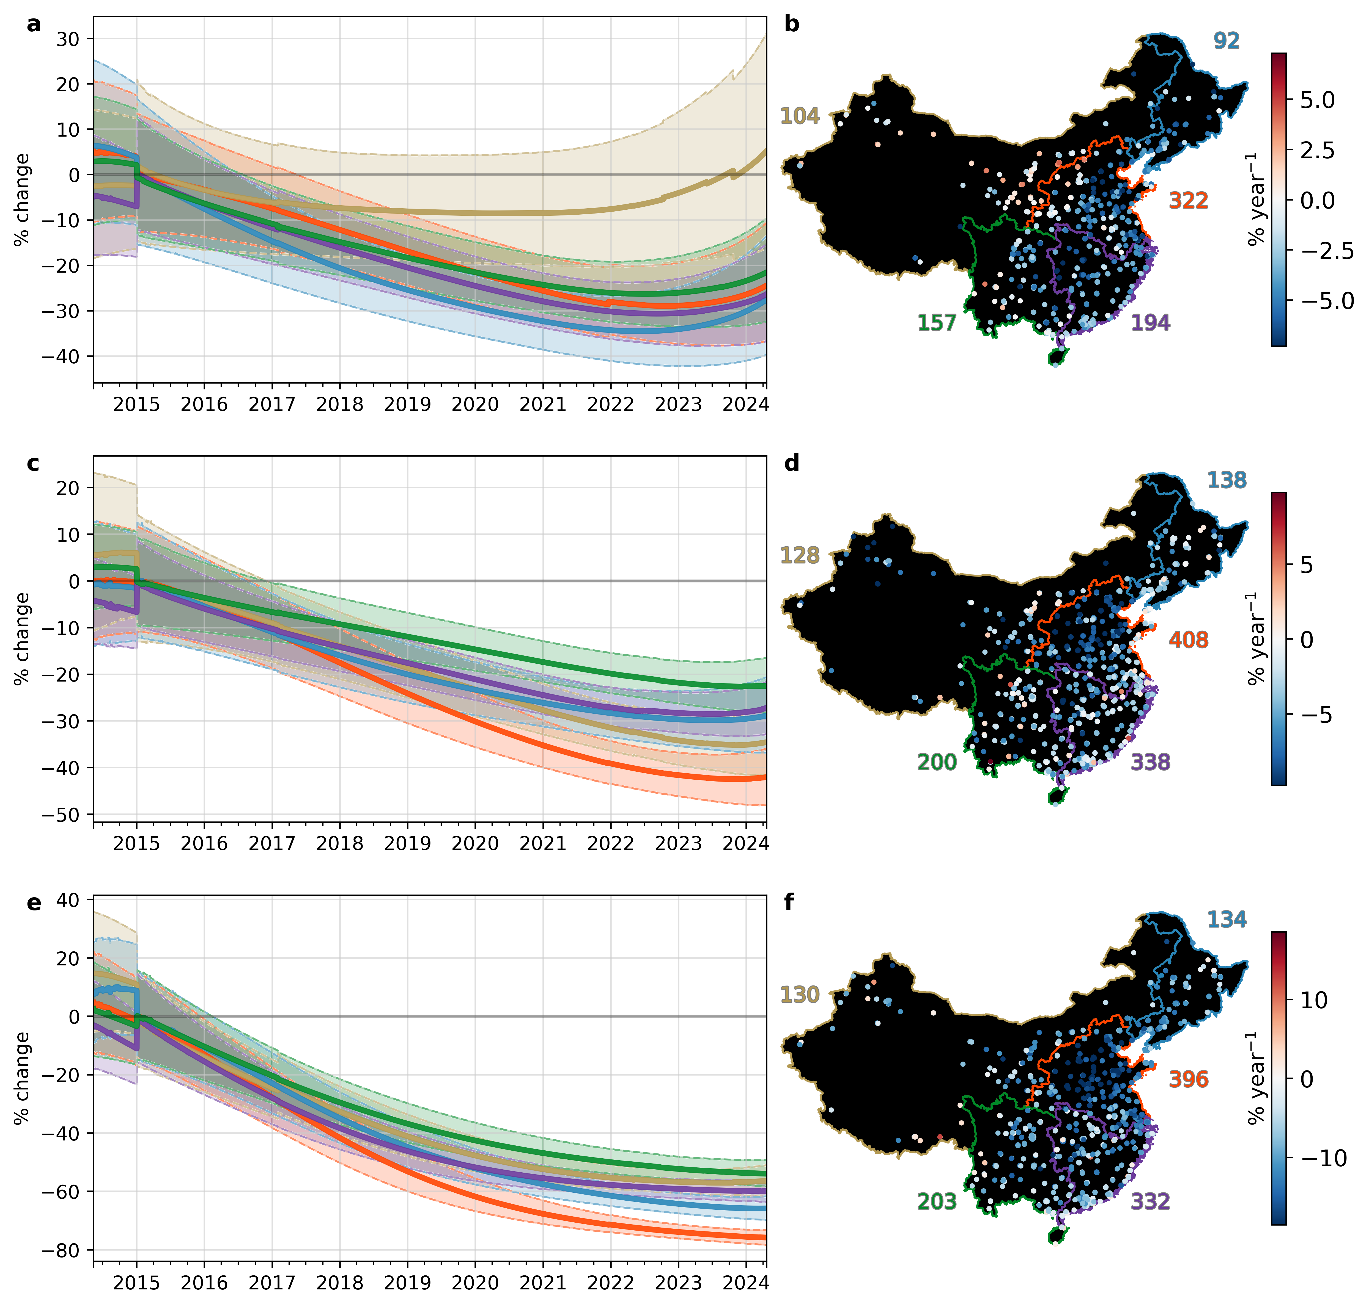
Supplementary Figure 5 Relative non-linear trends in (a, b) PM₁₀, (c, d) ozone, and (e, f) SO₂, averaged by region of China. In the left-hand column (a, c, e), the change is shown relative to the value at the start of 2015 (as prior to this data from ~60%) fewer stations are available. The shaded regions show the 95% confidence interval, coloured by each region. In the right-hand column (b, d, f) maps of the distribution relative linear trends for each valid station are shown. The linear trend is calculated for the entire timeseries (2014–2024).
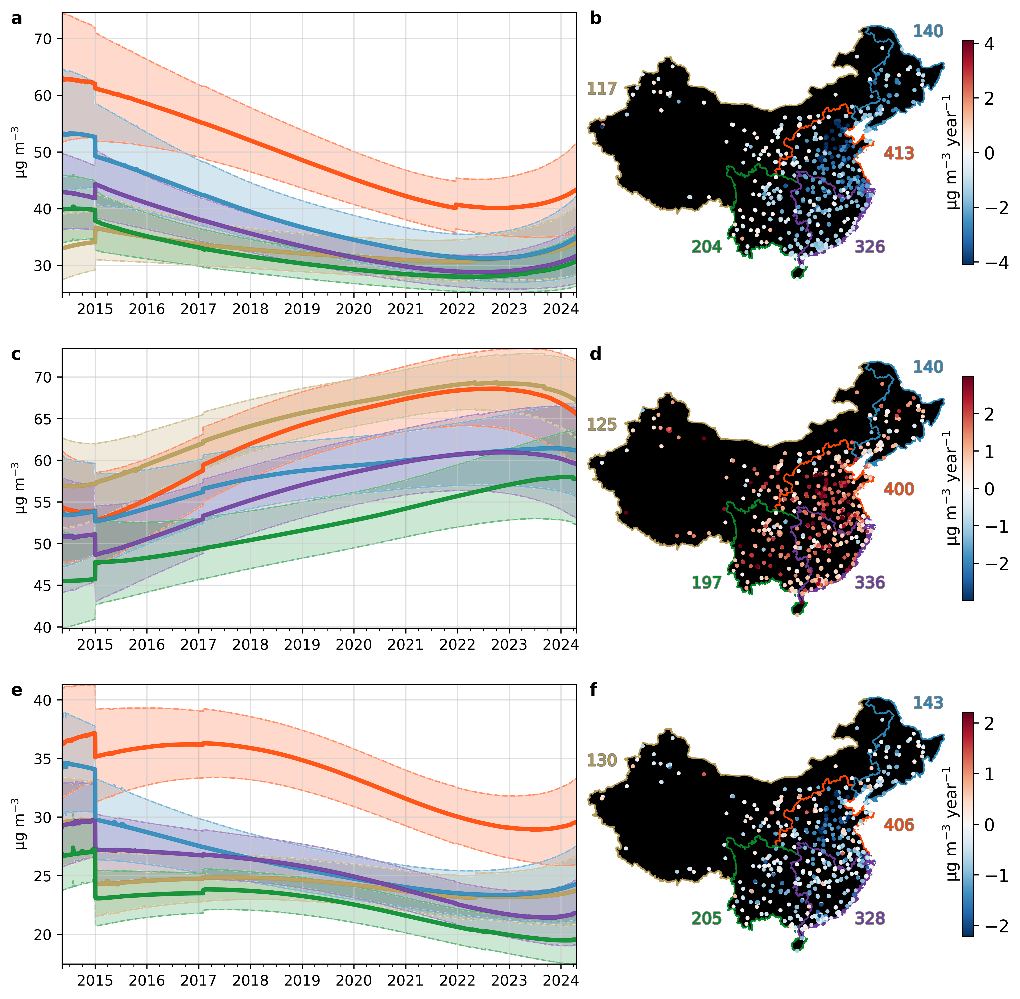
Supplementary Figure 6 Non-linear trends in (a, b) PM_{2.5}, (c, d) ozone, and (e, f) NO₂, averaged by region of China. In the left-hand column (a, c, e), the trend averaged across each of the five regions is shown. The shaded regions show the 95% confidence interval, coloured by each region. In the right-hand column (b, d, f) maps of the distribution linear trends for each valid station are shown. The linear trend is calculated for the entire timeseries (2014–2024).

References

1. Wu, H. et al. Probabilistic Automatic Outlier Detection for Surface Air Quality Measurements from the China National Environmental Monitoring Network. Advances in Atmospheric Sciences 35, 1522–1532 (2018).
2. van Donkelaar, A. et al. Monthly Global Estimates of Fine Particulate Matter and Their Uncertainty. Environ. Sci. Technol. 55, 15287–15300 (2021).
3. CIESIN. Gridded Population of the World, Version 4 (GPWv4): Population Count. (2016) doi:http://dx.doi.org/10.7927/H4X63JVC.

