Supplementary Information
Enhancing solar-to-chemical conversion through tailoring dimensions of semiconductors in biohybrid systems
Mingming Guo^{1,2†}, Xinke Kong^{3†}, Wenbo Cheng^{2,4}, Wenjun Yang¹, Shanshan Pi¹, Xin Wang¹, Xueyun Wang¹, Yang Xiang^{1,5}, Fangfang Duan⁵, Chen Yang^{6*}, Yuanyuan Wang^{3*}, Xiang Gao^{1*}
¹Key Laboratory of Quantitative Synthetic Biology, Shenzhen Institute of Synthetic Biology, Shenzhen Institutes of Advanced Technology, Chinese Academic of Science, Shenzhen 518000, P. R. China
²University of Chinese Academy of Sciences, Beijing 100049, P. R. China
³State Key Laboratory of Coordination Chemistry, School of Chemistry and Chemical Engineering, Nanjing University, Nanjing 210093, China
⁴CAS-Key Laboratory of Synthetic Biology, Key Laboratory of Plant Carbon Capture, CAS Center for Excellence in Molecular Plant Sciences, Shanghai Institute of Plant Physiology and Ecology, Chinese Academy of Sciences, Shanghai, 200032, China
⁵Department of Pharmacology, School of Medicine, Shenzhen Campus of Sun Yat-Sen University, Shenzhen 518107, P. R. China
⁶State Key Laboratory of Microbial Metabolism, and School of Life Sciences and Biotechnology, Shanghai Jiao Tong University, Shanghai, 200240, China
† These authors contributed equally to this work.
*Correspondence to: yang.c@sjtu.edu.cn, wangyy@nju.edu.cn, gaoxiang@siat.ac.cn
Table of Contents
Supplementary Fig. 1 | UV-vis absorbance of 0D, 1D and 2D CdS nano materials. 4
Supplementary Fig. 2 | The growth curve (OD₆₀₀) of 0D, 1D and 2D (4 ML) semiconductors-XG211 co-cultured with cells under light.. 5
Supplementary Fig. 3 | TEM images of 3 ML, 4 ML and 5 ML NPLs. 6
Supplementary Fig. 4 | UV-vis absorbance of (a) 3 ML and (b) 5 ML NPLs. 7
Supplementary Fig. 5 | Cross-sectional TEM images of CC NPLs-XG211 biohybrids samples, CC NPLs mainly gathered in cells. 8
Supplementary Fig. 6 | The acetoin production of XG211 and CC NPLs-XG211 biohybrid systems entities under light and dark. 9
Supplementary Fig. 7 | Classification of the molecular function of Gene Ontology (GO) enrichment analysis of Clusters of Orthologous Groups of proteins (COG) 10
Supplementary Fig. 8 | Heatmaps of notably regulated genes from RNA-seq analysis. 11
Supplementary Fig. 9 | Regeneration of NADH after the addition of thiamine for testing under blue light 12
Supplementary Fig. 10 | The OD₆₀₀ of biohybrid or biohybrid/bacteria under light and dark after addition of TPP or thiamine. 13
Supplementary Fig. 11 | The BDO and carbon yield of biohybrid or biohybrid/bacteria under light after addition of thiamine. 14
Supplementary Fig. 12 | Analysis of qRT-PCR transcriptional levels before and after induction of sgRNA expression. 15
Supplementary Fig. 13 | Analysis of qRT-PCR transcriptional levels in bacteria under light and dark. 16
Supplementary Table 1 | Primers of qRT-PCR. 17
Supplementary Table 2 | Biohybrid electron transfer mechanism. 21
References 22
Materials and chemicals
The following chemicals were used as received: Cadmium oxide (CdO, 99.99%, Aladdin), Cadmium acetate dihydrate (≥ 98%, Aladdin), sulfur (99.99%, Alfa Aesar), selenium powder (99.99%, Sigma-Aldrich), zinc acetate dihydrate (Zn(Ac)2·2H2O, 98.5%, Aldrich), myristic acid (≥ 99%, Aldrich), octadecene (ODE, 90%, Alfa Aesar), oleic acid (90%, Alfa Aesar), L-cysteine (L-cys, Aladdin), Tetradecylphosphonic acid (TDPA, Aladdin), octadecylphosphonic acid (ODPA, Aladdin), Trioctylphosphine oxide (TOPO, 99%, Sigma Aldrich), Trioctylphosphine (TOP, 97%, Strem), toluene (99%, Sinopharm Chemical Reagent Co., Ltd.), N,N-dimethylformamide (DMF, ≥ 99.5%, Sinopharm), nonanoic acid (96%, Aladdin), gold (III) chloride AuCl₃ (99%), dodecylamine (DDA, 98%, Aldrich) and NOBF₄ (97%, Acros), Flavin mononucleotide (Sigma Aldrich), Ethylacetate (Maclin, for LC-MS, ≥99%), Thiamine hydrochloride (Sigma Aldrich), Thiamine pyrophosphate (Aladdin, 98%).
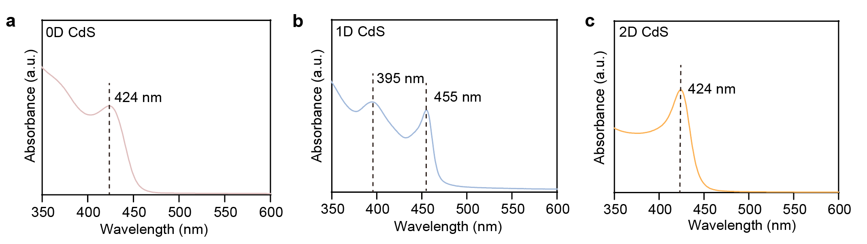

Supplementary Fig. 1 | UV-vis absorbance of 0D, 1D and 2D CdS nanomaterials.
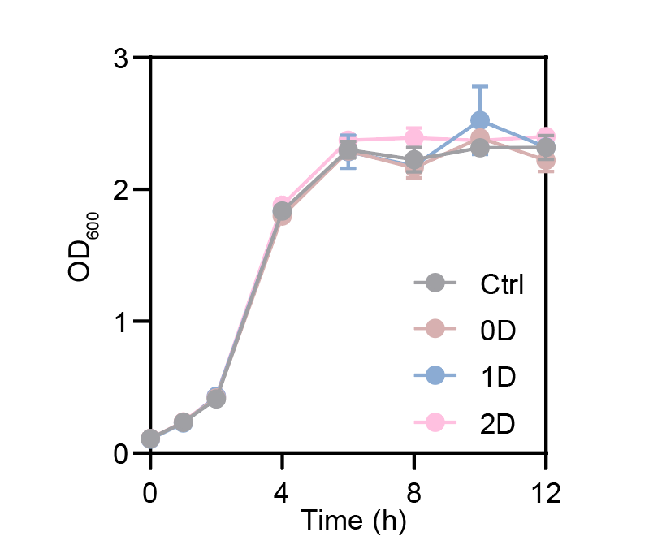
Supplementary Fig. 2 | The growth curve (OD₆₀₀) of 0D, 1D and 2D (4 ML) semiconductors-XG211 co-cultured with cells under light (470 nm, 5 mW cm⁻²) (n = 4). Materials concentration: 1.5 mg L⁻¹.
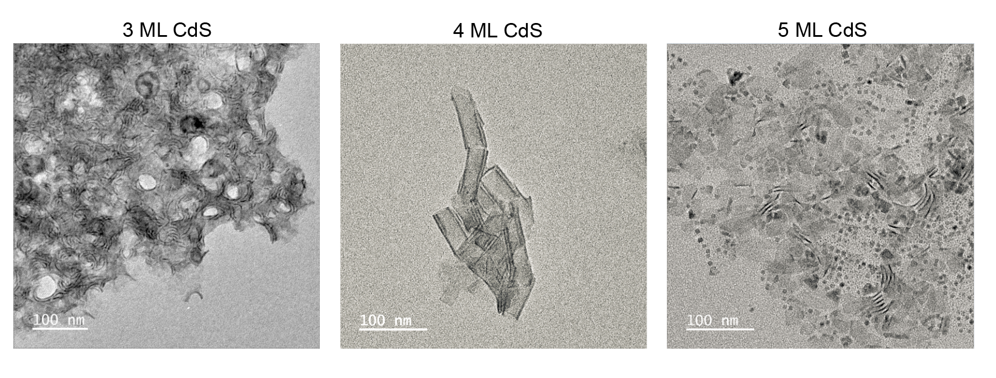

Supplementary Fig. 3 | TEM images of 3 ML, 4 ML and 5 ML NPLs.
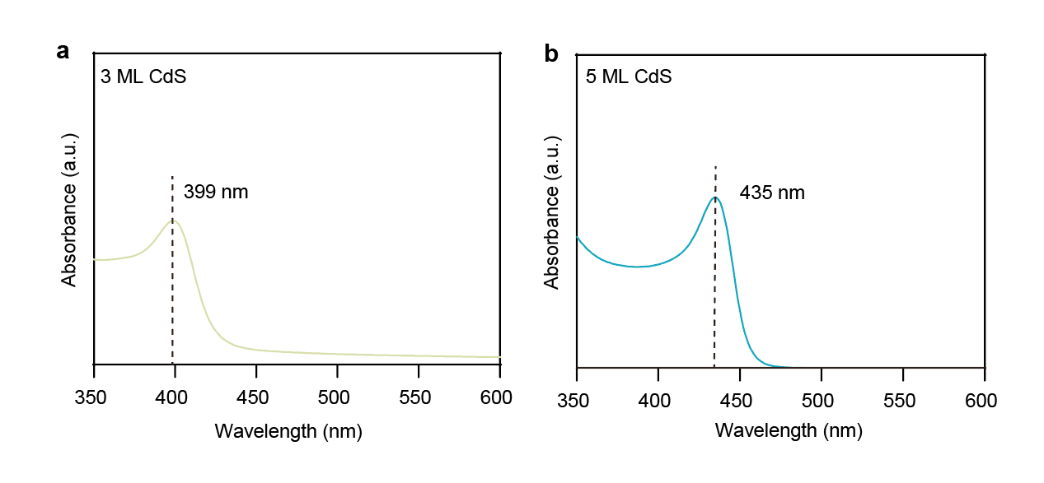

Supplementary Fig. 4 | UV-vis absorbance of (a) 3 ML and (b) 5 ML NPLs.
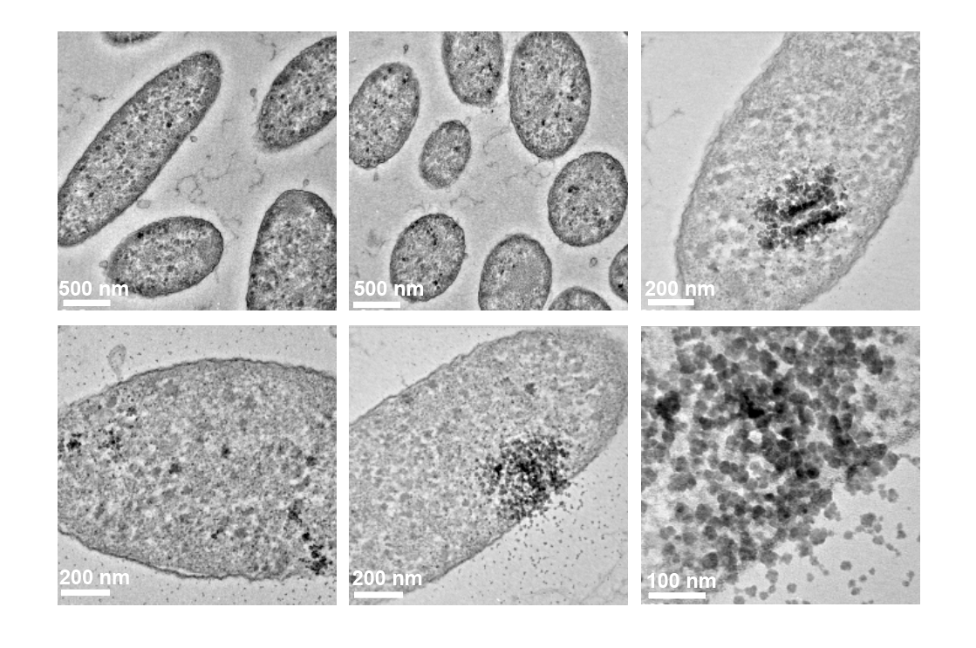

Supplementary Fig. 5 | Cross-sectional TEM images of CC NPLs-XG211 biohybrids samples, CC NPLs mainly gathered in cells.

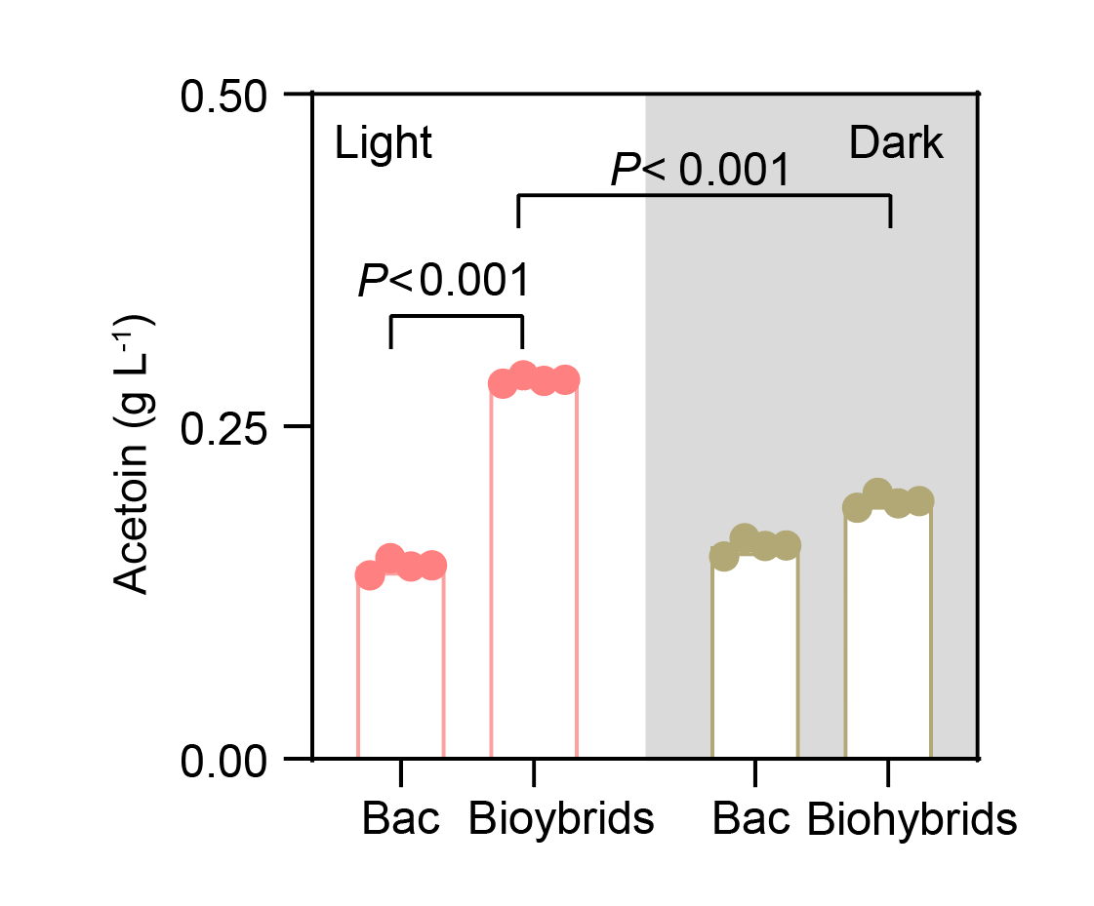
Supplementary Fig. 6 | The acetoin production of XG211 and CC NPLs-XG211 biohybrid systems entities under light and dark. Error bar: standard deviation, n = 4. P values are determined by a two-tailed unpaired t-test.

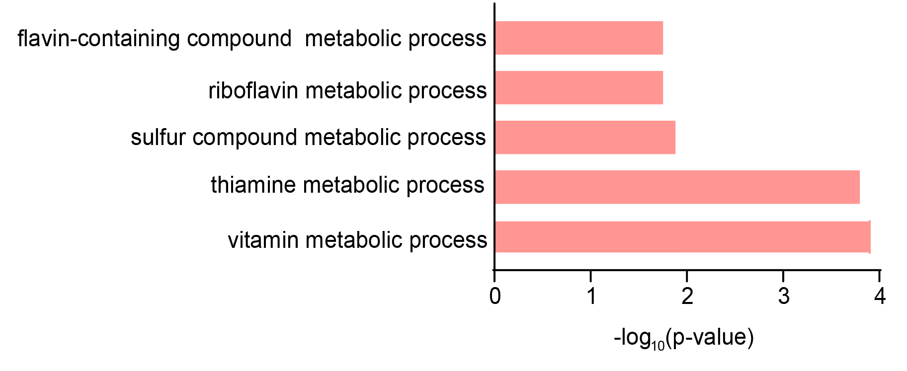
Supplementary Fig. 7 | Classification of the molecular function of Gene Ontology (GO) enrichment analysis of Clusters of Orthologous Groups of proteins (COG): energy production and conversion.” GO term analysis of up-regulated genes showed a common feature “thiamine metabolism” or “flavin binding”.
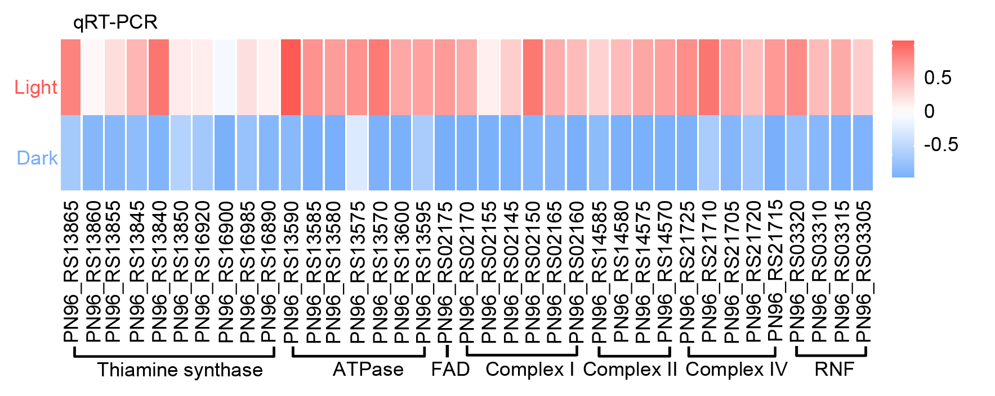

Supplementary Fig. 8 | Heatmaps of notably regulated genes from RNA-seq analysis.
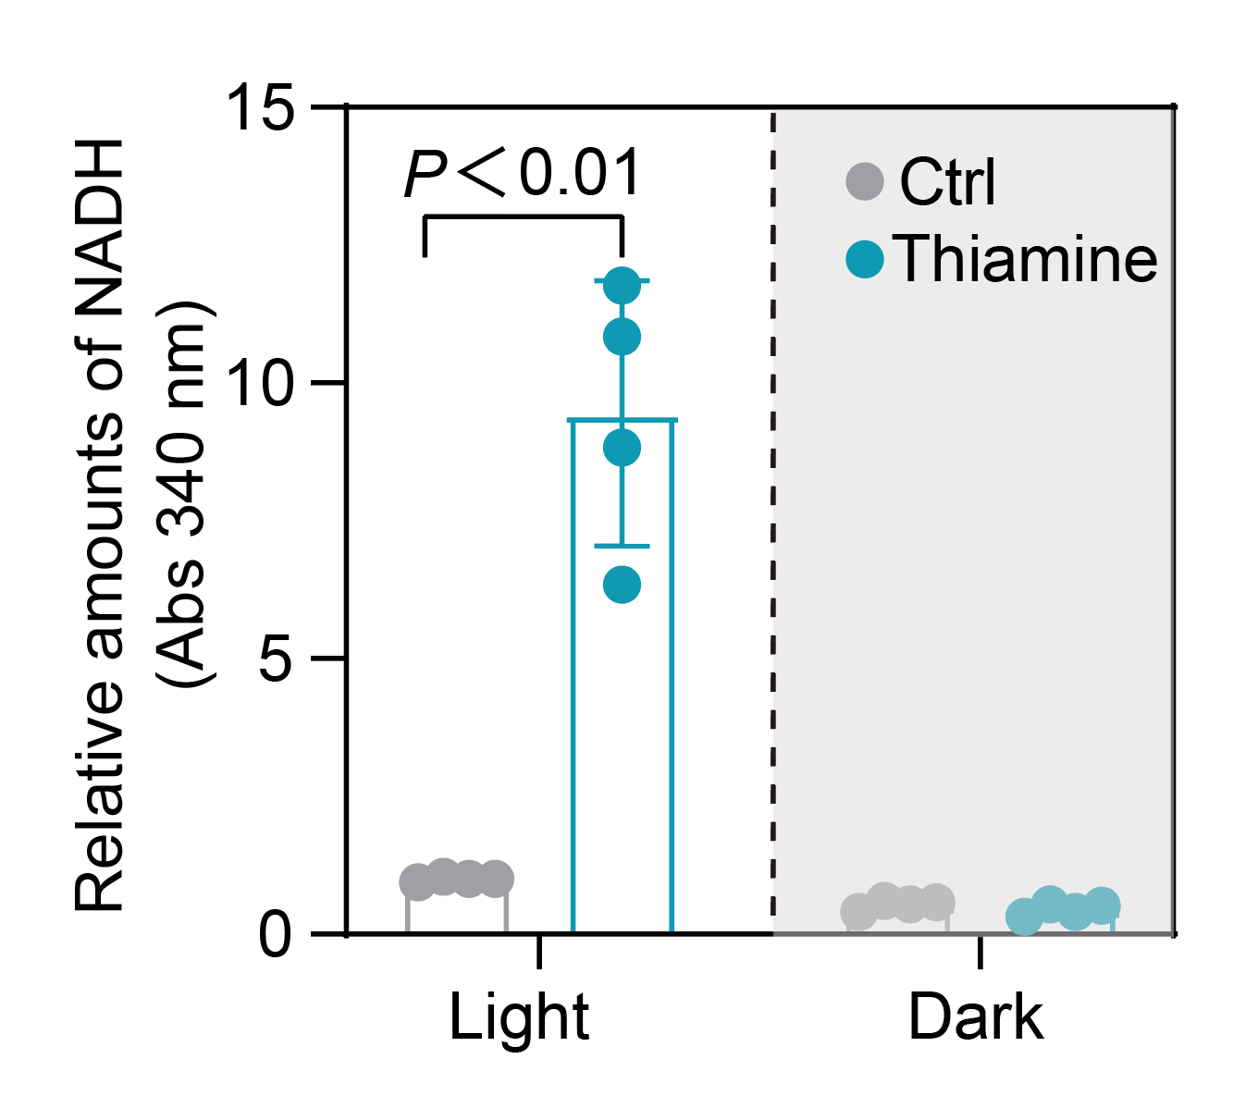
Supplementary Fig. 9 | Regeneration of NADH after the addition of thiamine for testing under blue light (470 nm, 5 mW cm⁻²) in vitro. Error bar: standard deviation, n = 4. P values are determined by a two-tailed unpaired t-test.
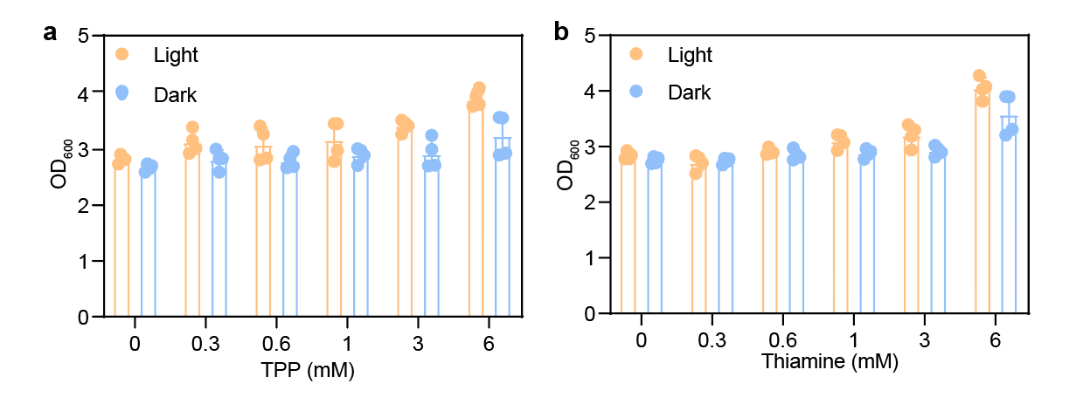
Supplementary Fig. 10 | The OD₆₀₀ of biohybrid or biohybrid/bacteria under light and dark after addition of TPP or thiamine. (a) The biomass of Bacteria-CC NPLs biohybrids after the addition of varying concentrations of TPP under light and dark. (b) The biomass of Bacteria-CC NPLs biohybrids after the addition of varying concentrations of thiamine under light and dark. Error bar: standard deviation, n = 4.
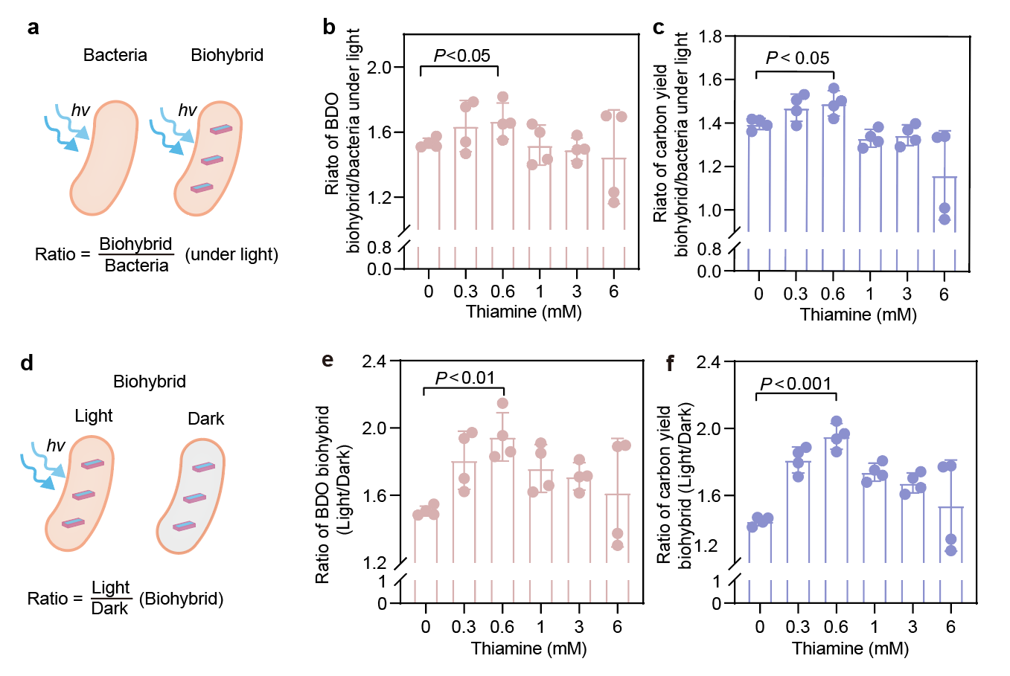
Supplementary Fig. 11 | The BDO and carbon yield of biohybrid or biohybrid/bacteria under light after addition of thiamine. (a) Schematic diagram of hybrids and bacteria used to calculate BDO production and carbon yield under light conditions. (b, c) The relative increase in biohybrid/bacteria BDO and carbon yield following the addition of varying concentrations of thiamine under light conditions. (d) Schematic diagram of biohybrids used to calculate BDO and carbon yield under light and dark conditions. (e, f) The relative increase in biohybrid/bacteria BDO and carbon yield following the addition of varying concentrations of thiamine under light conditions. Error bar: standard deviation, n = 4. P values are determined by a two-tailed unpaired t-test.
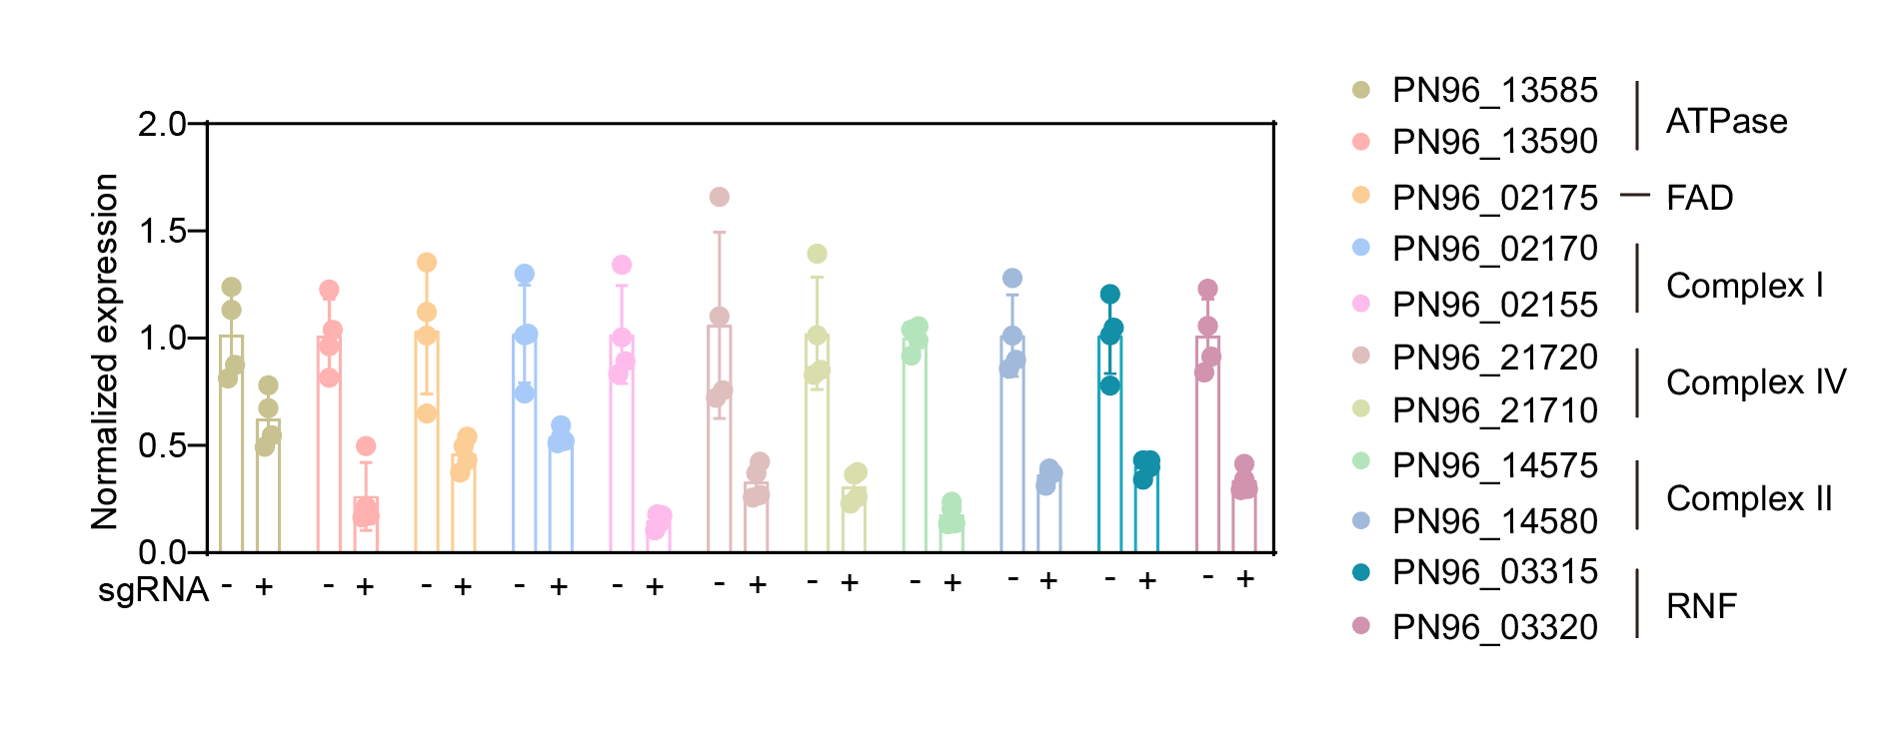

Supplementary Fig. 12 | Analysis of qRT-PCR transcriptional levels before and after induction of sgRNA expression. Error bar: standard deviation, n = 4.
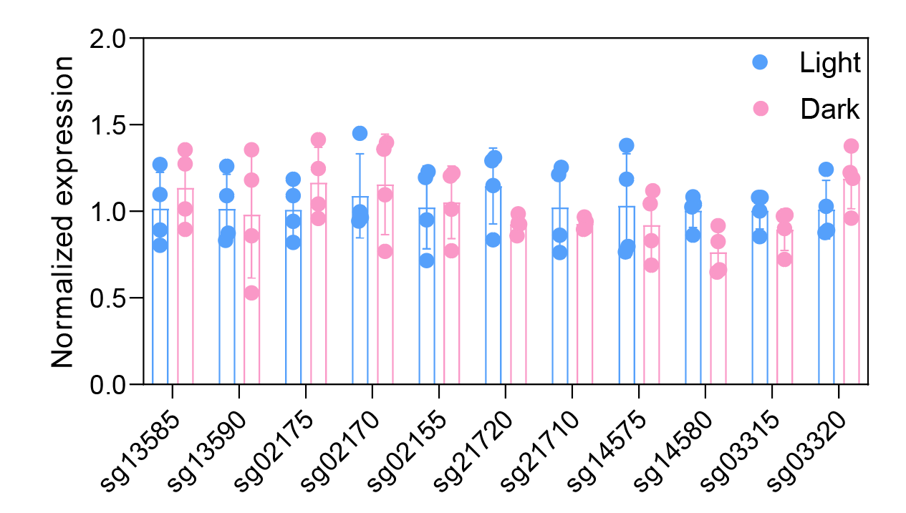

Supplementary Fig. 13 | Analysis of qRT-PCR transcriptional levels in bacteria under light and dark. Error bar: standard deviation, n = 4.

Supplementary Table 1 | Primers of qRT-PCR.
RT00205-R | GTTAGCGACAGAAGAAGCAC | Forward primer for PN96_RS00205  RT-PCR
RT00205-F | CCGGTATTCCTTCAGATCTC | Reverse primer for PN96_RS00205  RT-PCR
RT03315-F | CCGACTCTTCTGGCTCTA | Forward primer for PN96_RS03315  RT-PCR
RT03315-R | TGTGGTCAATGTGGCTATC | Reverse primer for PN96_RS03315  RT-PCR
RT03305-F | ATTGTCACGCCATCTACG | Forward primer for PN96_RS03305 RT-PCR
RT03305-R | GCTTATGTTGTGCTGCTTAT | Reverse primer for PN96_RS03305  RT-PCR
RT19150-F | AACCGCCATCAACTTCTC | Forward primer for PN96_RS19150 RT-PCR
RT19150-R | GACACCGACAACAACCAA | Reverse primer for PN96_RS19150  RT-PCR
RT07565-F | CTAACTCTTCCACTTCTTCTTC | Forward primer for PN96_RS07565 RT-PCR
RT07565-R | AGACCTGCTGATACCGTTA | Reverse primer for PN96_RS07565 RT-PCR
RT07575-F | ACGGACCAATGAACGATAA | Forward primer for PN96_RS07575 RT-PCR
RT07575-R | CTGCTGTGCCAAGTAGAA | Reverse primer for PN96_RS07575  RT-PCR
RT07465-F | TGTTCAACCATCTCACTCAA | Forward primer for PN96_RS07465 RT-PCR
RT07465-R | CAGTCGTCGTTGTCATCA | Reverse primer for PN96_RS07465  RT-PCR
RT07460-F | ATCTGCTGCCACTATTCAC | Forward primer for PN96_RS07460 RT-PCR
RT07460-R | GCCGACTCTAACGATTCAA | Reverse primer for PN96_RS07460  RT-PCR
RT13590-F | TCTCGTGTAGGTGGTTCA | Forward primer for PN96_RS13590 RT-PCR
RT13590-R | TGCTTCTGCTTCATTAGTTC | Reverse primer for PN96_RS13590  RT-PCR
RT13585-F | TGCTAACCAGTTCATTCTCT | Forward primer for PN96_RS13585 RT-PCR
RT13585-R | ACCATTCTCAGCCATCAC | Reverse primer for PN96_RS13585  RT-PCR
RT13580-F | GCAAGCGAATAAGCGTAAG | Forward primer for PN96_RS13580 RT-PCR
RT13580-R | ACAGCCAGAGTAGCAACT | Reverse primer for PN96_RS13580  RT-PCR
RT13575-F | GTAGGTATTATCGTCGGTCTT | Forward primer for PN96_RS13575 RT-PCR
RT13575-R | CTTGTAGCATAGGAGCCATT | Reverse primer for PN96_RS13575  RT-PCR
RT13570-F | CCGTCTGCTGATGTGAATA | Forward primer for PN96_RS13570 RT-PCR
RT13570-R | GGTGATTGAATGGATGTAGTG | Reverse primer for PN96_RS13570  RT-PCR
RT02170-F | GCCGCCTAATAATCCTGAC | Forward primer for PN96_RS02170 RT-PCR
RT02170-R | GCACCACCACCAATGAAT | Reverse primer for PN96_RS02170  RT-PCR
RT02175-F | ATCCAATCTCAAGGCATCAT | Forward primer for PN96_RS02175 RT-PCR
RT02175-R | CGGCTTCTCAATCGCTATA | Reverse primer for PN96_RS02175  RT-PCR
RT02155-F | CATTCCTATTCTTCGCTTACC | Forward primer for PN96_RS02155 RT-PCR
RT02155-R | CACCGTTACCACCTTGAG | Reverse primer for PN96_RS02155  RT-PCR
RT02150-F | CATTCCTATTCTTCGCTTACC | Forward primer for PN96_RS02150 RT-PCR
RT02150-R | CACCGTTACCACCTTGAG | Reverse primer for PN96_RS02150  RT-PCR
RT02145-F | CACGCTCTTCACAGTCTAA | Forward primer for PN96_RS02145 RT-PCR
RT02145-R | CTTACCGAACGCAATAACG | Reverse primer for PN96_RS02145  RT-PCR
RT21725-F | GGACACCAATAGCACCTT | Forward primer for PN96_RS21725 RT-PCR
RT21725-R | GGAAGCCTCAAGATACACA | Reverse primer for PN96_RS21725  RT-PCR
RT21710-F | CGCTTCTCGGTAGTCTTG | Forward primer for PN96_RS21710 RT-PCR
RT21710-R | GCACATTAGTCGGCAGTAT | Reverse primer for PN96_RS21710  RT-PCR
RT21705-F | CGCTTCTCGGTAGTCTTG | Forward primer for PN96_RS21705 RT-PCR
RT21705-R | GCACATTAGTCGGCAGTAT | Reverse primer for PN96_RS21705  RT-PCR
RT14580-F | TAGGCGAATTGGCATCAC | Forward primer for PN96_RS14580 RT-PCR
RT14580-R | CAAGGCTGGTTAGAGTTCA | Reverse primer for PN96_RS14580  RT-PCR
RT14570-F | TGGAACTAGGATACCAAGGA | Forward primer for PN96_RS14570 RT-PCR
RT14570-R | TTCGGATGAGCCAATCTG | Reverse primer for PN96_RS14570  RT-PCR
RT03320-F | GTTAGTGGTAATGAGCGGTAAGAAGATG | Forward primer for PN96_RS03320 RT-PCR
RT03320-R | TGGTTCAGTTCACAGAGATGGTTGT | Reverse primer for PN96_RS03320  RT-PCR
RT03310-F | ATTGTCACGCCATCTACG | Forward primer for PN96_RS03310 RT-PCR
RT03310-R | GCTTATGTTGTGCTGCTTAT | Reverse primer for PN96_RS03310  RT-PCR
RT13600-F | GTATGCCTTCTGCGGTAG | Forward primer for PN96_RS13600 RT-PCR
RT13600-R | TGCGATGTTACGGTTAAGT | Reverse primer for PN96_RS13600  RT-PCR
RT13595-F | GTTCTGTTGGCGTAATGC | Forward primer for PN96_RS13595 RT-PCR
RT13595-R | TTGGCTCAGGCTCATAGA | Reverse primer for PN96_RS13595 RT-PCR
RT02165-F | GCAGGTATCCGTGAGAAG | Forward primer for PN96_RS02165 RT-PCR
RT02165-R | TACAGTTGAACACCAGAGAA | Reverse primer for PN96_RS02165  RT-PCR
RT02160-F | CATTCGTCGTGCTAATACAG | Forward primer for PN96_RS02160 RT-PCR
RT02160-R | CTCGTAGTAAGTGATACCAGAT | Reverse primer for PN96_RS02160  RT-PCR
RT21720-F | TGGTAGACAGTTGGTGATAAG | Forward primer for PN96_RS21720 RT-PCR
RT21720-R | CTTGATTGCTGAAGGTTACG | Reverse primer for PN96_RS21720  RT-PCR
RT21715-F | CATCTGTCTTCGCTTCCAT | Forward primer for PN96_RS21715 RT-PCR
RT21715-R | GCTTATTCTAACGGTGATTCC | Reverse primer for PN96_RS21715  RT-PCR
RT14585-F | CGCAATTACGAAGTCCATAG | Forward primer for PN96_RS14585 RT-PCR
RT14585-R | GCTGATTAACGGTGAGAATG | Reverse primer for PN96_RS14585  RT-PCR
RT14575-F | TAGGCGAATTGGCATCAC | Forward primer for PN96_RS14575 RT-PCR
RT14575-R | CAAGGCTGGTTAGAGTTCA | Reverse primer for PN96_RS14575  RT-PCR

Supplementary Table 2 | Biohybrid electron transfer mechanism.
Materials | Location of materials | Cells | Electron transfer mechanism
CdS NPs¹ | Cell surface | Clostridium autoethanogenum | Electronic delivery via mediator. Mediator: FMN, Metal ions
CdTe QD² | Cell surface | Xanthobacter autotrophicus | Through the electron transport chain in oxidative phosphorylation.
CdS³ | Cell surface | Moorella thermoacetica | Two-pathway mechanism: a high-efficiency hydrogenase-mediated pathway generating hydrogen gas and a direct electron transfer pathway to enzymatic machinery for acetic acid production. Mediator: H₂.
CdS⁴ | Periplasmic space | Escherichia coli | Through the electron transport chain in oxidative phosphorylation.
g-C₃N₄⁵ | Cell surface | BACT3 and CHLO2 | Passed to the electron transport respiratory chain via cytochrome c and flavin. Mediator: cytochrome c and flavin.
CdS⁶ | Cell surface | Shewanella decolorationis | Through the electron transport chain.
CdS⁷ | Cell surface | Geobacter sulfurreducens | Electrons are transferred through C-type cytochrome on the extracellular molybdenum.
CdS⁸ | Cell surface | Shewanella oneidensis MR-1 | Transfer electrons through the reverse extracellular electron transfer (EET) chain.
CZSe QDs⁹ | Intracellular | Escherichia coli | Material electrons are transferred directly to the enzyme.
Ni: CdS¹⁰ | Cell surface | Methanosarcina barkeri | Electron transfer via membrane proteins that upregulate energy conversion.
CdS¹¹ | Cell surface | Sporomusa ovata | Electrons enter the bacterial cell through flavoprotein (Fp) transfer and ferredoxin (Fd), and then are transported along the cell membrane and shuttled with the help of menadione (Q) to participate in the reduction reaction within the bacteria.
Au NPs¹² | Intracellular | Clostridium butyricum | AuNPs transfer electrons to the FAD²⁺ cofactor, which generates hydrogen by transferring reduced FADH₂ to ferredoxin-coupled hydrogenase.
COE-IC¹³ | In cell membrane | Azotobacter vinelandii | Electron transfer to enzyme.
CdS¹⁴ | Cell surface | Methanosarcina barkeri | Electron transfer to extramembrane proteins.
CdS (This work) | Intracellular | Vibrio natriegens | Transfer electrons to NADH or the electron respiratory chain via TPP electron transfer mediator. Mediator: TPP.

References
1. Jin, S., et al. Acetogenic bacteria utilize light-driven electrons as an energy source for autotrophic growth. Proc. Natl. Acad. Sci. U. S. A. 118, (2021).
2. Guan, X., et al. Maximizing light-driven CO₂ and N₂ fixation efficiency in quantum dot-bacteria hybrids. Nat. Catal. 5, 1019-1029 (2022).
3. Kornienko, N., et al. Spectroscopic elucidation of energy transfer in hybrid inorganic-biological organisms for solar-to-chemical production. Proc. Natl. Acad. Sci. U. S. A. 113, 11750-11755 (2016).
4. Lin, Y., et al. Periplasmic biomineralization for semi-artificial photosynthesis. Sci. Adv. 9, eadg5858 (2023).
5. Dong, T., Zhang, L., Hao, S., Yang, J., Peng, Y. Interspecies cooperation-driven photogenerated electron transfer processes and efficient multi-pathway nitrogen removal in the g-C₃N₄-anammox consortia biohybrid system. Water Res. 255, 121532 (2024).
6. Wang, Y., et al. Light-driven biodegradation of azo dyes by Shewanella decolorationis-CdS biohybrid in wastewater lacking electron donors. Appl. Microbiol. Biotechnol. 107, 447-457 (2023).
7. Yi, X., Liu, S., Luo, M., Li, Q., Wang, Y. An outer membrane photosensitized Geobacter sulfurreducens-CdS biohybrid for redox transformation of Cr(VI) and tetracycline. J. Hazard. Mater. 431, 128633 (2022).
8. Han, H.X., Tian, L.J., Liu, D.F., Yu, H.Q., Sheng, G.P., Xiong, Y. Reversing electron transfer chain for light-driven hydrogen production in biotic-abiotic hybrid systems. J. Am. Chem. Soc. 144, 6434-6441 (2022).
9. Bassett, S., et al. Light-driven metabolic pathways in non-photosynthetic biohybrid bacteria. Chembiochem 25, e202300572 (2024).
10. Ye, J., et al. Efficient photoelectron capture by Ni decoration in methanosarcina barkeri-CdS biohybrids for enhanced photocatalytic CO₂-to-CH₄ conversion. iScience 23, 101287 (2020).
11. He, Y., et al. Photosynthesis of acetate by sporomusa ovata-CdS biohybrid system. ACS Appl. Mater. Interfaces 11, (2022).
12. Wang, Y., et al. Visible-light-driven enhanced biohydrogen production by photo-biohybrid system based on photoelectron transfer between intracellular photosensitizer gold nanoparticles and clostridium butyricum. ACS Sustainable Chem. Eng. 11, 300–311 (2023).
13. Chen, Z., et al. A Broad Light-harvesting conjugated oligoelectrolyte enables photocatalytic nitrogen fixation in a bacterial biohybrid. Angew Chem. Int. Ed. Engl. 62, e202307101 (2023).
14. Huang, L., et al. Light-driven carbon dioxide reduction to methane by Methanosarcina barkeri in an electric syntrophic coculture. Isme j 16, 370-377 (2022).

