  - Supplement A
  - Usability questionnaire Colli-Pee®
(the questionnaire will be offered electronically in Qualtrix to the participants)

Dear participant.

Thank you again for your participation in this clinical study from the University of Antwerp.

Through this questionnaire we want to collect information about your experiences as a user of the Colli-Pee® device. The questionnaire will take about 10 to 15 minutes and the collected data will be processed encrypted in a reliable manner.

Best regards.
The study team

General
- What is your codenumber?

- What is your birth year?
… … … … (jjjj)

- Did you previously participate in the VALHUDES study?
- Yes
- No
- I do not remember

- According to the study instructions. we asked you to complete the questionnaire after taking your first urine sample. that is. before taking the second sample.
After which sample did you complete this questionnaire?
- Before the first urine sample
- After the first urine sample
- After the second urine sample

- Did you collect the first urine sample with Colli-Pee whose container had a yellow sticker?
- Yes
- No
- I do not remember

- How much time was there between your last toilet visit and the toilet visit during which you urinated in the Colli-Pee?
- Les than one hour
- One to two hours
- Two to three hours
- Longer than three hours

Before urine collection: assembly of Colli-Pee®
- Mounting the collector tube on Colli-Pee® went smoothly.
- Yes
- No

- Did you leave the liquid in the collection tube while collecting the urine sample?
- Yes
- No

- It was clear when Colli-Pee was ready for use.
1 | 2 | 3 | 4 | 5 | 6 | 7 | 8
Completely Completely
disagree agree

During urine collection: performance of Colli-Pee®
- It was clear how to use Colli-Pee during urination.

1 | 2 | 3 | 4 | 5 | 6 | 7 | 8
Completely Completely
disagree agree

- Colli-Pee's funnel was held against the body during urination.
- Yes
- No

- How did you experience collecting urine with the urine collection device?

1 | 2 | 3 | 4 | 5 | 6 | 7 | 8
Not at all Very
comfortable comfortable

Please explain your answer:

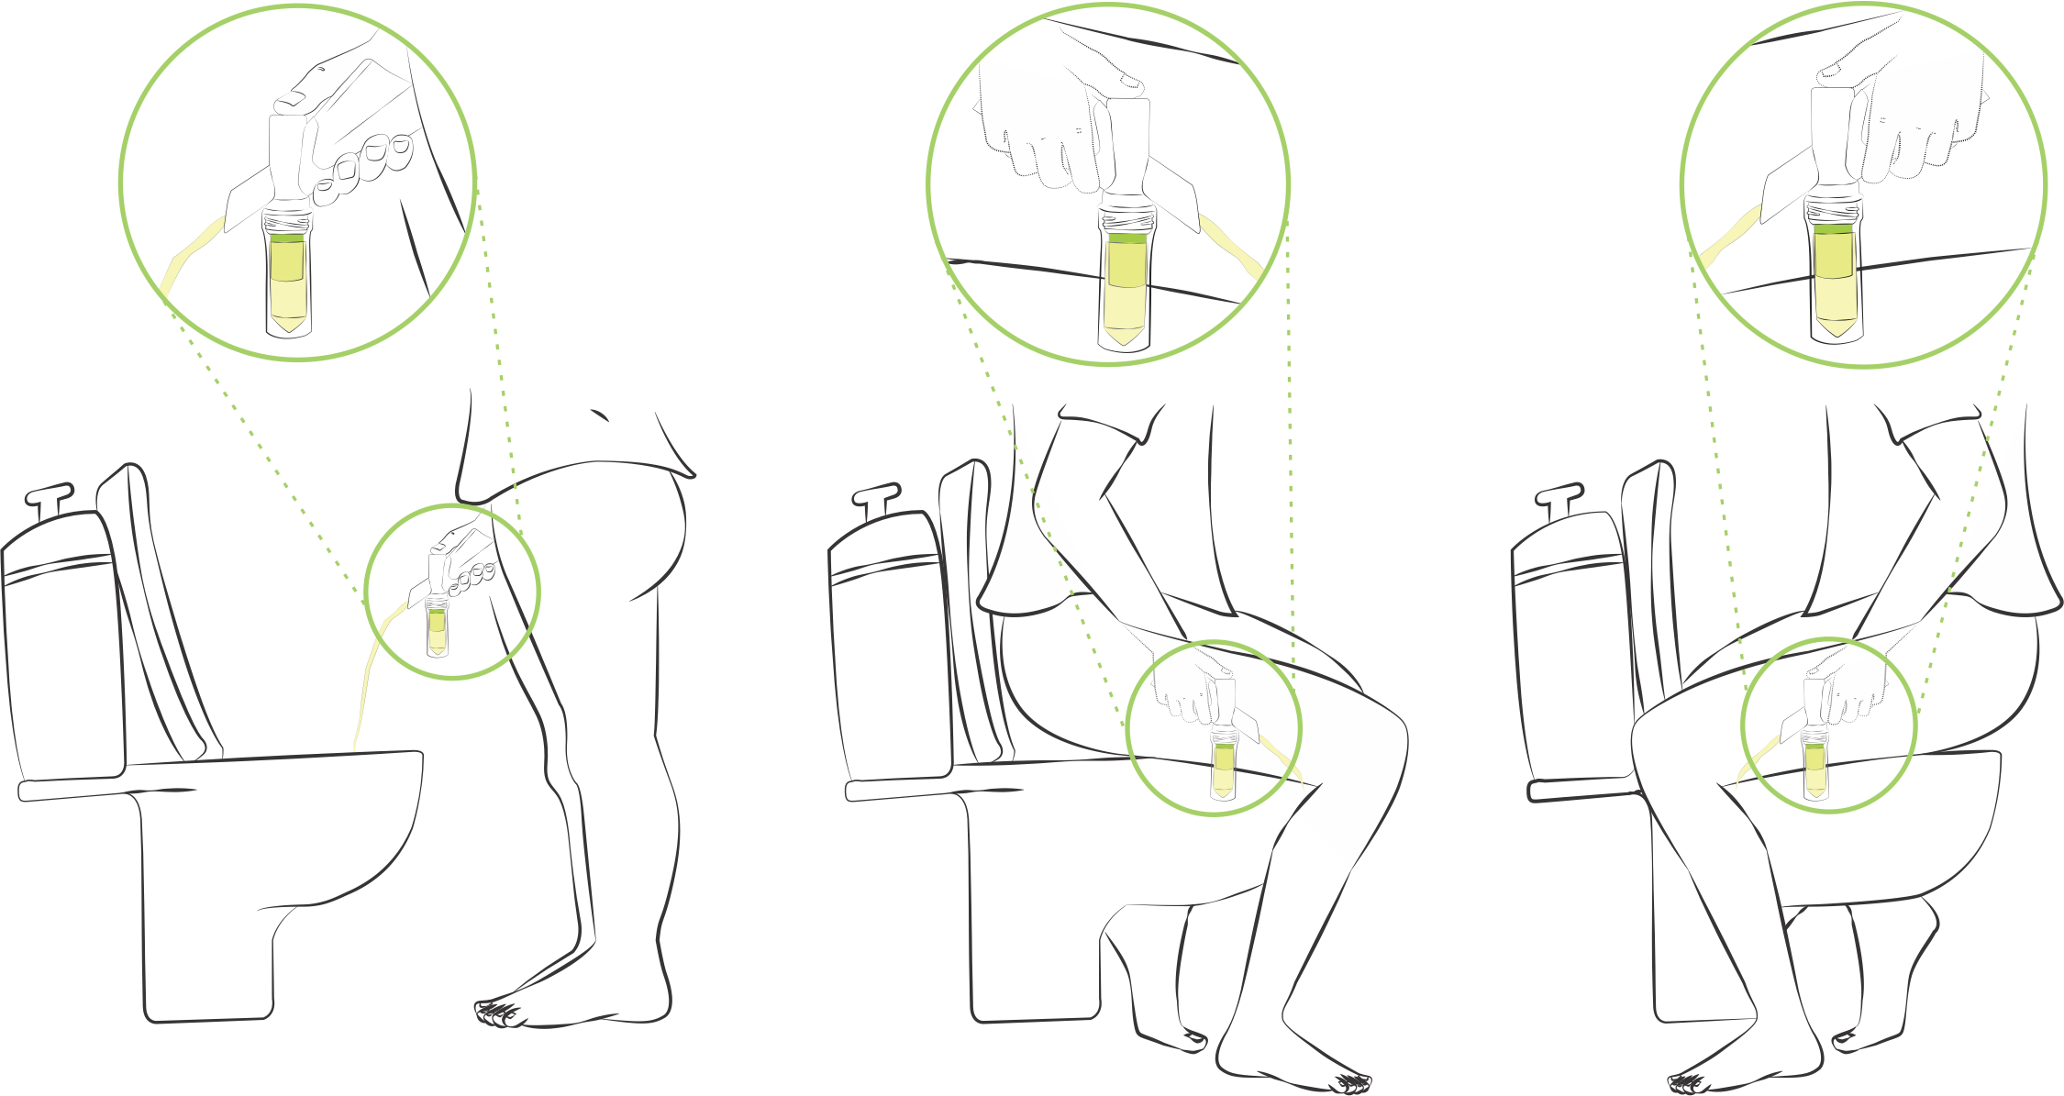
- Please indicate which position you used to collect the Colli-Pee® sample?
- Upright position (Left figure)
- Normal sitting position (Middle figure)
- Sitting backwards (Right figure)
- Other:

- During urination urine was spilled.
- Yes
- No

After collection: disassembly of Colli-Pee®
- During disassembly urine was spilled.
- Yes
- No

- It was easy to disassemble the Colli-Pee® tube.

1 | 2 | 3 | 4 | 5 | 6 | 7 | 8
Completely Completely
disagree agree

- Sealing the collector tube with the cap was easy.

1 | 2 | 3 | 4 | 5 | 6 | 7 | 8
Completely Completely
disagree agree

- It was clear which parts of Colli-Pee® could be discarded after collection.

1 | 2 | 3 | 4 | 5 | 6 | 7 | 8
Completely Completely
disagree agree

- Overall. how long did it take to collect the sample? (from reading the instructions for use until finishing sample collection)
  - Less than two minutes
  - 2 – 5 minutes
  - More than 5 minutes

- I felt it took me a long time to know how to use Colli-Pee®.

1 | 2 | 3 | 4 | 5 | 6 | 7 | 8
Completely Completely
disagree agree

Feedback on the use of Colli-Pee® (1/2)
- I took a urine sample before (with urine cup).
- Yes
- No

If so. which method do you prefer?
  - Colli-Pee®
  - Urine cup
Please explain your answer:

- As a patient. which type of sampling method do you prefer for HPV detection?
  - Pap smear. taken by your doctor
  - Urine self-collection
Please explain your answer:

- I would use Colli-Pee® again for urine collection.
  - Yes
  - No
Please explain your answer:

- I thought Colli-Pee® was easy in use.
  - Yes
  - No
Please explain your answer:

- I would recommend Colli-Pee® to others.
  - Yes
  - No
Please explain your answer:

- I was under the impression that the collection of urine was done correctly.

1 | 2 | 3 | 4 | 5 | 6 | 7 | 8
Completely Completely
disagree agree

- Did you use the instructions for use that came with Colli-Pee in the plastic package?
  - Yes
  - No
If yes: The instructions for use were clear
- Yes
- No
If no: Why did you not find this manual clear? (Multiple answers possible)
- The font was too small
- The explanation was not clear
- The images were not clear
- The images were too small
- Other. Please specify:

- It was clear from the instructions for use that I should not wash my intimate area thoroughly before use.
  - Yes
  - No
Please explain your answer:

Feedback on the use of Colli-Pee® (2/2)
- I would use Colli-Pee® again for urine collection.

1 | 2 | 3 | 4 | 5
Completely Completely
disagree agree

- I found Colli-Pee complex to use.

1 | 2 | 3 | 4 | 5
Completely Completely
disagree agree

- I found Colli-Pee easy to use.

1 | 2 | 3 | 4 | 5
Completely Completely
disagree agree

- I would like to have someone available to ask for advice on using Colli-Pee®.

1 | 2 | 3 | 4 | 5
Completely Completely
disagree agree

- It was easy to collect the first fraction of urine without stopping to urinate.

1 | 2 | 3 | 4 | 5
Completely Completely
disagree agree

- It was unclear that I collected the first fraction of urine.

1 | 2 | 3 | 4 | 5
Completely Completely
disagree agree
- I expect people to quickly learn how to use Colli-Pee®.

1 | 2 | 3 | 4 | 5
Completely Completely
disagree agree

- I found the use of Colli-Pee very cumbersome.

1 | 2 | 3 | 4 | 5
Completely Completely
disagree agree

- I was under the impression that the collection of urine was done correctly.

1 | 2 | 3 | 4 | 5
Completely Completely
disagree agree

- I felt it took me a long time to know how to use Colli-Pee.

1 | 2 | 3 | 4 | 5
Completely Completely
disagree agree

