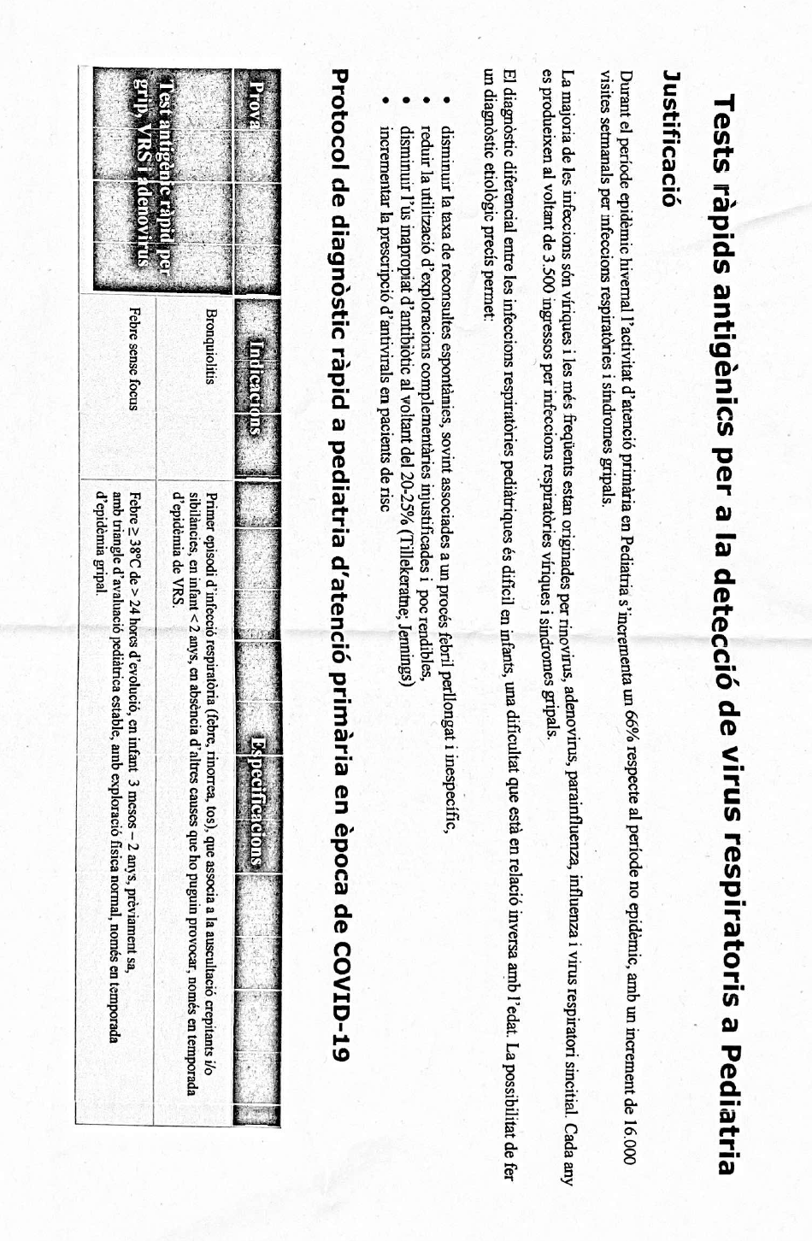
Supplementary Material for:
Introduction of nirsevimab in Catalonia, Spain: description of bronchiolitis and the Respiratory Syncytial Virus incidence in the 2023/24 season.
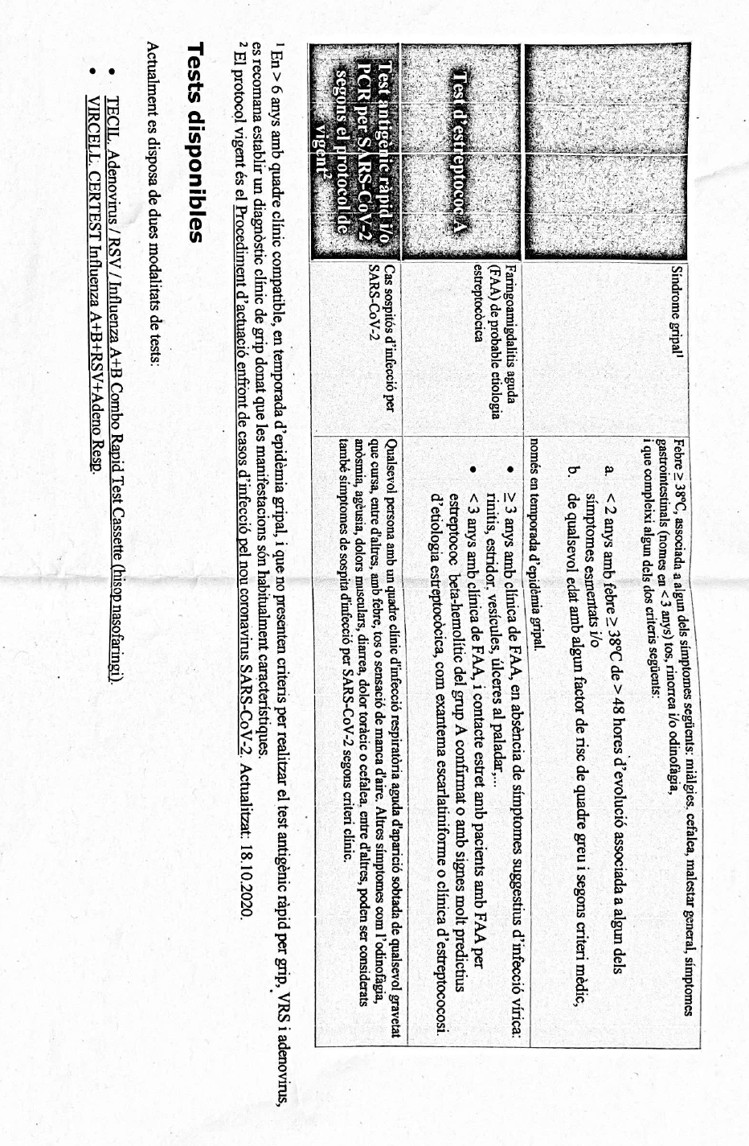
Protocol for RAT performance (Catalan version only):

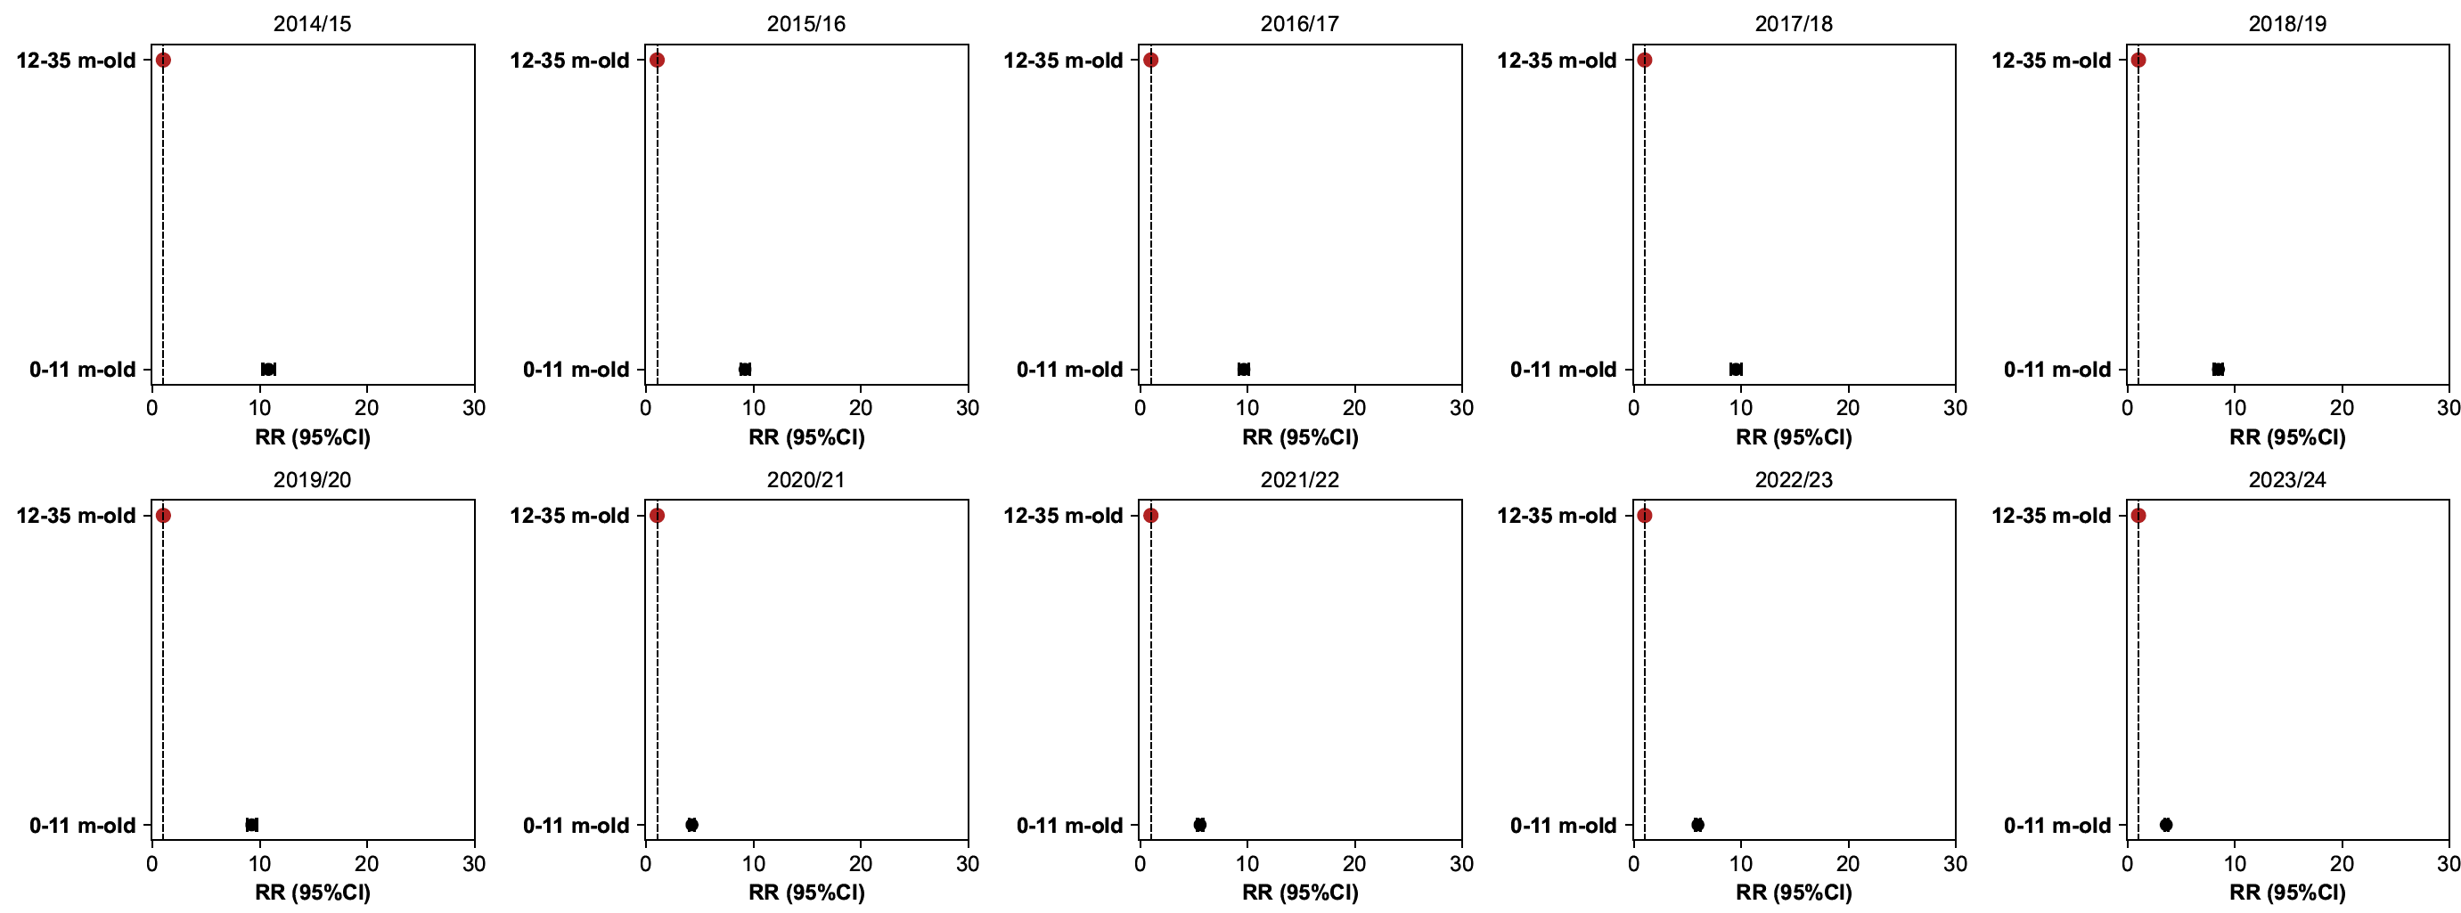
RRs for all-causes bronchiolitis:

Tables of cases and population considered per season for RSV:
Season | RSV 0-11 m-old | RSV 12-35 m-old | RSV >35 m-old | Population 0-11 m-old | Population 12-35 m-old | Population >35 m-old
2020/21 | 194.71 | 423.86 | 62 | 55543 | 131380 | 956610
2021/22 | 274.71 | 242.14 | 77.86 | 50007 | 125037 | 955363
2022/23 | 314.57 | 285.57 | 103.57 | 50538 | 118319 | 944280
2023/24 | 361.14 | 805.86 | 472.43 | 51443 | 116596 | 940813

Tables of cases and population considered per season for all-causes Bronchiolitis:

Season | Bronchiolitis 0-11 m-old | Bronchiolitis 12-35 m-old | Population 0-11 m-old | Population 12-35 m-old
2014/15 | 7459.43 | 1691.29 | 64267 | 157338
2015/16 | 9063.71 | 2265.43 | 63979 | 146969
2016/17 | 8432.86 | 2004.71 | 61589 | 141503
2017/18 | 7536.43 | 1827.29 | 61671 | 142124
2018/19 | 8100.29 | 2256 | 59322 | 139559
2019/20 | 7684.57 | 2005.57 | 57027 | 137446
2020/21 | 2827.86 | 1576.57 | 55543 | 131380
2021/22 | 5408.29 | 2423.43 | 50007 | 125037
2022/23 | 8226.14 | 3232.29 | 50538 | 118319
2023/24 | 4338 | 2739.43 | 51443 | 116596
Pre-pandemic | 48277.29 | 12050.29 | 367855 | 864939

